1

1



Proceedings of the Technical Expertise in Stock Assessment (TESA) national workshop on 'Best practices in age estimation', 31 January, 01-02 February 2023 in Moncton, New Brunswick

Daniel Ricard, Peter Comeau, Aaron Adamack, Jacob Burbank, Abby Daigle, Allan Debertin, Kim Emond, Tracey Loewen, Andrea Perreault, Gregory Puncher, Karen Robertson, Nicolas Rolland, Meredith Schofield, Andrew Smith, François-Étienne Sylvain and Stephen Wischniowski

Science Branch Gulf Region

Fisheries and Oceans Canada

Moncton, New Brunswick, E1C 5K4, Canada

2023

Canadian Technical Report of Fisheries and Aquatic Sciences ####

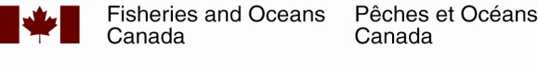

2

**Canadian Technical Report of Fisheries and Aquatic Sciences**

Technical reports contain scientific and technical information that contributes to existing knowledge but which is not normally appropriate for primary literature. Technical reports are directed primarily toward a worldwide audience and have an international distribution. No restriction is placed on subject matter and the series reflects the broad interests and policies of Fisheries and Oceans Canada, namely, fisheries and aquatic sciences.

Technical reports may be cited as full publications. The correct citation appears above the abstract of each report. Each report is abstracted in the data base *Aquatic Sciences and Fisheries Abstracts*.

Technical reports are produced regionally but are numbered nationally. Requests for individual reports will be filled by the issuing establishment listed on the front cover and title page.

Numbers 1-456 in this series were issued as Technical Reports of the Fisheries Research Board of Canada. Numbers 457-714 were issued as Department of the Environment, Fisheries and Marine Service, Research and Development Directorate Technical Reports. Numbers 715-924 were issued as Department of Fisheries and Environment, Fisheries and Marine Service Technical Reports. The current series name was changed with report number 925.

**Rapport technique canadien des sciences halieutiques et aquatiques**

Les rapports techniques contiennent des renseignements scientifiques et techniques qui constituent une contribution aux connaissances actuelles, mais qui ne sont pas normalement appropriés pour la publication dans un journal scientifique. Les rapports techniques sont destinés essentiellement à un public international et ils sont distribués à cet échelon. II n'y a aucune restriction quant au sujet; de fait, la série reflète la vaste gamme des intérêts et des politiques de Pêches et Océans Canada, c'est-à-dire les sciences halieutiques et aquatiques.

Les rapports techniques peuvent être cités comme des publications à part entière. Le titre exact figure au-dessus du résumé de chaque rapport. Les rapports techniques sont résumés dans la base de données *Résumés des sciences aquatiques et halieutiques.*

Les rapports techniques sont produits à l'échelon régional, mais numérotés à l'échelon national. Les demandes de rapports seront satisfaites par l'établissement auteur dont le nom figure sur la couverture et la page du titre.

Les numéros 1 à 456 de cette série ont été publiés à titre de Rapports techniques de l'Office des recherches sur les pêcheries du Canada. Les numéros 457 à 714 sont parus à titre de Rapports techniques de la Direction générale de la recherche et du développement, Service des pêches et de la mer, ministère de l'Environnement. Les numéros 715 à 924 ont été publiés à titre de Rapports techniques du Service des pêches et de la mer, ministère des Pêches et de l'Environnement. Le nom actuel de la série a été établi lors de la parution du numéro 925.

3 Canadian Technical Report of

4 Fisheries and Aquatic Sciences nnn

5 2023

6 PROCEEDINGS OF THE TECHNICAL EXPERTISE IN STOCK ASSESSMENT (TESA)

7 NATIONAL WORKSHOP ON BEST PRATICES IN AGE ESTIMATION, 31 JANUARY, 01-02

8 FEBRUARY 2023 IN MONCTON, NEW BRUNSWICK

9 by

10 Daniel Ricard1, Peter Comeau2, Aaron Adamack3, Jacob Burbank1, Abby Daigle1, Allan

11 Debertin4, Kim Emond5, Tracey Loewen6, Andrea Perreault3, Gregory Puncher2, Karen

12 Robertson1, Nicolas Rolland1, Meredith Schofield3, Andrew Smith5, Francois-Étienne Sylvain1

13 and Stephen Wischniowski7

14 1Gulf Fisheries Centre, Fisheries and Oceans Canada, 343 Université Avenue, Moncton, New

15 Brunswick, E1C 9B6

16 2Bedford Institute of Oceanography, Fisheries and Oceans Canada, 1 Challenger Dr., Dartmouth,

17 Nova Scotia, B2Y 4A2

18 3Nortwest Atlantic Fisheries Centre, Fisheries and Oceans Canada, 80 E White Hills Rd,

19 St. John’s, Newfoundland and Labrador, A1A 5J7

20 4Saint Andrews Biological Station, Fisheries and Oceans Canada, 125 Marine Science Dr.,

21 St. Andrews, New Brunswick, E5B 0E4

22 5Maurice Lamontagne Institute, Fisheries and Oceans Canada, 850 route de la Mer, Mont-Joli,

23 Québec, QC G5H 3Z4

24 6Freshwater Institute, Fisheries and Oceans Canada, 501 University Crescent, Winnipeg,

25 Manitoba, R3T 2N6

26 7Pacific Biological Station, Fisheries and Oceans Canada, 3190 Hammond Bay Road, Nanaimo,

27 British Columbia, V9T 6N7

28 © His Majesty the King in Right of Canada, as represented by the Minister of the

29 Department of Fisheries and Oceans, 2023

30 Cat. No. Fs97-6/nnnE-PDF ISBN ISSN 1488-5379

31 Correct citation for this publication:

32 Ricard, D., Adamack, A., Burbank, J., Comeau, P., Daigle, A., Debertin, A., Emond, K., Loewen,

33 T., Puncher, G., Robertson, K., Rolland, N., Schofield, M., Smith, A., Sylvain, F.-É. and

34 Wischniowski, S. 2023. Proceedings of the Technical Expertise in Stock Assessment (TESA)

35 national workshop on best pratices in age estimation, 31 January, 01-02 February 2023 in

36 Moncton, New Brunswick. Can. Tech. Rep. Fish. Aquat. Sci. nnn: vi + 14 p.

37 **CONTENTS**

|  |  |
| --- | --- |
| 38 **ABSTRACT** | **v** |
| 39 **RÉSUMÉ** | **vi** |
| 40 **1 Introduction** | **1** |
| 41 1.1 Motivations . . . . . . . . . . . . . . . . . . . . . . . . . . . . . . . . . . . . . . . . . | 1 |
| 42 1.2 Objectives . . . . . . . . . . . . . . . . . . . . . . . . . . . . . . . . . . . . . . . . . . | 2 |
| 43 1.3 Format . . . . . . . . . . . . . . . . . . . . . . . . . . . . . . . . . . . . . . . . . . . . | 2 |
| 44 **2 Day 1 - Basics of age estimation** | **2** |
| 45 **3 Day 2 - Digital imaging of ageing structures** | **3** |
| 46 **4 Day 3 - Analysis of age estimates** | **4** |
| 47 **5 Remarks from external experts** | **4** |
| 48 **6 Discussion** | **5** |
| 49 **7 Recommendations** | **5** |
| 50 7.1 Institutional . . . . . . . . . . . . . . . . . . . . . . . . . . . . . . . . . . . . . . . . . | 6 |
| 51 7.2 Ageing structure cataloguing, storage and inventory . . . . . . . . . . . . . . . . . . | 6 |
| 52 7.3 Reference collection . . . . . . . . . . . . . . . . . . . . . . . . . . . . . . . . . . . . | 6 |
| 53 7.4 Laboratory operations . . . . . . . . . . . . . . . . . . . . . . . . . . . . . . . . . . . | 7 |
| 54 7.5 Training . . . . . . . . . . . . . . . . . . . . . . . . . . . . . . . . . . . . . . . . . . . | 7 |
| 55 7.6 Digital imaging of ageing structures . . . . . . . . . . . . . . . . . . . . . . . . . . . . | 8 |
| 56 7.7 Analysis of age estimates . . . . . . . . . . . . . . . . . . . . . . . . . . . . . . . . . | 8 |
| 57 7.8 Preparing for changes associated with a warming climate . . . . . . . . . . . . . . . | 8 |
| 58 7.9 Research and development . . . . . . . . . . . . . . . . . . . . . . . . . . . . . . . . | 9 |
| 59 **8 Acknowledgements** | **9** |

60 **9 Tables** **9**

61 **10 Figures** **12**

62 **11 References** **14**

63 **ABSTRACT**

64 Ricard, D., Adamack, A., Burbank, J., Comeau, P., Daigle, A., Debertin, A., Emond, K., Loewen,

65 T., Puncher, G., Robertson, K., Rolland, N., Schofield, M., Smith, A., Sylvain, F.-É. and

66 Wischniowski, S. 2023. Proceedings of the Technical Expertise in Stock Assessment (TESA)

67 national workshop on best pratices in age estimation, 31 January, 01-02 February 2023 in

68 Moncton, New Brunswick. Can. Tech. Rep. Fish. Aquat. Sci. nnn: vi + 14 p.

69 A three-day workshop was held in Moncton, New Brunswick, from January 31 2023 to February

70 02 2023. The aim of the workshop was to examine and discuss best practices in the use of

71 structures for age estimation.

72 **RÉSUMÉ**

73 Ricard, D., Adamack, A., Burbank, J., Comeau, P., Daigle, A., Debertin, A., Emond, K., Loewen,

74 T., Puncher, G., Robertson, K., Rolland, N., Schofield, M., Smith, A., Sylvain, F.-É. and

75 Wischniowski, S. 2023. Proceedings of the Technical Expertise in Stock Assessment (TESA)

76 national workshop on best pratices in age estimation, 31 January, 01-02 February 2023 in

77 Moncton, New Brunswick. Can. Tech. Rep. Fish. Aquat. Sci. nnn: vi + 14 p.

78 Voici le résumé.

# 79 1 Introduction

80 The purpose of the Technical Expertise in Stock Assessment (TESA) program is to promote

81 stock assessment excellence through organizing national activities that contribute to the

82 development of expertise in stock assessment across Fisheries and Oceans Canada (DFO).

83 TESA was created in 2009, in response to a loss of stock assessment expertise in DFO owing

84 to retirements. Each year, TESA organises three or four training courses and one or two

85 topical workshops on stock assessment issues. TESA is a national program with one or two

86 representatives in each region – for more details see the [GCpedia website](http://www.gcpedia.gc.ca/wiki/DFO_Science_TESA_ETES) (only accessible from

87 the DFO network).

88 This report provides a written record of the TESA workshop on “Best practices in age estimation”

89 that was held in Moncton, NB, from January 31 to February 02 2023. The list of participants

90 can be found in Table 1 and all resources related to the workshop were stored in a [git repository](https://github.com/TESA-workshops/ageing-best-practices-2023)

91 [maintained by TESA](https://github.com/TESA-workshops/ageing-best-practices-2023).

# 92 1.1 Motivations

93 The use of an age-based population model is often lauded as the “gold standard” in stock

94 assessment. Age-based models are favored over simpler population models because of their

95 ability to convey biological realism and to provide a more nuanced understanding of population

96 dynamics, including the effects of fishing on harvested populations. As the name implies, an age-

97 based model requires information about the age of individuals in the population, which provides

98 scientists with a foundation for analyzing the demographics of a population as it evolves over

99 time. Ageing information, in conjunction with other observations, can inform us on the growth of

100 individuals, the age-at-maturation of individuals, the age structure of a population and on other

101 vital factors necessary to understand variations in numbers and biomass.

102 All DFO regions collect structures from marine organisms that are used in estimating their age.

103 The procedures associated with collecting, cataloguing, storing, and obtaining age estimates of

104 samples vary from lab to lab. It is important to follow best practices when estimating age from

105 hard structures and not all personnel are aware of these.

106 In any given year, DFO collects otoliths for a number of stocks and processes these structures to

107 obtain age estimates. It is estimated that tens of thousands of otoliths and scales are collected

108 yearly in scientific activities at DFO.

109 While the use of age-based models is common and the software available to implement such

110 assessments are available and evolving, the manipulation of the input data that feeds into

111 those models is often done in an ad-hoc fashion particular to the lab or agency in charge of the

112 assessment. While these ad-hoc methods are most likely defensible and appropriate, the details

113 that go into the computation of catch-at-age matrices are often poorly documented, making

114 results hard to reproduce by someone outside a given lab or agency. This workshop provided an

115 opportunity for DFO scientists using age-based assessments, and those involved in the analyses

116 of age and length information, to share ideas and develop better methods to use ageing data in

117 assessments.

118 **1.2 Objectives**

119 The objectives of this workshop were to create a forum for discussion and for exchanging ideas

120 among DFO scientists that use age-based models and that are involved in ageing activities. In

121 particular, the workshop provided:

122 • guidance on ageing structures collection and on the sampling design for collecting ageing

123 structures

124 • guidance on age determination using ageing structures, best practices for annuli validation,

125 reference collections, ager calibration, archival of ageing structures and data warehousing

126 • guidance on digital imaging of ageing structures

127 • guidance on going from length frequency samples and age-length keys to catch-at-age

128 matrices that feed into age-based population models

129 **1.3 Format**

130 A hybrid meeting was held from January 31 2023 to February 02 2023. The list of participants

131 and the attendance can be found in Table 1. A total of 76 participants attended the event (30

132 in person and 46 virtually), including two external experts who joined the meeting virtually. The

133 workshop was attended by a wide variety of DFO personnel ranging from research scientists, to

134 biologists, to fisheries technicians and also included two students and a professor from a local

135 university.

# 136 2 Day 1 - Basics of age estimation

137 The first day covered the basics of ageing. The literature on research associated with otoliths is

138 vast and varied.

139 Peter Comeau gave a presentation on the history and realities of age estimation of marine

140 organisms.

141 Julie Coad Davies gave an overview of the age estimation activities that she is involved in, in her

142 role as lab manager for DTU Aqua and also through her chairing the ICES Working Group on

143 SmartDots Governance (WGSMART) WKSMART and the ICES Working Group on Biological

144 Parameters (WGKBIOP).

145 Stephen Wischniowski shared his experience of running an age estimation laboratory at the

146 Pacific Biological Station and being involved in the Community of Age Reading Experts (CARE) .

147 Sylvie Robichaud and Karen Robertson presented the procedures associated with age

148 estimation of Atlantic Herring in the Gulf Region.

149 Kim Emond and Hélène Dionne presented the procedures associated with age estimation of

150 Atlantic Herring in the Québec Region. The stock assessment for this stock relies on a variety of

151 data sources and on a comprehensive sampling of otoliths.

152 Tania Davignon-Burton gave a talk of reconciling expectations and realities in a production

153 ageing environment. There is often high expectations for estimating ages using otoliths.

154 Tracey Loewen and Rick Wastle presented their work on estimating ages of Greenland Halibut in

155 the Arctic.

# 156 3 Day 2 - Digital imaging of ageing structures

157 The second day of the workshop focused on topics related to the capture of digital images of

158 ageing structures and how to annotate them.

159 The day started with a tour of the laboratory facilities used in age estimations at the Gulf

160 Fisheries Centre.

161 Presentation about SmartDots from external expert Julie Coad Davies.

162 Talk by Karen Robertson on taking good images of otoliths.

163 David Fishman presented options for developing a storage solution for otolith images. A

164 siscussion about DFO Dots followed.

165 Discussion on SmartDots reporting features and use for obtaining growth increments.

166 Capturing digital images of ageing structures adds time to the laboratory process used to

167 obtain age estimates. It is unclear whether the benefits of obtaining digital images of ageing

168 structures outweighs the costs associated with the additional time required. As a starting point,

169 a reference collection should be imaged. Having a reference collection of imaged otoliths allows

170 you to document examples of what otoliths of a particular age-class look like and to explain why

171 classification of being a different age would be incorrect. Reference collections are also useful

172 for training new readers and for providing continuity in ageing methodologies when there are

173 discontinuities in an aging program (e.g. times when there is no overlap between new and former

174 readers).

175 Once digital images of ageing structures are available, an additional step is to annotate them. It

176 is probably impractical to annotate images in production ageing situations, but as a starting point

177 the reference collection should be annotated in SmartDots. This provides an authoritative record

178 that can be used to better document the reference collection.

# 179 4 Day 3 - Analysis of age estimates

180 The third day of the workshop focused on what is done with age estimates, namely the use of

181 such data in fitting growth models and in computing catch-at-age matrices.

182 Growth models presentations by Daniel Ricard and Andrea Perreault. The importance of

183 accounting for length-stratified sampling was emphasized since it can lead to biased estimates of

184 growth model parameters (Perreault et al. 2020).

185 Lisa Ailloud from NOAA NMFS gave a presentation about age-length keys. She discussed the

186 distinction between forward and reverse age-length keys, and provided an alternative hybrid

187 methodology that was previously applied to bluefin tuna (Ailloud et al. 2019; Ailloud and Hoenig

188 2019).

189 Catch-at-age calculations presentation by Andrew Smith from the Quebec Region described

190 his experience with trying to replicate catch-at-age calculations that were previously done in a

191 bespoke software called *catch.exe*. An R package that was developed to compute catch-at-age

192 matrices was also presented (Ouellette-Plante et al. 2022).

193 Kim Emond from the Quebec Region presented the methodologies used in the herring stock

194 assessment to compute catch-at-age matrices from commercial landings and from hydroacoustic

195 surveys.

196 Christopher Corriveau and Ellie Weise from Dalhousie University presented their work on

197 using DNA methylation to estimate ages. The presentation provided an overview of this new

198 methodology.

199 A group discussion finally took place to draft the recommendations that appears in section 7. The

200 recommendations cover a variety of subjects, ranging from practical recommendations for age

201 estimation to institutional recommendations that could foster the development of a community of

202 age readers within DFO.

# 203 5 Remarks from external experts

204 Remarks from Julie Coad Davies from DTU Aqua:

205 The workshop has been an excellent forum for those working with age reading

206 and the age data resulting from their work. With such a variety of expertise across

207 labs and regions under the DFO it is important that a community is formed to

208 facilitate knowledge sharing on best practices. There are opportunities for age

209 reading calibration across labs who are age reading the same stocks, cooperation

210 on updating reference collections and knowledge sharing on image acquisition and

211 method testing.

212 Future plans to have a DFO version of SmartDots will facilitate this and will

213 support an overall improvement in the quality of the age data coming from the

214 age reading labs and how the data is subsequently used in the stock assessment

215 process. Forming a working group who meet annually will foster the communication

216 required to sustain the community.

217 Remarks from Lisa Ailloud from NOAA NMFS:

218 The 2023 TESA best practices in ageing workshop was a very successful

219 meeting. It provided a forum for experts from different labs and regions to share

220 experiences, pain points and new developments in fish age determination and

221 modeling. Age and growth play an important role in stock assessment and any

222 biases in these input quantities can ultimately affect the correct evaluation of stock

223 status and management advice. It is therefore essential to identify the potential

224 sources of bias and take the necessary steps to mitigate them. Discussions carried

225 out during the workshop helped advance this goal. Having a wide range of expertise

226 present helped broaden the discussions and bridge the gap between the various

227 stages of data and model development.

228 As participants shared their individual experiences, advances and setbacks, it

229 became clear that many of the issues raised were common across labs and relevant

230 to the group as a whole. This type of forum where solutions can be worked out and

231 shared among experts is an important step towards homogenizing protocols and

232 increasing overall efficiency. Participants clearly showed an interest in understanding

233 past practices and improving upon them. Discussions around making use of

234 automation and open science principles to increase transparency in the process

235 were very encouraging. New technological developments were also shared with the

236 group. Preliminary results for their application appear very promising.

237 **6 Discussion**

238 Over and over during the workshop, it was emphasized that while otoliths are the most common

239 structure used for estimating ages, other ageing structures are also used, and the best practices

240 used for otoliths are applicable to other structures.

241 It was discussed how age estimation using ageing structures is more than just “counting the

242 rings” and requires a wealth of experience in order to interpret the patterns observed on ageing

243 structures.

244 The workshop attendees identified the need to develop and foster a community of DFO scientists

245 whose tasks involve age estimation.

# 246 7 Recommendations

247 The working group formulated the following recommendations for how to deal with physical

248 collections of structures used for age estimation.

# 249 7.1 Institutional

250 1. Foster a community of DFO scientists whose mandated tasks include sampling of ageing

251 structures, age estimation using ageing structures or analysis of age estimates data.

252 2. Emulate the Pacific Ocean’s Community of Age Reading Experts (CARE) for the Atlantic

253 and Arctic Oceans.

254 3. Creation of a DFO working group that meets regularly to ensure that age estimations

255 practices in different labs follow shared best practices.

256 4. Provide support for inter-regional ageing structure exchanges and secondary reader

257 testing.

258 5. Achieve Canadian representation on appropriate ICES working groups related to quality

259 assurance of age estimation as input for stock assessment (WGBIOP) or those developing

260 the SmartDots platform (WGSMART).

261 6. Recognise the fact that the skills required to obtain unbiased age estimates from ageing

262 structures are unique and take time and dedication to acquire.

# 263 7.2 Ageing structure cataloguing, storage and inventory

264 1. Ensure that physical collections of ageing structures follow the DFO "Policy on Collection,

265 Storage, Management and Use of Physical Samples for Science Research".

266 2. Ageing structures should be stored in an environment that minimizes degradation and that

267 maintains readability.

268 3. Ageing structures removed from an individual should be uniquely identified.

269 4. Clearly label ageing structures so they can be traced back to their collection, implement

270 good bookkeeping of your ageing structures.

271 5. An electronic inventory of the physical ageing structures available should be documented

272 and updated regularly.

273 6. A subset of ageing structures should be preserved in their unaltered state for future

274 unforeseen usage (i.e. not in resin or glycerin).

# 275 7.3 Reference collection

276 1. Actively curate reference collections so that old ageing structures that have lost their

277 readability are replaced by new ageing structures, this includes renewing ageing

278 structures.

279 2. Ensure that the age structures in the reference collection are representative of what will

280 be available to age estimation technicians (the structures should cover wide spatial and

281 temporal ranges, both annual and inter annual, all ages used in the stock assessment and

282 both easy and difficult to read ageing structures,...).

283 3. Ensure reference collections are updated with samples from recent years.

284 4. In addition to a physical reference collection, develop its digital equivalent by taking images

285 of the ageing structures.

286 5. Ideally, also annotate your digital reference collection using SmartDots.

287 6. Strive to have a validation study to ascertain the periodicity of ageing patterns.

# 288 7.4 Laboratory operations

289 1. Strive to obtain unbiased age estimates by regularly performing age reader calibrations

290 and by carrying out regular quality-checks for each species/stock (both within and across

291 laboratories).

292 2. Develop and publish Standard Operating Procedures for each lab.

293 3. Develop standardized protocols to validate age estimates (add to your regional SOP).

294 4. Favour age estimation in a “blind” setting, where no prior knowledge (except date

295 of capture) is used when interpreting patterns in ageing structures, don’t let outside

296 information influence your age estimates.

297 5. Establish a quality-control process to identify mistakes made during data entry (e.g. typos).

298 6. Document the uncertainty associated with age estimates by means of a standardized

299 quality assurance scale.

300 7. Generate an age-error matrix as part of your standard procedures.

301 8. Have at least two age readers for any given stock, for redundancy.

302 **7.5 Training**

303 1. Develop a document that details the training steps for new agers, and/or add it to your

304 regional SOP.

305 2. Establish procedures that integrate current practices (e.g. labels that have been used for

306 many year) into improved practices.

# 307 7.6 Digital imaging of ageing structures

308 1. Ensure that a correctly calibrated scale bar is present in the image so that the image scale

309 in pixels per mm can be determined.

310 2. The file naming convention to use when taking images of ageing structures should

311 uniquely identify each ageing structure, a recommended nomenclature would be as

312 follows:

313 3. When practical, promote the capture of digital images of ageing structures.

314 4. Digital images (JPEG format) of ageing structures should be stored in enterprise-level

315 infrastructure where proper backups are in place.

316 5. A DFO-led app to store and retrieve digital images of ageing structures should be

317 implemented to facilitate the management of these images and to provide integration with

318 the SmartDots software.

# 319 7.7 Analysis of age estimates

320 1. When computing catch-at-age matrices, the sampling design used in the collection of data

321 should be accounted for.

322 2. Analyses that compute catch-at-age matrices from length samples and age estimates

323 should strive to be fully documented and reproducible.

324 3. Contemporary procedures that reduce bias in age structure estimates should be used.

325 4. Assessment methods would ideally incorporate ageing errors into the assessment

326 framework.

# 327 7.8 Preparing for changes associated with a warming climate

328 1. Rates of growths are likely to change, so are the patterns associated with age estimation.

329 So regularly revisit the pattern in the growth structures recognition used for estimating

330 ages to identify periods of weaker or stronger growth and/or changes in the timing of annuli

331 formation.

332 2. Continue inter-regional communication and organise events that promote collaborations.

333 3. Northward migration of species will shift stock boundaries and change the species that will

334 require science advice.

335 4. Establish a process so that “cheat sheets” and guides used for training agers, and the

336 associated laboratory processes for age estimation are updated regularly.

# 337 7.9 Research and development

338 1. Pursue further studies in sclerochronology that will support the identification of changes in

339 patterns used in estimating ages.

340 2. Investigate the trade-offs involved between taking images and annotating them versus just

341 estimating a single age-length pair.

342 These recommendations were formulated at the workshop and further revised by all authors.

343 They represent procedures that should be followed by all DFO personnel involved in age

344 estimations and also contain suggestions for fostering a community of age readers within DFO.

# 345 8 Acknowledgements

346 The authors would like to acknowledge all the workshop participants for their attendance and

347 their active participation in discussions. Joeleen Savoie helped with workshop organisation and

348 logistics. Lisa Leblanc from the ASEC was extremely generous with her time and hospitality

349 during the workshop. We thank the Gulf Region publication coordinator Jeffery Clements for his

350 help in handling this report submission.

351 **9 Tables**

Table 1. Alphabetical list of participants (by last name) to the TESA worskhop on best practices in age estimation. Particpants from Fisheries and Oceans Canada (DFO) are identified by their region (NL is the Newfoundland and Labrador Region, MAR is the Maritimes Region, GUL is the Gulf Region, QUE is the Quebec Region, OP is Ontario and Prairie Region, ARC is the Arctic Region and PAC is the Pacific Region).

|  |  |  |  |  |  |
| --- | --- | --- | --- | --- | --- |
| Name | Affiliation | Attendance | Day 1 | Day 2 | Day 3 |
| Aaron Adamack | DFO - NL | Virtual | ✓ | ✓ | ✓ |
| Lisa Ailloud | NOAA NMFS | Virtual |  |  | ✓ |
| Laura Alsip | DFO - ARC | Virtual | ✓ | ✓ | ✓ |
| Kelly Antaya | DFO - NL | Virtual | ✓ | ✓ | ✓ |
| Mark Billard | DFO - MAR | Virtual | ✓ | ✓ | ✓ |
| Jacob Burbank | DFO - GLF | In person | ✓ | ✓ | ✓ |
| Lauren Burke | DFO - OP | Virtual | ✓ | ✓ | ✓ |
| Barbara Campbell | DFO - PAC | Virtual | ✓ | ✓ | ✓ |
| Karalea Cantera | DFO - PAC | Virtual | ✓ | ✓ | ✓ |
| Lynn Collier | DFO - MAR | Virtual | ✓ | ✓ | ✓ |
| Peter Comeau | DFO - MAR | In person | ✓ | ✓ | ✓ |
| Chelsea Cooke | DFO - PAC | Virtual | ✓ | ✓ | ✓ |
| Christopher Corriveau | Dalhousie University | In person | ✓ | ✓ | ✓ |
| *Continued on next page ...* |  |  |  |  |  |

*... Continued from previous page*

|  |  |  |  |  |  |
| --- | --- | --- | --- | --- | --- |
| Name | Affiliation | Attendance | Day 1 | Day 2 | Day 3 |
| Abby Daigle | DFO - GLF | In person | ✓ | ✓ | ✓ |
| Andrew Darcy | DFO - GLF | In person | ✓ | ✓ |  |
| Guillaume Dauphin | DFO - GLF | In person | ✓ | ✓ | ✓ |
| Julie Davies | DTU Aqua | Virtual | ✓ | ✓ | ✓ |
| Tania Davignon-Burton | DFO - MAR | Virtual | ✓ | ✓ | ✓ |
| Allan Debertin | DFO - MAR | Virtual | ✓ | ✓ | ✓ |
| Nell den Heyer | DFO - MAR | Virtual | ✓ | ✓ | ✓ |
| Mathieu Desgagnés | DFO - QUE | Virtual | ✓ | ✓ | ✓ |
| Hélène Dionne | DFO - QUE | In person | ✓ | ✓ | ✓ |
| Dwight Drover | DFO - NL | Virtual | ✓ | ✓ | ✓ |
| Kim Emond | DFO - QUE | In person | ✓ | ✓ | ✓ |
| Gillian Forbes | DFO - NL | In person | ✓ | ✓ | ✓ |
| Isabelle Forest | DFO - GLF | In person | ✓ | ✓ | ✓ |
| Danni Harper | DFO - MAR | Virtual | ✓ | ✓ | ✓ |
| Sarah Hawkshaw | DFO - PAC | Virtual | ✓ | ✓ | ✓ |
| Victoria Healey | DFO - NL | Virtual | ✓ | ✓ | ✓ |
| Erin Herder | DFO - PAC | Virtual | ✓ | ✓ | ✓ |
| Kendra Holt | DFO - PAC | Virtual | ✓ | ✓ | ✓ |
| Matthew Horsman | DFO - GLF | In person | ✓ | ✓ | ✓ |
| Mary-Jane Hudson | DFO - PAC | Virtual | ✓ | ✓ | ✓ |
| Samantha Hudson | DFO - GLF | Virtual | ✓ | ✓ | ✓ |
| Yeongha Jung | DFO - PAC | Virtual | ✓ | ✓ | ✓ |
| Kelly Kraska | DFO - MAR | In person | ✓ | ✓ | ✓ |
| Madeline Lavery | DFO - PAC | Virtual | ✓ | ✓ | ✓ |
| Michael Legge | DFO - OP | In person | ✓ | ✓ | ✓ |
| Marc Legresley | DFO - NL | Virtual | ✓ | ✓ | ✓ |
| Lingbo Li | DFO - MAR | Virtual | ✓ | ✓ | ✓ |
| Tracey Loewen | DFO - OP | In person | ✓ | ✓ | ✓ |
| Ellen MacEachern | DFO - MAR | In person | ✓ | ✓ | ✓ |
| Colin MacFarlane | DFO - GLF | In person | ✓ | ✓ | ✓ |
| Brendan K Malley | DFO - ARC | Virtual | ✓ | ✓ | ✓ |
| Kiana Matwichuk | DFO - PAC | Virtual | ✓ | ✓ | ✓ |
| Mackenzie Mazur | DFO - PAC | Virtual | ✓ | ✓ | ✓ |
| Judy McArthur | DFO - PAC | Virtual | ✓ | ✓ | ✓ |
| Kelsey McGee | DFO - GLF | In person | ✓ | ✓ | ✓ |
| Jessie Mcintyre | DFO - MAR | Virtual | ✓ | ✓ | ✓ |
| Liz Miller | DFO - MAR | Virtual | ✓ | ✓ | ✓ |
| Maya Miller | DFO - PAC | Virtual | ✓ | ✓ | ✓ |
| Kirby Morrill | DFO - GLF | In person | ✓ | ✓ | ✓ |
| George Nau | DFO - MAR | Virtual | ✓ | ✓ | ✓ |
| Andrea Perreault | DFO - NL | Virtual | ✓ | ✓ | ✓ |
| Hannah Polaczek | DFO - NL | Virtual | ✓ | ✓ | ✓ |
| *Continued on next page ...* |  |  |  |  |  |

*... Continued from previous page*

|  |  |  |  |  |  |
| --- | --- | --- | --- | --- | --- |
| Name | Affiliation | Attendance | Day 1 | Day 2 | Day 3 |
| Gregory Puncher | DFO - MAR | In person | ✓ | ✓ | ✓ |
| Catriona | DFO - MAR | Virtual | ✓ | ✓ | ✓ |
| Regnier-McKellar  Daniel Ricard | DFO - GLF | In person | ✓ | ✓ | ✓ |
| Kierstyn Rideout | DFO - NL | In person | ✓ | ✓ | ✓ |
| Karen Robertson | DFO - GLF | In person | ✓ | ✓ | ✓ |
| Sylvie Robichaud | DFO - GLF | In person | ✓ | ✓ | ✓ |
| Nicolas Rolland | DFO - GLF | In person | ✓ | ✓ | ✓ |
| Chelsea Rothkop Daniel Ruzzante  Meredith Schofield | DFO - PAC  Dalhousie University DFO - NL | Virtual Virtual  In person | ✓  ✓ | ✓  ✓ | ✓  ✓  ✓ |
| Andrew Smith | DFO - QUE | Virtual | ✓ | ✓ | ✓ |
| Jolene Sutton | DFO - GLF | In person | ✓ | ✓ | ✓ |
| François-Étienne Sylvain | DFO - GLF | In person | ✓ | ✓ | ✓ |
| Jaime Thomson François Turcotte  Audrey Ty | DFO - NL DFO - GLF  DFO - PAC | In person Virtual  Virtual | ✓  ✓ | ✓  ✓ | ✓  ✓  ✓ |
| Kari Underhill | DFO - GLF | In person | ✓ | ✓ | ✓ |
| Lenore J Vandenbyllaardt | DFO - ARC | Virtual | ✓ | ✓ | ✓ |
| Rick J Wastle | DFO - ARC | Virtual | ✓ | ✓ | ✓ |
| Emily Way-Nee | DFO - MAR | Virtual | ✓ | ✓ | ✓ |
| Ellie Weise | Dalhousie University | In person | ✓ | ✓ | ✓ |
| Gabrielle Wilson | DFO - MAR | Virtual | ✓ | ✓ | ✓ |
| Stephen Wischniowski | DFO - PAC | Virtual | ✓ | ✓ | ✓ |
| Emily Yungwirth | DFO - PAC | Virtual | ✓ | ✓ | ✓ |

352 **10 Figures**

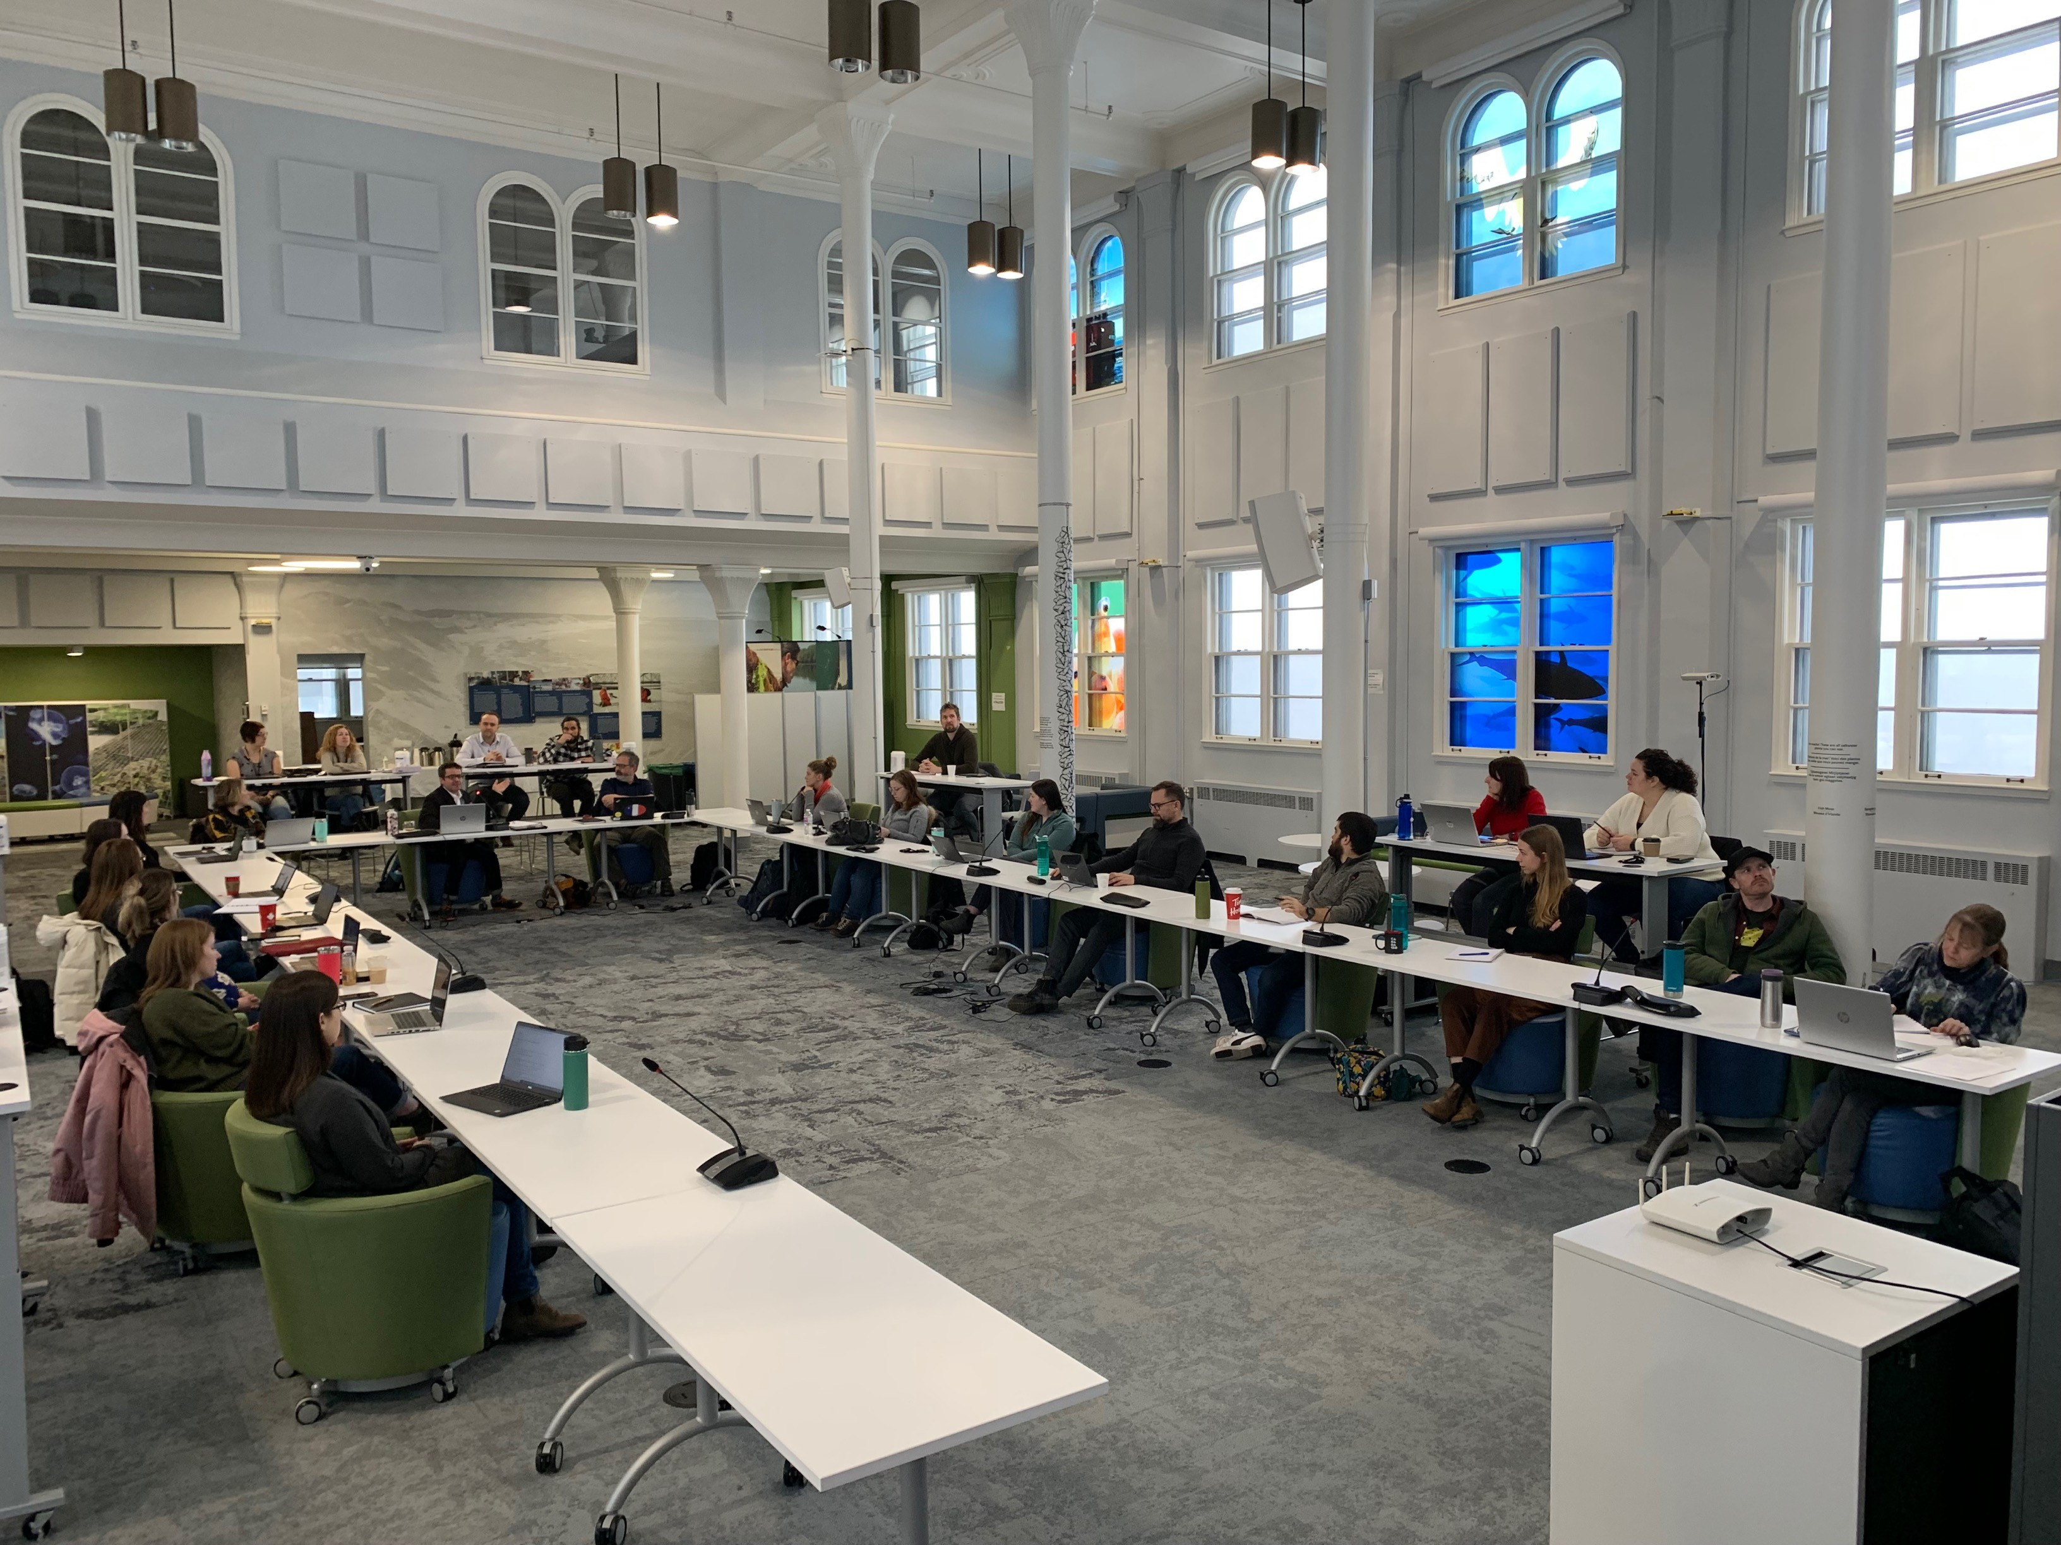

Figure 1. Day 1 of the TESA workshop “best practices in age estimation” held at the Atlantic Science Enterprise Center in Moncton, NB on 31 January, 01-02 February 2023.

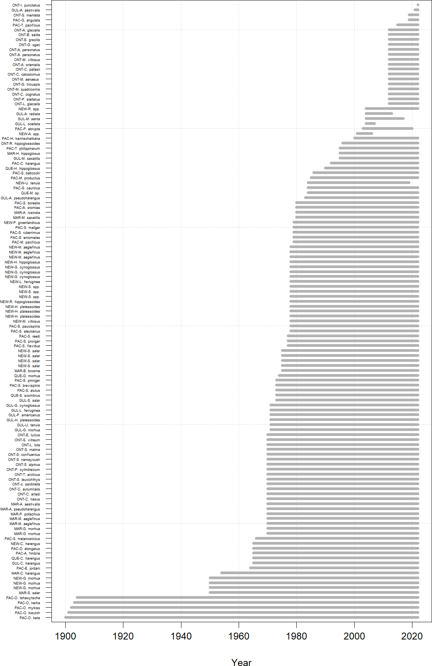

Figure 2. Timespan of ageing structure collections for marine stocks assessed by Fisheries and Oceans Canada. 13

|  |  |
| --- | --- |
| 353 | **11 References** |
| 3554 | Ailloud, L.E., and Hoenig, J.M. 2019. A general theory of age-length keys: Combining the |
| 356 | forward and inverse keys to estimate age composition from incomplete data. ICES Journal |
| 357 | of Marine Science 76: 1515–1523. |
| 358 | Ailloud, L.E., Lauretta, M.V., Walter III, J. F., and Hoenig, J.M. 2019. Estimating age |
| 359 | composition for multiple years when there are gaps in the ageing data: The case of |
| 360 | western Atlantic bluefin tuna. ICES Journal of Marine Science 76: 1690–1701. |
| 361 | Ouellette-Plante, J., Van Beveren, E., Benoît, H.P., and Brassard, C. 2022. Details of catchR, |
| 362 | an R package to estimate the age and length composition of fishery catches, with an |
| 363 | application to 3Pn4RS Atlantic cod. DFO Can. Sci. Advis. Sec. Res. Doc. 2022/015. iv + |
| 364 | 71 p. |
| 365 | Perreault, A.M.J., Zheng, N., and Cadigan, N.G. 2020. Estimation of growth parameters |
| 366 | based on length-stratified age samples. Can. J. Fish. Aquat. Sci. 77(3): 439–450. |

14