|  |  |
| --- | --- |
| PICTLOGO | **SCTR’s PUNE INSTITUTE OF COMPUTER TECHNOLOGY, PUNE - 411043** |
| **DEPARTMENT OF ELECTRONICS & TELECOMMUNICATION ENGINEERING** |

|  |  |  |  |  |  |  |  |
| --- | --- | --- | --- | --- | --- | --- | --- |
| **Lab Practice -2 [404184C] : ELECTIVE-III(C) - JavaScript** | | | | | | | |
| **ACADEMIC YEAR: 2024-25** | | | | | | | |
| **CLASS** | **: BE** | **DIV** | **: 5** | **Batch** | **: R5** | **DATE** | **: / /24** |
| **Roll No** | **42218** | **ABC ID** | **: 711-218-285-772** | | | **SEMESTER** | **: I** |

|  |
| --- |
| **Experiment No.: 10** |

**Code:**

1. Experiment10.js:

// Roll No: 42218

// Name: Sarvesh Deshpande

// Batch: R5

// Importing prompt-sync for taking input from the user

const prompt = require('prompt-sync')();

// Function to print multiplication table using a for loop

function forLoopTable(num) {

console.log(`Multiplication Table of ${num} (using For loop):`);

for (let i = 1; i <= 10; i++) {

console.log(`${num} x ${i} = ${num * i}`);

}

}

// Function to print multiplication table using a while loop

function whileLoopTable(num) {

console.log(`\nMultiplication Table of ${num} (using While loop):`);

let i = 1;

while (i <= 10) {

console.log(`${num} x ${i} = ${num * i}`);

i++;

}

}

// Function to print multiplication table using a do-while loop

function doWhileLoopTable(num) {

console.log(`\nMultiplication Table of ${num} (using Do-While loop):`);

let i = 1;

do {

console.log(`${num} x ${i} = ${num * i}`);

i++;

} while (i <= 10);

}

// Prompt user for a number

let number = prompt("Enter a number to print its multiplication table: ");

// Validate input to ensure it's a number

if (!isNaN(number) && number.trim() !== "") {

number = parseInt(number);

forLoopTable(number);

whileLoopTable(number);

doWhileLoopTable(number);

} else {

console.log("Please enter a valid number.");

}

**Output:**

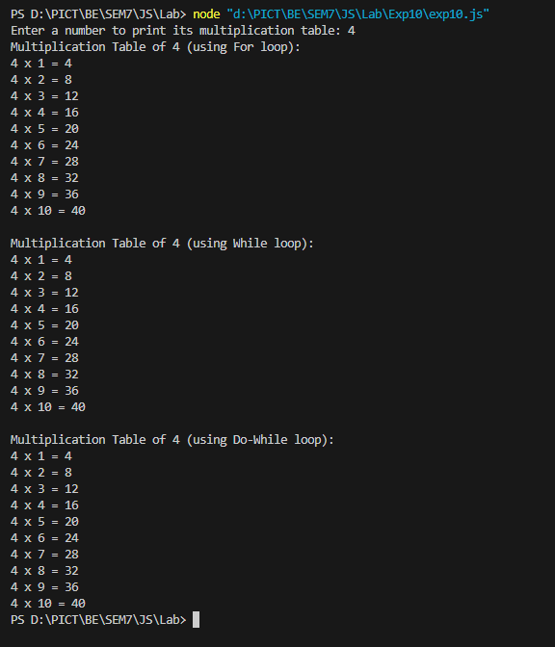

|  |  |  |
| --- | --- | --- |
|  | | |
| Date: |  | Course Teacher Sign |