LAB03:Assignment
Question 1:
#include <stdio.h>

int main(){
float marks;
int yourmarks;
printf("Enter your marks (0-100): " );
scanf("%f", &marks);
int b = marks /10;
if (marks==100)
{
printf("Your grade is A+.");
}
if (marks>=101){
printf("check your marks \n");
}
// if (marks>=0 && marks <101)
// {
// if (marks<=100 || marks>=90){
// yourmarks=1;
// //printf("A+");
// }
// else if (marks==90 || marks>=80){
// yourmarks=2;
// //printf("A");
// }
// else if (marks==80 || marks>=70){
// yourmarks=3;
// //printf("B+");
// }
// else if (marks==70 || marks>=60){
// yourmarks=4;
// //printf("B");
// }
// else if (marks==60 || marks>=50){
// yourmarks=5;
// //printf("C+");
// }
// else if (marks==50 || marks>=40){
// yourmarks=6;
// //printf("C");
// }
// else if (marks==40 || marks>=30){
// yourmarks=7;
// //printf("D");
// }
// else if (marks==30 || marks>=0){
// yourmarks=8;
// //printf("F");
// }
// else{
// printf("Invalid marks. \n" );
// }
// }
switch(b){
case 9:
printf("Your grade is A+.");
break;
case 8:
printf("Your grade is A.");
break;
case 7:
printf("Your grade is B+.");
break;
case 6:
printf("Your grade is B.");
break;
case 5:
printf("Your grade is C+.");
break;
case 4:
printf("Your grade is C.");
break;
case 3:
printf("Your grade is D.");
break;
case 2:
printf("Your grade is F.");
break;
case 1:
printf("Your grade is F.");
break;
case 0:
printf("Your grade is F.");
break;
default:
printf("Your marks is invalid" );
}

}

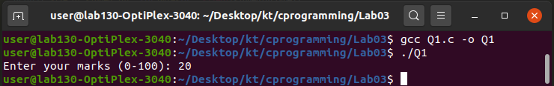

Question 2
#include <stdio.h>

int main(){
char AL;
int alphabet;
printf("Enter any alphabet;");
scanf("%c",&AL);

if (AL=='a'||AL=='e'||AL=='i'||AL=='o'||AL=='u')
{
alphabet=1;
}
else if (AL=='A'||AL=='E'||AL=='I'||AL=='O'||AL=='U')
{
alphabet=1;
}
else{
alphabet=2;
}

switch(alphabet){
case 1:
printf("%c is vowel. ",AL );
break;

case 2:
printf("%c is not vowel." ,AL );
break;

default:
printf("Check alphabet" );
}

}
