Lab 4: Assignment
1) What will be the output of the following program? Note down your understanding of every program, in few sentences.

a)
Answer:
The output of above source cod will be 30 because the value of I is 3 and value of *j is also 3 since the j is the address of I.

i=3
j=address of i
*j=value of j which is 3
now,
=> i**j*i+*j
=>3*3*3+3
=>30

Output:
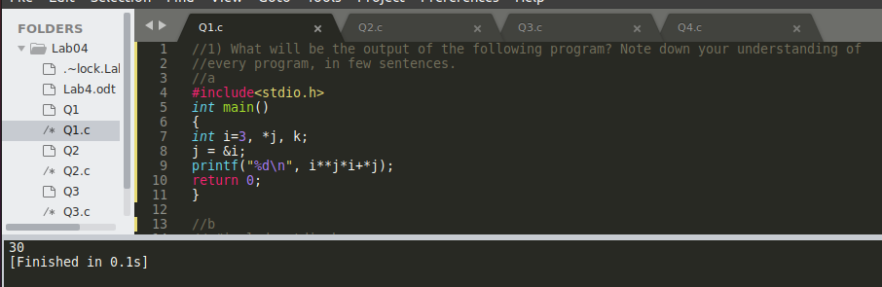
b)
Answer:
In this question x=31 because the x is incremented , y is the address of x that is also incremented by 1 and output of z= to the output of y since z=y and it will be incremented by 1.Hence the value of y and z be equal.

Output:
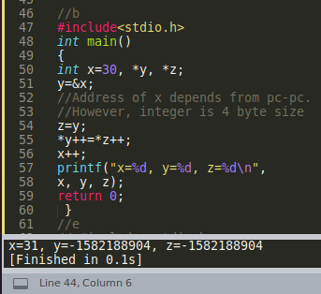

c)
Answer:
Here i=8 and p is the address of I and output for p* will be 8 since the p is pointed towards I.q is the address of p and p points towards I so the outcome of **p will be 8 and r is the address of q where q is pointed towards p and p is I (pointed towards I) the outcome ***r will be 8.

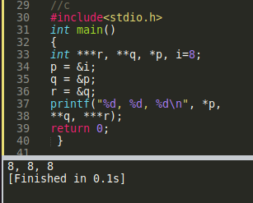
Outcome:

d)
Output:
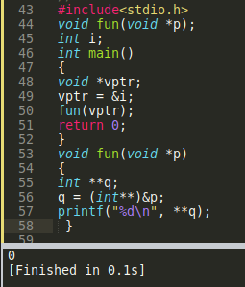

e)
Output:
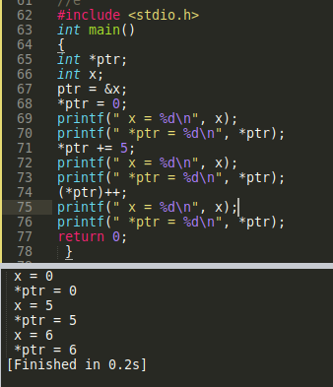

f)
Output:
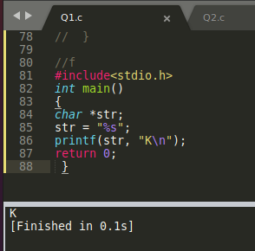

2) Write a C Program to swap 4-different elements using Call by Reference.
Answer:
Source code:

#include <stdio.h>

int swap(int *a,int *b,int *c,int *d)
{
int num;
num=*a;
*a=*d;
*d=*b;
*b=*c;
*c=num;
}
int main()
{
int num1,num2,num3,num4;
printf(" Enter first number : ");
scanf("%d",&num1);
printf(" Enter second number : ");
scanf("%d",&num2);
printf(" Enter third number : ");
scanf("%d",&num3);
printf(" Enter forth number : ");
scanf("%d",&num4);

printf("\n The numbers before swapping are : ");
printf(" %d %d %d %d",num1,num2,num3,num4);
swap(&num1,&num2,&num3,&num4);
printf("\n The numbers after swapping are : ");
printf(" %d %d %d %d ",num1,num2,num3,num4);
return 0;
}

Output:
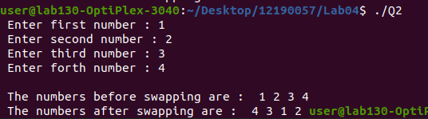

3) WAP a program to find if the Year entered by the user through keyboard is a leap year or not. Apply Call by Reference concept.
Answer:
Source code
#include <stdio.h>

int leapYear(int *check, int *x, int *y, int *z){
if (*check % *x == 0){
if (*check % *y == 0){
if (*check % *z == 0){
printf("It is a leap year.\n");
}
else{
printf("Not a leap year.\n");
}
}
else if (*check % *y != 0){
printf("It is a leap year.\n");
}
else{
printf("It is not a leap year.\n");
}
}
else if(*check % *y == 0){
if (*check % *z == 0){
printf("It is a leap year.\n");
}
else{
printf("It is not a leap year.\n");
}
}
else{
printf("It is not a leap year.\n");
}
}

int main(){
int year;
int a = 4;
int b = 100;
int c = 400;
printf("Enter the year: ");

Output:
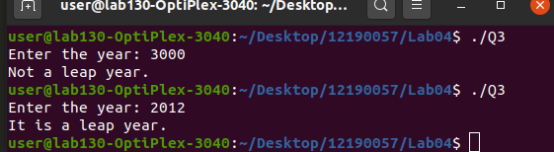

Question 4:
#include <stdio.h>
void reverseSentence();
int main()
{
printf("Enter a sentence: ");
reverseSentence();
return 0;
}
void reverseSentence(){
char c;

scanf("%c", &c);
if(c != '\n'){
reverseSentence();
printf("%c", c);
}
}

Output:

