**Assingment-1**

**Task 1:**

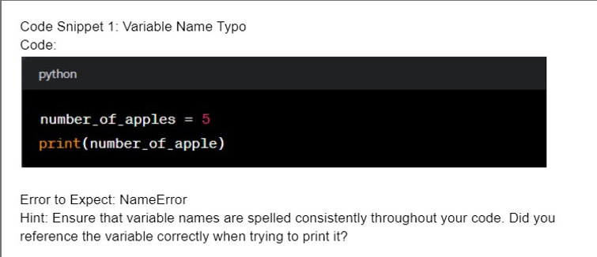

**Here the integer number is stored in number_of_apples Variable. But we print number_of_apple , in this such type of variable is not there ,so it shows name error. Then the fixed code is:**

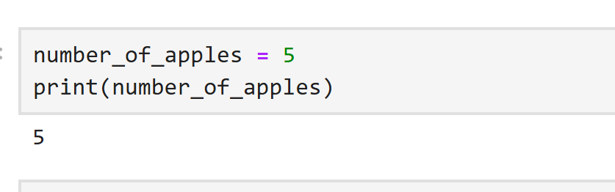

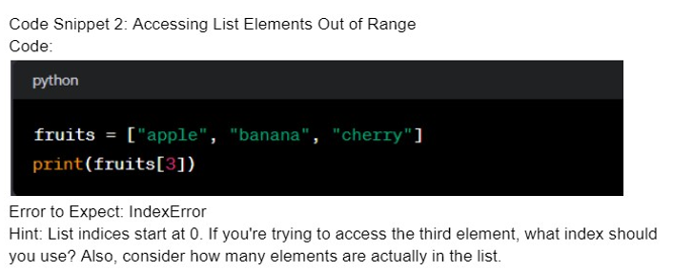

**In this code fruits list contains three elements.**

**In list elements index starts with “0”, so the last index of the list is 2.**

**0 1 2**

**apple banana cherry**

**in the given code we try to print index 3 position element, in that position there is no element is there so it arises IndexExrror.**

**Then fixed code is:**

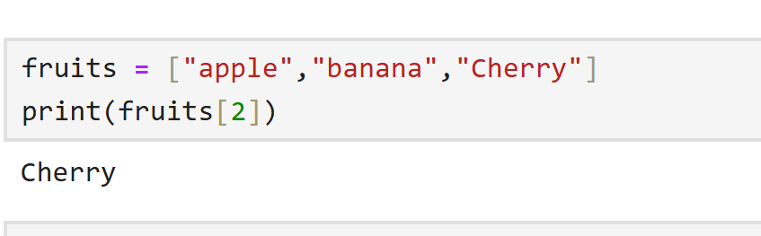

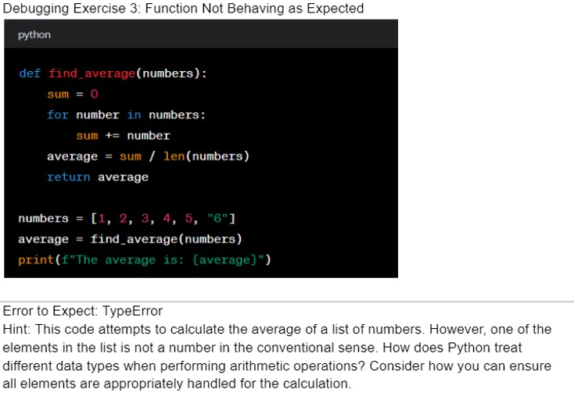

**In the given code runs ofter the result is:**

**Type error: unsupported operand type(s) fro +=:’int’ and ‘str’**

**It means the integer and string cant be added because these two are different data types.**

**In the given code the “numbers” list contains integers and string in last position so the type error arises. Solution is to convert the string into number . the fixed code is:**

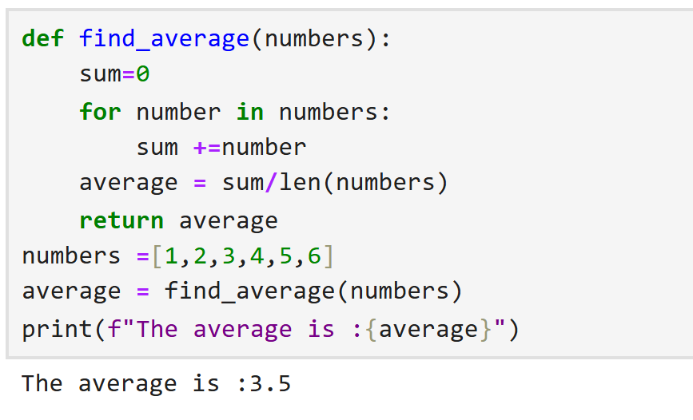

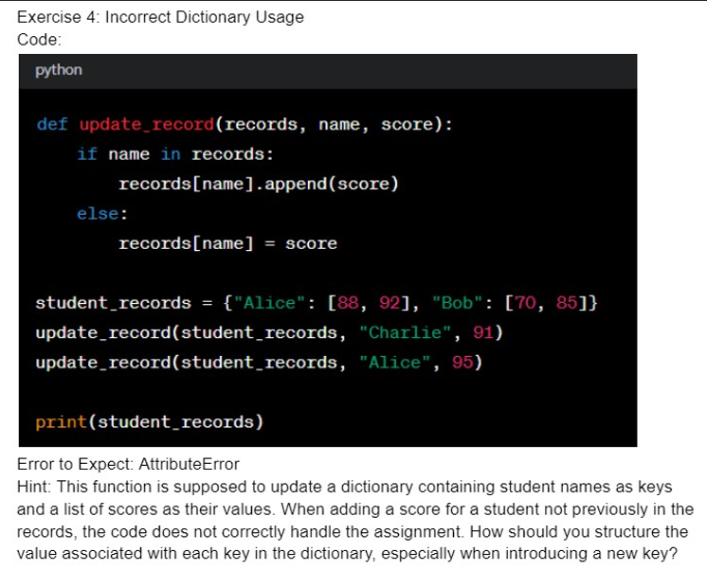

**The given code raises an Attribute Error because when a new key is added to the records dictionary (in this case, when adding “Charlie”),the value is directly asigned as integer.(i.e records[name]=score).**

**However, later the code tries to use the .append() method on that value, which is invalid because integers do not have an append() method.**

**The Fixed code is:**

