Title of Module Software Engineering

Title(s) of Assignment | Group Project (individual version for those it has been approved for)
Module Component | 80%
Module Team | Nazish Riaz  Scott Turner
Assignment Deadline | 30th March 2026
Expected Feedback Date | 30th April 2026
Location of Feedback | Via Turnitin on Blackboard
Assessment Type | Group Project
Where to Submit | Blackboard Submission Tool[1]
What to Submit | 3 * sprint reviews, 1 digital artefacts, peer ratings

OVERVIEW
As a Software Engineer recruited to work in a team of up to five new developers, you have been assigned the task of developing some new products. Over three sprints your team will develop three new products as part of a portfolio.
You are required to work using the Agile Framework, Scrum. User stories will be provided but the development team will need to estimate the stories, prioritise the backlog and produce a sprint backlog from the product backlog.
The timetable for the class tutorial sessions and presentations is given below. Please build your applications week by week and refer to the marking scheme/rubric and make sure that you do not miss any tutorial sessions. You are encouraged to use inclusive tools for team meetings outside of class such as Blackboard Collaborate, Microsoft Teams, Zoom(www.zoom.us), Skype (www.skype.com) or any other social tool that will enable cohesive group working such as Discord.
You will be graded each ’Sprint’ on the work you have produced at each sprint review, you are required to record your current product backlog of user stories, prioritised and estimated, your sprint backlog and a link to your projects GitHub..

ASSIGNMENT INSTRUCTIONS
Undertake a sizeable software development group project using the agile methodology
Scrum. You will build three products, one each sprint. You will, as a group provide a deliverable in the form of a report submitted to Turnitin detailing the project. You need to produce overall a software build for the following:

Develop a patient-centric hospital system that prioritizes self-service. The primary build must include a dynamic appointment booking interface, a secure personal portal for patients to view their own medical records, and a real-time calendar showing doctor availability for instant scheduling. The backend must focus on seamless data retrieval to ensure patients have up-to-date information regarding their care.

The emphasis in this assignment is the process of delivering and working in a team, to deliver a software product, but a software product must be produced.

All must involve user interfaces, backend systems but the choice of technology is up to the team.

Table 1: Project Timetable
Date Activity
Week 3 Sprint 1 Starts: Size stories, prioritise backlog, create sprint backlog.

Continue to work on the first iteration of your product. Sprint 1 ends

Week 6 Sprint 2 Starts: Size stories, prioritise backlog, create sprint backlog.

Week 8 Stand-up Meetings, design, coding, testing Sprint 2 ends

30/3/26 Submission

Deliverables
The end of each Sprint will involve a checkpoint where the artefacts will be presented to the module team. These must be submitted as document at the end but built up after each sprint.
Deliverable 1: A single document per group
Each sprint will be graded based on the marking criteria:
Sprint 1: 40% it is expected to include:
- The first part of Assignment 1 will be to produce a number of user stories based on the specification provided in the project overview.
- Please use the "user Story" template provided. You will need to nominate a "Scrum Master" who will add the completed "User Stories" for you group to the document.
- Include screenshots of your work to demonstrate your progression

Sprint 2: 40% is expected to include
In sprint 3 you will continue with you development of your project.
- Your group will select a further three user stories to develop as prototypes.
- Please use the Sprint Review template provided. Add the following to you document Update the Product Backlog, Sprint Backlog and Completed tables, along with a retrospective review of the sprint
- Include screenshots of your work to demonstrate your progression.
- As well as
  - What work was carried out?
  - What went well?
  - What could be improved?
  - Any Issues?

All the templates need for the documentation are in the Templates section these are expected to be used.

Deliverable 2
Short video of the testing (20%) In addition you will need to submit a short video, showing a demonstration of your chosen features. (This can be a recorded via a screen recording app or via smart phone ) The video should be short (around 5 minutes or less)

SUBMISSION GUIDELINES
The sprint review documents - submitted via Turnitin on Blackboard; this is the report that should include all artefacts required by the marking scheme.
Self and Peer Assessment Form - Submitted individually in a separate bucket

CCCU Late Submission Guidelines
As per standard CCCU rules.

MARK SCHEME/RUBRIC
Please see page 13 for a detailed rubric.

RESOURCES YOU MAY FIND USEFUL
The skills necessary for this module were taught in your first year module, MCOMD1ADC. You still have access to this blackboard page and will find the resources there useful for this project.
It is also advised that you seek answers to your coding from external sites such as w3schools, StackOverFlow, Google, and YouTube. This represents the same resource base that industrial software developers have at their disposal.

LEARNING OUTCOMES ASSESSED (FULLY OR PARTIALLY)

LO
Description

- Demonstrate awareness of current software development meth- odologies;
- Effective use of appropriate software framework when working in groups to develop software in a collaborative environment;
- Understand and use appropriately a range practices in Agile soft- ware development; this includes Version Control, Unit Testing, Continuous Integration, Automatic Build, and Regression Test- ing.
- Demonstrate awareness of the notion of Risk and Quality man- agement.
- Use appropriate techniques to plan a feasible software develop- ment project.

GRADUATE/EMPLOYABILITY SKILLS GAINED
Canterbury Christ Church University is committed to the development of graduates who are intellectually curious, skilled and ethically engaged with the world and its future. Through transformative experiences, students have the opportunity to develop critical and imaginative thinking and compassionate responsibility.

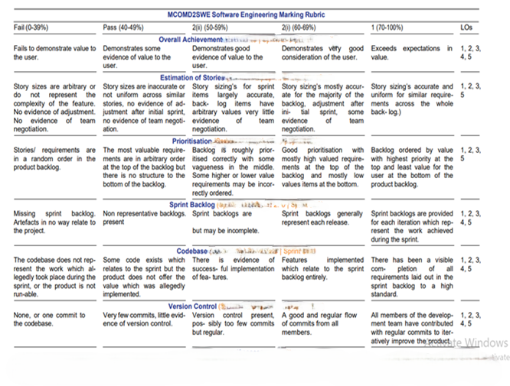

Video (20%) Submitted video with contributions for all named members. Reduction of 4% each for the following
- Code not discussed
- Limited testing
- Not all basic requirements implemented

