Lesson 1:
Nike Winflo 12
Every Customer is looking for something different. Some want a fast shoe for race day, while others want comfort for easy runs, walks and everyday movement. The Nike Winflo 12 is a men’s road-running shoe made for Customers who want soft cushioning, a balanced feel underfoot and a comfortable fit. In this course, you will learn who the shoe is best for, how to explain its benefits simply and how to recommend it with confidence.
Interaction / media note: Use a hero image of the Nike Winflo 12 with the course title and a short introduction to the product.
Customer moment
A Customer walks into the store and says:
“I am looking for a comfortable shoe for my easy runs and daily walks. I do not need a race shoe. I just want cushioning that feels good.”

This is a good clue that the Nike Winflo 12 may be the right shoe.
This Customer is not looking for speed or a race-day shoe. They want something comfortable for everyday runs and walks. The Nike Winflo 12 is a good option because it offers soft cushioning, a stable feel and a comfortable fit.
YOUR LEARNING JOURNEY
You will first get to know this men’s road-running shoe and its main benefits. Then you will learn who it is best for, what is new and how to recommend it during a Customer conversation. Let’s get started.

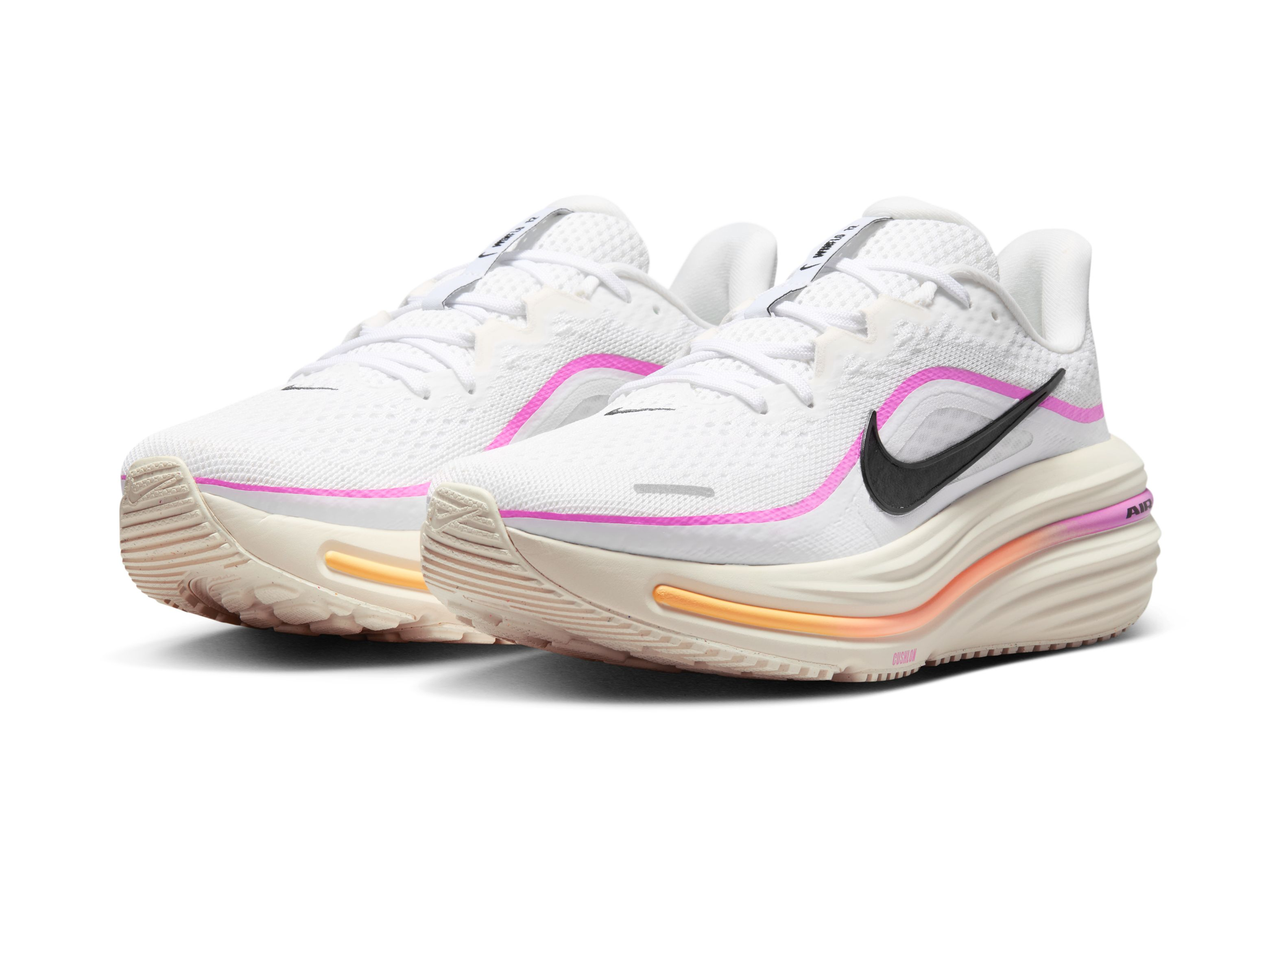

Lesson 2: Product basics
Let’s start with the basics. As you work through this lesson, think about the Customer who wants one comfortable shoe for everyday runs and walks.
The Nike Winflo 12 is made for Customers who want comfort during easy runs, walks and everyday activities. It has soft cushioning, a broad platform that helps the foot feel balanced and secure, and a comfortable fit. Customers may describe this need by saying they want a shoe that feels steady, supportive or less wobbly underfoot.
A SIMPLE WAY TO EXPLAIN IT
“The Nike Winflo 12 gives you soft cushioning, a balanced feel underfoot and a comfortable fit for your everyday runs and walks.”
Interaction / media note: Use a product image with short callouts that introduce the Winflo 12 as an everyday comfort shoe.

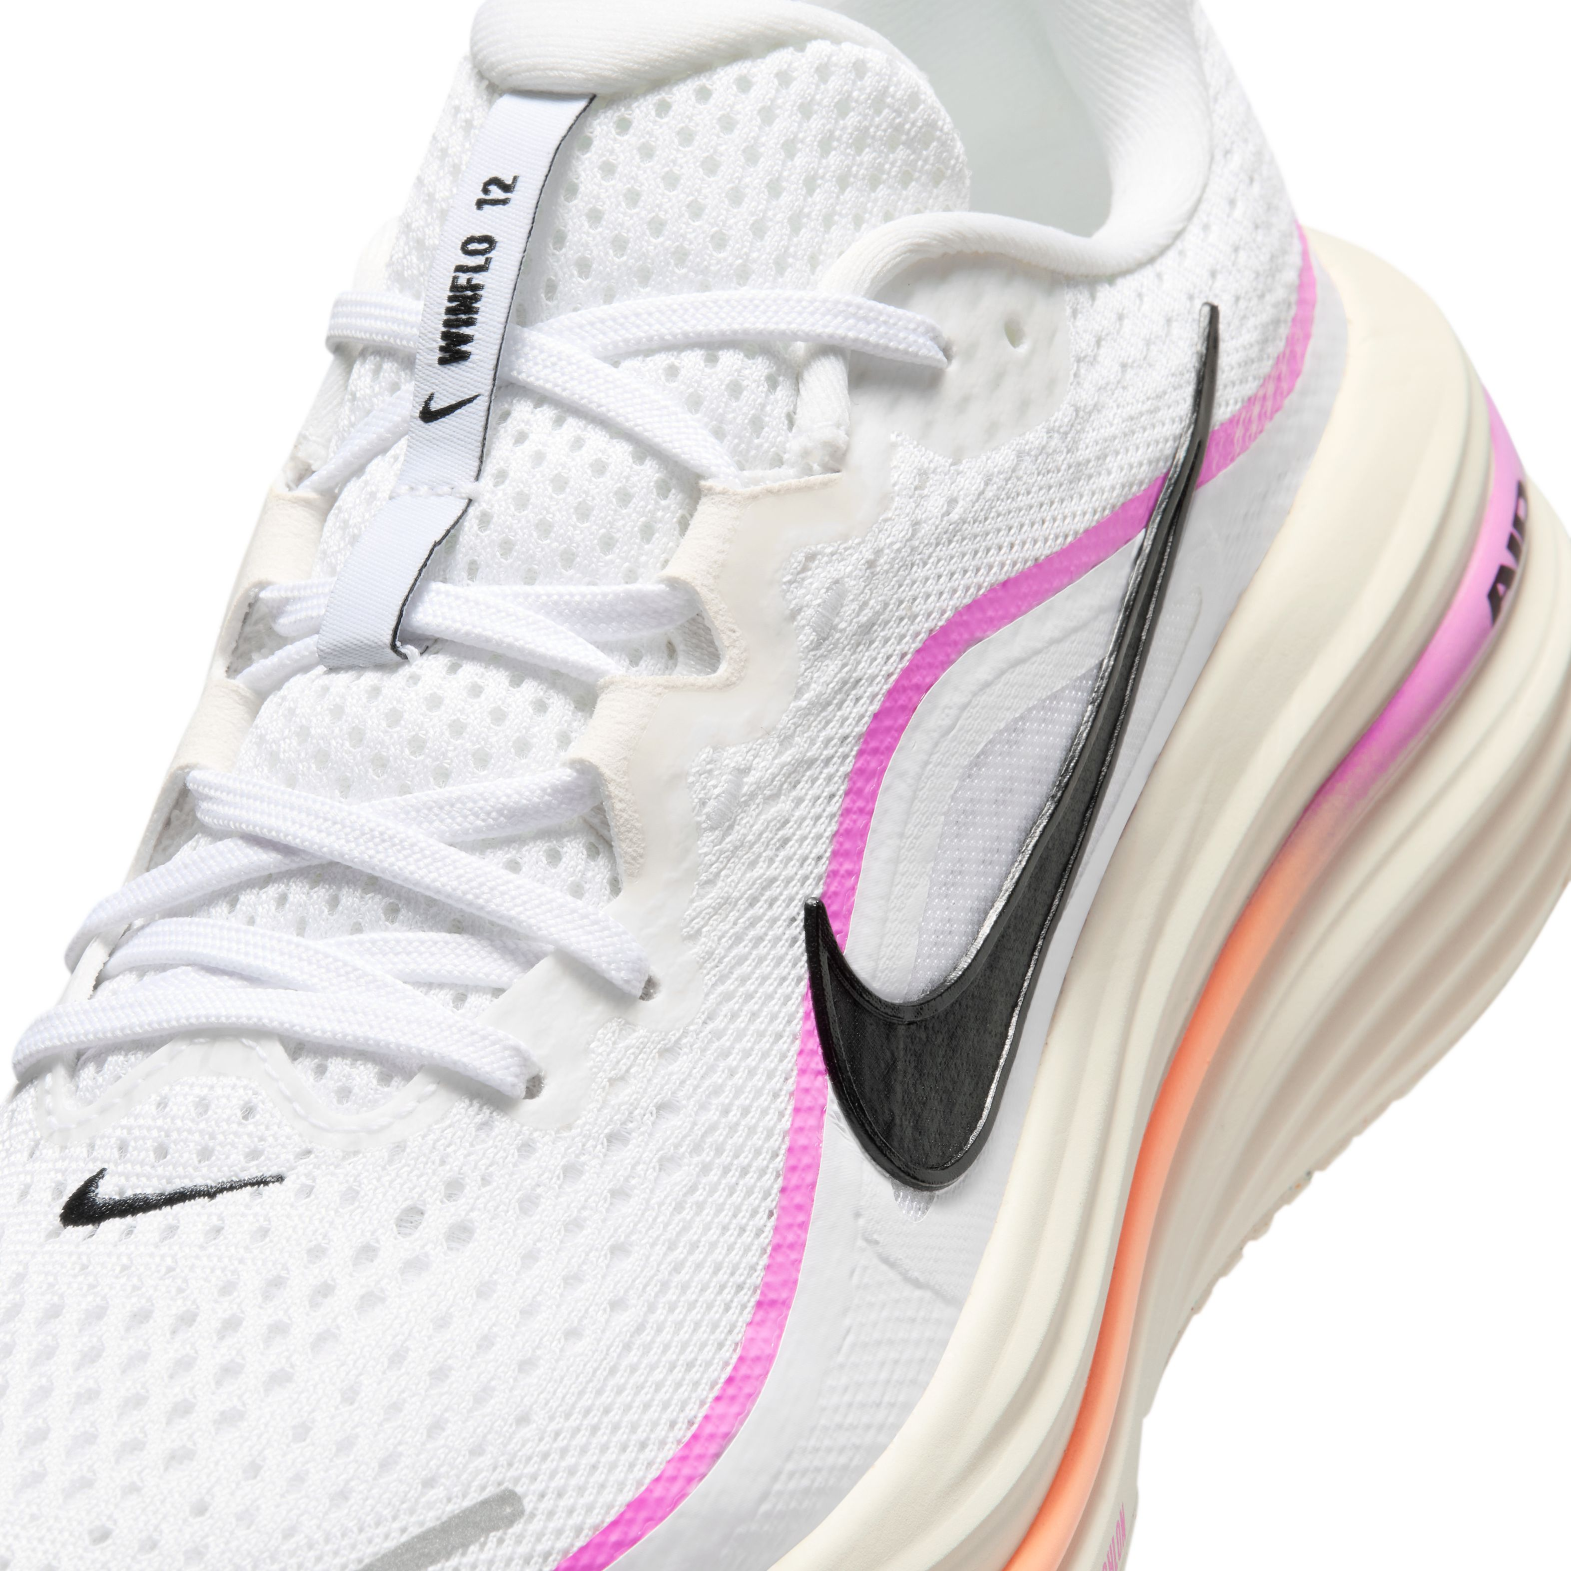
Lesson 3: How to explain the technology
Now let’s look at the features inside the shoe. As you explore each one, ask yourself: How does this help the Customer? Keep your explanation simple. Tell the Customer what the feature does, how it helps and why it matters to them.
Feature | What it means | Customer benefit | Say it like this
Cushlon 3.0 foam | Soft foam under the foot. | Helps the Customer feel cushioned and comfortable. | “The soft cushioning helps keep you comfortable during everyday runs.”
Nike Air unit | Extra cushioning is built into the shoe. | Adds cushioning when the foot lands. | “The Nike Air unit gives you extra cushioning when your foot lands.”
Open-hole mesh upper | Breathable material on the top of the shoe. | Allows air to move through the shoe. | “The breathable upper helps your feet feel comfortable while you move.”
Accommodating fit | The shoe is designed to give the foot more room. | Helps the shoe feel comfortable and secure. | “The fit feels comfortable and secure without feeling too tight.”
Broad, stable platform | A wider base under the foot. | Helps the shoe feel stable and balanced. | “The wider base helps you feel stable and secure as you move.”
10 mm heel-to-toe drop | There is a 10 mm height difference from the heel to the front of the shoe. | Gives many runners a familiar feel underfoot. | “The 10 mm drop gives the shoe a familiar everyday running feel.”
Interaction / media note: Use a hotspot image with clickable buttons that reveal the feature, Customer benefit and simple selling phrase.

SALES TIP
You do not need to explain every feature. Ask what the Customer needs, then focus on the one or two benefits that matter most to them.

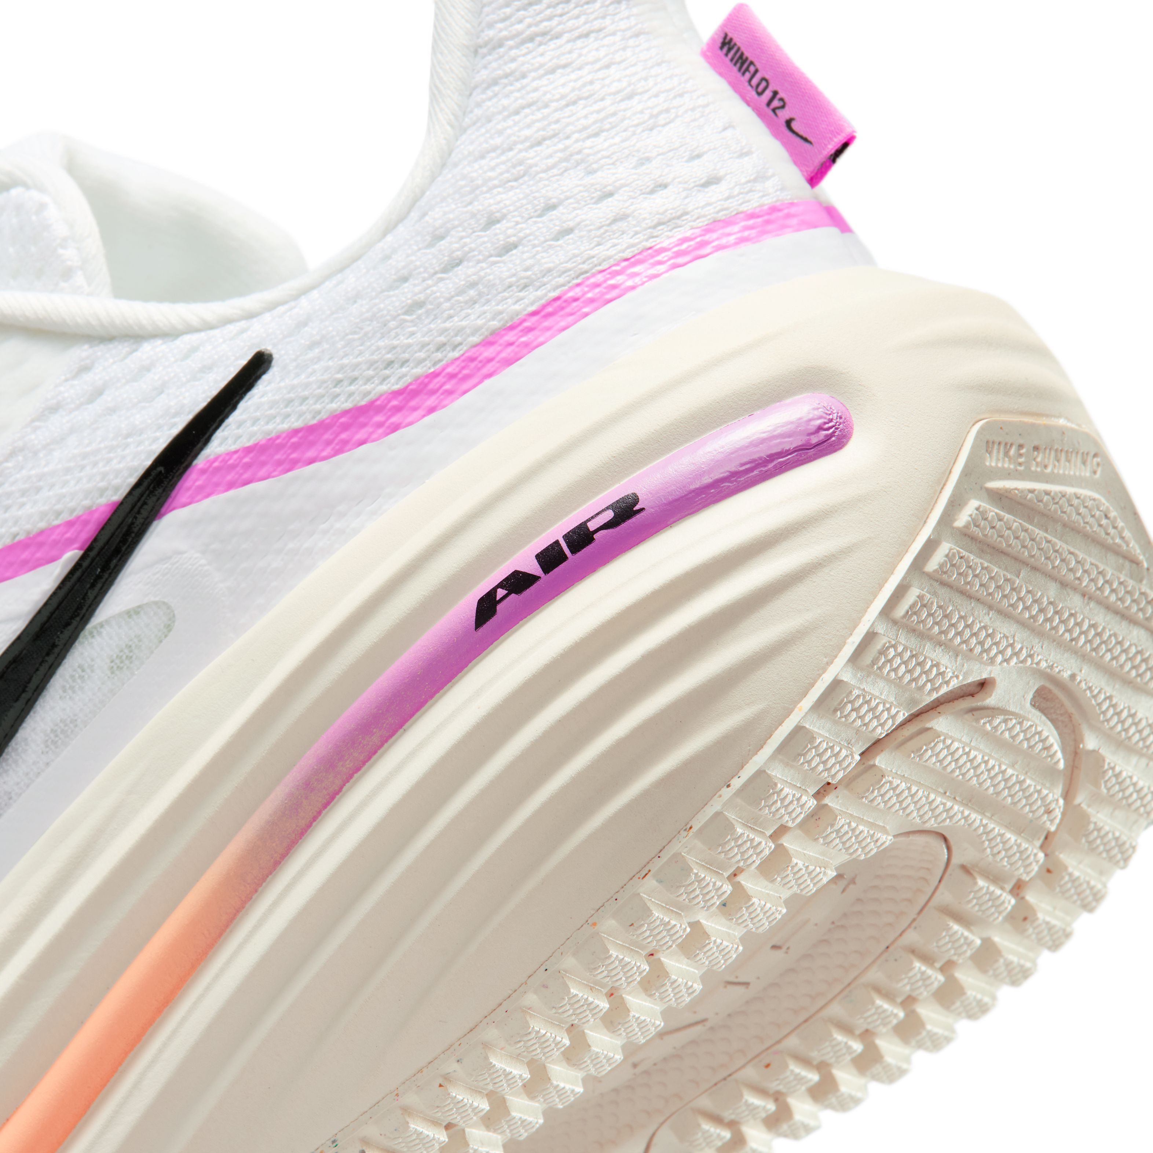
Lesson 4: Nike Winflo 12 Customer fit overview
Start with the Customer, not the shoe. Ask how they plan to use it, then decide whether the Winflo 12 matches their needs. It is a good option when comfort matters most for everyday runs, walking or general use.
If the Customer wants… | Why the Winflo 12 may fit | Simple recommendation cue
Easy, everyday road runs | Soft cushioning helps the Customer feel comfortable on everyday runs. | Recommend it when comfort is the main goal.
Long, relaxed runs | The cushioning and stable feel work well for a relaxed pace. | Recommend it for a comfortable, easy pace.
A first running shoe | It is a dependable daily trainer with cushioning and support. | Recommend it when the Customer wants a dependable daily trainer.
Walking or all-day comfort | The cushioning supports walking and time spent on your feet. | Recommend it when comfort matters across the day.
General gym use | The shoe can support general gym use and light treadmill running. | Recommend it for general use, not speed-focused sessions.
Interaction / media note: Use clickable Customer-need cards so store associates can decide when the Winflo 12 is, or is not, the right match.

When It May Not Be the Best Match
- Fast intervals or speed sessions
- Tempo runs where the Customer wants a light, quick feel
- Race day performance
- A Customer who prioritises a lightweight, agile shoe
BE HONEST WITH THE CUSTOMER
If the Customer wants speed or a race-day shoe, be honest that the Winflo 12 is made for comfortable everyday running. Then help them find a lighter performance shoe that better suits their goal.

Lesson 5: What is new in the Nike Winflo 12?
A Customer who knows the Winflo 11 may ask what has changed. Use these three updates to explain what is new in a simple way.
What is new? | What the Customer may notice
Increased Cushlon 3.0 foam stack height | More foam underfoot for extra cushioning.
Accommodating fit | More room for a comfortable fit.
Open-hole mesh upper | More airflow through the top of the shoe.
Interaction / media note: Use a simple Winflo 11 versus Winflo 12 reveal to show the three updates and what the Customer may notice.

Product Details to Remember
Detail | Specification
Product type | Men’s road-running shoe
Style code | HV9272
Weight | Approximately 322 g / 11.37 oz in a men’s US size 10
Heel-to-toe drop | 10 mm

KEEP IT CUSTOMER-FRIENDLY
Only share the weight and heel-to-toe drop if the Customer asks. Most of the time, focus on comfort, cushioning, fit and how they plan to use the shoe.

Lesson 6: Key selling message
You now know what the shoe offers and who it is best for. Next, use A-M-E-R to guide the conversation. Ask a question, listen to the Customer and recommend the shoe based on what they tell you.
Step | What to do | Example
Ask | Ask how the Customer plans to use the shoe. | “What type of running or activity will you use the shoe for?”
Match | Link the Customer’s need to the right feature. | “You said comfort matters most, so I would look at the Cushlon 3.0 cushioning.”
Explain | Explain how the feature helps the Customer. | “It gives you a soft, cushioned feel for everyday runs.”
Recommend | Recommend the shoe and explain why it matches their needs. | “Based on what you have told me, I recommend trying the Nike Winflo 12.”
Interaction / media note: Use a four-step visual flow for Ask, Match, Explain and Recommend. Reveal one step and example at a time.

Lesson 7: Customer scenario
Read what the Customer says below. Before you look at the example, think about what you would ask, which benefit you would focus on and how you would recommend the shoe.
CUSTOMER SAYS
“I am new to running. I mostly do easy 5 km runs and I also walk a lot. I want something comfortable, not a fast race shoe.”

A-M-E-R stands for Ask, Match, Explain and Recommend. It helps you keep the conversation simple. First, ask how the Customer will use the shoe. Then match their needs to the right benefit, explain how it helps and recommend the shoe if it is a good fit. This helps you make a useful recommendation based on what the Customer needs.
Store Associate response using A-M-E-R:
Step | Store Associate says
Ask | “Will you mainly use the shoe for easy road runs and walking?”
Match | “The Winflo 12 has soft cushioning and a stable base.”
Explain | “This helps the shoe feel comfortable and secure during your runs and walks.”
Recommend | “Based on what you have told me, I recommend trying the Nike Winflo 12. It gives you the everyday comfort and cushioning you are looking for.”

Experienced-runner scenario
Customer says | Helpful response
“I already own a fast shoe for workouts. I need a comfortable option for recovery runs and walking between sessions.” | “The Winflo 12 could complement your faster shoe. Its soft cushioning and broad platform suit easy-paced recovery runs and everyday walking. Try it on and compare the fit and feel with your current shoes.”

Match Customer Needs to Benefits
If the Customer says… | You can say…
“I want a soft shoe for easy runs.” | “The soft cushioning helps keep you comfortable during easy runs.”
“I usually land on my heel.” | “The Nike Air unit adds cushioning around the heel to help with impact.”
“My shoes often feel too tight.” | “The Winflo 12 has a roomy fit that feels comfortable and secure.”
“I want the shoe to feel stable.” | “The wider base helps the shoe feel stable underfoot.”
“My feet get warm.” | “The breathable upper allows air to move through the shoe.”
“I want a shoe for racing.” | “The Winflo 12 is made for comfortable everyday running. Let us look at a lighter performance shoe for racing.”
Interaction / media note: Use a branching scenario where store associates choose the best question, match the Customer need and select the most helpful recommendation.

Lesson 8: Practice knowledge check
Instructions
Read each Customer scenario and choose the best answer. After each question, show feedback that explains why the correct answer is the best choice.
Scenario 1
A Customer says, “I run regularly and already have a lightweight shoe for speed sessions. I want a comfortable second shoe for recovery runs and long walks.”
What is the best response?
- Recommend another race shoe so both pairs feel equally fast.
- Recommend trying the Nike Winflo 12 as a cushioned option for recovery runs and walking.
- Recommend the Winflo 12 for all sessions without discussing how it fits into the Customer’s shoe rotation.
Feedback: Correct. The Customer already has a speed shoe and is looking for comfort on easier days, which is where the Winflo 12 may fit.
Scenario 2
A Customer says, “I want a light, fast shoe for race day and speed sessions.”
What is the best response?
- Recommend the Winflo 12 because it is designed mainly for racing.
- Explain that the Winflo 12 is for comfortable everyday running, then help the Customer find a lighter performance shoe.
- Recommend the Winflo 12 without asking any more questions.
Feedback: Correct. The Customer’s priority is speed and racing, so a lighter performance shoe is a better match.
Scenario 3
A Customer says, “My shoes often feel too tight, and I want something comfortable and secure.”
Which Winflo 12 benefit should you explain?
- The style code and product weight.
- The race-day performance.
- The accommodating fit, which gives the foot more room while still feeling secure.
Feedback: Correct. The accommodating fit directly responds to the Customer’s concern about tight shoes.

Course Recap: Ready to Recommend
You have reached the end of the course. You can now identify the right Customer, explain the benefits that matter most and use A-M-E-R to recommend the Nike Winflo 12 with confidence.
Remember:
- It is a men’s road-running shoe designed for comfortable everyday use.
- Cushlon 3.0 foam and the Nike Air unit provide soft cushioning.
- The roomy fit and breathable upper support comfort.
- It is best suited to easy runs, relaxed runs, walking and everyday use.
- It is not the first choice when the Customer’s priority is speed or racing.
- Use A-M-E-R: Ask, Match, Explain and Recommend.
If the Customer wants similar features in another shoe
Ask what they want to keep—cushioning, room, breathability or a steady feel—and what they want to change. Then compare suitable options, encourage them to try the shoes on and recommend the one that best matches their use and fit preference.
EASY CLOSING LINE
“Based on what you have told me, I recommend trying the Nike Winflo 12 because it gives you the cushioning and everyday comfort you are looking for.”

When you understand what the Customer needs, it becomes easier to explain the right benefit and make a helpful recommendation.

