Q：Can the TFmini be tested on the surface of the water？

A：It is not recommended to detect on the water surface. Due to the principle of lidar ranging, it will penetrate the water surface, resulting in inaccurate ranging. Opaque liquids are viable, but there is a risk of failure.

Q: When will the peak current of TFmini occur? What will happen if the power supply is insufficient?

A: There will be A peak current when the LED lights, about 1.6ms after starting. If the power supply is insufficient, an error will be reported, and the current is insufficient, which will bring down the voltage.

Q: What is the power supply level and data level of TFmini-IIC?

A:Supply voltage of 5V, data level of 3.3v; If your supply voltage is only 3.3v，an optional 3.3v adapter is available.

Q: What is the meaning of 1.25-4p terminal (Molex 510210400) terminal connectors? Where to buy it?

A: This is the connector. You can find it from Molex, amazon and alibaba.

Q: Is there any pull-up resistor in the TFmini-IIC version? How much can it be removed? Can it be removed?

A: Yes, 2.2k, can't be removed.

Q: The chip of the radar generates a lot of heat during the working process. Is it necessary to add heat sinks?

A: The radar has been verified by internal test that the temperature rise in the working process of the radar will not affect the stability of the radar. Through internal fatigue detection, it can be used normally without heat sink, but if it is willing to add heat sink, it will be beneficial to the stability of radar measurement.

Q: How to get the data and how to connect the ports?

A: Our radar uses the serial port transmission UART by default. The communication level LVTTL is 3.3V, the baud rate is 115200, and the power supply voltage is +5V. The terminal type of the cable: one is GH1.25-4P for connection with TFmini and the other end is for ordinary 1.25-4p terminal for connecting devices.

(1) You can use the "radar-ttl /USB switchboard - computer" sequence from the computer to obtain data, but also can use a computer or serial port assistant for parameter configuration.

You need to use "usb-ttl" switchboard (you can purchase the switchboard through the company's taobao official website, or purchase the switchboard online by yourself), the corresponding line sequence link is TX<>RX; RX<>TX, can be self-disassembled and welded, as shown in the figure below.

(2) You can directly connect with your development board, TFmini can connect with any development board that provides serial communication, as long as the development board has a serial port, it can read our radar data, and according to the changes of radar data you can do the corresponding data processing.

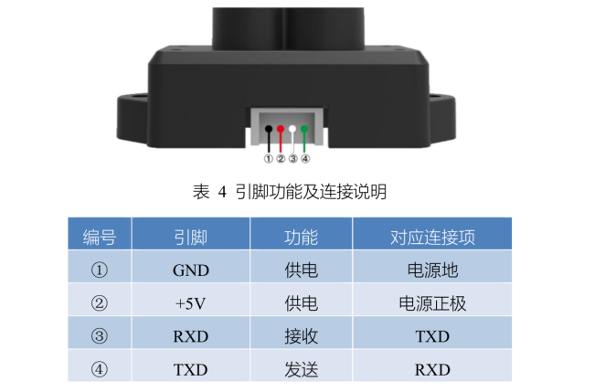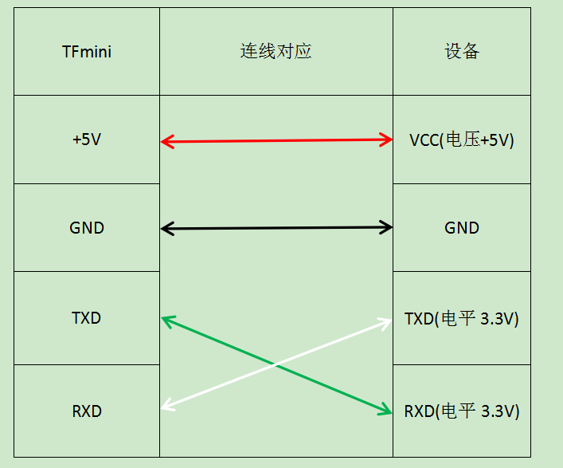

Q: How to reduce the power consumption of TFmini?

A: You can try the following methods to control radar power consumption:

1. Set the external trigger mode for measurement and reduce the measurement frequency, thereby reducing power consumption. This method is suitable for the scene with low frequency requirement. (recommended)
2. Control the power supply of 5V on and off. This method is suitable for scene where you only need to work at a certain time.
3. Set a low range of working mode to ensure stable power consumption. The method is suitable for only specific proximity measurements.

Q: Does TFmini have a driver in Linux, can the radar be communicated on Linux? Does TFmini have an SDK based on Linux?

A: At present, there is no driver under Linux, but the radar is a serial port data output, which can be directly connected to PC through ttl-usb module, and then analyzed through serial port protocol， so there is no need to drive. It has no SDK and reads data directly through a serial port.

Q: How to modify the baud rate? Can the host make changes?

A: Baud rate can be modified. The host computer does not support modification at present. You can modify it by sending instructions through serial port assistant.

Q: Can we add the serial cable of TFmini? Does the lengthening affect data communication? What is its maximum communication length?

A: TFmini currently uses serial TTL communication interface and IIC communication interface. These two kinds of communication do not support long-distance transmission; the longest line length recommended by TTL communication should not exceed 2m; the recommended line length of IIC communication should not exceed 1m; After the cable is extended, it may cause errors in individual data frames, with the risk of reducing the frame rate；In order to improve the transmission data, the baud rate can be reduced appropriately；At present, at the baud rate of 115200, the line length can be extended to 1.5m, which has no impact on data communication.

Q: How long is the power on the radar? How long does it take to power up to work? What is the communication time of each frame?

A: The power on time of the radar is 30ms, and the power on time of executing the program will be 500ms. The communication time of each frame is: （1/115200）\*8\*9=0.625ms。

Q: Can the TFmini be used in battery-powered systems?

A: Radar can be used for battery-powered equipment, but the battery output voltage should meet 5V± 0.1V.

Q: Is it possible to reset the device by sending a serial command instead of turning off the power?

A: You can send this command without re-powering: 42 57 02 00 00 00 00 01.

Q: There is data output within 30cm, can it be used?

A: The value measured in the blind zone is not credible. In the blind zone of TFmini, the data within 0-1m will appear according to the reflectivity of the target. Therefore, the data in the blind zone should be used cautiously. If the usage scene is single, the distance value can be distinguished according to the signal strength.

Q: What is the life of the TFmini when the radar works for 8 hours a day within the range of 0-40℃?

A: The short life of TFmini is LED, which can reach 30000h-50000h in general. Therefore, the product life can reach more than 30000h at room temperature of 25℃, equivalent to more than 3 years.

Q: Is there any correlation between radar accuracy and baud rate?

A: the accuracy of radar ranging is independent of the baud rate.

Q: The upper computer was used to connect the radar, but the coms port did not appear. How to deal with this situation?

A: 1) First ensure that the power supply is normal, the connection line is stable and reliable; at this time, observe the inside of the TFmini emission lens, you can see the weak red light;

2) Check if the serial port driver is installed. If not, please install the driver according to the model of the serial port chip;

Q: Why does the radar start to output data at an interval of 724ms after the reset instruction of tfmini-iic version is issued? Why send instructions to“exit configuration”mode?

A: The reset command is special. After resetting, it is recommended to wait for 1s and then send other configuration commands to the radar. Moreover, the reset command is designed to avoid the failure to recover after the customer configuration error. It is not recommended that you send the command too frequently; The "exit configuration mode" command may not be sent, It just gets the product going; Often the product will work after you restart.

Q: How does the radar achieve 485 communication?

A: At present, the radar does not have a 485 interface and requires a TTL to 485 conversion module. This conversion module is sold online.

Q: Why does the instruction to modify the output frequency "42 57 02 00 EE FF 00 07" mean 100 Hz?

A: "EE FF is not A number, it's just A sign for it. 100 Hz is 10 ms, 10 is 0A, and the code is 42, 57, 02, 0A, 0007; 20 Hertz is 50 milliseconds. 50 is 32, so the setting code is 42, 57, 02, 32, 00, 00, 07."

Q: Can the radar be supplied with 3.3v voltage?

A: No, but the 3.3v power supply can be achieved in the form of lifting platen.

Q: Why the data will continue to be output when the serial port helper is configured as an external trigger and then exits the configuration mode?

Did the configuration fail?

A: There is no need to exit the configuration instruction after the configuration is triggered externally.

Meanwhile, the measurement mode is triggered for power failure without saving. Once configured, if power is cut off or reset instructions are sent, the radar will revert to 100Hz spontaneous measurement.

Q: Does TFmini come with its own level conversion chip?

A: Not at the moment. You can connect it directly to the serial port end. If you want to connect to a computer, you need to switch.

Q: Does the IIC address of TFmini need to be modified many times, or just once?

A: After the TFmini modifies the IIC address, it will be saved, but it needs to be repowered or reset to take effect.

Q: How many addresses can IIC assign at most? How many TFmini can connect on a bus?

A: According to the manual, the address range of IIC is 0x10~0x78, so the maximum number of independent addresses can be supported theoretically. About the available quantity, 10 have been tested, and dozens should be no problem in theory.

Note: when there is too much load on the IIC bus, high frequency communication may be affected because the capacitance between the buses cannot be filled.

Q: Can TFmini communicate on non-windows systems?

A: TTL-USB does not distinguish between systems. Whether it is A Windows system or not, normal communication can be achieved as long as corresponding drivers are installed on different systems.

Q: After use, when the radar cable is forcibly pulled out, the radar terminal falls.

A: When you unplug the radar connector, you should not unplug it by force. You should gently press it and then unplug it. Specific operation can refer to the following radar using small video.

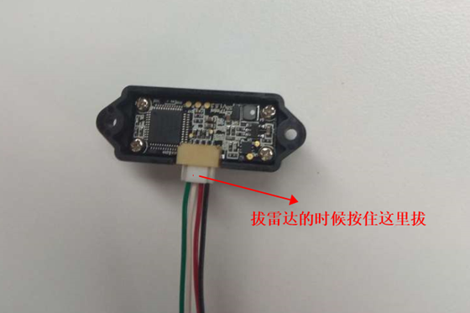



Q: Can we dismantle the Fmini radar when it fails?

A: You can't take it apart. First of all, we will have calibration test for each radar. If the normal radar is disassembled and reassembled, it will lead to abnormal accuracy. Secondly, the dismantling may also cause damage to some areas of radar hardware. Thirdly, the dismantler will destroy the first site where the radar goes wrong, so the after-sales cannot analyze the real cause of the problem. If you suspect radar failure, you can contact Benewake after - sales.

Q: After sending configuration instructions to the radar, if other operations are carried out within a very short time (below 30ms), will it have any impact on the radar?

A: After sending configuration instructions, the waiting time is too short (below 30ms) and other operations are carried out, which may lead to damage of radar program. It is recommended to wait at least 500ms from power on to configuration TFmini.