# Fast-Planner Dev Tests

## 

## Intro

Fast-Planner is a robust and computationally efficient planning system that enables quadrotor fast flight in complex unknown environments.

Fast Planner was originally developed by **HKUST-Aerial-Robotics Group**

Our goal in this project is to be able to navigate indoors around different obstacles.

In order to do so we configured the Kinodynamic path searching algorithm to work with Ardupilot and GAZEBO SITL.

After configuring the tf_kino algorithm, we encountered two main issues:

1. Errors between Fast Planner planned path and drone's actual path (Drone control error).

2. Non-trivial path planned by the Fast-Planner (Path error)

We divide those two issues

As a result, we decided to start running tests in order to try optimizing the algo parameters and the drone PID parameters.

**This paper summarizes our tests**

## Parameters and Metrics

**The Fast-Planner parameters we are going to test are:**

* max_vel - the planned path maximum velocity possible
* max_acc - the planned path maximum acceleration possible
* dt_yaw - delta time in segment of calculating yaw and yaw rate
* lambda1 - Path smoothness weight for optimization
* lambda2 - Distance from obstacles weight for optimization
* lambda3 - Path feasibility weight for optimization
* lambda4 -Endpoint weight for optimization
* lambda7 - Yaw b-spline waypoints weight for optimization

**The drones parameters we are going to test are:**

* PSC_POSXY_P - XY position controller P gain
* ACRO_YAW_P - Converts pilot yaw input into a desired rate of rotation. Higher values mean faster rate of rotation.
* PSC_VELXY_P - XY velocity (horizontal) P gain
* PSC_VELXY_I - XY velocity (horizontal) I gain
* PSC_VELXY_D - XY velocity (horizontal) D gain

You can see details about ardupilot parameters here: <https://ardupilot.org/copter/docs/parameters.html>

**The metrics we are going to use are:**

* Euclidean error - position euclidean error in 3 dimensions of planned path relative to drone odometry.
* Velocity euclidean error - velocity euclidean error in 3 dimensions of planned path relative to drone odometry.

## Table of Tests

|  |  |  |  |  |  |  |  |  |
| --- | --- | --- | --- | --- | --- | --- | --- | --- |
| **#** | **Parameters** | **Ranges**  **(start,stop,step)** | **Issue** | **Constants** | **Worlds** | **Waypoints** | **Date** | **Comments** |
| 1 | dt_yaw  max_vel | (0.3, 1.1, 0.1)  (1, 6, 1) | Drone control error | lambda1=10.0  lambda2=0.8  lambda3=10e-5  lambda4=0.1  lambda7=100  PSC_POSXY_P=1 | iris_no_corridor | (-7,0,1)  (0,0,1)  (0,-7,1) | 21/10/20 | max_acc = max_vel /3  Crashed at max_vel=2.0  **Need to rerun** |
| 2 | max_vel  max_acc | (1, 8, 1)  (0.5, 4, 0.5) | Drone control error | lambda1=10.0  lambda2=0.8  lambda3=10e-5  lambda4=0.1  lambda7=100  PSC_POSXY_P=1  dt_yaw=0.9 | iris_no_corridor | (10,10,1)  (10,-10,1)  (-10,-10,1)  (-10,10,1) | 25/10/20 | Crashed at max_vel = 8, max_acc = 3.5 |
| 3 | PSC_POXY_P  max_vel | (1, 3, 0.25)  (1, 5, 1) | Drone control error | lambda1=10.0  lambda2=0.8  lambda3=10e-5  lambda4=0.1  lambda7=100  dt_yaw=0.9 | iris_no_corridor | (10,10,1)  (10,-10,1)  (-10,-10,1)  (-10,10,1) | 27/10/20 | max_acc = max_vel /3 |
| 4 | lambda1  lambda2  lambda3  PSC_POXY_P | [1, 10, 100]  [0.1, 1, 10, 100]  [0.001, 0.1, 1]  [1, 2] | Path error | dt_yaw = 1.0  Max_vel = 3.0  Max_acc = 1.0  lambda4=0.1  lambda7=0.001 | obstacles | (20, 0, 1) | 1/11/20 | Crashed at :  lambda1=100  lambda2=100  lambda3=0.1  PSC_POXY_P=1  Lambdas values are in logarithmic scale |
| 5 | dt_yaw  lambda7 | (0.1, 1.1, 0.3)  [0.1, 1, 10, 100 | Drone control error  Path error | lambda1=10.0  lambda2=0.8  lambda3=10e-5  lambda4=0.1  Max_vel = 3.0  Max_acc = 1.0 | obstacles | (20, 0, 1) | 2/11/20 | Lambda7 values are in logarithmic scale |
| 6 | PSC_POSXY_P | (1, 2.75, 0.25) | Drone control error | lambda1=10.0  lambda2=0.8  lambda3=10e-5  lambda4=0.1  lambda7=10  dt_yaw=0.5  Max_vel = 3.0  Max_acc = 1.0 | obstacles | (20, 0, 1) | 2/11/20 |  |
| 7 | PSC_POSXY_P | (2, 5, 0.25) | Drone control error | lambda1=10.0  lambda2=0.8  lambda3=10e-5  lambda4=0.1  lambda7=10  dt_yaw=0.5  Max_vel = 3.0  Max_acc = 1.0 | obstacles | (20, 0, 1) | 3/11/20 | **We add previous test results to this test result** |
| 8 | ACRO_YAW_P | (1, 10, 1) | Drone control error | lambda1=10.0  lambda2=0.8  lambda3=10e-5  lambda4=0.1  lambda7=10  dt_yaw=0.5  Max_vel = 3.0  Max_acc = 1.0  PSC_POSXY_P=3 | obstacles | (20, 0, 1) | 5/11/20 |  |
| 9 |  |  | Final Test | lambda1=10.0  lambda2=0.8  lambda3=10e-5  lambda4=0.1  lambda7=10  dt_yaw=0.5  Max_vel = 3.0  Max_acc = 1.0  PSC_POSXY_P=3 | iris_included | (32, 0, 1)  (-32, 0, 1) | 5/11/20 |  |

## Summary

In order to determine max_vel and max_acc parameters we began running dev tests for drone control error, using empty world (no obstacles). In test #2 we obtained that the errors between the Fast-planner’s planned path and the drone's actual path is increasing linearly with max_vel and max_acc parameters. In addition, we notice from examining the path manually that for max_acc values lower than 1 the drone’s behavior is occasionally not smooth. Considering that, we will determine **max_acc = 1 and max_vel = 3.**

Combining both test #3 and test #7, we obtained that the drone control error is decreasing when PSC_POSXY_P is increasing until PSC_POSXY_P is reaching approximately value of 3. **Hence we determine PSC_POSXY_P value to be 3.**

In order to determine lambda1-3 we ran test #4 with different values using obstacles world. We didn’t obtain any correlation between lambdas parameters and drone control errors or path error. We ran manual tests and obtained ranges for lambdas parameters: **lambda1 - 1:100, lambda2- 0.1:100, lambda3: 0.001:1.**

In order to determine dt_yaw and lambda7 parameters we ran test #5 with different values using obstacles. We found that the minimum drone control error is obtained for **lambda7=1 and dt_yaw=0.7**. After examining these parameters manually we obtained that value for **dt_yaw value of 0.5-0.6** the drone yaw rate is higher and the drone is more reactive, while drone control error is approximately the same.

We tried to determine ACRO_YAW_P parameters similarly to PSC_POSXY_P but we didn’t find any correlation between ACRO_YAW_P values to yaw errors, hence we will use the default value of ACRO_YAW_P.

## 

## Test #1

**Date:** 21/10/20

**Map**: iris_no_corridor.world

**Parameters to vary:**

* max_vel
* max_yaw

**Constants:**

* lambda1=10.0
* lambda2=0.8
* lambda3=10e-5
* lambda4=0.1
* lambda7=100
* PSC_POSXY_P=1

Parameters Table:

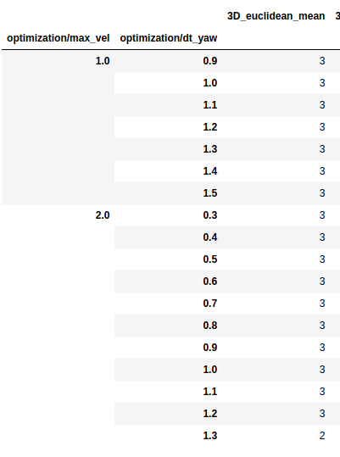

**This test crashed too soon. These parameters will be tested again.**

## Test #2

**Date:** 25/10/20

**Map**: iris_no_corridor.world

**Parameters to vary:**

* max_vel
* max_acc

**Constants:**

* lambda1=10.0
* lambda2=0.8
* lambda3=10e-5
* lambda4=0.1
* lambda7=100
* PSC_POSXY_P=1
* dt_yaw=0.9

**Comments:**

* max_acc values cannot be bigger then max_vel values
* Simulation crashed at max_vel=8, max_acc=3.5

**Path Example**

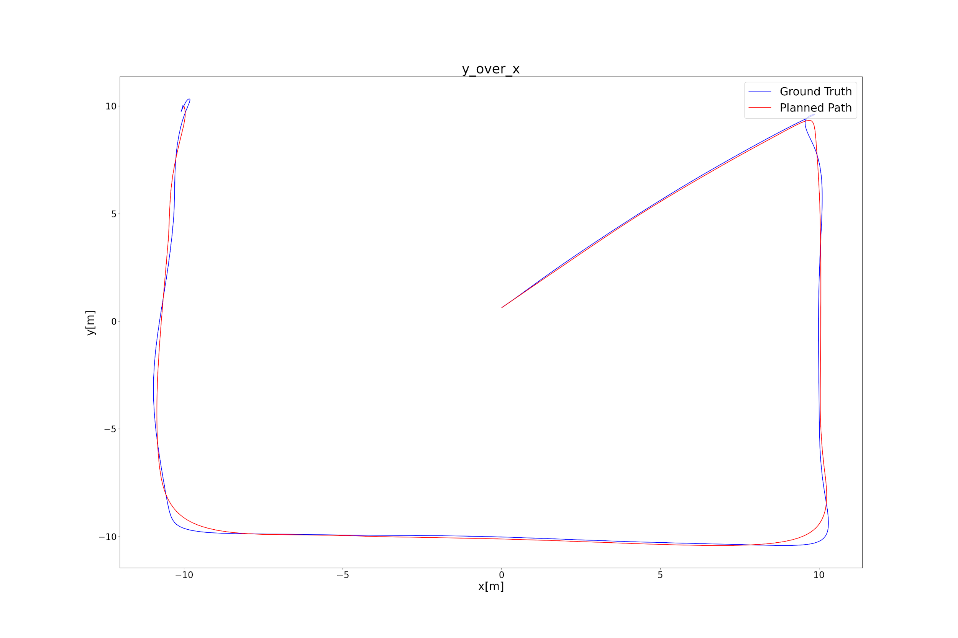

**Parameters Table:**

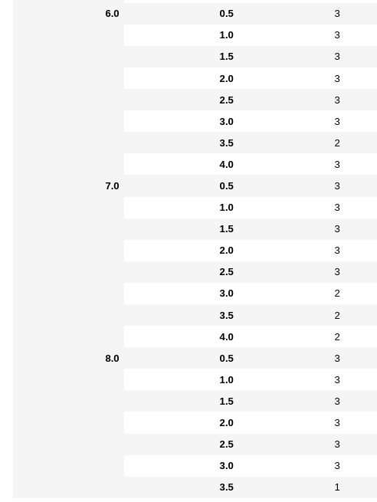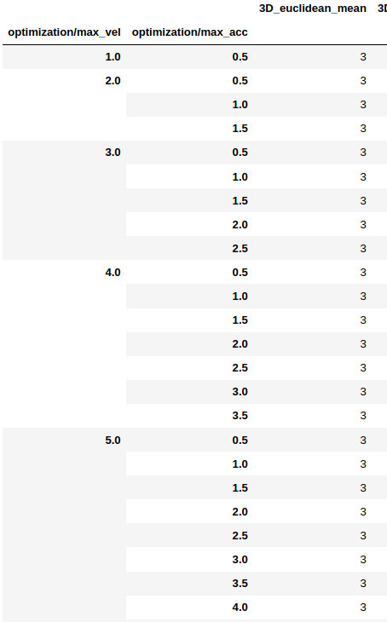

### General Results

A major conclusion one can conclude from observing the parameters table is that for max_vel 7 and 8 with max_acc bigger than 3 we get less successful runs, this is caused because the drone crashed during the current simulation. According to that we neglect higher max_vel values (bigger than 6 m/s) and max_acc values (bigger than 3 m/s^2).

Let us draw the max and mean of the position euclidean error against max_vel and max_acc, first separately and then as contour plot:

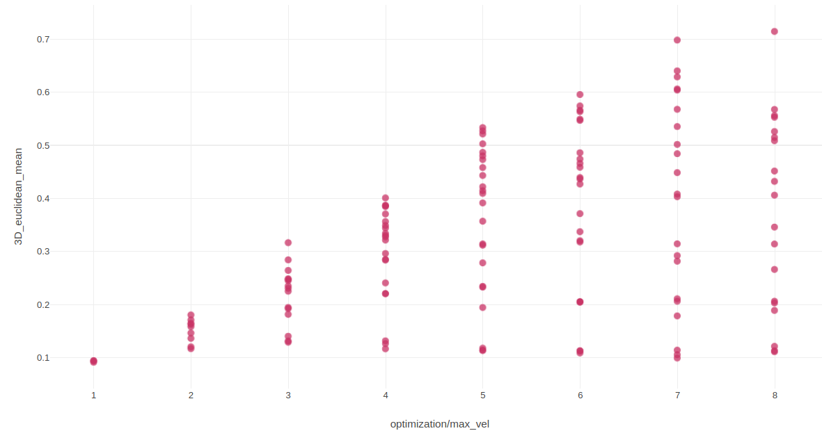

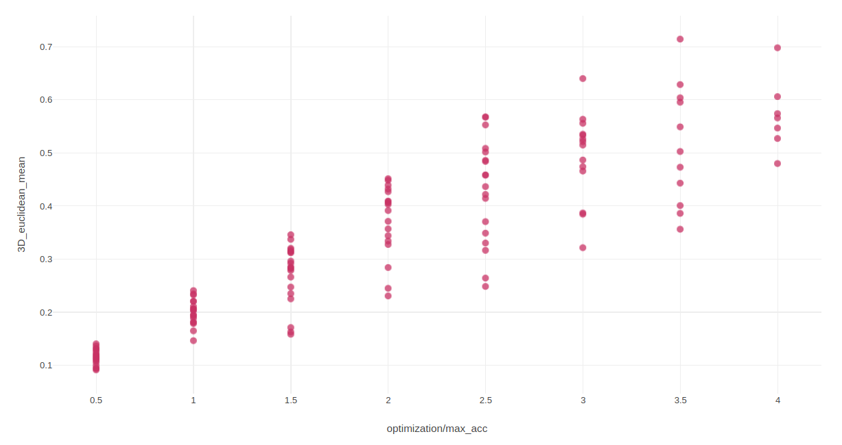

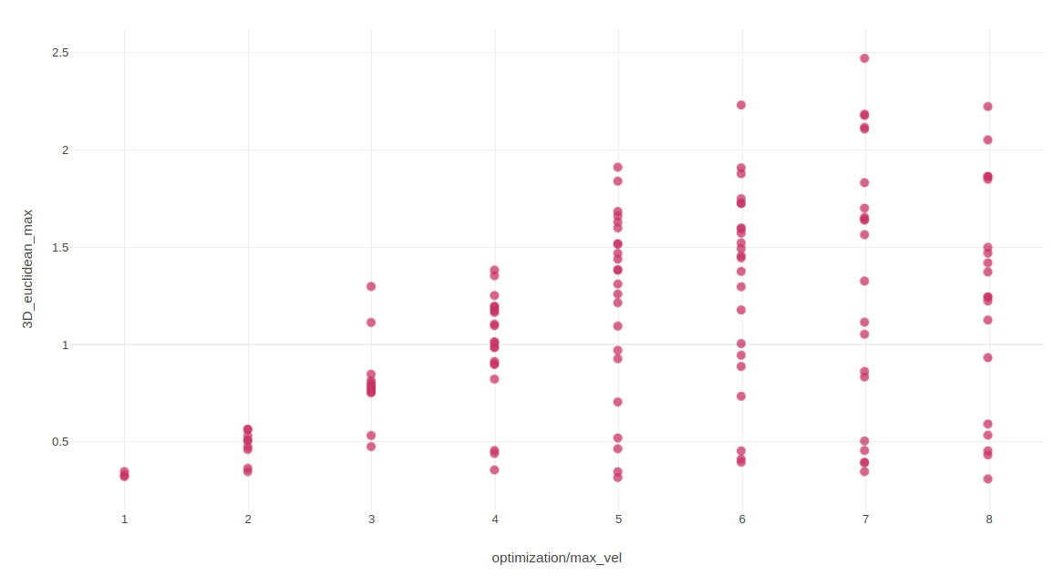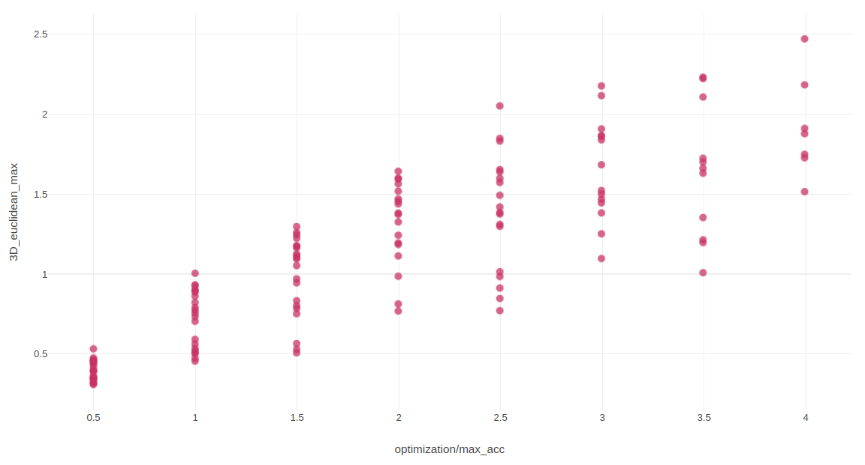

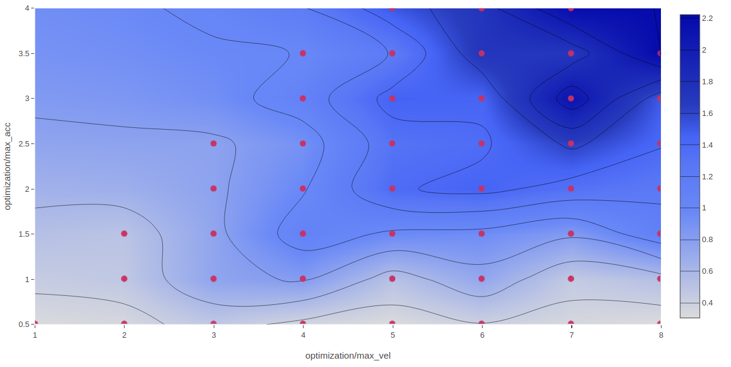

According to the graphs above, one can notice that the position euclidean error depends linearly on both max_vel and max_acc, more so its dependence is stronger to max_acc value.

We observed similar results in other metrics such as euclidean max and std error, velocities errors and yaw errors:

Velocity mean error:

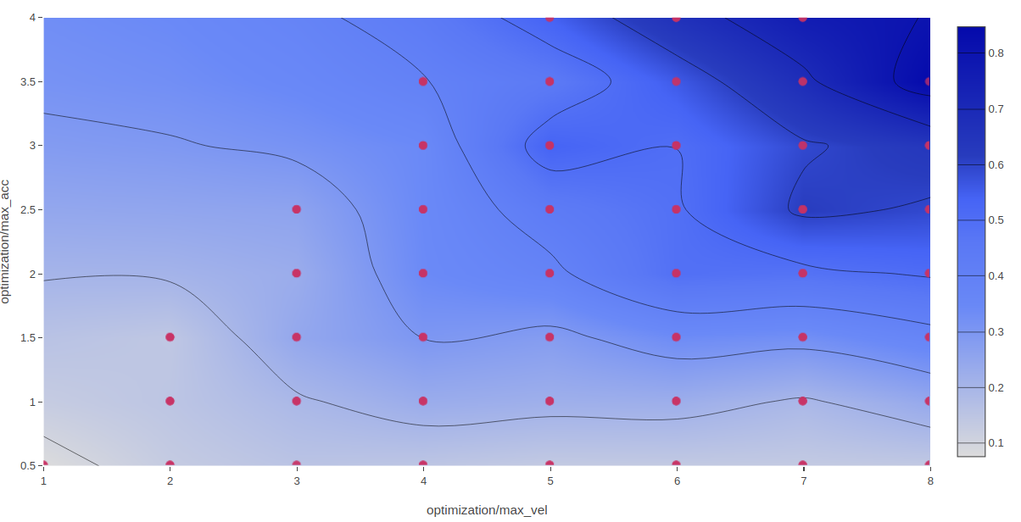

yaw mean error:

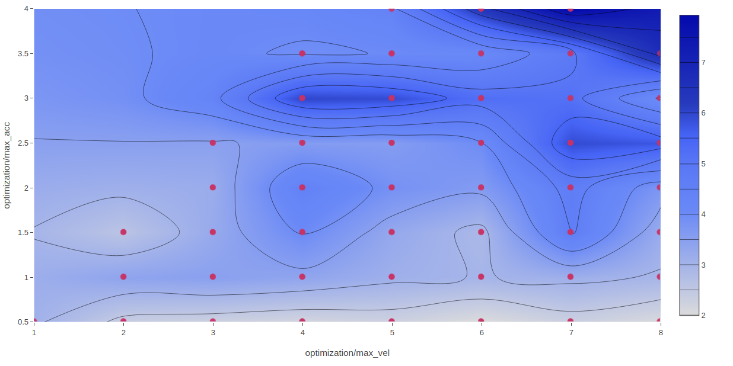

## Test #3

**Date:** 27/10/20

**Map**: iris_no_corridor.world

**Parameters to vary:**

* PSC_POSXY_P
* max_vel

**Constants:**

* lambda1=10.0
* lambda2=0.8
* lambda3=10e-5
* lambda4=0.1
* lambda7=100
* dt_yaw=0.9

**Comments:**

* max_acc - max_vel / 3

**Path Example**



**Parameters Table**

|  |  |  |
| --- | --- | --- |
|  |  |  |

### 

### General Results

In this test we will mainly look at the position euclidean error. The PSC_POSXY_P need to be chosen so that the mean and max of the euclidean error will be minimum along with maintaining the standard deviation, namely the oscillations the drone is doing around the planned path, to be acceptable.

First, let us draw the mean of the position euclidean error against max_vel, in order to compare to the previous tests. 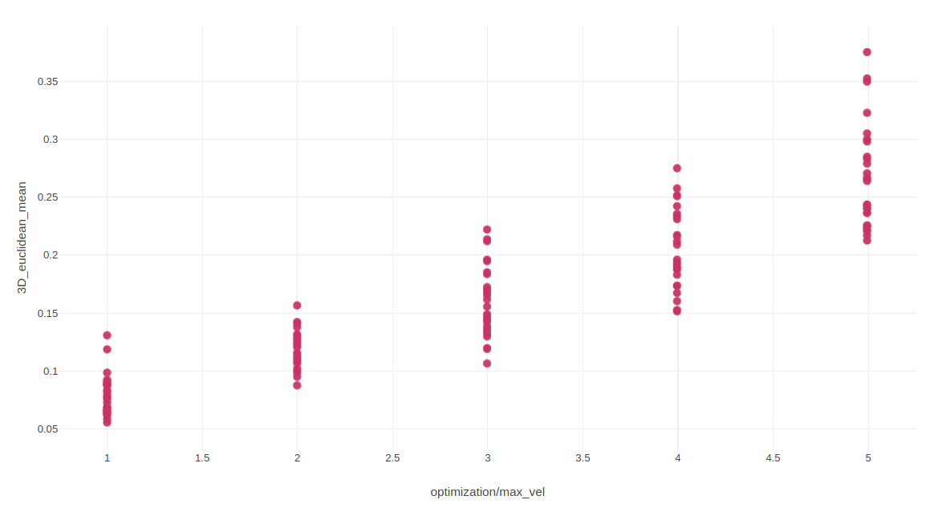

One can notice that similar to test #2 the position euclidean error is increasing linearly with max_vel parameter.

Now let us draw the mean and the standard deviation of the euclidean error against PSC_POSXY_P:

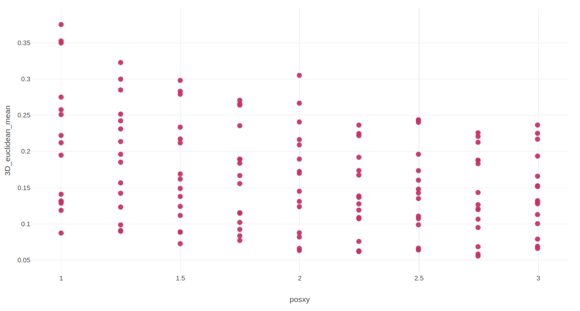

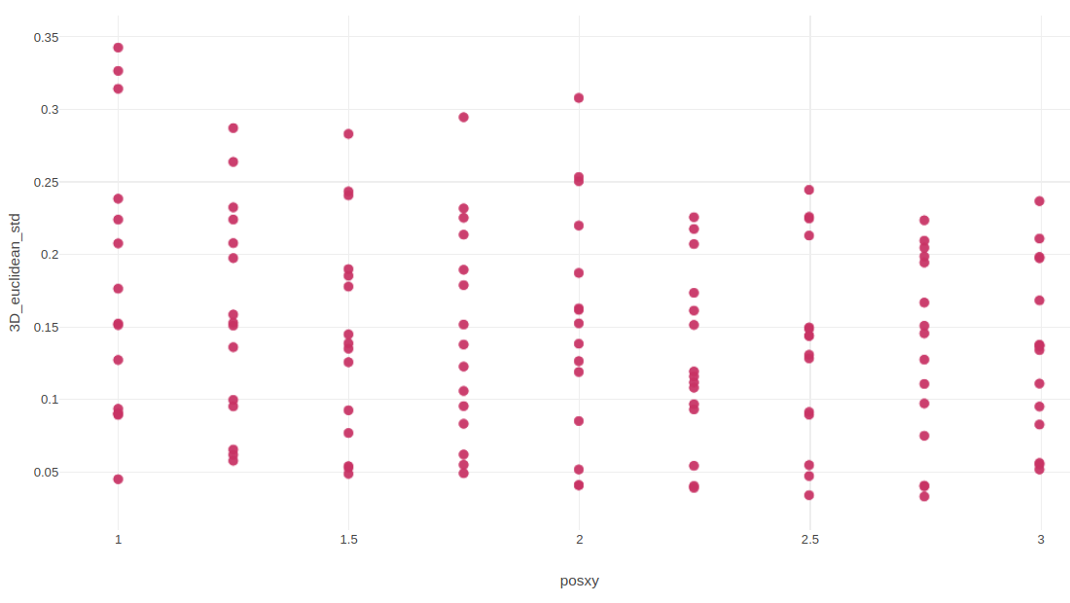

According to the graphs above, one can notice that there is a reversed ratio between PSC_POSX_P value and the euclidean error. Particularly it seem that the error is decreasing until PSC_POSX_P is reaching a value of 2.25 then it maintaining approximately the same values.

## Test #4

**Date:** 1/11/20

**Map**: obstacles.world

**Parameters to vary:**

* lambda1
* lambda2
* lambda3
* PSC_POSXY_P

**Constants:**

* dt_yaw = 1.0
* Max_vel = 3.0
* Max_acc = 1.0
* lambda4=0.1
* lambda7=0.001

**Comments:**

Lambdas values are in logarithmic scale

**Path Example**

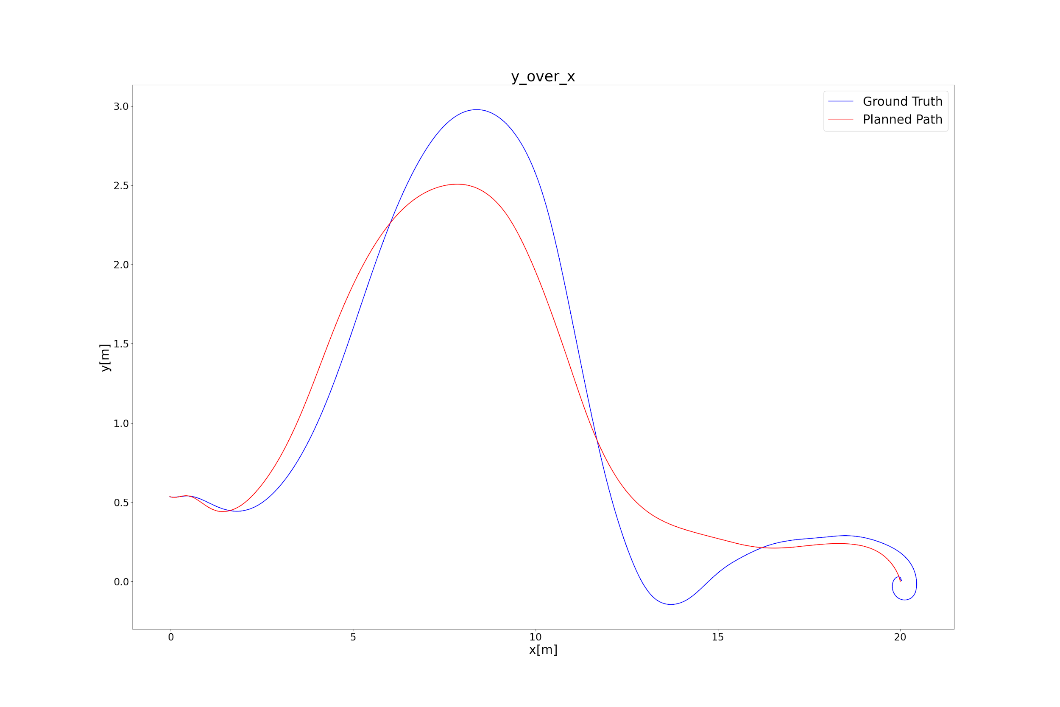

**Parameters Table**

|  |  |  |
| --- | --- | --- |
|  |  |  |

### 

### General Results

One main conclusion one may differ from the following graphs is that changing the lambdas values does not affect the errors between fast-planner planned path and drone's actual path (Drone control error).

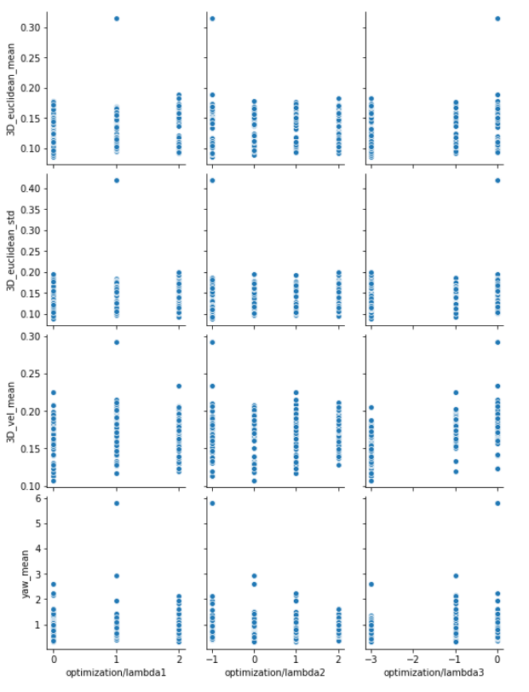

You can notice that there is no correlation between the lambdas values (in logarithmic scale) to the drone control error.

## Test #5

**Date:** 2/11/20

**Map**: obstacles.world

**Parameters to vary:**

* dt_yaw
* lambda7

**Constants:**

* lambda1=10.0
* lambda2=0.8
* lambda3=10e-5
* lambda4=0.1
* Max_vel = 3.0
* Max_acc = 1.0
* PSC_POSXY_P = 1

**Comments:**

Lambda7 values are in logarithmic scale

**Path Example**

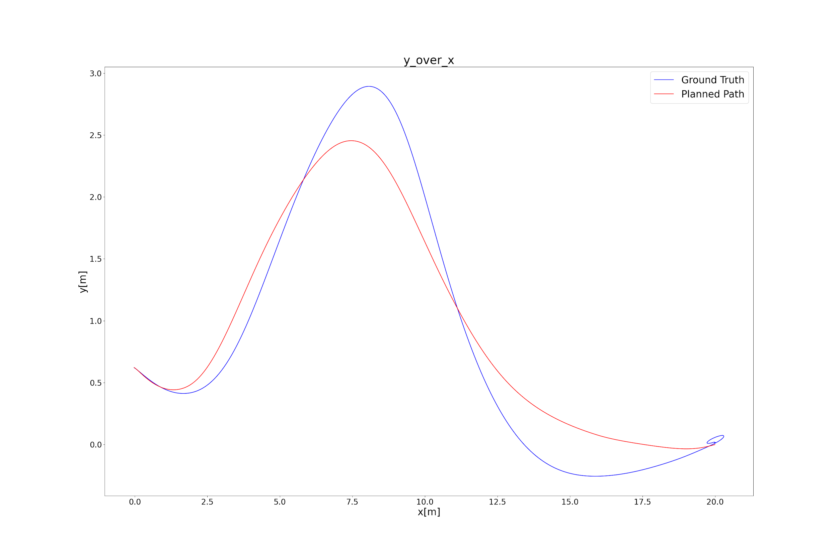

### Parameters Table

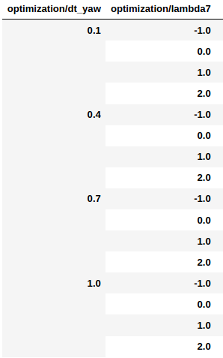

### General Results

Let us plot a contour plot of the yaw and yaw dot mean error, std and max error according to dt_yaw and lambda7 values:

Yaw mean error:

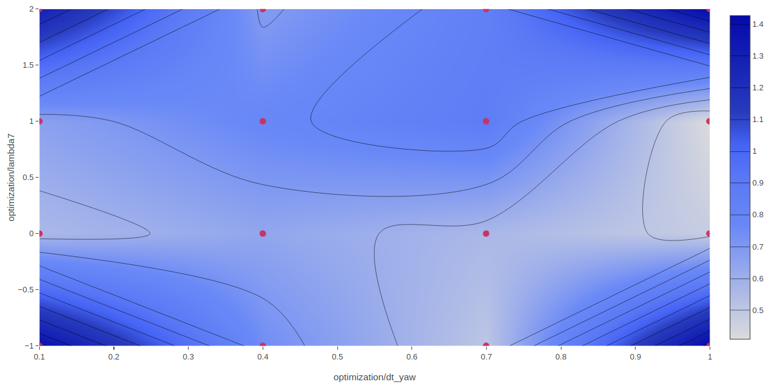

Yaw max error:

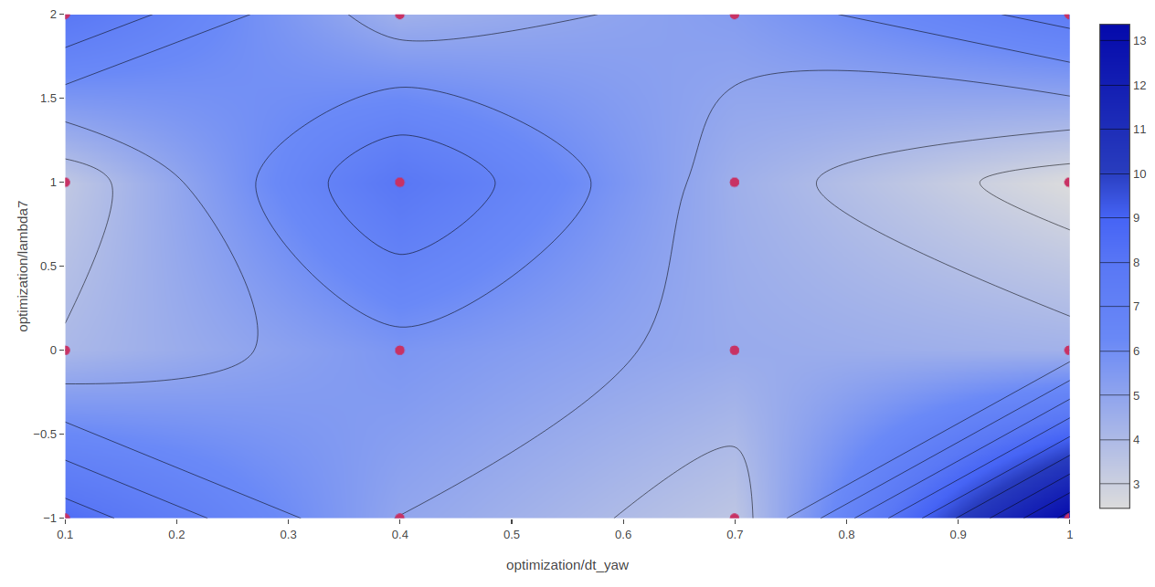

Yaw std:

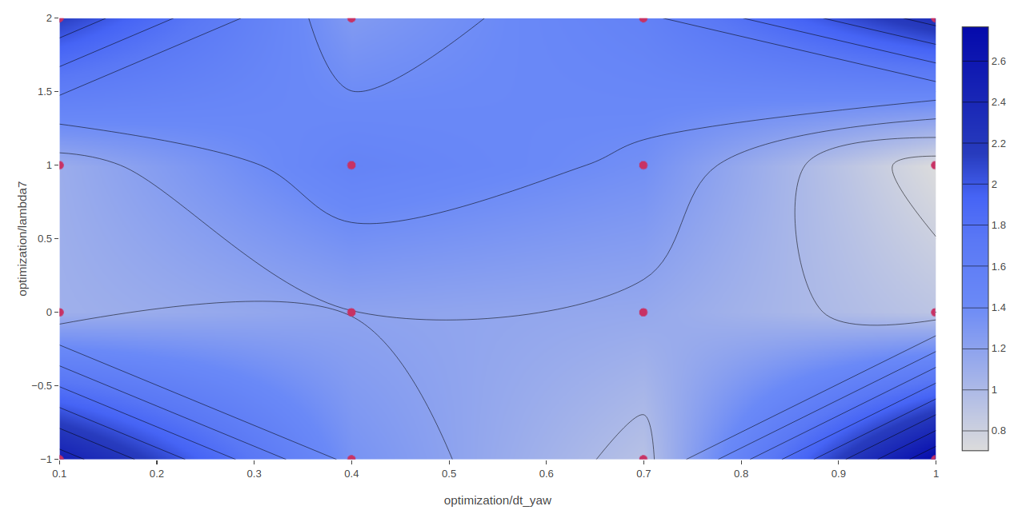yaw dot mean error:

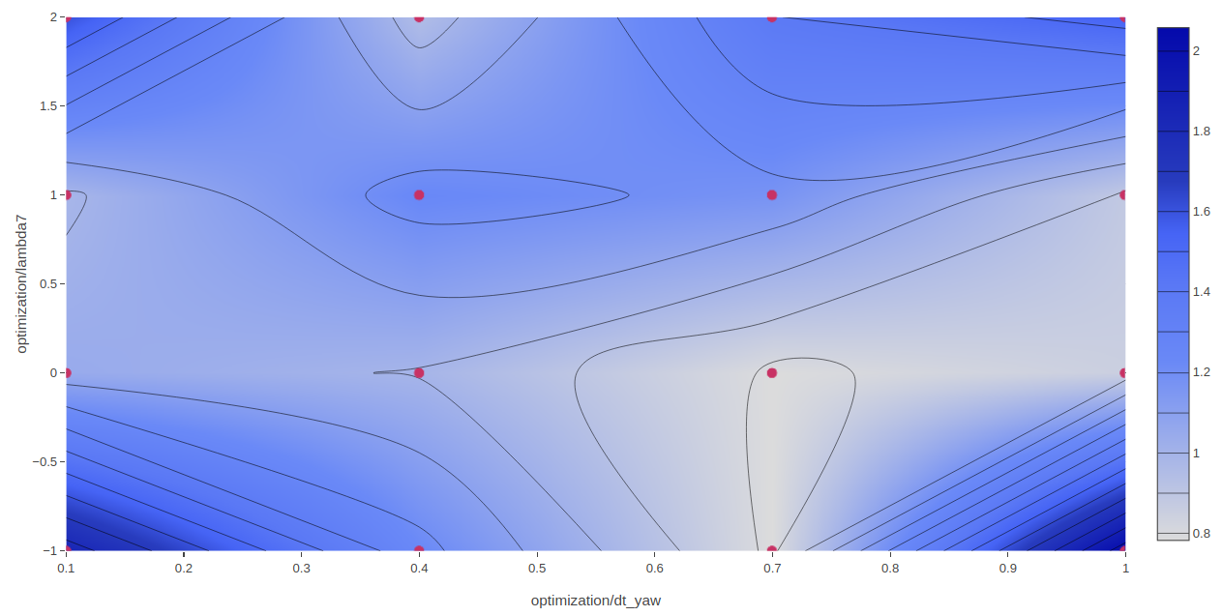

In addition let us plot yaw and yaw dot mean errors for different lambda7 values:

According to these figures, one can notice that for lambda7 value of 0 (actual value is 1) a minimum error value is obtained.

Once we choose the value of lambda7, we will choose a value of 0.7 for dt_yaw according to the figures above.

**After examining these parameters manually we obtained that value for dt_yaw value of 0.5-0.6 the drone yaw rate is higher and the drone is more reactive, while drone control error is approximately the same.**

## 

## Test #6

**Date:** 2/11/20

**Map**: obstacles.world

**Parameters to vary:**

* PSC_POSXY_P

**Constants:**

* lambda1=10.0
* lambda2=0.8
* lambda3=10e-5
* lambda4=0.1
* lambda7=10
* dt_yaw=0.5
* Max_vel = 3.0
* Max_acc = 1.0

**Comments:**

Crashed at PSC_POSXY_P=2.75 in the 4th iteration out of 5

**Path Example:**



### Parameters Table

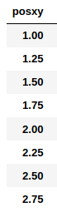

### General Results

Let us plot a contour plot of the position euclidean mean error, std and max error according to PSC_POSXY_P values:

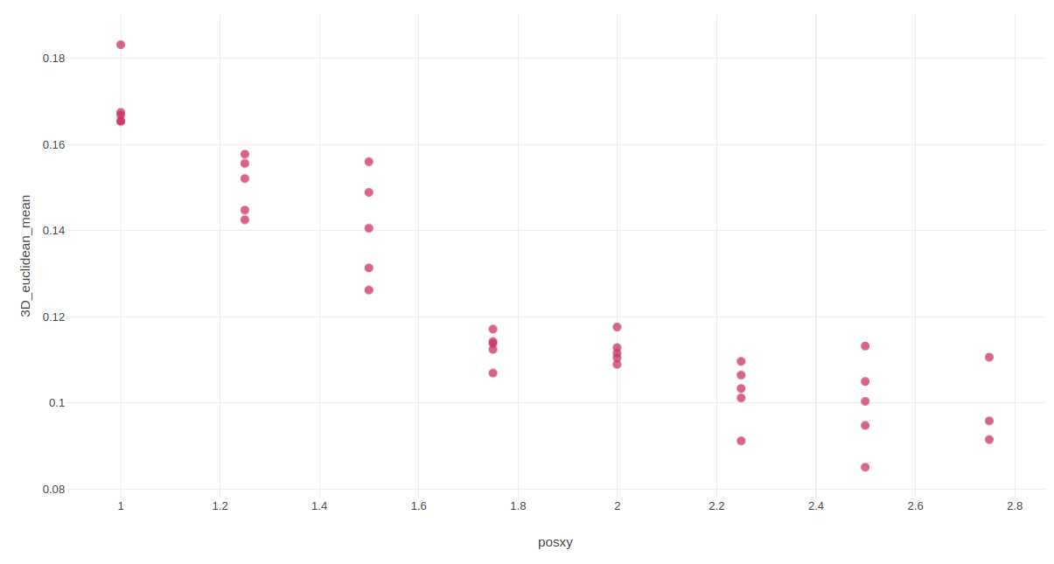

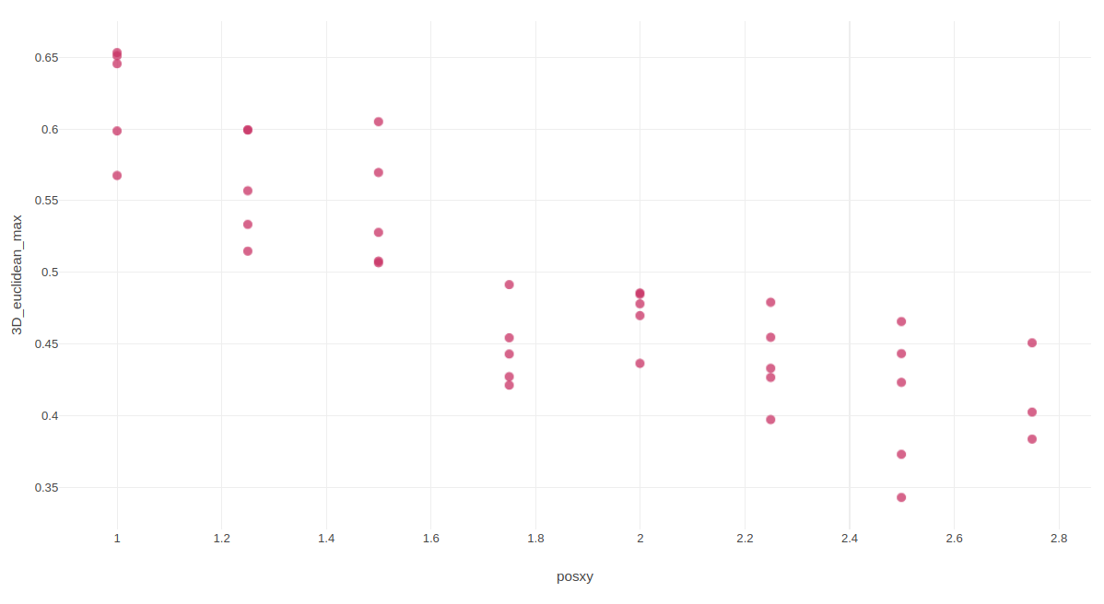

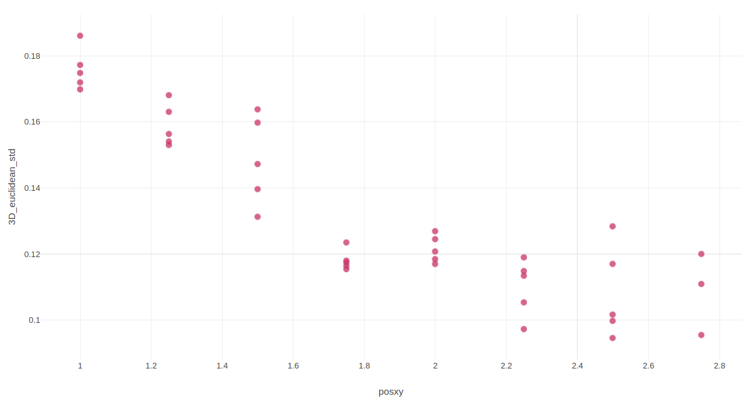

It is easy to notice that there is a strong opposite correlation between PSC_POSXY_P values and the position euclidean errors.

For summary, lets plot position euclidean, velocity and yaw errors against PSC_POXY_P values:

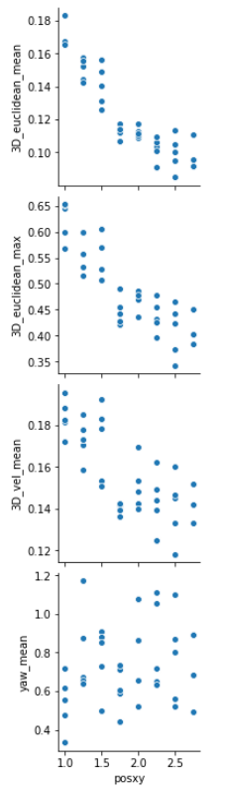

In addition to the euclidean errors, there is also an opposite correlation between velocity errors values and PSC_POSXY_P values, but there is no correlation to yaw errors values.

**Another test with higher values of PSC_POSXY_P is required.**

## Test #7

**Date:** 3/11/20

**Map**: obstacles.world

**Parameters to vary:**

* PSC_POSXY_P

**Constants:**

* lambda1=10.0
* lambda2=0.8
* lambda3=10e-5
* lambda4=0.1
* lambda7=10
* dt_yaw=0.5
* Max_vel = 3.0
* Max_acc = 1.0

**Comments:**

**These test results were united with the previous test results.**

**Path Example:**



### Parameters Table

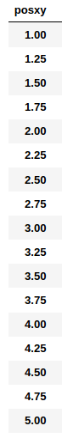

### General Results

Let us plot a contour plot of the position euclidean mean error, std and max error according to PSC_POSXY_P values:

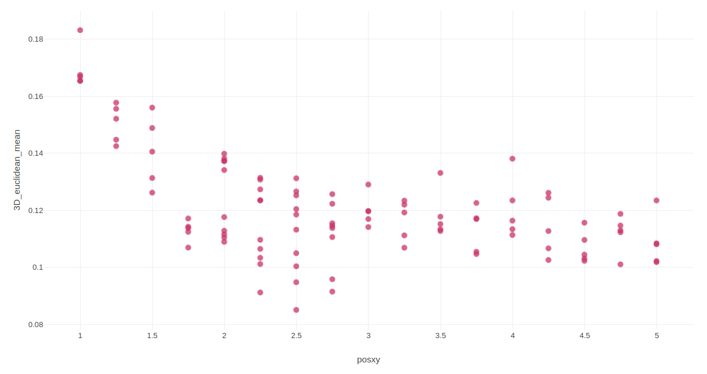

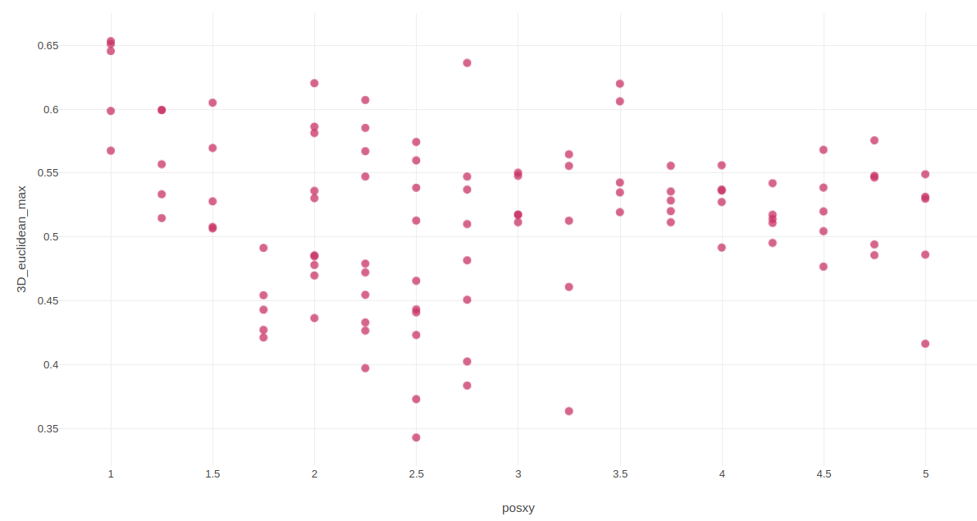

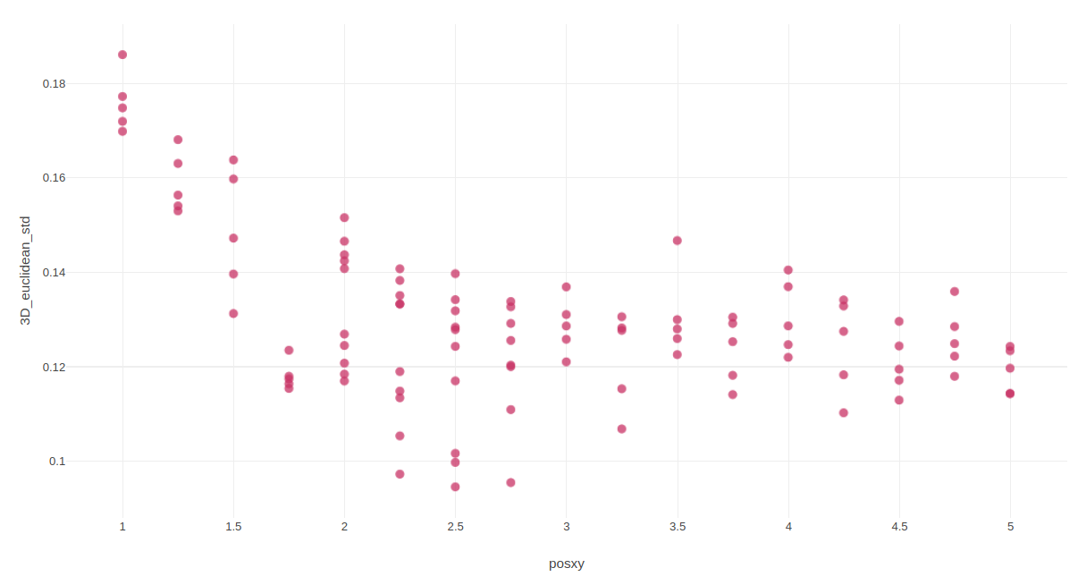

Similar to the previous test, it is easy to notice that there is a strong opposite correlation between PSC_POSXY_P values and the euclidean errors.

Furthermore one can notice that for PSC_POSXY_P values higher than 2.5 the errors value no more decreasing and additionally the euclidean max error is reaching a minimum value at PSC_POSXY_P=2.5.

**Hence the recommended value of PSC_POSXY_P is 3.**

For summary, lets plot euclidean, velocity and yaw errors against PSC_POXY_P values:

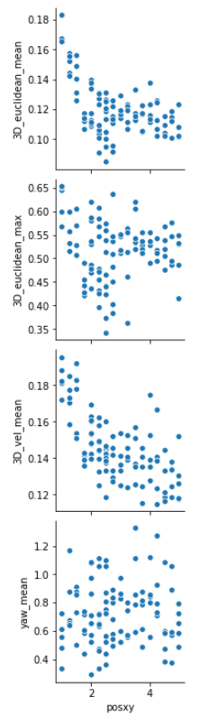

Similar to the previous test, in addition to the euclidean errors, there is also an opposite correlation between velocity errors values and PSC_POSXY_P values, but there is no correlation to yaw errors values.

**PSC_POSXY_P chosen value is 2.5.**

**In order to deal with the oscillation at the end of the path, one can change PSC_POSXY_P value to 1 after reaching the target.**

## Test #8

**Date:** 3/11/20

**Map**: obstacles.world

**Parameters to vary:**

* ACRO_YAW_P

**Constants:**

* lambda1=10.0
* lambda2=0.8
* lambda3=10e-5
* lambda4=0.1
* lambda7=10
* dt_yaw=0.5
* Max_vel = 3.0
* Max_acc = 1.0
* PSC_POSXY_P=1

**Comments:**

**Path Example:**



### Parameters Table

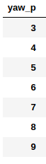

### General Results

Let us plot a contour plot of the yaw mean error, std and max error according to ACRO_YAW_P values:

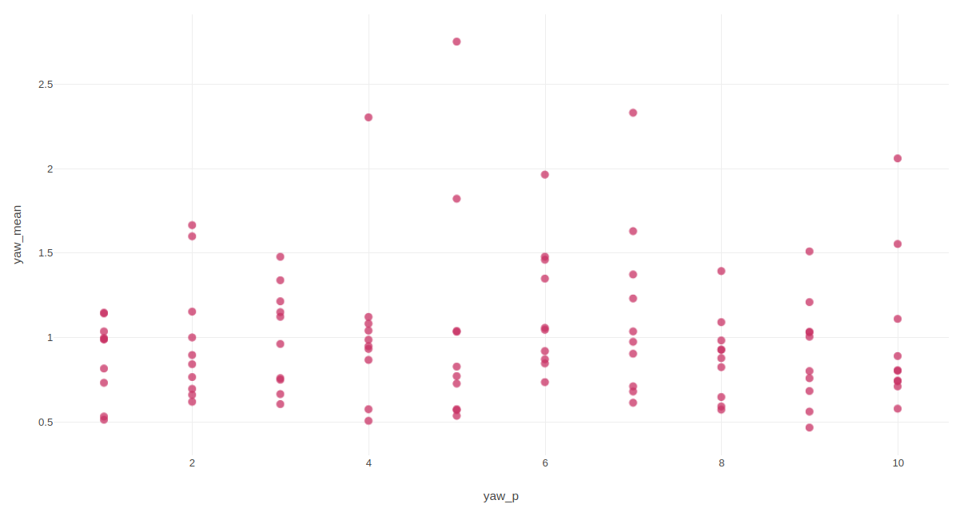

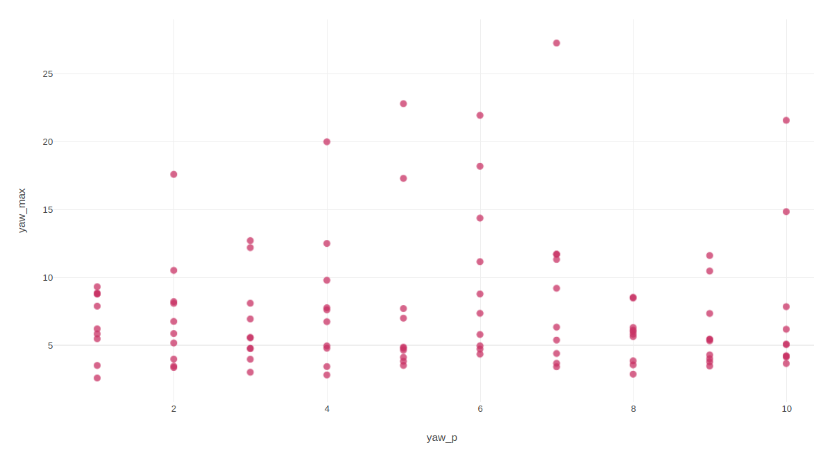

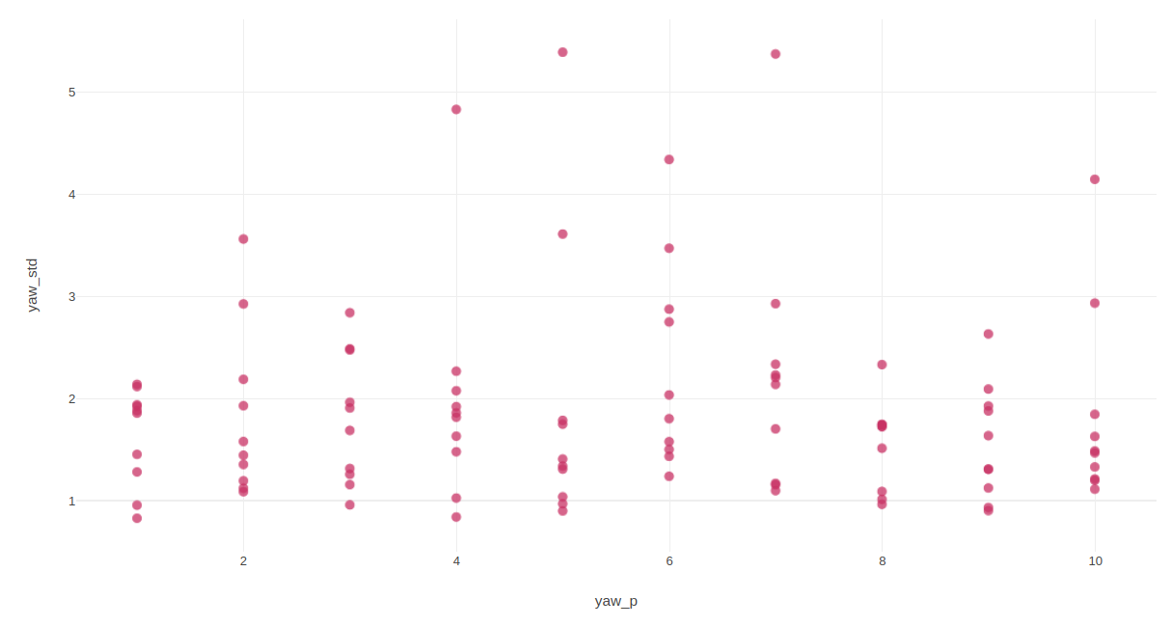

One can notice that there is no correlation between ACRO_YAW_P values and yaw error values. That is also true for other path errors (manually examined).

## Test #9

**Date:** 5/11/20

**Map**: iris_included.world

**Constants**

* lambda1=10.0
* lambda2=0.8
* lambda3=10e-5
* lambda4=0.1
* lambda7=10
* dt_yaw=0.5
* Max_vel = 3.0
* Max_acc = 1.0
* PSC_POSXY_P=1

**Comments:**

**Path Example:**

