CS 475 Project #1 Report

1. I ran this on the OSU Flip3 sever
2. From the program, the volume that I get is 25 units3.
3. Graph

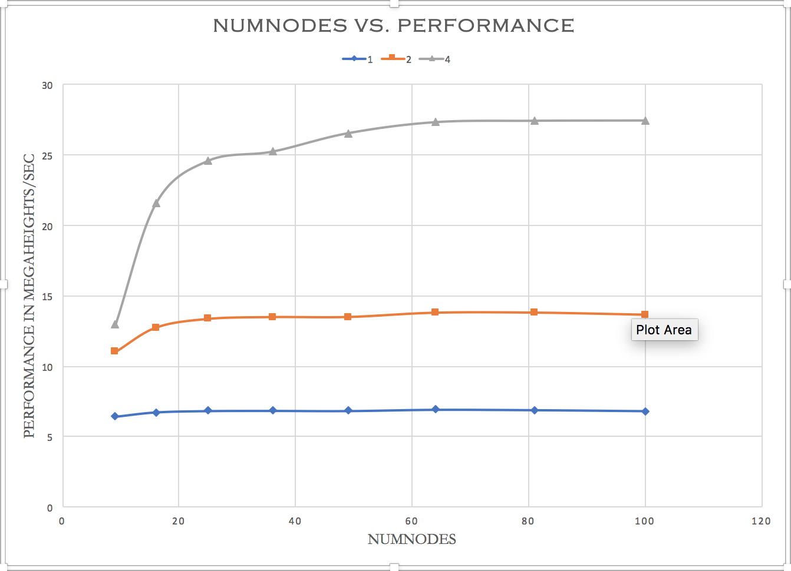

Table

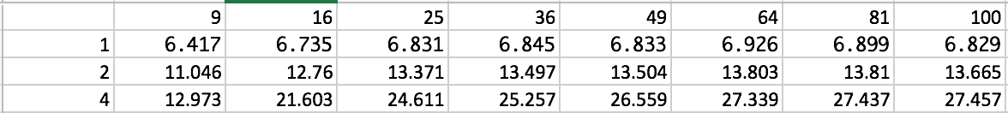

1. The speed initially increases as the number of nodes increase. However, it flattens out after the initial jump. After that, the line graph takes a slight downward turn.
2. The reason for the pattern is the violation of temporal coherence. This violation causes the graph to take a downward turn.

$Speedup at 49 nodes= \frac{P_{4}}{P_{1}}=\frac{26.559}{6.833}=3.886$

$Parallel Fraction= \frac{4}{3}*\left(1-\frac{1}{Speedup}\right)= \frac{4}{3}*\left(1-\frac{1}{3.886}\right) = 0.9903$

$$Speedup at 49 nodes= \frac{P_{2}}{P_{1}}=\frac{13.504}{6.833}=1.976$$

$Parallel Fraction= \frac{4}{3}*\left(1-\frac{1}{Speedup}\right)= 2*\left(1-\frac{1}{1.976}\right)=0.9838$

$Maximum Speedup 4 threads= \frac{1}{1-F_{parallel}}=\frac{1}{1- 0.9903}=103.093$

$$Maximum speedup 2 threads=\frac{1}{1-F_{parallel}}=\frac{1}{1-0.9838}=61.728$$