CS 475 Assignment #2

1. I ran this program on the FLIP server

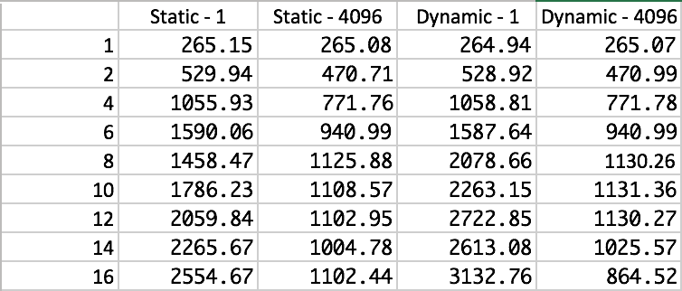

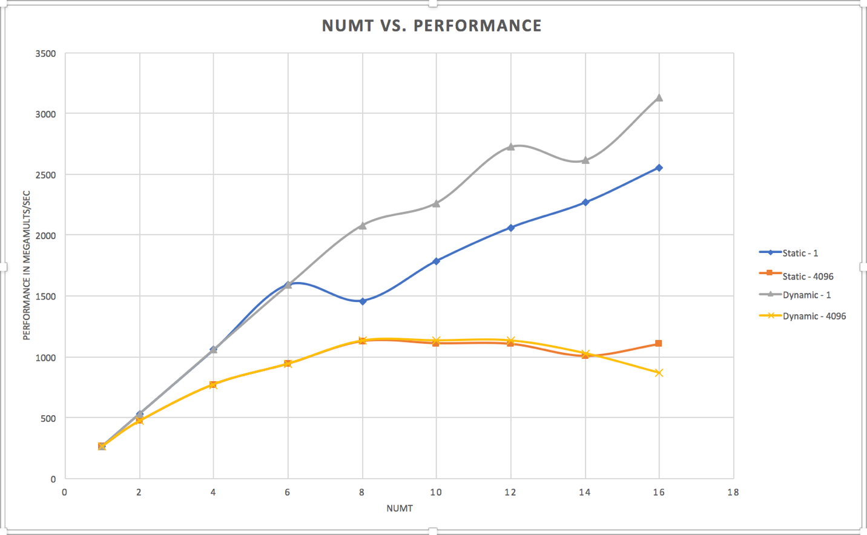

1. From the above plot, I see the static and dynamic scheduling with 4096 chunk size have a lower performance than the static and dynamic scheduling with 1 chunk. Another pattern that I observe is the static-1 and dynamic-1 have the same increase in performance until 6 threads. After that, static-1 takes a dip in performance and recovers at 10 threads. Meanwhile, dynamic-1 continues to increase with a dip at 14 threads. So, dynamic-1 scheduling outperforms static-1 after 6 threads.
2. The chunksize matters because, when it is as large as 4096, each thread has 4096 iterations. So, it takes time to complete it and get a new assignment. However, when the chunksize is only 1, the performance increases as adding more threads will mean more threads finishing more iterations quickly and get a new assignment.
3. Static and dynamic scheduling matters because, dynamic scheduling takes advantage of having a master and pool of threads. In dynamic scheduling, the master allots some work at run time to the threads. Once a thread finishes its work, the master allots some more. However, in static, all the work is allotted at runtime and if a thread finishes early, then it just idly sits there. Therefore, dynamic scheduling has a higher performance.