This document is a manual for the steps taken during the data upload workshop on the 15.06.2017.

It lists the steps necessary to use the wizard to submit population and trial data to the Brassica Information Portal. It also names all fields required for the submission of a new experimental plant population and plant trial.

In order to submit content to the Brassica Information Portal, you need to sign in with your ORCiD account. If you don’t have an ORCiD account yet, you will be referred to their services from our Sign in. [ACTION] To register, go to [bip.earlham.ac.uk](https://bip.earlham.ac.uk/) and click on the ‘sign in with ORCiD’ button in the top right corner.

Please create an account prior to the workshop, as our time is limited.



Your submission is split into two different submissions which need to be executed in the following order:

1. Population Submission (web - interface based)
   1. Population Submission extended
2. Trial Submission (web - interface based)
   1. Trial Submission extended

**Population Submission using the wizard**

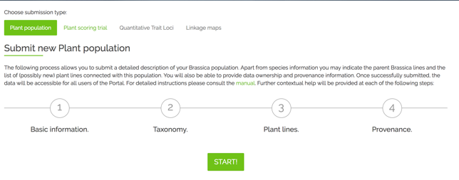You submit your experimental plant population first. This is the collection of the genetically different plant material used for your trial. In your trial submission you are asked for the name of your experimental population, to link the population with the samples. This is why it is necessary to submit population information first.

The population submission can be used for

* Crossing populations,
* Mutagenized (radiation, EMS, Azacytidine) populations,
* Diversity fixed foundation sets,
* Back crosses,
* Recombinant inbred,
* etc. [ACTION] if you feel the description of populations on the website is not adequate, or the list of populations should be extended, please let us know

Population Submission is a 4-step process during which you also submit metadata that describes your experimental plant population. [ACTION] Go to [bip.earlham.ac.uk](https://bip.earlham.ac.uk/) , sign in and click on submit data. Choose “Plant population” and click “START!”. There is also a manual, that describes Plant Population submission in a more general way.

The wizard walks you through all the steps, offering compulsory and optional fields to be filled out. In table 1 below you see a list of all fields during the submission process. Those fields marked with * are compulsory for the submission.

**Files required:**

In the workshop materials folder, the example file required for the wizard-based population submission is the file numbered with 1_ . It reflects part of the Diversity Fixed Foundation Set produced by OREGIN. Suppose, your institution has received OREGIN germplasm material, bulked it up and conducted experiments on it. This is what is reflected in the file

**1_BnaDFFS.csv**

* The input .csv file which contains metadata about the experimental population

Accession: seed or plants of a plant line arising from a single generation

|  |  |  |  |  |
| --- | --- | --- | --- | --- |
|  | **Table 1. Fields required* for the submission of an experimental Population. They are presented below by <resource_name>.<attribute_name>.** |  |  |  |
|  | **Step 1 - Basic Information** |  |  |  |
|  | Population Name* |  |  |  |
|  | Description |  |  |  |
|  | Population type* |  |  |  |
|  | Establishing organization* |  |  |  |
|  | Population owned by |  |  |  |
|  |  |  |  |  |
|  | **Step 2 - Taxonomy** |  |  |  |
|  | Taxonomy term |  |  |  |
|  | Female parent line |  |  |  |
|  | Male parent line |  |  |  |
|  |  |  |  |  |
|  | **Step 3 - Plant lines** |  |  |  |
|  | download .csv file template  (see below for template) |  |  |  |
|  |  |  |  |  |
|  | **Step 4 - Provenance** |  |  |  |
|  | Data owned by* |  |  |  |
|  | Data provenance |  |  |  |
|  | Comments |  |  |  |
|  | Visibility-public/private* |  |  |  |
|  |  |  |  |  |

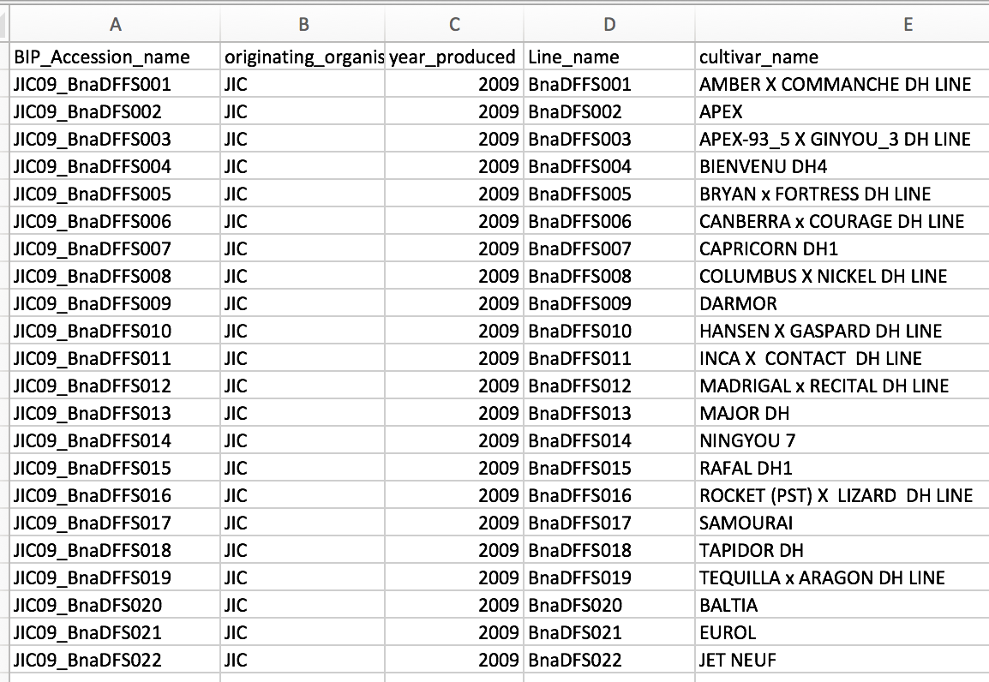

Figure 1 1_BnaDFFS.csv is a mock- population template that corresponds to the population submission client in the workshop material..

**Trial Submission using the wizard**

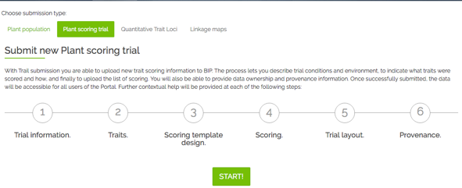After submitting your Population, you can submit the trait scoring data (your measured traits) of your trial. This is a 6-step process, during which you also submit metadata that describes your trial. Go to [bip.earlham.ac.uk](https://bip.earlham.ac.uk/) and click on submit data. Choose “Plant scoring trial” and click “START!”.

The wizard walks you through all the steps, offering compulsory and optional fields to be filled out. In the table below you see a list of all fields during the submission process. Those fields marked with * are compulsory for the submission.

[ACTION] Open the 3_Trial_data – file you will be using for the upload and become familiar with the data. The file contains all columns necessary for the submission of this trial raw data. In real life, things are more tricky. But to get your head around the actual submission process and initial practice, we work with easy data for now. In section Trial submission extended, we work with more complex data.

Each step in the submission corresponds to several [ACTION]s, so please follow the instructions below and the instructions on the website:

|  |  |  |  |  |  |  |  |  |  |  |  |  |  |  |  |  |  |  |  |  |  |  |  |  |  |  |  |  |  |  |  |  |  |  |  |  |  |  |  |  |  |  |  |  |  |  |  |  |  |  |  |  |  |  |  |  |  |  |  |  |  |  |  |  |  |  |  |  |  |  |  |  |  |  |  |  |  |  |  |  |  |  |  |  |  |  |  |  |  |  |  |  |  |  |  |  |  |  |  |  |  |  |  |  |  |  |  |  |  |  |  |  |  |  |  |  |  |  |  |  |  |  |  |  |  |  |  |  |  |  |  |  |  |  |  |  |  |  |  |  |  |  |  |  |  |  |  |  |
| --- | --- | --- | --- | --- | --- | --- | --- | --- | --- | --- | --- | --- | --- | --- | --- | --- | --- | --- | --- | --- | --- | --- | --- | --- | --- | --- | --- | --- | --- | --- | --- | --- | --- | --- | --- | --- | --- | --- | --- | --- | --- | --- | --- | --- | --- | --- | --- | --- | --- | --- | --- | --- | --- | --- | --- | --- | --- | --- | --- | --- | --- | --- | --- | --- | --- | --- | --- | --- | --- | --- | --- | --- | --- | --- | --- | --- | --- | --- | --- | --- | --- | --- | --- | --- | --- | --- | --- | --- | --- | --- | --- | --- | --- | --- | --- | --- | --- | --- | --- | --- | --- | --- | --- | --- | --- | --- | --- | --- | --- | --- | --- | --- | --- | --- | --- | --- | --- | --- | --- | --- | --- | --- | --- | --- | --- | --- | --- | --- | --- | --- | --- | --- | --- | --- | --- | --- | --- | --- | --- | --- | --- | --- | --- | --- | --- | --- | --- | --- |
| **Step 1** asks you for general trial information. When coming up with a Plant trial name, try to follow the nomenclature in the table to the right.  An already existing Trial name is called U.Nottm_2016_RIPRleafminerals_REMLmeans. In this step you also link your previously submitted plant_population to your plant_trial, by selecting your experimental plant_population from a drop-down menu.  **In step 2** you define the traits which you have investigated during your trial. For the workshop, you will submit traits that are already recorded in the database (the two first traits), and you will define one new trait by clicking “add new trait descriptor”. When adding new traits, some fields are compulsory, following the Crop Ontology model of <Trait><Method><Scale>. Other information can be added in case it is available. Please see below for the description of your 3rd trait. The traits are made up and just act as an example of what you could fill in in case your traits are not yet recorded in the database.  **In step 3** you specify what information you will upload together with your trait scores. This can be the number of technical replicates or the trial design in case you want to submit raw data –in the workshop, we submit raw data. Also, you specify whether you give information on the plant_lines or plant_varieties associated with your germplasm – in the workshop, we tick Plant varieties.  **In step 4** you will be able to download the template you use for the submission of your trait data. It has been created according to the choices you have made so far in your submission (e.g. traits to be submitted). If you see that the headers don’t correspond to the data you want to submit, navigate back to previous submission steps and amend them accordingly. An altered template can then be downloaded at this step.  Please **be careful when pasting your trait scores** beneath the correct headers, as they may not appear in the order they are recorded in your source spreadsheet.  **Step 5** is optional, where you can submit an image of the trial layout, in case you submit raw data. Such an image would be helpful to interpret patterns in the raw data- in the workshop we don’t have such information.  **Step 6** asks you to fill in some information about the provenance of the data you just submitted. You can choose to put an embargo on the data and wait with the submission until for example your paper is ready to be published. | **Trial submission**   |  |  |  | | --- | --- | --- | | **Step 1 - Trial information** | | | | Plant trial name*  <institute id>_<YYYY>_<trialSubject>_<raw/processed> | | | | Project name* | | | | Experimental plant population*  BnaDFFS_<group number> | | | | Trial year* | | | | Trial description*  mock trial submission during workshop | | | | select: data status: raw vs. processed (analysed) data | | | | Institute* | | | | Terrain | | | | Soil type | | | | Statistical factors | | | | Country* | | | | Place name* | | | | Trial location site name | | | | Latitude | | | | Longitude | | | | Altitude | | | |  | | | | Step 2 -Traits | | | | Select trait descriptors* | | | | | When adding new trait descriptor: | | | | Descriptor name* | Materials | Precautions | | Trait category* | Instrumentation required | Scoring  method | | Units of measurements* | Calibrated against | Possible interactions | | Score type | Likely ambiguities | Additional annotations | | Where to score | Controls |  | |  |  | | | Step 3 - Scoring template design | | | | Select genetic material origin | | | | plant lines | | | | plant varieties | | | | specify technical replicate numbers (raw data) | | | | select design factors: block plot rep etc (raw data) | | | |  | | | | Step 4 - Scoring Template Submission | | | | download .csv file template | | | | add trait scores to corresponding header | | | | add plant scoring unit (=sample_id)*, plant accession*, originating organisation*, | | | | Plant line or variety* | | | | upload .csv file* | | | |  | | | | Step 5 Submit Trial Layout | | | | Submit image of trial layout | | | |  | | | | Step 6- Provenance | | | | Data owned by | | | | Data provenance | | | | Comments | | | | Visibility-public/private* | | | |

**Morphological traits to add manually:**

Trait: plant dry weight

Unit of measurements: kg

Scoring method: Remove soil from roots, let dry in oven for 24 h, weigh on a scale.

Materials:

Plant part: whole plant

Trait: basal root thickness

Unit: cm

Method: generate cross-section in the middle of the basal root ( tip to beginning) and measure thickness using a ruler

Plant part: basal root

Trait: root dry weight

Unit: mg

Method: remove root from aboveground biomass, clean with water, careful not to remove roots during that process. Dry in a bag a drying chamber for 24h, measure weight of roots within the bag by putting on a scale.

A generic dried bag –weight was subtracted from all samples.

Trait: stem colour

Unit: colour

Method: pictures were taken at the same light intensity with a black square as reference in all images and analysed with Image J.

Trait: Lower stem length

Unit: cm

Method: use a tape measure to measure length of lower stem beginning at lowest leaf to the ground.

**Biochemical traits to add manually:**

Trait: Leaf nitrogen content

Unit of measurements: ng

Scoring method: Kjeldal, see Publication et al 1967

Plant part: leaf

Trait: Seed copper concentration

Unit of measurements: ng/mg (dry weight)

Scoring method: 3 seeds per tube and occasionally four for very small seeds from multiple replicate plants per accession were left to soak in nitric acid over night and then digested in block heaters prior to analysis by inductively coupled plasma-mass spectrometry (ICP-MS). This data was then weight normalised so that data from each element was in the units mg/kg

Plant part: seed

Trait: Pod and stem Aldehyde functional group content

Unit: µg

Scoring method: * 3 pods and 3 sections of stem (10 cm) were collected from each plant, and inserted into Pyrex glass tubes (122 mm (L) x 19 mm (D), roughly 20 ml vol.).  
* Wax was extracted using chloroform. Chloroform was spiked with a C22:0 alkane and C17:0 fatty acid as internal standards. Internal standard concentrations were 10 µM in chloroform (giving 100 pmol/µl for GC injection). Wax was extracted for 30 seconds using 10 ml of the chloroform/IS mixture. Sample tubes were inverted continuously during the extraction phase. PTFE cap liners were used to ensure minimal extraction of plasticisers.  
* Pod and stem material are removed from the tubes, and samples dried under vacuum in a centrifugal evaporator (Genevac, EZ-2) at ? 42°C using program low BP. Samples can also be dried under a stream of nitrogen at ? 30°C.   
* Wax components were derivatized with 200 µl of BSTFA + TMCS (99:1) for 1 hour at 85°C.  
* After cooling, 800 µl of heptane was added (total vol. 1 ml), and 1 µl was injected onto the GC-FID/MS.   
* GC program:  
* Initial temp: 50°C, to 200°C at 50°C/min, to 280°C at 2°C min, to 325°C at 10°C/min, hold for 6.5 minutes.  
* Inlet temp: 280°C, split-less injection.   
* Column: HP-1MS UI, 30 m x 0.25 mm x 0.25 µm, flow = 1 ml/ min.  
* FID temp: 325°C

-a beautifully long and detailed description of the method- good for trait reproducibility.

Trait: Canopy leaf Kjeldal N

Unit: ng/mg ( dry weight)

Method: 10 canopy leaves (the youngest leaf that is almost fully expanding, not cauline), from 10 plants representing the plot were sampled into a C5 pre-labelled brown envelope. Labelled control envelopes were placed at the end of each 13 winter plots and every 10 spring plots for use in subsequent biomass calculations. The 10 leaves were then weighed on a balance in the envelope that they were collected in. Balance was set to auto collect weights.

Plant part:leaf

Trait: Early leaf Kjeldal N

Unit:ng/mg (dry weight

Method: 10 early leaves ( leaf that is still expanding, usually second most youngest leaf) were sampled from 10 individual representative plants per plot. They were picked and put into an envelope that was pre-labelled. The samples were weighed on a balance in the envelope that they were collected in. Balance was set to auto collect weights.

Plant part:leaf

Trait: Chlorophyll-a content

Plant part: Leaf

Unit: %

Method: the percentage of chlorophyll a over total Chlorophyll content was generated using a spectrometer, following Wellburn et al 1977.

**Trial Submission extended**

This section uses the Trial submission wizard again, but draws from a more complex data sheet to give a more “real world” example.

[ACTION] Open the 3b_Trial_data – file you will be using for the upload and become familiar with the data. This file is a bit more complex: The format follows one data model from the RIPR spreadsheets, but the content is made up. You will notice that some columns may not need to be submitted to the database as they contain the same information and would lead to unnecessary duplication of information. For example, the header sample_id and sample are very similar. Follow the same steps as before. After downloading the submission template, you have to decide what information from this spreadsheet can be omitted from the submission.

Answer: sampls, line_number, Collaborator1_name, Internal_accession_name, JIC_internal_accession_id, ug/g