SERVICES
_______

Home Video to DVD/MP4

Home video to DVD:

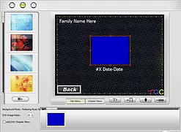
Your home videos will be digitized and burned to a DVD complete with menu using DeVeDe (See sample menu on right) each DVD can hold up to 3 hours of 640x480 (the resolution old home videos are in) footage. Cost is $5 per video plus the cost of DVDs

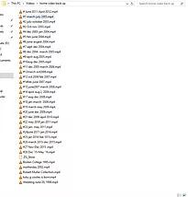
Home video to MP4 :

Your home video will be digitized then the mp4 files will be copied to a hard drive or flash drive to be played on a computer, Ruku, smart TV, etc. Cost is $4 per tape plus the cost of a flash drive or hard drive.

Both:
Get both MP4 files and DVDs. Cost: $6 per tape plus the cost of DVDs and flash drive or hard drive.

More info
Order now

I keep a back up of your video for 30 days, in the event that something happens to your drive in these 30 days I will charge a $20 recovery fee plus cost of new drive, I will then keep your video for an additional 30 days. All services with less then 10 tapes have a $10 fee as well as a $20 minimum charge

COMPUTER REPAIRS/UPGRADES
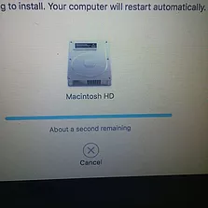
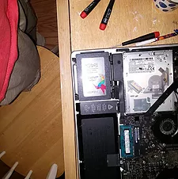

I can work on most PCs/Macs, laptops/desktop, I will not work on a computer I don't feel confident with. I can do a OS reinstall, SSD upgrades/hard disk replacement, Ram upgrades, Virus removal, and more

More info
Order Now

