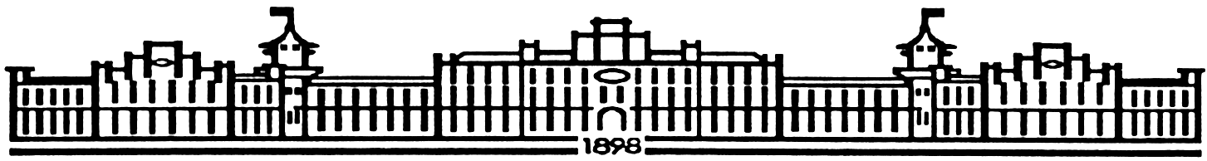

МIНIСТЕРСТВО ОСВIТИ І НАУКИ УКРАЇНИ

НАЦІОНАЛЬНИЙ ТЕХНІЧНИЙ УНІВЕРСИТЕТ УКРАЇНИ

“КИЇВСЬКИЙ ПОЛІТЕХНІЧНИЙ ІНСТИТУТ

ІМЕНІ ІГОРЯ СІКОРСЬКОГО”

Факультет прикладної математики

Кафедра програмного забезпечення комп’ютерних систем

**Лабораторна робота №** 5

з дисципліни “ Основи програмування ”

Тема “**Бібліотеки і формати даних**”

|  |  |  |
| --- | --- | --- |
| Виконав  студент I курсу  групи КП-62  Лук’янець Михайло Олександрович  (*прізвище, ім’я, по батькові*)  варіант №15 |  | Перевірив  “____” “____________” 2017 р.  викладач  Гадиняк Руслан Анатолійович  (*прізвище, ім’я, по батькові*) |

|  |  |  |  |  |  |  |  |  |  |  |  |  |  |
| --- | --- | --- | --- | --- | --- | --- | --- | --- | --- | --- | --- | --- | --- |
| Штрафні бали:   |  |  | | --- | --- | | **Термін здачі** | **Оформлення звіту** | |  |  | | Нараховані бали:   |  |  |  | | --- | --- | --- | | **Корект. програм (2 бала)** | **Відп. на теор. питання (1 бал)** | **Відп. на прогр. питання (2 бала)** | |  |  |  | | Сумарний бал:   |  | | --- | |  | |

Київ 2017

**Мета роботи**

Навчитися використовувати та створювати статичні бібліотеки в ОС Linux. Навчитися працювати із текстовими форматами обміну даних XML та JSON.

#### **Завдання №1. Формати даних**

Встановити та налаштувати бібліотеки для роботи із форматами XML та JSON.

Підключити бібліотеки до проекту лабораторної роботи №4. Додати до модуля сховища даних можливість завантаження і збереження даних у файл у форматах XML та JSON (без модифікації коду інших модулів).

*/* storage.h */*  
...  
**void** **Storage_writeAsXml**(**const** **char** * filePath, List * list);  
List * **Storage_readAsXml**(**const** **char** * filePath);  
  
**void** **Storage_writeAsJson**(**const** **char** * filePath, List * list);  
List * **Storage_readAsJson**(**const** **char** * filePath);  
...

Після цього додати у модулі CUI можливість автоматичного визначення формату даних у файлі, що відкривається користувачем (на основі його файлового розширення) із використанням відповідної функції конвертації для зчитування даних.

Аналогічно зберігати дані у відповідному форматі, коли користувач захоче зберегти дані у файл із розширенням .xml, .json чи .txt.

#### **Завдання №2. Бібліотеки**

Розділити код з лабораторної роботи №4 на бібліотечний і програмний (користувацький). У бібліотечний код винести всі модулі програми і створити на його основі статичну бібліотеку, яку підключати у основний проект. Описати конфігурацію CMake для компіляції і встановлення статичної бібліотеки.

**Тексти коду програм**

|  |
| --- |
| main.c |
| #include <progbase.h>  #include <string.h>  #include <ctype.h>  #include "interface.h"  #include "dino.h"  #include "totest.h"  #include "saves.h"  #include "list.h"  **int** main(**int** argc, **char** * argv[]) {  **char** key = '\0';  **if**(argc > 1 && (!strcmp(argv[1], "-test"))){  test();  }  **const struct** conShift MAIN_SHIFT = { 0, -10 + MAX_SIZE};  **const char** *START_TEXT = "Hello User! Welcome to jurasic's park pre-alpha version 0.0.2.255\n" \  "You can choose what to do via pressing needed button. Press h for info\nPress q to quit program\n\0";  **const char** *START_INFO = "Press 1 to rewrite certain field\n"  "Press 2 to rewrite one dino\n"  "Press 3 to delete needed position\n"  "Press 4 to save data\n"  "Press 5 to copy data from one dino to another\n"  "Press 6 to find all dinos with mass less than X\n"  "Press 7 to add dino if possible\n"  "Press 8 to fill with some random data ALL fields(for tests only!)\n"  "\n"  "Press h to return\n\0";  redraw(MAIN_SHIFT.cols , MAIN_SHIFT.rows );  **int** flagMode = start("Press 1 for new array. Press 2 for existing array");  **char** readFileName[100] = "";  **if**(flagMode == 2){  **char** * readFileTemp = getStringInter("read file name");  strcpy( readFileName , readFileTemp);  free(readFileTemp);  }  **struct** List * list = readFile(readFileName);  cleanCanvas();  printText(START_TEXT);  printStructArr(list);  **while**(key != 'q'){  key = conGetChar();  **switch** (key) {  **case** '1':  ;  **char** * number = getStringInter("number of a dino");  **char** * toChange = getStringInter("new data");  **char** * field = getStringInter("field to rewrite");  **if**(atoi(number) >= MAX_SIZE || !isdigit(number[0])){  free(number);  free(toChange);  free(field);  **continue**;  }  changeField(List_elementAt(list, atoi(number)), field, toChange, list);  cleanCanvas();  printText(START_TEXT);  printStructArr(list);  printResult("field was changed");  free(number);  free(toChange);  free(field);  **break**;  **case** '2':  ;  **char** * numberOfDino = getStringInter("number of a dino");  **char** * name = getStringInter("name");  **char** * age = getStringInter("age");  **char** * friend = getStringInter("number of friend");  **char** * mass = getStringInter("mass");  **if**(atoi(numberOfDino) >= MAX_SIZE || !isdigit(numberOfDino[0])){  printResult("Not correct number");  free(numberOfDino);  free(name);  free(age);  free(friend);  free(mass);  **continue**;  }  changeField(List_elementAt(list, atoi(numberOfDino)), "name", name, list);  changeField(List_elementAt(list, atoi(numberOfDino)), "age", age, list);  changeField(List_elementAt(list, atoi(numberOfDino)), "friend", friend, list);  changeField(List_elementAt(list, atoi(numberOfDino)), "mass", mass, list);  cleanCanvas();  printText(START_TEXT);  printStructArr(list);  printResult("Data was changed");  free(numberOfDino);  free(name);  free(age);  free(friend);  free(mass);  **break**;  **case** '3':  ;  **char** * numberToDelete = getStringInter("number of a dino to delete");  **if**(!isdigit(numberToDelete[0])){  printResult("Not correct number");  free(numberToDelete);  **continue**;  }  delete(list, atoi(numberToDelete));  free(numberToDelete);  cleanCanvas();  printText(START_TEXT);  printStructArr(list);  printResult("Dino was deleted. Or not");  **break**;  **case** '4':  ;  **char** * saveFileName = getStringInter("save file name");  **if**(!saveFile(list, saveFileName)){  printResult("Data saved");  } **else** {  printResult("Save was absolutely sabotaged");  }  free(saveFileName);  **break**;  **case** '5':  ;  **char** * first = getStringInter("dino to rewrite");  **char** * second = getStringInter("dino to copy");  **if**(!isdigit(first[0]) || !isdigit(second[0]) ||  atoi(first) >= MAX_SIZE || atoi(second) >= MAX_SIZE){  printResult("Not correct numbers");  free(first);  free(second);  **continue**;  }  rewrite(list, atoi(first), atoi(second));  cleanCanvas();  printText(START_TEXT);  printStructArr(list);  printResult("Data copied");  free(first);  free(second);  **break**;  **case** '6':  ;  **char** * massLower = getStringInter("mass");  **char** * result = findByMass(list, atof(massLower));  cleanCanvas();  printText(START_TEXT);  printStructArr(list);  **if**(strlen(result) == 0){  printResult("Not found");  } **else** {  printResult(result);  }  free(result);  free(massLower);  **break**;  **case** '7':  ;  **char** * data = getStringInter("data in format name age mass number of friend");  cleanCanvas();  **if**(!writeFromStr(list, data)){  printResult("Added successfully");  } **else** {  printResult("Added not successfully");  }  printText(START_TEXT);  printStructArr(list);  free(data);  **break**;  **case** '8':  fillRandList(list);  cleanCanvas();  printText(START_TEXT);  printStructArr(list);  printResult("Dinos were randomized");  **break**;  **case** 'h':  cleanCanvas();  printInfoText(START_INFO);  cleanCanvas();  printText(START_TEXT);  printStructArr(list);  **break**;  **default**: ;  }  }  List_free(&list);  exitInter();  **return** 0;  } |

|  |
| --- |
| dino.h |
| //  // Created by tgifr on 03.12.16.  //  #include <pbconsole.h>  #include <progbase.h>  #include <string.h>  #include <time.h>  #include "list.h"  #ifndef LAB3_DYNO_H  #define LAB3_DYNO_H  #define MAX_SIZE 10  #define NAMES_SIZE 10  **const char** * DIN0_NAMES[10] ;  **struct** dino {  **char** name[100];  **int** age;  **double** mass;  **struct** dino * friend;  **int** number;  **struct** dino * next;  };  **int** writeFromStr(**struct** List *list, **char** *str);  **char** * writeInStr(**struct** dino * dyno);  **struct** List * writeFromText(**char** *text);  **char** *writeInText(**struct** List *list);  **void** delete(**struct** List *list, **int** toDelete);  **void** rewrite(**struct** List *list, **int** toRewrite, **int** toCopy);  **void** changeField(**struct** dino *dyno, **char** *field, **char** *toChange, **struct** List *list);  **char**\* findByMass(**struct** List *list, **double** mass);  **void** initializeList(**struct** List *list);  **void** fillRandList(**struct** List *list);  #endif //LAB3_DYNO_H |

|  |
| --- |
| dino.c |
| //  // Created by tgifr on 03.12.16.  //  #include <ctype.h>  #include "dino.h"  #include "list.h"  **const char** * DIN0_NAMES[10] = { "Kvadrat", "Jurasic", "Star", "Katzchen", "Jet",  "Half", "life", "3", "Night_Fury", "Moonshine"};  **int** writeFromStr(**struct** List *list, **char** *str){  **int** i = 0;  **char** test[100] = "";  strcpy(test, str);  **char** * temp = strtok(test, " ");  **struct** dino * tempDino = List_elementAt(list, i);  **while**(strcmp(tempDino->name, "") || tempDino->age != 0 || tempDino->mass != 0.0){  i++;  tempDino = List_elementAt(list, i);  **if**(i == MAX_SIZE){  **return** EXIT_FAILURE;  }  }  **if**(temp != NULL && isalpha(temp[0])){  strcpy(tempDino->name, temp);  temp = strtok(NULL, " ");  }  **if**(temp != NULL && isdigit(temp[0])){  tempDino->age = atoi(temp);  temp = strtok(NULL, " ");  }  **if**(temp != NULL && isdigit(temp[0])){  tempDino->mass = atof(temp);  temp = strtok(NULL, " ");  }  **if**(temp != NULL && atoi(temp) < MAX_SIZE && atoi(temp) > -1 && isdigit(temp[0])){  tempDino->friend = List_elementAt(list,atoi(temp));  }  **return** EXIT_SUCCESS;  }  **char** * writeInStr(**struct** dino * dyno){  **char** *result = malloc(200 * **sizeof**(**char**));  **if**(result == NULL){  **return** 0;  }  sprintf(result, "%s %i %.3f %i\n", dyno->name, dyno->age, dyno->mass, dyno->friend->number);  **return** result;  }  **struct** List * writeFromText(**char** *text){  **char** temp[200] = "";  **struct** List * list = createDinoList();  **if**(list == NULL){  **return** NULL;  }  initializeList(list);  **char** toCopy[2] = "";  toCopy[1] = '\0';  **for** (**int** i = 0; text[i] != '\0'; ++i) {  toCopy[0] = text[i];  strcat(temp, toCopy);  **if**(text[i] == '\n'){  temp[i] = '\0';  **if** (!writeFromStr(list, temp)) {  **break**;  }  strcpy(temp, "");  }  }  **return** list;  }  **char** *writeInText(**struct** List *list){  **char** * temp;  **char** result[1000] = "";  **for** (**int** i = 0; i < MAX_SIZE; ++i) {  temp = writeInStr(List_elementAt(list, i));  strcat(result, temp);  free(temp);  }  temp = malloc((strlen(result) + 5 ) * **sizeof**(**char**));  **if**(temp == NULL){  **return** 0;  }  strcpy(temp, result);  **return** temp;  }  **void** delete(**struct** List *list, **int** toDelete){  **if**(toDelete >= MAX_SIZE || toDelete < 0){  **return**;  }  **struct** dino * temp = List_elementAt(list, toDelete);  strcpy(temp->name, "");  temp->age = 0;  temp->mass = 0.0;  temp->friend = List_elementAt(list, 0);  }  **void** rewrite(**struct** List *list, **int** toRewrite, **int** toCopy){  **if**(toRewrite >= MAX_SIZE || toCopy >= MAX_SIZE || toCopy < 0 || toRewrite < 0){  **return**;  }  **struct** dino * toRewriteD = List_elementAt(list, toRewrite);  **struct** dino * toCopyD = List_elementAt(list, toCopy);  strcpy(toRewriteD->name, toCopyD->name);  toRewriteD->age = toCopyD->age;  toRewriteD->mass = toCopyD->mass;  toRewriteD->friend = toCopyD->friend;  }  **void** changeField(**struct** dino *dyno, **char** *field, **char** *toChange, **struct** List *list) {  **if**(!strcmp("name", field)){  strcpy(dyno->name, toChange);  } **else if**(!strcmp("age", field)){  dyno->age = atoi(toChange);  } **else if**(!strcmp("mass", field)){  dyno->mass = atof(toChange);  } **else if**(!strcmp("friend", field) && atoi(toChange) < MAX_SIZE){  dyno->friend = List_elementAt(list,atoi(toChange));  }  }  **char**\* findByMass(**struct** List *list, **double** mass){  **char** temp[300] = "";  **for** (**int** i = 0; i < MAX_SIZE; ++i) {  **struct** dino * tempD = List_elementAt(list, i);  **if**(tempD->mass < mass){  strcat(temp, tempD->name);  strcat(temp, " ");  }  }  **char** * result = malloc((strlen(temp) + 5)* **sizeof**(**char**));  **if**(result == NULL){  **return** "";  }  strcpy(result, temp);  **return** result;  }  **void** initializeList(**struct** List *list){  **for**(**int** i = 0; i < MAX_SIZE; i ++){  **struct** dino * temp = List_elementAt(list, i);  strcpy(temp->name ,"");  temp->number = i;  temp->friend = List_elementAt(list, 0);  temp->age = 0;  temp->mass = 0.0;  }  }  **void** fillRandList(**struct** List *list){  srand(time(0));  **for**(**int** i = 0; i < MAX_SIZE; i ++){  **struct** dino * temp = List_elementAt(list, i);  strcpy(temp->name, DIN0_NAMES[rand() % NAMES_SIZE]);  temp->friend = List_elementAt(list, rand() % MAX_SIZE);  temp->age = (rand() % 1000) + 1;  temp->mass = 50.0 / ((rand() % 50) + 1) ;  }  } |

|  |
| --- |
| saves.h |
| //  // Created by tgifr on 03.12.16.  //  #include "dino.h"  #ifndef LAB3_SAVES_H  #define LAB3_SAVES_H  **int** Storage_writeAsXml(**const char** *filePath, List *list);  List * Storage_readAsXml(**const char** * filePath);  **int** Storage_writeAsJson(**const char** *filePath, List *list);  List * Storage_readAsJson(**const char** * filePath);  **int** Storage_write(**const char** *filePath, List *list);  List * Storage_read(**const char** * filePath);  **struct** List * Storage_readAsTxt(**const char** *readFileName);  **int** Storage_writeAsTxt(**struct** List *list, **const char** *saveFileName);  #endif //LAB3_SAVES_H |

|  |
| --- |
| saves.c |
| **//**  **// Created by tgifr on 03.12.16.**  **//**  **#include <stdio.h>**  **#include "../include/dino.h"**  **#include "../include/list.h"**  **#include <libxml/parser.h>**  **#include "../include/list.h"**  **#include <jansson.h>**  **#include "../include/saves.h"**  **enum{**  ***TXT*, *XML*, *JSON*, *NO_EXTENSION* = -1**  **};**  **int readAllText(const char * filename, char * text) {**  **char line[100];**  **FILE * fr = fopen(filename, "r");**  **if (fr == NULL) return 0;**  **while(fgets(line, 100, fr)) {**  **strcat(text, line);**  **}**  **fclose(fr);**  **return 1;**  **}**  **int analyzeExtension(const char * str){**  **const char * dot = str;**  **while(*dot != '.' && *dot != '\0'){**  **dot++;**  **}**  **if(*dot != '.'){**  **return *NO_EXTENSION*;**  **}**  **dot ++;**  **if(strcmp(dot, "xml") == 0)return *XML*;**  **else if(strcmp(dot, "json") == 0) return *JSON*;**  **else if(strcmp(dot, "txt") == 0) return *TXT*;**  **else return *NO_EXTENSION*;**  **}**  **int Storage_write(const char *filePath, List *list){**  **switch (analyzeExtension(filePath)){**  **case *NO_EXTENSION*:**  **return EXIT_FAILURE;**  **case *XML*:**  **return Storage_writeAsXml(filePath, list);**  **case *JSON*:**  **return Storage_writeAsJson(filePath, list);**  **case *TXT*:**  **return Storage_writeAsTxt(list, filePath);**  **default:**  **return EXIT_FAILURE;**  **}**  **}**  **List * Storage_read(const char * filePath){**  **switch (analyzeExtension(filePath)){**  **case *XML*:**  **return Storage_readAsXml(filePath);**  **case *JSON*:**  **return Storage_readAsJson(filePath);**  **default:**  **return Storage_readAsTxt(filePath);**  **}**  **}**  **int Storage_writeAsXml(const char *filePath, List *list){**  **FILE * write;**  **if((write = fopen(filePath, "w")) == NULL){**  **return EXIT_FAILURE;**  **}**  **xmlDoc * doc = NULL;**  **xmlNode * rootNode = NULL;**  **xmlNode * dinoNode = NULL;**  **char strBuf[4000];**  **doc = xmlNewDoc(BAD_CAST "1.0");**  **// create xml tree**  **// create one root element**  **rootNode = xmlNewNode(NULL, BAD_CAST "dinos");**  **xmlDocSetRootElement(doc, rootNode);**  **// student child**  **for (int j = 0; j < MAX_SIZE; j ++) {**  **dino * dino = List_elementAt(list, j);**  **dinoNode = xmlNewChild(rootNode, NULL, BAD_CAST "dino", NULL);**  **xmlNewChild(dinoNode, NULL, BAD_CAST "name", BAD_CAST dino->name);**  **sprintf(strBuf, "%i", dino->age); // copy number to string**  **xmlNewChild(dinoNode, NULL, BAD_CAST "age", BAD_CAST strBuf);**  **sprintf(strBuf, "%f", dino->mass); // copy number to string**  **xmlNewChild(dinoNode, NULL, BAD_CAST "mass", BAD_CAST strBuf);**  **sprintf(strBuf, "%i", dino->friend->number); // copy number to string**  **xmlNewChild(dinoNode, NULL, BAD_CAST "friend", BAD_CAST strBuf);**  **}**  **// copy xml contents to char buffer**  **xmlBuffer * bufferPtr = xmlBufferCreate();**  **xmlNodeDump(bufferPtr, NULL, (xmlNode *)doc, 0, 1);**  **fprintf(write, "%s", (const char *)bufferPtr->content);**  **xmlBufferFree(bufferPtr);**  **xmlFreeDoc(doc);**  **fclose(write);**  **return EXIT_SUCCESS;**  **}**  **List * Storage_readAsXml(const char * filePath){**  **char xmlStr[3000];**  **if(readAllText(filePath, xmlStr) == 0);**  **List * list = createDinoList();**  **initializeList(list);**  **xmlDoc * xDoc = xmlReadMemory(xmlStr, (int)strlen(xmlStr), NULL, NULL, 0);**  **if (NULL == xDoc) {**  **printf("Error parsing xml");**  **return list;**  **}**  **xmlNode * xRootEl = xmlDocGetRootElement(xDoc);**  **for (xmlNode * xCur = xRootEl->children; NULL != xCur ; xCur = xCur->next) {**  **if (*XML_ELEMENT_NODE* == xCur->type) {**  **dino * cur = dino_new();**  **for (xmlNode * xJ = xCur->children; NULL != xJ ; xJ = xJ->next) {**  **if (*XML_ELEMENT_NODE* == xJ->type) {**  **char * content = (char *)xmlNodeGetContent(xJ);**  **if (xmlStrcmp(xJ->name, BAD_CAST "friend") == 0) {**  **cur->friend = List_elementAt(list, atoi(content));**  **} else if (xmlStrcmp(xJ->name, BAD_CAST "name") == 0) {**  **strcpy(cur->name, content);**  **} else if (xmlStrcmp(xJ->name, BAD_CAST "age") == 0) {**  **cur->age = atoi( content);**  **} else if (xmlStrcmp(xJ->name, BAD_CAST "mass") == 0) {**  **cur->mass = (float) atof( content);**  **} else {**  **printf("ERROR WHILE READING");**  **return list;**  **}**  **xmlFree(content);**  **}**  **}**  **char * temp = writeInStr(cur);**  **free(cur);**  **writeFromStr(list, temp);**  **free(temp);**  **}**  **}**  **xmlFreeDoc(xDoc);**  **return list;**  **}**  **int Storage_writeAsJson(const char *filePath, List *list){**  **FILE * write;**  **if((write = fopen(filePath, "w")) == NULL){**  **return EXIT_FAILURE;**  **}**  **if(filePath == NULL || list == NULL) return EXIT_FAILURE;**  **// object construction**  **json_t * arr = json_array();**  **for (int i = 0; i < List_count(list); i++) {**  **dino * cur = List_elementAt(list, i);**  **json_t * curJ = json_object();**  **json_object_set_new(curJ, "name", json_string(cur->name));**  **json_object_set_new(curJ, "age", json_integer(cur->age));**  **json_object_set_new(curJ, "score", json_real(cur->mass));**  **json_object_set_new(curJ, "friend", json_integer(cur->friend->number));**  **json_array_append(arr, curJ);**  **}**  **// create JSON document string**  **char * jsonString = json_dumps(arr, JSON_INDENT(2));**  **fprintf(write, "%s", jsonString);**  **free(jsonString);**  **// decrease reference count (free's memory when count is 0')**  **json_decref(arr);**  **fclose(write);**  **return EXIT_SUCCESS;**  **}**  **List * Storage_readAsJson(const char * filePath){**  **char jsonStr[3000];**  **if(readAllText(filePath, jsonStr) == 0);**  **List * list = createDinoList();**  **initializeList(list);**  **json_error_t err;**  **json_t * jsonArr = json_loads(jsonStr, 0, &err);**  **int index = 0;**  **json_t * value = NULL;**  **json_array_foreach(jsonArr, index, value) {**  **dino * cur = dino_new();**  **strcpy(cur->name, (char *) json_string_value(json_object_get(value, "name")));**  **cur->mass = (float) json_real_value(json_object_get(value, "mass"));**  **cur->age = (int) json_integer_value(json_object_get(value, "age"));**  **cur->friend = List_elementAt(list, (int) json_integer_value(json_object_get(value, "friend")));**  **char * temp = writeInStr(cur);**  **writeFromStr(list, temp);**  **free(temp);**  **free(cur);**  **}**  **json_decref(jsonArr);**  **return list;**  **}**  **struct List * Storage_readAsTxt(const char *readFileName){**  **FILE * read;**  **char temp[150] = "";**  **struct List * list = createDinoList();**  **initializeList(list);**  **if((read = fopen(readFileName, "r")) == NULL){**  **return list;**  **}**  **while(!feof(read)){**  **fgets(temp, 150, read);**  **if(writeFromStr(list, temp)){**  **break;**  **}**  **}**  **fclose(read);**  **return list;**  **}**  **int Storage_writeAsTxt(struct List *list, const char *saveFileName){**  **FILE * save;**  **if((save = fopen(saveFileName, "w")) == NULL){**  **return EXIT_FAILURE;**  **}**  **char * toWrite = writeInText(list);**  **fprintf(save, "%s", toWrite);**  **free(toWrite);**  **fclose(save);**  **return EXIT_SUCCESS;**  **}** |

|  |
| --- |
| **interface.h** |
| **//**  **// Created by tgifr on 03.12.16.**  **//**  **#include <pbconsole.h>**  **#include <progbase.h>**  **#include <string.h>**  **#include "dino.h"**  **#ifndef INTERFACE_H**  **#define INTERFACE_H**  **void redraw(int cols, int rows);**  **void clearAnim();**  **void printText(const char *TEXT);**  **void printInfoText(const char *HELP);**  **struct conShift{**  **short cols;**  **short rows;**  **};**  **void conDefPos();**  **void cleanInp();**  **void cleanCanvas();**  **char * getStringInter(char * whatGet);**  **void exitInter();**  **void printStructArr(struct List ( *list));**  **int start(const char *START_TEXT);**  **void printResult(char * result);**  **#endif //LAB3_INTERFACE_H** |

|  |
| --- |
| **interface.c** |
| **//**  **// Created by tgifr on 03.12.16.**  **//**  **#include "interface.h"**  **#include "list.h"**  **unsigned long int MILLIS_WAIT = 30;**  **const struct consize DEF_SIZE = {87, 25};**  **const char * EXIT_TEXT = " _____ ____ ____ _____ ______ ________ \n"**  **" / ____|/ __ \\ / __ \\| __ \\| _ \\ \\ / / ____|\n"**  **" | | __| | | | | | | | | | |_) \\ \\_/ /| |__ \n"**  **" | | |_ | | | | | | | | | | _ < \\ / | __| \n"**  **" | |__| | |__| | |__| | |__| | |_) | | | | |____ \n"**  **" \\_____|\\____/ \\____/|_____/|____/ |_| |______|\n";**  **void redraw(int cols, int rows){**  **int i = 0;**  **conResize(DEF_SIZE.rows + (unsigned short)rows, DEF_SIZE.cols + (unsigned short)cols);**  **conClear();**  **const struct consize actSize = { DEF_SIZE.cols + (unsigned short)cols, DEF_SIZE.rows + (unsigned short)rows};**  **conSetAttr(*BG_WHITE*);**  **conSetAttr(*FG_INTENSITY_BLUE*);**  **for(i = 1; i <= actSize.cols; i ++){**  **conMove(1, i );**  **printf("=");**  **conMove(actSize.rows - 5, i);**  **printf("=");**  **conMove(actSize.rows, i );**  **printf("=");**  **fflush(stdout);**  **sleepMillis(MILLIS_WAIT/3);**  **}**  **for(i = 1; i <= actSize.rows; i ++){**  **conMove(i , 1);**  **printf("|");**  **conMove(i , actSize.cols);**  **printf("|");**  **fflush(stdout);**  **sleepMillis(MILLIS_WAIT);**  **}**  **conReset();**  **conMove( actSize.rows - 4, 3);**  **printf("Print here: ");**  **}**  **void clearAnim(){**  **int i = 0;**  **int j = 0;**  **const struct consize size = conGetSize();**  **for(i = 1; i <= size.cols; i ++){**  **conSetAttr(*BG_INTENSITY_BLACK*);**  **for(j = 1; j <= size.rows; j ++){**  **conMove(j, i);**  **printf(" ");**  **conMove(j, i + 1);**  **printf(" ");**  **}**  **conSetAttr(*BG_DEFAULT*);**  **if (i != 1) {**  **for(j = 1; j <= size.rows; j ++){**  **conMove(j, i - 1);**  **printf(" ");**  **}**  **}**  **if (i == size.cols) {**  **for(j = 1; j <= size.rows; j ++){**  **conMove(j, i);**  **printf(" ");**  **}**  **}**  **fflush(stdout);**  **sleepMillis(MILLIS_WAIT);**  **}**  **conReset();**  **conDefPos();**  **}**  **void printText(const char *TEXT){**  **int i = 0, yShift = 0;**  **conMove(3, 3);**  **for(i = 0; i < strlen(TEXT); i ++){**  **if(TEXT[i] == '\n'){**  **yShift++;**  **conMove(3 + yShift, 3);**  **} else printf("%c", TEXT[i]);**  **}**  **conDefPos();**  **}**  **void printInfoText(const char *HELP){**  **char key = '\0';**  **cleanCanvas();**  **printText(HELP);**  **while (key != 'h'){**  **key = conGetChar();**  **}**  **cleanInp();**  **}**  **void conDefPos(){**  **struct consize actSize = conGetSize();**  **conMove(actSize.rows - 4, 3 + sizeof("Print here: "));**  **}**  **void cleanInp(){**  **int i = 0;**  **struct consize actSize = conGetSize();**  **for(i = sizeof("Print here: ") + 3; i < actSize.cols - 2; i++){**  **conMove(actSize.rows - 4, i);**  **printf(" ");**  **conMove(actSize.rows - 3, i - sizeof("Print here: "));**  **printf(" ");**  **}**  **conMove(actSize.rows - 6, 3 );**  **printf(" ");**  **conDefPos();**  **}**  **void cleanCanvas(){**  **int i = 0;**  **int j = 0;**  **conReset();**  **struct consize actSize = conGetSize();**  **for(j = 2; j < actSize.rows - 5; j ++){**  **for(i = 2; i < actSize.cols; i++){**  **conMove(j, i);**  **printf(" ");**  **}**  **}**  **conDefPos();**  **}**  **char * getStringInter(char * whatGet){**  **struct consize actSize = conGetSize();**  **conMove(actSize.rows - 6, 3 );**  **printf("Please, enter %s:", whatGet);**  **conDefPos();**  **char * result = getString();**  **cleanInp();**  **return result;**  **}**  **void exitInter(){**  **clearAnim();**  **printText(EXIT_TEXT);**  **sleepMillis(MILLIS_WAIT * 100);**  **conClear();**  **}**  **void printStructArr(struct List *list){**  **for(int i = 0; i < MAX_SIZE ; i ++){**  **conMove(6 + i, 3);**  **struct dino * temp = List_elementAt(list, i);**  **if(strcmp(temp->name, "") || temp->age != 0 || temp->mass != 0.0) {**  **printf("Dino number[%i]. Name: %s. Age: %i. Mass: %.3f. Friend: %s", i, temp->name, temp->age,**  **temp->mass, temp->friend->name);**  **}**  **}**  **conDefPos();**  **}**  **int start(const char *START_TEXT){**  **conMove(3,3);**  **char key = '\0';**  **printf("%s", START_TEXT);**  **while(key != '1' && key != '2'){**  **key = conGetChar();**  **}**  **return key - '0';**  **}**  **void printResult(char * result){**  **struct consize actSize = conGetSize();**  **conMove(actSize.rows - 6 , 3);**  **printf("%s", result);**  **conDefPos();**  **}** |

|  |
| --- |
| **totest.h** |
| **//**  **// Created by tgifr on 03.12.16.**  **//**  **#include <assert.h>**  **#ifndef LAB3_TOTEST_H**  **#define LAB3_TOTEST_H**  **void test();**  **#endif //LAB3_TOTEST_H** |

|  |
| --- |
| **totest.c** |
| **//**  **// Created by tgifr on 03.12.16.**  **//**  **#include <check.h>**  **#include "totest.h"**  **#include "dino.h"**  **#include "saves.h"**  **#include "list.h"**  **START_TEST (createList_void_eqMAXSIZE){**  **struct List * list1 = createDinoList();**  **ck_assert(dino_count(list1) == MAX_SIZE);**  **List_free(&list1);**  **}**  **END_TEST**  **START_TEST (initializeList_void_eqNULL){**  **struct List * list1 = createDinoList();**  **initializeList(list1);**  **ck_assert(List_elementAt(list1, 1) != NULL);**  **List_free(&list1);**  **}**  **END_TEST**  **START_TEST (writeInStr_dino_eqZeroStr){**  **struct List * list1 = createDinoList();**  **initializeList(list1);**  **char * tempStr = writeInStr(List_elementAt(list1, 0));**  **ck_assert(!strcmp(tempStr, " 0 0.000 0\n"));**  **List_free(&list1);**  **free(tempStr);**  **}**  **END_TEST**  **START_TEST (writeFromStr_str_eqEnteredStr) {**  **struct List * list1 = createDinoList();**  **initializeList(list1);**  **ck_assert(writeFromStr(list1, "Vasya 15 25 3") == 0);**  **List_free(&list1);**  **}**  **END_TEST**  **START_TEST (writeFromStr_strUncorrect_AgeEqZero) {**  **struct List * list1 = createDinoList();**  **initializeList(list1);**  **writeFromStr(list1, "Vasya a5 5 3");**  **ck_assert(List_elementAt(list1, 0)->age == 0);**  **List_free(&list1);**  **}**  **END_TEST**  **START_TEST (writeInStr_dino_eqEnteredStr){**  **struct List * list1 = createDinoList();**  **initializeList(list1);**  **writeFromStr(list1, "Vasya 15 25 3");**  **char * tempStr = writeInStr(List_elementAt(list1, 0));**  **ck_assert(!strcmp(tempStr, "Vasya 15 25.000 3\n"));**  **free(tempStr);**  **List_free(&list1);**  **}**  **END_TEST**  **START_TEST (writeInStr_dinoWithUncorrectEnteredMass_MassIsZero){**  **struct List * list1 = createDinoList();**  **initializeList(list1);**  **writeFromStr(list1, "Vasya 15 blah 3");**  **char * tempStr = writeInStr(List_elementAt(list1, 0));**  **ck_assert(!strcmp(tempStr, "Vasya 15 0.000 0\n"));**  **free(tempStr);**  **List_free(&list1);**  **}**  **END_TEST**  **Suite *test_suite() {**  **Suite *s = suite_create("Module");**  **TCase *tc_sample;**  **tc_sample = tcase_create("TestCase");**  **tcase_add_test(tc_sample, createList_void_eqMAXSIZE);**  **tcase_add_test(tc_sample, initializeList_void_eqNULL);**  **tcase_add_test(tc_sample, writeInStr_dino_eqZeroStr);**  **tcase_add_test(tc_sample, writeFromStr_str_eqEnteredStr);**  **tcase_add_test(tc_sample, writeInStr_dino_eqEnteredStr);**  **tcase_add_test(tc_sample, writeFromStr_strUncorrect_AgeEqZero);**  **tcase_add_test(tc_sample, writeInStr_dinoWithUncorrectEnteredMass_MassIsZero);**  **suite_add_tcase(s, tc_sample);**  **return s;**  **}**  **void test(){**  **Suite *s = test_suite();**  **SRunner *sr = srunner_create(s);**  **srunner_set_fork_status(sr, *CK_NOFORK*);**  **srunner_run_all(sr, *CK_VERBOSE*);**  **srunner_free(sr);**  **struct List * list1 = createDinoList();**  **assert(dino_count(list1) == MAX_SIZE);**  **assert(List_elementAt(list1, 0) != NULL);**  **List_elementAt(list1, 2 )->next->age = 10;**  **assert(List_elementAt(list1, 3)->age == 10);**  **initializeList(list1);**  **assert(List_elementAt(list1, 2)->age == 0);**  **assert(List_elementAt(list1, 3)->mass == 0.0);**  **assert(List_elementAt(list1, 4)->friend == List_elementAt(list1, 0));**  **assert(strcmp(List_elementAt(list1, 7)->name, "") == 0);**  **assert(!writeFromStr(list1, "Vasya 10 15 1"));**  **assert(List_elementAt(list1, 0)->age == 10);**  **assert(List_elementAt(list1, 0)->mass == 15.0);**  **assert(List_elementAt(list1, 0)->friend == List_elementAt(list1, 0)->next);**  **assert(strcmp(List_elementAt(list1, 0)->name, "Vasya") == 0);**  **char * tempStr = writeInStr(List_elementAt(list1, 0));**  **assert(strcmp(tempStr, "Vasya 10 15.000 1\n") == 0);**  **free(tempStr);**  **rewrite(list1, 1, 0);**  **assert(List_elementAt(list1, 1)->age == 10);**  **assert(List_elementAt(list1, 1)->mass == 15.0);**  **assert(List_elementAt(list1, 1)->friend == List_elementAt(list1, 1));**  **assert(strcmp(List_elementAt(list1, 1)->name, "Vasya") == 0);**  **tempStr = writeInStr(List_elementAt(list1, 1));**  **assert(strcmp(tempStr, "Vasya 10 15.000 1\n") == 0);**  **free(tempStr);**  **List_free(&list1);**  **assert(list1 == NULL);**  **}** |

|  |
| --- |
| **list.c** |
| **//**  **// Created by tgifr on 19.02.17.**  **//**  **#include <assert.h>**  **#include "list.h"**  **#include "dino.h"**  **#include "dino.h"**  **struct List {**  **dino * head;**  **};**  **struct List * createDinoList(){**  **struct List * result = malloc(sizeof(struct List));**  **result->head = dino_new();**  **struct dino * temp = result->head;**  **for (int i = 1; i < MAX_SIZE; ++i) {**  **temp->next = dino_new();**  **temp = temp->next;**  **}**  **return result;**  **}**  **int dino_count(struct List *self) {**  **int count = 0;**  **struct dino * cur = self->head;**  **while (cur != NULL) {**  **count += 1;**  **cur = cur->next;**  **}**  **return count;**  **}**  **struct dino * List_elementAt(struct List *self, int position) {**  **assert(position >= 0);**  **if (self == NULL) assert(0); // just to throw error**  **int i = 0;**  **struct dino * cur = self->head;**  **while (cur->next != NULL && i != position) {**  **i += 1;**  **cur = cur->next;**  **}**  **if (i != position) assert(0);**  **return cur;**  **}**  **struct dino *dino_new() {**  **struct dino * node = (struct dino*)malloc(sizeof(struct dino));**  **node->next = NULL;**  **return node;**  **}**  **void List_free(struct List **self) {**  **assert(NULL != self);**  **struct dino * temp;**  **struct dino * cur = (*self)->head;**  **while(cur!= NULL){**  **temp = cur;**  **cur = cur->next;**  **free(temp);**  **}**  **free(*self);**  **\*self = NULL;**  **}** |

|  |
| --- |
| **list.h** |
| **//**  **// Created by tgifr on 19.02.17.**  **//**  **#ifndef LAB3_LIST_H**  **#define LAB3_LIST_H**  **typedef struct List List;**  **typedef struct dino dino;**  **int dino_count(struct List *self);**  **struct List * createDinoList();**  **struct dino * List_elementAt(struct List *self, int position);**  **struct dino * dino_new();**  **void List_free(struct List **self);**  **#endif //LAB3_LIST_H** |

**Приклади результатів**

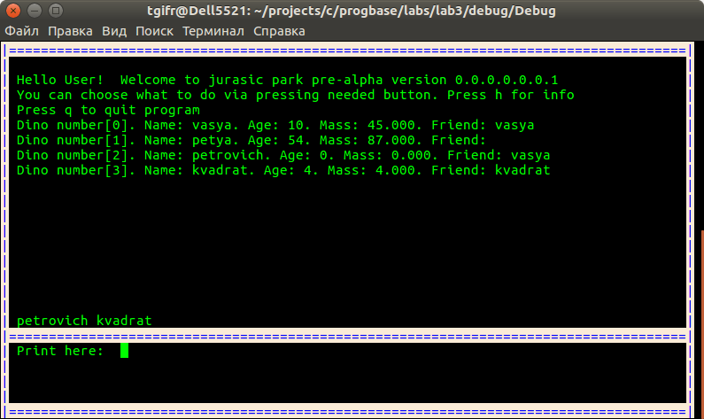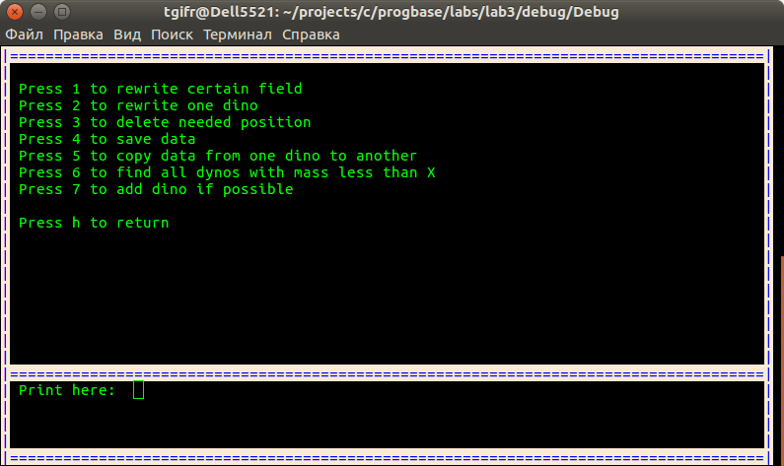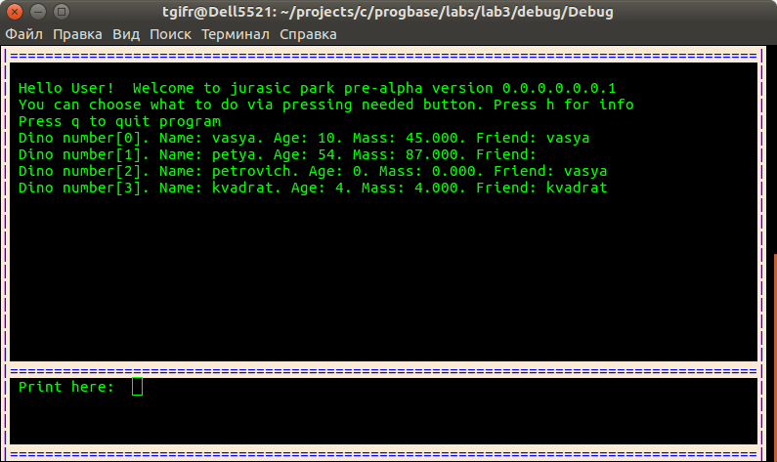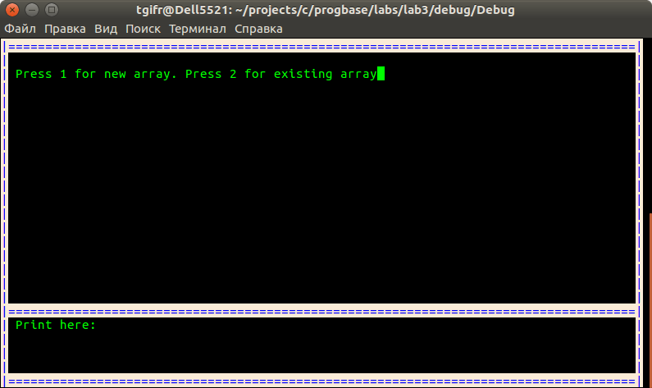

**Висновки**

Виконавши дану лабораторну роботу було використано можливості мови С з викорситання динамічної пам’яті, структур данних, вказівників та файлових потоків.

Було виконано розділення програми на окремі модулі і їх модульне тестування.