To check to see if a User’s account is locked out

Step-01 Go to search and search for users and computers

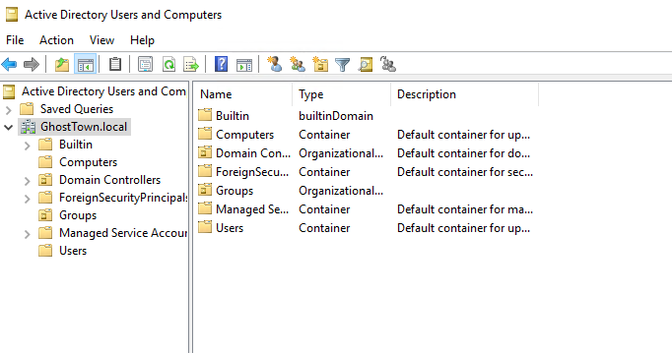

Step-02 Expand your Organizational Unit (OU) to find the group or services folder. Since we are looking at a user account issue. Users folder would be selected

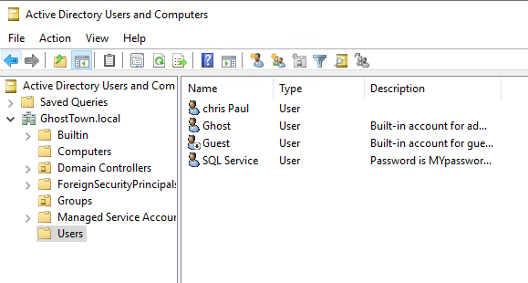

Step-03 Find the user of question. For this example, I am using Chris Paul. Right Click on Chris Paul’s name and go into properties. Once in the properties go to the account Tab.

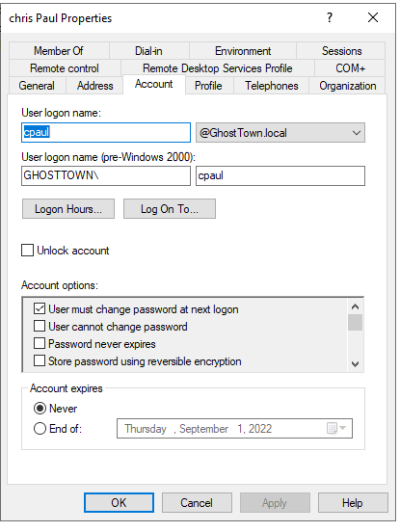

Looking here we can see Chris Paul’s account is not locked and is good to go. If it was locked out, there would be a message by the Unlock Account check box

To Reset or Change a user’s password

Step-01 Follow Step 1-3 but instead of going to properties you will be selecting Reset password. Therefore, its User 🡪 Right click 🡪 Reset Password

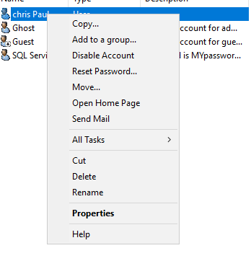

Step-02 The below image allows you to commit the user password change. If the user is in the same LAN, you can just have the user change their password. If the user was a remote worker and they needed their password to be change then you would generate a temporary password and ensure User must change password at next logon box is checked.

