COMP6841 Week 2 Portfolio

Name:
zID:
Date Submitted:

Setup

Security Everywhere

Security Engineering

Decryption Game
- From the current cipher problems I have tried finding a common starting word of a sentence, as there is a highly likelihood that a sentence will be structure to introduce a context/noun and then a property about it. Words like the, that, is, it etc are common targets
- Conjunctions are a high frequency are my target and make the rest of the cipher easier, This reconveys that the more the key or cipher is shared that the more likely that it will be leaked or broken (even ignoring the human element). The more it is present in the sentence the more have more conditions and can narrow down available letters due to English spelling

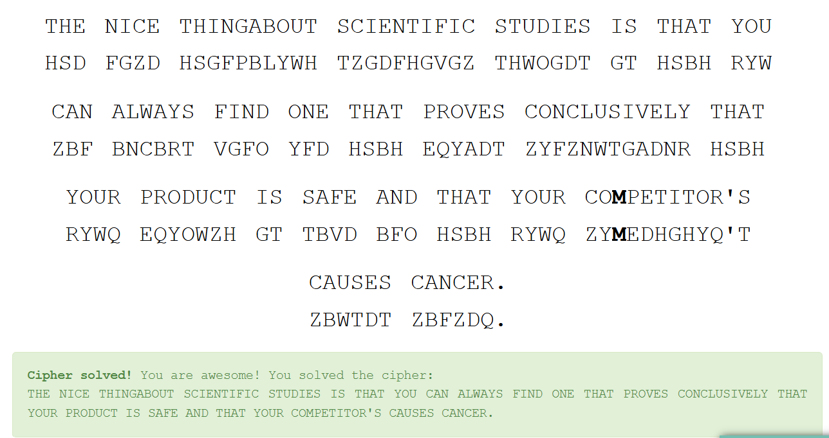

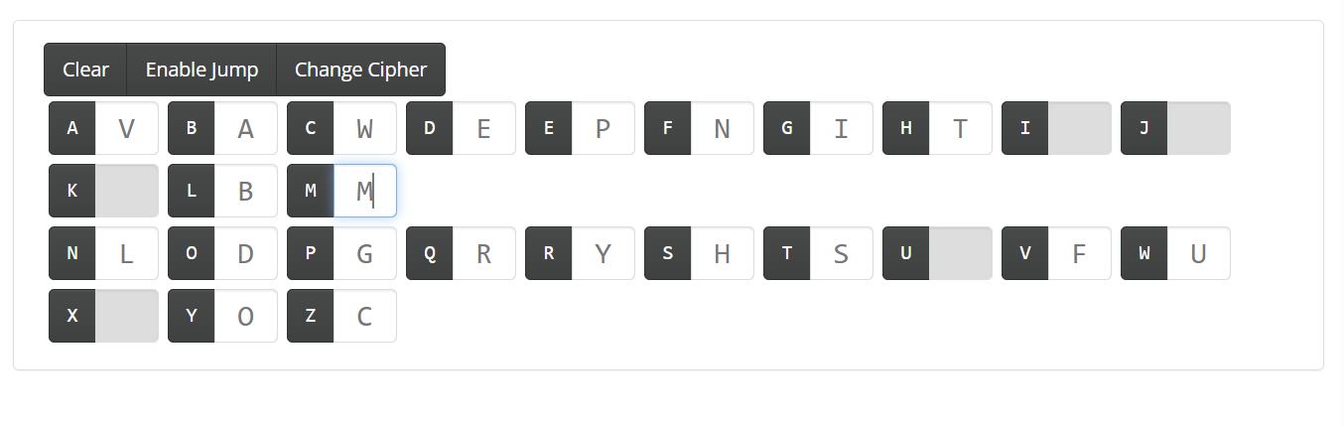

Classical Ciphers
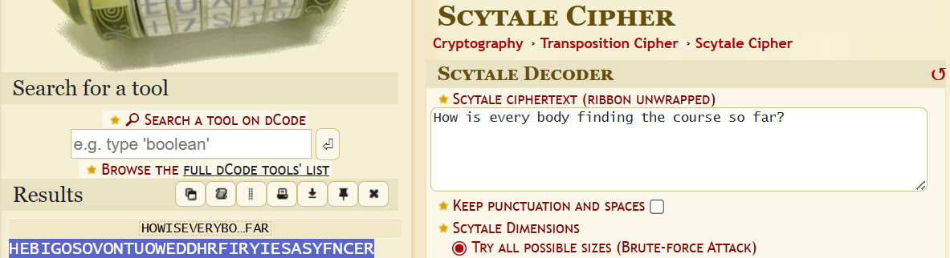

Project Proposal

Extended

Week 2 Extension Wargames

Analysis and Reflection

Tutorial 2: Doors

5. Wrap up

Submission Instructions
To submit a valid portfolio entry, complete the activities, save your work as a PDF, and upload it to the relevant week’s submission page on Moodle.

