COMP6841 PROJECT REPORT
Signal Forge CTF
A Sim-First Contested-Spectrum Cybersecurity Training Environment
Thomas Gosman (z5425064) 27 July 2026

Abstract
Signal Forge is a simulation-first capture-the-flag environment designed to teach contested-spectrum cybersecurity without requiring software-defined radio hardware, live transmission, or interaction with real radio systems. The project addresses a gap between RF education and conventional cybersecurity training by showing how decoded wireless data can become attacker-controlled input once it crosses into software, databases, embedded parsers, displays, or operational decisions. The implementation combines synthetic civilian scenarios, a browser-based waterfall interface, receiver controls, local-only transmit actions, challenge artefacts, and a dependency-free Python backend that manages RF command handling, vulnerable training endpoints, secure comparison endpoints, and session-specific flags. Across the completed beginner and moderate challenges, learners practise signal inspection, receiver tuning, modulation analysis, packet decoding, controlled interference, protocol interpretation, weak random-number analysis, replay and spoofing reasoning, and defensive comparison. The report evaluates Signal Forge as a safe and accessible training model, identifies limitations in the front end and incomplete advanced hardware-focused tasks, and proposes future blue-team, red-team, advanced, and expert-level extensions. Overall, the project demonstrates that RF security education is most effective when physical-layer behaviour, embedded implementation, application-layer trust boundaries, and ethical operating constraints are taught as a single cross-disciplinary problem.
Scope and ethics: Signal Forge is designed for authorised, local education. It does not require SDR hardware, does not transmit over the air, and does not target real radio systems, restricted frequencies, or operational infrastructure.

1. Introduction

1.1 Context
Wireless systems increasingly sit at the boundary between physical communications and conventional software security. RF signals can carry telemetry, control messages, operator notes, identifiers, and protocol fields that later influence web services, databases, embedded parsers, and user decisions. Weaknesses in signal capture, decoding, trust handling, or backend validation can therefore become cybersecurity issues rather than purely communications problems. Unlike many software attacks, which can be emulated safely in sandboxed environments, RF experimentation is constrained by strict legal limits on interference and often requires expensive specialist equipment. As a result, hardware-focused learners may have limited opportunities to explore realistic RF threat models and the practical risks they create.
Historically, this risk was limited by the small number of people with the specialised knowledge needed to target these systems. Recent advances in unmanned and defence-related technologies, however, have increased research, funding, and access to relevant countermeasures. This has broadened the group of people capable of interacting with RF-enabled systems and expanded the potential attack surface.
Despite this overlap, cybersecurity education often treats software exploitation and RF signal analysis as separate disciplines. Hardware-focused learners may not see how decoded fields can become attacker-controlled inputs, while software-focused learners may miss how physical-layer assumptions affect application-layer security. Signal Forge addresses this gap by providing a safe, synthetic environment where both perspectives can be practised together.

1.2 Problem Statement
The project problem is to provide realistic contested-spectrum cybersecurity training without requiring specialist SDR hardware, live RF transmission, or interaction with real systems. Signal Forge addresses this by combining RF acquisition, protocol interpretation, familiar cyber weaknesses, and defensive comparison in a local simulation-first CTF workflow.

2. Threat Modelling and Research

2.1 SDR Simulation Systems That Exist
GNU Radio provides reusable signal-processing blocks for software radios and can operate with external RF hardware or in a simulation-like environment [1]. GNU Radio has previously run CTF competitions where contestants earn points by finding flags hidden in radio signals, including the GRCon CTF [5]. However, those competitions focus on deconstructing or processing signals rather than developing a broader RF-to-application threat model in a cybersecurity training environment. This makes GNU Radio suitable as an artefact-generation path: signals can be produced and inspected without making live transmission part of the assessed build. Therefore, there are tools that exist out their but not into a threat modelling context.

2.2 Threat Modelling and Industry Security Measures
Open resources on industry RF threat modelling are limited, partly because practical analysis can expose sensitive signal behaviour, operational assumptions, and defensive design choices. For this reason, the project uses public electronic-warfare and spectrum-security material only as a high-level frame rather than as an operational guide. Order of the Old Crows resources and David L. Adamy’s EW 101, EW 102, and EW 103 textbooks helped identify recurring receiver-side concerns, including denial of service, spoofing, replay, localisation, traffic analysis, and weak trust boundaries between decoded signal fields and downstream software [6], [7], [8]. These ideas were then adapted into civilian, synthetic scenarios so that Signal Forge can teach the security reasoning without reproducing real systems or encouraging live interference.

Asset or security goal | Threats | Defensive Measures
Transmitter anonymity and location privacy | Direction finding, localisation, device fingerprinting from timing, modulation, or power patterns, and traffic analysis based on repeated transmissions. | Minimise unnecessary transmissions, use short bursts and randomised timing where appropriate, and avoid stable identifiers in unauthenticated broadcasts.
Receiver availability | Denial of service through jamming, noise, spot, barrage, stand-in, or stand-off interference, and signal flooding that prevents useful decoding. | Use frequency hopping or channel agility, filtering, squelch, redundancy, fallback channels, and monitoring for abnormal noise floors or interference patterns.
Message integrity and authenticity | Replay of captured messages, spoofed telemetry, commands, or warnings, and bit-level manipulation before decoding. | Use message authentication codes, signatures, or keyed hashes, supported by nonces, timestamps, sequence numbers, replay windows, and checksums or CRCs for accidental corruption detection.
Confidentiality of RF-carried data | Passive interception of traffic or metadata, recovery of identifiers, commands, or operational patterns, and exposure of sensitive data through weak encoding. | Encrypt sensitive payloads where appropriate, limit metadata leakage and unnecessary identifiers, and separate teaching examples from real operational values.
Receiver-to-application trust boundary | Decoded RF fields may be treated as trusted input, enabling injection into web views, databases, or parsers, and unsafe downstream decisions based on spoofed data. | Validate, normalise, and encode decoded values before use, rely on parameterised queries and safe rendering paths, and require server-side authorisation for consequential actions.

3. Methodology and Implementation

3.1 Development Approach
Because my web development experience was limited, I used Codex to support development of the front end and data-parsing interface. This let me focus more time on the project’s core security content, while still reviewing and refining the generated code to ensure the interface met the required UI and functional requirements. My primary hands-on work involved designing the secure and vulnerable waveforms, developing the attack strategies used to analyse them, and creating each scenario through independent brainstorming and research. I also built the signal chains and staged vulnerable code used throughout the challenges. Additional research and development was required to add security features beyond basic waveform behaviour. Encryption was largely avoided to keep the learning curve across RF and cybersecurity concepts manageable; it is also only one layer of defence, not a complete solution.
Development followed a vertical-slice approach. Each slice links a scenario, signal scheme, downloadable evidence, user interaction, server-side success condition, and session-specific flag.
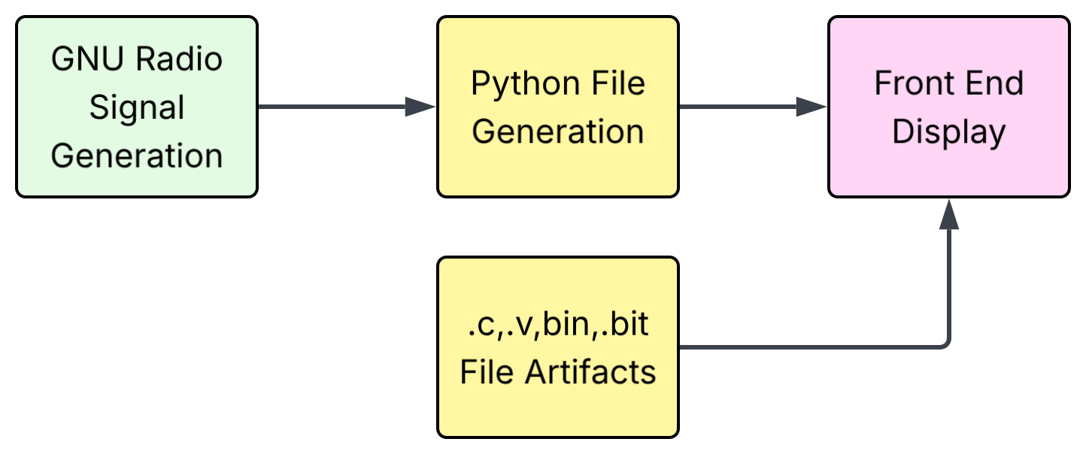

3.2 CTF Tasks Breakdown
Although many of these systems appear physically remote from conventional cybersecurity, they often rely on the same underlying information-handling patterns. RF links still encode, transmit, decode, and act on data, even when the carrier is wireless rather than networked. In several challenges, the signal can be viewed as a form of information hiding: cyber-generated data is embedded into a waveform, recovered by a receiver, and then interpreted by software or a user. This makes the RF layer an entry point into the broader trust chain rather than a separate domain. The key learning point is that any decoded field, metadata value, or received command can become attacker-controlled input once it crosses into an application, database, display, or decision process.

Challenge 1: Tunnel Context (Beginner)
The first context models a simple civilian radio system that sends fixed binary packets without built-in security controls. Its purpose is to show how an unsecured signal can expose useful information and remain vulnerable to basic interference. The signal chain serialises a binary packet containing the flag, uses the bit values to modulate a high-frequency carrier, and then applies low-pass filtering to mimic the rise-time limits of real hardware. Learners first identify the signal in the captured data, extract the embedded information, tune the receiver to inspect it, and then complete a basic spot jamming scenario. This progression gives learners from different backgrounds a practical introduction to why ordinary RF signals need additional security controls.
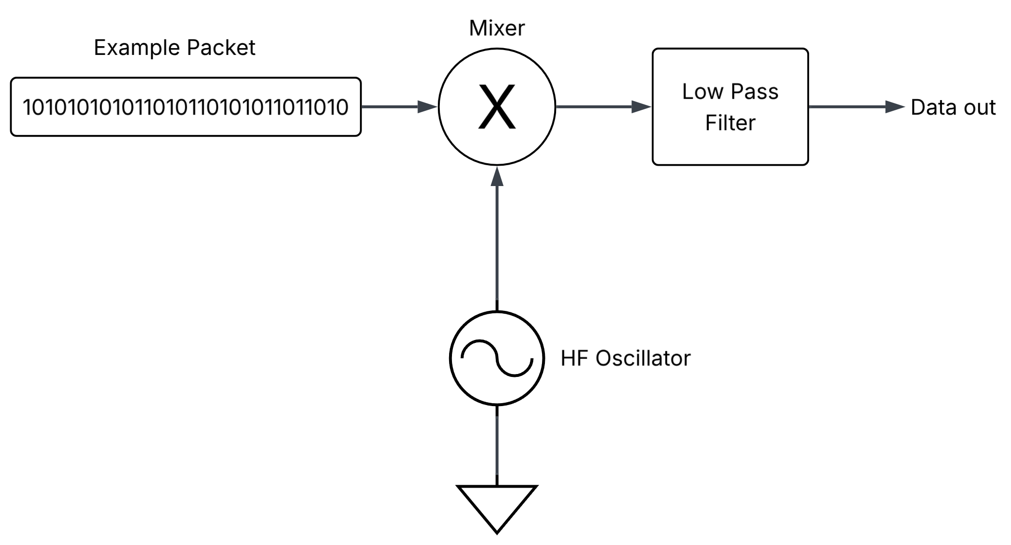
This scenario highlights several risks, with denial of service being the most immediate concern. The flag itself is the packet being transmitted by the simulated radio system, so disrupting the transmission prevents the receiver from recovering the information needed to complete the task. Because the signal is sent on a fixed frequency and the packets are streamed in sequence, a sufficiently strong burst of interference can corrupt or block the entire exchange. In the scenario, the protected assets are the tunnel traffic signs and information displays used by road users. Loss or manipulation of those messages would be especially serious during an emergency, when drivers rely on timely and accurate guidance.
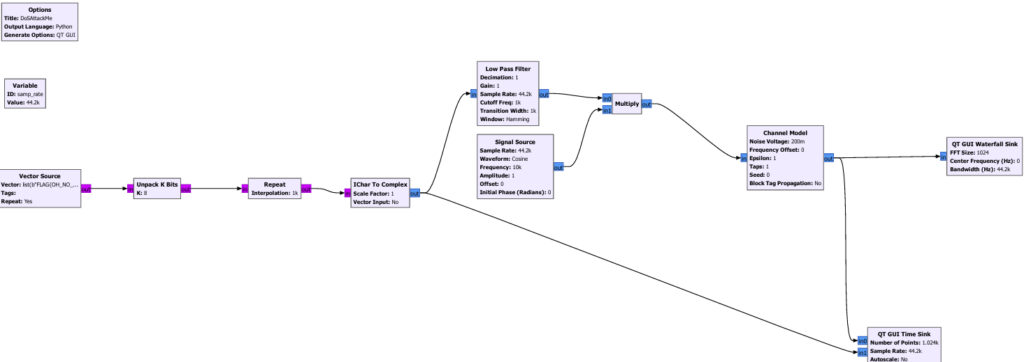

Challenge 2: Song Meta Data (Beginner)
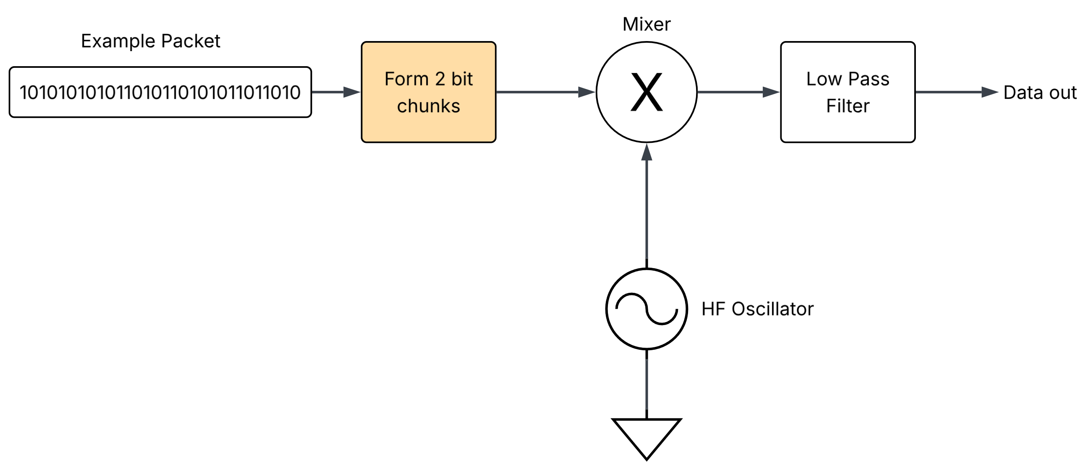
This challenge extends the earlier tunnel-context task by replacing the fixed binary packet with four-level amplitude-shift keying. Instead of using two amplitudes to represent 0 and 1, each of the four levels represents a two-bit symbol. Learners must first recognise the modulation scheme, then map the measured amplitude levels back to binary values to recover the message.
This adds an extra layer of analysis because a simple high-or-low threshold will not decode the signal correctly. However, the amplitude levels remain observable and can be identified through measurement or basic clustering. The task therefore reinforces that making data less obvious may slow analysis, but it does not provide confidentiality, authentication, or integrity protection.
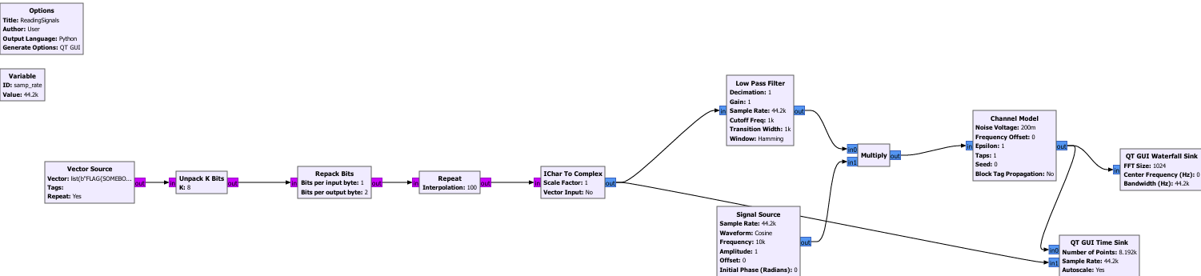
The challenge also introduces the idea that communication systems often combine primary data with control information or metadata. FM radio is a familiar example: analogue audio may be transmitted alongside digital information such as the station name, song title, or artist. Learners are therefore encouraged to examine the complete signal rather than focusing only on its most obvious payload.

Challenge 3: Weather Broadcasting (Moderate)
The weather-broadcasting project extends basic signal reception into a broader cybersecurity scenario, showing how weaknesses across the physical, protocol, and software layers can combine. Learners must determine not only what is being transmitted, but also how the signal is concealed and how recovered data influences the receiving system.
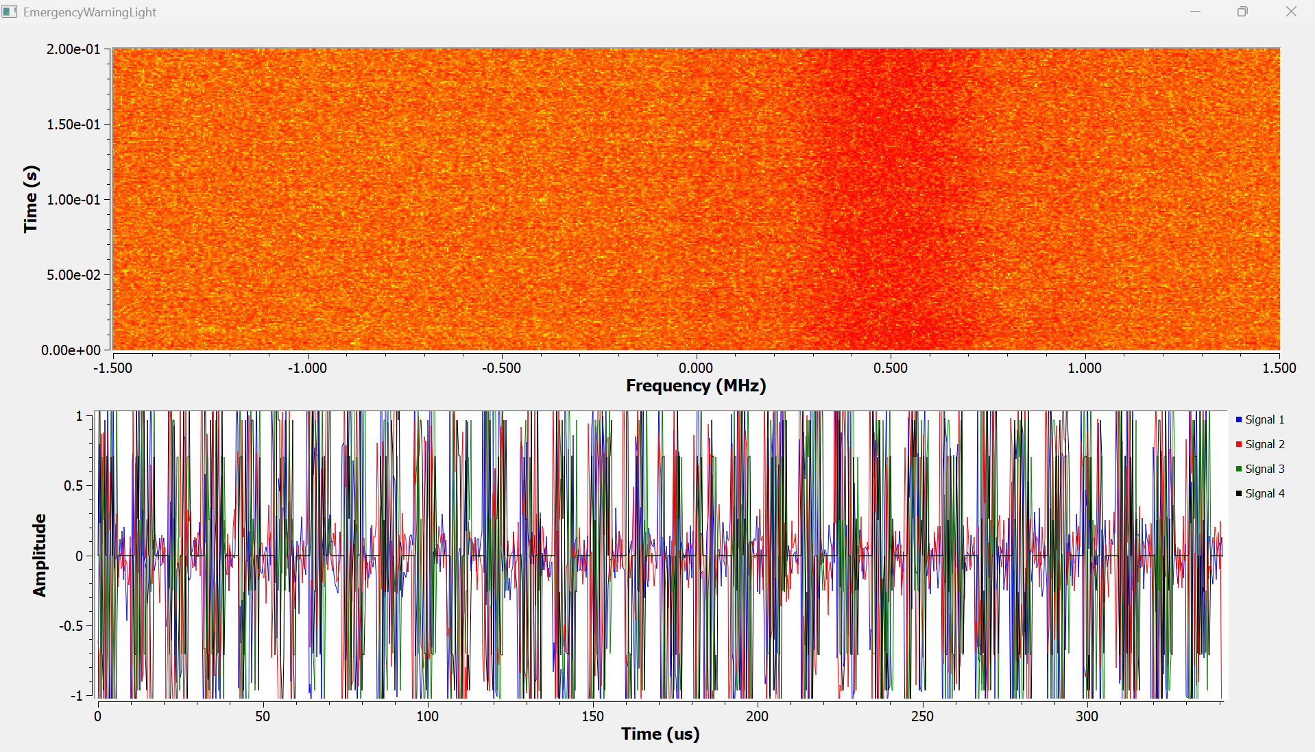
The first extension introduces frequency-hopping QAM using a predictable hopping pattern. Learners must identify the sequence and configure a receiver that can remain synchronised as the carrier changes. The transmitted codeword acts as both the station callsign and the challenge flag, requiring learners to recover the signal structure before decoding the payload. This demonstrates that frequency hopping provides little security when the sequence is deterministic or observable.

A later variation replaces the fixed pattern with pseudorandom hopping generated by RANDU. Learners know only that one generator from a small set is being used, so they must analyse the hopping behaviour and reproduce the correct sequence. Although the output appears random, RANDU is structurally weak and predictable. Groups of three values occupy only a limited number of planes when plotted in three dimensions, revealing patterns that can help identify the generator and predict future hops. A custom RANDU block was required because the generator is obsolete and rarely included in modern software packages. The progression from the harder to track signal can be shown in my GNURadio Blocks below.

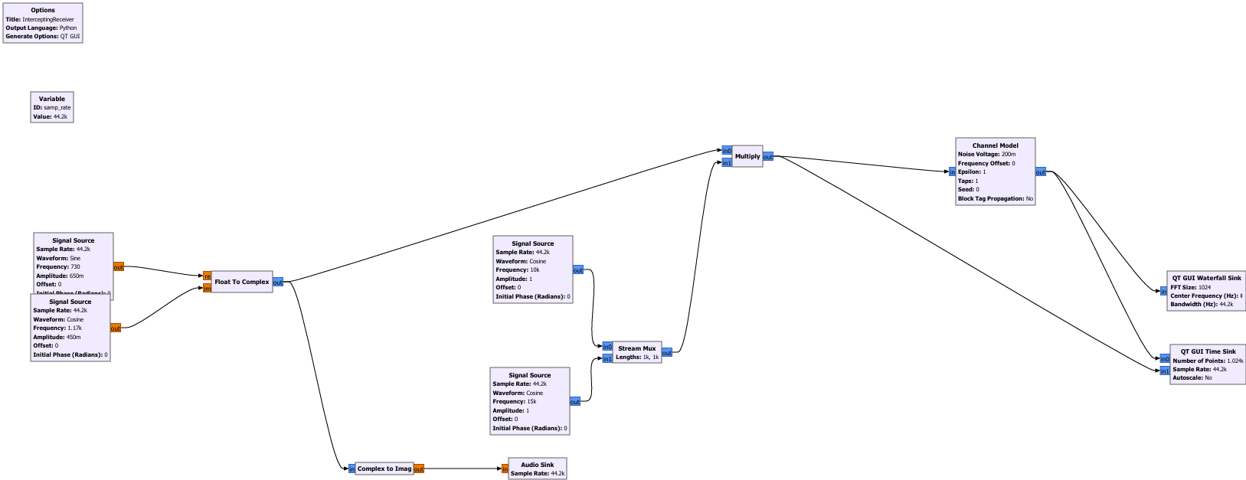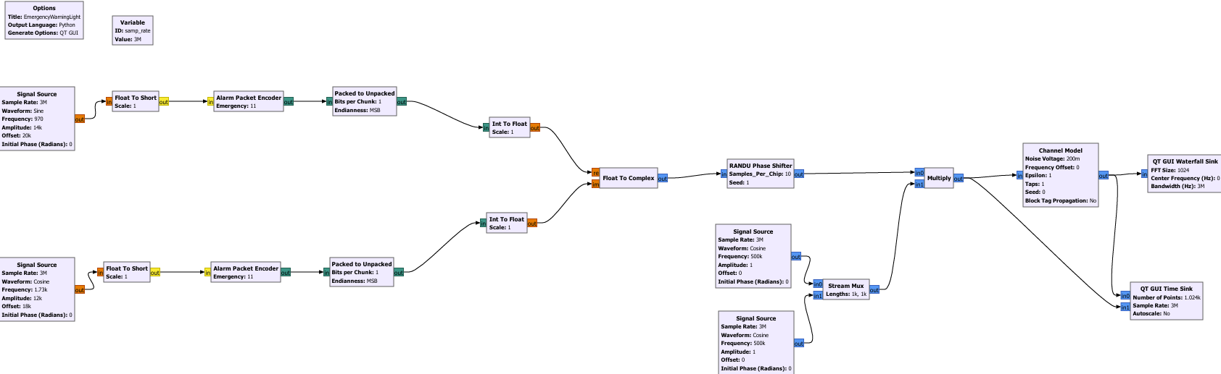
The challenge then moves from signal recovery to protocol interpretation. A digital-audio transmission contains a hidden four-bit emergency message, inserted by a custom scrambler after every two audio bits with a value of one. This provides limited obfuscation, but no authentication, integrity checking, replay protection, or genuine confidentiality. Once the encoding method is understood, an attacker can extract or construct emergency messages without a trusted key.
To complete the scenario, learners reverse engineer an extracted C file to understand the scrambler and packet-processing logic. They then combine their knowledge of the waveform, hopping sequence, random-number generator, and message format to construct and inject a valid alert packet. This models a spoofing attack in which a message is accepted because its format is correct, even though its origin and integrity are not verified. The original intension of scrambling is to spread the spectrum and to make any interception or jamming/modification to a packet have a reduced impact to the overall packet since the true packet is spread out across time and hence burst attacks will have a reduced effect.
Overall, the challenge demonstrates how a predictable hopping sequence, weak random-number generation, and unauthenticated message format can form a complete attack chain. It shows that RF cybersecurity depends not only on receiving a signal, but also on how decoded information is interpreted, trusted, and acted upon by software.

Challenge 4: Emergency Broadcasting (Moderate)
This challenge builds on the previous weather-broadcasting task by adding a CRC check and Barker codes to the signalling process. The CRC provides basic integrity checking by helping the receiver detect accidental corruption, while the Barker code improves synchronisation and makes the start of a message easier to identify. These features make the signal more structured and realistic, but they do not fully secure it. A CRC is not an authentication mechanism, and a Barker code does not prove that a message came from a trusted source but often these misinterpretations can be. As a result, the challenge demonstrates that even when a system includes recognisable engineering safeguards, weaknesses can remain if authenticity, replay resistance, and trust handling are not addressed.

Challenge 5: Emergency Fire Tower (Advanced)
This challenge was only partially implemented, so the report describes the intended scenario and the generated outputs rather than a complete playable task. The concept was designed to show why advanced RF systems need both hardware understanding and cybersecurity analysis. The scenario uses a complex multi-antenna fire-tower system with digital beamforming, implemented on an FPGA, to reject signals that could not plausibly come from an authorised direction. This reflects a common industry approach, where antenna arrays and signal processing are used to improve selectivity and reduce false inputs. However, beamforming is not a complete security control. Side lobes and back lobes can create unexpected reception paths, and a signal that appears invalid from the main beam may still be observed through another part of the antenna pattern. A hardware-focused engineer may recognise this as an antenna-pattern limitation, while a cybersecurity-focused analyst may frame it as a trust-boundary and validation problem. The intended learning outcome was therefore not only to exploit a weakness, but to show that secure RF system design depends on clear communication between RF engineers, embedded developers, and security practitioners and an understanding of the cross-discipline impacts of these technologies. Hence a .v file and a .c files are generated with this rough idea however the signalling project setup was not able to be completed.

4. Evaluation and Results

4.1 Walkthrough
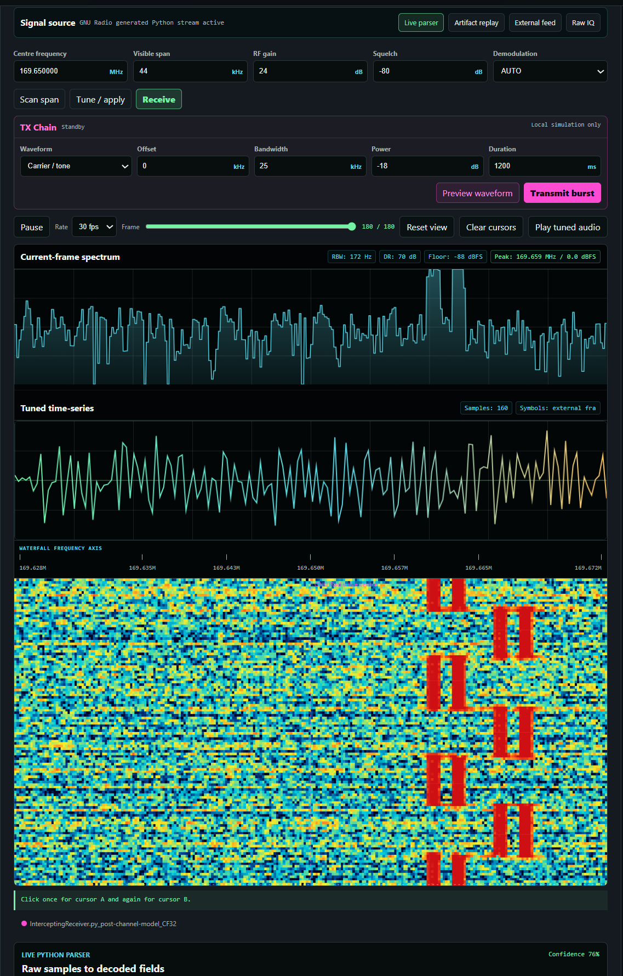
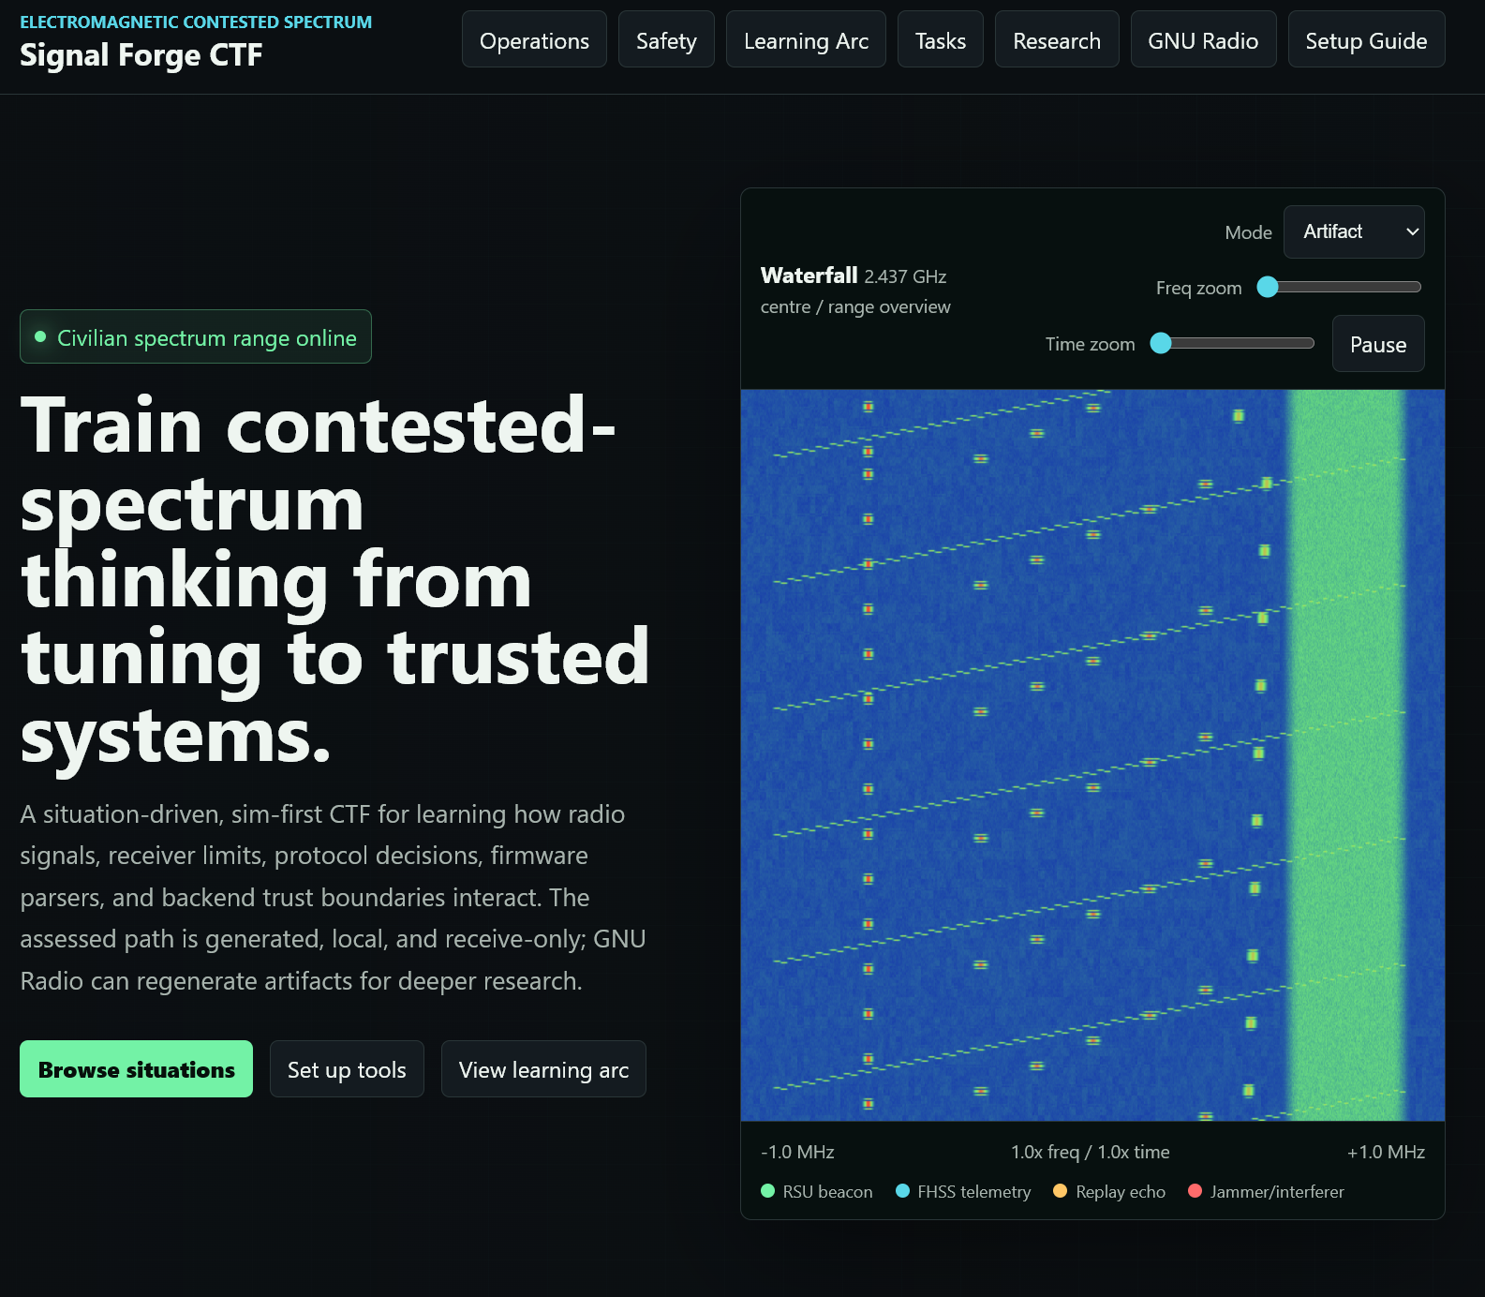
In case this may not work on your device and hence I will show the key pages developed as part of the project. It has the main home page and then the individual tasks pages and then a signal capture with a waterfall plot/spectrogram, time captures and the frequency domain plots. Users are able to download artifacts and begin the investigation.
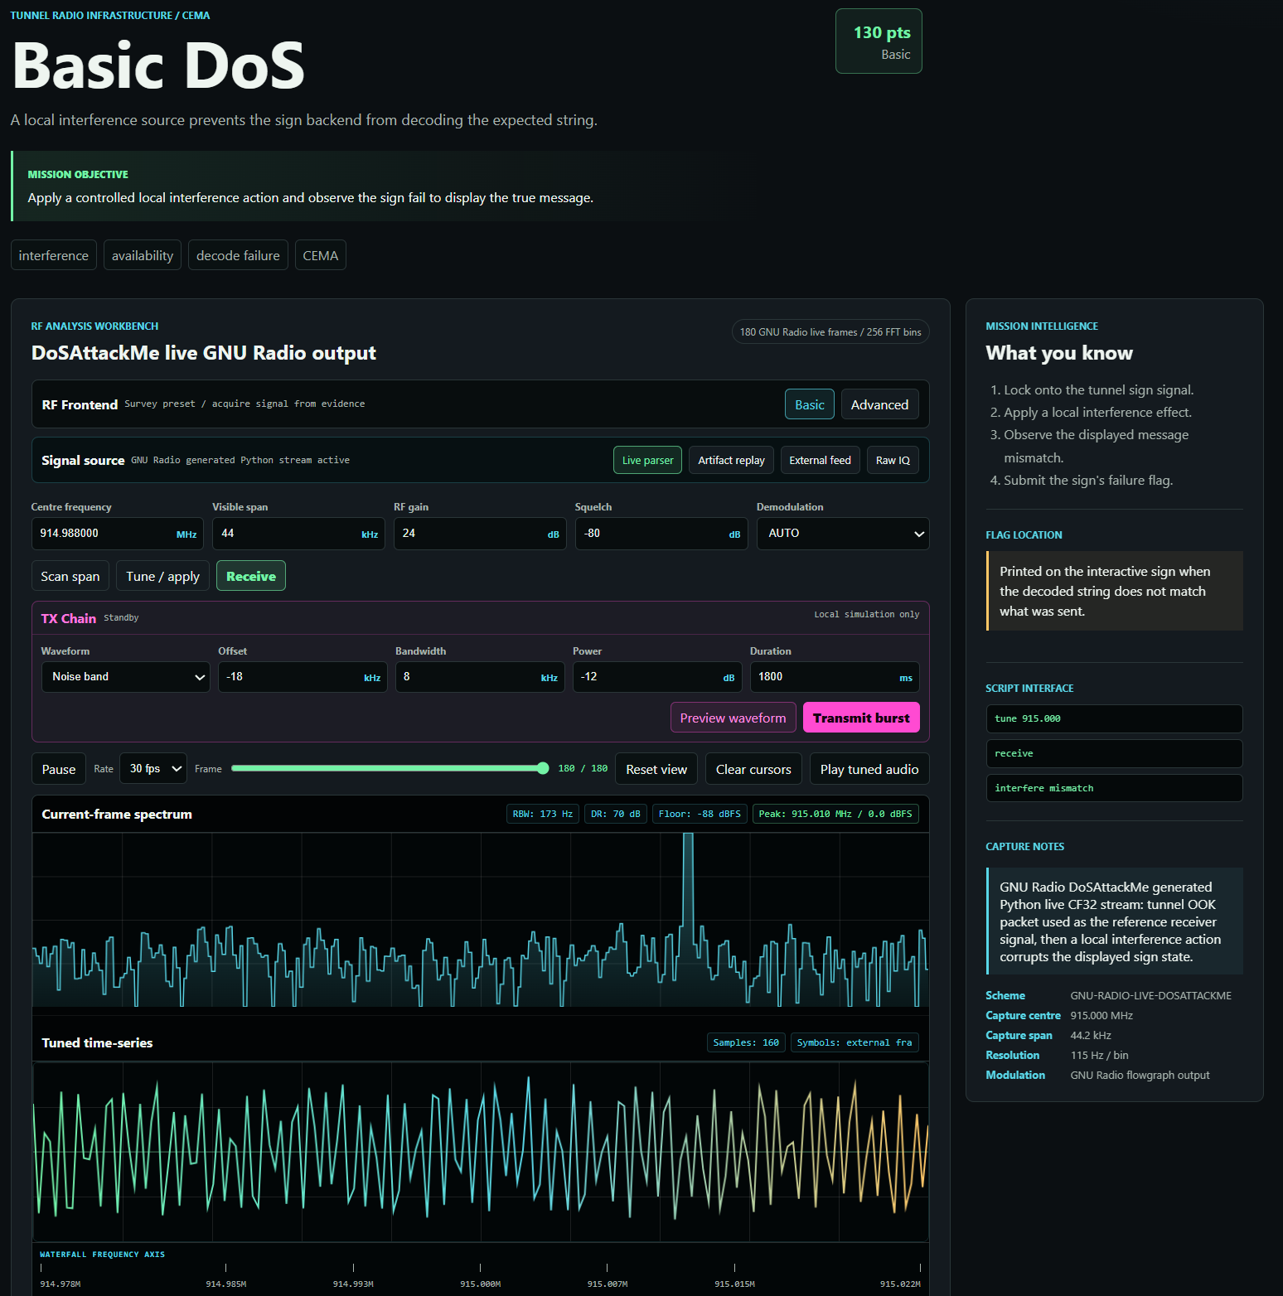

Signalling
Below are some demonstrations of the signalling schemes implemented in the time domain. The files to generated this are .grc files and work using the GNU radio software. These can also show the block diagrams. To generate signalling further signals.

Task/Signalling | Evidence
Challenge 1: OOK Signalling | 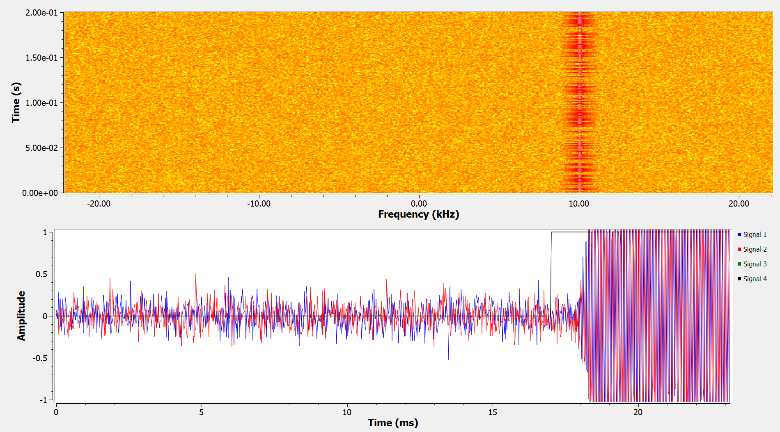
Challenge 2: ASK Signalling | 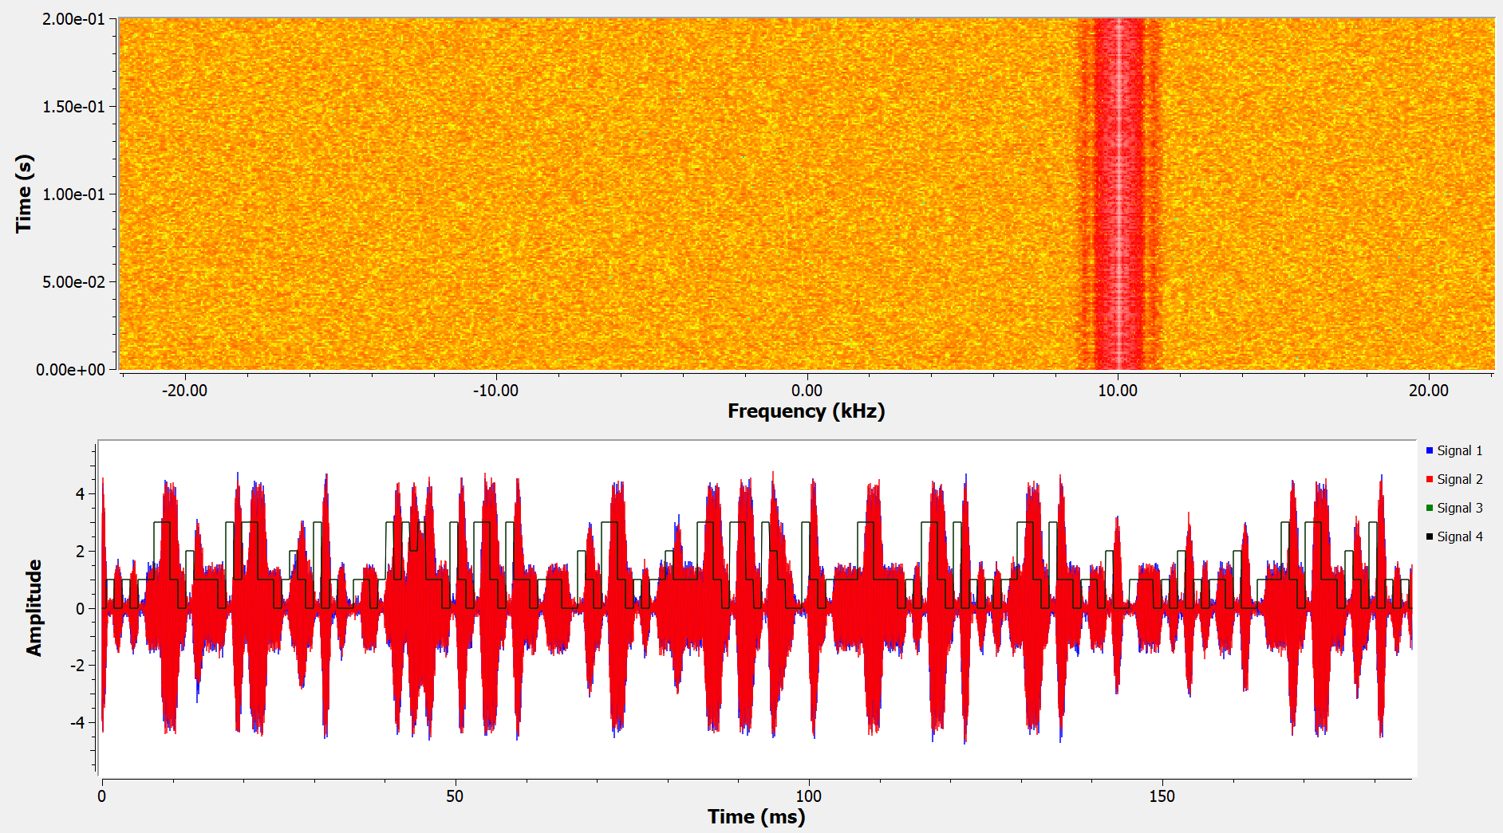
Challenge3/4 | 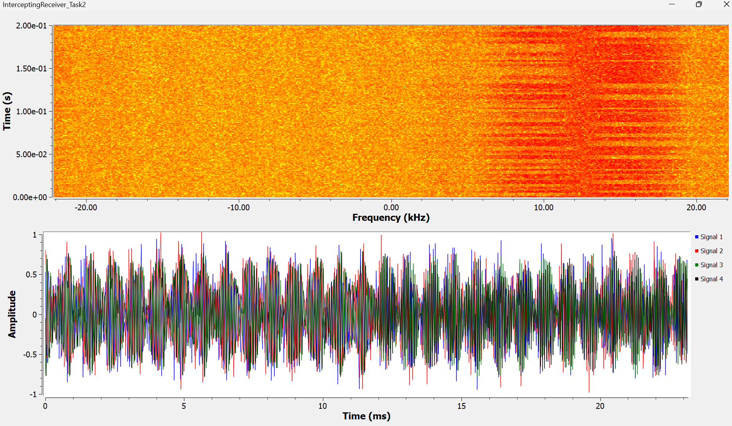  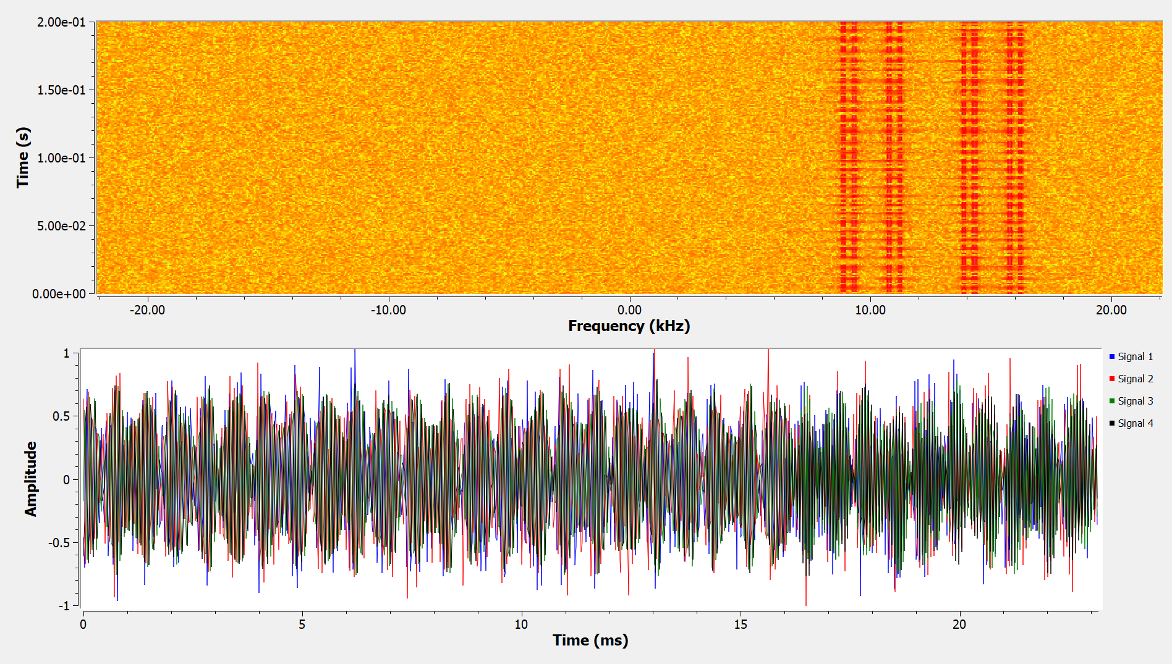

4.2 Limitations
This implementation has several limitations. The front-end still contains some issues, particularly in how it interprets audio and presents challenge artefacts. These issues were accepted during development because the main focus was the security design and learning value of the CTF rather than interface polish. A stronger implementation would also use randomly generated flags more consistently across challenges. Finally, the HDL component could be developed further by providing learners with a bitstream to reverse engineer against a known hardware target, using existing FPGA reverse-engineering tools where appropriate.

5. Discussion and Reflection

5.1 Key Design Challenges
The main design challenge was balancing realism, accessibility, and safety. Using GNU Radio with SDR hardware would have increased physical fidelity, but it would also have introduced setup complexity, cost, and the risk of unsafe RF use. A simulation-first approach made the assessed experience easier to reproduce.
A second challenge was connecting RF interaction to meaningful cybersecurity reasoning. A waterfall display by itself would not create a strong learning outcome, while a conventional web CTF would miss the communications boundary that makes this project distinctive. The most effective challenges therefore require learners to acquire or decode RF-derived data, then consider how that data is parsed, trusted, and acted on by software. Designing this interaction was difficult because the web interface, signal generation, coding schemes, scenarios, and vulnerability placement all needed to reinforce one another without making the tasks too confusing or difficult to complete. AI-assisted development also became part of the workflow: I used it to help manage front-end implementation and interface design, while I retained responsibility for scenario design, security reasoning, validation, and final integration.

5.2 Learning and Future Improvement
The project demonstrates that contested-spectrum security is not a single technical problem. Signal processing, protocol design, embedded implementation, web rendering, database access, and operator decision-making can all influence the final security outcome. The next stage should complete the current advanced-level challenge, add one further advanced challenge, and introduce two expert-level challenges that require learners to combine RF analysis, embedded reasoning, and software-security validation. These additions should be organised into a clearer blue-team and red-team scenario landscape, where offensive tasks show how RF-derived data can be misused and defensive tasks require monitoring, validation, hardening, and response planning.
- Complete the existing advanced fire-tower challenge by turning the generated FPGA and C artefacts into a playable end-to-end task.
- Add one additional advanced challenge that focuses on secure hardware trust, such as signed firmware, protected key storage, attestation evidence, or authenticated update paths.
- Add two expert-level challenges that require multi-stage reasoning across RF capture, protocol reconstruction, reverse engineering, backend validation, and incident response.
- Create a blue-team scenario track covering detection, logging, replay prevention, anomaly monitoring, input validation, and operational response to suspicious RF-derived events.
- Create a red-team scenario track covering spoofing attempts, weak trust-boundary exploitation, signal-pattern analysis, protocol manipulation, and controlled adversarial testing within the safe simulation environment.
- Retain evidence-quality improvements through automated walkthroughs, screenshots, command transcripts, demonstration recordings, learner observations, and repeatable validation tests.

6. Conclusion
Signal Forge demonstrates that RF security can be taught safely and effectively through a simulation-first CTF environment. By combining waveform inspection, receiver tuning, packet decoding, controlled interference, protocol analysis, reverse engineering, and defensive comparison, the project links physical-layer communication concepts with conventional cybersecurity concerns. The completed challenges show how weak assumptions in modulation, hopping sequences, metadata handling, backend validation, and trust boundaries can create security risks once RF-derived data is interpreted by software.
The project also shows the value of keeping realism, accessibility, and ethics in balance. Avoiding live transmission and real infrastructure targets made the work repeatable and safe, while the use of synthetic civilian scenarios preserved meaningful security context. Although some advanced tasks remain incomplete, the design provides a strong foundation for future blue-team, red-team, advanced, and expert-level scenarios. Overall, Signal Forge contributes a practical training model for understanding contested-spectrum cybersecurity as a cross-disciplinary problem involving RF engineering, embedded systems, software security, and operational decision-making.

References
[1] GNU Radio, 'About GNU Radio,' GNU Radio Project. Accessed 20 July 2026. GNU Radio project page
[2] SigMF, 'Signal Metadata Format Specification, Version 1.2.6.' Accessed 20 July 2026. SigMF specification
[3] OWASP Foundation, 'SQL Injection Prevention Cheat Sheet.' Accessed 20 July 2026. OWASP SQL injection guidance
[4] OWASP Foundation, 'Cross Site Scripting Prevention Cheat Sheet.' Accessed 20 July 2026. OWASP XSS guidance
[5] GNU Radio, 'GRCon 2025 CTF,' GNU Radio Project. Accessed 27 July 2026. GRCon 2025 CTF
[6] D. L. Adamy, EW 101: A First Course in Electronic Warfare. Norwood, MA: Artech House, 2001.
[7] D. L. Adamy, EW 102: A Second Course in Electronic Warfare. Norwood, MA: Artech House, 2004.
[8] D. L. Adamy, EW 103: Tactical Battlefield Communications Electronic Warfare. Norwood, MA: Artech House, 2008.

