**Assignment 6**

1. successfully implemented neural network for XOR gate.

**input test case 1:**

[[0 0]

[0 1]

[1 0]

[1 1]]

**Expected Output:**

[[0]

[1]

[1]

[0]]

**Module Output:**

[[0]

[1]

[1]

[1]]

2. successfully implemented Multi-Layer Perceptron (MLP) classifier by taking 5 hidden layers on iris dataset.

It is giving 97% overall accuracy.

Output:

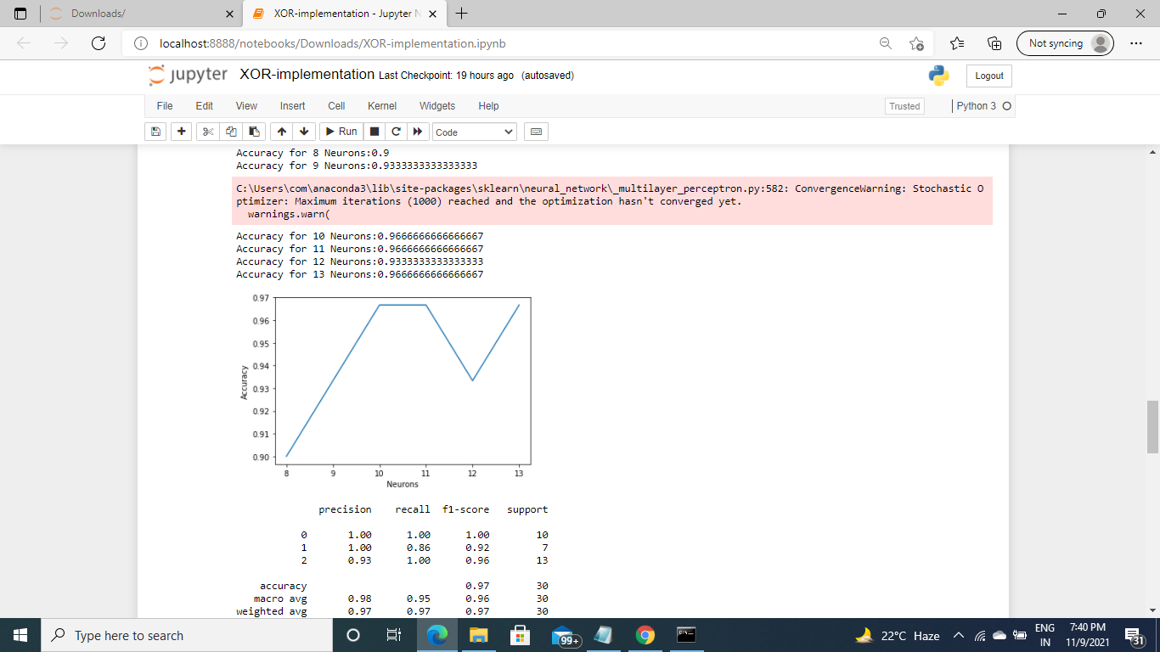

3. successfully implemented Multi-Layer Perceptron (MLP) classifier on MNIST dataset.

Output:

