**Physical Factors:**

Physical factors affect the price of houses directly. Such as Condition of house, cost of construction and Location of house.

1. **Condition of house**

Condition of house such as Age of House, Renovated or not, Flat Area, No of Bedrooms, No of Bathrooms, No of Floors, plays an important role in price of house. But in next decade **Technologies used in house plays a vital role** in overall cost in house price, tech like IOT and AI personal assistant combined makes a lot of difference.

Example: Now a day google assistant (or any other AI assistant like Alexa, Siri) is used to control most of appliance. We can expect up to **25% hike in house price** if it is fully loaded with technologies.

1. **Locality**

Location is key to valuable real estate. Always remember one thing, a great location can change an entire neighbourhood overnight. You can change the condition of the house, its price, and even its size. However, you cannot change its location.

1. **Cost of Construction**

Cost of construction plays an important role, as Cost of construction increases the overall cost also increase. This includes Labour cost, Construction material cost, and Land cost.

Example: At the time of pandemic the cost of labour and cost of materials are increased up to 50% so this impacted overall price of house

**Non-Physical Factors:**

Physical factors affect the price of houses indirectly. Such as Demand and Supply.

1. **GDP**

GDP can act as reasonable estimator for the progression of residential and commercial real estate markets. Figure exhibits the nominal GDP per capita history as well as the mean residential real estate prices in nominal terms for United States. Indices cover the years from 1970 to 2015. The data was collected from central national banks.

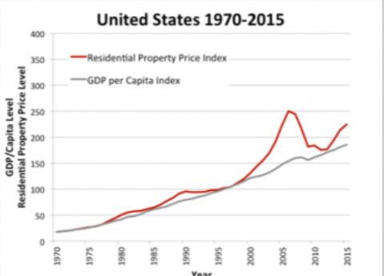

1. Interest rate

Generally, house prices fall when interest rates rise because the subsequent rise in mortgage payments reduces demand from buyers. People are less willing to begin a bigger mortgage, fewer people want to buy, and real estate prices either drop or simply stagnate until interest rates fall again.

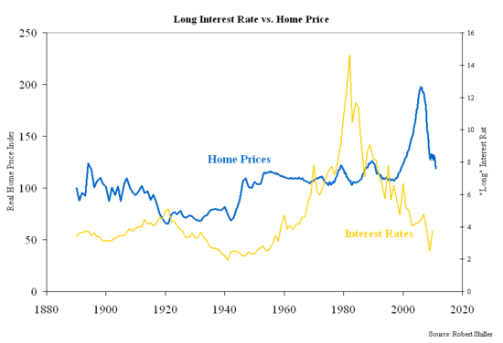

1. **GEO politics**

All real estate may be local, but that doesn’t necessarily shield one market from major incidents occurring thousands of miles away. In today’s global economy, important geo-political events have consequences that can easily ripple across the planet. Election results, economic policies and international relations all have spill over effects on global real estate by (directly or indirectly) creating incentives for buyers to be drawn toward—or repelled from—various geographic markets. Some factors are purely financial in nature, like changes in currency values or tax treatments. Other policies may make some destinations more or less appealing by easing or restricting immigration or cross border trade. In worst-case scenarios, geo-political events can escalate into full-fledged military conflicts, displacing entire communities and endangering lives. This issue of Global Perspectives examines many of the most significant geo-political developments of the past year with an eye towards possible directions in 2017. As a global real estate practitioner, it’s important to stay dialled into these and other stories. Doing so puts you in a much better position to spot opportunities and understand where future business may originate from—and why.

1. **Population of immigrants**

As the number of immigrants increase the demand to residential real estate. Due to this there may be fluctuation in price. The following graph shows the relation between population of immigrants

And house market price.

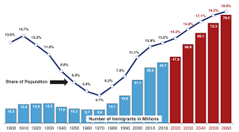 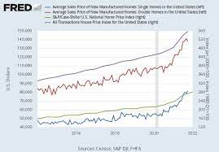

First figure shows population of immigrants, and second figure shows house market price.

We can corelate both as immigrants increases house price also increase.

1. **Supply**

When it comes to the law of supply, prices drop when there is an increase in the supply of a good or service in the market. But when prices increase, the number of goods and services tend to drop. That's because it tends to cost more to produce and sell goods at a higher price. So, supply plays an significant role in house market.