ArdiChef Project
by Thomas Gittins
The ArdiChef Project attempts to automate the entire process of kitchen cooking through the use of automatically microcontrolled food dispensers, cooking units (stove), mix / stir equipment (blenders) and cleaning (dish washer).

Introduction

Actual to Google Sketchup Measurements

Bulk Dry Foods
Using the Gumball approach the 1-Gallon bulk dispensor was created with a 3D-Printer and a 28BYJ-48 5V 4-Phase 5-Line Stepper Motor with ULN2003 Driver Module Board.
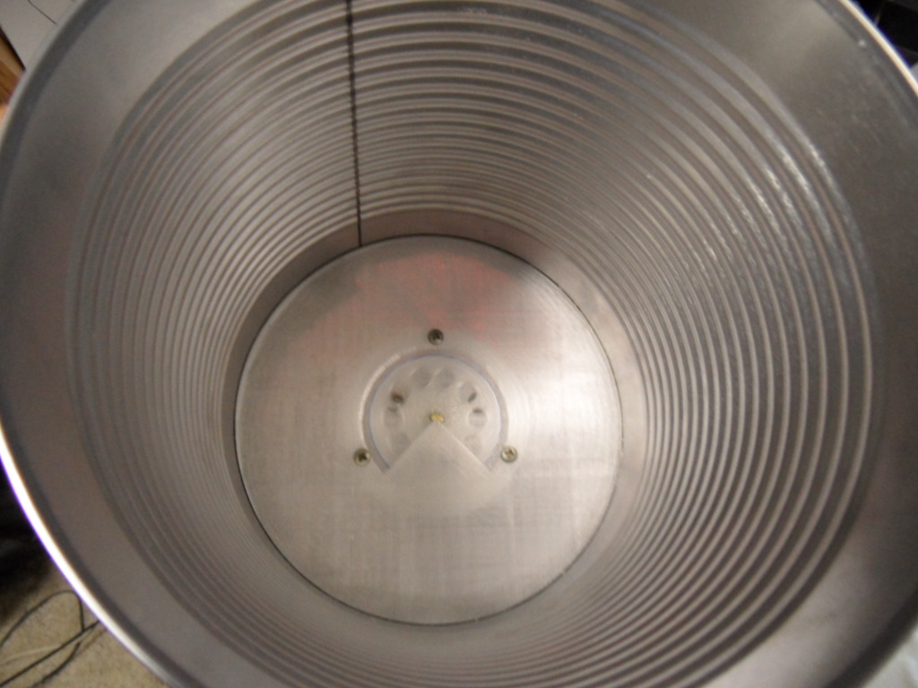
Bottom of inner-can
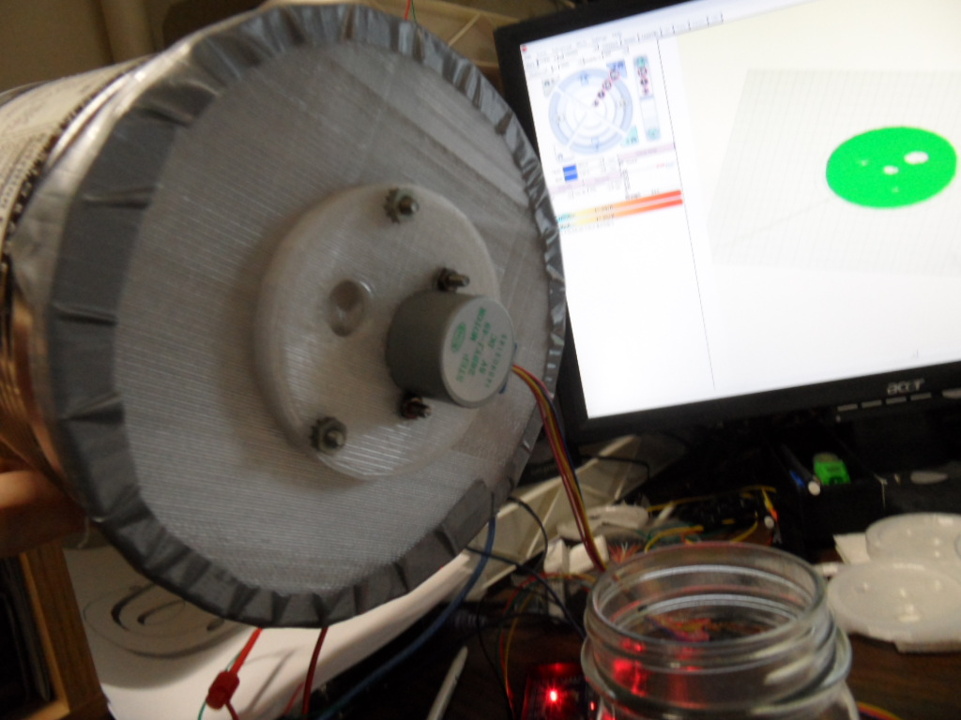
The Stepper Motor is attached (by bolts) to the 3D created Motor Base.
The 3D created Gear Dispensor is placed on the Motor shaft
The Motor Base is then attached (by bolts) to the Can Base
The 3D created can base is then Duct taped to the bottom of a 1-gallon tin can

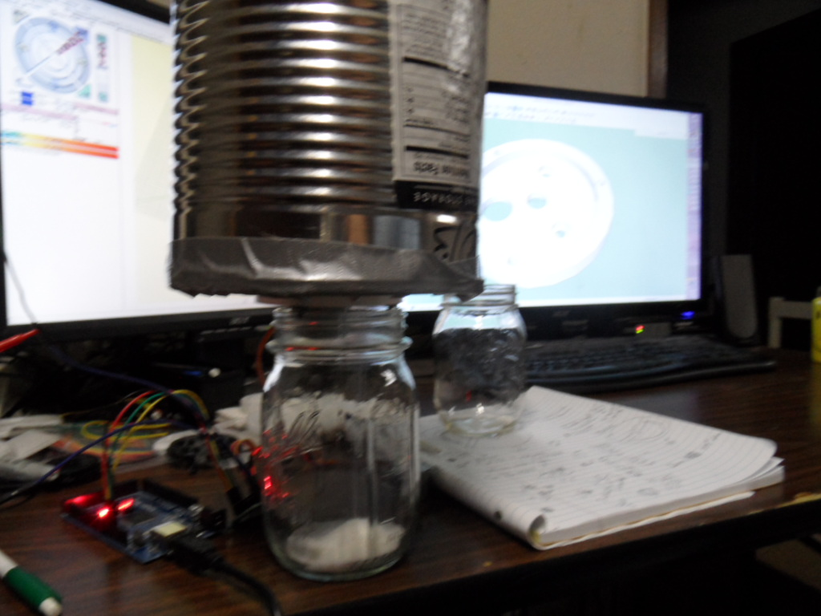
Stepper motor is then driven by the Arduino Microcontroller to dispense sugar

11/23/2014
Two disperse cans are built identical and extrusion pipes are attached using
Nylon Hose Barb 3/8" in ID x 1/4" in MIP(Screw side) $0.95 / each
Nylon Hose 3/8" inner $0.39 / ft
Purchased at Grovers!

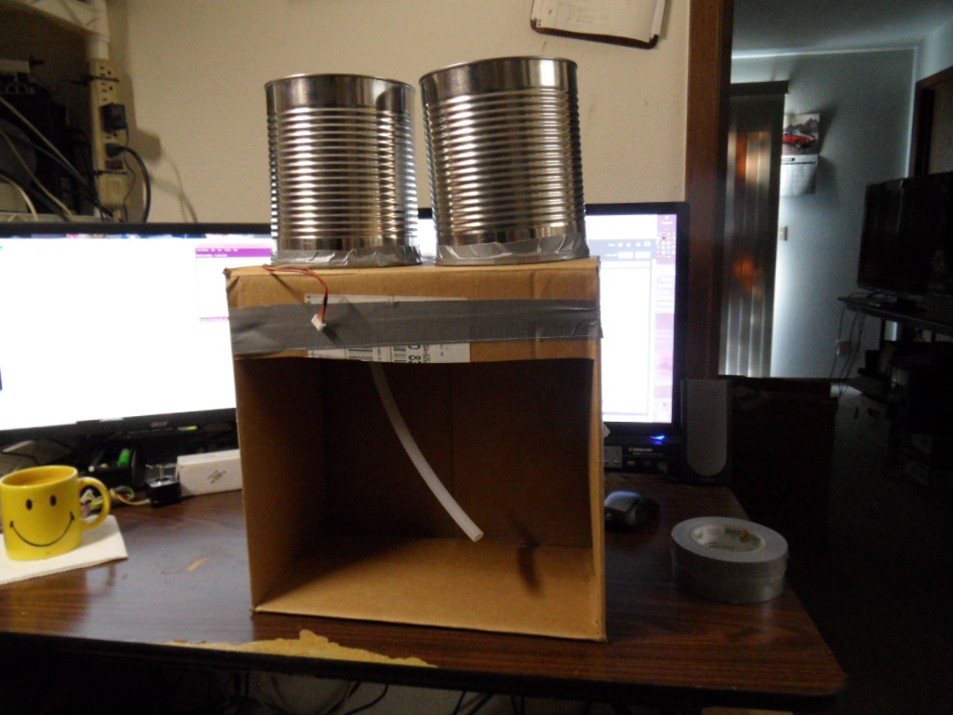

Used a box to elevate cans

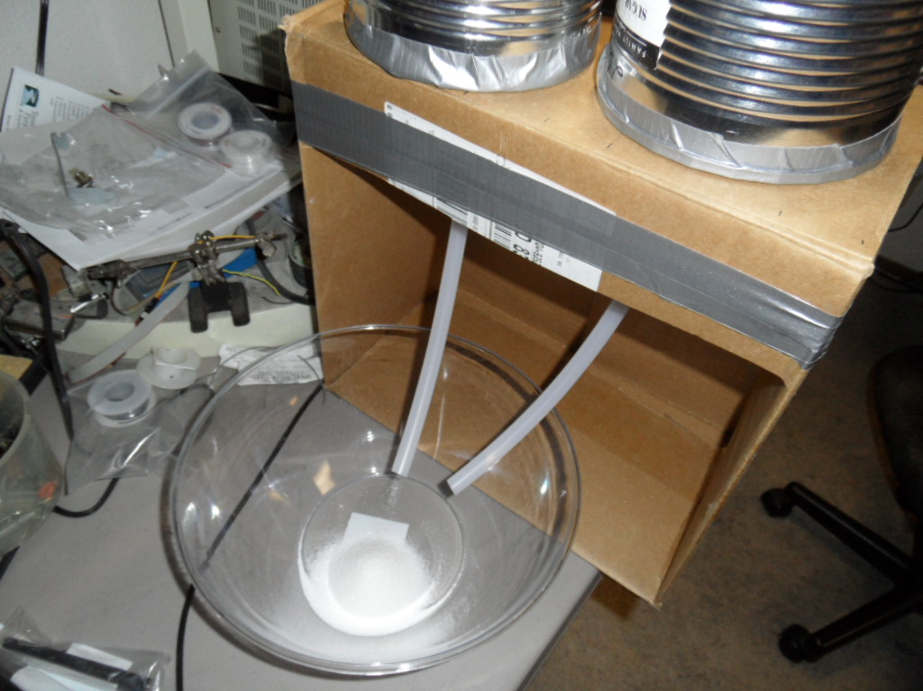
Attached hoses to out-holes using MotorMountSpout.STL and "Nylon Hose Barb" screwed into the bottom of Spout 3D printed parts and cut ~1ft hoses to barbs.

Wired motors from the tail end
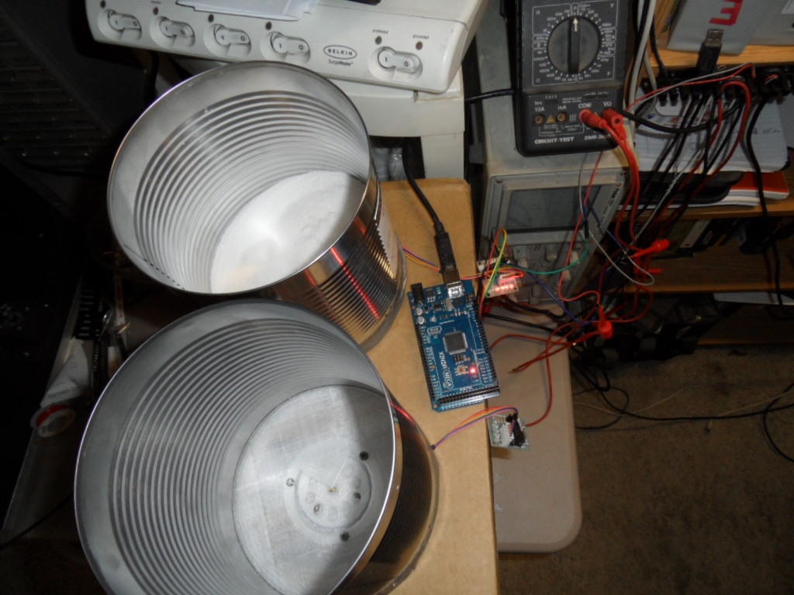

Issues
Problem: Original setup will not extrude flour. The flour packs into the tiny holes and will not release under drop hole.
Solution: We'll try a gear and MotorMount with larger holes.

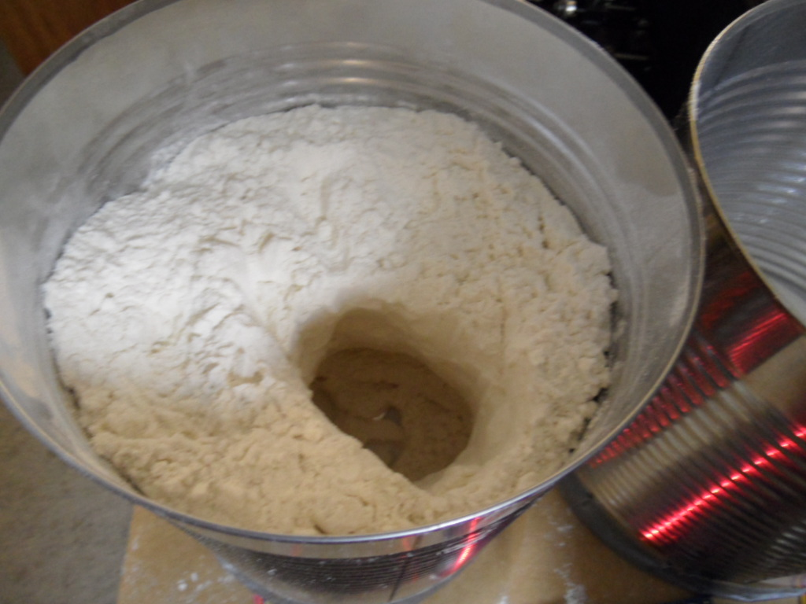

No matter how large the holes are the flour will not drop. Many attempts were tried.
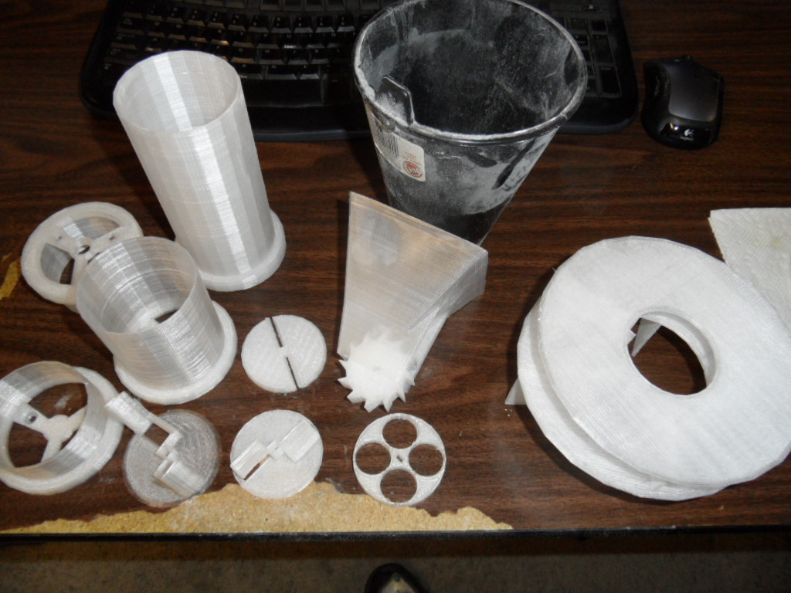

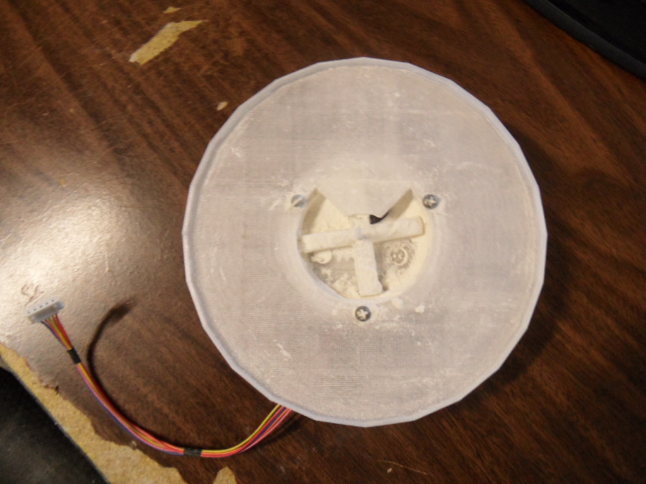

After much struggle a Top down scrapping approach was devised.
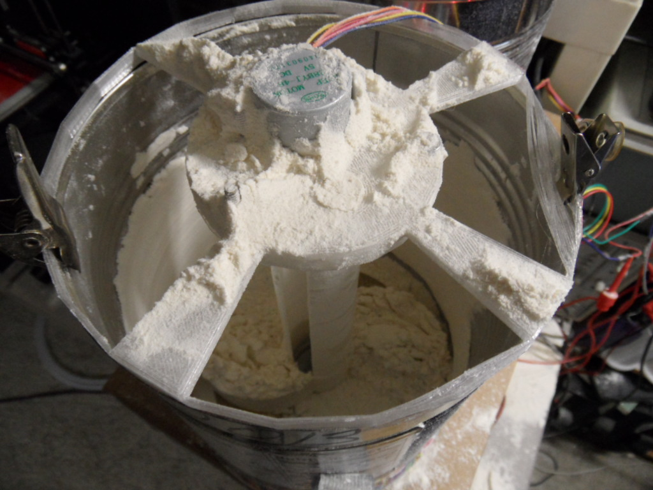
However there are many dis-advantages to this approach.
- The scrapping gear must be held up while filling the cannister
- The center shaft has large holes that leak while filling the cannister
- A cap must be put on the end of the shaft to keep it from binding the gear
- Filling with flour is more difficult due to motor being attached at the top
The flour did dispense well as shown above the can has been dispensed of flour completely without any intervention.

To perfect the idea 1/2" PVC pipe was used with 3/4" PVC pipe.
The outer-edge of 1/2" PVC measures just a titch over 5/8" = Model ( D-1' 3 7/8" , R-7 15/16" )
An 11.3oz Folgers-red coffee container measures:
Little less than 3 1/2" inner = Model ( D-7' 4 3/4", R-3' 8 3/8" )

Files: Shaft.stl
File: ShaftGear.stl

While this worked for flour – corn starch and small holed centered cause issues.

Debate
- 4- Canisters into one spout or 4-spouts together
- Turn-table or Conveyor
- Mixer on mixing bowl over head?

Purchases
From http://www.gearbest.com/

GZGW09 3D Printer Reprap Stepper Motor Driver Module Works with Official Arduino  GZGW09 3D Printer Reprap Stepper Motor Driver Module  Step angle: 1.8 degree  Rated voltage: DC 4.83V  Rated current: 0.84A  Phase impedance: 5.75 Ohm + / - 10 degree centigrade  Phase inductance: 9.3 mH + / - 20 degree centigrade (1kHz 1V RMA)  Shaft diameter: 5mm / 0.188  Shaft length: 20mm  Motor height: 34mm  Number of lead wire: 4 wires  Product Weight: 0.22 kg  Package Weight: 0.23 kg  Product Size(L x W x H): 5.8 x 4.2 x 4.2 cm / 2.28 x 1.65 x 1.65 inches  Package Size(L x W x H): 8.0 x 6.0 x 5.0 cm | 106842801 | 2 | $30.54
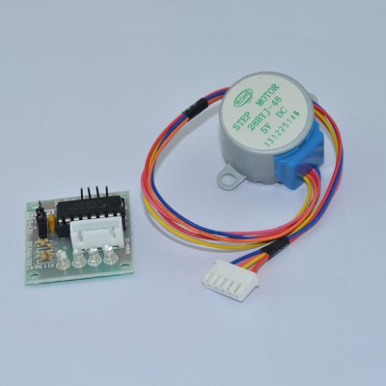  28BYJ-48 5V 4-Phase 5-Line Stepper Motor with ULN2003 Driver Module Board  Google Sketchup 3" x 5 3/16" Rectangular Drive Hole | NZ0019501 | 3 | $11.22
Arduino MEGA2560 RepRap Circuit Sets for 3D Printer Ramps  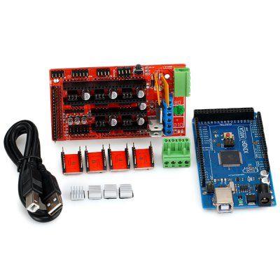  Package Contents:  1 x MEGA2560 Circuit Sets  1 x Ramps 1.4  4 x A4988  1 x USB Cable | NZ0049801 | 2 | $75.24

Order at www.DX.com

SKU | Product Name
(1)  112766  $3.15 | 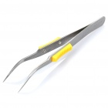  WEITUS A05 Anti-Slip Stainless Steel Precision Angled Tweezers (120mm)
(1)  191637  $38.99 | 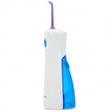  XM-5002 Ultrasonic Pulse Oral Irrigator / Tooth Cleaner / Water Pick - White + Blue
(1)  277147  $4.99 | 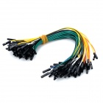  Double Tip 21cm Dupont Cable - Black + Multicolored (70 PCS)
(1)  145357  $7.91 | 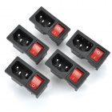  3-Pin Power Adapter Socket with Rock Switch for DIY Project - Black + Red (5-Piece Pack)
(1)  344826  $4.80 | 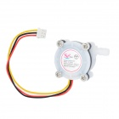  S401 1/4" Water Flow Sensor for Dispenser / Coffee Machine - White
(1)  263660  $10.99 | 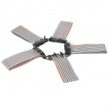  DIY Copper Breadboard DuPont Connection / Test Cables - Multicolored (200 PCS)
(1)  120283  $2.20 | 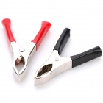  20A Battery Terminal Alligator Crocodile Clamp Clip (Pair)
(1)  123648  $1.46 |   2.54mm Mini Jumper Connector - Black (50-Piece Pack)
(1)  162180  $3.91 | 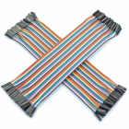  1-Pin Female to Female DuPont Cables for Arduino (2 x 40 PCS / 21cm)
(1)  4593  $2.33 | 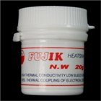  Heatsink Thermal Compound (Grease-like)
(1)  285349  $2.77 | 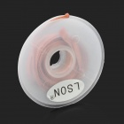  LSON 3mm x 1.5m Desoldering Wire Solder Wick - Brown
(1)  206265  $1.77 | 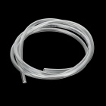  SZF303 Small Water Pump Motor Water / Oxygen Pipe / Tube - Transparent (100cm)
(1)  232242  $2.41 | DIY Plastic Water Pump Line Tube - White (4 PCS)
(1)  203330  $4.99 | 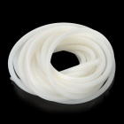  20904 Silicone Tube Pipe - Translucent White (5 Meters)
(1)  219983  $41.23 | 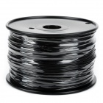  YZ02-175 ABS 1.75~1.8mm 3D Printer Consumables Filaments for Makerbot / RepRap / Mendel - Black
(1)  268732  $41.67 | 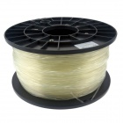  Heacent P175 3D Printers Dedicated 1.75mm Filament PLA Print Materials - Transparent (1kg)
(2)  236808  $5.23 | 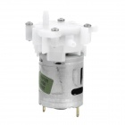  HSYY01 Micro Gear Water Pump Motor w/ Hose - White + Silver  $5.23  Brand N/A  Model HSYY01  Quantity 1  Color White + Silver  Material Iron casing + PVC  Specification  Working voltage: 4~12V; Working current: 0.8A;  Motor diameter: 2.7cm; inlet opening outer diameter: 0.4cm Features  Working voltage: 4~12V; Working current: 0.8A;  Motor diameter: 2.7cm; inlet opening outer diameter: 0.4c.  Water flow rate: Approx. 1.2L/M (5V)  Application DIY project  English Manual/Spec NO  Packing List  1 x Motor  1 x Hose (100cm)  Dimensions: 2.56 in x 1.69 in x 1.61 in (6.5 cm x 4.3 cm x 4.1 cm)  Weight: 3.03 oz (86 g)
(1)  229082  $5.92 | 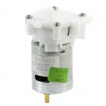  DIY Electric Motor Mini Water Pump  $5.92
(1)  300904  $8.48 | 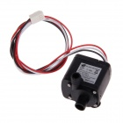  5.5V- 12V Submersible Water Pump - Black
(1)  185970  $6.49 | 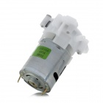  MPX08 Micro Liquid Gear Pump w/ Silicone Tube - White (DC 5V)
Order Subtotal: | USD$ 206.92
Shipping Cost: | USD$ 1.70
Handling Fee: | USD$ 0
Discount Total: | - USD$ 1.70
Grand Total: | USD$ 206.92

