ArdiChef Project
The Automated Kitchen Cooker

Started By: Thomas G (12/2014)
Feel free to use: no strings attached (text content only / images respectfully referenced)

Table of Contents
1. INTRODUCTION 1
1.1 Software 1
1.2 Control 1
1.3 Hardware 1
2. FOOD DISPENSERS 1
2.1 Granular Foods Dispenser (GFD-28BYJ) 1
2.1.1 1-Gallon Can Granular Foods Dispenser (GC-GFD-28BYJ) 1
2.2 Powder Foods Dispenser (PFD-28BYJ) 2
2.2.1 1-Gallon Can Powder Foods Dispenser (GC-PFD-28BYJ) 2
2.2.2 Cambells 26.25Oz Family Size Can Powder Foods Dispenser (CC-PFD-28BYJ) 3
3. Up For Discussion 3
4. Bill Of Materials (BOM) 3
4.1 Tools 3
4.2 Materials 3
4.3 Original Purchases 4
5. Failed Attempts For Reference 6
5.1 Powder Dispensing 6

INTRODUCTION
The ArdiChef project will reside within http://www.github.com/tgit23/ArdiChef/

Software
The software will mostly be written using the Arduino programming software package along with the "Processing" programming language.

Control
The ArdiChef project will be controlled using the Arduino project (http://www.arduino.cc/) micro-controller board and mimic a lot of the 3D RepRap printer project technologies.

Hardware
- Repository of Models - http://www.github.com/tgit23/Ardichef/ → Hardware/
- Bill of Materials
Many of the hardware parts are printed using a 3D printer while some will need to be purchased. Currently all 3D printed parts are designed in Google Sketchup and stored at

FOOD DISPENSERS

Granular Foods Dispenser (GFD-28BYJ)
Granular foods like sugars and spices can be dispensed using what I'd call the Gumball approach. A circular plate with holes in it rotating to a covered drop-hole.

1-Gallon Can Granular Foods Dispenser (GC-GFD-28BYJ)

The 1-Gallon granular food dispenser requires
- One Gallon Tin Can with a base diameter that measures 16.125 inches
- 28BYJ-48 5Vdc 4-Phase 5-Line Stepper Motor with ULN2003 Driver Module Board
- 3D Printer for printing the following parts @ http://www.github.com/tgit23/ArdiChef → /Hardware/GranularDispensers

File-Name | Google Sketchup | Thumb | Description
MotorMount.skp | 2014 - Inches |  | 1) The 28BYJ Stepper motor is bolted into this motor mount (Shaft up)
DispGear_4inHoles.skp | 2014 -Inches |  | 2) The Disp (Dispense) gear is placed on the motor shaft
GallonCanBase_6pt125inchBase.skp | 2014 - Inches |  | 3) The “MotorMount/Stepper/DispGear” assembly is then bolted to the CanBase  4) The Assembly is then attached to the bottom of the One-Gallon tin can.
MotorMountSpout.skp | 2014 - Inches |  | 5) Optionally – A spout holder can be attached to the MotorMount under the dispensing hole.

Powder Foods Dispenser (PFD-28BYJ)

1-Gallon Can Powder Foods Dispenser (GC-PFD-28BYJ)
The 1-Gallon powder food dispenser requires
- One Gallon Tin Can with a base diameter that measures 16.125 inches
- 28BYJ-48 5Vdc 4-Phase 5-Line Stepper Motor with ULN2003 Driver Module Board
- 3/4” Shedule 80 PVC Pipe threaded and notched the height of the tin can
- 3/4” PVC Pipe Nut (Created by cutting a PVC cap)
- 3D Printer for printing the following parts located at http://www.github.com/tgit23/ArdiChef/ → Hardware/PowderDispensers/GallonCan_ThreeQtrPipe

File-Name | Google Sketchup | Thumb | Build Instructions
MotorMountGearBox.skp | 2014 - Inches |  | 1) The 28BYJ Stepper motor is bolted into this motor mount gear box (Shaft up)
MotorGear.skp | 2014 -Inches |  | 2) The MotorGear is placed on the motor shaft
PipeDriverGear.skp | 2014 - Inches |  | 3) The PipeDriverGear is dropped freely into the MotorMountGearBox.
Scrapper.skp | 2014 - Inches |  | 4) A 3/4” Schedule 80 PVC pipe is threaded the height of the gallon can in use  5) Using a dremel with grinder stone create 2-notches vertically along the pipe for the DriverGear  6) The Scrapper is attached (glued) to the top of the 3/4” Threaded and notched PVC pipe.
GalCanBase_ThreeQtrNutBase.skp |  |  | 7) A PVC Nut (A cut in half PVC Cap) is glued into the CanBase  8) The CanBase is then attached to the bottom of a one-gallon tin can  9) The “MotorMountGearBox/MotorGear/PipeDriverGear” assembly is bolted to the CanBase.  10) The Threaded and Notched “PVC-Pipe/Scrapper” is threaded down the CanBase Nut till the PipeDriverGear's Notches catches the Notches in the PVC pipe.

- 28BYJ Stepper Motor Bolted to MotorMountGearBox.skp  - MotorGear.skp attached to the shaft of 28BYJ Stepper  - PipeDriverGear.skp placed in the MotorMountGearBox.skp | - 3/4” Schedule 80 Threaded and Notched PVC Pipe  - Scrapper.skp glued to the top of the 3/4” PVC Pipe  - GalCanBase_ThreeQtrNutBase.skp with 3/4” PVC Cap nut | - Thread the 3/4” Schedule 80 PVC Pipe with a 3/4” pipe threader die - the length of the height of the gallon tin can minus the height of the attaching scrapper.
- Using a Dremel with a grind stone (~ 1/8” thick), notch the threaded 3/4” PVC pipe on both sides so the PipeDriverGear.skp locks rotation-ally to the pipe but freely slides vertically along the pipe. | - The stepper motor drives the PipeDriverGear which turns the PVC Pipe which rotates the attached Scrapper while the Cans base with PVC nut moves (via threads) the scrapper/pipe assembly from Top-to-Bottom. | - The rotating scrapper pulls the powder to the center of the PVC pipe (Drop-hole) while also pulling the scrapper a set distance down the can via the pipes threads and base nut.

Cambells 26.25Oz Family Size Can Powder Foods Dispenser (CC-PFD-28BYJ)
The Family Size Cambells Soup Can powder food dispenser requires
- One Family Size Cambells Soup Can with a base diameter that measures 3 3/8 inches
- 28BYJ-48 5Vdc 4-Phase 5-Line Stepper Motor with ULN2003 Driver Module Board
- 1/2” Shedule 80 PVC Pipe threaded and notched the height of the tin can
- 1/2” PVC Pipe Nut (Created by cutting a PVC cap)
- 3D Printer for printing the following parts located at http://www.github.com/tgit23/ArdiChef/ → Hardware/PowderDispensers/Cambells_26.26OZ_HalfInchPipe

File-Name | Google Sketchup | Thumb | Build Instructions
MotorMountGearBox.skp | 2014 - Inches |  | 1) The 28BYJ Stepper motor is bolted into this motor mount gear box (Shaft up)
MotorGear.skp | 2014 -Inches |  | 2) The MotorGear is placed on the motor shaft from /PowderDispensers/GallonCan_ThreeQtrPipe
PipeDriverGear.skp | 2014 - Inches |  | 3) The PipeDriverGear is dropped freely into the MotorMountGearBox.
Scrapper.skp | 2014 - Inches |  | 4) A 1/2” Schedule 80 PVC pipe is threaded the height of the gallon can in use  5) Using a dremel with grinder stone create 2-notches vertically along the pipe for the DriverGear  6) The Scrapper is attached (glued) to the top of the 1/2” Threaded and notched PVC pipe.
CanBase_Campbells26.25OZ.skp |  |  | 7) A PVC Nut (A cut in half PVC Cap) is glued into the CanBase  8) The CanBase is then attached to the bottom of a one-gallon tin can  9) The “MotorMountGearBox/MotorGear/PipeDriverGear” assembly is bolted to the CanBase.  10) The Threaded and Notched “PVC-Pipe/Scrapper” is threaded down the CanBase Nut till the PipeDriverGear's Notches catches the Notches in the PVC pipe.

Up For Discussion
- 4- Canisters into one spout or 4-spouts together
- Turn-table or Conveyor
- Mixer on mixing bowl over head?

Bill Of Materials (BOM)

Tools
- 3D Printer
- Pipe Threader Die for 1/2” and 3/4” pipes

Materials
- 1/2” Schedule 80 PVC Pipe
- 3/4” Schedule 80 PVC Pipe

Original Purchases

Qty/SKU/Price | Product Name / Description | Picture
(2)  106842801  $30.54  www.gearbest.com | GZGW09 3D Printer Reprap Stepper Motor Driver Module Works with Official Arduino  GZGW09 3D Printer Reprap Stepper Motor Driver Module  Step angle: 1.8 degree  Rated voltage: DC 4.83V  Rated current: 0.84A  Phase impedance: 5.75 Ohm + / - 10 degree centigrade  Phase inductance: 9.3 mH + / - 20 degree centigrade (1kHz 1V RMA)  Shaft diameter: 5mm / 0.188  Shaft length: 20mm  Motor height: 34mm  Number of lead wire: 4 wires  Product Weight: 0.22 kg  Package Weight: 0.23 kg  Product Size(L x W x H): 5.8 x 4.2 x 4.2 cm / 2.28 x 1.65 x 1.65 inches  Package Size(L x W x H): 8.0 x 6.0 x 5.0 cm | 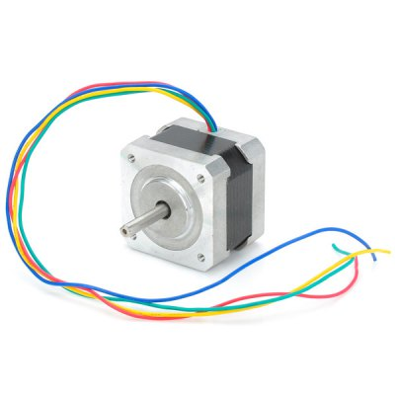
(3)  NZ0019501  $11.22  www.gearbest.com | 28BYJ-48 5V 4-Phase 5-Line Stepper Motor with ULN2003 Driver Module Board  Google Sketchup 3" x 5 3/16" Rectangular Drive Hole
(2)  NZ0049801  $75.24  www.gearbest.com | Arduino MEGA2560 RepRap Circuit Sets for 3D Printer Ramps  Package Contents:  1 x MEGA2560 Circuit Sets  1 x Ramps 1.4  4 x A4988  1 x USB Cable
(1)  277147  $4.99  www.dx.com | Double Tip 21cm Dupont Cable - Black + Multicolored (70 PCS) | 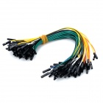
(1)  145357  $7.91  www.dx.com | 3-Pin Power Adapter Socket with Rock Switch for DIY Project - Black + Red (5-Piece Pack) | 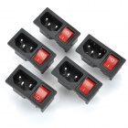
(1)  344826  $4.80  www.dx.com | S401 1/4" Water Flow Sensor for Dispenser / Coffee Machine - White | 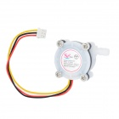
(1)  263660  $10.99  www.dx.com | DIY Copper Breadboard DuPont Connection / Test Cables - Multicolored (200 PCS) | 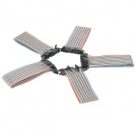
(1)  123648  $1.46  www.dx.com | 2.54mm Mini Jumper Connector - Black (50-Piece Pack) | 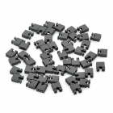
(1)  162180  $3.91  www.dx.com | 1-Pin Female to Female DuPont Cables for Arduino (2 x 40 PCS / 21cm) | 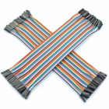
(1)  206265  $1.77  www.dx.com | SZF303 Small Water Pump Motor Water / Oxygen Pipe / Tube - Transparent (100cm)  Model SZF303  Quantity 1  Color Transparent  Material Plastic housing  Features Use for small fish tank oxygen supply; DIY project  Specification Inner diameter: 0.2cm; Thickness: 0.4cm; Length: 100cm  Application Small water pump pipe / tube  English Manual/Spec No  Packing List 1 x Water pipe  Dimensions: 39.37 in x 0.16 in x 0.16 in (100.0 cm x 0.4 cm x 0.4 cm)  Weight: 0.32 oz (9 g) | 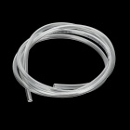
(1)  232242  $2.41  www.dx.com | DIY Plastic Water Pump Line Tube - White (4 PCS)  Brand N/A  Quantity 4 Piece(s)/pack  Color White  Material Plastic  Compatible Models Small water pump  Application Used to connect small water pump  Other Feature Outer diameter: 4mm; Inner diameter: 3mm  Packing List 4 x Water pump line tubes  Dimensions: 1.14 in x 0.71 in x 0.16 in (2.9 cm x 1.8 cm x 0.4 cm)  Weight: 0.18 oz (5 g) | 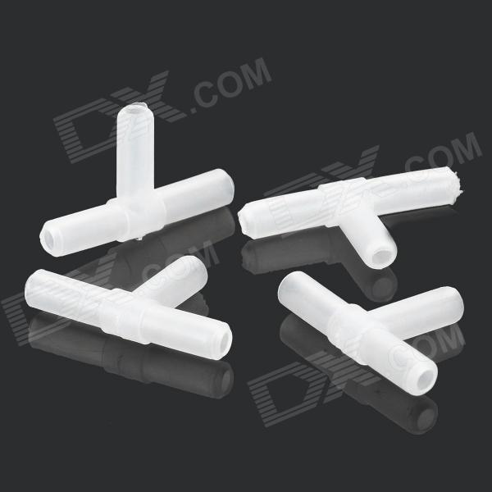
(1)  203330  $4.99  www.dx.com | 20904 Silicone Tube Pipe - Translucent White (5 Meters)  Model 20904  Quantity 1  Color Translucent white  Material Silicone  Specification Outer diameter: 5mm; Inner diameter: 3mm; Thickness: 12mm; Working temperature range: -65'C~200'C  Features Silicone tube  Application Widely used for water dispenser, coffeemaker, electronic instrument, medical equipment, wine connection tube etc.  English Manual/Spec No  Packing List 1 x Silicone tube (5 meters)  Dimensions: 196.85 in x 0.20 in x 0.20 in (500.0 cm x 0.5 cm x 0.5 cm)  Weight: 2.82 oz (80 g) | 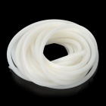
(2)  236808  $5.23  www.dx.com | HSYY01 Micro Gear Water Pump Motor w/ Hose - White + Silver  $5.23  Brand N/A  Model HSYY01  Quantity 1  Color White + Silver  Material Iron casing + PVC  Specification  Working voltage: 4~12V; Working current: 0.8A;  Motor diameter: 2.7cm; inlet opening outer diameter: 0.4cm Features  Working voltage: 4~12V; Working current: 0.8A;  Motor diameter: 2.7cm; inlet opening outer diameter: 0.4c.  Water flow rate: Approx. 1.2L/M (5V)  Application DIY project  English Manual/Spec NO  Packing List  1 x Motor  1 x Hose (100cm)  Dimensions: 2.56 in x 1.69 in x 1.61 in (6.5 cm x 4.3 cm x 4.1 cm)  Weight: 3.03 oz (86 g) | 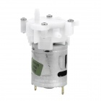
(1)  229082  $5.92  www.dx.com | DIY Electric Motor Mini Water Pump  $5.92  Brand N/A  Quantity 1 Piece(s)/pack  Color Silver + white  Material Iron + copper + plastic  Compatible Models N/A  Application Testing, fish-farming, etc.  Other Feature Inlet and outlet hole external diameter: 4mm; Rated voltage: 7.2V; DC voltage: 3~9V; Please note: No-load test should not take a long time; With plastic blade, Can't be inhaled impurities  Packing List 1 x Pump  Dimensions: 2.56 in x 1.61 in x 1.50 in (6.5 cm x 4.1 cm x 3.8 cm)  Weight: 2.54 oz (72 g) | 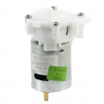
(1)  300904  $8.48  www.dx.com | 5.5V- 12V Submersible Water Pump - Black  Voltage: 3.5-12V, head: 40-160cm. the maximum flow: 300L/H. 60 degrees below temperature resistant. - Continuous working life (24 hours non-stop work) more than 20000 hours, about 10 hours per day, water pump life for 8 years. - The inlet and outlet diameter is 8.3MM, the inner diameter 6.2MM. With 2 soft sucker, can be fixed freely. - Super mute, noise figure is 30dB  Brand: N/A  Quantity: 1-Piece  Color: Black  Material: ABS  Dimensions: 1.89 in x 1.57 in x 1.06 in (4.8 cm x 4 cm x 2.7 cm)  Weight: 2.52 oz (71.5 g)  Packing List: 1 x Pump (38cm-cable) | 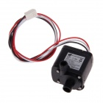
(1)  185970  $6.49  www.dx.com | MPX08 Micro Liquid Gear Pump w/ Silicone Tube - White (DC 5V)  Model MPX08  Quantity 1  Color White  Material Plastic + Iron  Features Start current: 2A; Perfect for DIY projects such as fish tank, model, etc.  Packing List 1 x Micro pump  1 x Silicone tube (100cm)  Dimensions: 2.56 in x 1.65 in x 1.54 in (6.5 cm x 4.2 cm x 3.9 cm)  Weight: 3.28 oz (93 g) | 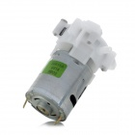

Failed Attempts For Reference

Powder Dispensing
Dispensing powder proved to be quite challenging
- Large holed Granular type approach – FAILED
- Funnel container – FAILED (Didn't attempt a super-long auger approach as it was thought to fail also)
- Large bottom “Water Wheel” type approach - FAILED

- Partial Solution “Top Down” – WORKS (But needs refinement – as per actual unit)
  - Creating a scrapper that falls down as product is removed while scrapping product to a center drop hole.
  - While this worked for flour – corn starch and small holed center (1/2” pipe) will most likely still be an issue
  - Disadvantages
    - The scrapping gear must be held up while filling the cannister
    - The center shaft has large holes that leak while filling the cannister
    - A cap must be put on the end of the shaft to keep it from binding the gear
    - Filling with flour is more difficult due to motor being attached at the top
    - The flour did dispense well as shown above the can has been dispensed of flour completely without any intervention.

