IE 590: Augmented Turret & Robotic Arm
Terrell Glenn¹ Ana Villanueva¹
¹Purdue University, Department of Mechanical Engineering
{glenn3, villana} @purdue.edu

Literature Review
Everyday life is surrounded by multiple interactive devices and smart objects targeted to different goals in different contexts. As such, it is complicated for application developers to exactly predict which situations, environments, and objects the end user will subject their smart objects to. Thus, it is important to make end users capable of easily and autonomously control and interact with the behavior of their Internet of Things (IoT) applications [1].
Utilizing IoT devices can contribute in a variety of activities. To manage home appliances based on end user preferences and dynamic contextual factors can provide comfort, safety, and implement energy efficient techniques [2]. From production line and warehousing to retail delivery and store shelving, the IoT is transforming business processes by providing more accurate and real-time visibility into the flow of materials and products. For example, both John Deere and UPS are already using IoT-enabled fleet tracking technologies to cut costs and improve supply efficiency.
In a different context, children’s interaction with technology is rapidly evolving to shape their activities, their cognitive development and even their approach to technology [3]. To facilitate the usability of IoT devices, it is important to come up with interfaces that children can quickly manipulate and navigate on. In terms of ubiquity, the interfaces can be easily delivered and accessed via a mobile app. Furthermore, a virtual interface would enable combining IoT devices and augmented reality. An interface with such capabilities would transform mobile augmented reality from science fiction to reality [4].
To align virtual content with physical smart objects in the real world, we need to enable tracking and registration to evaluate current pose information. There are two types of tracking and registration: sensor-based and vision-based. For this project, we will focus on vision-based. Vision-based tracking uses feature correspondence to estimate pose information. We can classify vision-based methods intro two types: marker-based and nature feature method.
The marker-based method uses fiducials and markers as artificial features. A fiducial has a set of determined geometric characteristics and properties, such as shape, size, color patterns to facilitate identification. Many available libraries use planar fiducials for tracking, such as ARToolkit [5], ARTag [6], ARToolKitPlus [7], OpenTracker [8]. Several AR applications rely on these fiducials to procure accurate tracking [9, 10, 11, 12].
Conversely, nature feature method tracks point, and region feature in image sequences to calculate corresponding relationships to estimate pose environment [4]. The frame-by-frame tracking aids in removing mismatches and drift errors, unlike in sensor-based methods. Several robust local descriptors including SIFT [13] and SURF [14] are introduced for nature feature tracking in mobile applications. For example, a multiple target tracking and detection method for mobile phones included separating target detection and tracking, so that the tracking runs at full frame rate and creates a mask to guide detector to look for new target [15]. To reduce calculations, the assumption was that local area around positive matched key points were visible in camera images, and uncovered regions were ignored during key point detection.
In this context a mobile augmented reality application which successfully combines computer vision and IoT accessibility would allow:
- Combining IoT and virtual objects in a real environment
- Interactivity and mapping in real time
- Registering and aligning real and virtual objects with each other
- Running and/or displaying the augmented reality interface, and view, on the mobile device.
Methodology
To develop the mobile augmented reality interface, we plan to utilize Unity game engine. The UI will be generated to allow the user to program specific steps, and to easily navigate all the capabilities of the IoT device, while giving access to the graphics, and animations of the application. We will integrate computer vision techniques to allow the IoT device (robot) to map and navigate the room. The IoT device will be programmed via Arduino software, in which we write the basic code to get the breadboarded device to do anything what we wanted to do. Our UI built in Unity will receive accurate input from the user and deliver it to the controllers to the IoT device. The programming language to code in Unity is C#. Moreover, the UI will enable the user to have finer control of all robot’s extremities and mobility (Fig.1). 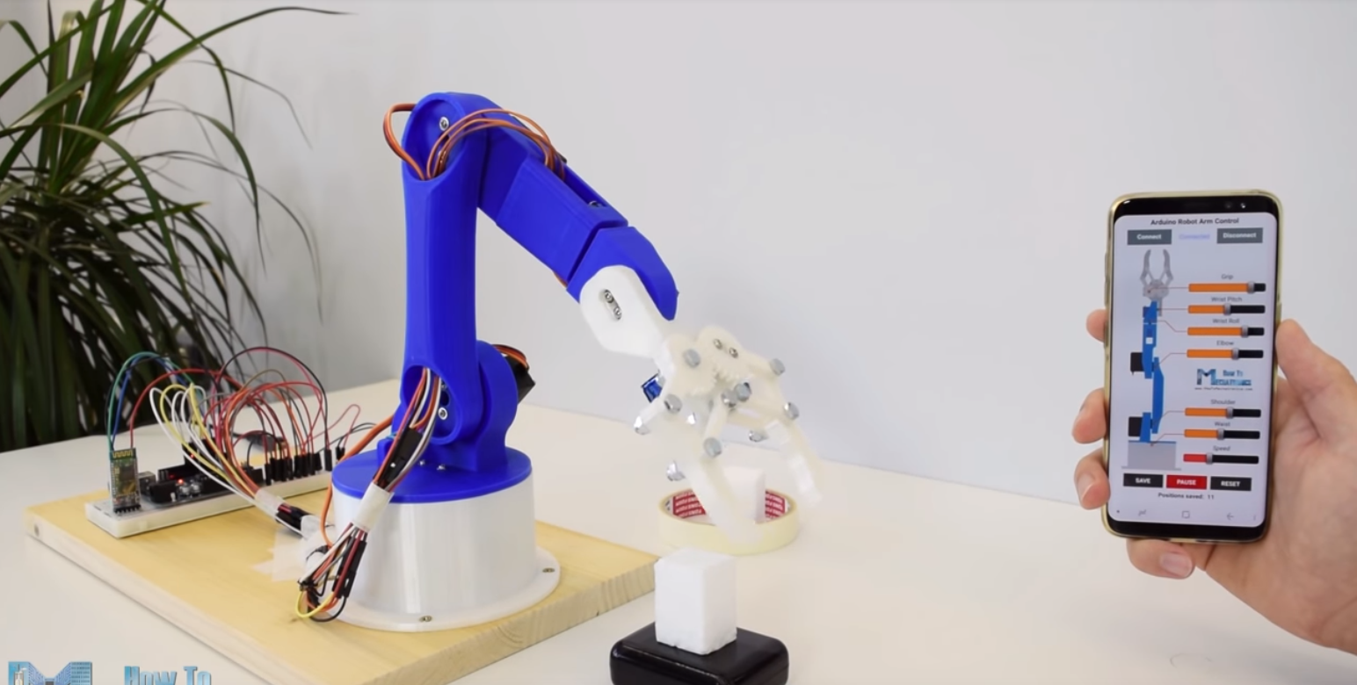Fig.1: IoT device programmed using Arduino, while UI created in Unity allows finer control to the user.
However, since we want the robot to have navigation capabilities in a room, it is necessary to add a camera. The camera will receive images of the surroundings and utilize OpenCV to process and match corresponding features. The programming language we will utilize for coding using OpenCV is Python. After this process, Arduino will pick up the data, which in turn is sent to Unity (Fig. 2).
Fig. 2: Image data picked up by the camera is processed by OpenCV. Then, Arduino is used to program the robot’s capabilities. Finally, Unity is the link between the IoT device and the end-user, who has finer control of the robot’s activities.
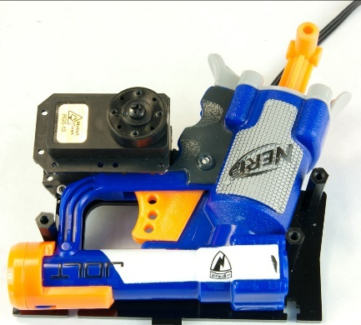
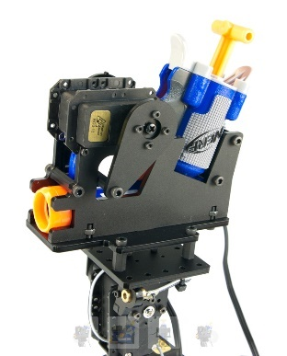
To test the functionality of our setup, we will provide capabilities of navigation of the IoT-based device across a room. Then, the robot will have to locate a specific target. Augmented reality via our phone will deliver us the projected trajectory that the robot will reach if we decide to hit the target. Thus, giving us opportunity to move or adjust the robot’s position. Finally, the robot will accept our input and shoot the target.
Fig. 3: Preliminary design for the NERF Blaster carriage

Project Description

Augmented Reality (AR) is an emerging form of experience in which the real world is enhanced by computer-generated content tied to specific locations and/or activities. Over the past few years, researchers have found several applications in which AR has become portable with robotics applications. In fact, AR is very visible in today’s audio-visual media through our smart phones and tablets (e.g. ARCore and ARKit) and will soon be integrated into our daily lives through social robots. Robotics is an area that could potentially assist humans with our daily tasks that are more difficult for us to achieve. Additionally, AR has implication on the way that we, as humans, interact with technology through the media of learning and education.
With the advent of ARCore and ARKit, AR applications are just now being brought to the smart phone with great succession. Augmented Robotics – the combination of AR and Robotics – is an area that is still under development. Imagine a world where your own personal robot would not only become your companion but help you to complete tasks that were difficult for you to achieve - a robot that could build a map of its surroundings, then locate a reachable target in that area.
We are proposing a robot arm that would have several functions. First, the robot would enter a blank field and build a map of that field based on its own computer vision algorithm. During this map-building process, the robot would survey the field in search of a specific, user-defined target. Once the robot finds the target, the robot uses its own set of algorithms to complete tasks assigned to that target. A cell phone application would be used to accompany the robot to help the human give the robot further instructions. Some sample tasks would include the following:
- Accurately aim and shoot a projectile at the target. The cell phone application would show the trajectory of the projectile using AR where the user could adjust to make it more accurate. The robot is free to retrieve the projectile if it misses.
- Grab physical targets that are within reach and return them to a specified location. The cell phone application would display information about the target and allow the user to specify where the drop off location should be.
This project combines the areas of (1) Computer Vision, (2) Augmented/Mixed Reality and (3) Robotics in order to create an immersive environment where a robot can survey a field in search of a target and complete a given set of objectives in that field.
Workflow
For this project, we will be using a camera made to interact with the Arduino microcontroller as our primary source of vision. Our workflow is given in Figure 4 (a) – (e). The robot will be faced with generating a map where it initially has no knowledge of its surroundings. It will start driving forward and travel in a zig-zag pattern until it finds either the “graspable object” or the target. If it finds the target, the robot will aim at, and shoot the target with a custom NERF blaster using physics to calculate its trajectory. If it finds the graspable object, it will home in and grab the object, then continue to traverse the field until it finds the Drop-Off Bin.

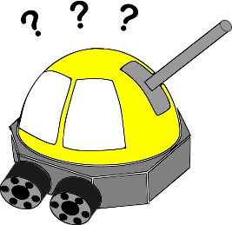
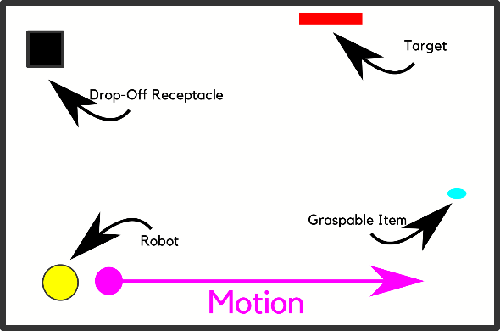
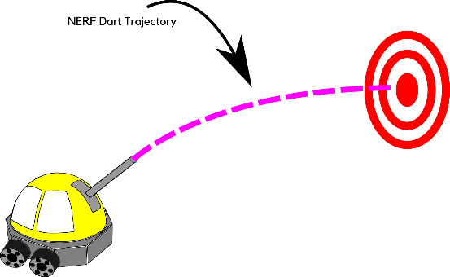
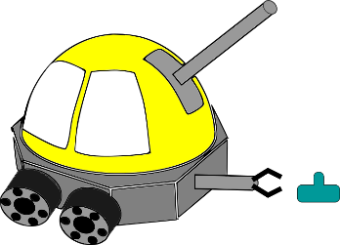
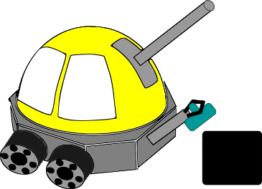
Bill of Materials
c
a
b
d
e
Figure 4

Bill of Materials
Product Name | Description | Link | Quantity | Unit price | Sub-Total
HiLetgo ESP-WROOM-32 ESP32 ESP-32S Development Board | Arduino development board that we will use to program the robot | ESP32 | 1 | $10.99 | $10.99
AL422 640x480 CMOS With 3M-Bits OV7670 FIFO Camera STM32 Chip Driver Module | Camera module compatible with ESP32 dev board | Arduino Camera | 1 | $10.58 | $10.58
LCD Module Display PCB Adapter 1.8 Inch Serial SPI TFT Power IC SD Socket 128X160 C1 1.8'' 128x160 for arduino DIY KIT | Camera screen for Arduino compatible with ESP32 dev board. We will use this for debugging purposes. | Small Camera Screen | 1 | $3.73 | $3.73
HC-SR04 Ultrasonic Sonar Distance Sensor | Ultrasonic sensor that we will use to detect obstacles around the robot | Ultrasonic Sensor | 3 | $3.95 | $11.85
DC Electric Motor 3-6V Dual Shaft Geared TT Magnetic Gearbox Engine with 4Pcs Plastic Toy Car Tire Wheel | The motors and wheels that will drive our robot | DC Motors | 4 | $3.42 | $13.68
L298N Motor Drive Controller Board Module Dual H Bridge DC Stepper For Arduino | These motor drivers will be used to control the 4 DC motors that drive the robot | Motor Driver | 1 | $6.89 | $6.89
TowerPro SG90 Micro Servo | Micro servos that we will use to position and aim our NERF blasters | Servos | 2 | $3.65 | $7.30
MG996R Metal Gear Torque Digital Servo with Arm Horn | This servo will be used to activate the NERF blaster. It has enough torque to push the trigger. | Continuous Servo | 4 | $12.95 | $12.95
Nerf N-Strike Elite Jolt Blaster | Small NERF Single Shot Blaster that we will use to shoot targets | NERF Blaster | 1 | $5.69 | $5.69
Robot arm/claw | The arm will be designed for 3D printing and will include 2 continuous rotation servos and 1 micro servo. |  | 1 | $0 | $0
Grand Total: |  |  |  |  | $76.77

Appendix
Sample UI:
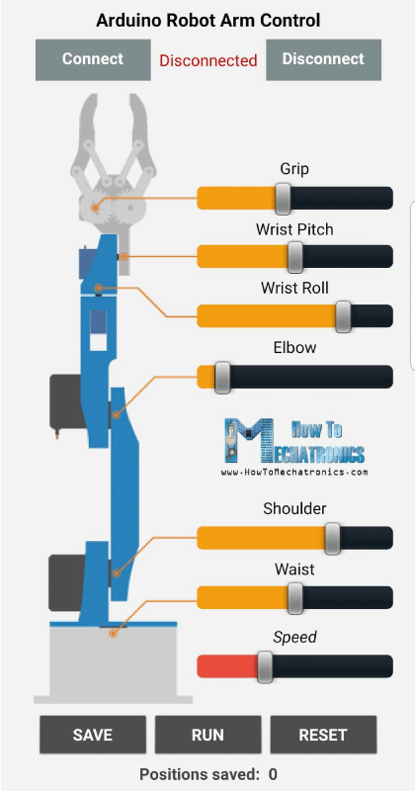
App Code:
- #include <SoftwareSerial.h>
- #include <Servo.h>

- Servo servo01;
- Servo servo02;
- Servo servo03;
- Servo servo04;
- Servo servo05;
- Servo servo06;

- SoftwareSerial Bluetooth(3, 4); // Arduino(RX, TX) - HC-05 Bluetooth (TX, RX)

- int servo1Pos, servo2Pos, servo3Pos, servo4Pos, servo5Pos, servo6Pos; // current position
- int servo1PPos, servo2PPos, servo3PPos, servo4PPos, servo5PPos, servo6PPos; // previous position
- int servo01SP[50], servo02SP[50], servo03SP[50], servo04SP[50], servo05SP[50], servo06SP[50]; // for storing positions/steps
- int speedDelay = 20;
- int index = 0;
- String dataIn = "";

- void setup() {
- servo01.attach(5);
- servo02.attach(6);
- servo03.attach(7);
- servo04.attach(8);
- servo05.attach(9);
- servo06.attach(10);
- Bluetooth.begin(38400); // Default baud rate of the Bluetooth module
- Bluetooth.setTimeout(1);
- delay(20);
- // Robot arm initial position
- servo1PPos = 90;
- servo01.write(servo1PPos);
- servo2PPos = 150;
- servo02.write(servo2PPos);
- servo3PPos = 35;
- servo03.write(servo3PPos);
- servo4PPos = 140;
- servo04.write(servo4PPos);
- servo5PPos = 85;
- servo05.write(servo5PPos);
- servo6PPos = 80;
- servo06.write(servo6PPos);
- }

- void loop() {
- // Check for incoming data
- if (Bluetooth.available() > 0) {
- dataIn = Bluetooth.readString(); // Read the data as string

- // If "Waist" slider has changed value - Move Servo 1 to position
- if (dataIn.startsWith("s1")) {
- String dataInS = dataIn.substring(2, dataIn.length()); // Extract only the number. E.g. from "s1120" to "120"
- servo1Pos = dataInS.toInt(); // Convert the string into integer
- // We use for loops so we can control the speed of the servo
- // If previous position is bigger then current position
- if (servo1PPos > servo1Pos) {
- for ( int j = servo1PPos; j >= servo1Pos; j--) { // Run servo down
- servo01.write(j);
- delay(20); // defines the speed at which the servo rotates
- }
- }
- // If previous position is smaller then current position
- if (servo1PPos < servo1Pos) {
- for ( int j = servo1PPos; j <= servo1Pos; j++) { // Run servo up
- servo01.write(j);
- delay(20);
- }
- }
- servo1PPos = servo1Pos; // set current position as previous position
- }

- // Move Servo 2
- if (dataIn.startsWith("s2")) {
- String dataInS = dataIn.substring(2, dataIn.length());
- servo2Pos = dataInS.toInt();

- if (servo2PPos > servo2Pos) {
- for ( int j = servo2PPos; j >= servo2Pos; j--) {
- servo02.write(j);
- delay(50);
- }
- }
- if (servo2PPos < servo2Pos) {
- for ( int j = servo2PPos; j <= servo2Pos; j++) {
- servo02.write(j);
- delay(50);
- }
- }
- servo2PPos = servo2Pos;
- }
- // Move Servo 3
- if (dataIn.startsWith("s3")) {
- String dataInS = dataIn.substring(2, dataIn.length());
- servo3Pos = dataInS.toInt();
- if (servo3PPos > servo3Pos) {
- for ( int j = servo3PPos; j >= servo3Pos; j--) {
- servo03.write(j);
- delay(30);
- }
- }
- if (servo3PPos < servo3Pos) {
- for ( int j = servo3PPos; j <= servo3Pos; j++) {
- servo03.write(j);
- delay(30);
- }
- }
- servo3PPos = servo3Pos;
- }
- // Move Servo 4
- if (dataIn.startsWith("s4")) {
- String dataInS = dataIn.substring(2, dataIn.length());
- servo4Pos = dataInS.toInt();
- if (servo4PPos > servo4Pos) {
- for ( int j = servo4PPos; j >= servo4Pos; j--) {
- servo04.write(j);
- delay(30);
- }
- }
- if (servo4PPos < servo4Pos) {
- for ( int j = servo4PPos; j <= servo4Pos; j++) {
- servo04.write(j);
- delay(30);
- }
- }
- servo4PPos = servo4Pos;
- }
- // Move Servo 5
- if (dataIn.startsWith("s5")) {
- String dataInS = dataIn.substring(2, dataIn.length());
- servo5Pos = dataInS.toInt();
- if (servo5PPos > servo5Pos) {
- for ( int j = servo5PPos; j >= servo5Pos; j--) {
- servo05.write(j);
- delay(30);
- }
- }
- if (servo5PPos < servo5Pos) {
- for ( int j = servo5PPos; j <= servo5Pos; j++) {
- servo05.write(j);
- delay(30);
- }
- }
- servo5PPos = servo5Pos;
- }
- // Move Servo 6
- if (dataIn.startsWith("s6")) {
- String dataInS = dataIn.substring(2, dataIn.length());
- servo6Pos = dataInS.toInt();
- if (servo6PPos > servo6Pos) {
- for ( int j = servo6PPos; j >= servo6Pos; j--) {
- servo06.write(j);
- delay(30);
- }
- }
- if (servo6PPos < servo6Pos) {
- for ( int j = servo6PPos; j <= servo6Pos; j++) {
- servo06.write(j);
- delay(30);
- }
- }
- servo6PPos = servo6Pos;
- }
- // If button "SAVE" is pressed
- if (dataIn.startsWith("SAVE")) {
- servo01SP[index] = servo1PPos; // save position into the array
- servo02SP[index] = servo2PPos;
- servo03SP[index] = servo3PPos;
- servo04SP[index] = servo4PPos;
- servo05SP[index] = servo5PPos;
- servo06SP[index] = servo6PPos;
- index++; // Increase the array index
- }
- // If button "RUN" is pressed
- if (dataIn.startsWith("RUN")) {
- runservo(); // Automatic mode - run the saved steps
- }
- // If button "RESET" is pressed
- if ( dataIn == "RESET") {
- memset(servo01SP, 0, sizeof(servo01SP)); // Clear the array data to 0
- memset(servo02SP, 0, sizeof(servo02SP));
- memset(servo03SP, 0, sizeof(servo03SP));
- memset(servo04SP, 0, sizeof(servo04SP));
- memset(servo05SP, 0, sizeof(servo05SP));
- memset(servo06SP, 0, sizeof(servo06SP));
- index = 0; // Index to 0
- }
- }
- }

- // Automatic mode custom function - run the saved steps
- void runservo() {
- while (dataIn != "RESET") { // Run the steps over and over again until "RESET" button is pressed
- for (int i = 0; i <= index - 2; i++) { // Run through all steps(index)
- if (Bluetooth.available() > 0) { // Check for incomding data
- dataIn = Bluetooth.readString();
- if ( dataIn == "PAUSE") { // If button "PAUSE" is pressed
- while (dataIn != "RUN") { // Wait until "RUN" is pressed again
- if (Bluetooth.available() > 0) {
- dataIn = Bluetooth.readString();
- if ( dataIn == "RESET") {
- break;
- }
- }
- }
- }
- // If speed slider is changed
- if (dataIn.startsWith("ss")) {
- String dataInS = dataIn.substring(2, dataIn.length());
- speedDelay = dataInS.toInt(); // Change servo speed (delay time)
- }
- }
- // Servo 1
- if (servo01SP[i] == servo01SP[i + 1]) {
- }
- if (servo01SP[i] > servo01SP[i + 1]) {
- for ( int j = servo01SP[i]; j >= servo01SP[i + 1]; j--) {
- servo01.write(j);
- delay(speedDelay);
- }
- }
- if (servo01SP[i] < servo01SP[i + 1]) {
- for ( int j = servo01SP[i]; j <= servo01SP[i + 1]; j++) {
- servo01.write(j);
- delay(speedDelay);
- }
- }

- // Servo 2
- if (servo02SP[i] == servo02SP[i + 1]) {
- }
- if (servo02SP[i] > servo02SP[i + 1]) {
- for ( int j = servo02SP[i]; j >= servo02SP[i + 1]; j--) {
- servo02.write(j);
- delay(speedDelay);
- }
- }
- if (servo02SP[i] < servo02SP[i + 1]) {
- for ( int j = servo02SP[i]; j <= servo02SP[i + 1]; j++) {
- servo02.write(j);
- delay(speedDelay);
- }
- }

- // Servo 3
- if (servo03SP[i] == servo03SP[i + 1]) {
- }
- if (servo03SP[i] > servo03SP[i + 1]) {
- for ( int j = servo03SP[i]; j >= servo03SP[i + 1]; j--) {
- servo03.write(j);
- delay(speedDelay);
- }
- }
- if (servo03SP[i] < servo03SP[i + 1]) {
- for ( int j = servo03SP[i]; j <= servo03SP[i + 1]; j++) {
- servo03.write(j);
- delay(speedDelay);
- }
- }

- // Servo 4
- if (servo04SP[i] == servo04SP[i + 1]) {
- }
- if (servo04SP[i] > servo04SP[i + 1]) {
- for ( int j = servo04SP[i]; j >= servo04SP[i + 1]; j--) {
- servo04.write(j);
- delay(speedDelay);
- }
- }
- if (servo04SP[i] < servo04SP[i + 1]) {
- for ( int j = servo04SP[i]; j <= servo04SP[i + 1]; j++) {
- servo04.write(j);
- delay(speedDelay);
- }
- }

- // Servo 5
- if (servo05SP[i] == servo05SP[i + 1]) {
- }
- if (servo05SP[i] > servo05SP[i + 1]) {
- for ( int j = servo05SP[i]; j >= servo05SP[i + 1]; j--) {
- servo05.write(j);
- delay(speedDelay);
- }
- }
- if (servo05SP[i] < servo05SP[i + 1]) {
- for ( int j = servo05SP[i]; j <= servo05SP[i + 1]; j++) {
- servo05.write(j);
- delay(speedDelay);
- }
- }

- // Servo 6
- if (servo06SP[i] == servo06SP[i + 1]) {
- }
- if (servo06SP[i] > servo06SP[i + 1]) {
- for ( int j = servo06SP[i]; j >= servo06SP[i + 1]; j--) {
- servo06.write(j);
- delay(speedDelay);
- }
- }
- if (servo06SP[i] < servo06SP[i + 1]) {
- for ( int j = servo06SP[i]; j <= servo06SP[i + 1]; j++) {
- servo06.write(j);
- delay(speedDelay);
- }
- }
- }
- }
- }

PHASE 2
Setup:
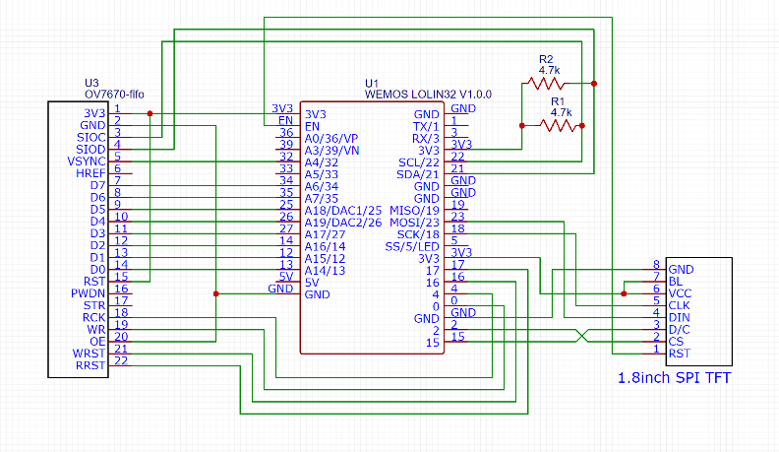
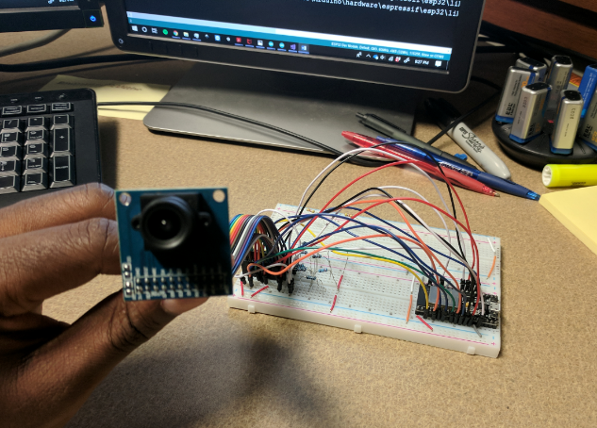
To start off Phase 2, we began to build the circuit for our OV7670 camera for Arduino. The circuit diagram for this can be seen in Figure 5b and includes both the OV7670 camera and the SPI TFT screen; although, Figure 5a shows just the camera hookup. This is because the screen has not arrived to us. Once the screen arrives, we will be able to do some preliminary testing and get the camera running. We have attached some of the code that we have for running the camera and displaying the output on the LCD screen.
Figure 5: (a) The components in our setup are: an ESP32 board, an Arduino camera (OV7670 FIFO), and a
LCD screen (to be delivered). (b) The circuit diagram for our preliminary camera setup.
Next, we have begun 3D printing the parts for our robotic gripper arm. A screenshot of the assembly file is seen in Figure 6, which shows the entire set up. Once the parts are finished printing, we will begin assembling and attaching them to our robot chassis. A screenshot of the drawing file is shown in Figure 7. The dimensions can be viewed in the ‘Arduino Robot Arm.dwg’ file, which is also attached to this submission. Additionally, any individual CAD or assembly files can be available upon request.
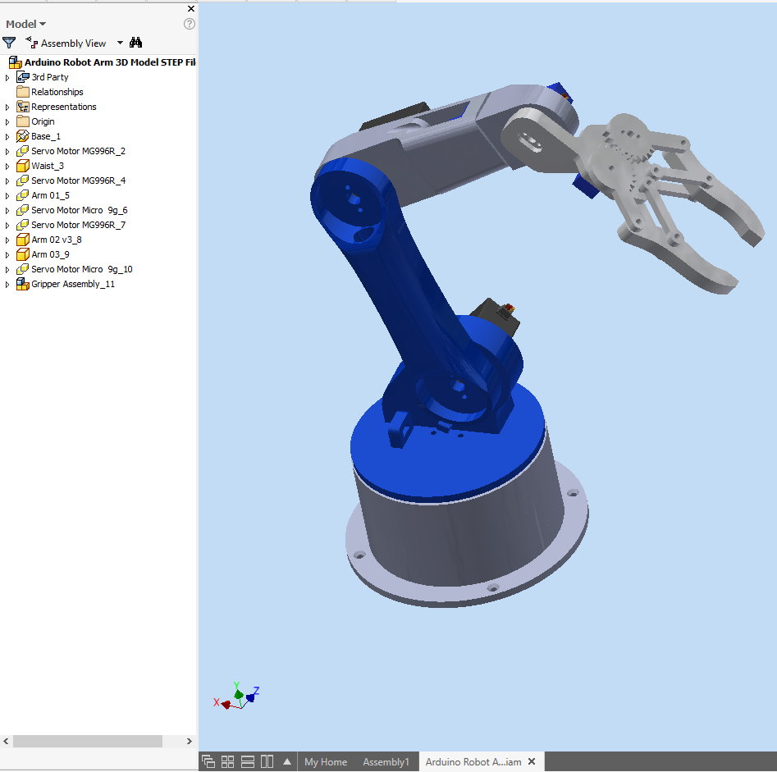
Figure 6. CAD model of our robot arm (3D printing in process).

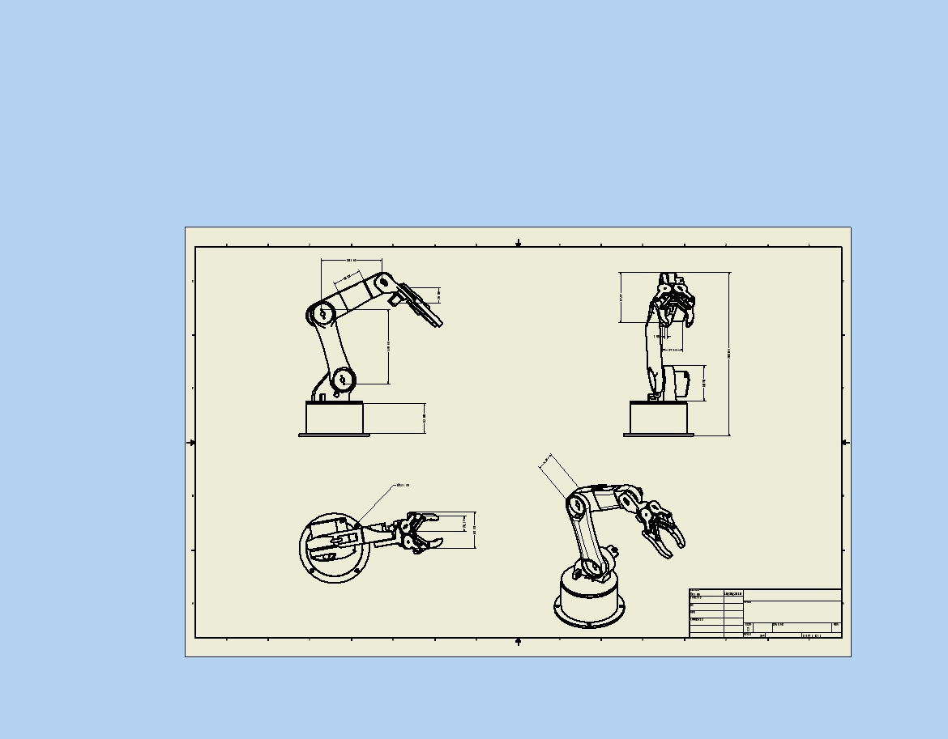
Figure 7. CAD Drawings of the robot arm.
References
[1] Ghiani, Giuseppe, et al. "Personalization of context-dependent applications through trigger-action rules." ACM Transactions on Computer-Human Interaction (TOCHI) 24.2 (2017): 14.
[2] Buckl, Christian, et al. "Services to the field: An approach for resource constrained sensor/actor networks." Advanced Information Networking and Applications Workshops, 2009. WAINA'09. International Conference on. IEEE, 2009.
[3] Manches, Andrew, et al. "Three questions about the Internet of things and children." TechTrends 59.1 (2015): 76-83.
[4] Chatzopoulos, Dimitris, et al. "Mobile augmented reality survey: From where we are to where we go." IEEE Access 5 (2017): 6917-6950.
[5] H. Kato and M. Billinghurst, ‘‘Marker tracking and HMD calibration for a video-based augmented reality conferencing system,’’ in Proc. IWAR, Oct. 1999, pp. 85–94.
[6] M. Fiala, ‘‘ARTag, a fiducial marker system using digital techniques,’’ in Proc. IEEE Comput. Soc. Conf. Comput. Vis. Pattern Recognit., Jun. 2005, pp. 590–596.
[7] D. Wagner and D. Schmalstieg, ‘‘Artoolkitplus for pose tracking on mobile devices,’’ in Proc. CVWW, 2007, pp. 233–234.
[8] G. Reitmayr and D. Schmalstieg, ‘‘OpenTracker—An open software architecture for reconfigurable tracking based on XML,’’ in Proc. IEEE Virtual Reality, Mar. 2001, pp. 285–286.
[9] D.SchmalstiegandD.Wagner,‘‘Experienceswithhandheldaugmented reality,’’ in Proc. 6th IEEE ACM Int. Symp. Mixed Augmented Reality, Nov. 2007, pp. 3–18.
[10] A. Henrysson and M. Ollila, ‘‘Umar: Ubiquitous mobile augmented reality,’’ in Proc. 3rd Int. Conf. Mobile Ubiquitous Multimedia, 2004, pp. 41–45.
[11] D. Schmalstieg and D. Wagner, ‘‘Mobile phones as a platform for aug- mented reality,’’ in Proc. IEEE VR Workshop Softw. Eng. Archit. Realtime Interact. Syst., 2008, pp. 43–44.
[12] G. Reitmayr and D. Schmalstieg, ‘‘Mobile collaborative augmented real- ity,’’ in Proc. ISAR, Oct. 2001, pp. 114–123.
[13] D. G. Lowe, ‘‘Distinctive image features from scale-invariant keypoints,’’ Int. J. Comput. Vis., vol. 60, no. 2, pp. 91–110, 2004.
[14] H. Bay, T. Tuytelaars, and L. Van Gool, ‘‘SURF: Speeded up robust features,’’ in Proc. 9th Eur. Conf. Comput. Vis., vol. 3951. 2006,
[15] D. Wagner, D. Schmalstieg, and H. Bischof, ‘‘Multiple target detection and tracking with guaranteed framerates on mobile phones,’’ in Proc. ISMAR, 2009, pp. 57–64.

