Group Project 4280 Spring

Members:

Luke Bickein

Ashan Khan

Tom Grossman

James Spatola

Project: Develop Messaging App for Music Department

Customer: Gary Brandes, Department Chair

Description: Instant message music department groups easily to iPhone or Android. Includes integration with Google Calendar for event notification.

Documentation:

1. Administrative Guide
2. Users Guides
   1. Faculty
   2. Students
3. System Administrative Documentation

Administrative Guide

Steps

Register Administrators

1. Register
   1. Go to thedeamteam.me in a web browser. The UMSL Music Notification System home page displays.

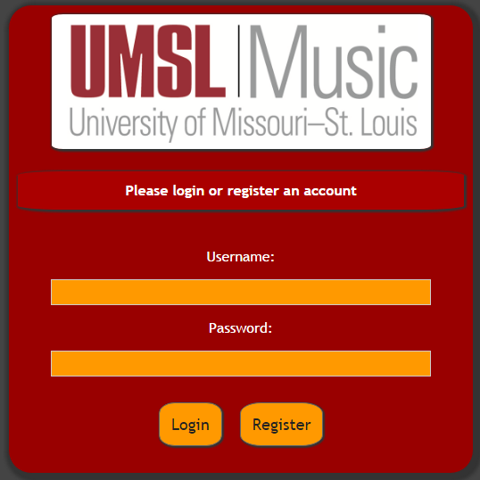

* 1. Click on Register button.

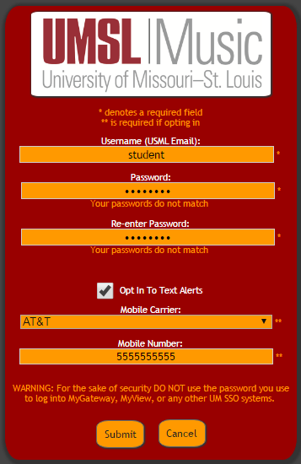

* 1. Fill out required fields.
  2. Click Submit. A confirmation text or email will be sent to you.
  3. Click on the link in that text or email to finish registration process.

1. Setup – for first time use
   1. Go to thedeamteam.me in a web browser. The UMSL Music Notification System home page displays.



* 1. Enter admin as username and password as password and click on Login. That takes you to Main Menu.

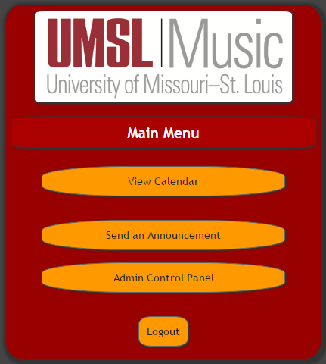

* 1. For set up purposes click on Administration Control Panel.

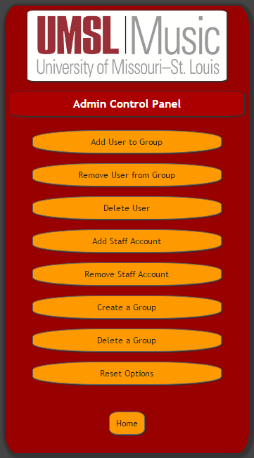

1. Add Administrators
   1. Click on Add Staff Account.

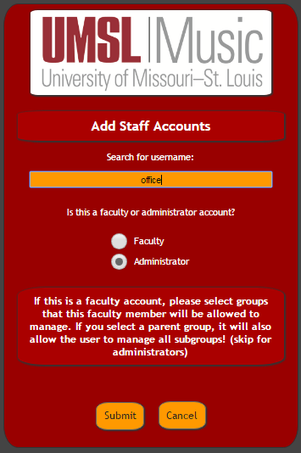

* 1. Enter the User name for the first Administrator account.
  2. Select the radio button for Administrator.
  3. Click on Submit.

1. Add Groups
   1. From Administration Control Panel click on Create a Group. You will see the Group Control Panel:

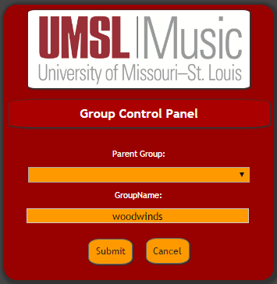

* 1. Start by adding the highest level groups without parents like woodwinds. Type that name in GroupName and click Submit.
  2. Next add a subgroup within a parent group. Click on Create a Group from Administration Control Panel.
  3. From Group Control Panel select from pull down menu the parent group your new group will be a child of (subgroup).

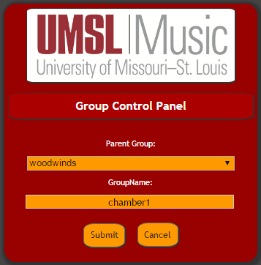

* 1. Finally type the GroupName and click on Submit.

1. Add Faculty
   1. Click on Add Staff Account.

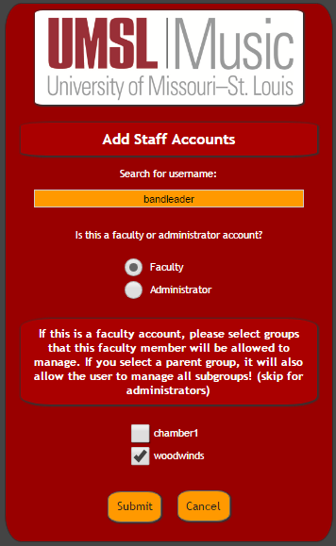

* 1. Enter User name for faculty account.
  2. Select Faculty radio button.
  3. Check the box next to the group(s) this account can manage.
  4. Click on Submit.

1. Add Users to Groups
   1. From Administration Control Panel click on Add User to Group.

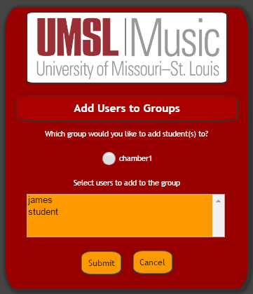

* 1. Click on the radio button to select group.
  2. Click on Users to add to group.
  3. Click on Submit.

1. Cleanup
   1. Remove User from Group
      * 1. From Administration Control Panel select Remove User from Group.

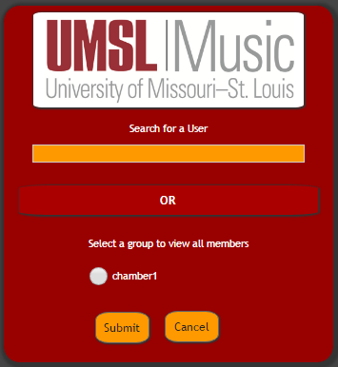

* + - 1. Enter User name in box or select group by clicking on its radio button to view all members.
      2. After selecting the user to remove click on Submit. You will get this screen:

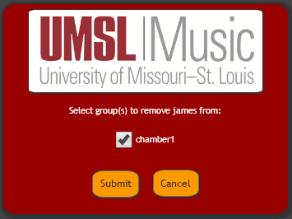

* + - 1. Click in check box for group(s) to remove selected user from then click on Submit.
  1. Delete User
     + 1. From Administration Control Panel select Delete User.

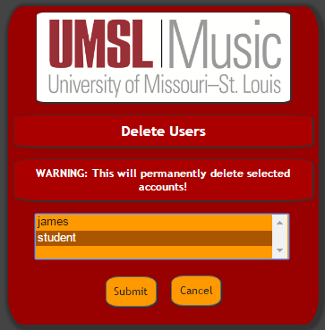

* + - 1. Click to select User to be removed.
      2. Click on Submit button.
  1. Remove Staff Account
     + 1. From Administration Control Panel select Remove Staff Account.

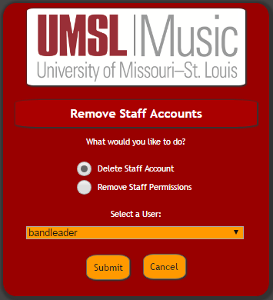

* + - 1. Click on radio button for Delete Account or Remove Permissions(to change).
      2. Select the User.
      3. Click on the Submit button.
  1. Delete Group
     + 1. From Administration Control Panel select Delete a Group.

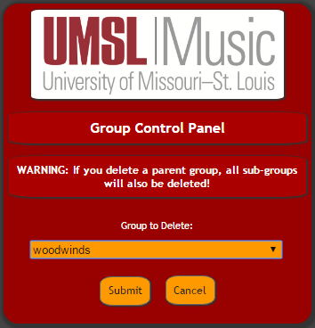

* + - 1. Select Group to Delete.
      2. Click on the Submit button.
  1. Reset Options
     + 1. From Administration Control Panel select Reset Options.

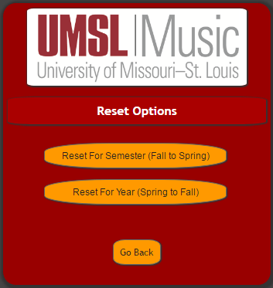

* + - 1. Select appropriate Reset option.

Faculty Guide

1. Register
2. Go to thedeamteam.me in a web browser. The UMSL Music Notification System home page displays.



1. Click on Register button.

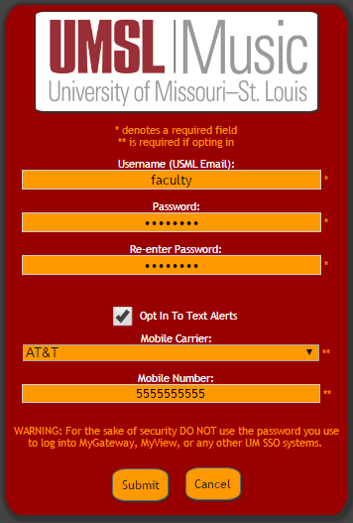

1. Fill out required fields.
2. Click Submit. A confirmation text or e-mail will be sent to you.
3. Click on the link in that text or email to finish registration process.
4. Add/Remove User to Group
5. Go to thedeamteam.me in a web browser. The Umsl Music Notification System home page displays.
6. Type in Username and Password and Click on the Login button.



1. From Main Menu, select Admin Control Panel

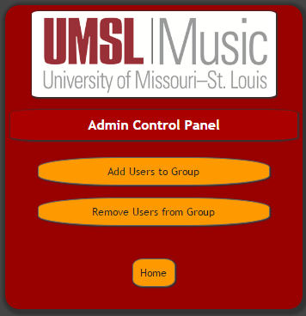

1. For Add Users to Group, click on that button.



1. Click on the radio button to select group.
2. Click on Users to add to group.
3. Click on Submit.
4. For Remove Users From Group, click on that button.



1. Enter User name in box or select group by clicking on its radio button to view all members.
2. After selecting the user to remove click on Submit. You will get this screen:



1. Click in check box for group(s) to remove selected user from then click on Submit.
2. Send Message
3. Go to thedeamteam.me in a web browser. The Umsl Music Notification System home page displays.
4. Type in Username and Password and Click on the Login button.



1. From Main Menu, select Send an Announcement.

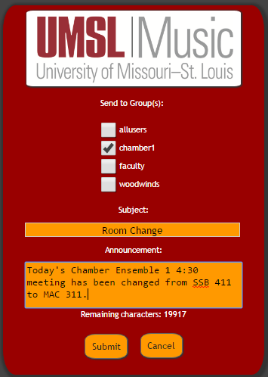

1. Check boxes for all groups to send to.
2. Type Subject and Announcement and Click on Submit button. A confirmation screen displays:

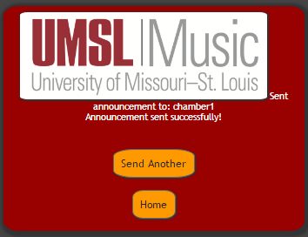

1. Google Calendar:

Go to thedeamteam.me in a web browser. Login. Click on the Google Calendar button.

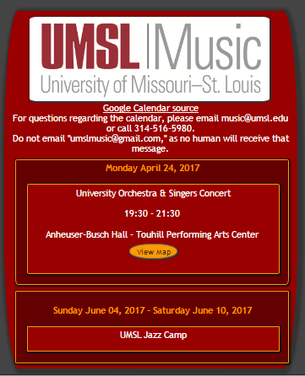

Student Guide

1. Register
   1. Go to thedeamteam.me in a web browser. The UMSL Music Notification System home page displays.



* 1. Click on Register button.



* 1. Fill out required fields.
  2. Click Submit. A confirmation text or e-mail will be sent to you.
  3. Click on the link in that text or email to finish registration process.

1. Message reception:

A text or email will be sent when important timely information changes. Upon text reception, click on the web link to view message.

1. Google Calendar:

Go to thedeamteam.me in a web browser. Login. Click on the Google Calendar button.



Registration Name field: Unique and min/max Character length?

System Administrative Documentation

Description: describe project completely from systems engineering perspective. (In one year when the system is transferred to the department, this will be the important stuff. 4/24/2017)

This project consists mostly of html code with php, css, mysql calls. A decent amount of integrated server support and configuration is used. Outgoing messages go through mail server and api calls google calendar updates.

Sections:

1. Server Components and Configurations
2. Html code

Server Components and Configurations:

1. Domain Name System registration/IP address
2. Apache Web Sever
3. SQL Server
   1. tables
4. PHP Interpreter
5. Mail Server
   1. configuration

Html code: