RH: disparate disparity analyses.
The disparate ways to analyse morphological disparity
Thomas Guillerme, Natalie Cooper, Stephen Brusatte, Katie Davis, Andrew L Jackson, Sylvain Gerber, Anjali Goswami, Kevin Healy, Melanie Hopkins, Graeme Lloyd, Joseph O’Reilly, Abi Pate, Emilie Rayfield, Erin Saupe, Emma Sherratt, Graham Slater, Gavin H Thomas and Philip Donoghue
School of Biological Sciences, University of Queensland, St. Lucia, Queensland, Australia.
Department of Life Sciences, Natural History Museum, London, Cromwell Road, London, SW7 5BD, UK.
Bristol
+ These authors contributed equally to the manuscript.
*Corresponding author: guillert@tcd.ie
NOTE TO ALL THE CO-AUTHORS:
-Please write in Google docs using Suggesting mode only (upper right corner of your screen)
-The word limit for this is 5000 words so we can’t add any large sections.
-There is no reference limit per se but please don’t add too many. I will sort out the references later so don’t correct the formatting of them here.
-I suggest you add your references using the Paperpile addon (go in Add-ons menu > Get Add-ons… > Search for Paperpile > Add/Install; then go in Add-ons menus > Paperpile > Manage citation). If you don’t use Paperpile, please don’t add references as just (“Someone et al. 2000” but add also a link to the correct Google Scholar entry in comments).
-Add your affiliation in the author list above. The affiliations count in the word count so please 1) keep it short (max 1 per person!) and 2) try to use one that’s already in there. Also add any initials I’ve missed in your names.
- If in doubt, check formatting here: https://royalsociety.org/journals/authors/author-guidelines/
Thanks!
Abstract (200 words max)
Morphological disparity analysis is used to characterize and investigate discrete patterns of variation in the shape, form, function, and the ecology of organisms. Since their conception in the 1980s, these methods have been used to ask a variety of questions about how and why morphological diversity evolves, and the ecological consequences of these changes. There are many methodological approaches for studying disparity, however, all of these come with caveats and pitfalls that can, if ignored, lead to misinterpretations of disparity patterns. Here we review morphological disparity methods and their caveats, and provide best practice guidelines for their application and interpretation. We discuss the data required for disparity studies, as well as methodological challenges, including multidimensionality, ordination, metric choice, hypothesis testing, and ancestral state estimations. There is no “one-size-fits-all” approach to characterizing and investigating the evolution of morphological disparity, and the available tools should always be used in the context of a specific biological question that will determine data and method selection at every stage of the analysis.
Keywords: multidimensionality, palaeobiology, ecology

1. Introduction
Variation in the shape, form and function of organisms often exhibits a pattern of discrete clusters rather than continuous gradients. These patterns can be pictured as multidimensional spaces encompassing all the possible forms an organism can take, and where each individual region of this space is the result of a unique combination of many variables. One commonly used approach to analyse these patterns and to understand the processes that lead to them, is to analyse the morphological diversity of a group, often referred to as a “morphological disparity analysis” (Deline et al. 2018).
The initial informal definition of morphological disparity was “multidimensional morphological dissimilarity at a macroevolutionary scale” (Runnegar 1987, (Gould 2000)). In the seminal disparity papers of the late 1980s, disparity was used to investigate body plan evolution after the Cambrian explosion (Briggs, Fortey, and Wills 1992)(Gould 1991; Valentine 1986; M. Foote and Gould 1992; Morris 1989); (Briggs, Fortey, and Wills 1992);. Early disparity analyses focused on broad questions such as: How does diversity evolve? Are some phenotypes more common than others? and Can anatomical shapes evolve in all “directions” of the multidimensional space (Mike Foote 1997, 1995)? Since the 1990s, a great deal of literature from a range of sub-fields in biology and palaeontology, and an equally large number of methods, have used “disparity” as a broader umbrella term for studies of multivariate variation. Although most influential reviews have treated disparity as a pattern (Mike Foote 1997; Wills 2001; Melanie J. Hopkins and Gerber 2017), there is currently no consensus on whether to restrict use of the term disparity to its original macroevolutionary-scale definition, or whether it can refer to any study of multivariate variation. Here we use a broader definition and suggest that morphological disparity is a pattern of variation in phenotype. Disparity analysis has been used to tackle a vast array of questions. We identify four main classes of disparity analysis as follows.
(1) Descriptive disparity analyses. The seminal studies of disparity described the shapes of organisms and how they differed among groups (Mike Foote 1995; Wills, Briggs, and Fortey 1994). These consist of descriptive multidimensionality analyses of the patterns in the diversity of morphological traits, addressing questions such as: why are some morphological traits combinations more common than others and what are the properties of the resulting morphospace? (Mike Foote 1995; Raup 1961; Gerber 2017).
(2) Disparity-through-time analyses. This approach investigates how the shapes of organisms have changed through time, focussing on the disparity of taxa in particular time bins or slices. This approach has been widely used in palaeobiology to answer a range of macroevolutionary questions (Close et al. 2015; Cisneros and Ruta 2010; Hughes, Gerber, and Wills 2013), such as: how does disparity accumulate over the history of a clade (Guillerme and Cooper 2018; Wright 2017), and how does disparity change across mass extinction events (Friedman 2010)?
(3) Disparity and diversity. Morphological disparity provides another perspective on biodiversity; high morphological disparity represents a high diversity of morphologies (i.e. shapes or body plans) and is, presumably, associated with high levels of ecological and functional diversity (see below). This makes disparity a more useful measure of diversity than merely species richness. Indeed, most studies that have investigated disparity and taxonomic diversity support an effective decoupling (Fortey, Briggs, and Wills 1996; Ruta et al. 2013; M. J. Hopkins 2013; Moyne and Neige 2007) - though this result breaks down at extremes of diversity; extremely low diversity tends to yield low disparity and vice versa. This approach has been used to investigate whether some groups are more successful than other in their exploration of new evolutionary strategies @@@.
(4) Disparity and ecology. The disparity of a group can be used as a proxy for either the functional role it plays within an ecosystem or its ecological niche. These analyses assume that groups with high disparity are also likely to be functionally and ecologically diverse, and that groups found in similar regions of shape space will have similar functional and ecological roles (Friedman 2010; Pierce, Angielczyk, and Rayfield 2008; P. S. L. Anderson et al. 2011). Note however, that the links between form and function are not always clear cut; traits can be linked to multiple functions and multiple functions can be linked to a single trait (Wainwright et al. 2005). This approach is used to investigate competitive replacements (Stephen L. Brusatte et al. 2008) and changes in ecosystem function during and after mass extinctions (Friedman 2010). It is particularly common in paleobiology where it is not possible to observe directly the ecological or functional characteristics of extinct species. (Wainwright et al. 2005)
Of course, these four broad categories are not independent and many studies use a combination of approaches (Stephen L. Brusatte et al. 2008). Furthermore, disparity analysis is continuously expanding into areas. While this is exciting for the field, there are several issues that may reduce the utility of disparity analyses if they are not tackled. Here we review these issues and present best practice guidelines to allow researchers to optimise their analyses. We first discuss the appropriate data required for disparity analyses, then review various challenging methodological aspects of disparity analyses. Throughout it is important to remember that these tools should always be used in the context of a specific scientific question, as this will drive data and methodological choices at every stage of the process.
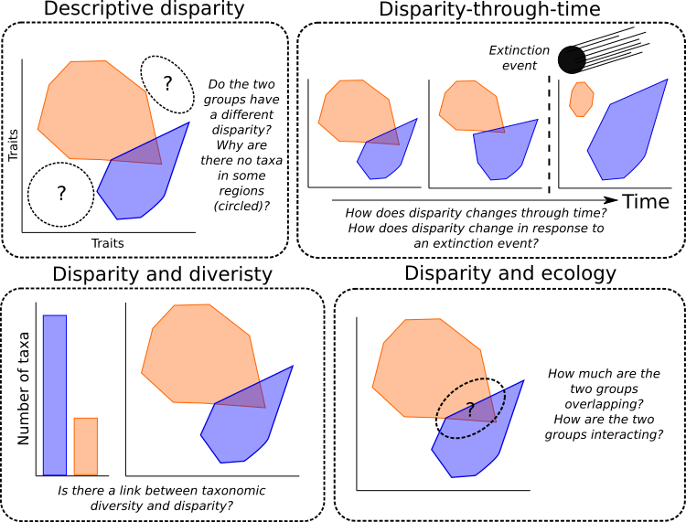
Figure disparities [figure_disparities.pdf]: The four main types of disparity analysis. Descriptive disparity analyses focus on describing the properties of the morphospace ; Disparity-through-time analyses investigate the evolution of the morphospace through time including the effect of extinction events; Disparity and diversity analysis use disparity as a proxy for species diversity; Disparity and ecology analyses use disparity as a proxy for the ecological or functional role of a group. These categories are not independent and many analyses will cover more than one.

2. Data in Disparity Analyses
Regardless of the precise approach being used, disparity analyses are based on morphological traits. It is important, therefore, to consider which traits to use in the context of the specific question under investigation. Traits for disparity analyses come from three main types of data: (1) discrete “cladistic” characters, i.e coding the absence-or-presence of features or a discrete characteristic of a trait (Close et al. 2015)); (2) continuous measurements of features (P. S. L. Anderson et al. 2011); or (3) more sophisticated mathematical measurements from geometric morphometric data (e.g. Procrustes superimpositions (Cooney et al. 2017), or Fourier contours (Spriggs et al. 2018)). None of these are fundamentally better, however, some questions and methodological pipelines are more appropriate with specific types of data.
When investigating variation within bat wing shapes, for example, both homologous landmarks from geometric morphometric analysis and continuous measurements of bones may be appropriate to capture patterns of wing variation. However, if the question focuses on the convergence between bat and bird wings, the homology of the traits to measure is more complex to define and the outline shape of the wings might more readily answer the question from a mechanical perspective. Similarly, if the focus is on wing function, i.e. whether the aerodynamic properties of wings vary within bats or between bats and birds, the traits collected should reflect these aerodynamic properties (e.g. wingspan, aspect ratio, etc.). Whereas if the focus is on convergence between different bats and birds, it would be preferable to use traits that have facilitated flight in both groups (e.g. digit length, integumentary system, etc.). Where there is any doubt about the appropriate traits to choose, we advise using different kinds of data for the same feature to determine whether it captures the same disparity.
This dicussion assumes that researchers are collecting their own data for disparity analyses, but often this is not the case. It is common, especially in disparity-through-time analyses, to recycle discrete character data collected for use in phylogenetic inference (e.g. REFs that have done this). This has the advantage of being quick, cheap and efficient, but tends to artificially increase disparity between phylogenetically distinct groups because phylogenetic characters are collected specifically for the purpose of discriminating groups (Mike Foote 1995). This needs to be considered when interpreting results, especially as when new clades appear, the synapomorphies of that clade will naturally lead to an apparent shift or increase in disparity. Similarly, data used for phylogenetic reconstruction is likely to be highly skewed towards easily available and taxonomically relevant traits, for example teeth in mammals. If your disparity question is related to feeding ecology or similar then this may be appropriate, but if the focus is on dispersal ability then it would be sensible to select only postcranial traits. It is often tempting to use all of a large dataset to increase the power of your analyses, but if the data are not suitable for the question at hand then the results may be meaningless (although ssome studies have suggest this may not be a major issue; (Zou and Zhang 2016; Dávalos et al. 2014) (Melanie J. Hopkins 2017)).
Finally, trait data suffers from the same shortcomings as most data – data can be missing, non-overlapping, hierarchical, inapplicable, ambiguous, polymorphic, correlated, or have insufficient sample size (Palci and Lee 2018), (Brazeau, Guillerme, and Smith 2017) [String of morpho data problems cite]. Biological phenomena such as allometry and sexual dimorphism may also influence trait data. More practically, data collection is constrained by the time and money available, making collating a “perfect” dataset difficult. We suggest that trait data are collected with the question in mind and considering all of the caveats above, but where issues are unavoidable at the very least these caveats must be considered during the analyses and subsequent interpretation of the results.
Figure data [figure_data.pdf]: major routes to obtain disparity data. Data can be collected as discrete trait observations (e.g. presence or absence data) or as continuous data. Continuous data can be collected by different methods: linear measurements, landmark coordinates or contours (curves). These measurement can then in turn be mathematically transformed (logarithm, scaling, Procrustes Superimposition, Elliptic Fourier, etc.). Regardless of the method, this data collection results in a trait matrix where the observed traits constitute columns and the studied elements (e.g. taxa) the rows.
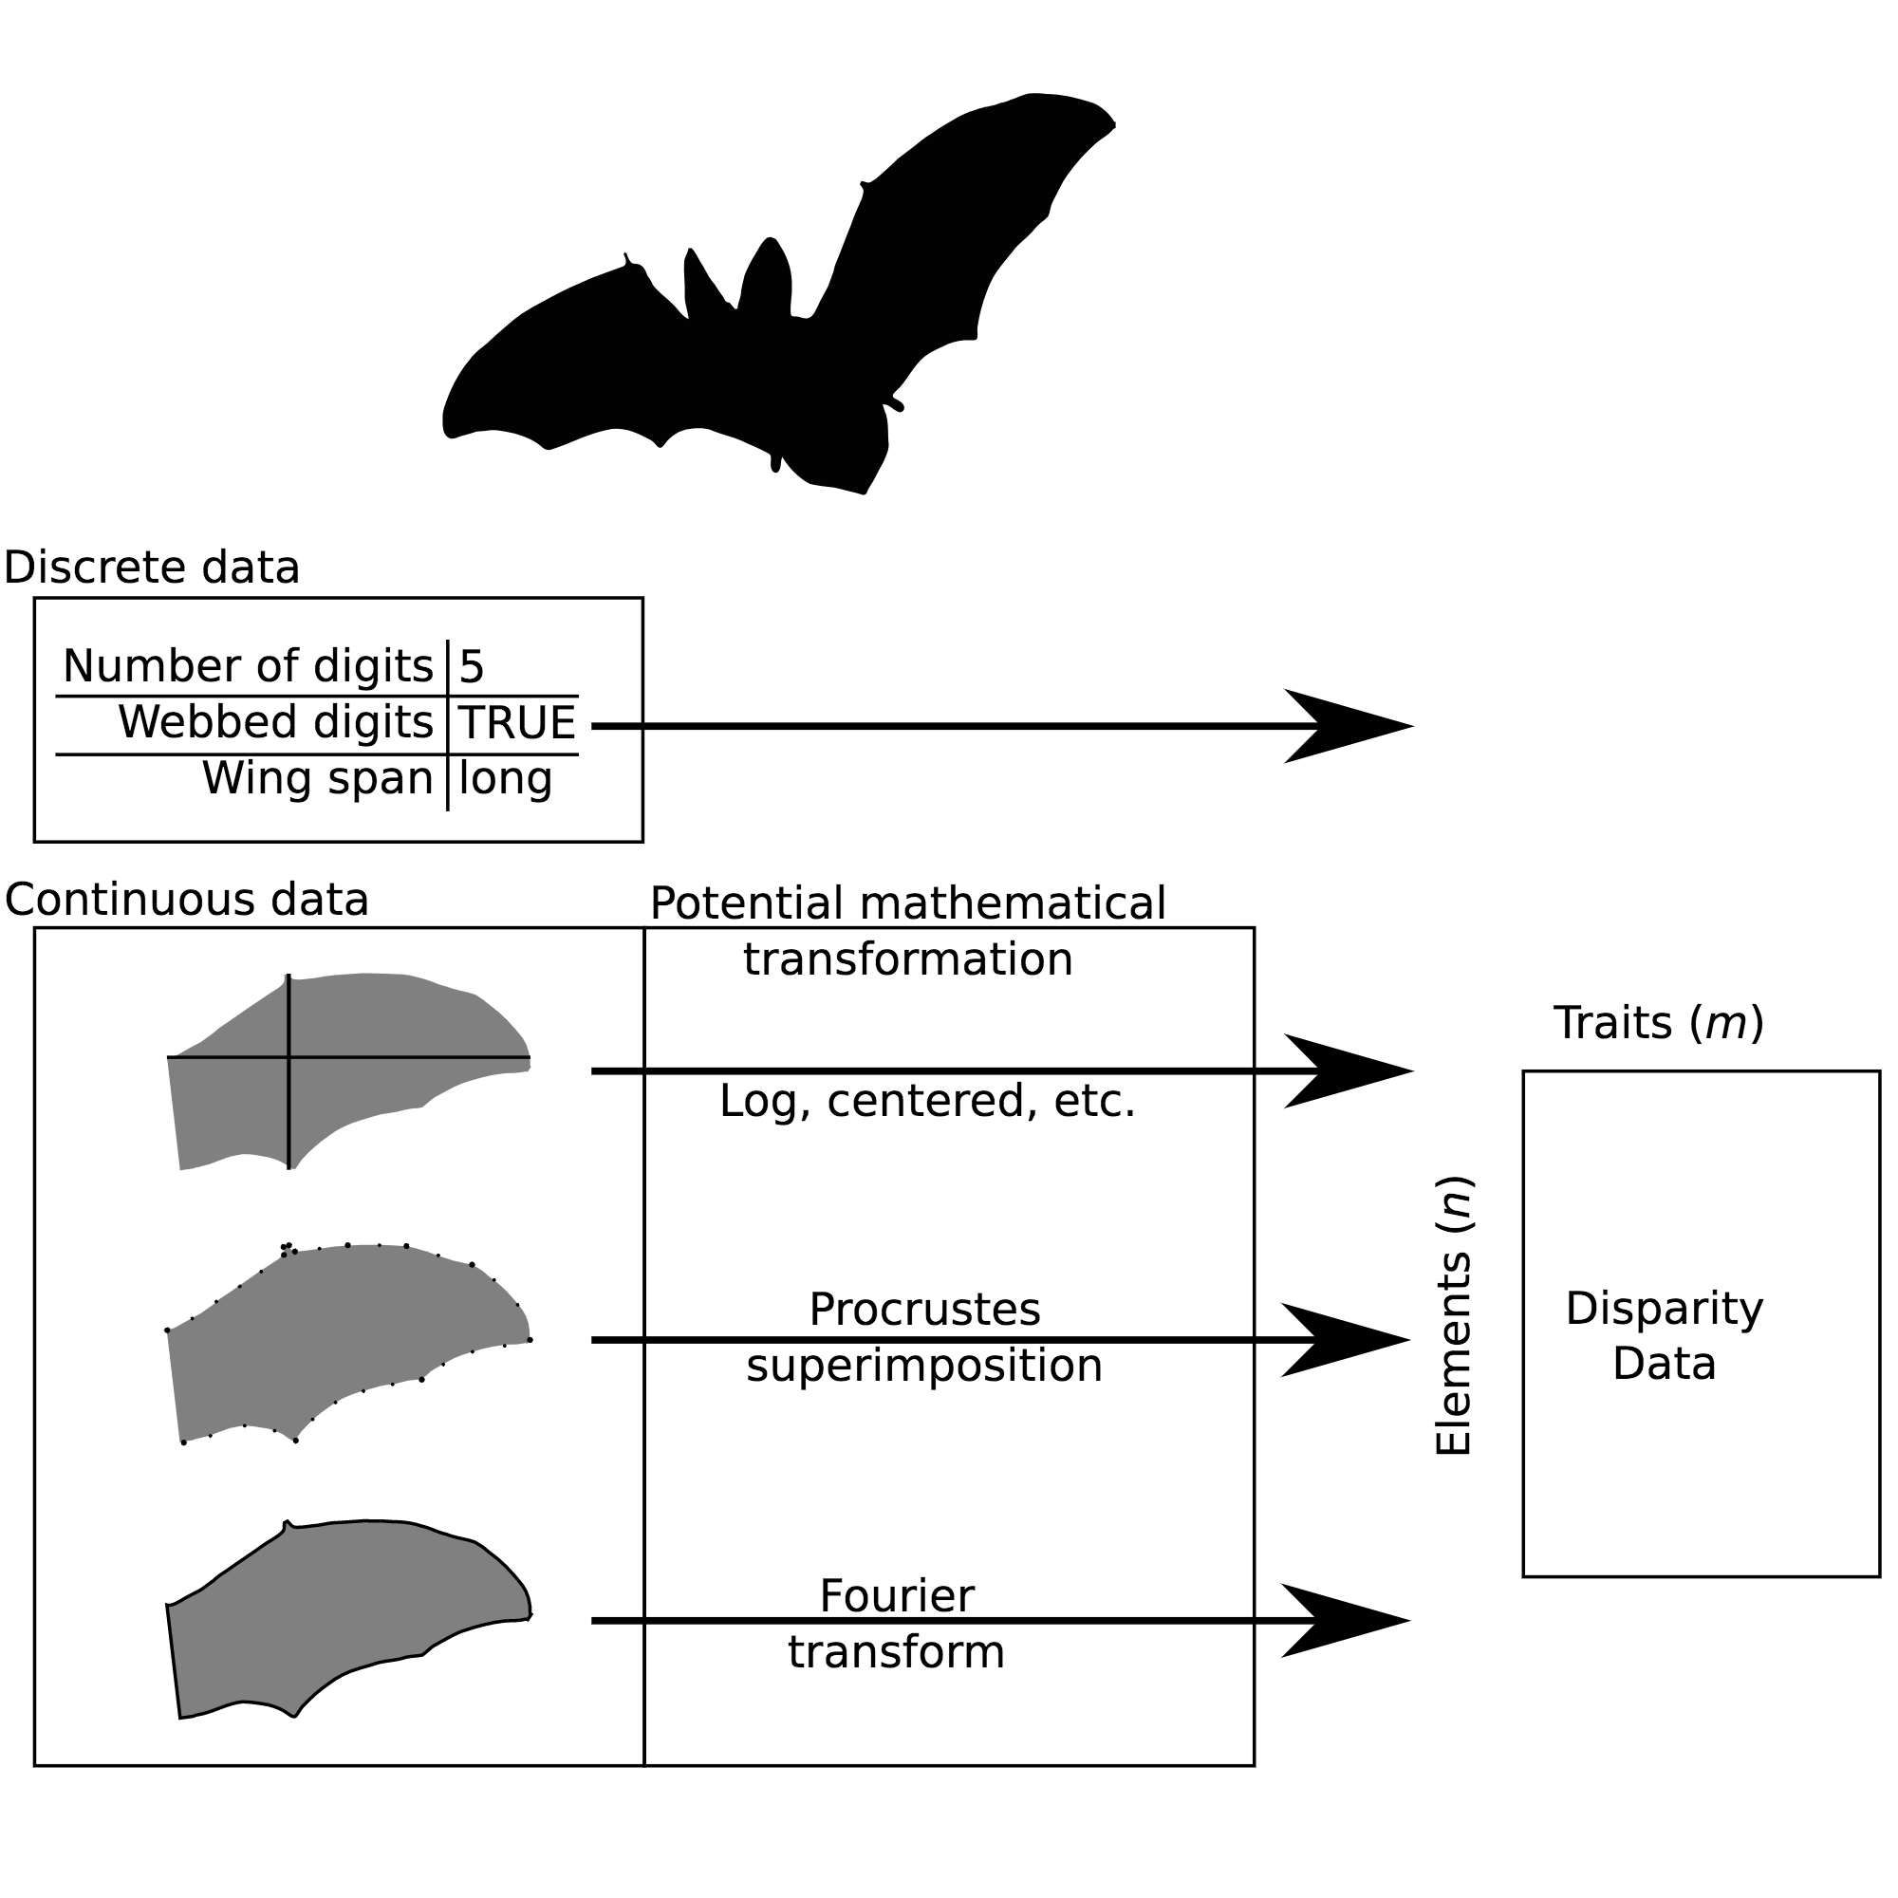

3. Disparity Methods
Once suitable trait data have been collected, we need to consider the disparity analysis. Below we address several key aspects including (i) the difficulty of dealing with multidimensional data; (ii) caveats associated with using ordination techniques to reduce the dimensionality of the data; (iii) various metrics used to summarise the disparity of a group; (iv) caveats related to methods that exist for hypothesis testing within a disparity analysis framework; and (v) the specific case of ancestral state estimations in disparity-through-time analyses. As noted above, these tools should always be used in the context of a specific question, as this will determine which methods are most appropriate.

3.1. Multidimensional mayhem
The multidimensional aspect of disparity analyses adds a layer of technical complexity because the human brain naturally struggles to comprehend more than three spatial dimensions. This problem is often apparent in how people interpret the results of disparity analyses. For example, it is standard for disparity results to use ordination techniques to reduce their dimensionality, and for only the first or second axes of ordination (e.g. principal components (PCs) one and two) to be interpreted and used to draw conclusions. Changes in disparity along these axes may show a pattern or gradient, but often do not reflect the true changes across all the dimensions of the data (Bookstein 1997, 2015, [b] 2017, [a] 2017)[CITE Vera and Thomas paper]. Visual interpretations of multidimensional data can also easily be misleading. For example, an obvious discontinuity (or overlap) between two groups in a morphospace of PC1 and PC2, may not be apparent when looking at the same groups in a morphospace of PC2 and PC3 etc. or across the whole multidimensional space. Furthermore, multidimensional spaces are not necessary Euclidean. Such non-Euclidean spaces often have non-intuitive properties, for example straight lines in some dimensions are not straight in non-Euclidean space and, even less intuitively, the distance between points A and B might not be equal to the distance between points B and A (Gerber 2014).

3.2. To ordinate or not to ordinate; that is the (multidimensional) question?
Reducing the dimensionality of a disparity dataset can be tricky. Ordination is advantageous for plotting and visualising the data, and can reveal properties of the morphospace not captured by disparity metrics (see Metrics section [metrics]). Additionally, after ordinating the data it is possible to further reduce the number of dimensions by only selecting a certain number of axes, for example by selecting only the axes that describe up to 95% of the variation. In the case of geometric morphometric data, ordination is particularly useful as it conserves the mathematical properties of the data while efficiently reducing the dimensions (Legendre and Legendre 2012). This has clear advantages for interpreting the results. For example, the axes will represent gradients of biological variation (e.g. elongation and flattening of the beak (Cooney et al. 2017)).
However, various caveats can arise from such transformations of the data. For example, in the case of an ordination in a geometric morphometric context, not using all the axes from the ordination can lead to misinterpretation of the results. Furthermore, interpreting biological variation along the axes is always a post-hoc procedure and may have little relation to the disparity question, for example, if the first few ordination axes represent the elongation of the beak in birds, but the question is about wing disparity.
In many cases, ordination might not be necessary. For example, if the disparity metric being used relies on all the data (see Metrics section [metrics]) it is not necessary to calculate it on ordinated data [e.g.(Close et al. 2015)]. Additionally, in some cases, reducing the dimensionality of a dataset can render its interpretation more problematic. For example, when the analysed data is non-Euclidean (e.g. discrete morphological characters), ordination can be difficult, and the resulting non-Euclidean ordinated space can be hard to interpret (Gerber 2014). This is problematic when comparing the position of groups in the multidimensional space, as the measured distances might not be comparable. Finally, the post-hoc interpretation of the gradient of variation on the ordination axes can be impossible or biologically meaningless. Although some gradients are easy to detect or interpret (e.g. the elongation of the beak along the first axis; cooney paper), some are not. For example, with discrete morphological data, a gradient between the species that have many characters in state 1 and the ones that have more in state 0 has no biological meaning. Because of these caveats, we strongly recommend that data for multidimensional analyses is not automatically ordinated, and that careful consideration is given to whether the question can be answered without ordination.
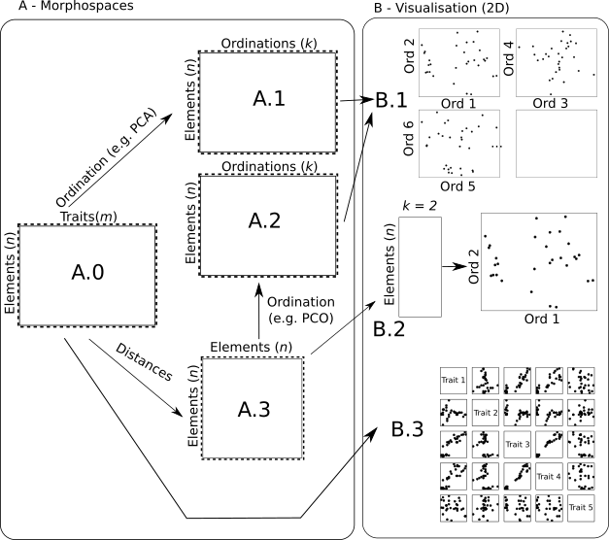
Figure methods: Different ways to define and visualise a morphospace: A.0: The morphospace is the collected trait space (with some potential modification - see data section above): this can be visualised using bi-plots (or correlation plots - B.3) between all the traits but becomes hard to interpret after a few traits. Another approach is to directly ordinate the trait matrix (with a PCA - A.1 - e.g. in (Zelditch, Swiderski, and David Sheets 2012)- or a PCO - A.2; e.g. in Brusatte et al. 2008). This results in a k (<m) space that can also be hard to visualise even though the first axis hold most of the variation (B.1). Another approach is to create a distance matrix (A.3; e.g. in Close et al., 2015) this matrix can then be ordinated as well for further analysis (A.2 and used as the ordinated morphospaces described above) or “flattened” to a manageable number of dimensions (2 or 3 - B.2).

3.3. Disparity metrics
Because disparity is multidimensional, a large component of any disparity analysis involves considering how to extract a meaningful (and interpretable) summary of disparity, i.e. choosing which disparity metric (or index)(Melanie J. Hopkins and Gerber 2017) to use. As with any summary metric, and because of this reduction in dimensionality, disparity metrics will only reflect some aspects of the morphospace, never its whole complexity. It is therefore often beneficial to use more than one metric to summarise different aspects of interest. The choice of disparity metric is essential to the disparity analysis and should always be driven by the question at hand.
When considering only one dimension, disparity metrics can be used to reflect the “size” of the distribution (e.g. the range, quantiles or variance), or the most likely value (i.e. the central tendency, mean, median or mode). Among these metrics, some will have more attractive properties than others, such as sensitivity to outliers – range, mean and mode are highly sensitive whereas quantiles, variance and median are less so – and will thus be more or less appropriate for different questions. For example, if the question refers to “size” of a group in the morphospace (e.g. does group A occupy as much space as group B?), metrics related to the spread of the group in the morphospace are the most appropriate (e.g. volume (Díaz et al. 2016), distance from the centroid (Melanie J. Hopkins and Gerber 2017; Finlay and Cooper 2015), variance and range (S. L. Brusatte et al. 2008)). Conversely, if the question refers to the “position” of a group in the morphospace (e.g. does group A occupy the same space as group B?), metrics related to the distance between the elements within a group and a fixed point in the morphospace are most appropriate (e.g. ????). Finally, if the question relates to the density of elements in some regions of the morphospace (e.g. is group A more dense than group B?), metrics related to the pairwise distances between elements will be most appropriate (e.g. nearest neighbour distance, pairwise distances, etc. (Close et al. 2015)).
In addition to considering what properties of disparity the metrics should capture, it is important to also consider the mathematical properties of the metrics and their associated caveats (Wills 2001; Ciampaglio, Kemp, and McShea 2001). For example, measuring the full sum of the variance of each dimension of the space does not require one to add the covariance between the axes in a ordinated space using a principal components analysis (PCA). This is not true however, in other mathematical spaces or when not all dimensions or elements are considered, even in a PCA. More simply, when looking at a group within morphospace, the sum of variances is not mathematically equal to the sum of the variance of each dimension in the space. Further, multidimensional space has some counter-intuitive properties that need to be considered such as the “curse of dimensionality” (Bellman 1966). Product-based metrics used as proxies of volumes (e.g. product of ranges, hypervolume, hypercube, etc.) will tend towards zero fairly quickly for spaces with even a modest number of dimensions [(Bellman 1966); Donoho 2000]. Some other types of metrics are also extremely sensitive to outliers and can be easily biased by sample size, for example range (Butler et al. 2012) or convex hull based metrics (Butler et al. 2012; Jackson et al. 2011).

3.4. Testing disparity hypotheses
As mentioned above, disparity analysis should always be used in the context of a specific question. Once disparity metrics have been calculated, the associated question must be tested in an appropriate statistical framework. The multidimensional statistical toolkit for ecology and evolution has been greatly expanded in recent years (Adams and Collyer 2018) but is not routinely applied to disparity analyses. Instead, disparity hypothesis testing is mostly confined to a small set of well-established methods. One commonly used test is the non-parametric permutation analysis of variance (M. J. Anderson and Walsh 2013; M. J. Anderson 2001). This test is an analysis of variance (ANOVA) of the pairwise distances between different groups. Although statistically valid, this test is sometimes not directly related to the hypothesis under test. For example, PERMANOVA tests whether two groups share the same variance/covariance in a “distance-space”. This is not the same as testing whether the two groups overlap in morphospace. Explicitly stating the hypothesis being tested can help with understanding which statistical test to apply for a specific question.
It is also important to consider which data to apply a statistical test on. For example, in morphological disparity analysis, especially for palaeobiological questions, data are often bootstrapped. This has two advantages: first, when the disparity metric is unidimensional, e.g. the sum of variances, bootstrapping the data generates a distribution of the metric that can then be analysed using the vast statistical toolkit available for comparing distributions; second, when data are scarce, bootstrapping the data allows users to introduce variance, rendering the test less sensitive to outliers. However, bootstrapped data are pseudoreplicates and thus non-independent. This violates the assumptions of most parametric statistical tests. Furthermore, the number of bootstrap pseudoreplicates will inevitably increase the Type I error rate. These factors are often ignored in disparity analyses.

3.5. Phylogenetic autocorrelation
As with all comparative datasets, the data used in disparity analyses are not independent because close relatives will tend to have more similar morphologies than more distant relatives (Harvey and Pagel 1998). Thus for many disparity analyses phylogenetic relationships should be taken into account. Multivariate phylogenetic comparative methods have been reviewed recently by (Adams and Collyer 2018) and therefore will not covered further in this review. However, we do briefly draw attention to the fact that phylogenetic corrections of PCA are inappropriate (cite Pennell Uyeda paper on phylo PCA).

3.6. Ancestral state estimation in disparity-through-time analyses
One final methodological detail to consider applies only to disparity-through-time analyses. Often these analyses use ancestral state estimation (often mistakenly referred to as ancestral state reconstruction) to extract disparity estimates for non-sampled taxa and/or nodes of a phylogeny. Ancestral state estimation can be performed at two points in the disparity analysis pipeline, either (1) pre-ordination, i.e. the estimation is done before transformation of the data (e.g. ordination, or distance matrix construction) and is simply based on the original data; or (2) post-ordination, i.e. the estimation is done after transformation of the data by estimating the ancestral states using the transformed matrix (e.g. the ordination scores) (Lloyd 2018).
Pre-ordination ancestral state estimation can change the ordinated space’s geometry – i.e. the relationship between the points are not yet estimated – and implies longer computational times, but once the morphospace is defined its properties will not change. Post-ordination ancestral state estimation will not change the ordinated space’s geometry and is faster to compute, however, it will change the morphospace properties such as the number of parameters, i.e. elements in the space, or the variance on each axis, which can be problematic for statistical tests down the line (Lloyd 2018).
More importantly, however, using any ancestral state estimation method has several caveats. First and foremost, ancestral state estimations are highly dependent on the data and chosen methods. Second, when using post-ordination ancestral state estimates, the morphospace can be saturated leading pairwise-distance metrics to tend to zero. In general, using ancestral state estimation can help with recovering patterns of changes in disparity but should not be used simply to generate extra data points to increase statistical power. In fact, these extra points are not independent and can also generate problematic side effects, especially when testing for the effects of mass extinctions on disparity.

4. Disparity analyses for the future
Morphological disparity analyses are a major tool in evolutionary biology, but they have many caveats. There, there is no “one-size-fits-all” morphological disparity analysis pipeline. As with any multidimensional analysis, there are many nuances in deciding which data to use and how to analyse it, stemming from the explicit hypothesis being tested. We believe that many of the problems in morphological disparity analysis can arise when “blindly” applying methodological pipelines while losing sight of the biological question being tested. We therefore advise keeping the methodology simple and tractable, at least in the preliminary analysis. Also, many of the caveats and technical problems in disparity analyses have been tackled in other fields, mainly ecology. This is unsurprising, as ecological data are also often multidimensional (Donohue et al. 2013; Canter et al. 2018). Seeking solutions using these literature is a sensible next step for disparity analysis.
While morphological disparity would greatly benefit from advances in multidimensional analysis in different fields similarly, the concept of a morphospace could benefit other fields. For example, the multidimensional analysis in Diaz (Díaz et al. 2016) looking at the patterns of form and function in plants can be thought as a morphospace or a life-history-space (an eco-space?); isotopic analyses in (Jackson et al. 2011) can be represented as a isotope-space; ecosystem functioning in (Donohue et al. 2013) as an ecosystem-space, etc. These generalisations could also be exported for any set of traits (e.g. acousto-spaces for acoustic traits?) and even beyond evolutionary biology (e.g. glotto-spaces for linguistic traits?).
Although disparity analyses are now simple to implement (Guillerme 2018; Adams and Otárola-Castillo 2013; Bouxin 2005; Harmon et al. 2008; Lloyd 2016; Navarro 2003; Dixon 2003), it is crucial to remember that they are multidimensional analyses; and multidimensional analyses are complex. In Jurassic Park, Dr Ian Malcolm summarises this problem in an elegant way: “[We] scientists were so preoccupied with whether or not [we] could that [we] didn’t stop to think if [we] should.” We believe that morphological analysis in general will greatly benefit from emphasising the methodological decisions made (whether we should), rather than simply using disparity analysis because we can.

5. Author contributions
TG, NC and PD proposed this review. All authors edited the manuscript.

6. Acknowledgments
The Royal Society. TG funding.

Donoho, D. L. (2000). High-dimensional data analysis: The curses and blessings of dimensionality. AMS math challenges lecture, 1(2000), 32.

References
Adams, Dean C., and Michael L. Collyer. 2018. “Multivariate Phylogenetic Comparative Methods: Evaluations, Comparisons, and Recommendations.” Systematic Biology 67 (1): 14–31.
Adams, Dean C., and Erik Otárola-Castillo. 2013. “Geomorph: Anrpackage for the Collection and Analysis of Geometric Morphometric Shape Data.” Methods in Ecology and Evolution / British Ecological Society 4 (4): 393–99.
Anderson, Marti J. 2001. “A New Method for Non-Parametric Multivariate Analysis of Variance.” Austral Ecology 26 (1): 32–46.
Anderson, Marti J., and Daniel C. I. Walsh. 2013. “PERMANOVA, ANOSIM, and the Mantel Test in the Face of Heterogeneous Dispersions: What Null Hypothesis Are You Testing?” Ecological Monographs 83 (4): 557–74.
Anderson, Philip S. L., Matt Friedman, Martin D. Brazeau, and Emily J. Rayfield. 2011. “Initial Radiation of Jaws Demonstrated Stability despite Faunal and Environmental Change.” Nature 476 (7359): 206–9.
Bellman, R. 1966. “Dynamic Programming.” Science 153 (3731): 34–37.
Bookstein, Fred L. 1997. Morphometric Tools for Landmark Data: Geometry and Biology. Cambridge University Press.
———. 2015. “The Relation between Geometric Morphometrics and Functional Morphology, as Explored by Procrustes Interpretation of Individual Shape Measures Pertinent to Function.” Anatomical Record 298 (1): 314–27.
———. 2017a. “A Newly Noticed Formula Enforces Fundamental Limits on Geometric Morphometric Analyses.” Evolutionary Biology 44 (4): 522–41.
———. 2017b. “A Method of Factor Analysis for Shape Coordinates.” American Journal of Physical Anthropology 164 (2): 221–45.
Bouxin, Guy. 2005. “Ginkgo, a Multivariate Analysis Package.” Journal of Vegetation Science: Official Organ of the International Association for Vegetation Science 16 (3): 355–59.
Brazeau, Martin D., Thomas Guillerme, and Martin R. Smith. 2017. “Morphological Phylogenetic Analysis with Inapplicable Data.” https://doi.org/10.1101/209775.
Briggs, D. E., R. A. Fortey, and M. A. Wills. 1992. “Morphological Disparity in the Cambrian.” Science 256 (5064): 1670–73.
Brusatte, S. L., M. J. Benton, M. Ruta, and G. T. Lloyd. 2008. “The First 50 Myr of Dinosaur Evolution: Macroevolutionary Pattern and Morphological Disparity.” Biology Letters 4 (6): 733–36.
Brusatte, Stephen L., Michael J. Benton, Marcello Ruta, and Graeme T. Lloyd. 2008. “Superiority, Competition, and Opportunism in the Evolutionary Radiation of Dinosaurs.” Science 321 (5895): 1485–88.
Butler, Richard J., Stephen L. Brusatte, Brian Andres, and Roger B. J. Benson. 2012. “How Do Geological Sampling Biases Affect Studies of Morphological Evolution in Deep Time? A Case Study of Pterosaur (Reptilia: Archosauria) Disparity.” Evolution; International Journal of Organic Evolution 66 (1): 147–62.
Canter, Erin J., Catalina Cuellar-Gempeler, Abigail I. Pastore, Thomas E. Miller, and Olivia U. Mason. 2018. “Predator Identity More than Predator Richness Structures Aquatic Microbial Assemblages in Sarracenia Purpurea Leaves.” Ecology 99 (3): 652–60.
Ciampaglio, Charles N., Matthieu Kemp, and Daniel W. McShea. 2001. “Detecting Changes in Morphospace Occupation Patterns in the Fossil Record: Characterization and Analysis of Measures of Disparity.” Paleobiology 27 (4): 695–715.
Cisneros, Juan Carlos, and Marcello Ruta. 2010. “Morphological Diversity and Biogeography of Procolophonids (Amniota: Parareptilia).” Journal of Systematic Palaeontology 8 (4): 607–25.
Close, Roger A., Matt Friedman, Graeme T. Lloyd, and Roger B. J. Benson. 2015. “Evidence for a Mid-Jurassic Adaptive Radiation in Mammals.” Current Biology: CB 25 (16): 2137–42.
Cooney, Christopher R., Jen A. Bright, Elliot J. R. Capp, Angela M. Chira, Emma C. Hughes, Christopher J. A. Moody, Lara O. Nouri, Zoë K. Varley, and Gavin H. Thomas. 2017. “Mega-Evolutionary Dynamics of the Adaptive Radiation of Birds.” Nature 542 (7641): 344–47.
Dávalos, Liliana M., Paúl M. Velazco, Omar M. Warsi, Peter D. Smits, and Nancy B. Simmons. 2014. “Integrating Incomplete Fossils by Isolating Conflicting Signal in Saturated and Non-Independent Morphological Characters.” Systematic Biology 63 (4): 582–600.
Deline, Bradley, Jennifer M. Greenwood, James W. Clark, Mark N. Puttick, Kevin J. Peterson, and Philip C. J. Donoghue. 2018. “Evolution of Metazoan Morphological Disparity.” Proceedings of the National Academy of Sciences of the United States of America 115 (38): E8909–18.
Díaz, Sandra, Jens Kattge, Johannes H. C. Cornelissen, Ian J. Wright, Sandra Lavorel, Stéphane Dray, Björn Reu, et al. 2016. “The Global Spectrum of Plant Form and Function.” Nature 529 (7585): 167–71.
Dixon, Philip. 2003. “VEGAN, a Package of R Functions for Community Ecology.” Journal of Vegetation Science: Official Organ of the International Association for Vegetation Science 14 (6): 927.
Donohue, Ian, Owen L. Petchey, José M. Montoya, Andrew L. Jackson, Luke McNally, Mafalda Viana, Kevin Healy, Miguel Lurgi, Nessa E. O’Connor, and Mark C. Emmerson. 2013. “On the Dimensionality of Ecological Stability.” Ecology Letters 16 (4): 421–29.
Finlay, Sive, and Natalie Cooper. 2015. “Morphological Diversity in Tenrecs (Afrosoricida, Tenrecidae): Comparing Tenrec Skull Diversity to Their Closest Relatives.” PeerJ 3 (April): e927.
Foote, M., and S. J. Gould. 1992. “Cambrian and Recent Morphological Disparity.” Science 258 (5089): 1816.
Foote, Mike. 1995. “Morphological Diversification of Paleozoic Crinoids.” Paleobiology 21 (03): 273–99.
———. 1997. “THE EVOLUTION OF MORPHOLOGICAL DIVERSITY.” Annual Review of Ecology and Systematics 28 (1): 129–52.
Fortey, R. A., D. E. G. Briggs, and M. A. Wills. 1996. “The Cambrian Evolutionary ‘explosion’: Decoupling Cladogenesis from Morphological Disparity.” Biological Journal of the Linnean Society. Linnean Society of London 57 (1): 13–33.
Friedman, Matt. 2010. “Explosive Morphological Diversification of Spiny-Finned Teleost Fishes in the Aftermath of the End-Cretaceous Extinction.” Proceedings. Biological Sciences / The Royal Society 277 (1688): 1675–83.
Gerber, Sylvain. 2014. “Not All Roads Can Be Taken: Development Induces Anisotropic Accessibility in Morphospace.” Evolution & Development 16 (6): 373–81.
———. 2017. “The Geometry of Morphospaces: Lessons from the Classic Raup Shell Coiling Model.” Biological Reviews of the Cambridge Philosophical Society 92 (2): 1142–55.
Gould, Stephen Jay. 1991. “The Disparity of the Burgess Shale Arthropod Fauna and the Limits of Cladistic Analysis: Why We Must Strive to Quantify Morphospace.” Paleobiology 17 (04): 411–23.
———. 2000. Wonderful Life: The Burgess Shale and the Nature of History. Random House.
Guillerme, Thomas. 2018. “dispRity : A Modular R Package for Measuring Disparity.” Methods in Ecology and Evolution / British Ecological Society 9 (7): 1755–63.
Guillerme, Thomas, and Natalie Cooper. 2018. “Time for a Rethink: Time Sub-Sampling Methods in Disparity-through-Time Analyses.” Palaeontology 61 (4): 481–93.
Harmon, Luke J., Jason T. Weir, Chad D. Brock, Richard E. Glor, and Wendell Challenger. 2008. “GEIGER: Investigating Evolutionary Radiations.” Bioinformatics 24 (1): 129–31.
Harvey, Paul H., and Mark D. Pagel. 1998. The Comparative Method in Evolutionary Biology. Oxford University Press, USA.
Hopkins, Melanie J. 2017. “How Well Does a Part Represent the Whole? A Comparison of Cranidial Shape Evolution with Exoskeletal Character Evolution in the Trilobite Family Pterocephaliidae.” Palaeontology 60 (3): 309–18.
Hopkins, Melanie J., and Sylvain Gerber. 2017. “Morphological Disparity.” In Evolutionary Developmental Biology, 1–12.
Hopkins, M. J. 2013. “Decoupling of Taxonomic Diversity and Morphological Disparity during Decline of the Cambrian Trilobite Family Pterocephaliidae.” Journal of Evolutionary Biology 26 (8): 1665–76.
Hughes, Martin, Sylvain Gerber, and Matthew Albion Wills. 2013. “Clades Reach Highest Morphological Disparity Early in Their Evolution.” Proceedings of the National Academy of Sciences of the United States of America 110 (34): 13875–79.
Jackson, Andrew L., Richard Inger, Andrew C. Parnell, and Stuart Bearhop. 2011. “Comparing Isotopic Niche Widths among and within Communities: SIBER - Stable Isotope Bayesian Ellipses in R.” The Journal of Animal Ecology 80 (3): 595–602.
Legendre, P., and Loic F. J. Legendre. 2012. Numerical Ecology. Elsevier.
Lloyd, Graeme T. 2016. “Estimating Morphological Diversity and Tempo with Discrete Character-Taxon Matrices: Implementation, Challenges, Progress, and Future Directions.” Biological Journal of the Linnean Society. Linnean Society of London 118 (1): 131–51.
———. 2018. “Journeys through Discrete-Character Morphospace: Synthesizing Phylogeny, Tempo, and Disparity.” Palaeontology 61 (5): 637–45.
Morris, S. C. 1989. “Burgess Shale Faunas and the Cambrian Explosion.” Science 246 (4928): 339–46.
Moyne, Sébastien, and Pascal Neige. 2007. “The Space-Time Relationship of Taxonomic Diversity and Morphological Disparity in the Middle Jurassic Ammonite Radiation.” Palaeogeography, Palaeoclimatology, Palaeoecology 248 (1-2): 82–95.
Navarro, Nicolas. 2003. “MDA: A MATLAB-Based Program for Morphospace-Disparity Analysis.” Computers & Geosciences 29 (5): 655–64.
Palci, Alessandro, and Michael S. Y. Lee. 2018. “Geometric Morphometrics, Homology and Cladistics: Review and Recommendations.” Cladistics: The International Journal of the Willi Hennig Society. https://doi.org/10.1111/cla.12340.
Pierce, Stephanie E., Kenneth D. Angielczyk, and Emily J. Rayfield. 2008. “Patterns of Morphospace Occupation and Mechanical Performance in Extant Crocodilian Skulls: A Combined Geometric Morphometric and Finite Element Modeling Approach.” Journal of Morphology 269 (7): 840–64.
Raup, D. M. 1961. “THE GEOMETRY OF COILING IN GASTROPODS.” Proceedings of the National Academy of Sciences of the United States of America 47 (4): 602–9.
Ruta, Marcello, Kenneth D. Angielczyk, Jörg Fröbisch, and Michael J. Benton. 2013. “Decoupling of Morphological Disparity and Taxic Diversity during the Adaptive Radiation of Anomodont Therapsids.” Proceedings. Biological Sciences / The Royal Society 280 (1768): 20131071.
Spriggs, Elizabeth L., Samuel B. Schmerler, Erika J. Edwards, and Michael J. Donoghue. 2018. “Leaf Form Evolution in Viburnum Parallels Variation within Individual Plants.” The American Naturalist 191 (2): 235–49.
Valentine, J. W. 1986. “Fossil Record of the Origin of Baupläne and Its Implications.” In Patterns and Processes in the History of Life, 209–22.
Wainwright, Peter C., Michael E. Alfaro, Daniel I. Bolnick, and C. Darrin Hulsey. 2005. “Many-to-One Mapping of Form to Function: A General Principle in Organismal Design?” Integrative and Comparative Biology 45 (2): 256–62.
Wills, Matthew A. 2001. “Morphological Disparity: A Primer.” In Topics in Geobiology, 55–144.
Wills, Matthew A., Derek E. G. Briggs, and Richard A. Fortey. 1994. “Disparity as an Evolutionary Index: A Comparison of Cambrian and Recent Arthropods.” Paleobiology 20 (02): 93–130.
Wright, David F. 2017. “Phenotypic Innovation and Adaptive Constraints in the Evolutionary Radiation of Palaeozoic Crinoids.” Scientific Reports 7 (1): 13745.
Zelditch, Miriam Leah, Donald L. Swiderski, and H. David Sheets. 2012. Geometric Morphometrics for Biologists: A Primer. Academic Press.
Zou, Zhengting, and Jianzhi Zhang. 2016. “Morphological and Molecular Convergences in Mammalian Phylogenetics.” Nature Communications 7 (September): 12758.

