Electronic Supplementary Material
Tsai, C.-H. and Fordyce, R. E. 2014. Juvenile morphology in baleen whale phylogeny.

Supplementary file 2:

Phylogenetic analysis
The traditional search in TNT (v.1.1) (Goloboff et al., 2003, 2008) is used to perform a heuristic parsimony analysis. Details include following settings, 10,000 maximum trees in the “Memory” option, 10,000 random stepwise-addition replicates and tree bisection reconnection (TBR) branch swapping; 10 trees per replicate are saved. All characters are equally weighted and unordered.

Two foetal/neonatal mysticete specimens were coded for the 166 characters of Fordyce and Marx (2013) as follows:
B. borealis, NSMT M24943 111001011101111113121?0020101111000100010?10021000?001011001013112111201100010001??0100?1000010?001011100000??01101101111011-11100-010111200101111011?????????????????

C. marginata, SAM M9079 101001011110111113101111300011010001020001101210020000-00011104100011301122111111--0?11-?012-00000101011001-0211101101011-1---00011{0 1}01111201111121011?????????????????

Two foetal/neonatal mysticete specimens were coded for the 246 characters of Bisconti et al. (2013) as follows:
B. borealis, NSMT M24943 200000011011--10101111000110?0?100011200012002010120113010011-00110021-000001111100-000111010140100-211011001----100001?0---10011000-001111000?111-21000-------11100120--?011111010-0-0--01000101?1121????????????????????????????????????????????????

C. marginata, SAM M9079 0?00100101011?10110011001111???10011120001?001121221011112210?3---002?10100010-11221??1021001110210-21110330-110?10??11121?1??01100030011?0000?0??????????001?0--10011101??01111000-0-1010200110111121????????????????????????????????????????????????

The TNT files for performing the phylogenetic analyses are attached separately.

Phylogenetic result:
In Fordyce and Marx (2013) matrix, one most parsimonious tree was recovered.
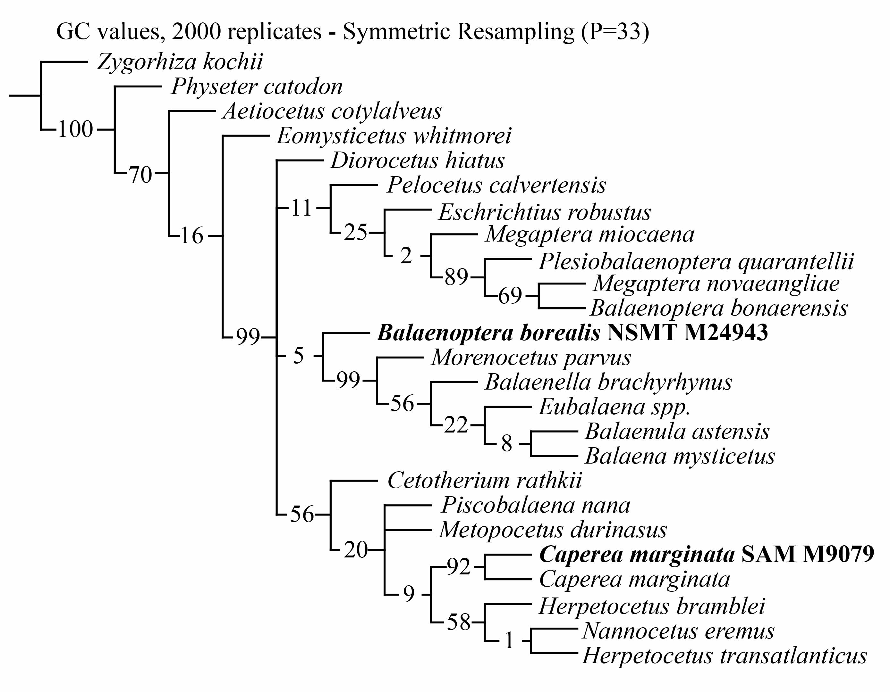
Figure S2-1 Symmetric resampling, showing GC values to indicate the branch support in Fordyce and Marx (2013) matrix

In Bisconti et al. (2013) matrix, 48 most parsimonious trees were recovered.
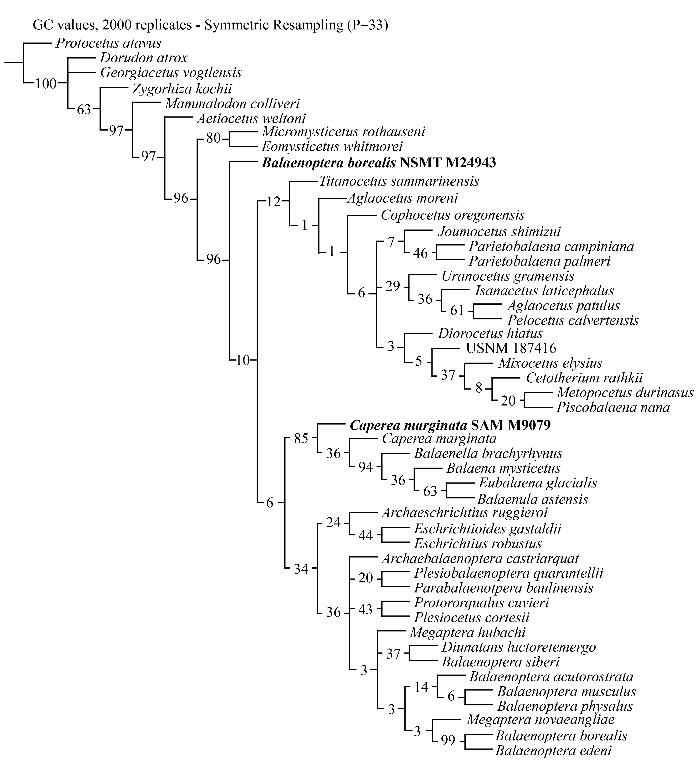
Figure S2-2 Symmetric resampling, showing GC values to indicate the branch support in Bisconti et al. (2013) matrix
The characters that recognise Balaenoptera borealis NSMT M24943 as a basal balaenid in Fordyce and Marx (2013) matrix include:
Character 4: Premaxilla in dorsal view, state 0: portion anterior to nasal opening narrows or remains the same width anteriorly (Figure S2-1)
Character 31: Maxillary window originating from posterior border of infraorbital plate, state 1: present (Figure S2-2)
Character 57: Supramastoid crest of zygomatic process of squamosal, state 1: absent (Figure S2-3)
Character 80: Angle formed by the basioccipital crests in ventral view, state 0: diverging posteriorly (Figure S2-10)
Character 85: Anterior process in lateral view, state 1: pointed and tapering (Figure S2-17)
Character 123: Medial lobe of tympanic bulla, state 1: absent or indistinct (Figure S2-25)
Character 127: Anteriormost point of involucral ridge, state 1: in line with or posterior to the anterior border of the bulla (Figure S2-21)
Character 128: Dorsolateral surface of involucrum, state 1: forms a continuous rim (Figure S2-21)
Character 149: Sulcus for attachment of mylohyoid muscle on ventromedial surface of mandible, state 1: present (Figure S2-12)

The characters that cluster Caperea marginata SAM M9079 being a sister taxon with the adult Caperea marginata in Fordyce and Marx (2013) matrix include:
Character 23: Anterior edge of supraorbital process lateral to ascending process of maxilla, state 1: pointing posteriorly (Figure S2-26)
Character 25: Supraorbital process of frontal, state 3: the lateral skull wall above the supraorbital formed by parietal only (Figure S2-28)
Character 47: Parietal and interparietal, state 1: anteriormost point in line with supraorbital process (Figure S2-28)
Character 50: Anteriormost point of supraoccipital in dorsal view, state 2: in line with the anterior half or anterior edge of the supraorbital process (Figure S2-26)
Character 51: Anteroposterior position of posterior apex of nuchal crest, state 0: posterior to the condyles (Figure S2-26)
Character 61: Transverse width of squamosal lateral to exoccipital width, state 1: exposed portion of squamosal is less than 15% of that distance (Figure S2-26)
Character 68: Squamosal cleft, state 1: present (Figure S2-26)
Character 75: Position of foramen pseudovale (= external foramen ovale), state 2: foramen lies within pterygoid (Figure S2-27)
Character 123: Medial lobe of tympanic bulla, state 1: absent or indistinct (Figure S2-47)
Character 140: Horizontal ramus of mandible in lateral view, state 1: arched dorsally (Figure S2-35)
Character 149: Sulcus for attachment of mylohyoid muscle on ventromedial surface of mandible, state 1: present (Figure S2-34)

The characters that plot Balaenoptera borealis NSMT M24943 as the most basal lineage of the crown Mysticeti in Bisconti et al. (2013) matrix include:
Character 10: Antorbital groove, state 0: absent (Figure S2-1)
Character 11: Antorbital notch, state 1: present (Figure S2-1)
Character 20: Ascending process of maxilla, state 1: lateral border forms a wide curve with posterior border of maxilla (Figure S2-1)
Character 22: Ascending process of maxilla, state 1: terminates posteriorly to the nasal (Figure S2-1)
Character 46: Supraorbital process of frontal, state 2: abruptly depressed from interorbital region (Figure S2-5)
Character 53: Postorbital corner of supraorbital process of frontal shows a clearly visible articular facet for zygomatic process of squamosal, state 1: yes (Figure S2-2)
Character 58: Anterior exposition of interorbital region of frontal, state 0: long (Figure S2-1)
Character 78: Interparietal exposition at vertex, state 1: present (Figure S2-1)
Character 87: Supramastoid crest, state 0: absent (Figure S2-3)
Character 89: Zygomatic process of squamosal in lateral view, state 1: short (Figure S2-3)
Character 90: Zygomatic process of squamosal in lateral view, state 1: projecting anteriorly and ventrally (Figure S2-3)
Character 92: Zygomatic process of squamosal in dorsal view (lateral border), state 1: projecting anteriorly (Figure S2-1)
Character 136: Anterior inflation of pars cochlearis, state 1: absent (Figure S2-16)
Character 138: Tensor tympani groove, state 1: absent (Figure S2-16)
Character 139: Round window and perilymphatic duct confluent, state 1: yes (Figure S2-18)
Character 144: Fossa for stapedial muscle well separated from round window by a thin crest, state 1: no (Figure S2-15)
Character 146: Anterior process of periotic, state 1: very short-to-nearly absent (Figure S2-14)
Character 172: Dorsal border of involucrum in medial view, state 1: projecting dorsally at anterior end (Figure S2-21)
Character 191: Attach for mylohyoidal muscle, state 1: sharp groove (Figure S2-12)

The characters that plot Caperea marginata SAM M9079 in the Balaenoidea that also contains adult Caperea marginata in Bisconti et al. (2013) matrix include:
Character 1: Rostrum length, state 0: rostrum forms around half of the length of the skull (Figure S2-26)
Character 5: Rostrum straight in lateral view, state 1: no (Figure S2-28)
Character 9: Lateral process of maxilla, state 0: long (Figure S2-26)
Character 56: Posterior contact of interorbital region of frontal in dorsal view, state 1: supraoccipital (Figure S2-26)
Character 58: Anterior exposition of interorbital region of frontal, state 2: short because supraoccipital superimposes on it (Figure S2-26)
Character 63: Exposition of parietal at vertex, state 3: absent (Figure S2-26)
Character 82: Squamosal cleft emergence at adulthood, state 2: from squamosal-pterygoid suture (Figure S2-28)
Character 89: Zygomatic process of squamosal in lateral view, state 2: very short (Figure S2-28)
Character 104: Massive elongation of supraoccipital, state 1: present (Figure S2-26)
Character 118: Ventral lamina of pterygoid, state 1: present (Figure S2-27)
Character 168: Anterolateral expansion, state 0: short (Figure S2-42)
Character 191: Attach for mylohyoidal muscle, state 1, sharp groove (Figure S2-34)

References:
Goloboff, P., J. Farris, and K. Nixon. 2003. TNT: Tree Analysis Using New Technology. Program and documentation, available from the authors, and from www.zmuc.dk/public/phylogeny.
Goloboff, P. A., J. S. Farris, and K. C. Nixon. 2008. TNT, a free program for phylogenetic analysis. Cladistics 24:774-786.

