Pattern Printing

**Question: 1**

#include <stdio.h>

int main() {

    int rows;

    printf("Enter how many rows you want: ");

    scanf("%d",&rows);

    int i,j;

    for (i = 1; i <= rows; i++) {

        for (j = 1; j <= i; j++) {

            printf("%d", i);

        }

        printf("\n");

    }

    return 0;

}

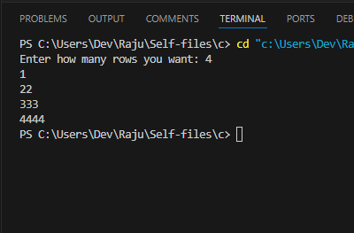Output:

Question 2:

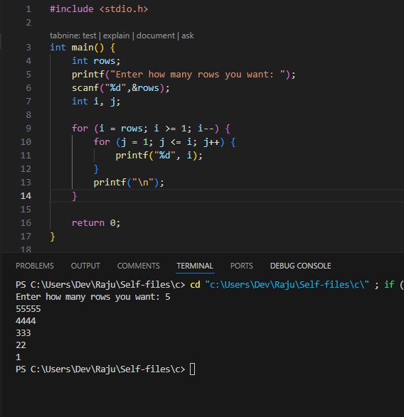

Question 3:

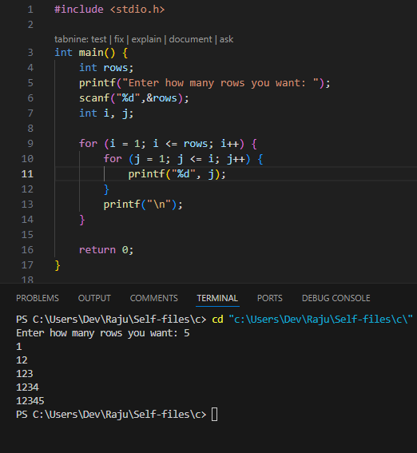

Question 4:

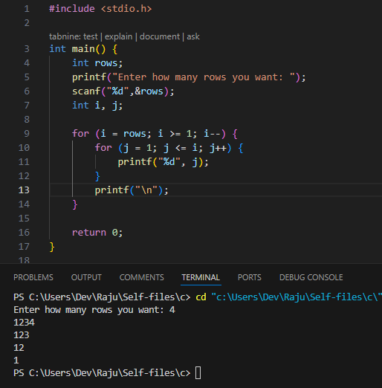

**Array**

Question 1:

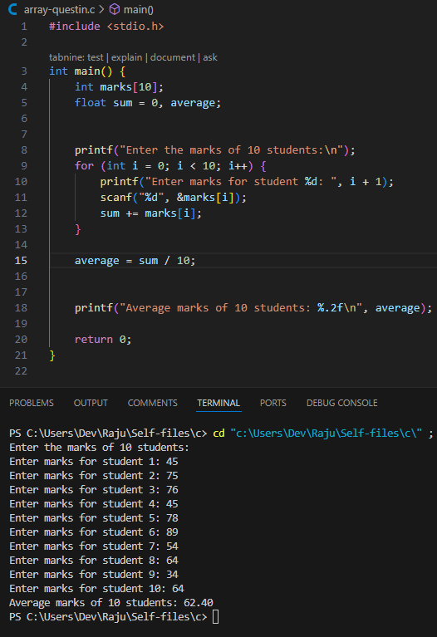

Question 2:

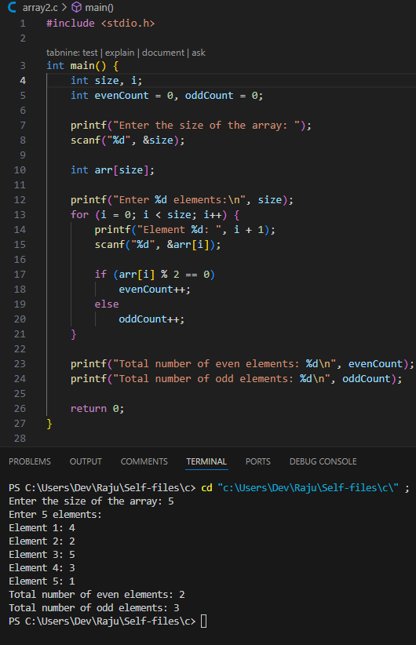

Question-3:

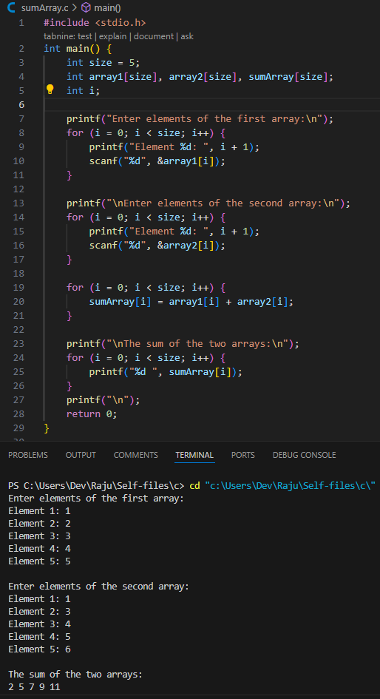

Question 4:

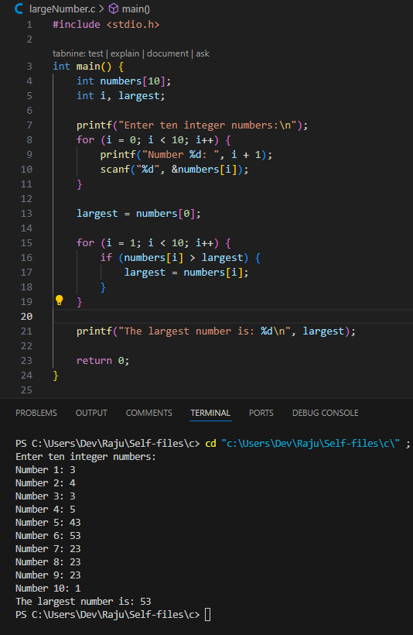

Question 5:

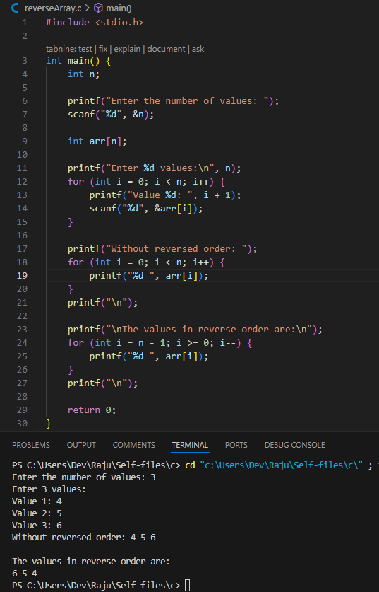

**String**

**Question-1:**

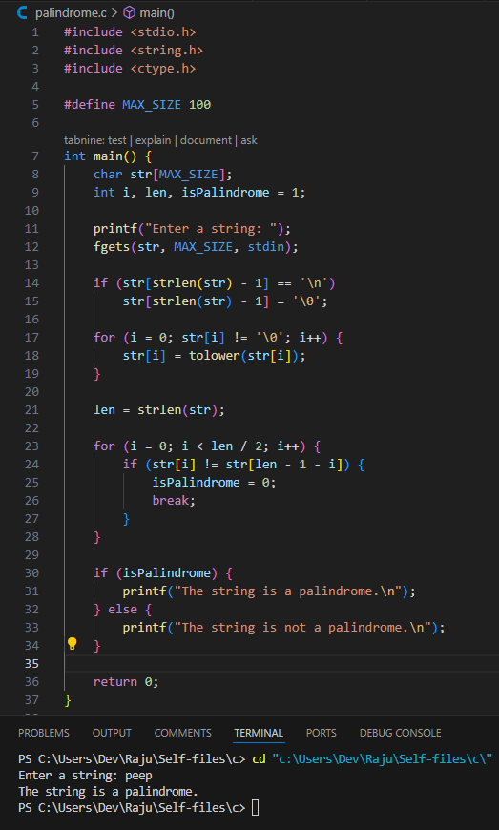

**Question-2:**

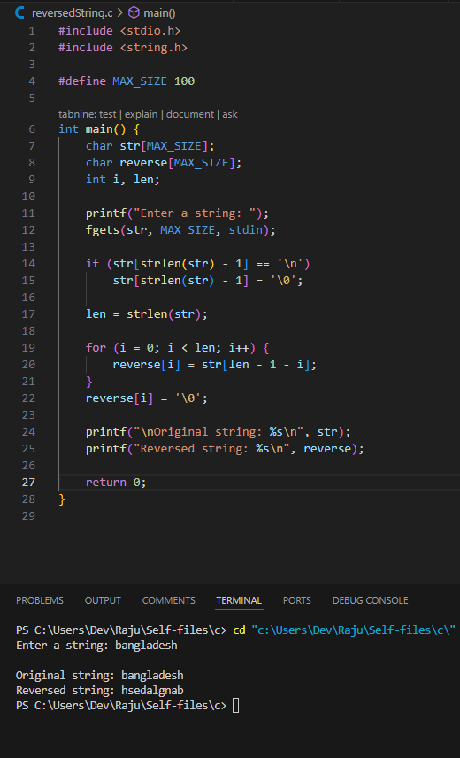

**Question-3:**

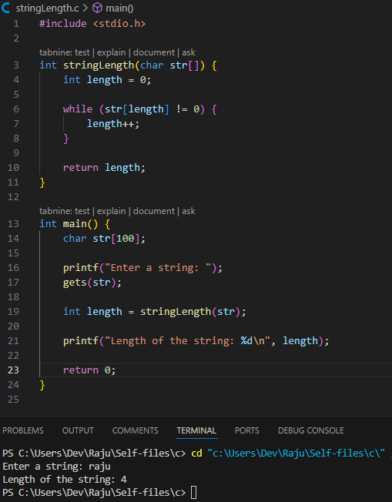

**Qestion-4:**

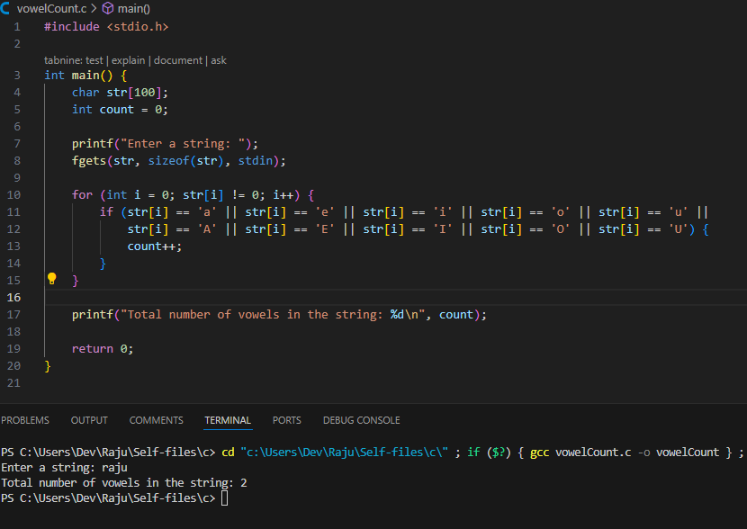

**Pointer**

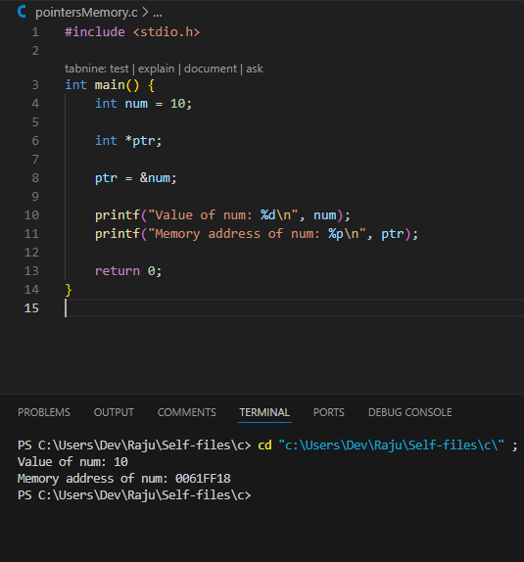**Question: 1**

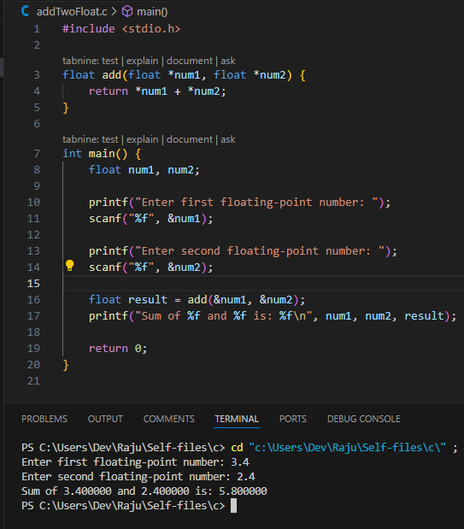

**Question: 2**

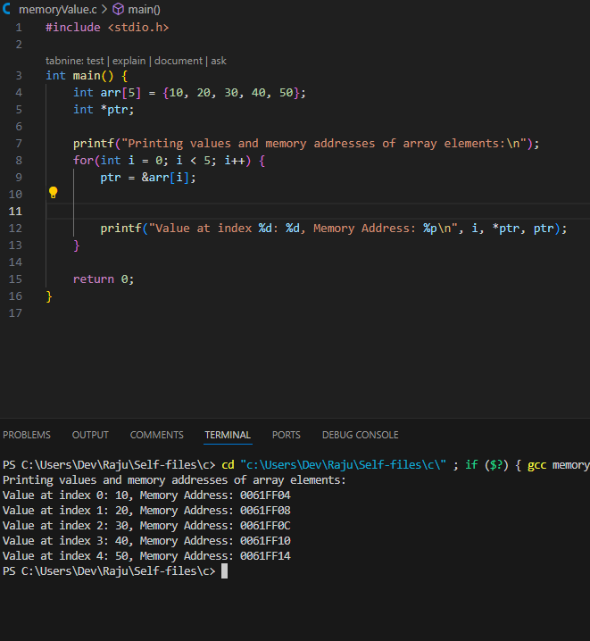**Question-3;**

**Structure**

**Question-1:**

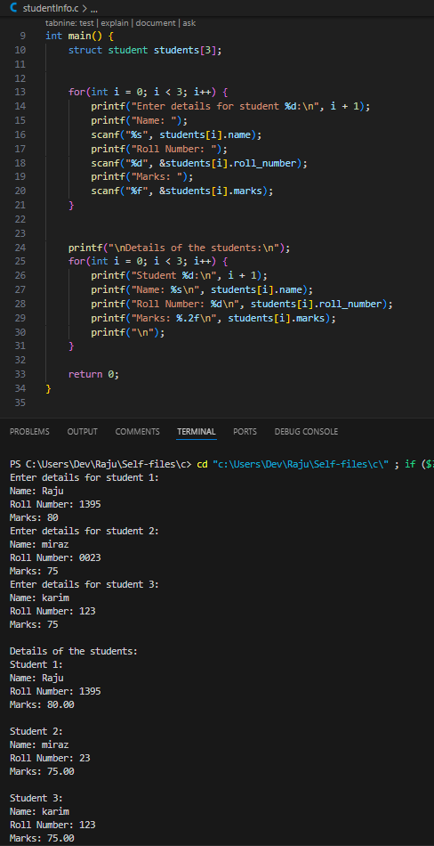

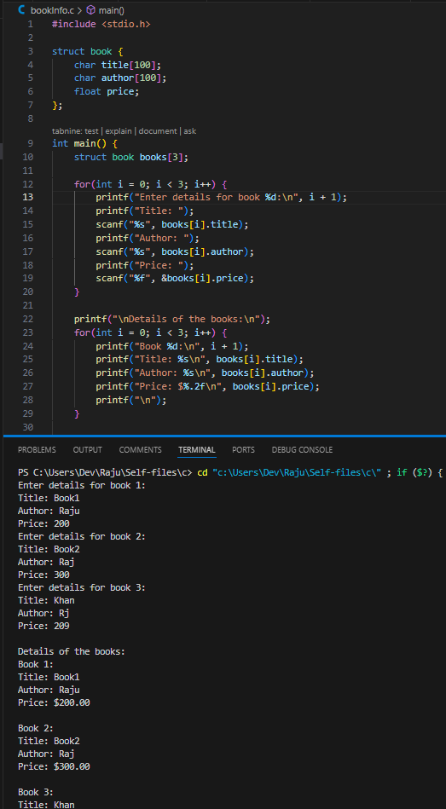**Question-2:**

**Question-3:**

