Question: Is there a relationship between AI Impact Level and Industry?

Methodology: Chi Square Test for Independence

Hypothesis:

H₀: AI Impact Level is independent of Industry.

H₁: AI Impact Level is associated with Industry.

Steps:

1. Filter the Data
2. Create a contingency table
3. Observation
4. Compute the expected table
5. Compute the chi square test
6. Find the chi square critical using (Chi Square Table)
7. Compare the results
8. Conclusion (Decision)

Filtering the Data:

Wrote Python Code to drop the rows where the AI Impact Level or Industry labels are null.

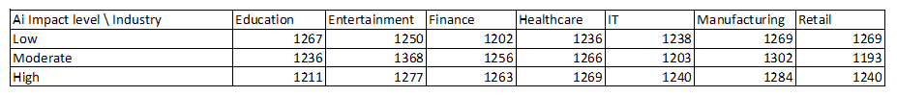Results:

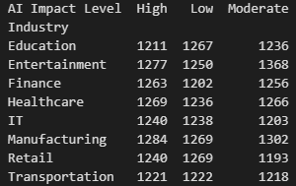

Creating the contingency table:

Used MS Excel to create filter and get the needed values, Wrote Python Code to check the table, and created a Heat Map to represent the table.

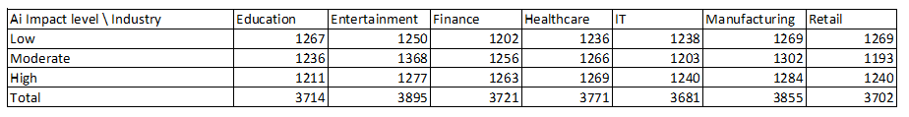Results:

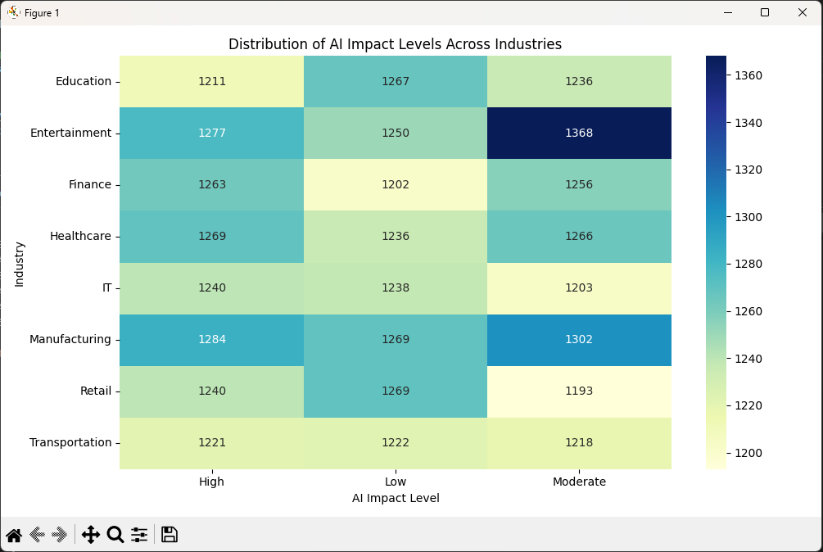

Observations:

Records did not change in the contingency table, so there were not empty records, which implies data cleanness. Heat Map also shows that there are no outliers in the data in terms of number of records for each dependent variable.

Computing the Expected table:

Used MS Excel to form a function that automatically calculates each entry in the expected table, Wrote Python Code to check the table.

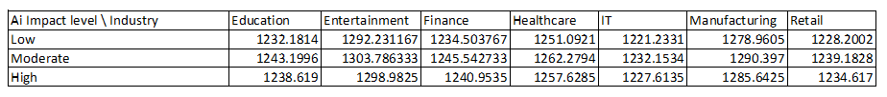Results:

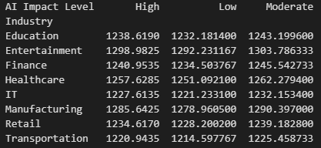

Computing the Chi Square Statistic (Test):

Wrote Python Code to compute the X2test, and supported the computed value by computing the calculation on separate steps in MS Excel

Results:

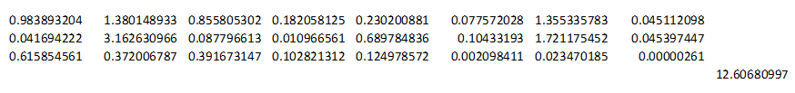

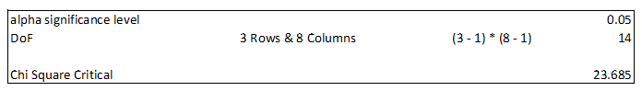

Finding the Chi Square Critical using the X2 table:

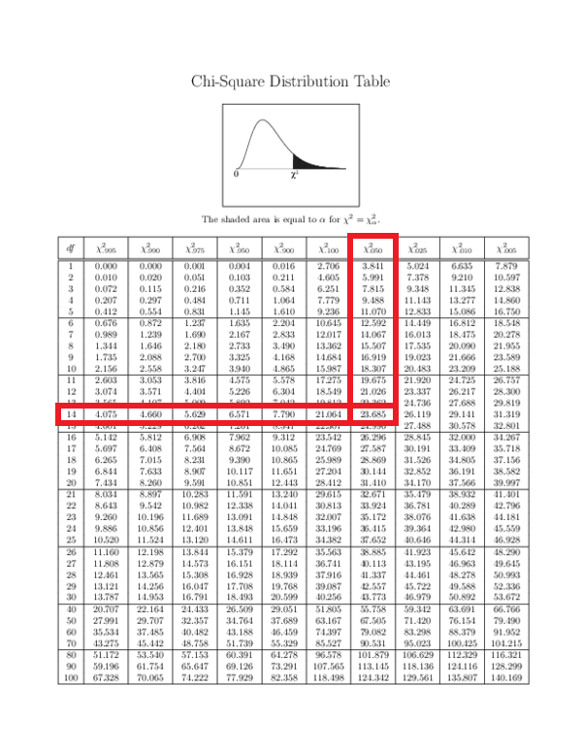

Comparing the Results:

X2test = 12.6068

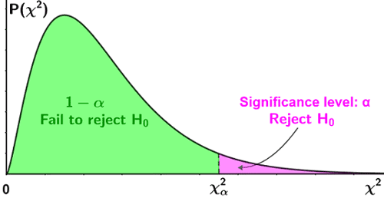X2critical = 23.685

Conclusion:

X2test  < X2critical 🡪 We fail to reject the Ho as we are in the accepted region, there is no statistically significant relationship between **AI Impact** and **Industry** in this Data Set.