**Exp 04 : Create a simple cloud software application for Car Booking Reservation System** **for using any Cloud Service Provider to demonstrate SaaS.**

**AIM:**

To design and deploy a cloud-based Car Booking Reservation System using Zoho Creator as SaaS.

**Procedure :**

1. Create a new app in Zoho Creator.

2. Add forms for User Details, Car Selection, Booking Confirmation.

3. Implement workflows for booking status updates.

4. Deploy the application on Zoho cloud.

5. Publish the app URL for access.

6. Test the system with a sample booking.

**Output :**

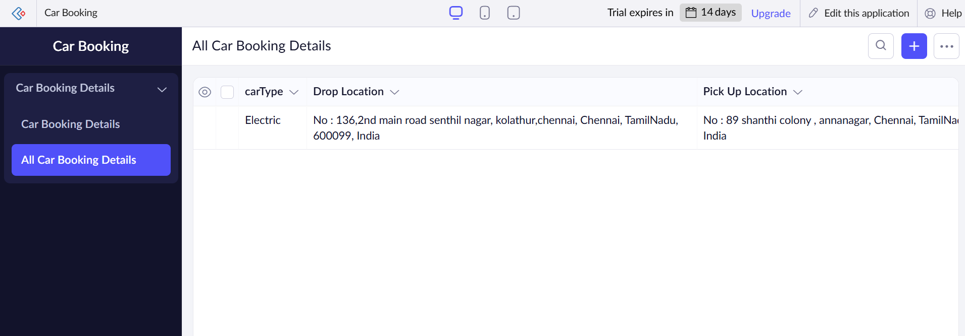

**Result :**

The Car Booking Reservation System was successfully created and deployed on Zoho Creator, working as a SaaS application.