**Exp 05 : Create a simple cloud software application for based Library Book Reservation System for SIMATS library using any Cloud Service Provider to demonstrate SaaS.**

**AIM:**

To create a cloud-based Library Book Reservation System for SIMATS library using Zoho Creator and demonstrate SaaS.

**Procedure :**

1. Login to Zoho Creator and start a new project.

2. Create forms for Book Search, Book Reservation, User Details.

3. Add workflows for reservation confirmation and notification.

4. Deploy the application on Zoho cloud.

5. Publish the public link of the application.

6. Test the app by reserving a sample book.

**Output :**

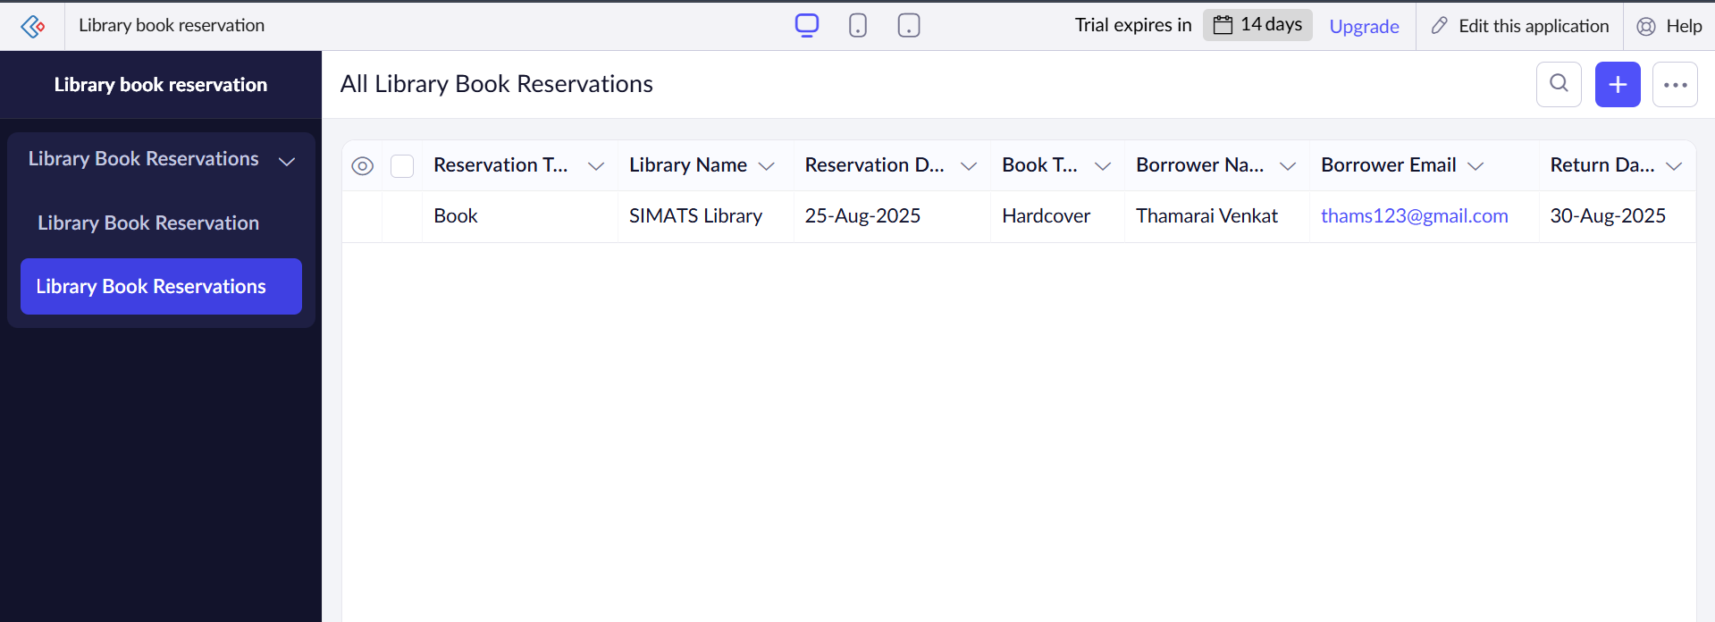

**Result :**

The Library Book Reservation System was successfully designed and deployed using Zoho Creator, providing a SaaS-based solution.