SIMATS ENGINEERING (SAVEETHA SCHOOL OF ENGINEERING)
Department of Computer Science and Engineering

ASSESSMENT TOOL 1 – ANALYTICAL PROBLEM SOLVING

Course Code: | CSA0615 | Course Title: | Design and Analysis of Algorithms
CO Assessed: | CO2 – Manipulation (BL1, BL2, BL3) | Assessment: | Assessment Tool 1 – Analytical Problem Solving
Weightage: | 40% of CIA | Total Marks: | 100
CO2 Statement: | Apply Brute Force technique to solve sorting, searching, Closest-Pair and Convex-Hull problems  (BL1, BL2, BL3)
Student Name: | Lella Thannveer Reddy | Reg. No.: | 192524293
Section / Batch: | Slot - A | Date: | 29/07/2026

Instructions to Students
- Answer ALL questions. Total Marks: 100.
- Analyze each problem carefully before applying the appropriate Brute Force technique.
- Clearly show all intermediate steps, comparisons, iterations, and logical reasoning used in solving the problems.
- Apply suitable algorithms for sorting, searching, Closest-Pair, and Convex-Hull problems wherever required.
- Justify the correctness and efficiency of the proposed solution using appropriate complexity analysis.
- Use diagrams, tables, or stepwise illustrations wherever necessary for better explanation.
- Maintain neat presentation, proper algorithmic notation, and structured analytical reasoning throughout the answers.

Question Type | Focus Area | Questions | Marks
Application-Based Questions | Apply Brute Force techniques for sorting, searching, Closest-Pair and Convex-Hull problem analysis | Q1 Q2,Q3 | 40 60 (2X30)
 | GRAND TOTAL: | 100 Marks

SECTION A – APPLICATION BASED QUESTIONS

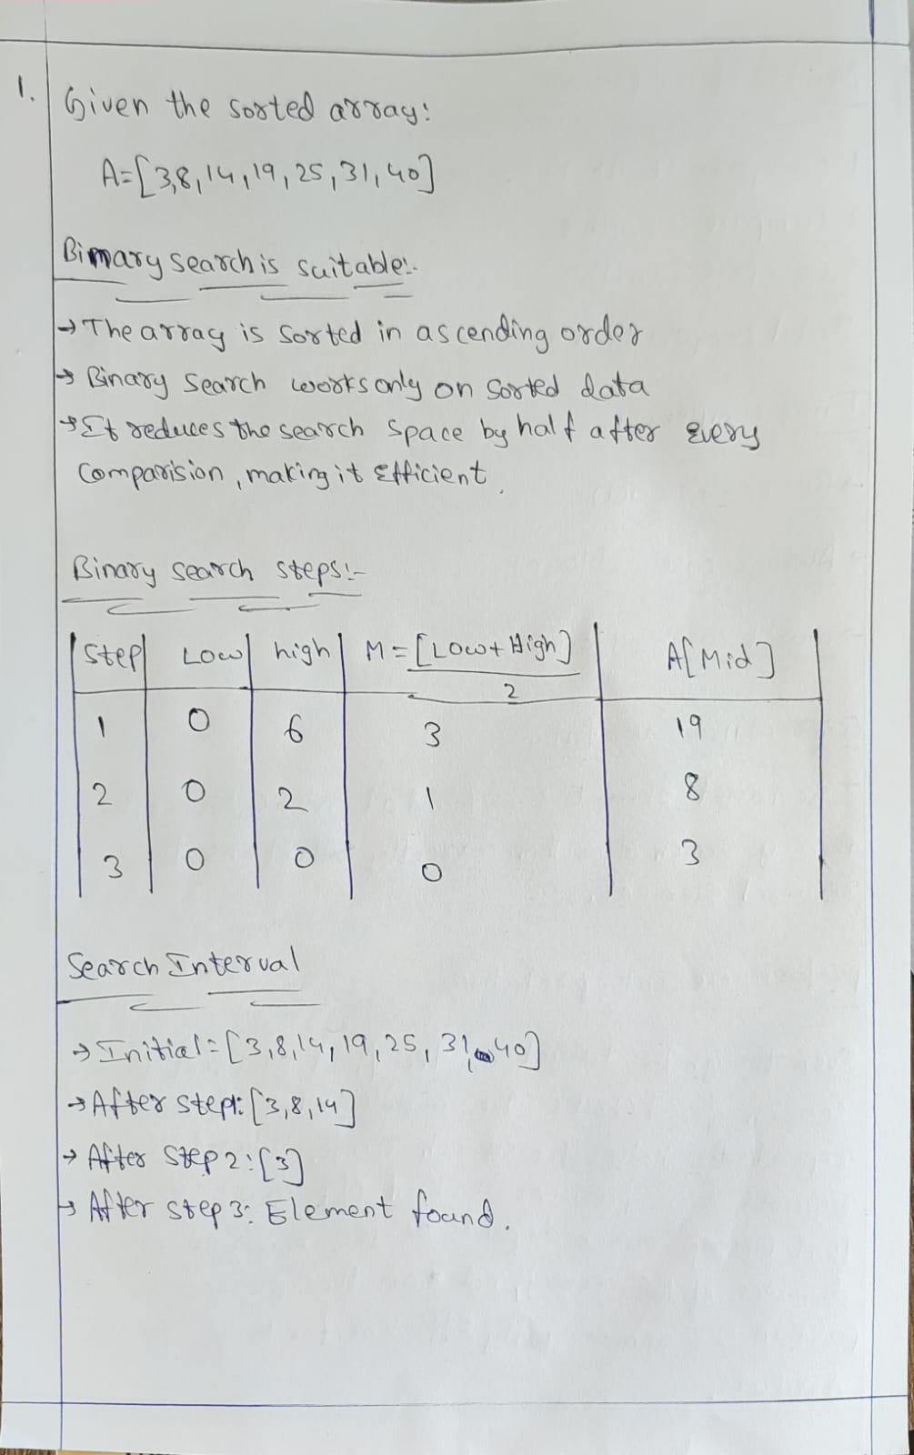
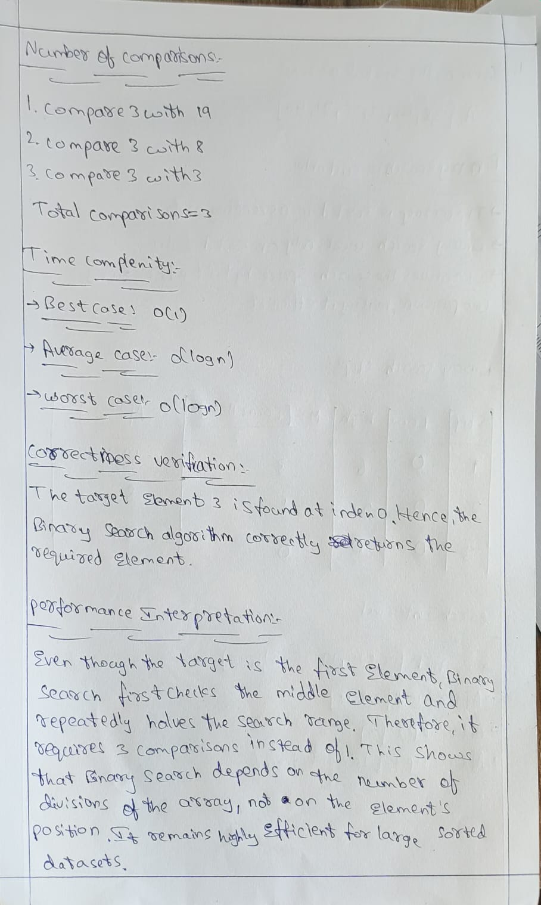

Code of Conduct
I _Lella Thannveer Reddy/192524293_ (Name / Reg No) certify that this submission is my original work and that I have adhered to the guidelines specified for this assessment. I understand that any violation of academic integrity rules will result in disciplinary action.
Signature of the Student: 

RUBRICS FOR CALCULATION

Criteria | Wt. | Level 4 – Exemplary | Level 3 –  Proficient | Level 2 –  Developing | Level 1 –  Beginning
Understanding of Problem Context | 20% | Clearly understands the problem and accurately identifies all requirements | Good  understanding with minor gaps | Basic understanding; some requirements unclear | Poor  understanding or misinterpretation of the problem
Application of Concepts | 30% | Accurately applies appropriate concepts to solve complex problems | Applies relevant concepts correctly with minor errors | Applies basic concepts with limited accuracy | Fails to apply appropriate concepts
Problem-Solving Approach | 20% | Logical, well-structured, and efficient approach | Mostly logical approach with minor gaps | Basic approach with  some  inconsistencies | Illogical or  unclear approach
Accuracy of Solution | 20% | Completely correct solution with proper justification | Mostly correct with minor errors | Partially correct solution | Incorrect or incomplete solution
Clarity | 10% | Clear, well-organized, and properly explained solution | Understandable with minor clarity issues | Limited clarity and explanation | Poorly presented and difficult to understand

Marks Evaluation:
Question No. | Understanding of Problem  Context (20%) | Application of  Concepts  (30%) | ProblemSolving  Approach  (20%) | Accuracy  of  Solution  (20%) | Clarity (10%) | Total Marks
Q1 (40 Marks) | 4 | 4 | 4 | 4 | 4 | 40
Q2 (30 Marks) | 4 | 4 | 4 | 4 | 4 | 30
Q3 (30 Marks) | 4 | 3 | 3 | 2 | 2 | 22
 |  |  |  | Overall Total (100) |  | 92

Faculty In-charge | Course Coordinator | Head of Department
Signature: _______________ | Signature: _______________ | Signature: _______________
Date: ___________________ | Date: ___________________ | Date: ___________________

