Image Processing

Noise Filter

Contents

1. Introduction 3

2. Mean Filtering 3

2.1. Overview 3

2.2. Experiment Settings 3

2.3. Results 4

3. Median Filtering 5

3.1. Overview 5

3.2. Experiment Settings 5

3.3. Results 6

4. K-Closest Averaging 7

4.1. Overview 7

4.2. Experiment Settings 7

4.3. Results 8

5. Threshold Averaging 9

5.1. Overview 9

5.2. Experiment Settings 9

5.3. Results 10

6. Conclusion 11

# Introduction

The digital image processing noise can often degrade the quality of an image. The address this issue, various noise filtering techniques are employed to enhance the visual clarity of images. In this project, we explore the application of four different noise filtering methods that are Mean Filtering, Median Filtering, K-Closest Averaging, and Threshold Averaging. Each method is applied to a noisy image with varying parameters, and the results are analyzed.

# Mean Filtering

## Overview

Mean filtering is a basic yet effective noise reduction technique. It involves replacing each pixel value with the average value of its neighboring pixels within a specified kernel size. Here, we explore the impact of different kernel sizes on the noise-canceling ability of mean filtering.

## Experiment Settings

A noisy input image with random noise artifacts.

There are Filter Parameters that is varying kernel sizes (3x3, 5x5, 7x7) to observe the influence on noise reduction.

## Results

Kernel size = 3

The 3x3 kernel provides a mild smoothing effect.

kernel size = 5

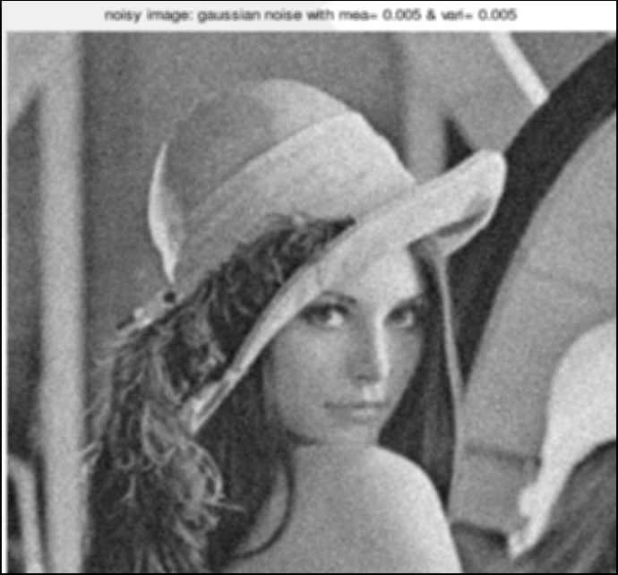

Increasing the kernel size to 5x5 enhances noise reduction but may result in slight blurring.

kernel size = 7

A larger 7x7 kernel further reduces noise, but may lead to more pronounced blurring effects.

# Median Filtering

## Overview

Median filtering is a non-linear noise reduction technique that replaces each pixel value with the median value of its neighboring pixels within a specified kernel. This section explores the impact of different kernel sizes on the noise reduction capabilities of median filtering.

## Experiment Settings

A noisy input image with random noise artifacts.

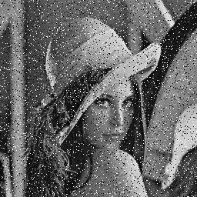

There are Filter Parameters that is varying kernel sizes (3x3, 5x5, 7x7) to observe the influence on noise reduction.

## Results

Kernel size = 3

The 3x3 median filter provides moderate noise reduction while preserving edges.

kernel size = 5

Increasing the kernel size to 5x5 enhances noise reduction without significant blurring.

kernel size = 7

A larger 7x7 kernel further reduces noise, but may lead to more pronounced blurring effects.

# K-Closest Averaging

## Overview

K-Closest Averaging is an adaptive filtering technique that considers the k-closest neighboring pixels. This section investigates the impact of different kernel sizes and k values on the noise cancellation capabilities of this method.

## Experiment Settings

A noisy input image with random noise artifacts.

There are Filter Parameters that is varying kernel sizes (3x3, 5x5, 7x7) and k values (5, 8, 10).

## Results

Kernel size = 3 and K = 5

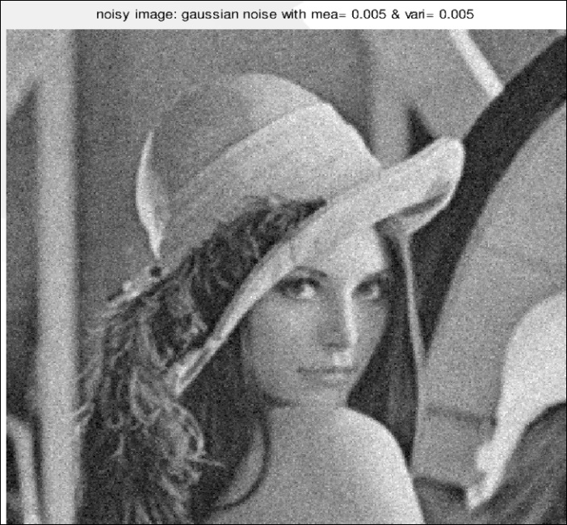

A 3x3 kernel with k=5 provides adaptive smoothing, reducing noise without significant blurring.

kernel size = 5 and K = 8

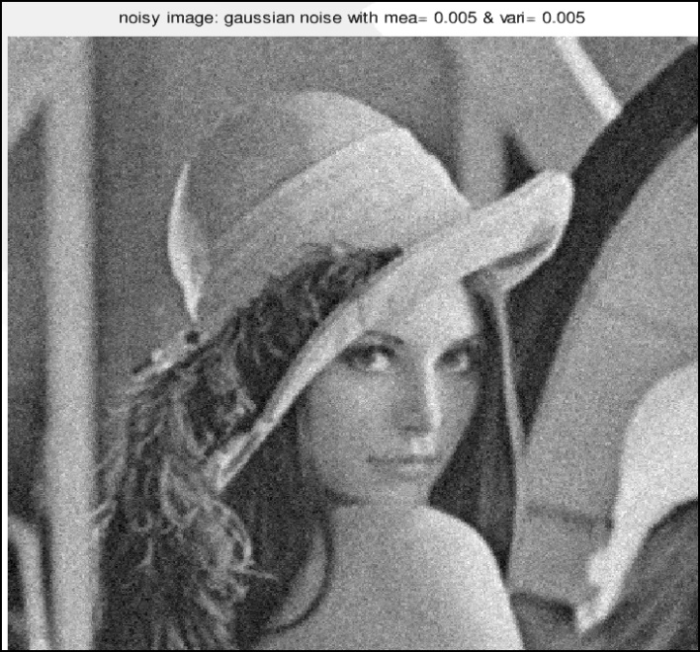

Increasing the kernel size to 5x5 with k=8 enhances noise reduction adaptively.

kernel size = 7 and K = 10

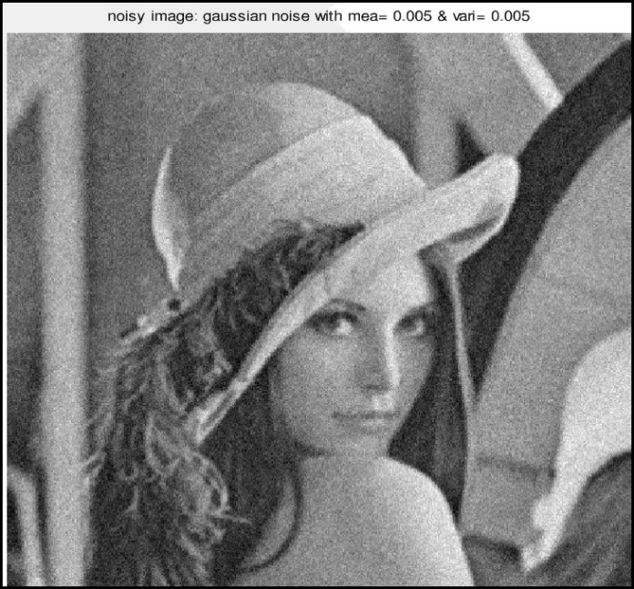

A larger 7x7 kernel with k=10 further adapts to noise while maintaining image details.

# Threshold Averaging

## Overview

Threshold Averaging involves selectively applying averaging based on a threshold value. This section explores the impact of different kernel sizes and threshold values on the noise reduction performance.

## Experiment Settings

A noisy input image with random noise artifacts.

There are Filter Parameters that is varying kernel sizes (3x3, 5x5, 7x7) and threshold values (200, 210, 220).

## Results

Kernel size = 3 and T = 200

A 3x3 kernel with a threshold of 200 selectively applies averaging, reducing noise where necessary.

kernel size = 5 and T = 210

Increasing the kernel size to 5x5 with a threshold of 210 refines noise reduction adaptively.

kernel size = 7 and T = 220

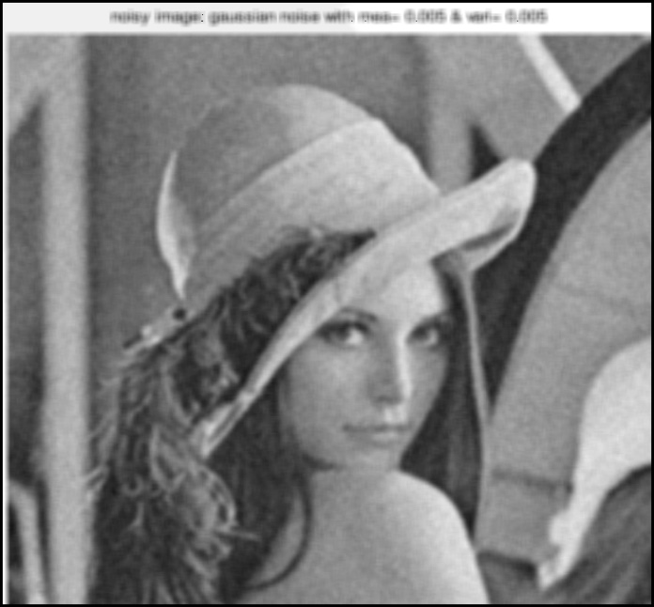

A larger 7x7 kernel with a threshold of 220 provides enhanced noise reduction in specific regions.

# Conclusion

Our exploration of various noise filtering techniques, including Mean Filtering, Median Filtering, K-Closest Averaging, and Threshold Averaging, revealed distinctive characteristics and trade-offs associated with different parameters. Mean Filtering, with larger kernel sizes, exhibited increased noise reduction at the expense of potential blurring. Median Filtering effectively reduced noise while preserving image edges, with larger kernels providing enhanced noise reduction. K-Closest Averaging demonstrated adaptive smoothing, showcasing its ability to reduce noise while preserving image details, particularly with larger kernel sizes. Threshold Averaging allowed for selective noise reduction based on a threshold value, offering flexibility in preserving image details. The choice of the most suitable technique and parameter settings should be made considering the specific characteristics of the input image and the desired balance between noise reduction and preservation of image details.