**GOVERNMENT COLLEGE OF ENGINEERING ERODE**



B.E Electronics and Communication Engineering

**Name of the Students: University Register no:**

**Team Leader:**

Anburaj.S 731121106103

**Team Members:**

Dharaneeswaran K 731121106008

Thanush Vishal S 731121106051

Boopathi Raj V 731121106003 Prabhakaran S 731121106035

Under the mentor of

**Dr.M.Poongothai**

**Department of Information Technology(IT)**

**Department of Electronics and Communication Engineering**

Government College of Engineering

Erode,Near Vasavi College, TamilNadu-638316,

Affiliated to Anna University, Chennai.

Measure Energy Consumption

**ABSTRACT:**

Energy Consumption, especially electricity consumption, is one of the serious problems that has facing in today’s world. There is a need for an efficient system to monitor this energy consumption. Internet of Things opens a way to solve these problems by interconnecting hardware, software and cloud.

Therefore, an energy consumption monitoring system for home appliances which can be used to calculate the energy consumption of the household and to keep the informed about the electricity consumption through an android app where he can view the units of electricity used and a prediction of the bill at the end of the month. The system can also be incorporated with the features of controlling the energy consumed by the appliances as desired by the user and the app will notify if the electricity consumption exceeds a threshold value set .

**INTRODUCTION:**

Measuring energy consumption in AI is an important step towards making AI systems more sustainable and environmentally friendly. Here are the project steps to measure energy consumption in AI. In this part will need to understand the problem statement and create a document on what have you understood and how will you proceed ahead with solving the problem. Please think on a design and present in form of a document. Conclusionesign ThinkingIn this part you will need to understand the problem statement and create a document.

**BLOCK DIAGRAM:**

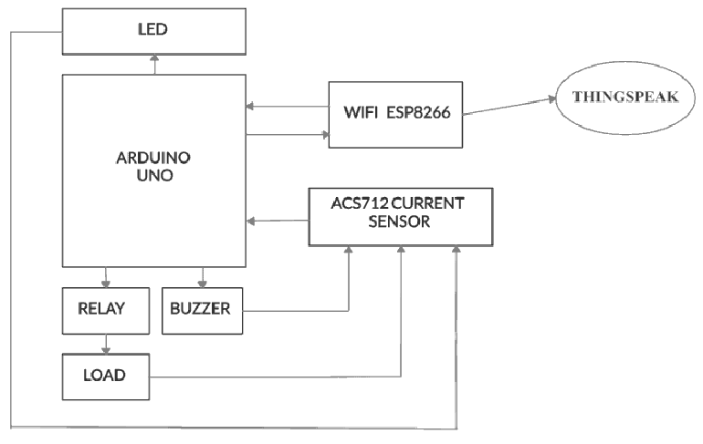

**FLOW CHART:**

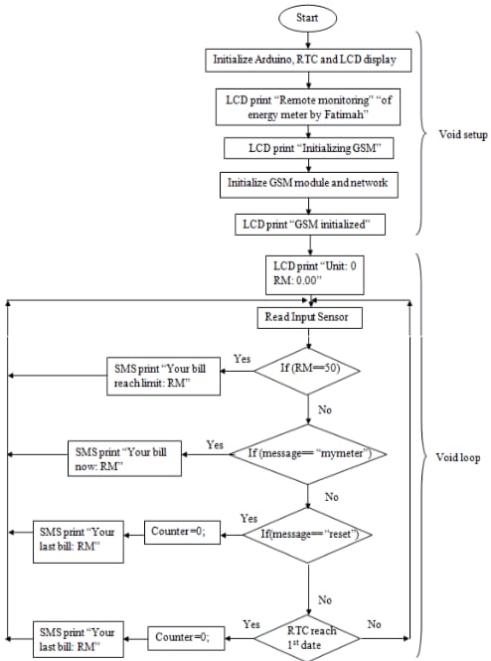

**3D MODULE:**

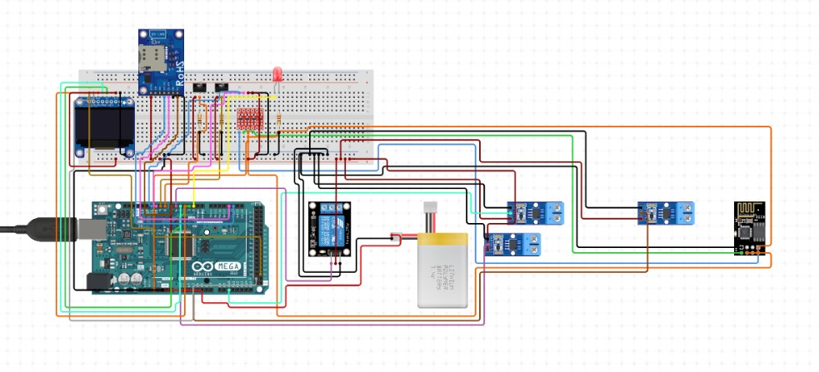

**PROGRAM:**

import pandas as pd

import numpy as np

import matplotlib.pyplot as plt

import seaborn as sns

import warnings

warnings.filterwarnings("ignore", category=UserWarning)

from sklearn.model_selection import train_test_split

from sklearn.preprocessing import StandardScaler

from sklearn.svm import SVR

from sklearn.metrics import mean_squared_error, r2_score

RED = "\033[91m"

GREEN = "\033[92m"

YELLOW = "\033[93m"

BLUE = "\033[94m"

RESET = "\033[0m"

df = pd.read_csv(r'C:\Users\user\Desktop\AEP_hourly.csv')

df["Datetime"] = pd.to_datetime(df["Datetime"])

# DATA CLEANING

print(BLUE + "\nDATA CLEANING" + RESET)

# --- Check for missing values

missing_values = df.isnull().sum()

print(GREEN + "Missing Values : " + RESET)

print(missing_values)

# --- Handle missing values

df.dropna(inplace=True)

# --- Check for duplicate values

duplicate_values = df.duplicated().sum()

print(GREEN + "Duplicate Values : " + RESET)

print(duplicate_values)

# --- Drop duplicate values

df.drop_duplicates(inplace=True)

# DATA ANALYSIS

print(BLUE + "\nDATA ANALYSIS" + RESET)

# --- Summary Statistics

summary_stats = df.describe()

print(GREEN + "Summary Statistics : " + RESET)

print(summary_stats)

# SUPPORT VECTOR MODELLLING

print(BLUE + "\nMODELLING" + RESET)

# Reduce the dataset size for faster training

df = df.sample(frac=0.2, random_state=42)

# Split the data into features (Datetime) and target (AEP_MW)

X = df[["Datetime"]]

y = df["AEP_MW"]

# Split the data into training and testing sets

X_train, X_test, y_train, y_test = train_test_split(

X, y, test_size=0.2, random_state=42

)

# Preprocess the features (Datetime) to extract the day of the year

X_train["DayOfYear"] = X_train["Datetime"].dt.dayofyear

X_test["DayOfYear"] = X_test["Datetime"].dt.dayofyear

# Convert X_train and X_test to NumPy arrays

X_train = X_train["DayOfYear"].values.reshape(-1, 1)

X_test = X_test["DayOfYear"].values.reshape(-1, 1)

# Standardize the data

scaler = StandardScaler()

X_train_scaled = scaler.fit_transform(X_train)

X_test_scaled = scaler.transform(X_test)

# Create an SVR (Support Vector Regression) model with a linear kernel

svr = SVR(kernel="linear", C=1.0)

# Train the SVR model

svr.fit(X_train_scaled, y_train)

# Predict on the test set

y_pred = svr.predict(X_test_scaled)

# Evaluate the model

mse = mean_squared_error(y_test, y_pred)

r2 = r2_score(y_test, y_pred)

print(f"Mean Squared Error: {mse}")

print(f"R-squared: {r2}")

# Plot the actual vs. predicted values

plt.figure(figsize=(10, 6))

plt.scatter(X_test, y_test, color="b", label="Actual")

plt.scatter(X_test, y_pred, color="r", label="Predicted")

plt.xlabel("Day of the Year")

plt.ylabel("Energy Consumption (MW)")

plt.title("SVR Model: Actual vs. Predicted")

plt.legend()

plt.grid()

plt.show()

# DATA VISUALIZATION

print(BLUE + "\nDATA VISUALIZATION" + RESET)

# --- Line plot

print(GREEN + "LinePlot : " + RESET)

plt.figure(figsize=(10, 6))

sns.lineplot(data=df, x="Datetime", y="AEP_MW")

plt.xlabel("Datetime")

plt.ylabel("Energy Consumption (MW)")

plt.title("Energy Consumption Over Year")

plt.grid()

plt.show()

# --- Histogram

print(GREEN + "Histogram : " + RESET)

plt.figure(figsize=(10, 6))

plt.hist(

df["AEP_MW"],

bins=100,

histtype="barstacked",

edgecolor="white",

)

plt.xlabel("AEPMW")

plt.ylabel("Frequency")

plt.title("Histogram of MEGAWATT USAGE")

plt.show( )

**OUTPUT:**

**DATA CLEANING**

Missing Values :

Datetime 0

AEP_MW 0

dtype: int64

Duplicate Values :

0

**DATA ANALYSIS**

Summary Statistics :

Datetime AEP_MW

count 121273 121273.000000

mean 2011-09-02 03:17:01.553025024 15499.513717

min 2004-10-01 01:00:00 9581.000000

25% 2008-03-17 15:00:00 13630.000000

50% 2011-09-02 04:00:00 15310.000000

75% 2015-02-16 17:00:00 17200.000000

max 2018-08-03 00:00:00 25695.000000

std NaN 2591.399065

MODELLING

Mean Squared Error: 6758395.805638685

R-squared: 0.00270160624748228

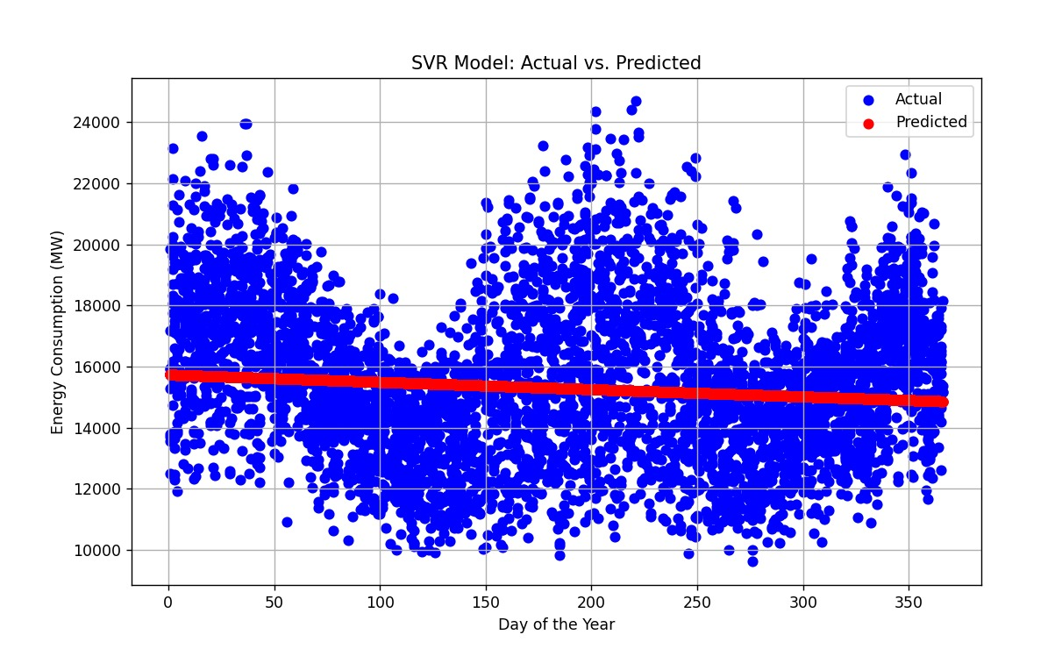

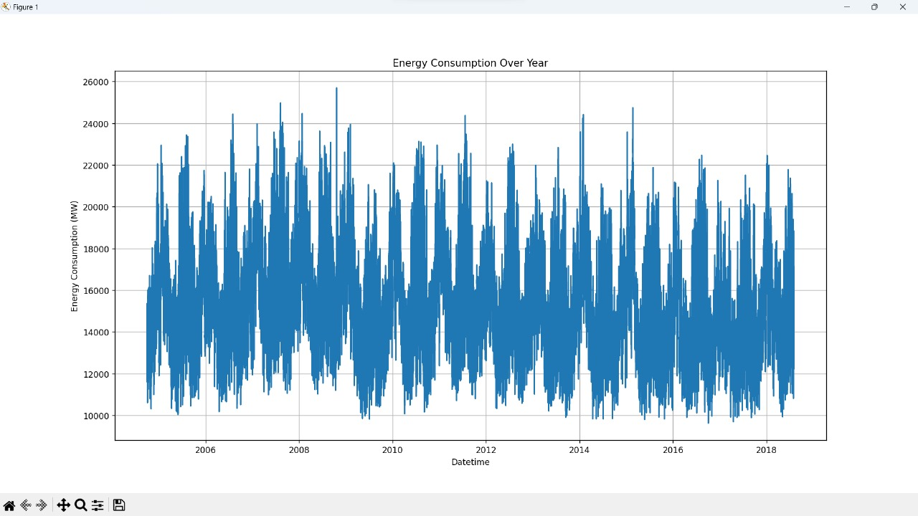

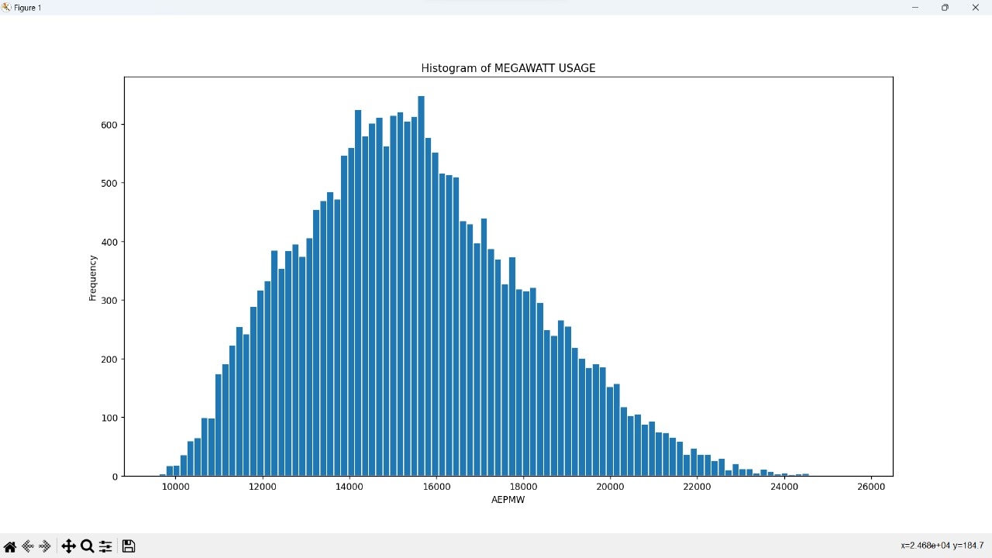

**CONCLUSION:**

Domestic energy consumption keep a slight increase to 2030. Population and

household increases significantly offset the energy efficiency. Further improvement the

energy efficiency especially focusing on space heating. Promote renewable energy and

nuclear power Strategy - Low Carbon Transition plan.ar power Strategy - Low Carbon Transition plan.