**Exercise 1: Control Structures**

**Scenario 1:** The bank wants to apply a discount to loan interest rates for customers above 60 years old.

**Question:** Write a PL/SQL block that loops through all customers, checks their age, and if they are above 60, apply a 1% discount to their current loan interest rates.

**Solution:**

BEGIN

FOR rec IN (

SELECT l.LoanID, l.InterestRate

FROM Customers c JOIN Loans l ON c.CustomerID = l.CustomerID

WHERE TRUNC(MONTHS_BETWEEN(SYSDATE, c.DOB) / 12) > 60

) LOOP

UPDATE Loans SET InterestRate = rec.InterestRate - 1 WHERE LoanID = rec.LoanID;

END LOOP;

END;

/

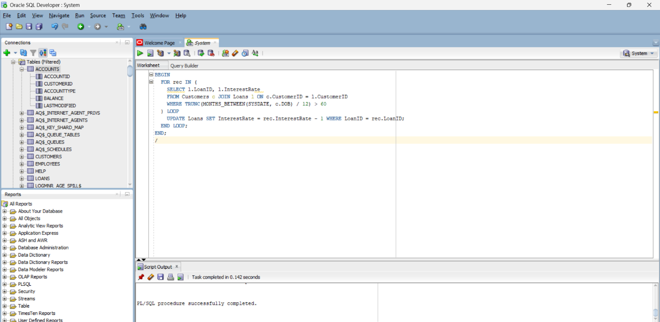

**Scenario 2:** A customer can be promoted to VIP status based on their balance.

**Question:** Write a PL/SQL block that iterates through all customers and sets a flag IsVIP to TRUE for those with a balance over $10,000.

**Solution:**

ALTER TABLE Customers ADD IsVIP CHAR(1);

BEGIN

FOR rec IN (SELECT * FROM Customers) LOOP

IF rec.Balance > 10000 THEN

UPDATE Customers SET IsVIP = 'T' WHERE CustomerID = rec.CustomerID;

END IF;

END LOOP;

END;

/

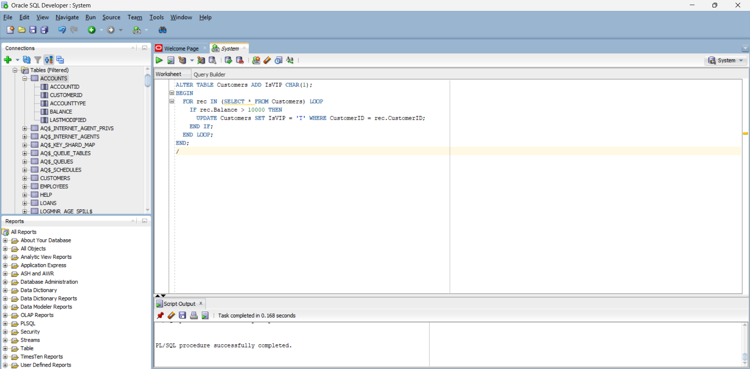

**Scenario 3:** The bank wants to send reminders to customers whose loans are due within the next 30 days.

**Question:** Write a PL/SQL block that fetches all loans due in the next 30 days and prints a reminder message for each customer.

**Solution:**

BEGIN

FOR rec IN (SELECT * FROM Loans WHERE EndDate <= SYSDATE + 30) LOOP

DBMS_OUTPUT.PUT_LINE('Reminder: Loan ' || rec.LoanID || ' for Customer ' || rec.CustomerID || ' is due on ' || rec.EndDate);

END LOOP;

END;

/

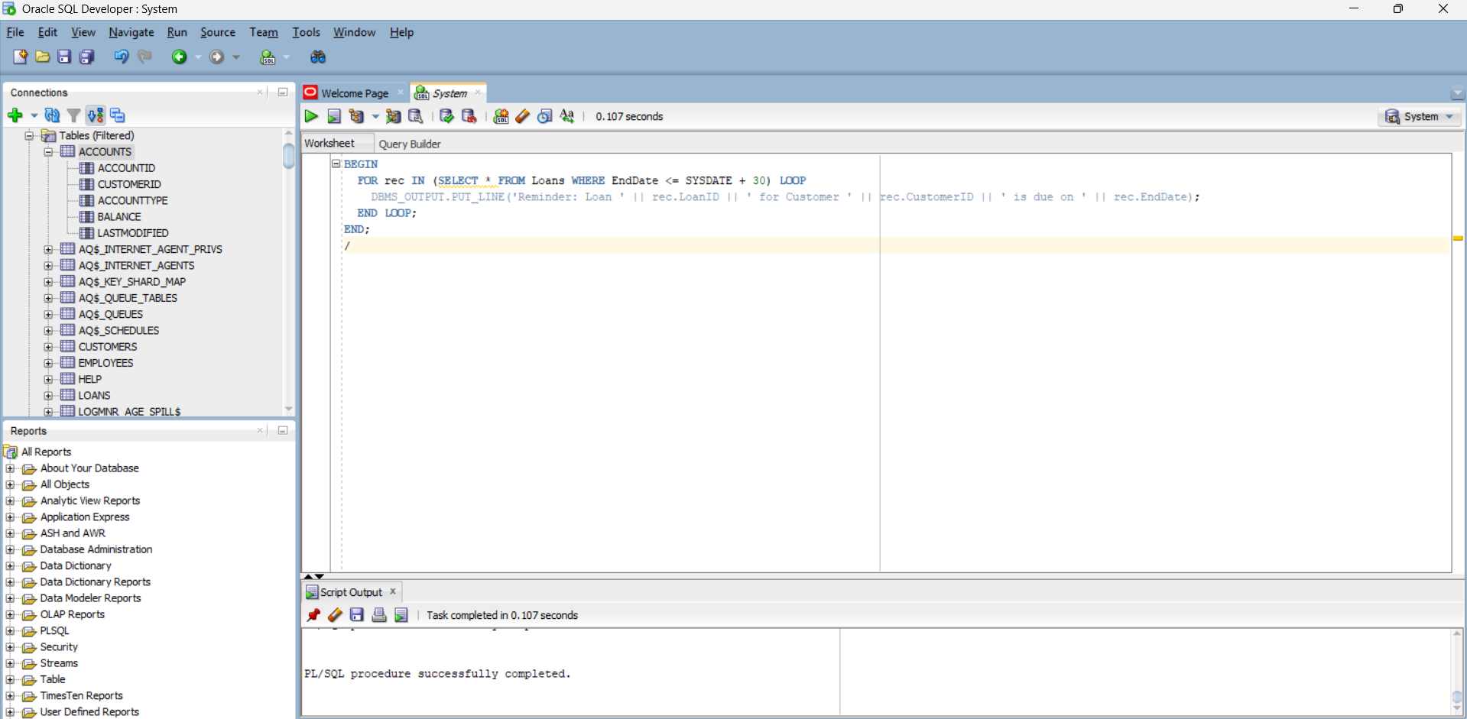

**Exercise 3: Stored Procedures**

**Scenario 1:** The bank needs to process monthly interest for all savings accounts.

**Question:** Write a stored procedure **ProcessMonthlyInterest** that calculates and updates the balance of all savings accounts by applying an interest rate of 1% to the current balance.

**Solution:**

CREATE OR REPLACE PROCEDURE ProcessMonthlyInterest IS

BEGIN

UPDATE Accounts SET Balance = Balance + Balance * 0.01 WHERE AccountType = 'Savings';

END;

/

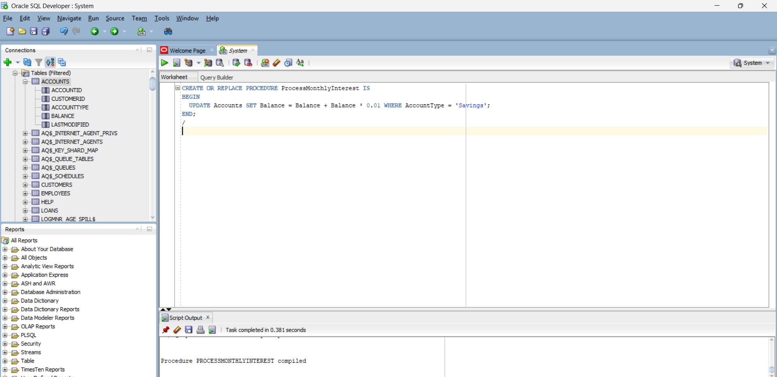

**Scenario 2:** The bank wants to implement a bonus scheme for employees based on their performance.

**Question:** Write a stored procedure **UpdateEmployeeBonus** that updates the salary of employees in a given department by adding a bonus percentage passed as a parameter.

**Solution:**

CREATE OR REPLACE PROCEDURE UpdateEmployeeBonus(p_dept VARCHAR2, p_bonus NUMBER) IS

BEGIN

UPDATE Employees SET Salary = Salary + Salary * p_bonus / 100 WHERE Department = p_dept;

END;

/

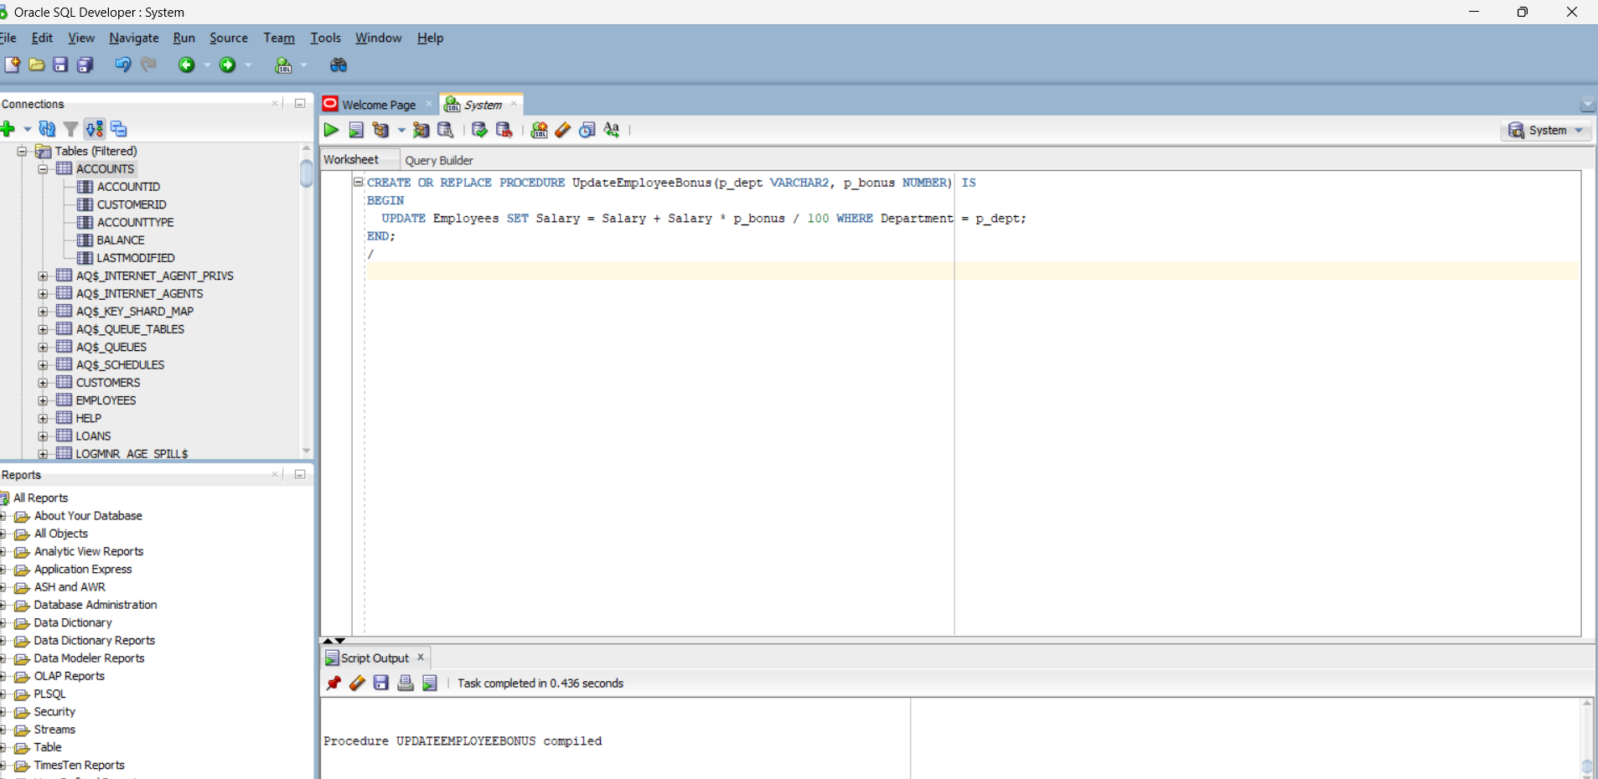

**Scenario 3:** Customers should be able to transfer funds between their accounts.

**Question:** Write a stored procedure **TransferFunds** that transfers a specified amount from one account to another, checking that the source account has sufficient balance before making the transfer.

**Solution:**

CREATE OR REPLACE PROCEDURE TransferFunds(p_from NUMBER, p_to NUMBER, p_amount NUMBER) IS

v_balance NUMBER;

BEGIN

SELECT Balance INTO v_balance FROM Accounts WHERE AccountID = p_from FOR UPDATE;

IF v_balance < p_amount THEN

RAISE_APPLICATION_ERROR(-20001, 'Insufficient balance');

END IF;

UPDATE Accounts SET Balance = Balance - p_amount WHERE AccountID = p_from;

UPDATE Accounts SET Balance = Balance + p_amount WHERE AccountID = p_to;

COMMIT;

EXCEPTION

WHEN OTHERS THEN

ROLLBACK;

DBMS_OUTPUT.PUT_LINE(SQLERRM);

END;

/

