# Hands-on 1: My First React App

**1.Create a new folder for React projects and navigate into it:**  
 mkdir react-hands-on  
 cd react-hands-on

**2.Create a new React application named 'myfirstreact':**  
 npx create-react-app myfirstreact

**3. Navigate into the project folder:**  
 cd myfirstreact

**4. Open the project in Visual Studio Code:**  
 code .

**5. Edit the App.js file:**  
 - Go to src/App.js  
 - Delete all the existing content and replace it with the following code:  
  
 import React from 'react';  
  
 function App() {  
 return (  
 <div>  
 <h1>Welcome to the first session of React</h1>  
 </div>  
 );  
 }  
  
 export default App;

**6. Start the React development server:**  
 npm start

**7. Open your browser and go to:**  
 http://localhost:3000

**OUTPUT:**

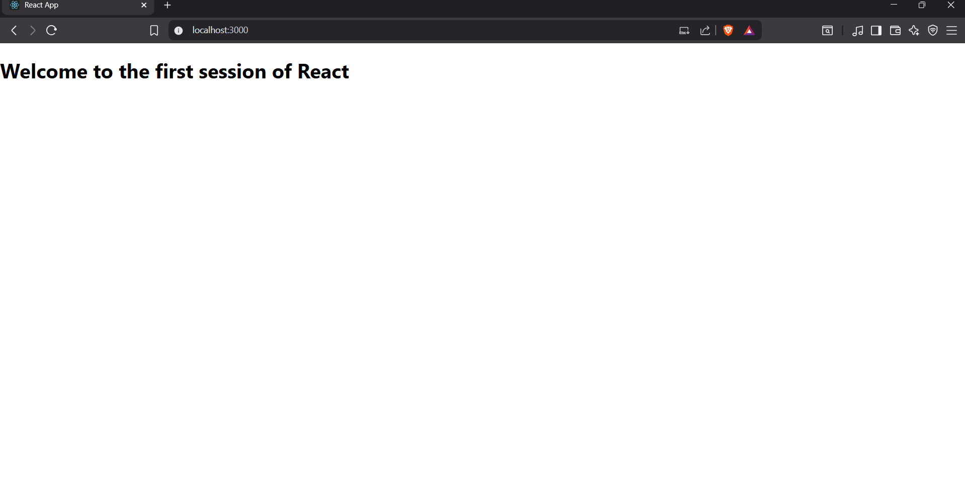

# Hands-on2: Student Management Portal – StudentApp

## 1. Create React App

Open a terminal and type the following command to create a React project named “StudentApp”:  
  
npx create-react-app StudentApp

## 2. Create Components Folder

Navigate into the "src" folder and create a new folder named "Components". Inside "Components", add a new file named "Home.js".

## 3. Add Home Component

Type the following code in Home.js:  
  
import React from "react";  
  
function Home() {  
 return <h2>Welcome to the Home page of Student Management Portal</h2>;  
}  
  
export default Home;

## 4. Add About Component

Similarly, create a new file named "About.js" under "Components" folder and add the following code:  
  
import React from "react";  
  
function About() {  
 return <h2>Welcome to the About page of the Student Management Portal</h2>;  
}  
  
export default About;

## 5. Add Contact Component

Also create a file named "Contact.js" under "Components" folder with the following content:  
  
import React from "react";  
  
function Contact() {  
 return <h2>Welcome to the Contact page of the Student Management Portal</h2>;  
}  
  
export default Contact;

## 6. Edit App.js

Import and use all three components (Home, About, Contact) in "App.js" as shown below:  
  
import React from "react";  
import Home from "./Components/Home";  
import About from "./Components/About";  
import Contact from "./Components/Contact";  
  
function App() {  
 return (  
 <div>  
 <Home />  
 <About />  
 <Contact />  
 </div>  
 );  
}  
  
export default App;

## 7. Run the React App

In the terminal, navigate to the project folder:  
  
cd StudentApp  
  
Then start the React app:  
  
npm start

## 8. View in Browser

Open your browser and go to:  
  
http://localhost:3000  
  
**OUTPUT:**

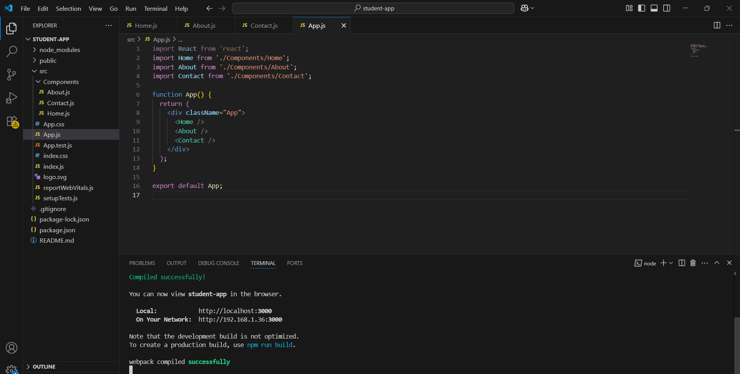

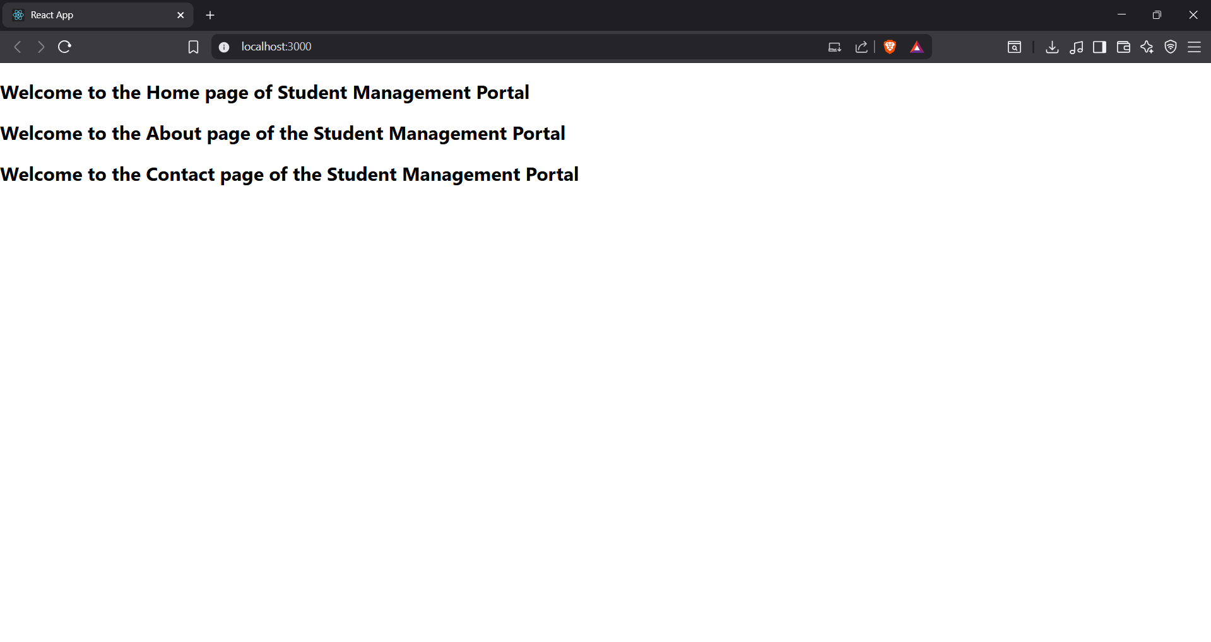

**HandsOn3:**

**React App: Score Calculator App**

**1. Create React Project**

Open the terminal (or Command Prompt) and run the following command to create a new React project named scorecalculatorapp:

npx create-react-app scorecalculatorapp

After successful installation, navigate to the project folder:

cd scorecalculatorapp

**2. Create Components Folder and File**

Under the src folder:

* Create a folder named Components
* Inside Components, create a file named CalculateScore.js

**3. Code for CalculateScore.js**

Inside src/Components/CalculateScore.js, add the following code:

import React from 'react';

import '../Stylesheets/mystyle.css';

function CalculateScore() {

const name = "Thanushya";

const school = "XYZ Matric Hr Sec School";

const total = 465;

const goal = 500;

const average = total / 5;

return (

<div className="score-card">

<h2>Student Score Card</h2>

<p><strong>Name:</strong> {name}</p>

<p><strong>School:</strong> {school}</p>

<p><strong>Total Marks:</strong> {total}</p>

<p><strong>Goal:</strong> {goal}</p>

<p><strong>Average:</strong> {average}</p>

</div>

);

}

export default CalculateScore;

**4. Create Stylesheet**

Under src, create a folder named Stylesheets.  
Inside that folder, create a file named mystyle.css and add styles like:

.score-card {

background-color: #f0f8ff;

padding: 20px;

margin: 40px;

border-radius: 10px;

box-shadow: 0 0 10px rgba(0, 0, 0, 0.1);

font-family: Arial, sans-serif;

**5. Modify App.js**

In src/App.js, replace the contents with:

import React from 'react';

import CalculateScore from './Components/CalculateScore';

function App() {

return (

<div className="App">

<CalculateScore />

</div>

);

}

export default App;

**6. Run the Application**

In the terminal, navigate to the project directory (if not already):

cd scorecalculatorapp

npm start

**7. View in Browser**

Open your browser and visit:

<http://localhost:3001>

**OUTPUT:**

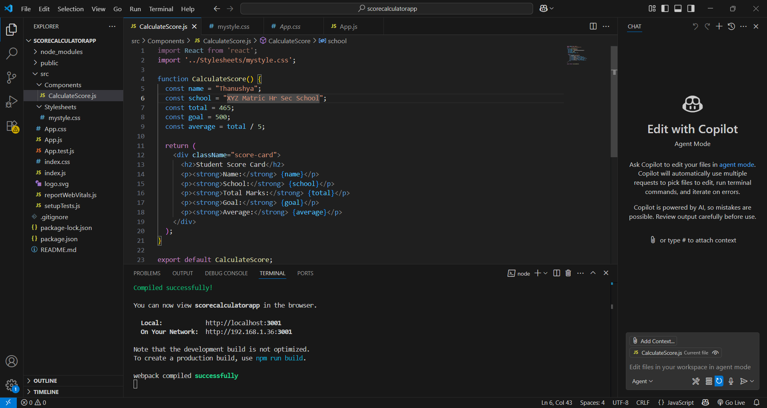

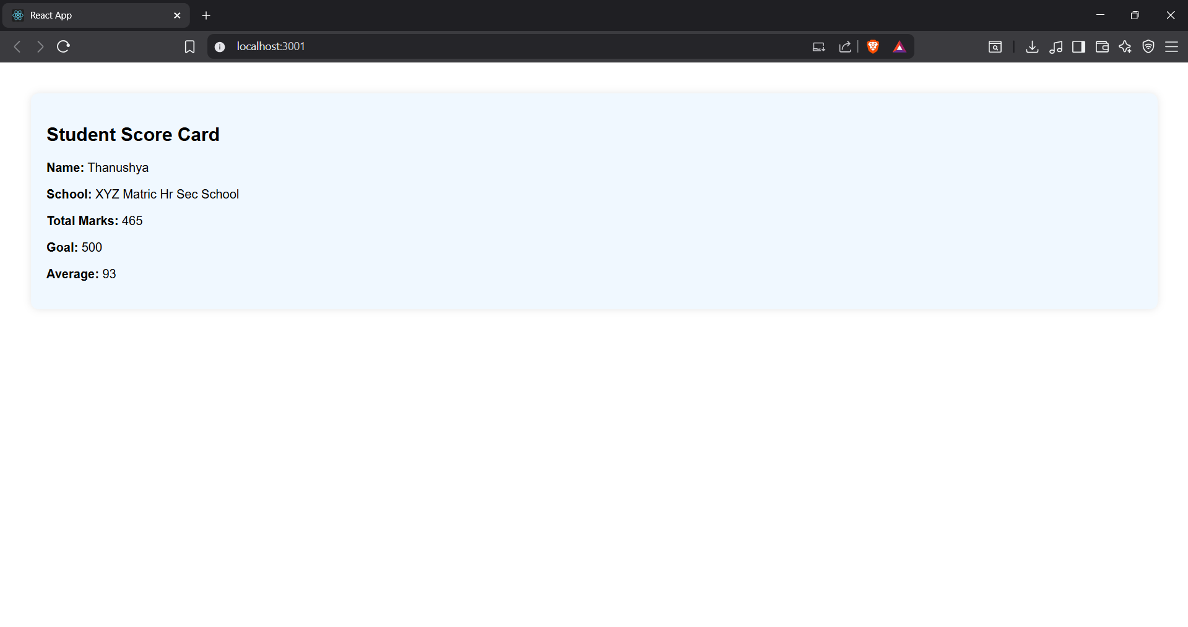

**HandsOn4:**

**Step 1: Create a New React App**

1. Open **Command Prompt**.  
   npx create-react-app blogapp  
   cd blogapp  
   code .

**Step 2: Create a Post Class**

1. Inside src/, create a new file called Post.js.
2. Add the following code:

**class** Post {  
 constructor(userId, id, title, body) {  
 **this**.userId = userId;  
 **this**.id = id;  
 **this**.title = title;  
 **this**.body = body;  
 }  
}  
  
**export** **default** Post;

**Step 3: Create Posts Component**

1. Create a new file called Posts.js inside src/.
2. Add the following code:

**import** React, { Component } **from** 'react';  
**import** Post **from** './Post';  
  
**class** Posts **extends** Component {  
 constructor(props) {  
 **super**(props);  
 **this**.state = {  
 posts: []  
 };  
 }  
  
 loadPosts = () **=>** {  
 fetch('https://jsonplaceholder.typicode.com/posts')  
 .then(res **=>** res.json())  
 .then(data **=>** {  
 **const** postList = data.map(p **=>** **new** Post(p.userId, p.id, p.title, p.body));  
 **this**.setState({ posts: postList });  
 });  
 }  
  
 componentDidMount() {  
 **this**.loadPosts();  
 }  
  
 componentDidCatch(error, info) {  
 alert("An error occurred in Posts component.");  
 }  
  
 render() {  
 **return** (  
 <div>  
 <h1>Posts</h1>  
 {  
 **this**.state.posts.map(p **=>** (  
 <div key={p.id}>  
 <h3>{p.title}</h3>  
 <p>{p.body}</p>  
 </div>  
 ))  
 }  
 </div>  
 );  
 }  
}  
  
**export** **default** Posts;

**Step 4: Modify App.js to Load Posts Component**

1. Open src/App.js.
2. Replace contents with the following:

**import** React **from** 'react';  
**import** './App.css';  
**import** Posts **from** './Posts';  
  
**function** App() {  
 **return** (  
 <div className="App">  
 <Posts />  
 </div>  
 );  
}  
  
**export** **default** App;

**Step 5: Run the Application**

npm start

**OUTPUT:**

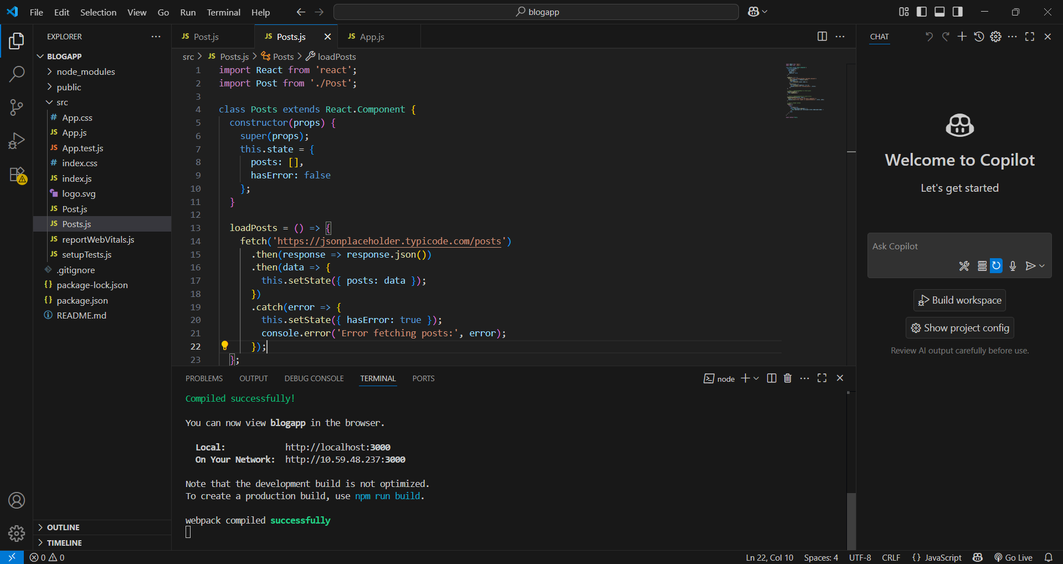

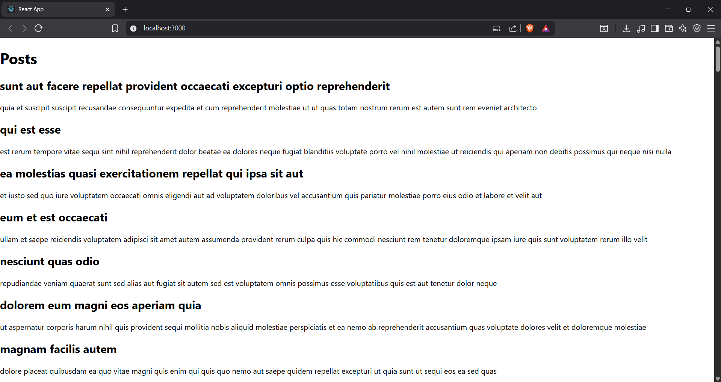

**HandsOn5:**

**Output:**

