**HandsOn 9:**

1. Run the command to create a new React app:  
 npx create-react-app cricketapp

2. Navigate into the app folder:  
 cd cricketapp

3. Replace src/index.js with the React 18 compatible code:  
 import React from 'react';  
 import ReactDOM from 'react-dom/client';  
 import App from './App';  
 const root = ReactDOM.createRoot(document.getElementById('root'));  
 root.render(<React.StrictMode><App /></React.StrictMode>);

4. Create the following component files in src/:  
- ListofPlayers.js  
- Scorebelow70.js  
- OddPlayers.js  
- EvenPlayers.js  
- ListofIndianPlayers.js

**ListofPlayers.js**

import React from 'react';

const ListofPlayers = ({ players }) => {

  return (

    <ul>

      {players.map((player, index) => (

        <li key={index}>{player.name} - {player.score}</li>

      ))}

    </ul>

  );

};

export default ListofPlayers;

**Scorebelow70.js**

import React from 'react';

const Scorebelow70 = ({ players }) => {

  const filtered = players.filter(player => player.score < 70);

return (

    <ul>

      {filtered.map((player, index) => (

        <li key={index}>{player.name} - {player.score}</li>

      ))}

    </ul>

  );

};

export default Scorebelow70;

**OddPlayers.js**

import React from 'react';

const OddPlayers = ({ IndianTeam }) => {

  const oddPlayers = IndianTeam.filter((_, index) => index % 2 === 1);

  return (

    <ul>

      {oddPlayers.map((name, index) => (

        <li key={index}>{name}</li>

      ))}

    </ul>

  );

};

export default OddPlayers;

**EvenPlayers.js**

import React from 'react';

const EvenPlayers = ({ IndianTeam }) => {

  const evenPlayers = IndianTeam.filter((_, index) => index % 2 === 0);

  return (

    <ul>

      {evenPlayers.map((name, index) => (

        <li key={index}>{name}</li>

      ))}

    </ul>

  );

};

export default EvenPlayers;

**ListofIndianPlayers.js**

import React from 'react';

const ListofIndianPlayers = ({ IndianPlayers }) => {

  return (

    <ul>

      {IndianPlayers.map((player, index) => (

        <li key={index}>{player}</li>

      ))}

    </ul>

  );

};

export default ListofIndianPlayers;

5. Replace App.js with the logic that uses a flag variable to switch between two views.

6. Run the application:  
 npm start

7. If you see 'List of Players' with scores, the flag is set to true.  
 If you see 'Odd Players' and 'Even Players', the flag is set to false.

**OUTPUT:**

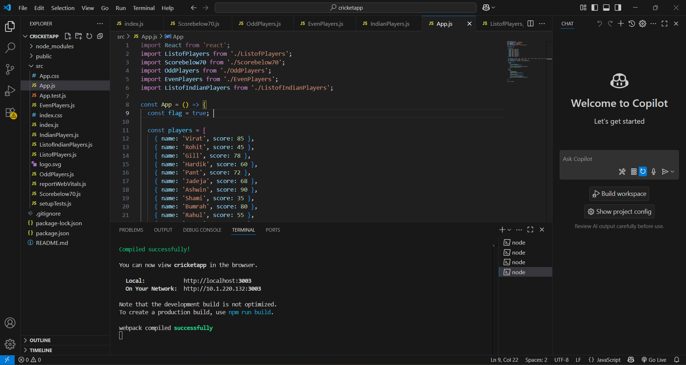

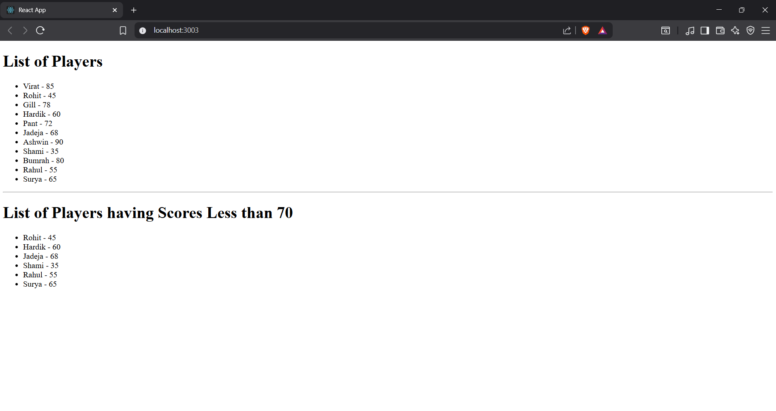

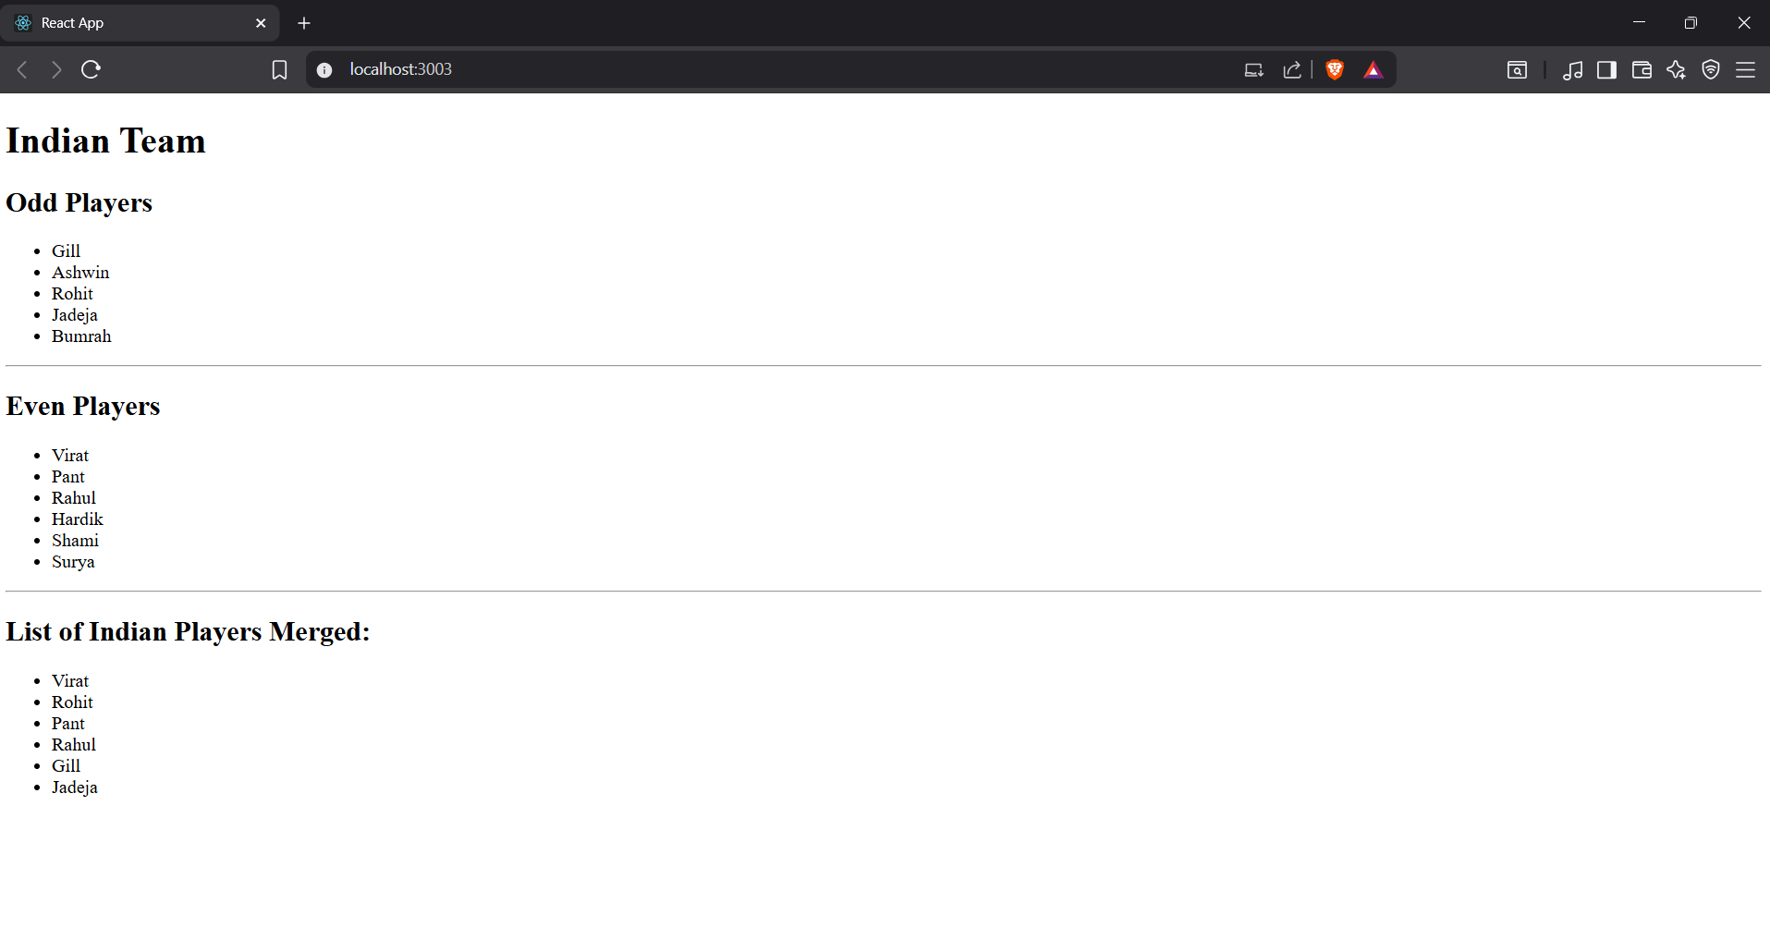

**HandsOn 10:**

**1. Create the React App**

1. Open your terminal.
2. Run the following commands:

npx create-react-app officespacerentalapp  
cd officespacerentalapp  
npm start

**2. Create App.js**

1. Open App.js.
2. Add the following code:

**import** React **from** 'react';  
**import** './App.css';  
  
**function** App() {  
 **const** office = {  
 name: "Tech Hub Workspace",  
 rent: 55000,  
 address: "123, IT Park, Bangalore",  
 image: "https://via.placeholder.com/300x200?text=Office+Space"  
 };  
  
 **const** offices = [  
 {  
 name: "Startup Space",  
 rent: 45000,  
 address: "5th Floor, City Tower, Pune",  
 image: "https://via.placeholder.com/300x200?text=Startup+Space"  
 },  
 {  
 name: "Corporate Hub",  
 rent: 75000,  
 address: "88, MG Road, Chennai",  
 image: "https://via.placeholder.com/300x200?text=Corporate+Hub"  
 },  
 {  
 name: "Creative Corner",  
 rent: 60000,  
 address: "44, Indiranagar, Bangalore",  
 image: "https://via.placeholder.com/300x200?text=Creative+Corner"  
 }  
 ];  
  
 **return** (  
 **<div** className="App"**>**  
 **<h1>**Office Space Rental App**</h1>**  
  
 **<div** className="office-card"**>**  
 **<h2>**{office.name}**</h2>**  
 **<img** src={office.image} alt={office.name} **/>**  
 **<p>**  
 Rent: {" "}  
 **<span** style={{  
 color: office.rent < 60000 ? "red" : "green",  
 fontWeight: "bold"  
 }}**>**  
 ₹{office.rent}  
 **</span>**  
 **</p>**  
 **<p>**Address: {office.address}**</p>**  
 **</div>**  
  
 **<hr** **/>**  
  
 **<h2>**Available Office Spaces**</h2>**  
 **<div** className="office-list"**>**  
 {offices.map((item, index) **=>** (  
 **<div** key={index} className="office-card"**>**  
 **<h3>**{item.name}**</h3>**  
 **<img** src={item.image} alt={item.name} **/>**  
 **<p>**  
 Rent: {" "}  
 **<span** style={{  
 color: item.rent < 60000 ? "red" : "green",  
 fontWeight: "bold"  
 }}**>**  
 ₹{item.rent}  
 **</span>**  
 **</p>**  
 **<p>**Address: {item.address}**</p>**  
 **</div>**  
 ))}  
 **</div>**  
 **</div>**  
 );  
}  
  
**export** **default** App;

**3. Add CSS Styling**

1. Open App.css.
2. Add the following styles:

.App {  
 **text-align**: center;  
 **padding**: 20px;  
}  
  
.office-card {  
 **border**: 1px solid #ddd;  
 **border-radius**: 10px;  
 **padding**: 15px;  
 **margin**: 10px;  
 **display**: inline-block;  
 **width**: 300px;  
 **background-color**: #f9f9f9;  
}  
  
.office-card img {  
 **width**: 100%;  
 **height**: auto;  
 **border-radius**: 5px;  
}  
  
.office-list {  
 **display**: flex;  
 **justify-content**: center;  
 **flex-wrap**: wrap;  
}

**4. Run the App**

1. Save all files.
2. In terminal, run:

npm start

1. The app will open in your browser and display:
   * A heading **Office Space Rental App**
   * One featured office space
   * A list of office spaces with rent highlighted in **red** if below ₹60000 and **green** if above.

**OUTPUT:**

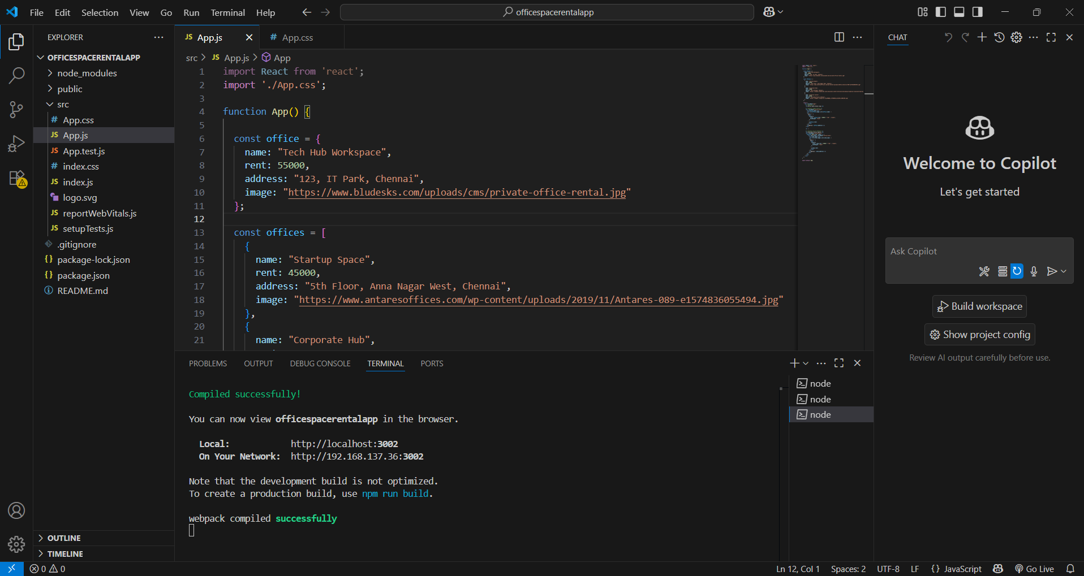

r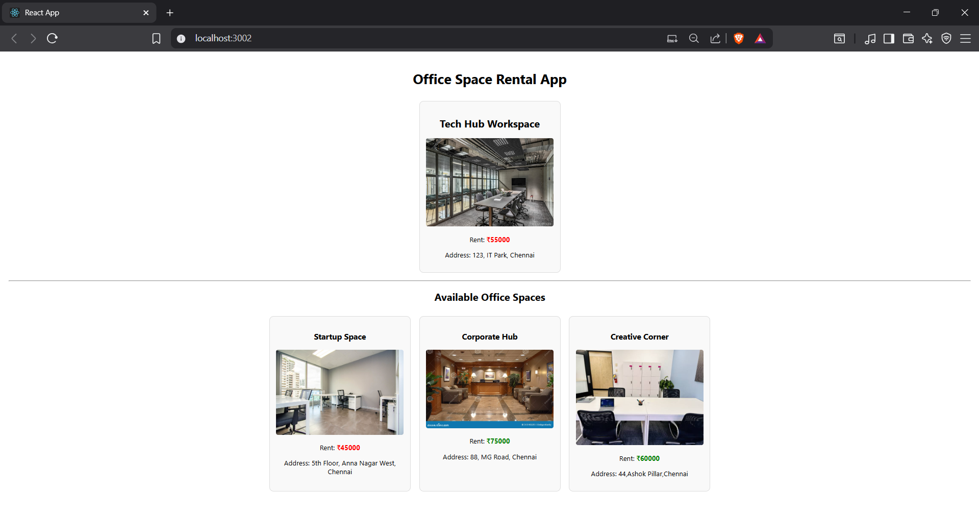

**HandsOn 11:**

**1. Create the React App**

1. Open your terminal.
2. Run:

npx create-react-app eventexamplesapp  
cd eventexamplesapp  
npm start

**2. Create App.js**

**import** React, { useState } **from** 'react';  
**import** './App.css';  
  
**function** CurrencyConvertor() {  
 **const** [amount, setAmount] = useState('');  
 **const** [currency, setCurrency] = useState('Euro');  
  
 **const** handleSubmit = (e) **=>** {  
 e.preventDefault();  
 **if** (currency === 'Euro') {  
 **const** result = amount * 80; *// Example conversion rate*  
 alert(`Converting to Euro Amount is ${result}`);  
 }  
 };  
  
 **return** (  
 **<div>**  
 **<h2** style={{ color: 'green' }}**>**Currency Convertor!!!**</h2>**  
 **<form** onSubmit={handleSubmit}**>**  
 **<div>**  
 **<label>**Amount: **</label>**  
 **<input** type="number" value={amount} onChange={(e) **=>** setAmount(e.target.value)} **/>**  
 **</div>**  
 **<div>**  
 **<label>**Currency: **</label>**  
 **<select** value={currency} onChange={(e) **=>** setCurrency(e.target.value)}**>**  
 **<option** value="Euro"**>**Euro**</option>**  
 **</select>**  
 **</div>**  
 **<button** type="submit"**>**Submit**</button>**  
 **</form>**  
 **</div>**  
 );  
}  
  
**function** App() {  
 **const** [count, setCount] = useState(1);  
  
 **const** increment = () **=>** {  
 setCount(count + 1);  
 };  
  
 **const** sayHello = () **=>** {  
 alert("Hello - This is a static message");  
 };  
  
 **const** incrementAndGreet = () **=>** {  
 increment();  
 sayHello();  
 };  
  
 **const** sayWelcome = (msg) **=>** {  
 alert(msg);  
 };  
  
 **const** handleOnPress = () **=>** {  
 alert("I was clicked");  
 };  
  
 **return** (  
 **<div** className="App"**>**  
 **<p>**{count}**</p>**  
 **<button** onClick={incrementAndGreet}**>**Increment**</button>**  
 **<button** onClick={() **=>** setCount(count - 1)}**>**Decrement**</button>**  
 **<br** **/><br** **/>**  
 **<button** onClick={() **=>** sayWelcome("Welcome")}**>**Say welcome**</button>**  
 **<br** **/><br** **/>**  
 **<button** onClick={handleOnPress}**>**Click on me**</button>**  
 **<br** **/><br** **/>**  
 <CurrencyConvertor />  
 **</div>**  
 );  
}  
  
**export** **default** App;

**3. Add Basic CSS in App.css**

.App {  
 **text-align**: left;  
 **padding**: 20px;  
}  
button {  
 **margin**: 5px;  
 **padding**: 6px 10px;  
 **font-size**: 14px;  
}  
input, select {  
 **margin**: 5px;  
 **padding**: 5px;  
}

**4. Run the App**

npm start

**OUTPUT:**

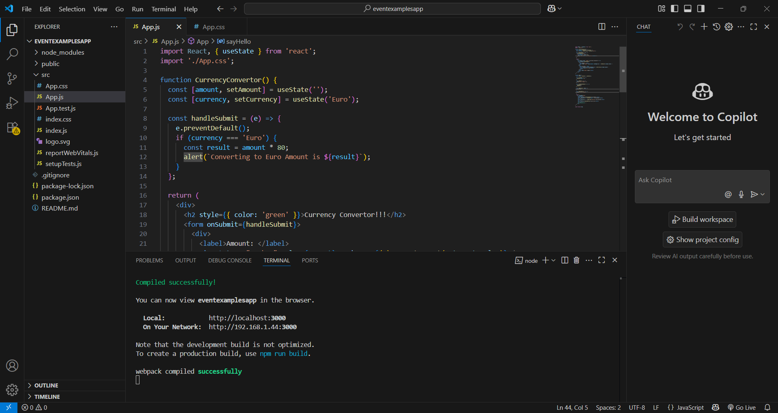

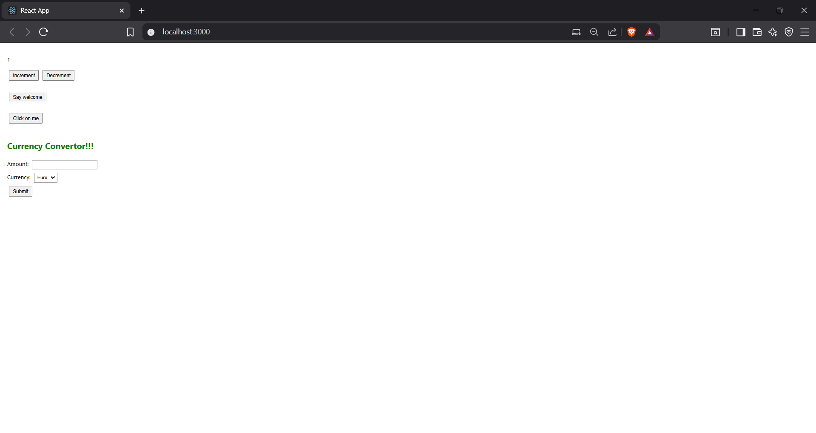

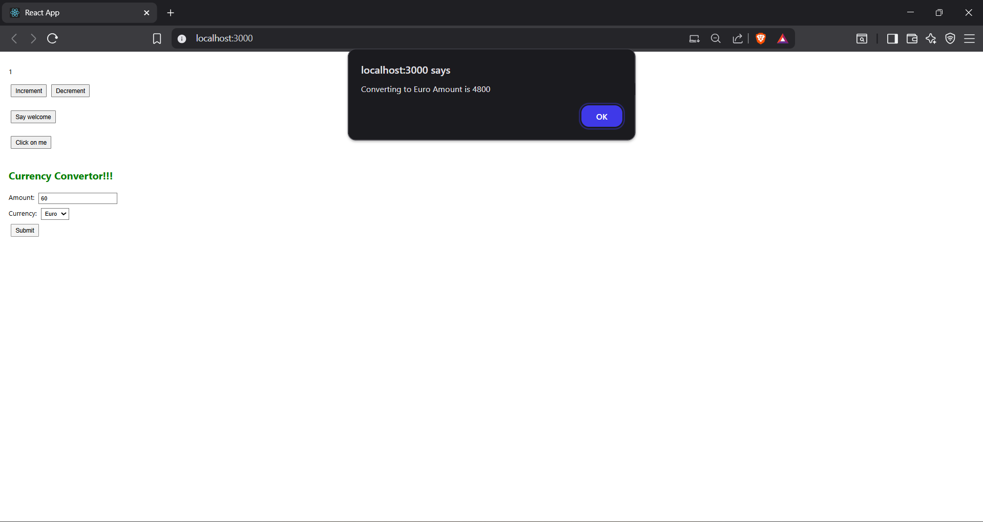

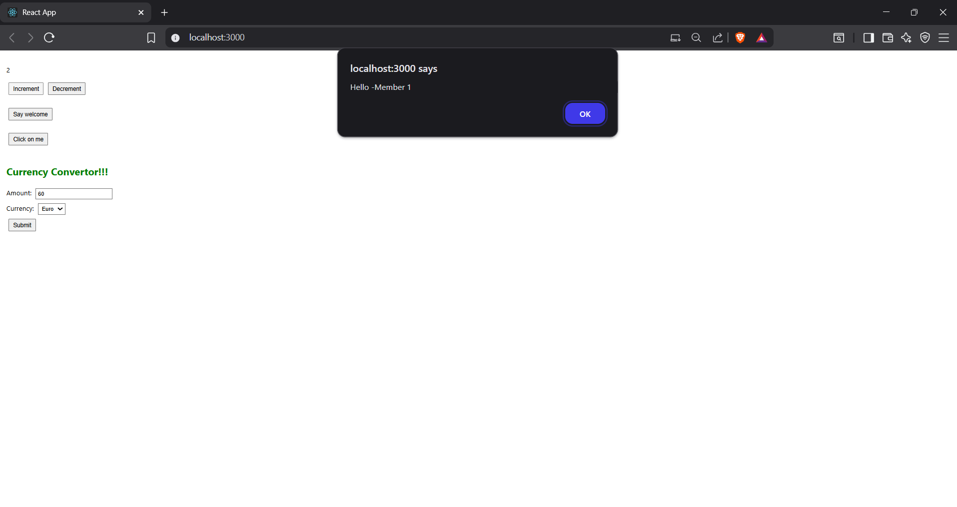

**HandsOn 12:**

**1. Create the React Application**

1. Open Command Prompt (cmd) or Terminal.  
2. Navigate to your projects folder:  
 cd D:\react-projects  
3. Create the React application:  
 npx create-react-app ticketbookingapp

**2. Start the React App**

Run the following command to start the development server:  
 npm start  
This will open your app in the browser at http://localhost:3000

**3. Replace the Files in src/**

Inside your 'src' folder, replace or create the following files:

***LoginButton.js***

function LoginButton(props) {  
 return (  
 <button onClick={props.onClick}>Login</button>  
 );  
}  
export default LoginButton;

***LogoutButton.js***

function LogoutButton(props) {  
 return (  
 <button onClick={props.onClick}>Logout</button>  
 );  
}  
export default LogoutButton;

***FlightList.js***

import React from "react";  
  
function FlightList() {  
 const flights = [  
 { id: 1, airline: "Air India", from: "Chennai", to: "Delhi", price: 5000 },  
 { id: 2, airline: "IndiGo", from: "Mumbai", to: "Bangalore", price: 3500 },  
 { id: 3, airline: "Vistara", from: "Kolkata", to: "Hyderabad", price: 4500 }  
 ];  
 return (  
 <div>  
 <h3>Available Flights</h3>  
 <table border="1" cellPadding="10" style={{ margin: "auto" }}>  
 <thead>  
 <tr>  
 <th>Airline</th>  
 <th>From</th>  
 <th>To</th>  
 <th>Price (₹)</th>  
 </tr>  
 </thead>  
 <tbody>  
 {flights.map(f => (  
 <tr key={f.id}>  
 <td>{f.airline}</td>  
 <td>{f.from}</td>  
 <td>{f.to}</td>  
 <td>{f.price}</td>  
 </tr>  
 ))}  
 </tbody>  
 </table>  
 </div>  
 );  
}  
export default FlightList;

***GuestPage.js***

import React from "react";  
import FlightList from "./FlightList";  
  
function GuestPage() {  
 return (  
 <div>  
 <h2>Welcome Guest</h2>  
 <p>Please log in to book tickets.</p>  
 <FlightList />  
 </div>  
 );  
}  
export default GuestPage;

***UserPage.js***

import React from "react";  
import FlightList from "./FlightList";  
  
function UserPage() {  
 const handleBook = () => {  
 alert("Your ticket has been booked!");  
 };  
  
 return (  
 <div>  
 <h2>Welcome User</h2>  
 <p>You can now book tickets.</p>  
 <FlightList />  
 <br />  
 <button onClick={handleBook}>Book Ticket</button>  
 </div>  
 );  
}  
export default UserPage;

***App.js***

import React, { useState } from "react";  
import LoginButton from "./LoginButton";  
import LogoutButton from "./LogoutButton";  
import GuestPage from "./GuestPage";  
import UserPage from "./UserPage";  
  
function App() {  
 const [isLoggedIn, setIsLoggedIn] = useState(false);  
  
 const handleLoginClick = () => setIsLoggedIn(true);  
 const handleLogoutClick = () => setIsLoggedIn(false);  
  
 return (  
 <div style={{ textAlign: "center" }}>  
 <h1>Ticket Booking App</h1>  
 {isLoggedIn ? (  
 <>  
 <LogoutButton onClick={handleLogoutClick} />  
 <UserPage />  
 </>  
 ) : (  
 <>  
 <LoginButton onClick={handleLoginClick} />  
 <GuestPage />  
 </>  
 )}  
 </div>  
 );  
}  
export default App;

**4. Run the Application Again**

After saving all files, restart the app (if needed) by running:  
 npm start  
Then visit http://localhost:3000 to test.

**5. Test the Login/Logout**

1. Initially, you should see the Guest Page with a Login button.  
2. Click Login → User Page will appear with a Book Ticket button.  
3. Click Logout → Back to Guest Page

**OUTPUT:**

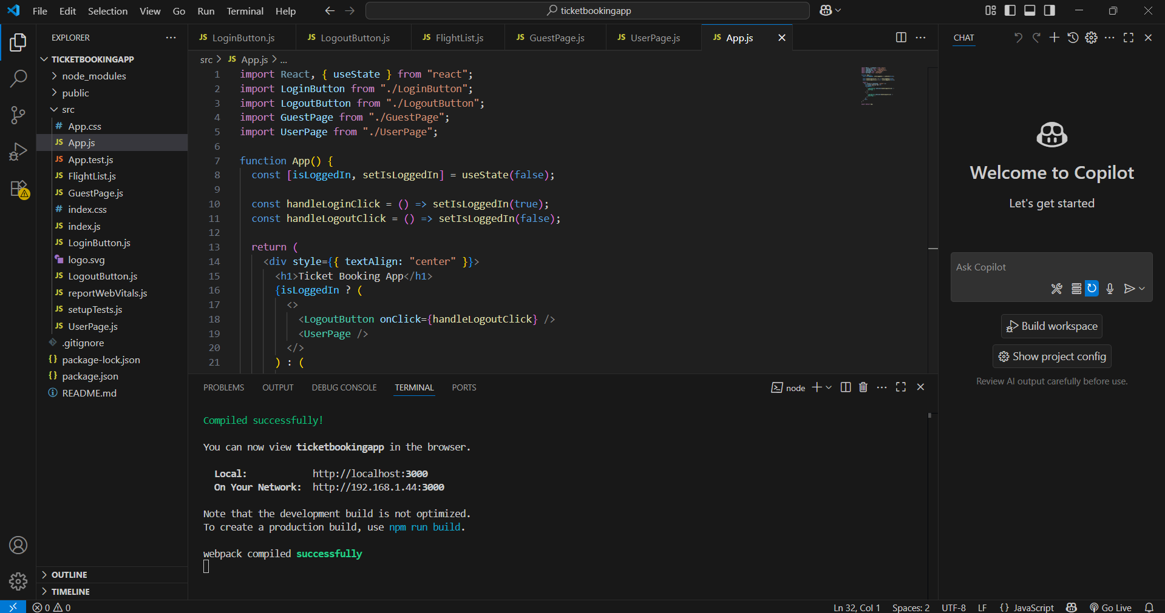

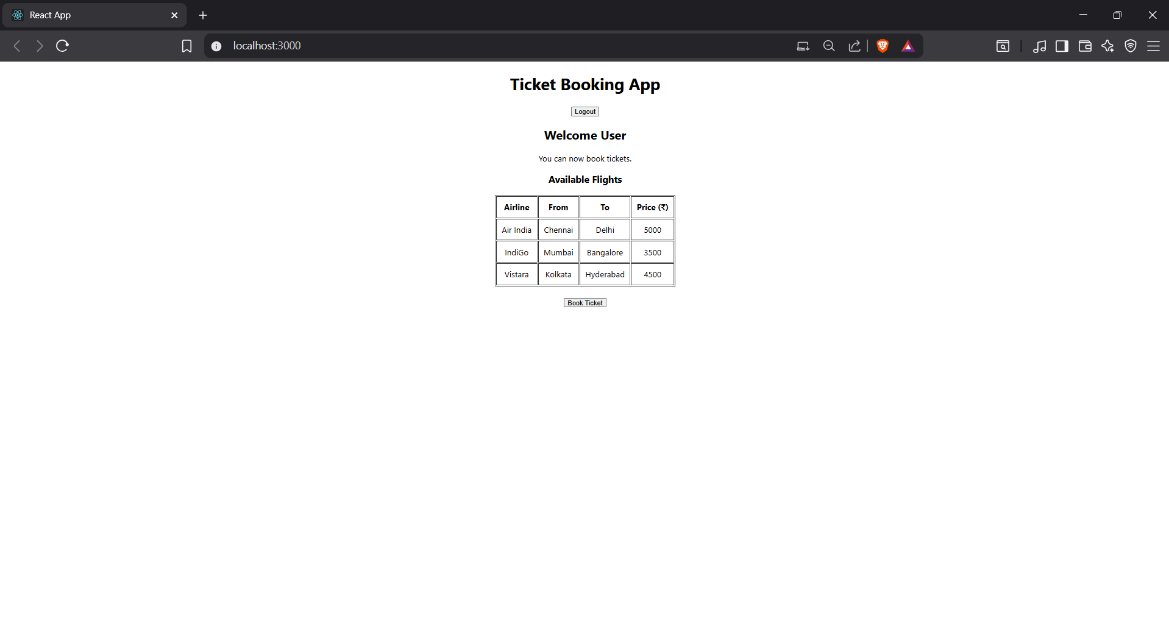

.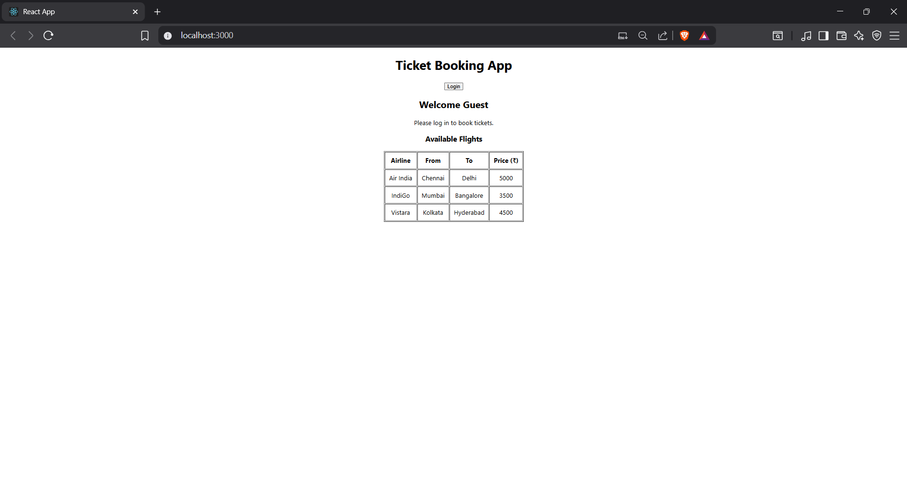

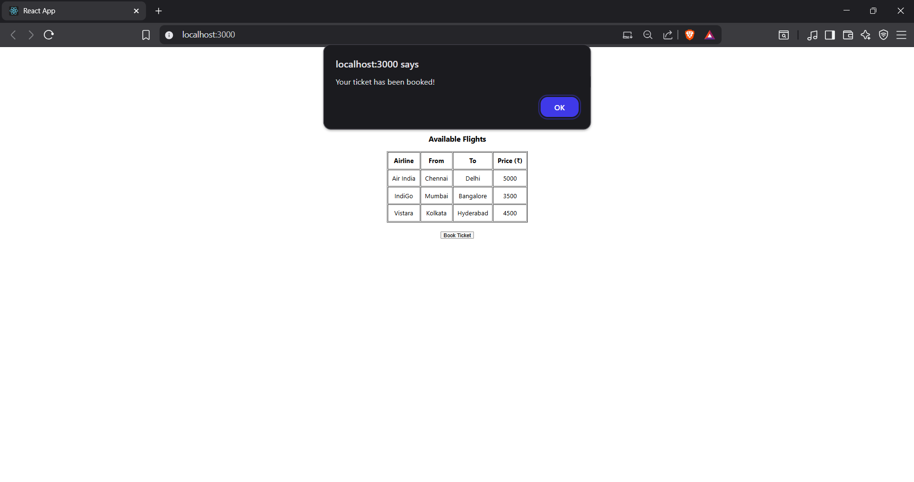

**HandsOn 13:**

**1. Create the React App**

Open Command Prompt or Terminal and run:  
cd D:\react-projects  
npx create-react-app bloggerapp  
cd bloggerapp  
npm start

**2. Create Components**

***CourseDetails.js***

function CourseDetails() {  
 return (  
 <div>  
 <h2>Course Details</h2>  
 <p><strong>Angular</strong></p>  
 <p>4/5/2021</p>  
 <p><strong>React</strong></p>  
 <p>6/3/20201</p>  
 </div>  
 );  
}  
export default CourseDetails;

***BookDetails.js***

function BookDetails() {  
 return (  
 <div>  
 <h2>Book Details</h2>  
 <p><strong>Master React</strong></p>  
 <p>670</p>  
 <p><strong>Deep Dive into Angular 11</strong></p>  
 <p>800</p>  
 <p><strong>Mongo Essentials</strong></p>  
 <p>450</p>  
 </div>  
 );  
}  
export default BookDetails;

***BlogDetails.js***

function BlogDetails() {  
 return (  
 <div>  
 <h2>Blog Details</h2>  
 <p><strong>React Learning</strong></p>  
 <p>Stephen Biz</p>  
 <p>Welcome to learning React!</p>  
 <p><strong>Installation</strong></p>  
 <p>Schwezdenier</p>  
 <p>You can install React from npm.</p>  
 </div>  
 );  
}  
export default BlogDetails;

**5. Update App.js**

import React from "react";  
import CourseDetails from "./CourseDetails";  
import BookDetails from "./BookDetails";  
import BlogDetails from "./BlogDetails";  
import "./App.css";  
  
function App() {  
 return (  
 <div className="container">  
 <CourseDetails />  
 <BookDetails />  
 <BlogDetails />  
 </div>  
 );  
}  
  
export default App;

**6. Create App.css**

.container {  
 display: flex;  
 justify-content: space-around;  
 text-align: left;  
 margin: 20px;  
}  
  
.container > div {  
 border-left: 4px solid green;  
 padding-left: 20px;  
 flex: 1;  
}  
  
h2 {  
 font-size: 1.5em;  
}

**7. Run the Application**

npm start

**OUTPUT:**

