Assignment – 6.2

## Task - 1

Task Description #1 (Classes – Employee Management)  
• Task: Use AI to create an Employee class with attributes (name,  
Id, salary) and a method to calculate yearly salary.

**Code:**

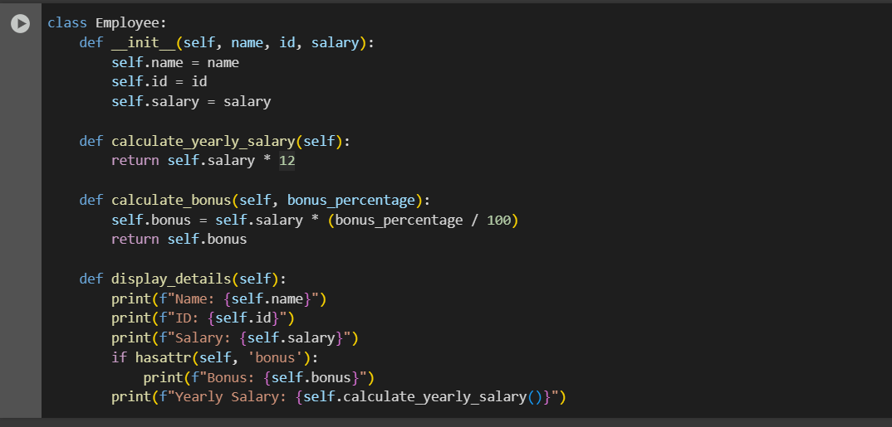

**Task – 2**

ask Description #2 (Loops – Automorphic Numbers in a Range)  
• Task: Prompt AI to generate a function that displays all  
Automorphic numbers between 1 and 1000 using a for loop

**code:**

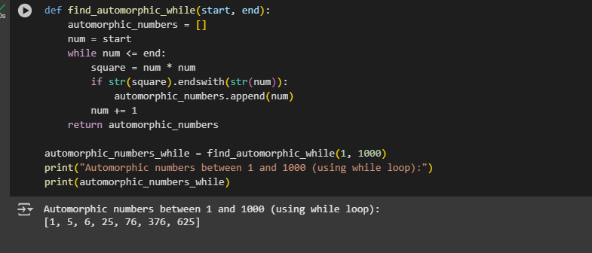

Task – 3

Task Description #3 (Conditional Statements – Online Shopping  
Feedback Classification)  
• Task: Ask AI to write nested if-elif-else conditions to classify  
online shopping feedback as Positive, Neutral, or Negative based  
on a numerical rating (1–5).

Code :

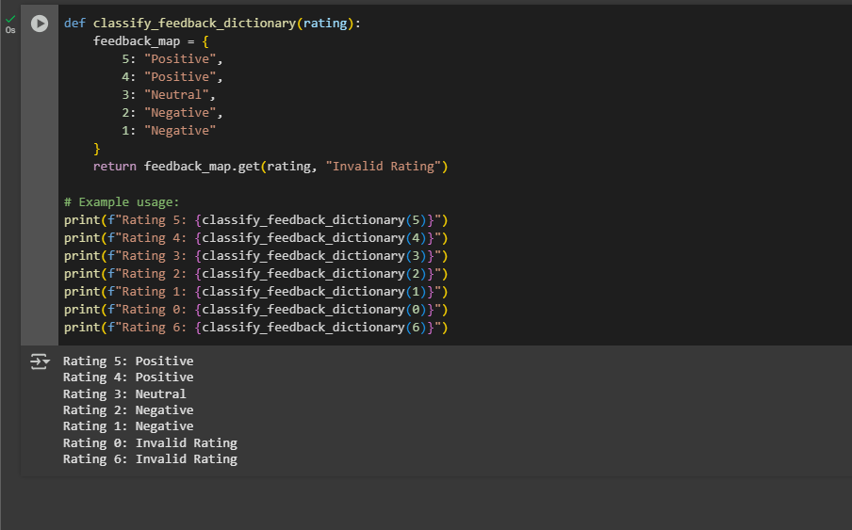

Task-4

Task Description #4 (Loops – Prime Numbers in a Range)  
• Task: Generate a function using AI that displays all prime  
numbers within a user-specified range (e.g., 1 to 500).

Code:

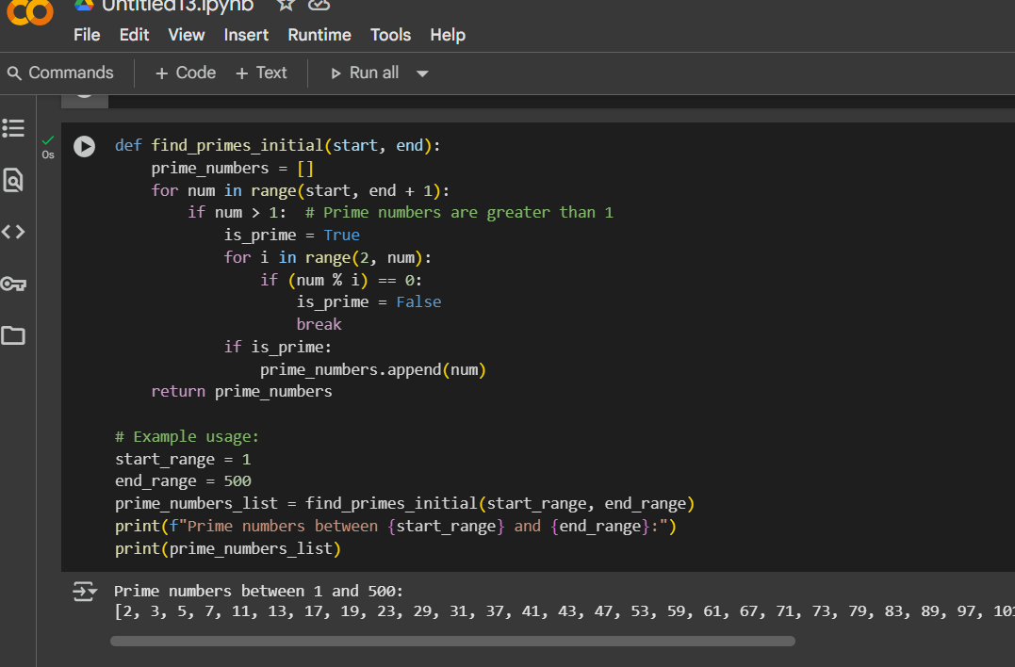

Task – 5

Task Description #5 (Classes – Library System)  
• Task: Use AI to build a Library class with methods to  
add_book(), issue_book(), and display_books().

Code:

