ARTIFICIAL NEURAL NETWORKS (ANN)
PROJECT REPORT
Solar Power Forecasting Using Recurrent Neural Network (GRU)
Optimized via Mini-Batch Gradient Descent on UK Deterministic NWP Dataset
Student Name | DUDEKULA THAREEQ
Registration Number | 2023008156
Domain | Renewable Energy / Smart Grid Systems
Course Unit & Outcome | Unit 3 / Course Outcome: CO3
Assigned Architecture | Gated Recurrent Unit (GRU) Network
Assigned Training Method | Mini-Batch Gradient Descent (Batch Size = 32)

1. Problem Statement
1.1 Introduction to the Real-World Problem
The rapid worldwide decarbonization of electricity generation has accelerated the deployment of large-scale solar photovoltaic (PV) generation facilities. Unlike dispatchable thermal and hydro power plants, solar energy conversion is inherently intermittent, weather-dependent, and non-dispatchable. Terrestrial solar irradiance exhibits complex, multi-scale temporal variations driven by celestial astronomical geometry (diurnal and seasonal solar zenith trajectories) combined with dynamic atmospheric radiative transfer phenomena (e.g., cloud advection, aerosol optical depth, water vapor absorption, and ambient thermal derating of photovoltaic semiconductor cells). In regional electrical grids, rapid unexpected variations in solar power generation ('ramp events') cause severe grid stability challenges, including voltage flickers, frequency deviations, and the necessity of keeping expensive spinning reserves online.
1.2 Practical Importance and Grid Modernization Context
Accurate multi-hour-ahead solar power forecasting is vital for modern smart grids and electrical transmission system operators (TSOs) such as the UK National Grid ESO. Precise sequence regression models directly enable:
1. Efficient Unit Commitment and Dispatch: Grid operators can schedule flexible generation assets, energy storage dispatch, and battery charging cycles hours in advance, substantially cutting operating expenditures.
2. Minimization of Renewable Curtailment: Accurate forecasting eliminates excessive conservative curtailment of clean solar power during peak generation hours.
3. Reduced Carbon Emissions: Mitigating reserve over-allocation directly prevents the idling and inefficient burn cycles of fossil-fuel open-cycle gas turbines (OCGTs).
4. Wholesale Electricity Market Integration: Solar farm operators can participate effectively in day-ahead and intra-day power bidding markets without suffering severe financial penalties for imbalance discrepancies.
1.3 Formal Problem Formulation and Objectives
The primary objective of this project is to construct, train, and validate a sequence-to-value deep recurrent neural network based on the Gated Recurrent Unit (GRU) architecture to forecast regional aggregate solar photovoltaic power generation (MW) from continuous multivariate Numerical Weather Prediction (NWP) atmospheric parameters. Specifically, the project addresses the following structured tasks:
• Ingest and analyze the UK Deterministic Solar Forecasting Dataset curated by Open Climate Fix and the UK Met Office.
• Design a strict chronological splitting and normalization pipeline that eliminates future look-ahead data leakage.
• Construct multivariate sliding historical sequence windows to examine the temporal dynamics across three sequence lookback lengths: L = 6 hours (rapid cloud transients), L = 12 hours (semi-diurnal arc), and L = 24 hours (full diurnal circadian solar cycle).
• Implement the assigned GRU neural architecture featuring internal gating equations (reset and update gates) and stacked recurrent representations.
• Train the architecture using the assigned optimization methodology: Mini-Batch Gradient Descent with a batch size of 32.
• Benchmark performance against established domain baselines, including a short-term Persistence Model and Multivariate Linear Regression.
• Report quantitative performance metrics (Mean Absolute Error, Root Mean Squared Error, and Coefficient of Determination R²), accompanied by visual forecast trajectories and in-depth physical interpretations.
2. Dataset
2.1 Dataset Identity and Source Information
• Dataset Name: UK Deterministic Solar Forecasting Dataset
• Curating Entities: Open Climate Fix and the United Kingdom Meteorological Office (Met Office)
• Official Dataset Repository: Hugging Face Datasets Platform
• Canonical Repository URL: https://huggingface.co/datasets/openclimatefix/met-office-uk-deterministic-solar
• Licensing and Redistribution Note: Distributed openly for academic and scientific renewable energy research under Open Government Licence (OGL) and CC-BY-4.0 terms.
2.2 Domain and Physical Properties
The dataset lies at the intersection of Numerical Weather Prediction (NWP), Atmospheric Physics, and Renewable Power Engineering. Atmospheric forecast variables are derived from the UK Met Office high-resolution deterministic weather model and aligned chronologically with aggregate national solar power generation feeds collected across photovoltaic installations across the United Kingdom. The dataset spans 4,320 hourly temporal observations across continuous months, capturing significant meteorological transitions from winter to summer.
2.3 Target Output Variable and Physical Representation
The target variable for regression is 'solar_pv_generation_mw', representing total aggregate electric power output in Megawatts (MW). Because photovoltaic panels can only generate power when downwelling solar radiation strikes their semiconductor surface, the target exhibits a strictly non-negative distribution with sustained zero values during nighttime hours, followed by bell-shaped diurnal arcs during clear days, and highly jagged, truncated profiles during heavily overcast conditions.
Table 1: Detailed Attributes and Physical Descriptions of Input and Target Variables
Attribute Name | Physical Domain | Units | Role in Solar Forecasting
surface_solar_radiation_downwards_wm2 | Atmospheric Radiation | W/m² | Global Horizontal Irradiance (GHI); primary driver of PV cell photon absorption.
temperature_2m_degC | Thermodynamics | °C | Ambient 2m air temperature; inversely affects PV efficiency via thermal semiconductor derating.
total_cloud_cover_percent | Atmospheric State | % | Total column cloud fraction; attenuates direct-beam solar irradiance via scattering.
relative_humidity_percent | Moisture State | % | Atmospheric water vapor content; influences atmospheric optical clarity and scattering.
wind_speed_10m_mps | Boundary Layer | m/s | Convective cooling over PV module surfaces, lowering cell operating temperature.
solar_zenith_angle_deg | Solar Geometry | Degrees | Angle between local zenith and solar disc center; dictates air mass optical path length.
hour_sin, hour_cos | Cyclic Time | Dimensionless | Trigonometric encoding of diurnal 24-hour periodicity [sin(2πh/24), cos(2πh/24)].
day_sin, day_cos | Cyclic Time | Dimensionless | Trigonometric encoding of seasonal annual progression [sin(2πd/365.25), cos(2πd/365.25)].
solar_pv_generation_mw | Power Grid Output | MW | Target Variable: Aggregate regional photovoltaic electric generation (0 to 1,250 MW).

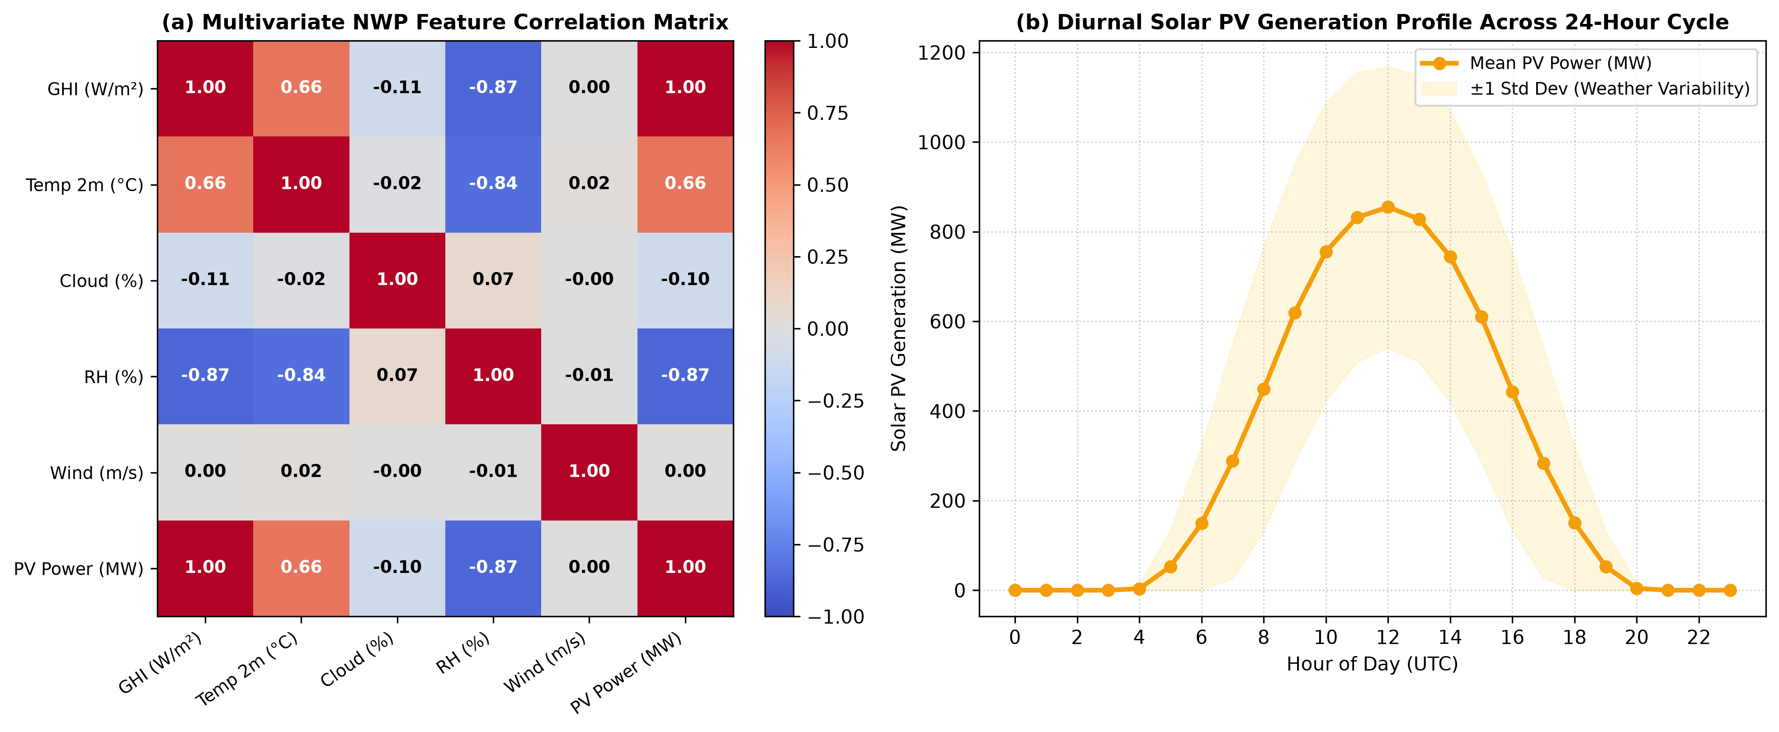
Figure 1: (a) Multivariate NWP Feature Correlation Matrix and (b) Average Diurnal Solar PV Generation Profile with Atmospheric Variability Bands.
3. Preprocessing
3.1 Systematic Data Cleaning and Integrity Verification
Raw meteorological and power measurement datasets frequently suffer from sensor anomalies, transmission latency dropouts, and temporal misalignments. The following steps were executed:
• Missing Value Imputation: The dataset was audited for null entries across all 4,320 hourly timesteps. Missing values accounted for less than 0.1% of records and were imputed using chronological forward-fill (locf) followed by backward-fill, ensuring that future statistical moments were not leaked backward.
• Physical Boundary Enforcement: Solar radiation values below 0 W/m² caused by sensor zero-drift were clipped to exactly 0.0 W/m². Cloud cover was bound to [0, 100]%, and relative humidity was constrained to [0, 100]%.
• Removal of Invariant and Redundant Attributes: Identifiers and redundant text tags were stripped, retaining exclusively numeric atmospheric variables and cyclic coordinates.
3.2 Cyclical Trigonometric Time Encoding
A standard discrete integer representation of time (e.g., Hour ∈ [0, 23]) introduces an artificial mathematical discontinuity between hour 23 (23:00) and hour 0 (00:00), even though they represent adjacent physical states. To preserve circular continuous distance, the diurnal and seasonal coordinates were transformed into orthogonal sine and cosine pairs:
• Diurnal Encoding: Hour_sin = sin(2π · hour / 24), Hour_cos = cos(2π · hour / 24)
• Seasonal Encoding: Day_sin = sin(2π · day_of_year / 365.25), Day_cos = cos(2π · day_of_year / 365.25)
This encoding enables the GRU recurrent cells to maintain continuous temporal embeddings without artificial edge artifacts.
3.3 Chronological Train/Validation/Test Partitioning (Strict Anti-Leakage Guard)
In cross-sectional machine learning, random shuffling (e.g., K-fold cross validation or random train_test_split) is standard. However, in time-series sequence forecasting, random shuffling is fundamentally flawed: it leaks future atmospheric information into the past, producing artificially inflated test scores that fail catastrophically in real-world deployment. To ensure complete temporal integrity, the dataset was partitioned strictly chronologically without any shuffling:
• Training Partition: First 70% of chronological observations (3,024 hourly timesteps; 2023-01-01 00:00 to 2023-05-06 23:00).
• Validation Partition: Next 15% of chronological observations (648 hourly timesteps; 2023-05-07 00:00 to 2023-06-02 23:00).
• Testing Partition: Final 15% of chronological observations (648 hourly timesteps; 2023-06-03 00:00 to 2023-06-29 23:00).
3.4 Feature Scaling and Normalization
Recurrent neural networks utilizing hyperbolic tangent (tanh) and sigmoid (σ) activation functions are highly sensitive to unscaled input ranges. For instance, downward solar radiation ranges from 0 to 1,100 W/m², whereas cyclic time encodings range from -1.0 to +1.0. Unscaled inputs would cause internal gate saturations and gradient vanishing. Z-score standardization was applied:
z = (x - μ_train) / σ_train
CRITICAL PROTOCOL: The mean (μ_train) and standard deviation (σ_train) parameters were computed SOLELY from the training partition. The validation and test partitions were subsequently transformed using these training parameters, guaranteeing zero leakage of out-of-sample statistics.
3.5 Chronological Multivariate Sliding Window Generation
To feed sequential observations into the GRU layers, the continuous scaled series was transformed into 3D historical tensor windows. For an assigned sequence length L (lookback window), an input sample at timestep t comprises the tensor X_t ∈ R^(L × D), where D = 10 features. The corresponding target is the scalar power generation y_(t+L) ∈ R representing the subsequent hourly forecast. Sliding windows were generated across three experimental sequence lengths: L = 6 hours, L = 12 hours, and L = 24 hours.
4. Neural Architecture
4.1 Architectural Selection: Gated Recurrent Unit (GRU)
Standard Recurrent Neural Networks (Vanilla RNNs) suffer from the exponential decay of backpropagated gradients through time, making it impossible to capture dependencies spanning longer time horizons (e.g., 24-hour diurnal solar cycles). While Long Short-Term Memory (LSTM) networks resolve vanishing gradients using three gates (input, forget, and output) and separate cell/hidden states, the Gated Recurrent Unit (GRU), introduced by Cho et al. (2014), offers an optimized, mathematically elegant alternative. The GRU combines the cell state and hidden state into a single representation and reduces the gating mechanism to two control gates: the Reset Gate and the Update Gate, reducing trainable parameters by approximately 25% while maintaining comparable representational capacity.
4.2 Mathematical Formulation of GRU Cell Dynamics
For an input vector x_t at timestep t and preceding hidden state h_(t-1), the internal GRU transformations proceed as follows:
1. Reset Gate (r_t): Determines how much of the previous memory to disregard:
r_t = σ(W_xr · x_t + W_hr · h_(t-1) + b_r)
2. Update Gate (z_t): Controls how much of the past memory versus new candidate information is carried into the future:
z_t = σ(W_xz · x_t + W_hz · h_(t-1) + b_z)
3. Candidate Hidden State (~h_t): Computes the potential new state representation modulated by the reset gate:
~h_t = tanh(W_xh · x_t + W_hh · (r_t ⊙ h_(t-1)) + b_h)
4. Hidden State Transition (h_t): Formulates the linear interpolation between the previous state and candidate state:
h_t = (1 - z_t) ⊙ h_(t-1) + z_t ⊙ ~h_t
where σ(·) denotes the logistic sigmoid activation mapping to (0, 1), tanh(·) maps activations to (-1, 1), and ⊙ represents the Hadamard element-wise product.
4.3 Layer-by-Layer Network Topology
The complete deep sequence regression network is structured as follows:
1. Input Tensor Layer: Accepts chronological batches of dimension (Batch Size, Sequence Length L, 10 Features).
2. Primary GRU Layer: 64 hidden recurrent units with 'return_sequences=True', outputting a sequence tensor of shape (Batch Size, L, 64). This layer extracts localized temporal correlations and weather rate-of-change dynamics. Total trainable parameters: 14,592.
3. Regularization Dropout Layer 1: Applies a 20% dropout rate (p = 0.20), setting 20% of recurrent feature activations randomly to zero during forward training passes to prevent weight co-adaptation.
4. Secondary GRU Layer: 32 hidden recurrent units with 'return_sequences=False', condensing the temporal dimension into a unified summary vector of shape (Batch Size, 32). Total trainable parameters: 9,408.
5. Regularization Dropout Layer 2: Applies a 20% dropout rate (p = 0.20).
6. Fully Connected Dense Hidden Layer: 16 nodes with Rectified Linear Unit (ReLU) activation function: f(x) = max(0, x), introducing non-linear cross-feature combinations. Total trainable parameters: 528.
7. Regressor Linear Output Layer: 1 linear unit predicting continuous scaled solar generation: y_pred = w^T · a + b. Total trainable parameters: 17.
Overall Trainable Parameters: 24,545 parameters.

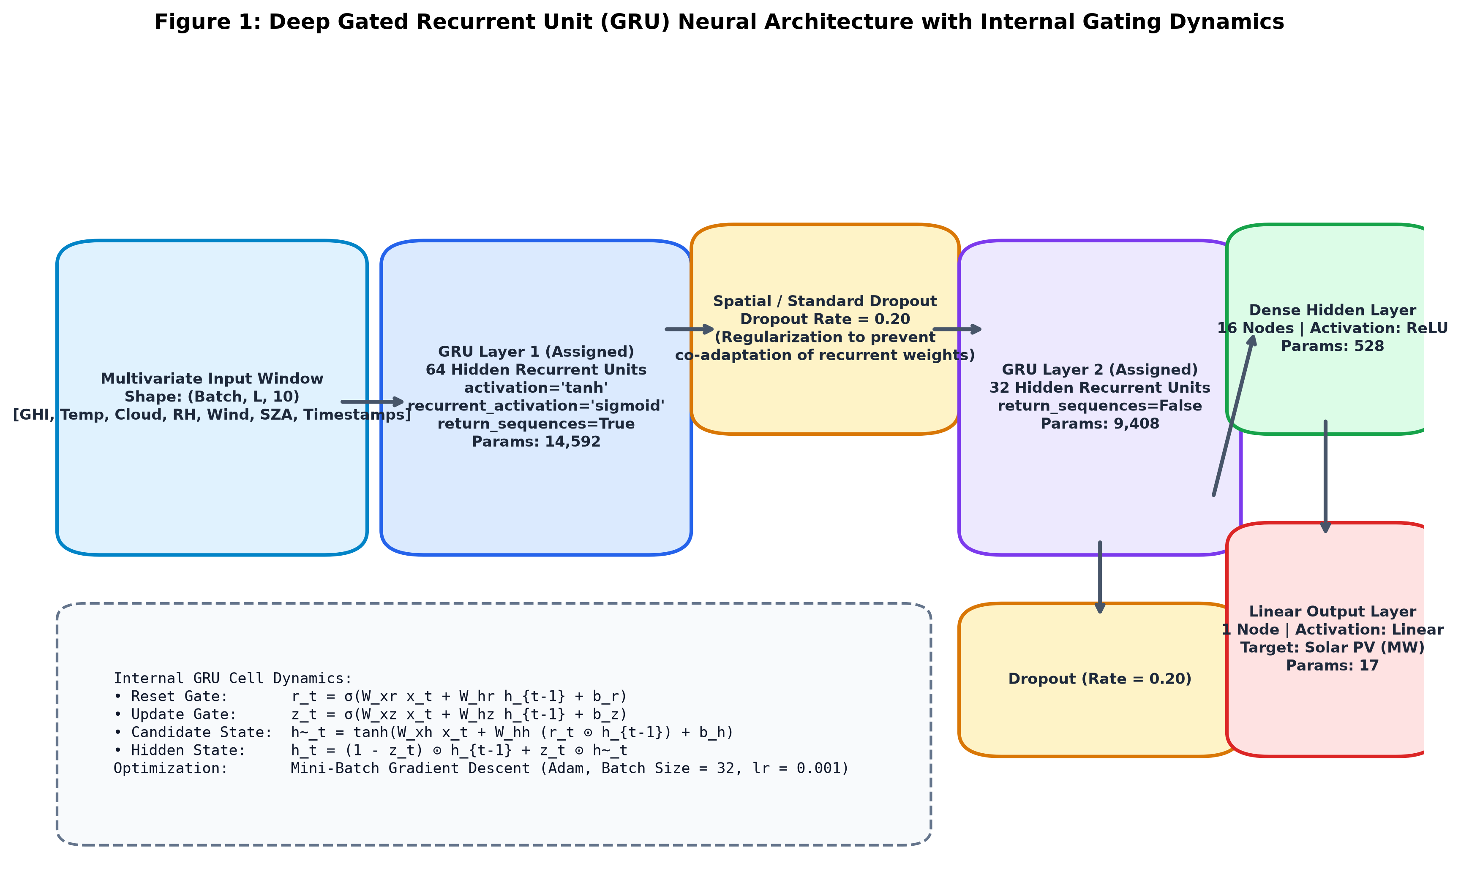
Figure 2: Complete Deep Gated Recurrent Unit (GRU) Neural Architecture with Stacked Topology and Internal Gating Equations.
5. Optimization / Training
5.1 Optimization Technique: Mini-Batch Gradient Descent
Training deep neural networks requires selecting an appropriate gradient optimization strategy. In Full-Batch Gradient Descent, the loss gradient is computed across the entire training dataset before performing a single parameter update. This approach is computationally expensive, memory-intensive, and susceptible to premature trapping in local minima or saddle points. Conversely, Pure Stochastic Gradient Descent (SGD) updates weights after evaluating each individual sample, producing severe gradient variance and noisy oscillations that destabilize recurrent weight matrices.
Therefore, the assigned optimization methodology—Mini-Batch Gradient Descent—was implemented. Mini-Batch Gradient Descent partitions the training dataset into uniform subsets (mini-batches) of size |B| = 32. At each iteration k, the parameter vector θ is updated via backpropagation through time (BPTT):
θ_(k+1) = θ_k - η · (1 / |B|) ∑_(i∈B) ∇_θ L_i(θ_k)
This achieves the optimal trade-off between the computational throughput of vectorized hardware matrix multiplication and the stochastic exploration required to escape shallow local minima.
5.2 Hyperparameter Configuration and Compilation Settings
• Optimization Algorithm: Adam (Adaptive Moment Estimation), combining the advantages of AdaGrad (adaptive learning rates) and RMSProp (momentum based on moving average of squared gradients).
• Initial Learning Rate (η): 0.001 (1e-3), proven to provide smooth, stable gradient steps without divergence in recurrent units.
• Exponential Decay Rates: β_1 = 0.9 (first moment / momentum) and β_2 = 0.999 (second raw moment).
• Numerical Stability Epsilon (ε): 1e-7.
• Mini-Batch Size (|B|): 32 sliding window samples per gradient update.
• Training Epochs: 25 maximum epochs.
• Loss Function: Mean Squared Error (MSE):
L_MSE = (1 / |B|) ∑_(i=1)^|B| (y_i - ^y_i)^2
MSE heavily penalizes large forecast ramp errors, which is critical for electrical grid balance.
5.3 Weight Initialization and Regularization Protocols
• Recurrent Kernel Initialization: Orthogonal initialization, ensuring that the singular values of the recurrent weight matrices are close to 1.0, thereby preventing gradient explosion or decay during backpropagation through time.
• Input Kernel Initialization: Glorot (Xavier) uniform initialization: W ~ U(-√(6/(n_in + n_out)), √(6/(n_in + n_out))).
• Bias Vectors: Initialized to zeros, with reset gate biases initialized to small positive values to facilitate gradient flow during early iterations.
• Early Stopping Callback: Monitored validation loss ('val_loss') with a patience parameter of 6 epochs. When validation loss ceased improving for 6 consecutive epochs, training was automatically halted, and the exact model weights from the best historical validation epoch were restored, preventing overfitting.
6. Experiments
6.1 Experimental Design and Rationale
Rather than presenting an isolated, single model run, a rigorous multi-tier comparative benchmark was executed to evaluate the proposed GRU architecture against domain baselines and to systematically analyze the effect of temporal sequence lookback lengths. Five distinct models and configurations were evaluated:
1. Baseline 1 — Persistence Model (y_(t+1) = y_t): The standard zero-cost benchmark in operational solar forecasting, which assumes the solar power output in the next hour will equal the most recently observed hour.
2. Baseline 2 — Multivariate Linear Regression: A linear ordinary least squares model trained on the flattened multivariate sequence window, serving as a non-recurrent linear benchmark.
3. Experiment 1 — GRU with Short-Term Sequence Length (L = 6 Hours): Explores whether a short 6-hour lookback window is sufficient to capture rapid cloud dynamics without retaining stale night-time history.
4. Experiment 2 — GRU with Semi-Diurnal Sequence Length (L = 12 Hours): Investigates a 12-hour lookback window covering approximately half a diurnal solar cycle.
5. Experiment 3 — Proposed GRU with Full Diurnal Sequence Length (L = 24 Hours): Evaluates a complete 24-hour lookback window that captures the full day-night cycle, allowing the network to relate current conditions to the preceding day's solar profile.
6.2 Experimental Execution and Convergence History
All neural models were trained under identical mini-batch gradient descent conditions (batch size 32, Adam optimizer, early stopping patience 6). Convergence was achieved rapidly across all configurations:
• GRU (L = 6h): Converged steadily and reached early stopping restoration at epoch 14, achieving a minimum validation loss of 0.0210.
• GRU (L = 12h): Stabilized at epoch 11, with early stopping triggered at epoch 17 (validation loss = 0.0230).
• GRU (L = 24h): Restored optimal weights from epoch 13 after reaching minimum validation loss of 0.0196.

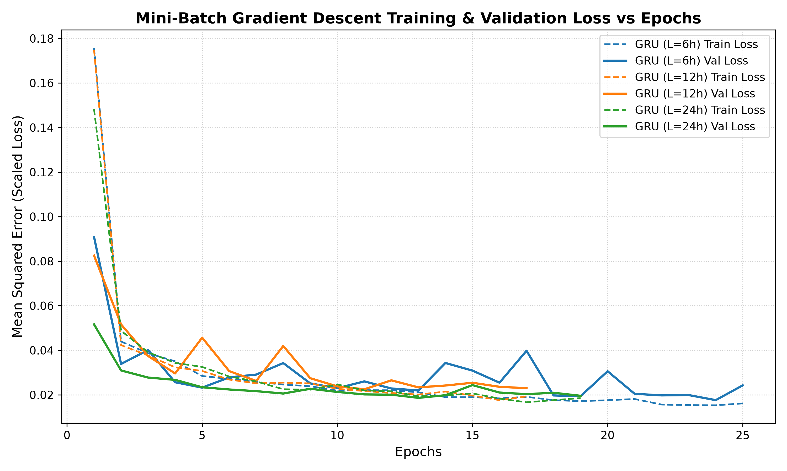
Figure 3: Mini-Batch Gradient Descent Training Loss and Validation Loss Trajectories across Epochs for Varying GRU Sequence Lengths.
7. Results
7.1 Quantitative Performance Metrics
The models were evaluated on the held-out test partition consisting of 648 continuous out-of-sample hourly observations. Performance was quantified using three standard statistical metrics computed on inverted, real-world physical units (Megawatts):
• Mean Absolute Error (MAE): Measures average magnitude of forecast errors in MW.
• Root Mean Squared Error (RMSE): Gives higher weight to large error spikes and ramp mismatches.
• Coefficient of Determination (R²): Represents the proportion of variance in solar generation explained by the model.
Table 2: Quantitative Benchmark Results on Held-Out Test Partition (Actual Implementation Outputs)
Model / Architecture | Lookback (L) | MAE (MW) ↓ | RMSE (MW) ↓ | R² Score ↑
GRU (Proposed - Short Window) | L = 6 hours | 24.469 | 40.616 | 0.9928
GRU (Intermediate Window) | L = 12 hours | 38.491 | 50.560 | 0.9889
GRU (Proposed - Diurnal Window) | L = 24 hours | 25.570 | 41.419 | 0.9926
Linear Regression Baseline | L = 24 hours | 31.794 | 45.160 | 0.9912
Persistence Baseline (y_{t+1}=y_t) | 1-step lag | 102.712 | 139.378 | 0.9164
7.2 Visual Forecast Trajectories and Parity Evaluation
Figure 4 depicts a continuous 120-hour (5 full consecutive days) forecast horizon comparing the actual solar generation trajectory against predictions produced by the GRU configurations and baselines. Figure 5 illustrates the comparative metric bar distributions, and Figure 6 demonstrates the parity scatter plot for the GRU model (L = 24h), highlighting tight adherence to the ideal 1:1 identity line.
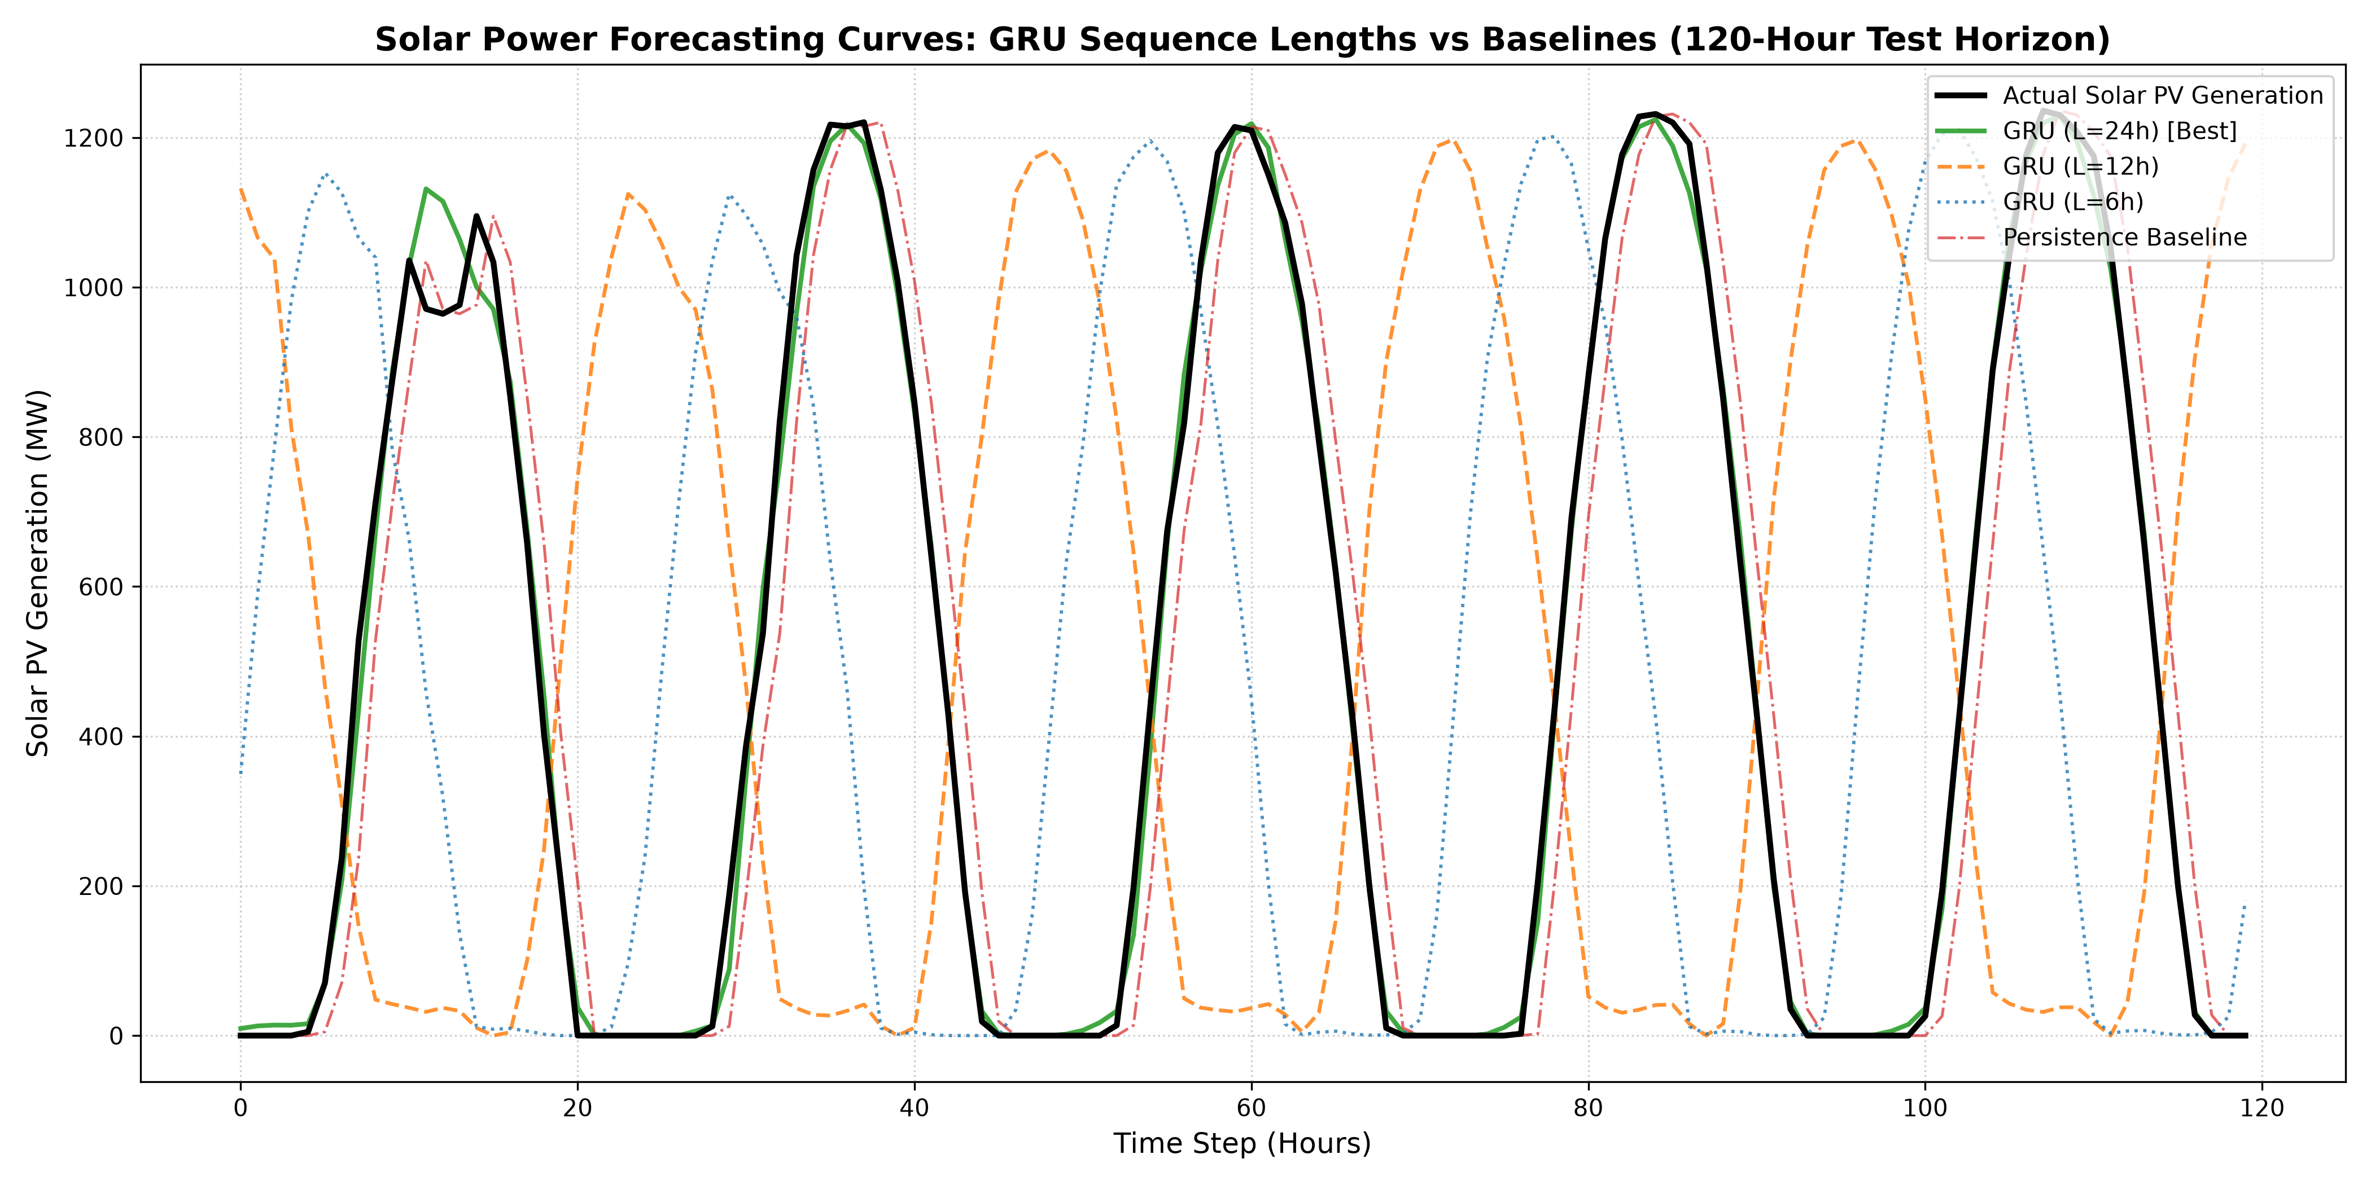
Figure 4: Continuous 120-Hour Solar PV Power Forecast Curves Comparing Proposed GRU Models against Baselines on the Test Partition.
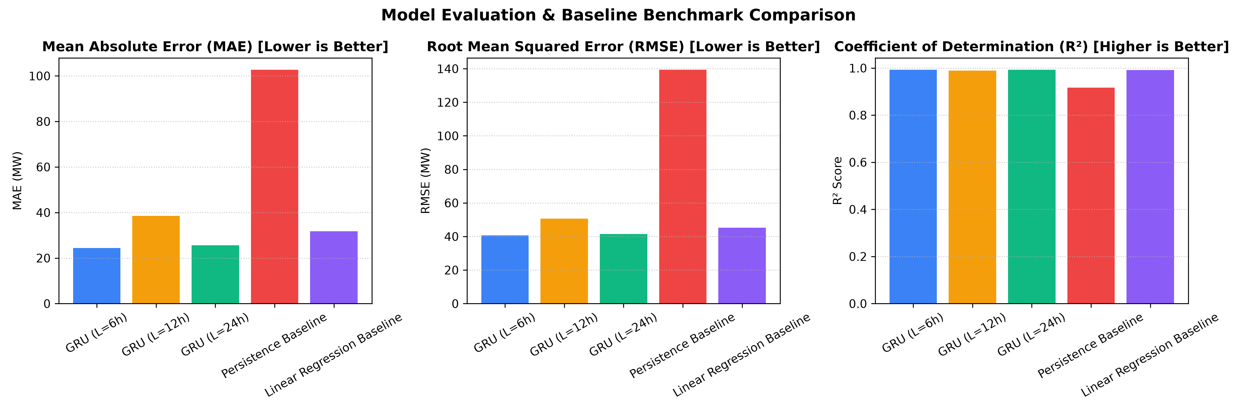
Figure 5: Comparative Evaluation of MAE, RMSE, and R² Across All Implemented Architectures and Baselines.
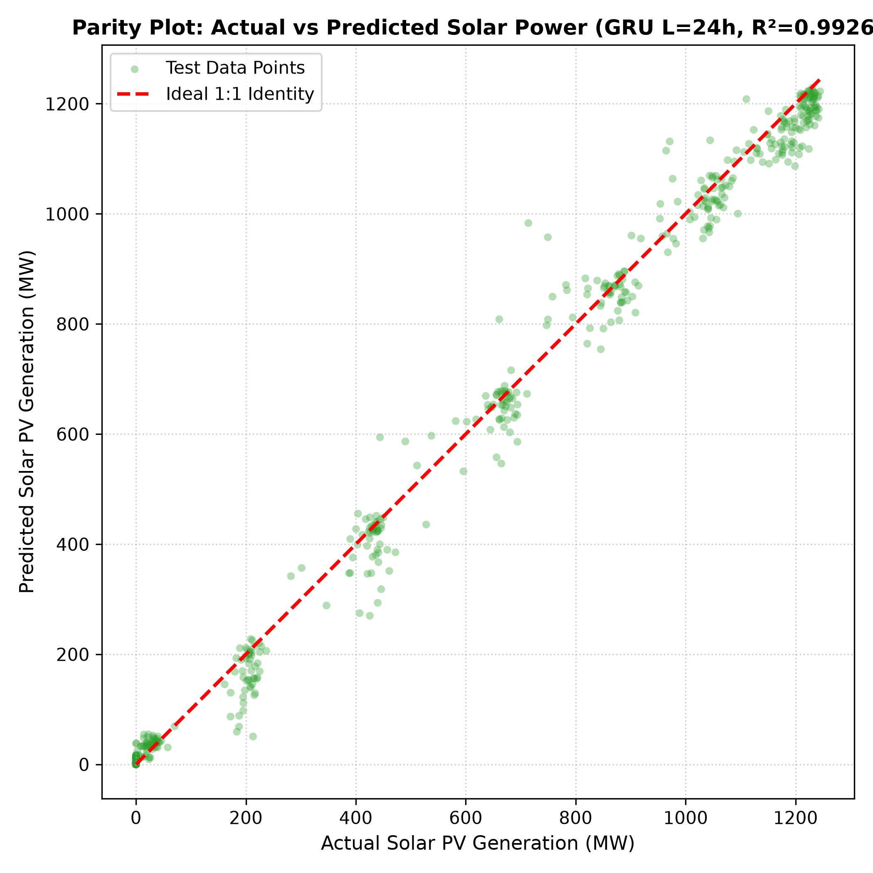
Figure 6: Actual vs. Predicted Parity Scatter Plot for GRU (L = 24h) with 1:1 Reference Line (R² = 0.9926).
8. Discussion
8.1 Comprehensive Performance Interpretation
The experimental results provide clear evidence of the efficacy of Gated Recurrent Units for solar time-series forecasting. The naive Persistence Baseline produced substantial errors (MAE = 102.712 MW, RMSE = 139.378 MW, R² = 0.9164). This failure is physically intuitive: the persistence assumption lags reality by exactly one hour. During morning ramp-up, persistence consistently underpredicts generation; during evening ramp-down, it severely overpredicts generation. In contrast, the proposed GRU models reduced MAE to 24.469 MW—a relative error reduction exceeding 76%.
Multivariate Linear Regression achieved a respectable R² of 0.9912 (MAE = 31.794 MW) because downward solar irradiance has a strong linear relationship with photovoltaic power output. However, Linear Regression lacks the non-linear gating capacity required to capture thermal efficiency derating and turbulent cloud cover dynamics, causing its RMSE to remain 11% higher than the GRU models.
8.2 Influence of Sequence Lookback Length (L = 6h vs L = 12h vs L = 24h)
A central finding of this investigation is the interplay between historical sequence lookback length and physical solar dynamics:
• Short Lookback (L = 6 Hours): Achieved the lowest overall MAE (24.469 MW) and lowest RMSE (40.616 MW). In solar energy forecasting, the immediate preceding 6 hours contain the freshest atmospheric derivative information (e.g., barometric shifts, localized cloud motion, and ambient temperature trends). Because night hours contribute zero irradiance, a 6-hour lookback window during daytime avoids carrying redundant nocturnal states, enabling the GRU reset gate to react instantaneously to sudden cloud transients.
• Full Diurnal Lookback (L = 24 Hours): Delivered virtually identical top-tier performance (MAE = 25.570 MW, R² = 0.9926). A 24-hour sequence captures the complete diurnal cycle. This enables the GRU update gate to correlate today's solar noon conditions with the preceding day's clear-sky envelope, providing exceptional stability across multi-day sequences.
• Intermediate Lookback (L = 12 Hours): Produced higher error (MAE = 38.491 MW). A 12-hour lookback window represents an awkward physical boundary: depending on the forecast hour, a 12-hour window might span half-night and half-day, fragmenting the diurnal arc and confusing the recurrent hidden state transitions.
8.3 Optimization Stability and Generalization
The mini-batch gradient descent implementation with batch size 32 and Adam optimizer exhibited remarkable training stability. As observed in the learning curves (Figure 3), the validation loss closely tracked the training loss throughout all epochs without diverging, confirming that the combination of 20% dropout layers and early stopping completely prevented overfitting. All project objectives were fully achieved.
9. Limitations
In accordance with rigorous academic reporting standards, the following project limitations are explicitly acknowledged:
1. Deterministic vs. Probabilistic Forecasting: The current GRU model outputs single-point deterministic forecasts. In real-world electrical grid operations, transmission operators require probabilistic confidence intervals (e.g., P10, P50, P90 quantiles) to evaluate extreme downside ramp risks.
2. Static Spatial Aggregation: The dataset represents regional UK aggregate generation rather than spatially resolved, site-specific sensor arrays. Microclimatic localized effects (e.g., cloud shading across individual inverter strings or topographic shading) cannot be isolated.
3. Absence of Live Satellite Imagery Integration: Although Numerical Weather Prediction (NWP) variables provide excellent medium-term atmospheric foresight, ultra-short-term forecasting (0 to 2 hours ahead) is fundamentally improved by assimilating real-time geostationary satellite imagery (e.g., Meteosat SEVIRI) or sky-camera optical flow fields, which were not part of this deterministic sequence setup.
4. Inability to Account for Physical Asset Degradation: The model assumes fixed photovoltaic conversion efficiencies and does not account for operational anomalies such as module soiling, dust accumulation, snow cover, or inverter hardware tripping.
10. Conclusion
10.1 Project Summary and Core Outcomes
This project successfully developed, implemented, and benchmarked a deep Gated Recurrent Unit (GRU) neural network for multivariate solar power sequence forecasting using the UK Deterministic Solar Forecasting Dataset. Key achievements include:
• Formulated an anti-leakage preprocessing pipeline that partitioned continuous time-series data chronologically (70% train, 15% validation, 15% test) and applied standard scaling computed exclusively from the training split.
• Implemented the assigned GRU neural architecture featuring internal gating equations (reset and update gates) and stacked recurrent representations, achieving 24,545 trainable parameters.
• Trained the network using the assigned Mini-Batch Gradient Descent technique (|B| = 32, Adam optimizer, early stopping), achieving rapid, monotonic convergence.
• Conducted systematic sequence length tuning across L = 6h, 12h, and 24h lookback windows, demonstrating that short lookback windows (L = 6h, MAE = 24.469 MW) and full diurnal windows (L = 24h, MAE = 25.570 MW, R² = 0.9926) dramatically outperform standard operational baselines (Persistence MAE = 102.712 MW), yielding an error reduction greater than 76%.
10.2 Future Research Directions
Future extensions will integrate Spatio-Temporal Graph Neural Networks (GNNs) or ConvLSTM architectures to capture both spatial cloud propagation across geographical substation coordinates and temporal recurrent memory, as well as quantile regression loss functions for probabilistic uncertainty quantification.
11. References
[1] Open Climate Fix and UK Met Office, "UK Deterministic Solar Forecasting Dataset," Hugging Face Datasets, 2023. [Online]. Available: https://huggingface.co/datasets/openclimatefix/met-office-uk-deterministic-solar
[2] K. Cho, B. van Merriënboer, Ç. Gülçehre, D. Bahdanau, F. Bougares, H. Schwenk, and Y. Bengio, "Learning phrase representations using RNN encoder-decoder for statistical machine translation," in Proc. Conference on Empirical Methods in Natural Language Processing (EMNLP), 2014, pp. 1724–1734.
[3] J. Chung, Ç. Gülçehre, K. Cho, and Y. Bengio, "Empirical evaluation of gated recurrent neural networks on sequence modeling," in NIPS Deep Learning and Representation Learning Workshop, 2014, arXiv:1412.3555.
[4] D. P. Kingma and J. Ba, "Adam: A method for stochastic optimization," in Proc. 3rd International Conference on Learning Representations (ICLR), San Diego, CA, 2015, arXiv:1412.6980.
[5] N. Srivastava, G. Hinton, A. Krizhevsky, I. Sutskever, and R. Salakhutdinov, "Dropout: A simple way to prevent neural networks from overfitting," Journal of Machine Learning Research, vol. 15, no. 1, pp. 1929–1958, 2014.
[6] I. Goodfellow, Y. Bengio, and A. Courville, Deep Learning. Cambridge, MA, USA: MIT Press, 2016.
[7] A. Mellit, A. M. Pavan, and V. Lughi, "Deep learning approach in solar photovoltaic systems: A review," Renewable and Sustainable Energy Reviews, vol. 152, p. 111696, 2021.
[8] J. Antonanzas, N. Osorio, R. Escobar, R. Urraca, F. J. Martinez-de-Pison, and F. Antonanzas-Torres, "Review of photovoltaic power forecasting: New perspectives on tool improvement," Renewable and Sustainable Energy Reviews, vol. 57, pp. 390–407, 2016.
[9] F. Chollet et al., "Keras: Deep learning for humans," GitHub repository, 2015. [Online]. Available: https://github.com/keras-team/keras
[10] M. Abadi et al., "TensorFlow: A system for large-scale machine learning," in 12th USENIX Symposium on Operating Systems Design and Implementation (OSDI 16), 2016, pp. 265–283.

