SIMATS ENGINEERING
ASSESSMENT TOOL 2

COURSE NAME:Database Management Systems
COURSE CODE: CSA05

COURSE OUTCOME COVERED

CO3: Analyze relational databases using functional dependencies, normalization (1NF to 5NF), and key constraints to identify redundancy and ensure data integrity. (BL2, BL3)

Activity Tool : Case Study (Medium)
Assessment Tool Weightage: 30%

QUESTIONS Total Marks: 50
Q.No | Question | Bloom's Level | Marks
1 | Analyze the case: An online shopping platform stores Order(OrderID, CustID, CustName, ProdID, ProdName, Qty, Price). Identify FDs and normalize to 3NF. | BL2 – Understand | 5
2 | A hospital maintains Patient(PID, PName, DocID, DocName, Specialization, WardNo, WardName). Identify anomalies and normalize to BCNF. | BL3 – Apply | 5
3 | Case study: A university stores Enrollment(SID, SName, CourseID, CourseName, Faculty, Grade). Analyze FDs and apply 2NF decomposition. | BL3 – Apply | 5
4 | Given the airline booking case: Booking(FlightNo, PassID, PassName, Seat, DeptCity, ArrCity, Date). Normalize up to BCNF. | BL3 – Apply | 5
5 | Analyze an HR system schema for a multinational company. Identify all functional and transitive dependencies and normalize to 3NF. | BL2 – Understand | 5
6 | Case: Library(MemberID, MemberName, BookID, Title, Author, Genre, BorrowDate). Identify MVDs and decompose to 4NF. | BL3 – Apply | 5
7 | Analyze a telecom billing schema and identify all candidate keys, primary keys, and functional dependencies before normalization. | BL2 – Understand | 5
8 | A retail inventory system has Product(PID, PName, SupplierID, SupplierName, Category, Price, Warehouse). Apply complete normalization. | BL3 – Apply | 5
9 | Study the given poorly normalized schema for a School ERP and propose a fully normalized design up to BCNF with justification. | BL3 – Apply | 5
10 | Given a movie streaming platform schema, identify join dependencies and decompose to 5NF with lossless-join verification. | BL3 – Apply | 5

Code of Conduct:

I THARUN KUMAR-192571017 certify that this submission is my original work and that I have adhered to the guidelines specified for this assessment.
I understand that any violation of academic integrity rules will result in disciplinary action.

Signature of the student:


RUBRICS FOR CALCULATION:

Criteria | Level 4 – Exemplary | Level 3 – Proficient | Level 2 – Developing | Level 1 – Beginning
Understanding of Case | Thorough understanding; clearly identifies all key issues | Good understanding with most issues identified | Basic understanding; some issues missed | Poor understanding; problem not identified correctly
Application of Concepts | Effectively applies relevant concepts to analyze the case deeply | Applies appropriate concepts with minor gaps | Limited application of concepts | Fails to apply relevant concepts
Analysis | In-depth analysis with strong reasoning and insights | Good analysis with logical reasoning | Basic analysis with limited depth | Weak or no analysis; lacks reasoning

Q1. Online Shopping Platform
Scenario
An online shopping platform stores order, customer, and product information in a single relation named ORDER. The relation contains attributes such as OrderID, CustID, CustName, ProdID, ProdName, Qty, and Price. Since a customer can place multiple orders and an order can contain multiple products, customer and product details may be repeated in several records. Functional dependencies such as OrderID → CustID, CustID → CustName, ProdID → ProdName, Price, and (OrderID, ProdID) → Qty are identified. These dependencies create redundancy and transitive dependencies. Therefore, the relation is decomposed into separate CUSTOMER, PRODUCT, ORDERS, and ORDER_DETAILS tables to achieve 3NF.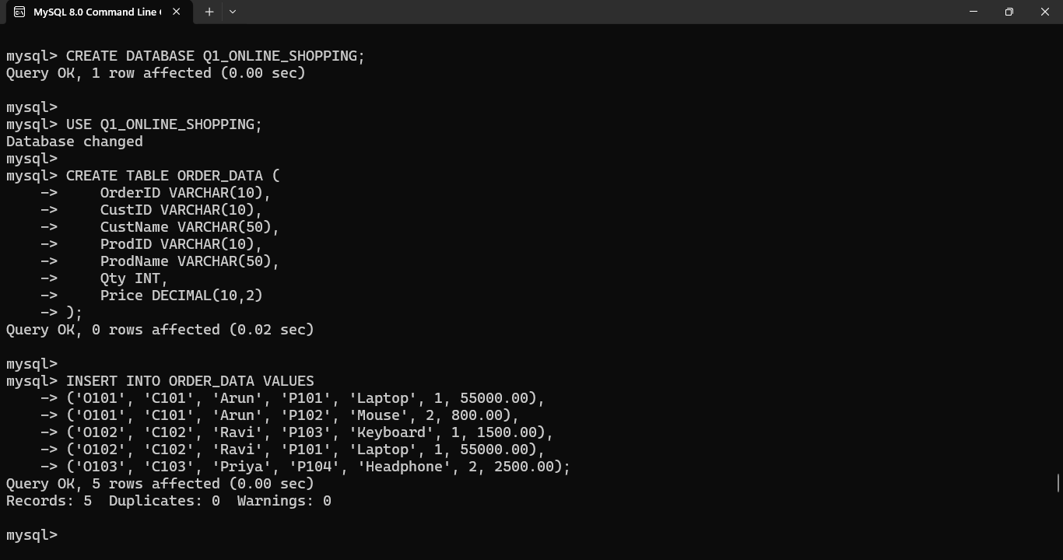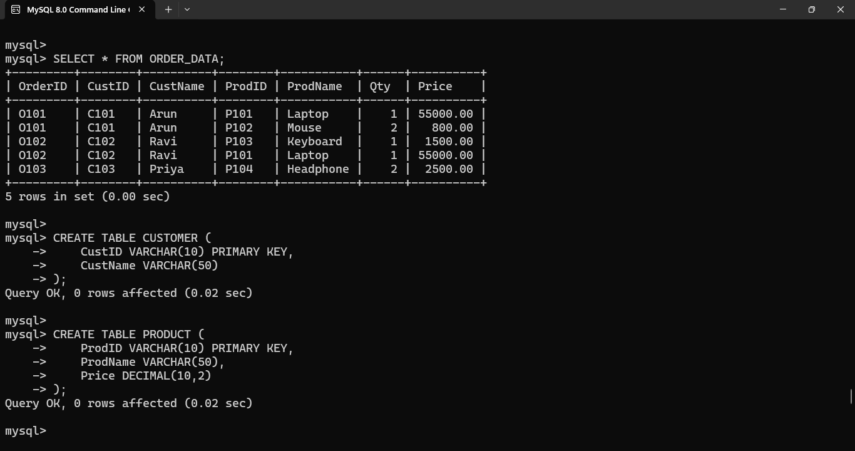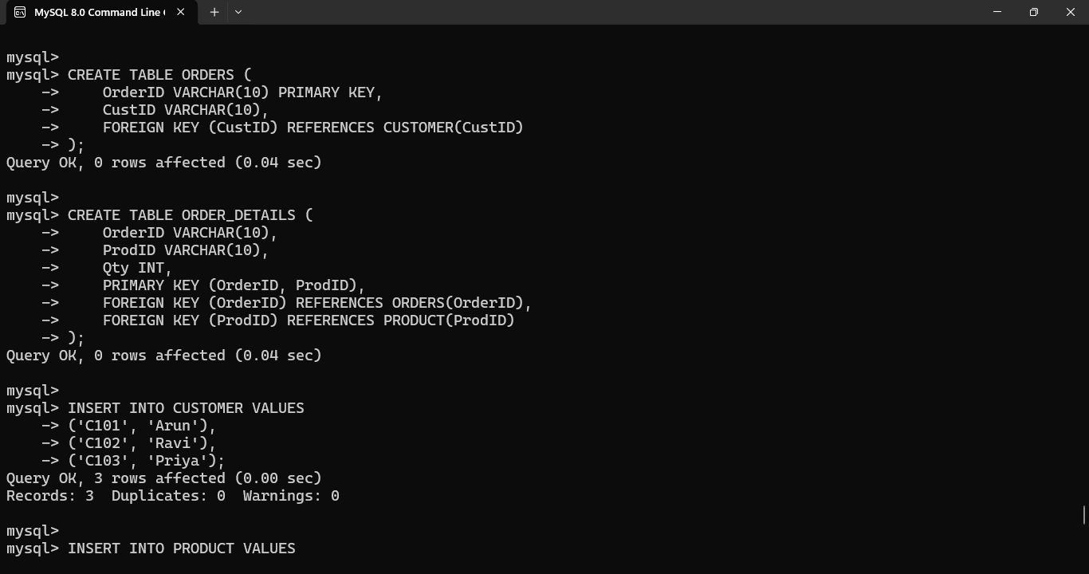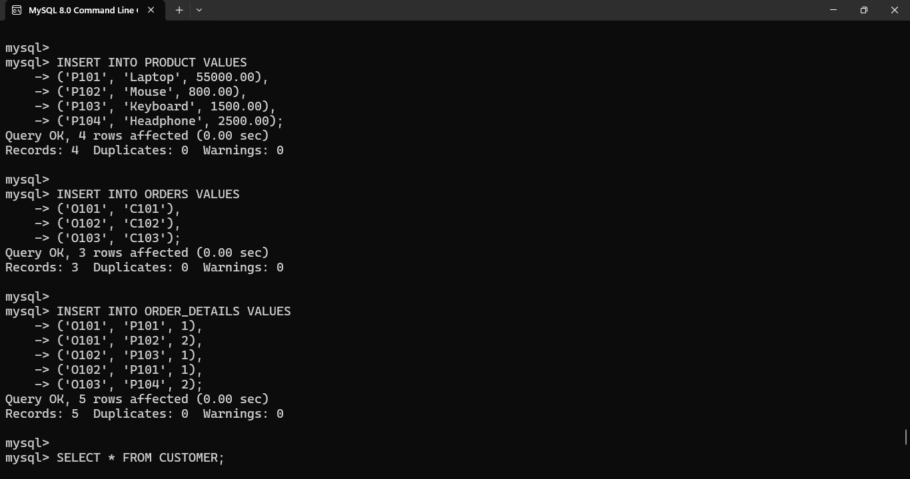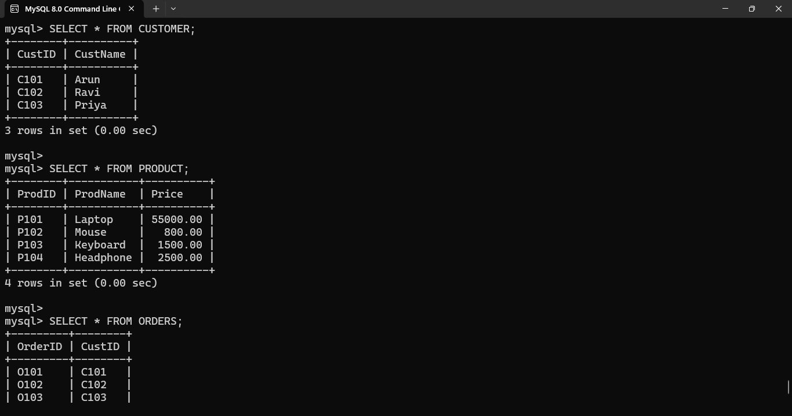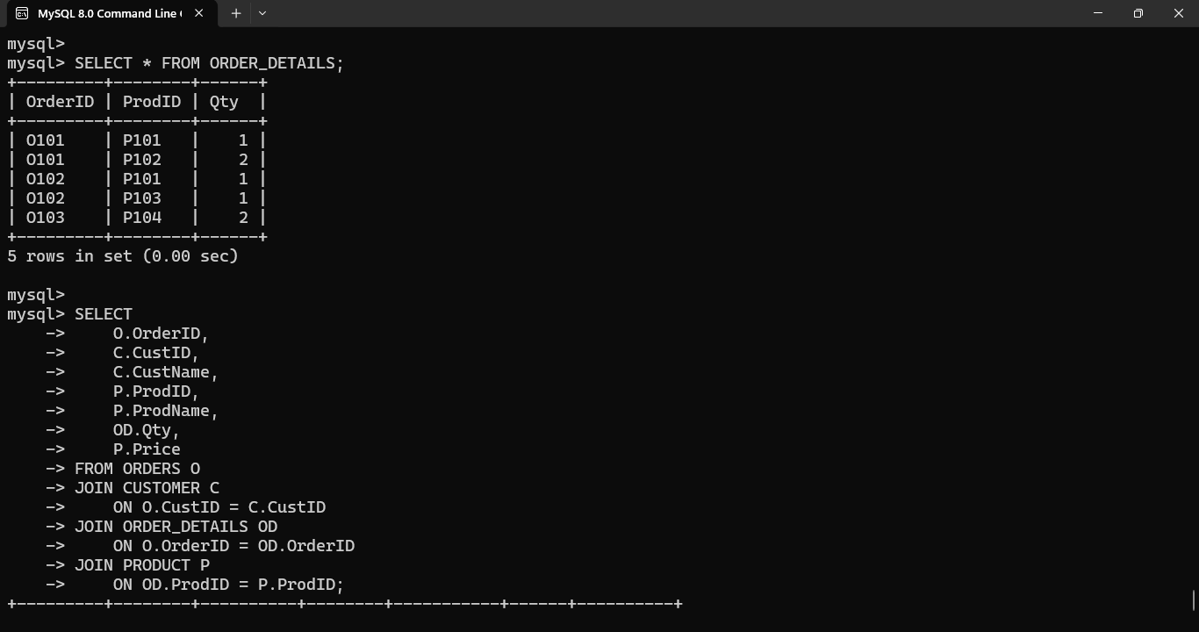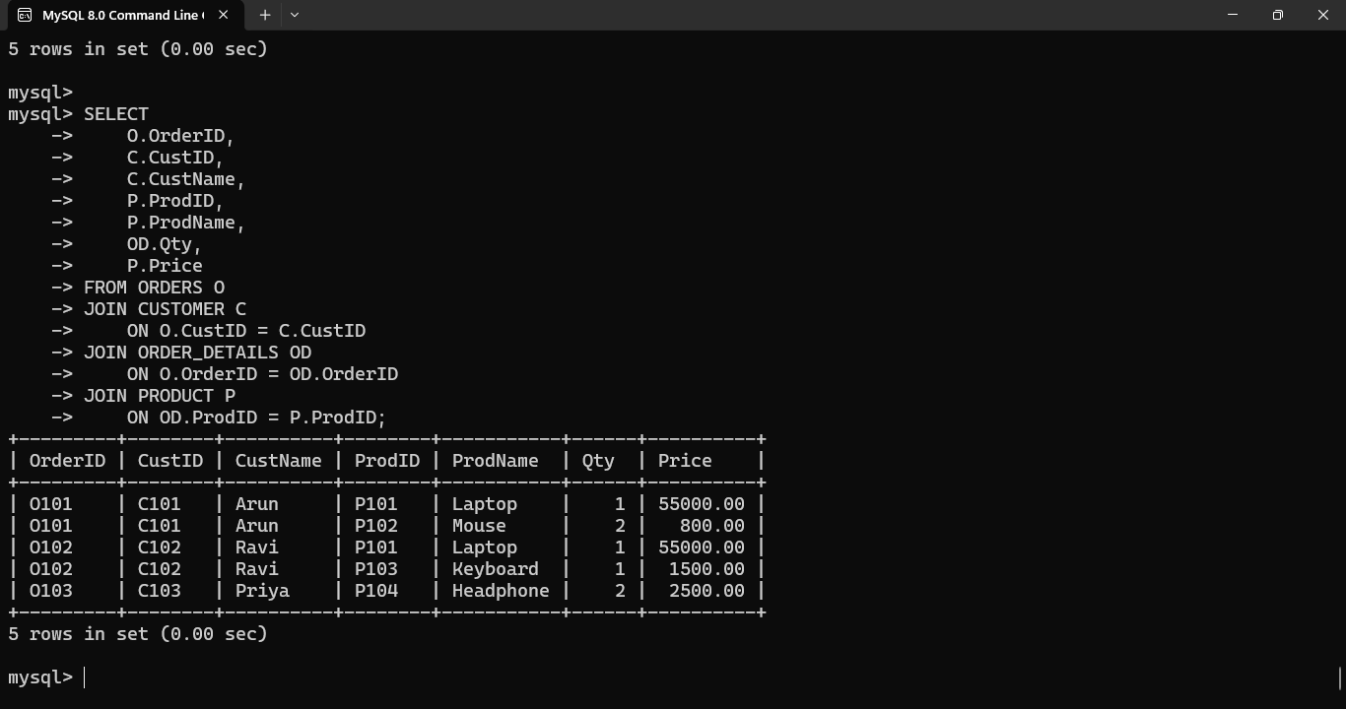

Conclusion
The online shopping database was successfully normalized to 3NF. The decomposition removes redundant customer and product information and eliminates transitive dependencies. Primary and foreign keys maintain relationships between the tables and improve data consistency and integrity.
Q2. Hospital Patient Management
Scenario
A hospital maintains patient information in a single relation containing PID, PName, DocID, DocName, Specialization, WardNo, and WardName. A patient may be associated with a doctor, while doctors have their own specialization and wards have their own names. Functional dependencies such as PID → PName, DocID, DocID → DocName, Specialization, WardNo, and WardNo → WardName result in transitive dependencies. Repeating doctor and ward information can cause insertion, deletion, and update anomalies. The relation is therefore decomposed into separate PATIENT, DOCTOR, and WARD relations to achieve BCNF.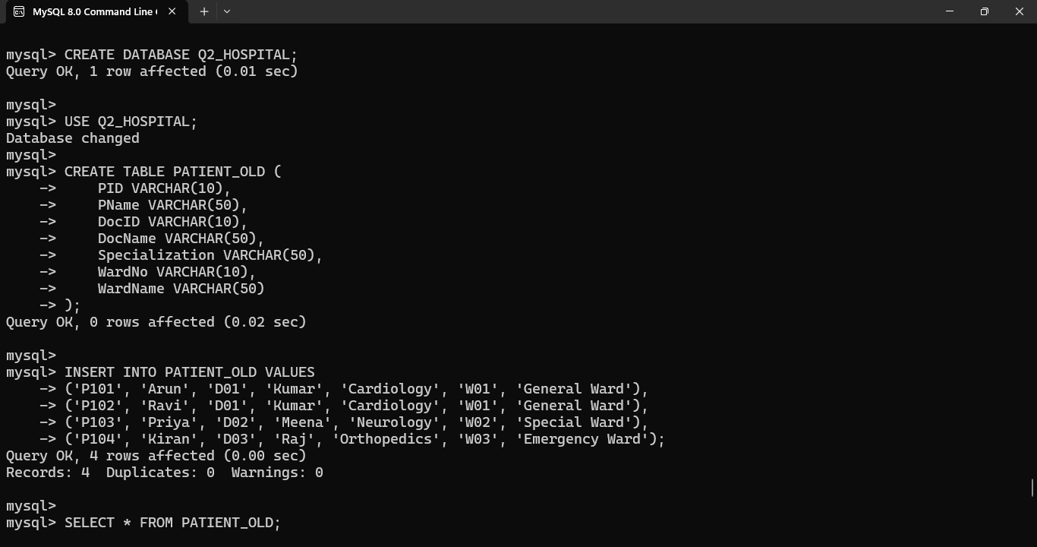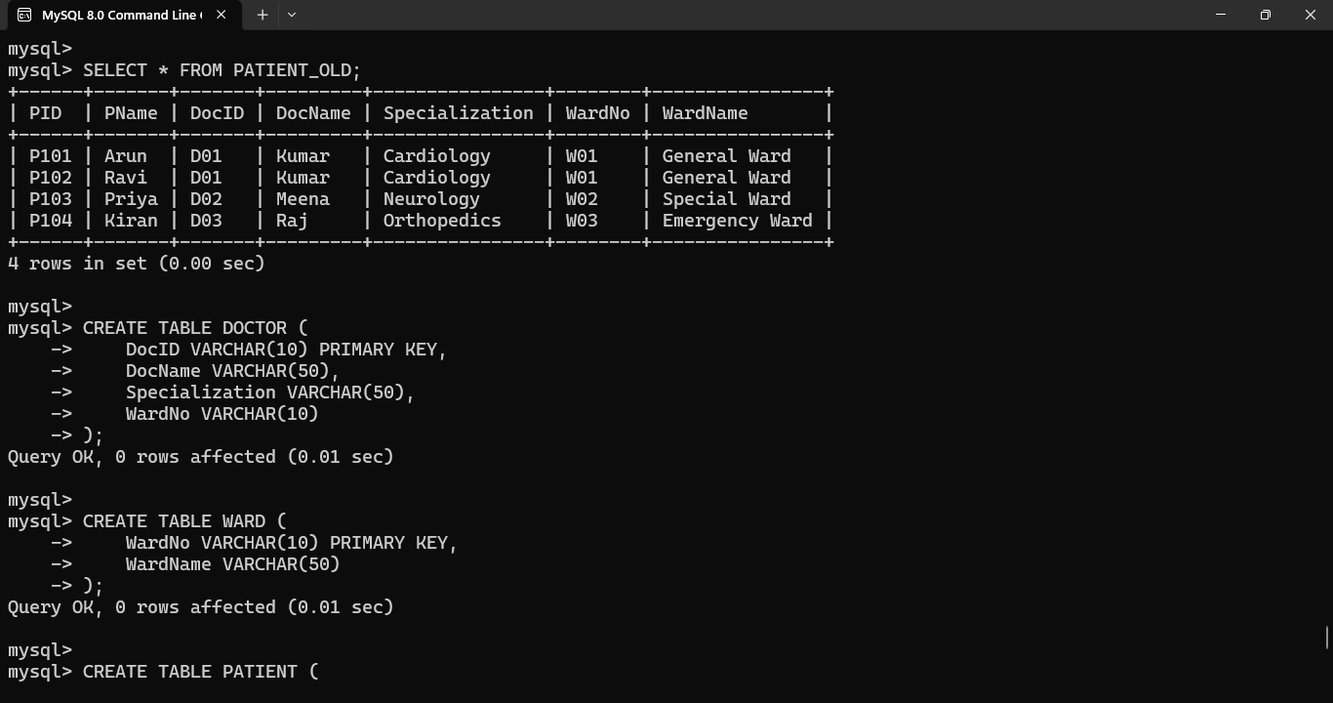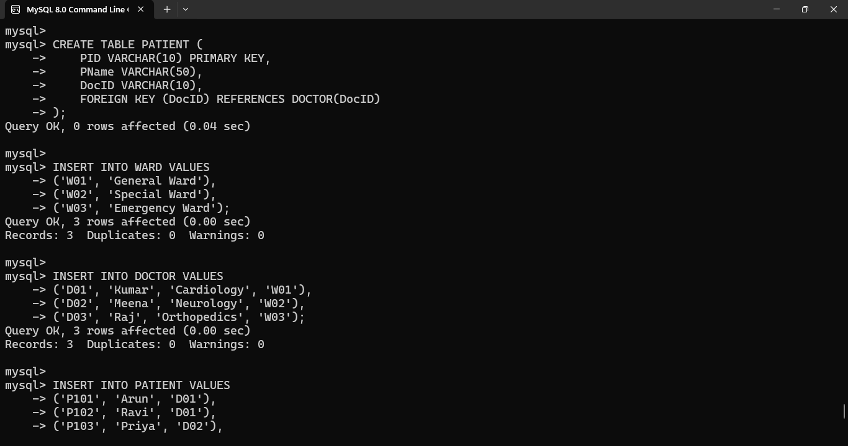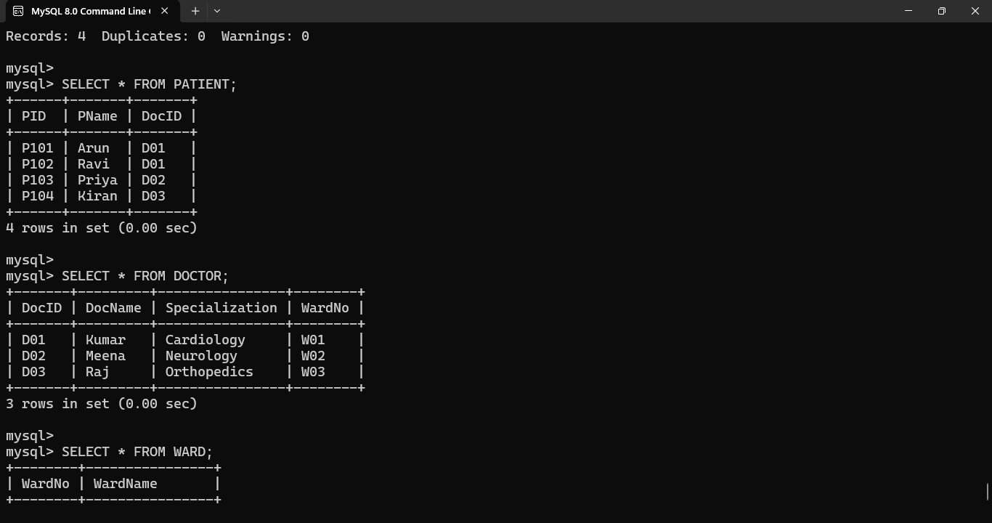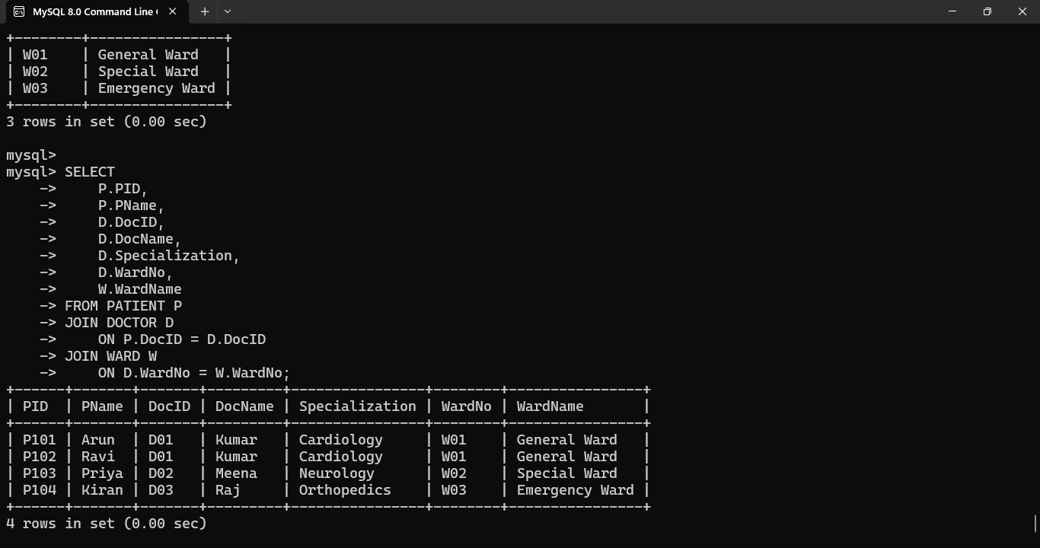
Conclusion
The hospital database was successfully normalized to BCNF by removing transitive dependencies and separating patient, doctor, and ward information. The decomposition reduces redundancy, prevents anomalies, and improves data integrity. Each relation has an appropriate candidate or primary key, and foreign keys maintain the relationships between the tables.

Q3. University Enrollment System
Scenario
A university stores student enrollment information in a single relation containing SID, SName, CourseID, CourseName, Faculty, and Grade. A student can enroll in multiple courses, and a course can have multiple students. The combination of SID and CourseID uniquely identifies an enrollment record. The functional dependencies are SID → SName, CourseID → CourseName, Faculty, and (SID, CourseID) → Grade. Since student and course details depend only on part of the composite key, partial dependencies exist. Therefore, the relation is decomposed into STUDENT, COURSE, and ENROLLMENT tables to achieve 2NF.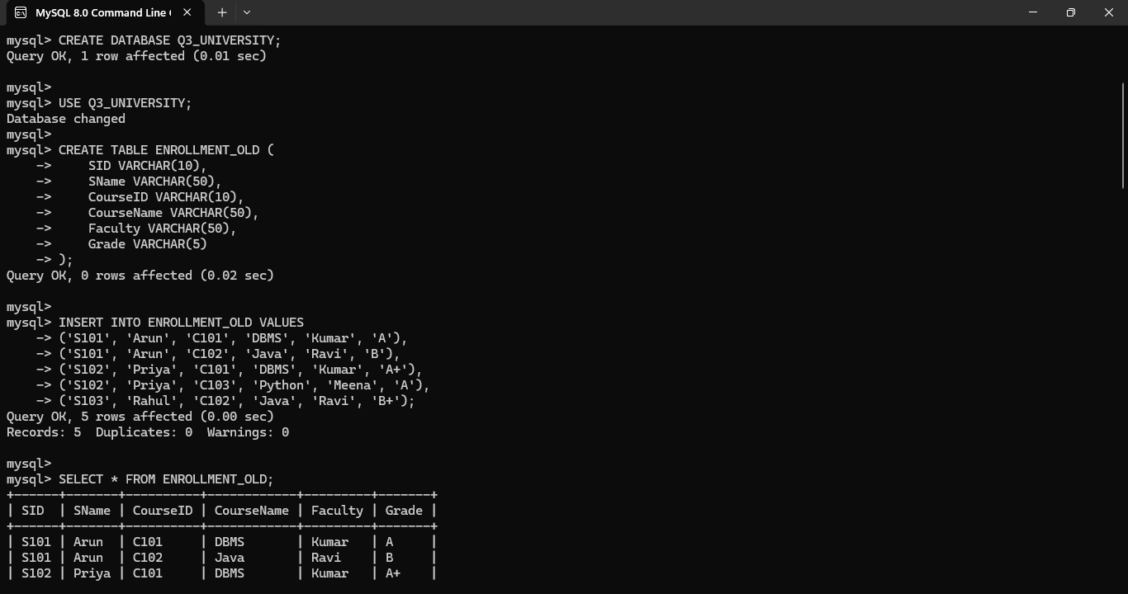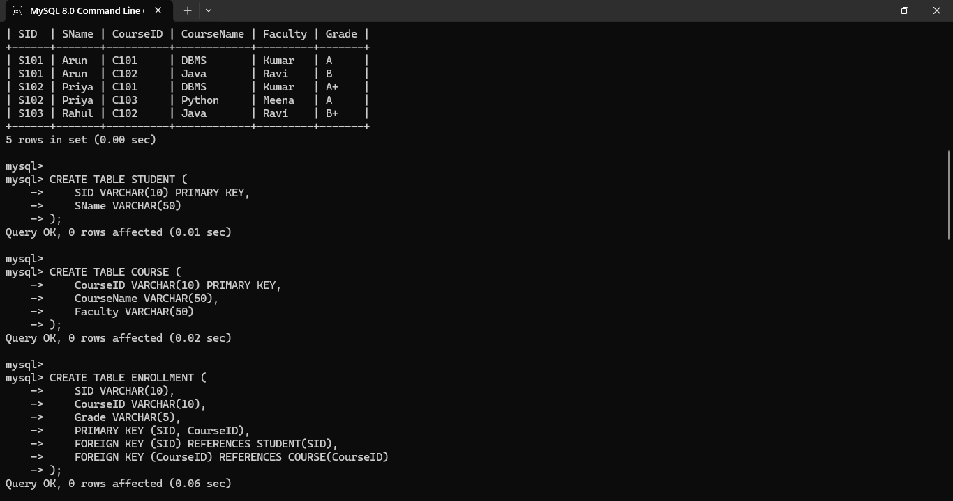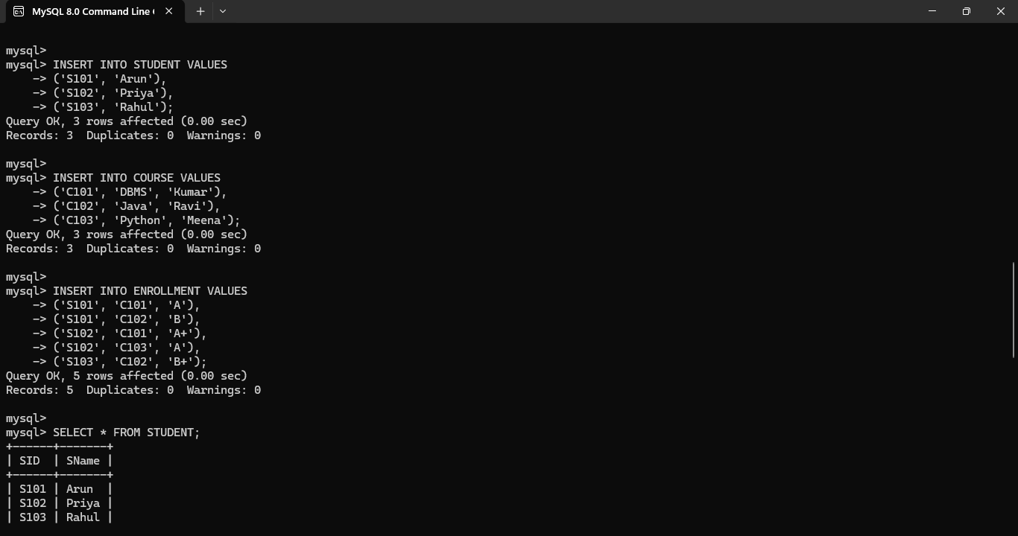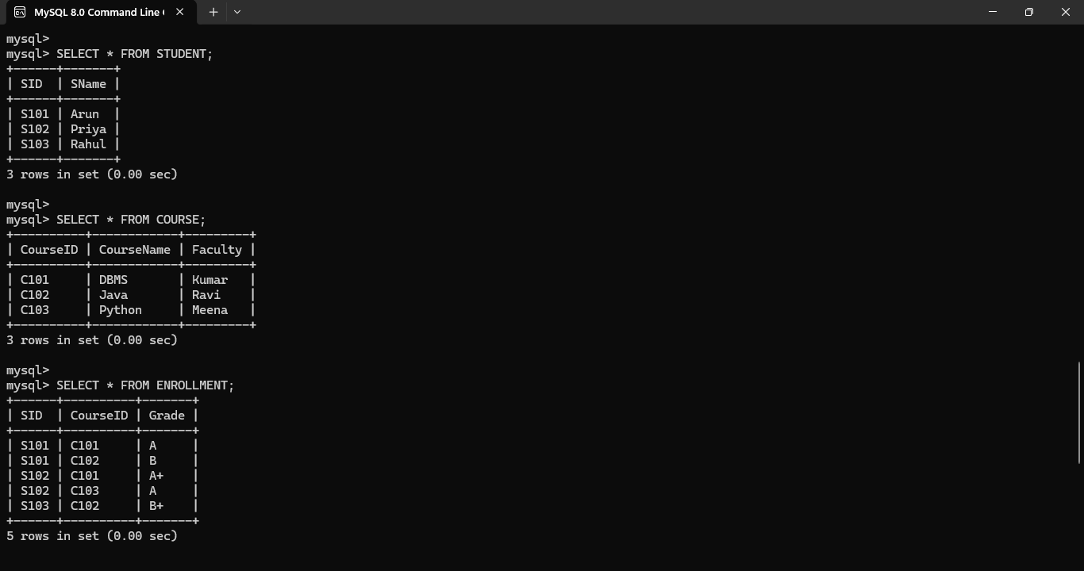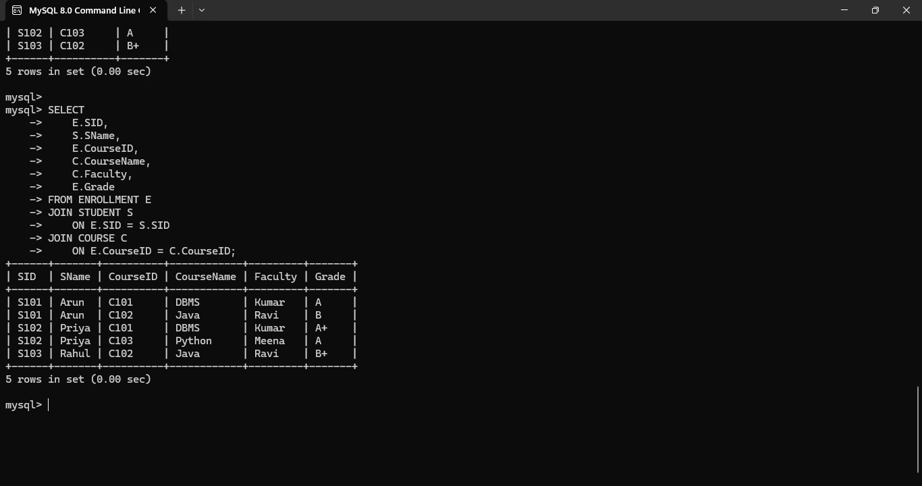
Conclusion
The university enrollment relation was successfully decomposed into 2NF by removing partial dependencies. Student details, course details, and enrollment information are stored separately. This reduces unnecessary repetition and improves consistency while maintaining the relationship through primary and foreign keys.
Q4. Airline Booking System
Scenario
An airline booking system stores flight and passenger information in a single relation containing FlightNo, PassID, PassName, Seat, DeptCity, ArrCity, and Date. A flight can have many passengers, while each passenger has a unique identity. Flight number determines flight-related information such as departure city, arrival city, and date. Passenger ID determines the passenger name. The combination of FlightNo and PassID identifies a booking. These dependencies can produce partial and transitive dependencies. Therefore, the relation is decomposed into PASSENGER, FLIGHT, and BOOKING relations and normalized up to BCNF.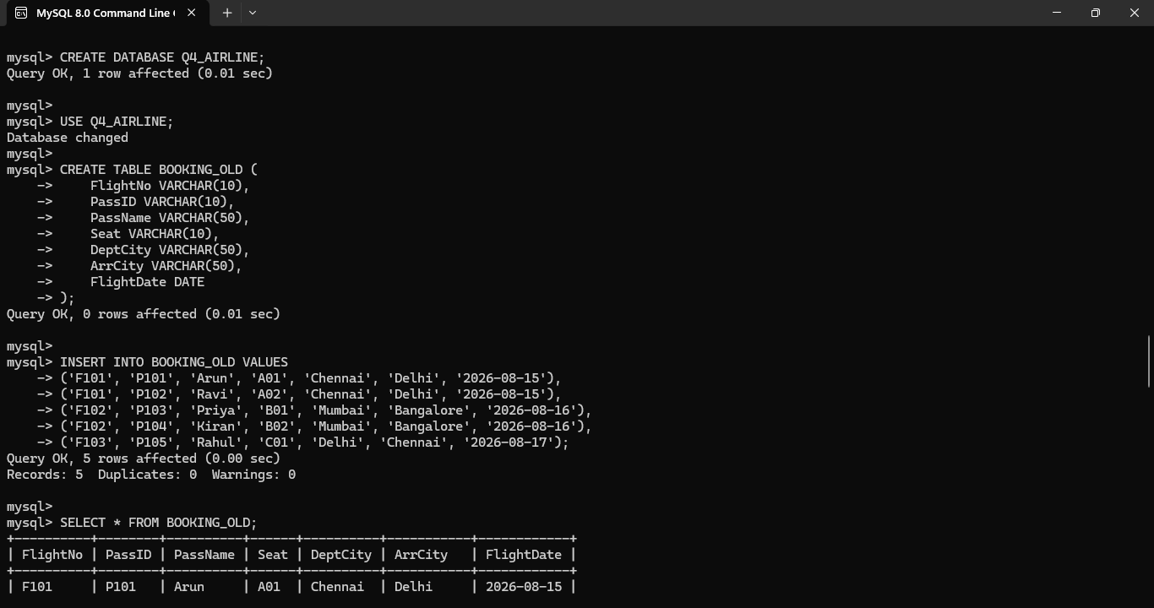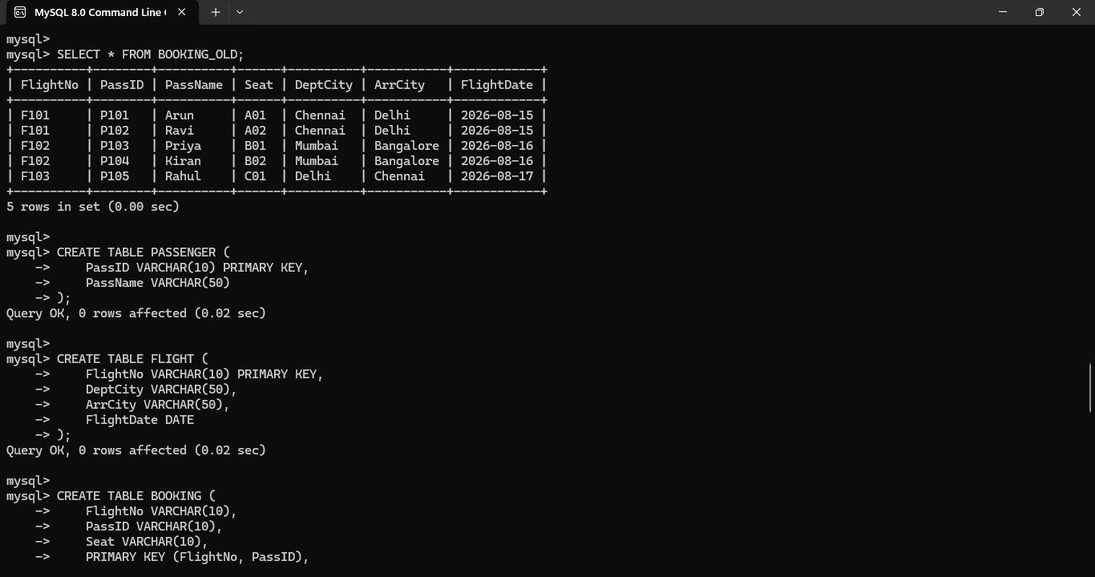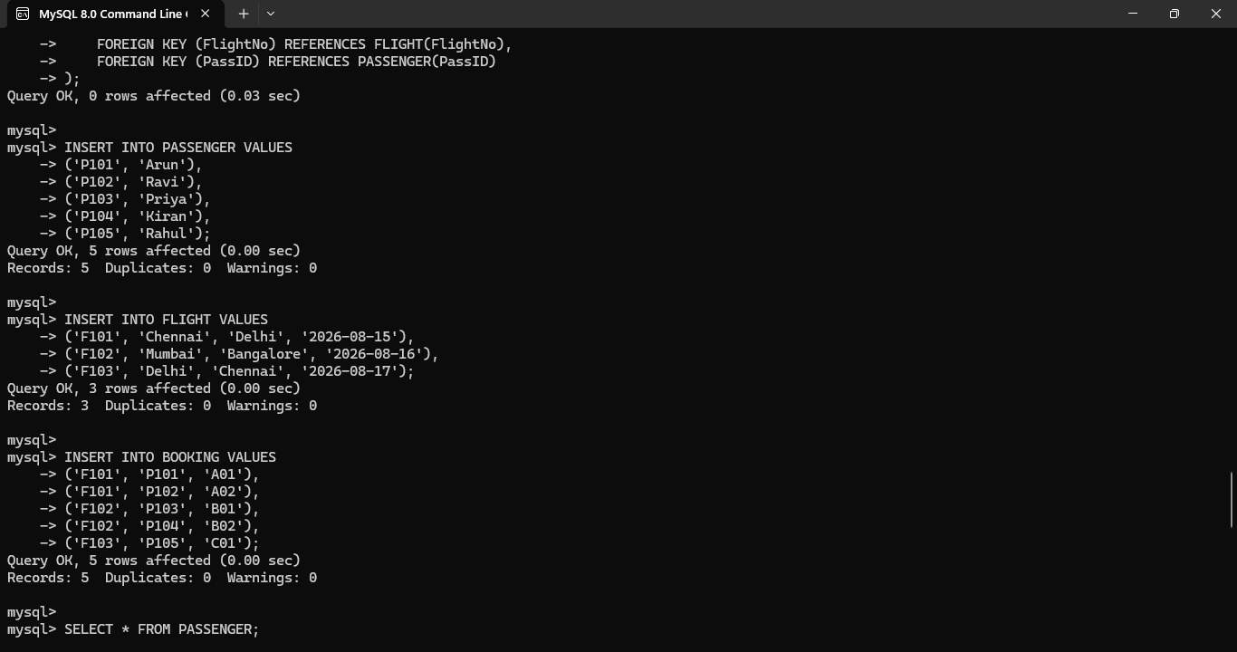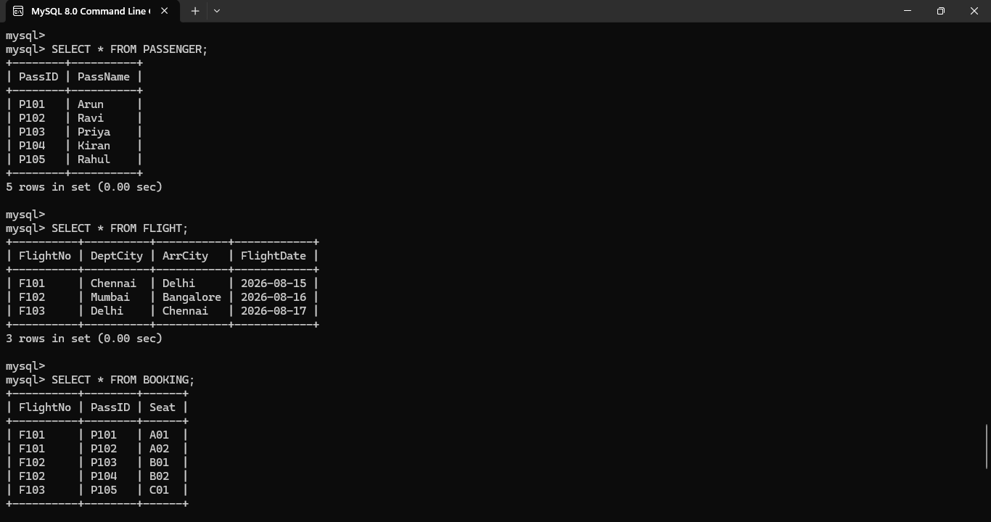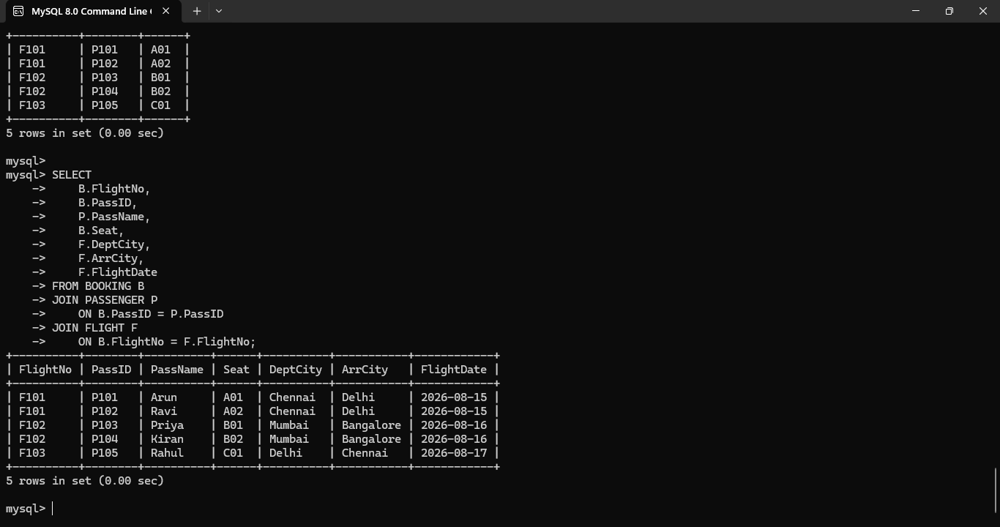
Conclusion
The airline booking database was successfully normalized up to BCNF. Passenger, flight, and booking information are separated into appropriate relations. The decomposition eliminates unnecessary redundancy and dependency problems while maintaining data integrity through primary and foreign keys.

Q5. HR System for a Multinational Company
Scenario
A multinational company maintains employee information such as EmployeeID, EmployeeName, DepartmentID, DepartmentName, ManagerID, ManagerName, and Location. An employee belongs to a department, and a department is managed by a particular manager. Functional dependencies such as EmployeeID → EmployeeName, DepartmentID, DepartmentID → DepartmentName, ManagerID, and ManagerID → ManagerName, Location can exist. These dependencies produce transitive dependencies because employee information indirectly determines manager and department information. The relation is decomposed into EMPLOYEE, DEPARTMENT, and MANAGER tables to achieve 3NF.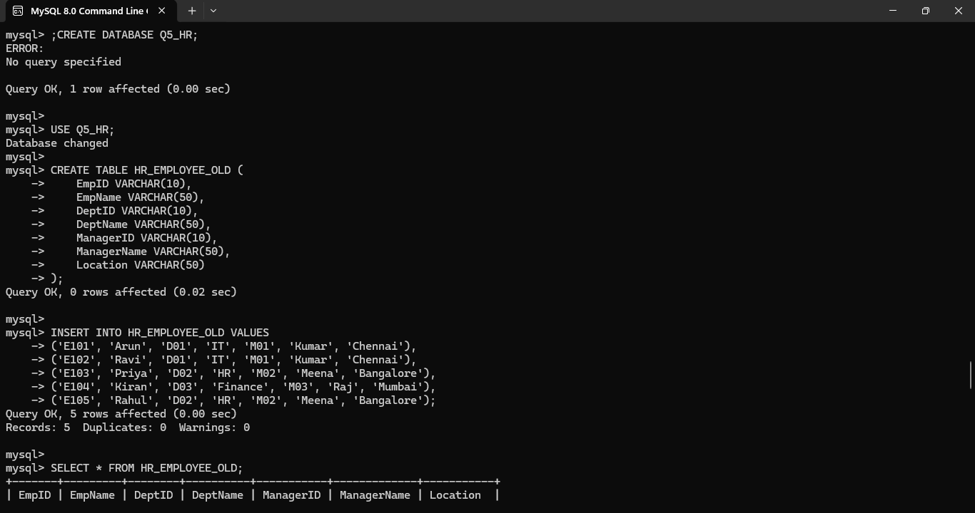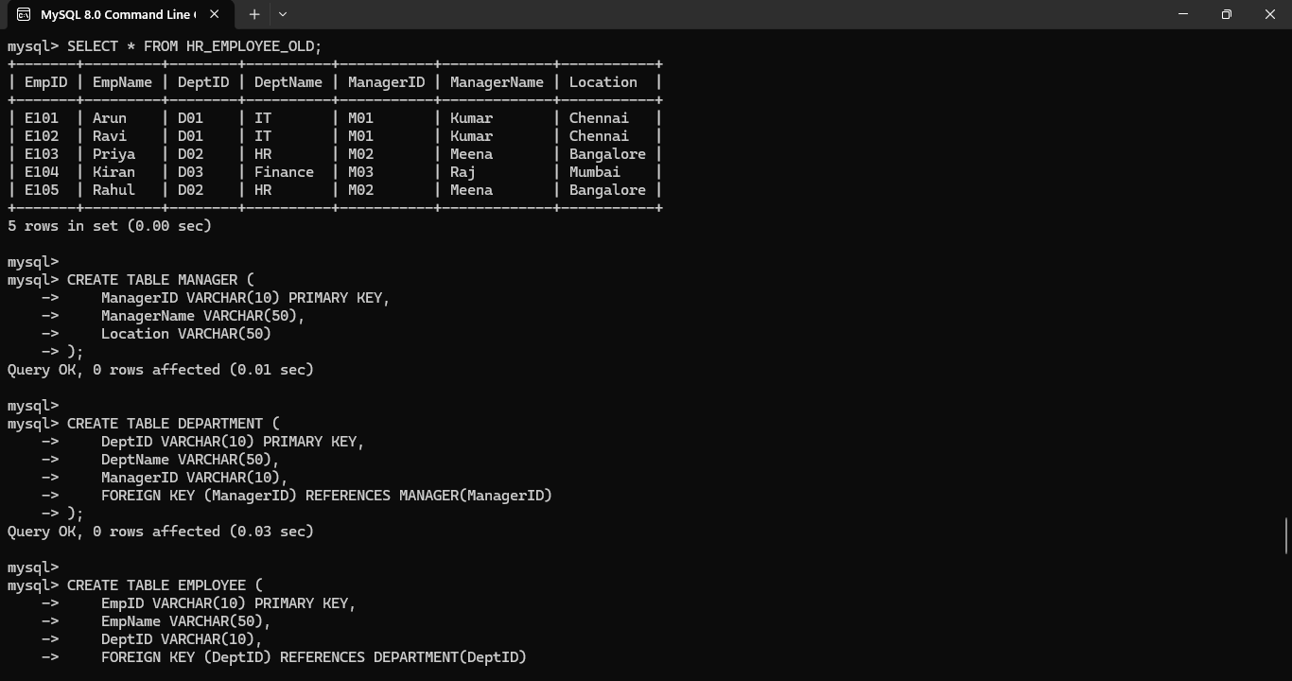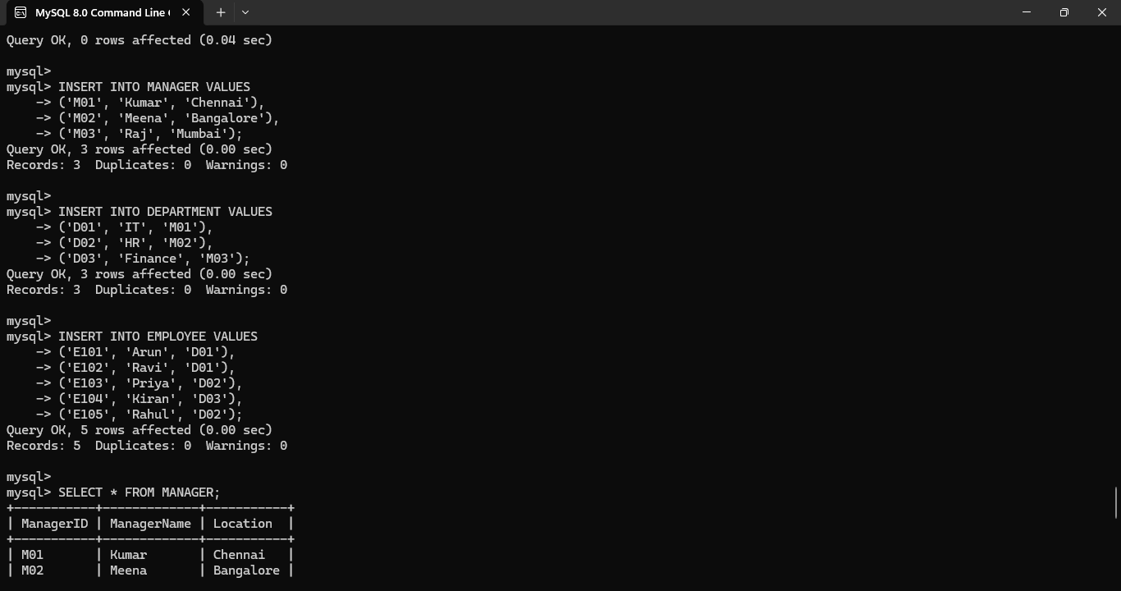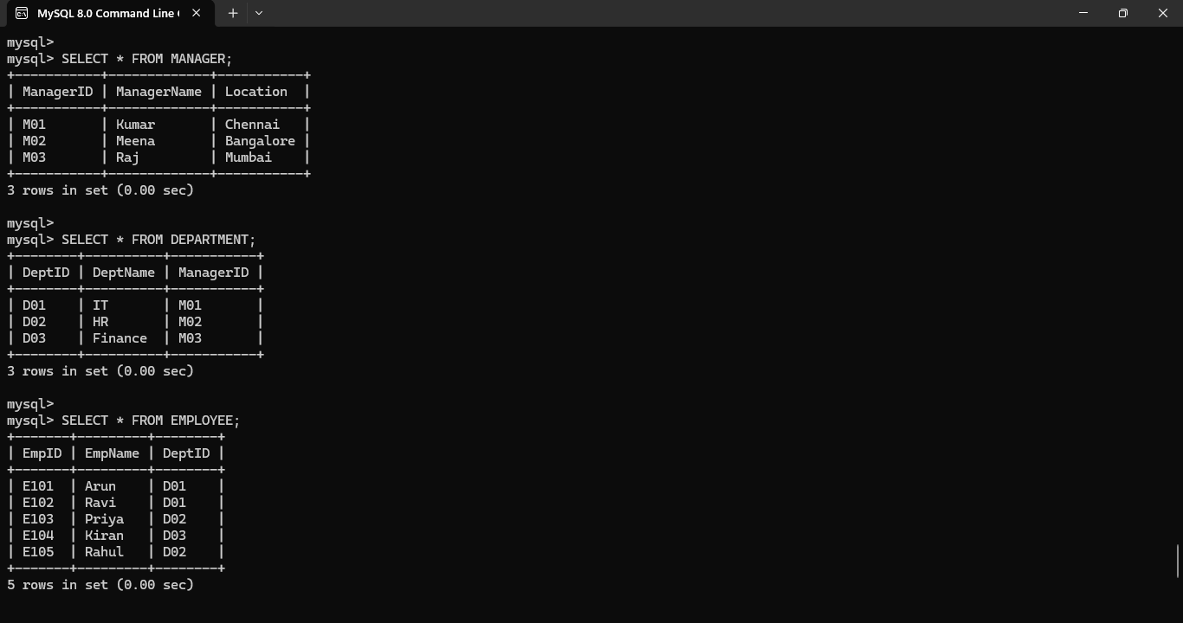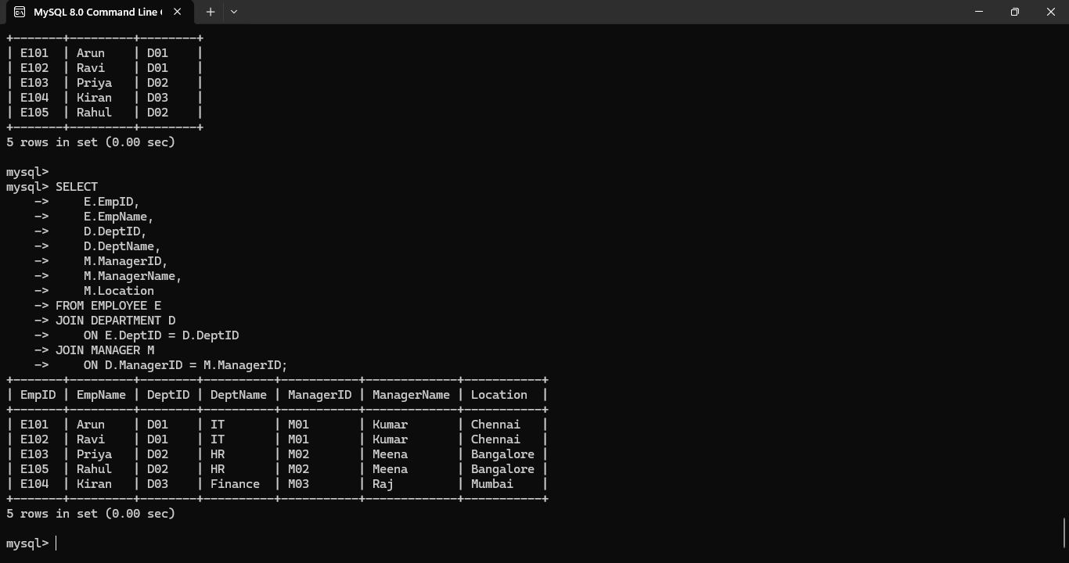
Conclusion
The HR database was successfully normalized to 3NF by identifying functional and transitive dependencies. Employee, department, and manager information are stored independently, reducing redundancy and preventing update, insertion, and deletion anomalies. The resulting design provides better data consistency and integrity.
Q6. Library Management System
Scenario
A library maintains information using the relation LIBRARY(MemberID, MemberName, BookID, Title, Author, Genre, BorrowDate). A member can borrow multiple books, and a book may have information about its title, author, and genre. If members and books have independent multiple-valued relationships, multivalued dependencies can occur. For example, a member can borrow several books independently of the book's author or genre information. Such dependencies cause repeated data. Therefore, the relation is decomposed into MEMBER, BOOK, and BORROW relations to satisfy 4NF.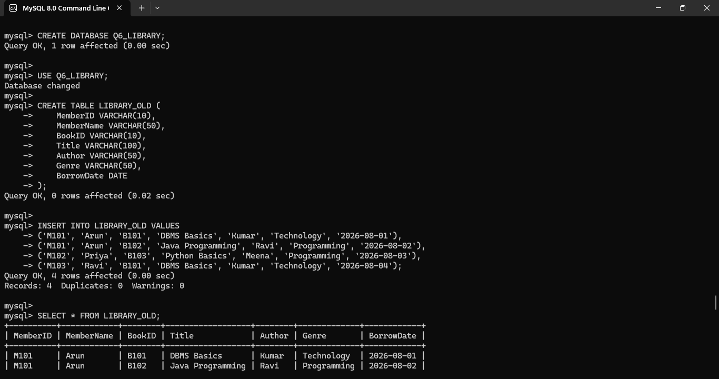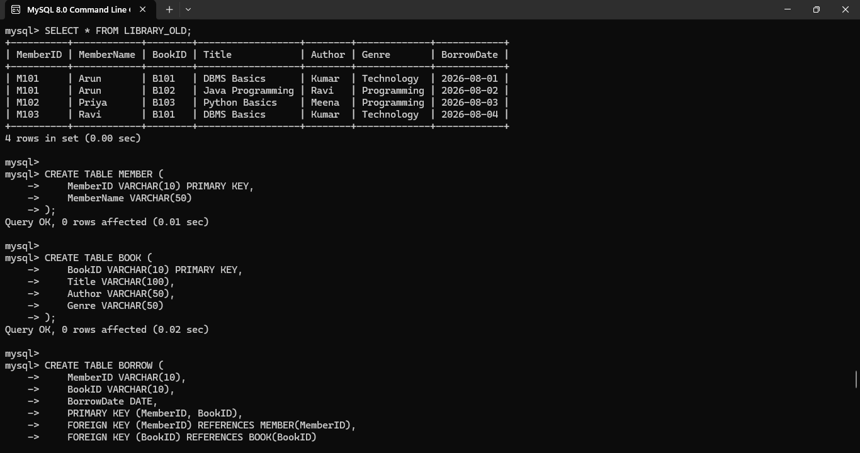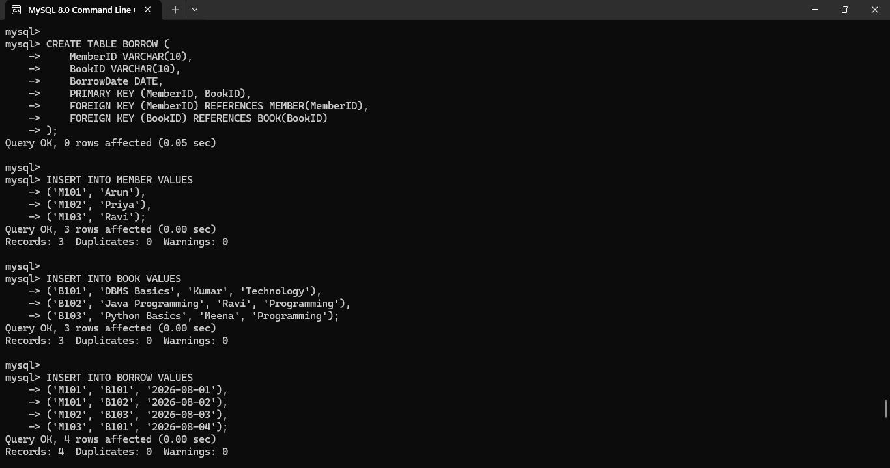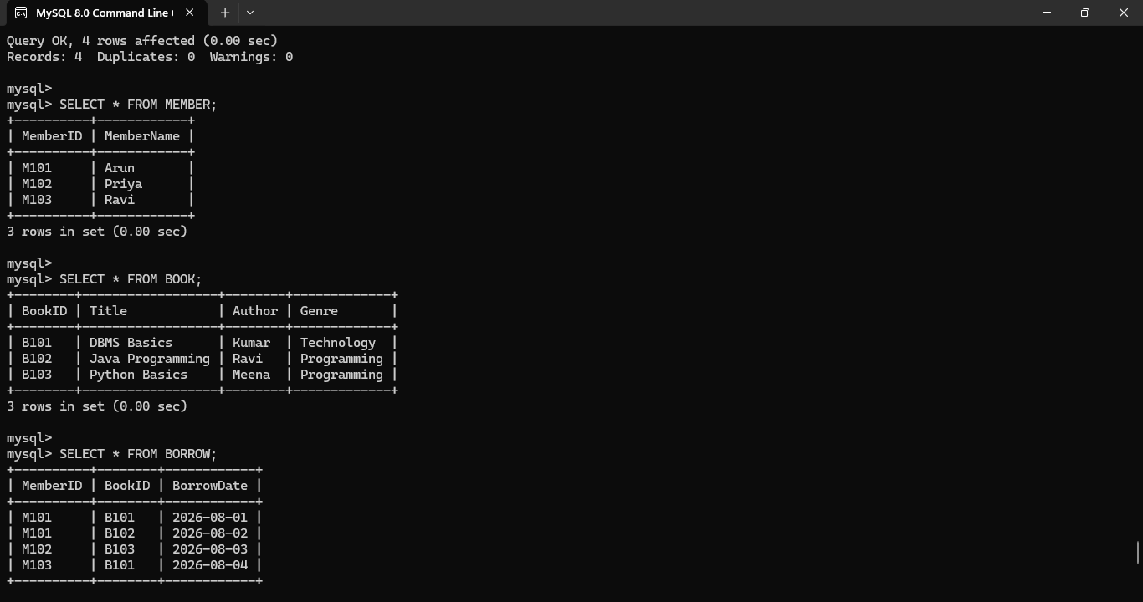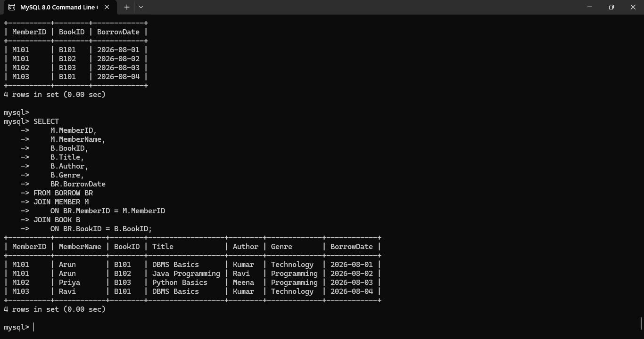
Conclusion
The library database was successfully decomposed into 4NF by identifying and removing multivalued dependencies. Member, book, and borrowing information are stored separately, which reduces redundancy and prevents unnecessary repetition. The normalized design improves database consistency and maintains data integrity.
Q7. Telecom Billing System
Scenario
A telecom company stores customer, phone number, plan, and billing information in a billing relation. Attributes may include CustomerID, CustomerName, PhoneNo, PlanID, PlanName, CallID, CallDuration, and BillAmount. CustomerID uniquely identifies a customer, PhoneNo identifies a registered phone number, and PlanID identifies a particular telecom plan. CallID identifies an individual call record. The functional dependencies and candidate keys must be identified before normalization. Suitable primary keys are selected to uniquely identify customers, plans, phone numbers, and billing transactions.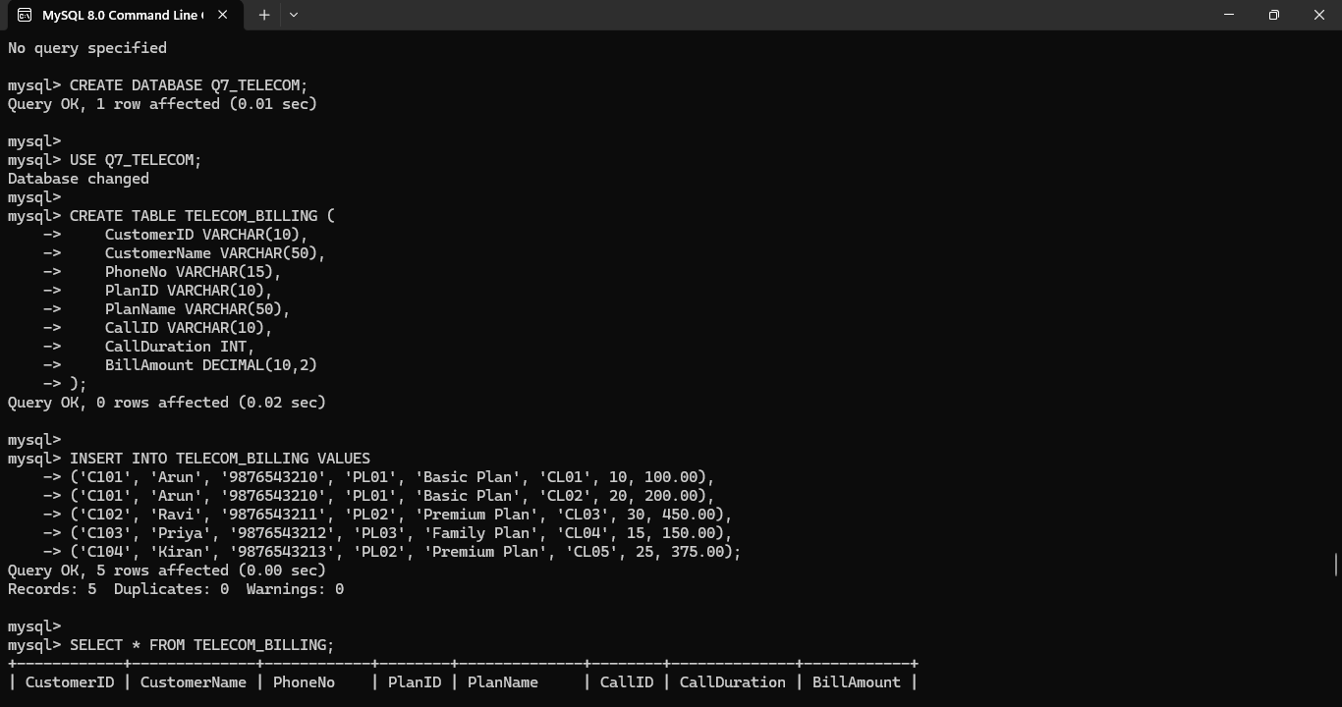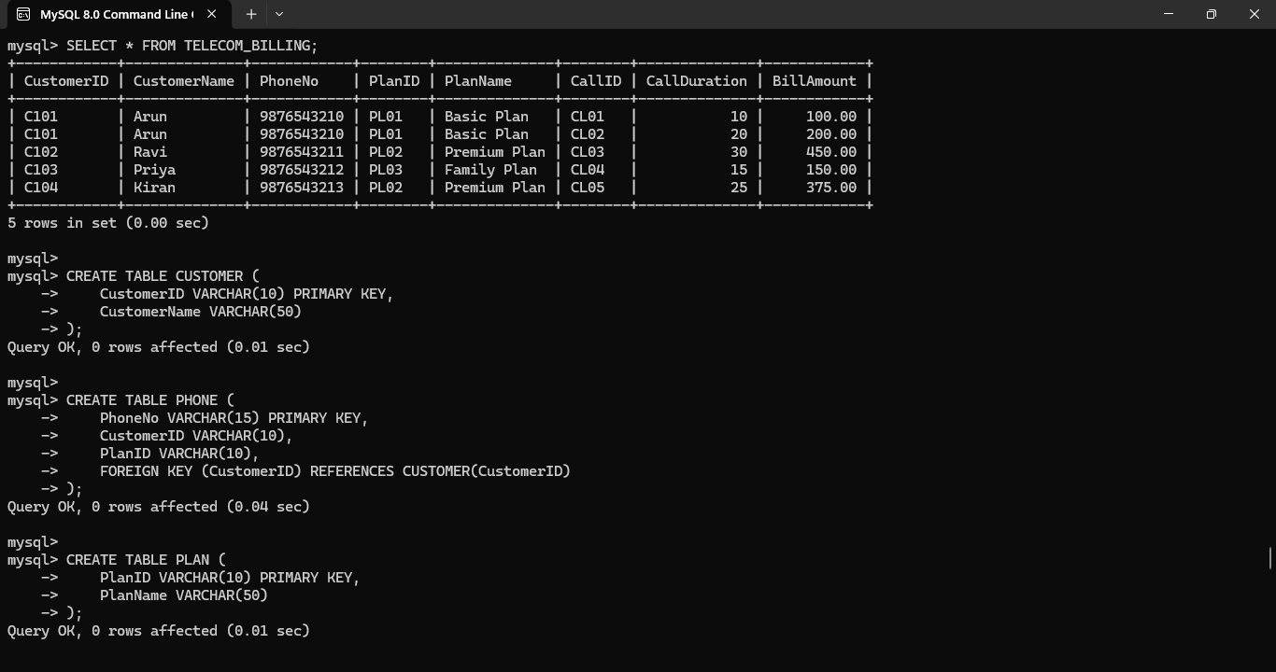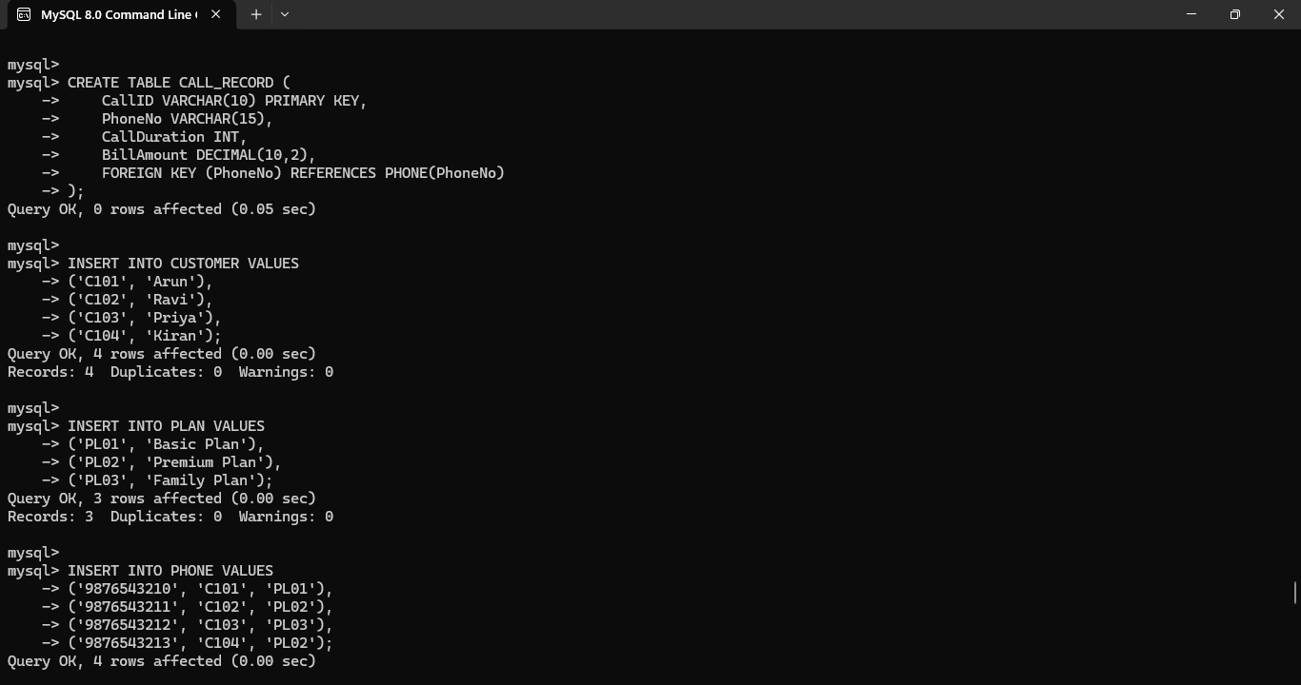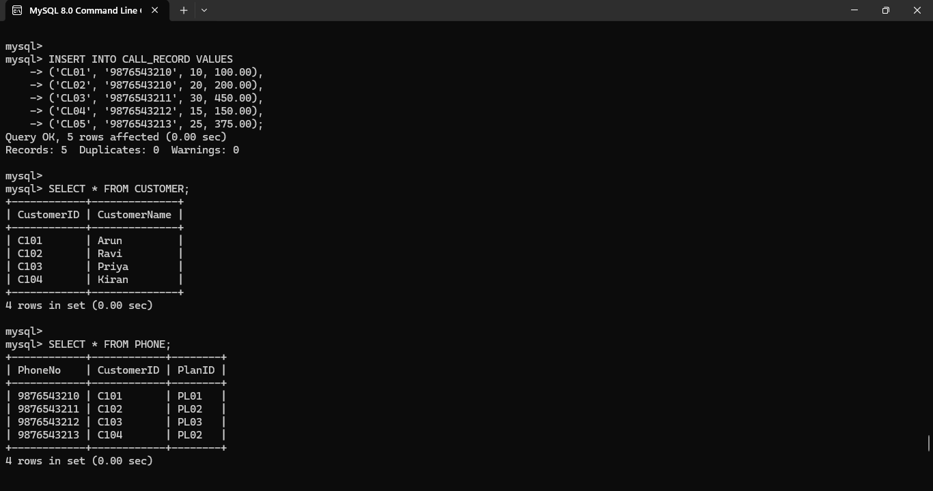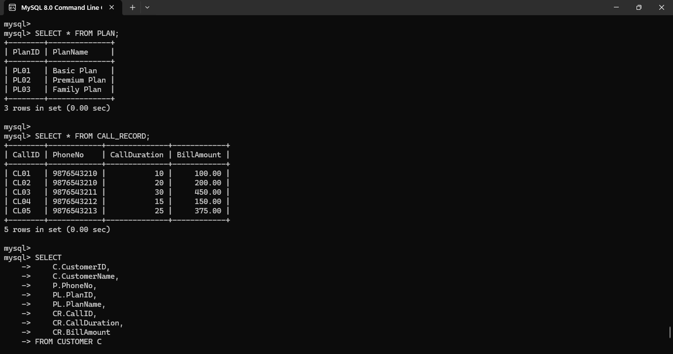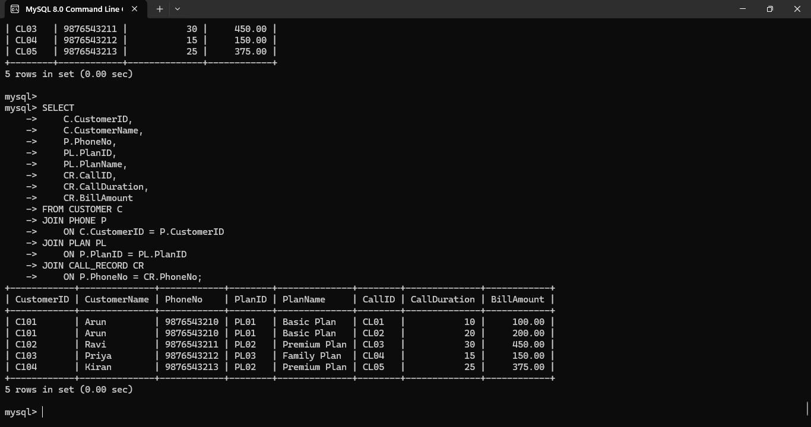
Conclusion
The telecom billing schema was analyzed by identifying its functional dependencies, candidate keys, and primary keys. Separating customer, plan, phone, call, and billing information provides a better foundation for normalization. This analysis helps prevent redundancy and ensures that each entity can be uniquely identified and maintained correctly.

Q8. Retail Inventory System
Scenario
A retail inventory system stores product information using Product(PID, PName, SupplierID, SupplierName, Category, Price, Warehouse). A product has a unique PID, while a supplier has a unique SupplierID. SupplierID determines SupplierName, and PID determines product-related information. A product may also be stored in different warehouses. Keeping all these details in one relation can create redundant supplier and product information. The relation is therefore decomposed into PRODUCT, SUPPLIER, WAREHOUSE, and INVENTORY relations and normalized through the appropriate normal forms.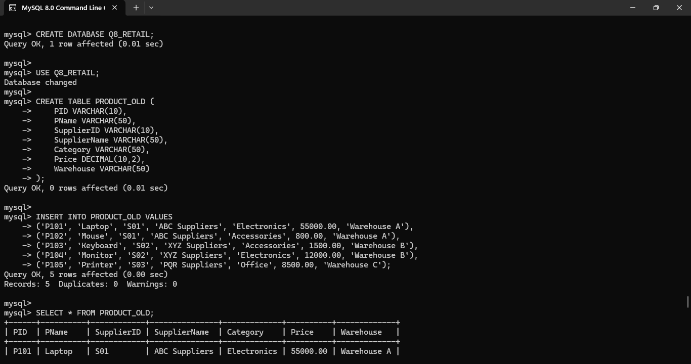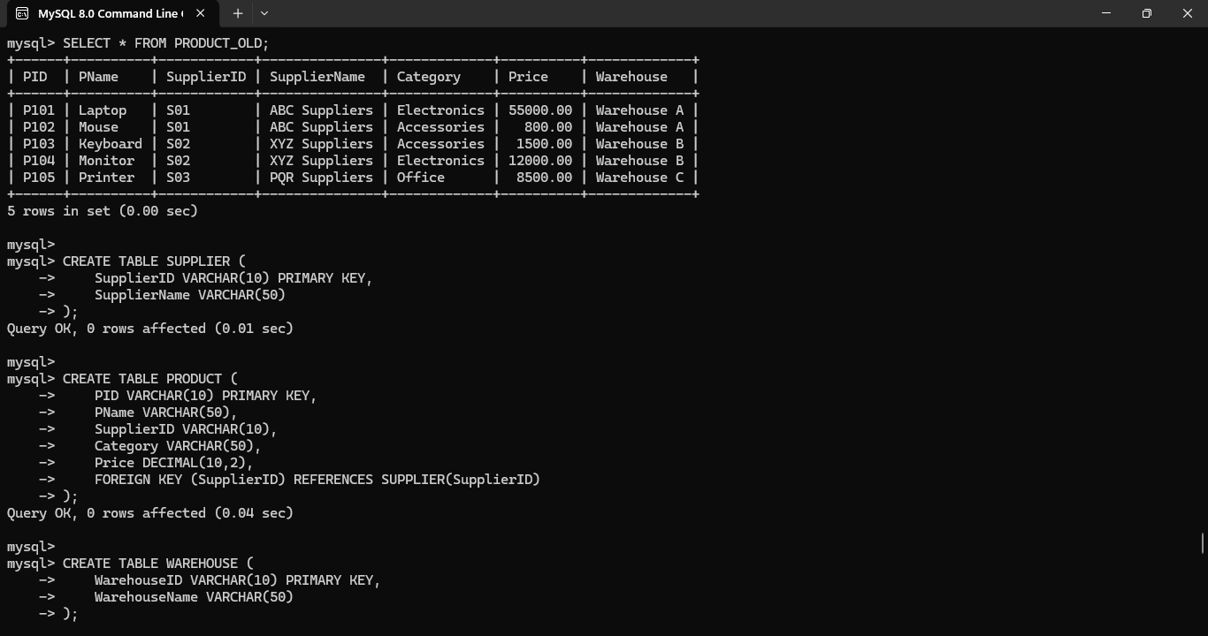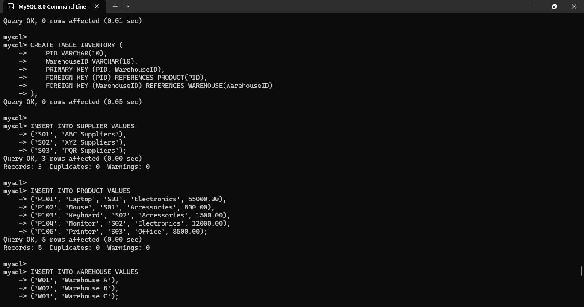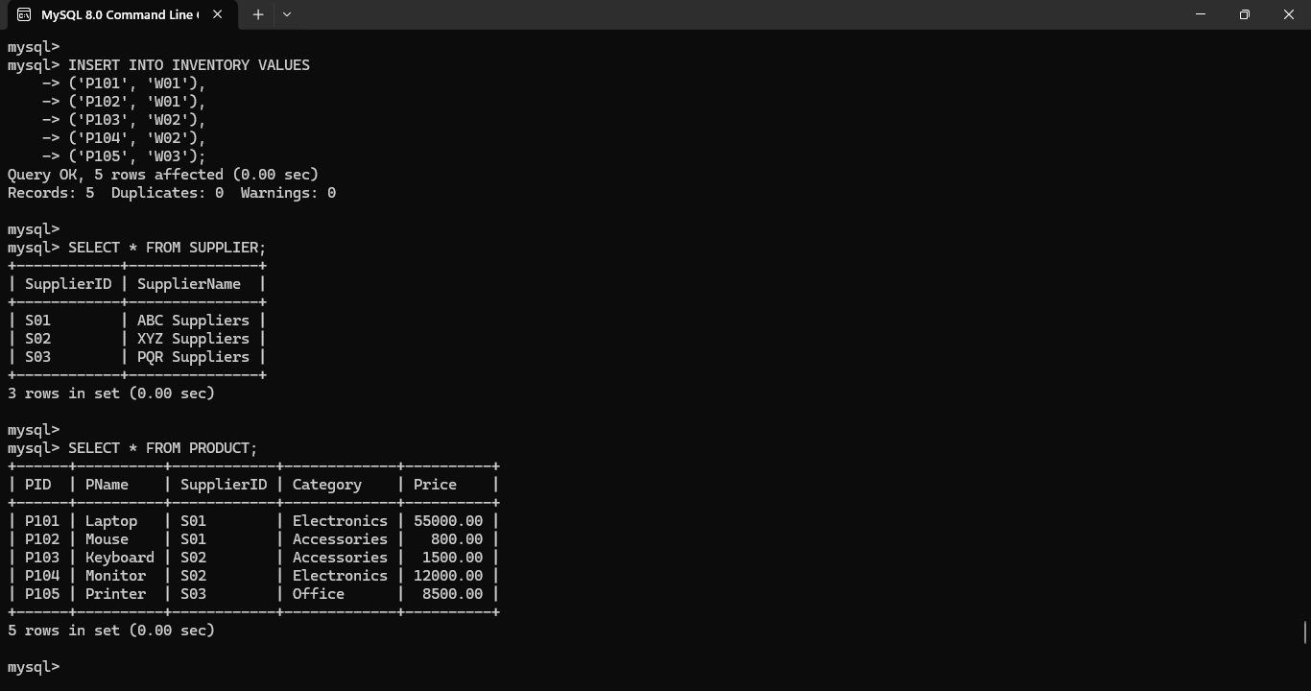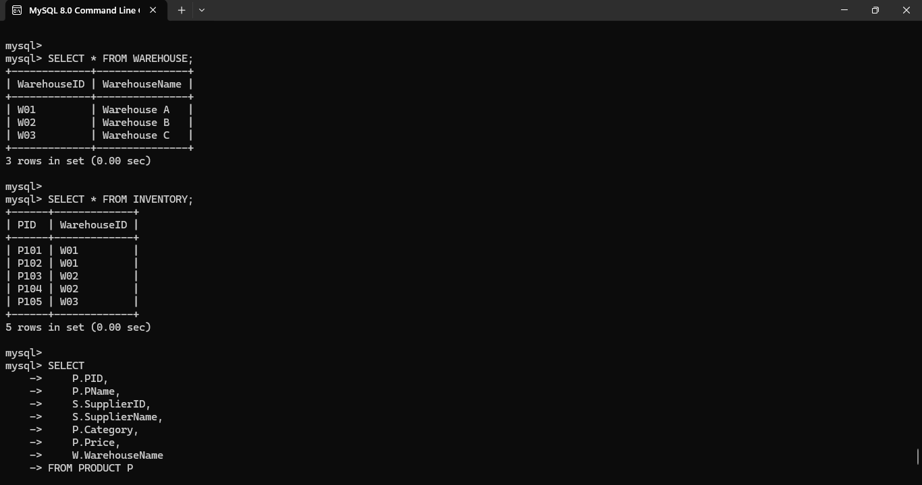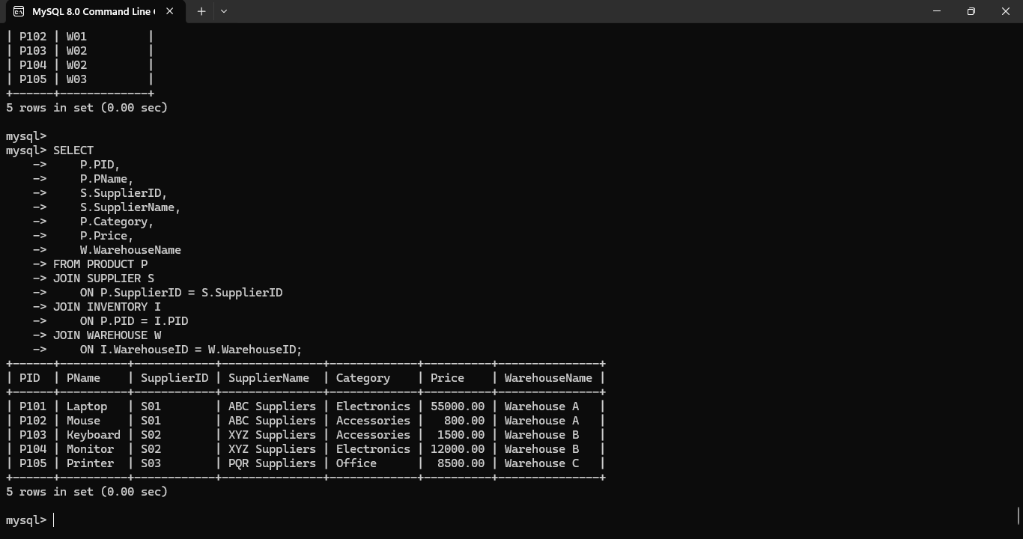
Conclusion
The retail inventory database was completely normalized by separating product, supplier, warehouse, and inventory information. Functional and transitive dependencies were removed where necessary. The final design reduces redundancy, prevents anomalies, and provides better data integrity and efficient management of inventory information.

Q9. School ERP System
Scenario
A School ERP system may store student, parent, class, teacher, subject, and examination information in a single poorly normalized relation. A student can study multiple subjects, a teacher can teach multiple subjects, and a class can contain many students. Storing all these details together causes repeated student, teacher, class, and subject information. It can also produce insertion, deletion, and update anomalies. Functional dependencies and candidate keys are identified, and the relation is decomposed into separate STUDENT, PARENT, CLASS, TEACHER, SUBJECT, ENROLLMENT, and other required relations. The design is normalized up to BCNF wherever the dependencies permit.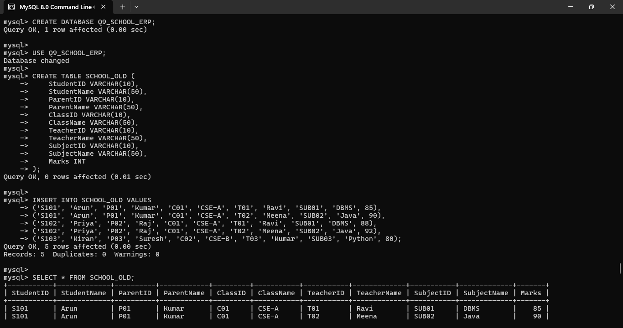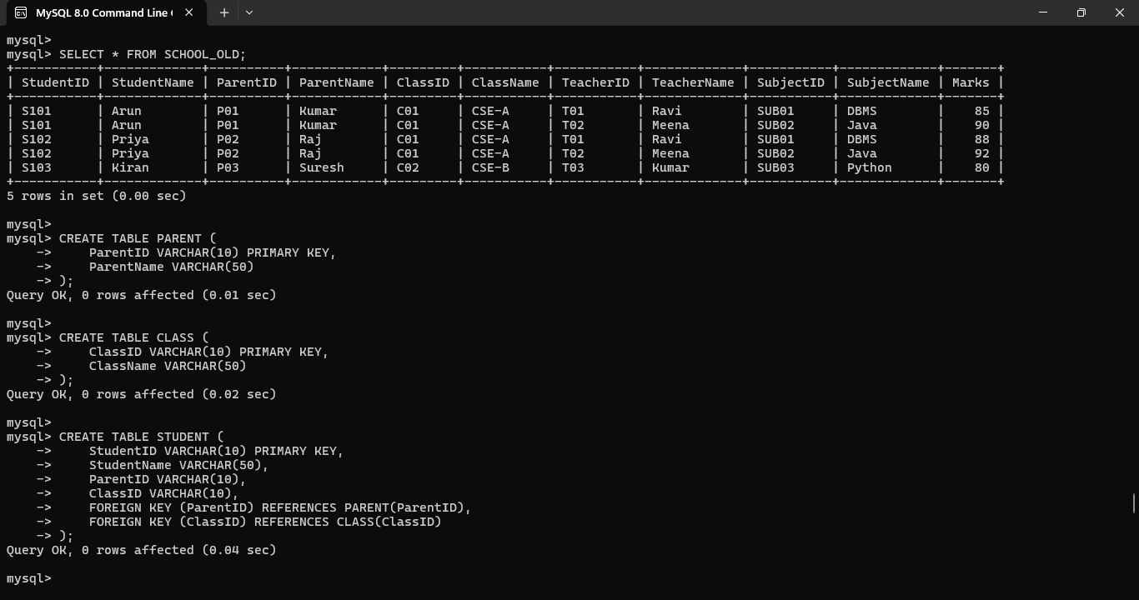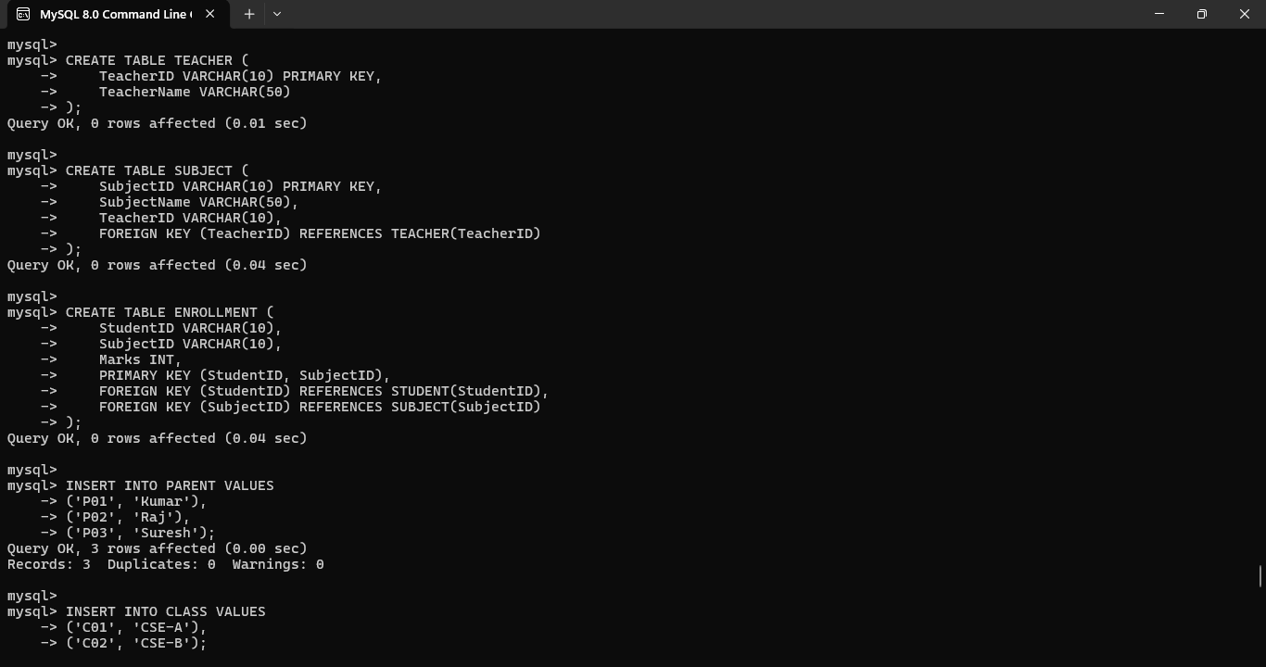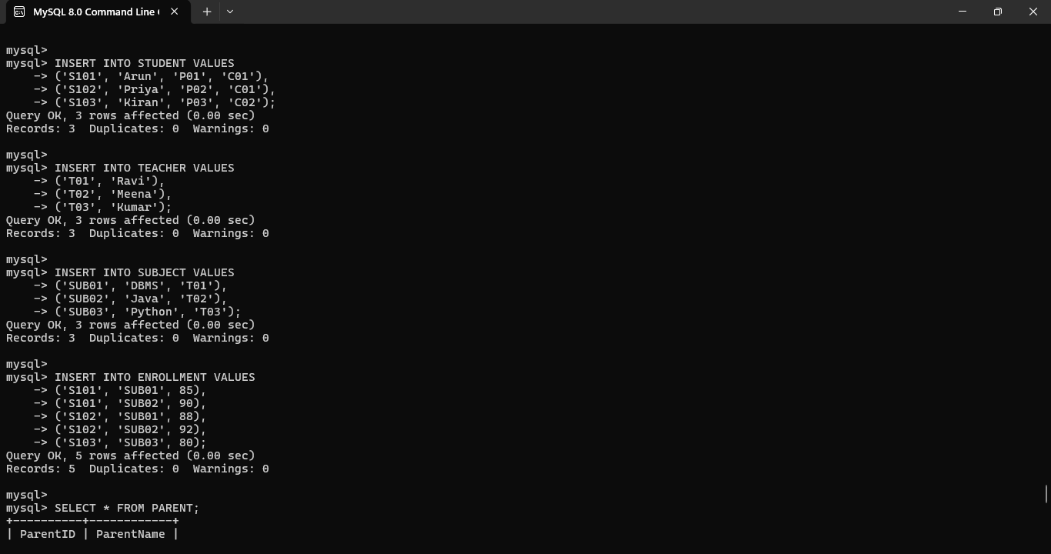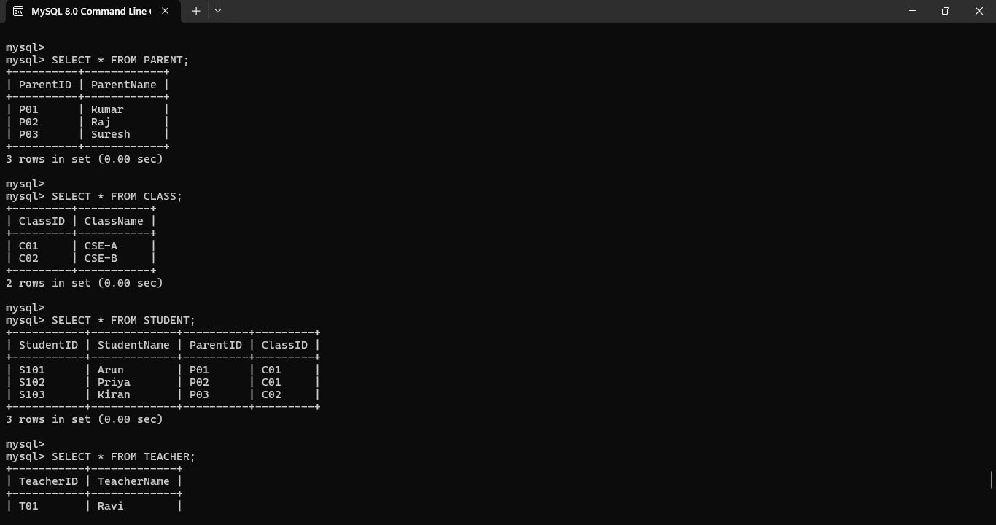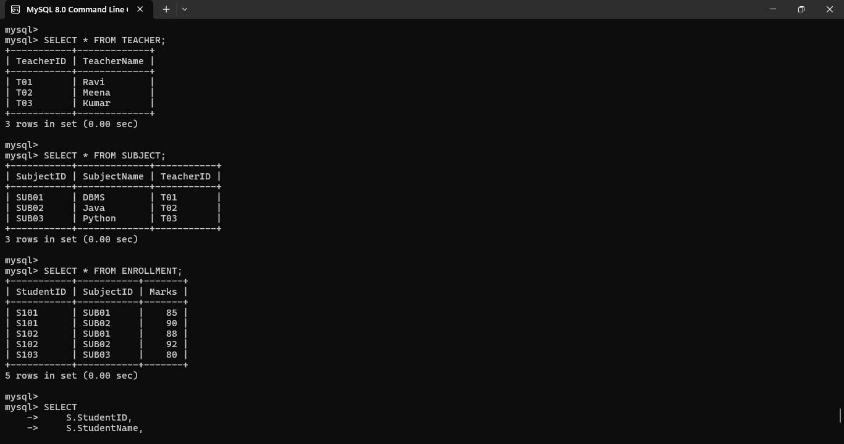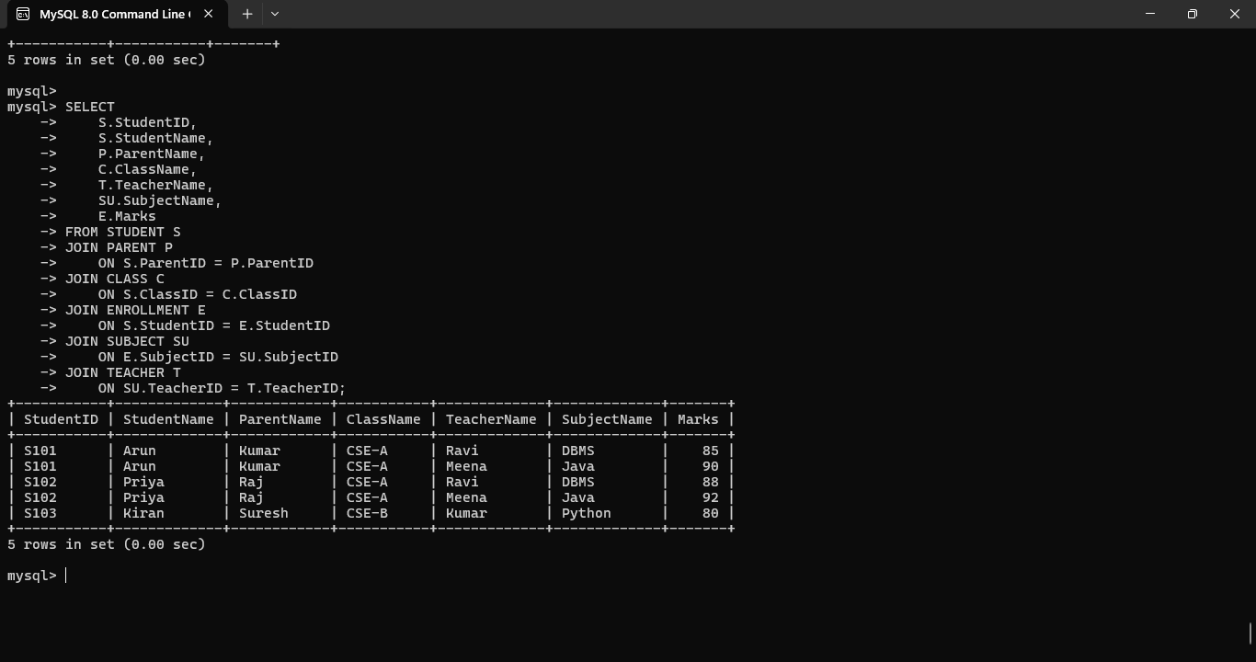
Conclusion
The School ERP schema was successfully redesigned into a normalized structure up to BCNF. Separate relations for students, parents, teachers, subjects, classes, and enrollments reduce redundancy and prevent data anomalies. Primary and foreign keys maintain relationships and ensure data integrity throughout the system.
Q10. Movie Streaming Platform
Scenario
A movie streaming platform may maintain information about movies, actors, directors, genres, and streaming platforms in a single relation. A movie can have multiple actors, multiple genres, and may be available on multiple platforms. These independent relationships can produce join dependencies and significant redundancy when stored in one relation. To remove this redundancy, the original relation can be decomposed into smaller relations such as MOVIE_ACTOR, MOVIE_GENRE, and MOVIE_PLATFORM. The decomposed relations can then be joined to reconstruct the required information, providing a lossless-join design when the specified join dependency holds.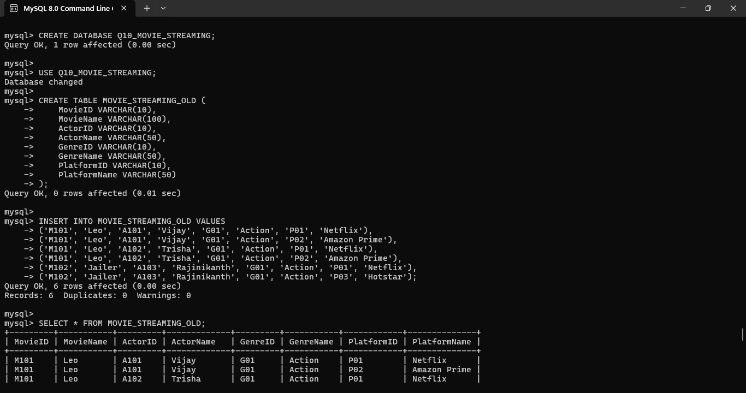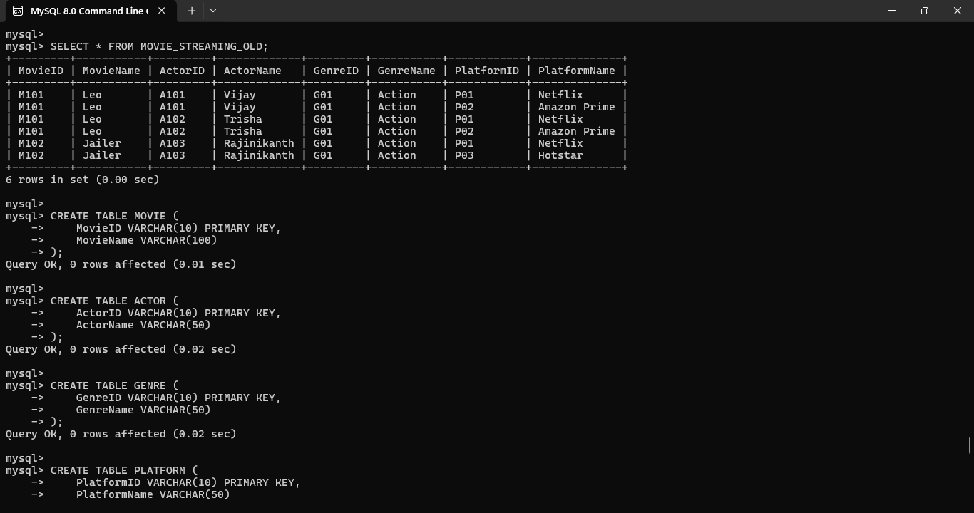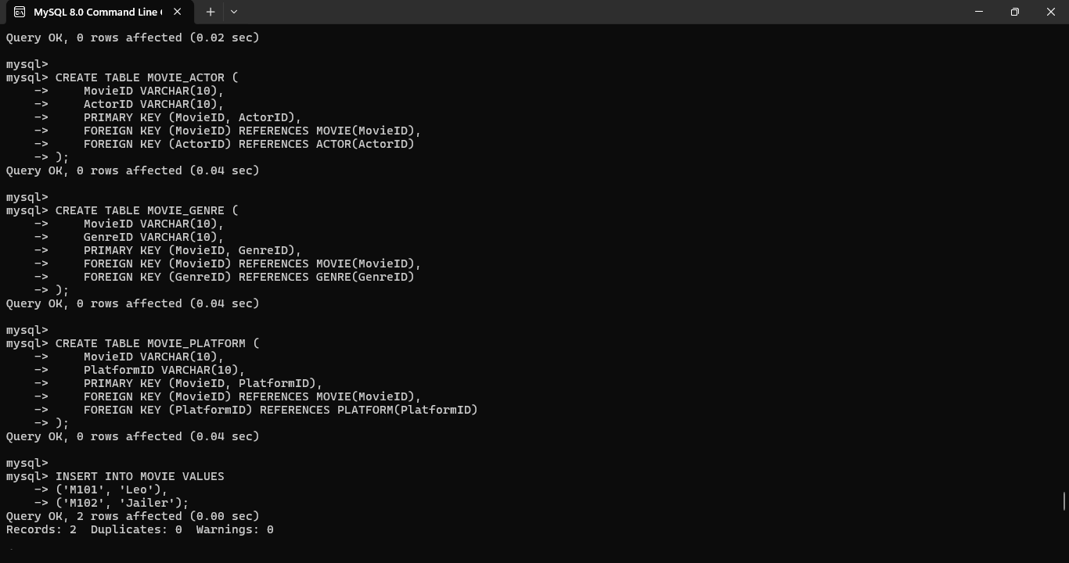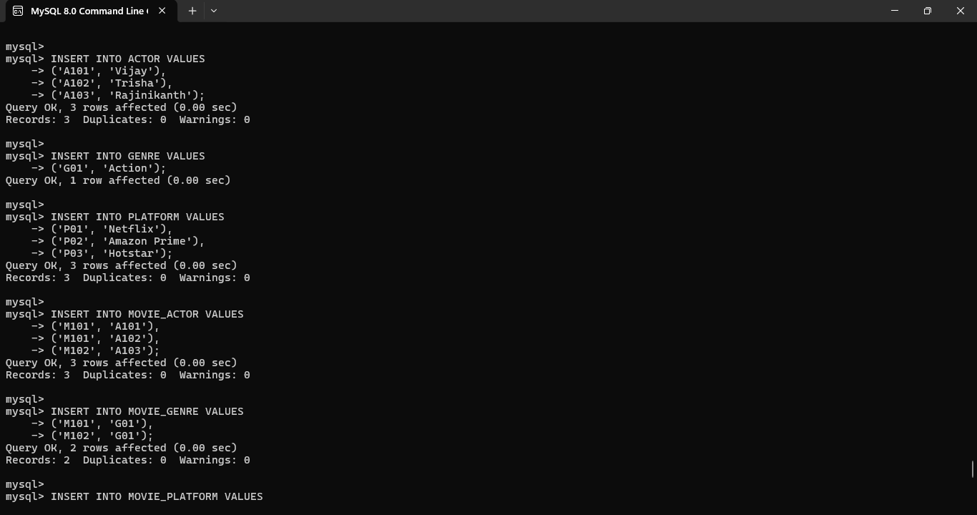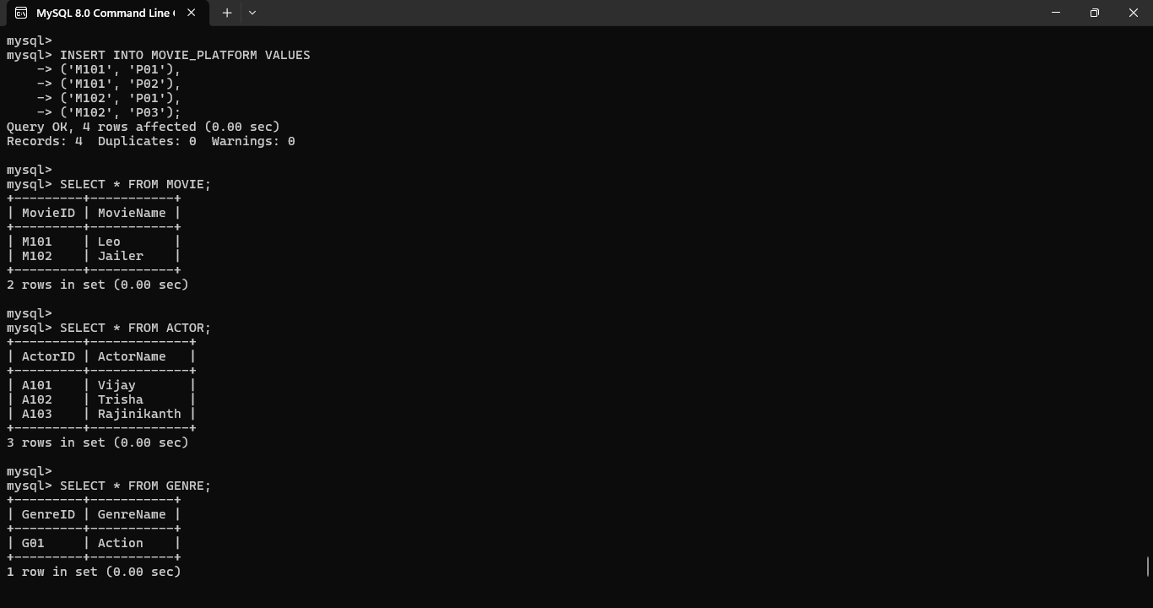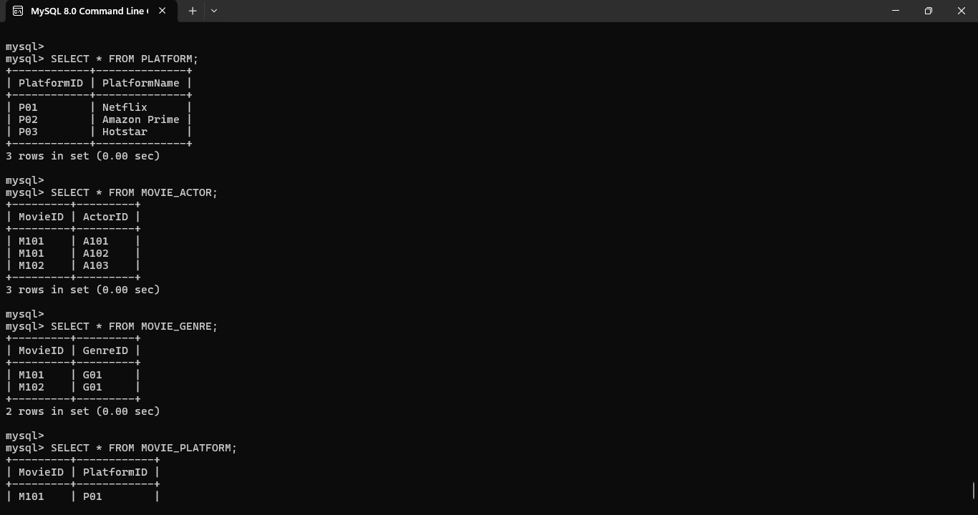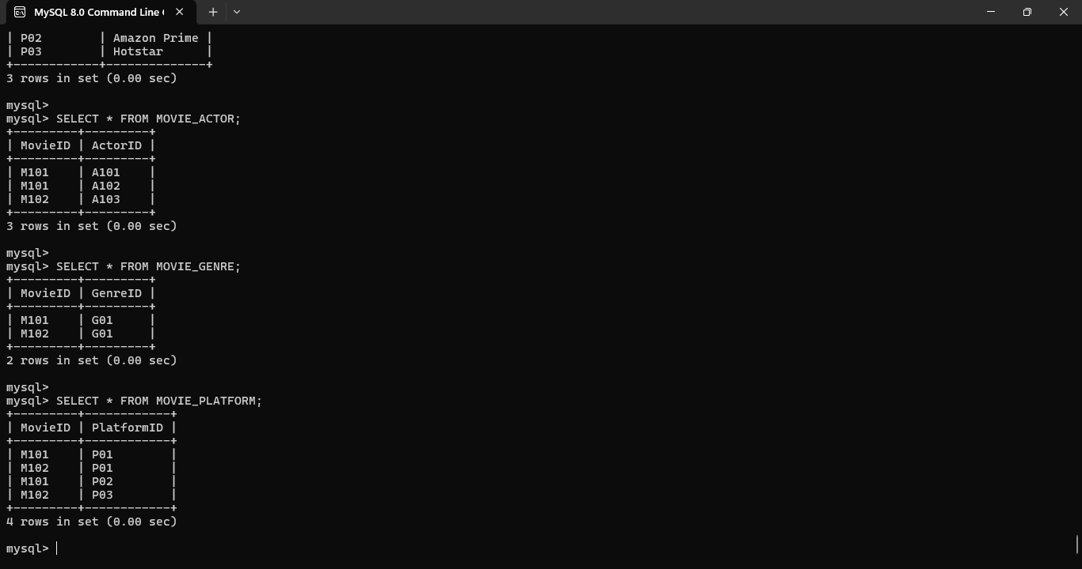
Conclusion
The movie streaming database was decomposed into smaller relations based on join dependencies and normalized to 5NF. The decomposition eliminates redundant combinations of movie, actor, genre, and platform information. Lossless-join verification confirms that the required information can be reconstructed from the decomposed relations without unnecessary data duplication.

