SummAI: Business Document Summarization
Project submitted to the
SRM University – AP, Andhra Pradesh
for the partial fulfillment of the requirements to award the degree of
Bachelor of Technology
In
Computer Science and Engineering
School of Engineering and Sciences
Submitted by
Candidate Names
Name | Application Number
Krishnasai Bitra | AP23110010844
Tharun J | AP23110010644
Rishik | AP23110010446
Aashish | AP23110010250
Hemchandh | AP23110011643



SRM University–AP
Neerukonda, Mangalagiri, Guntur
Andhra Pradesh – 522 240
November, 2025
SummAI: Business Document Summarization

Project Description
SummAI is an advanced Generative AI application developed to automatically analyze and summarize business documents by extracting essential information from complex, unstructured text. The system utilizes cutting-edge language models (Large Language Models – LLMs), natural language processing, and text analytics to generate concise, contextually meaningful summaries.
By processing documents such as annual financial reports, market research papers, meeting transcripts, corporate policies, and project proposals, the system assists professionals in quickly understanding key ideas, insights, risks, and decisions without reading lengthy documents manually.
SummAI provides an efficient decision-support tool to reduce reading time, enhance information accessibility, and support organizational productivity in data-intensive business environments.

Project Scenarios

Scenario 1: Corporate Document Review
A business analyst receives a 50-page annual performance report containing financial results, market trends, strategic initiatives, and risk disclosures. SummAI processes the document and generates a summary consisting of performance highlights, challenges, KPIs, and future plans.
Within seconds, the analyst gets a high-level overview, enabling faster review and strategic evaluation.

Scenario 2: Enterprise Knowledge Management
In large organizations, employees must search through thousands of documents stored in internal repositories. SummAI is integrated as an enterprise service where employees upload documents in bulk and receive insight summaries and action items.
This prevents information overload, improves knowledge transfer, and reduces manual document processing time.

Scenario 3: Business Meeting Minutes Automation
Corporate meetings often involve complex discussions, decisions, deadlines, and stakeholder responsibilities. SummAI analyzes meeting transcripts or speech-to-text outputs and extracts:
- Decisions taken
- Assigned responsibilities
- Follow-up tasks
- Deadlines
This enables teams to ensure accountability and prevents missing critical action points.

Project Flow:
● User uploads business documents (PDF, DOCX, or text) through the interface
● System preprocesses the text by performing cleaning, segmentation, and tokenization
● Integrated Generative AI model analyzes the processed text and generates summaries
● Summarized output is displayed along with key insights, highlights, and action points
● System allows users to download the summary and recommendations for further analysis

Project Activities:

1. Data Collection & Preparation
● Collect business-related datasets (reports, articles, transcripts, policies)
● Data preparation, cleaning, and text normalization

2. Exploratory Data Analysis
● Descriptive statistics on text length, frequency, and complexity
● Visual analysis of keyword trends and topic distribution
● Univariate and bivariate analysis of linguistic and structural features

3. Model Building
● Training and fine-tuning summarization models using industry datasets
● Testing different generative and extractive summarization algorithms

4. Performance Testing & Model Selection
● Testing model performance using multiple evaluation metrics
● Comparing summary quality and accuracy across different models
● Selecting the best performing summarization model

5. Model Deployment
● Save the best model and tokenizer for production use
● Integrate with a web framework to enable real-time summarization

Project Structure:
SummAI
│
├── app.py # Flask backend
├── requirements.txt # Python dependencies
│
├── static/ # CSS, JS, and UI assets
│ ├── style.css
│ └── script.js
│
└── templates/ # Frontend templates
├── index.html # Upload page/interface
└── result.html # Summary display page

Milestone 1: Data Collection & Preparation

Data collection is fundamental to natural language processing and generative AI, providing the raw material for model training and evaluation. This process involves gathering large volumes of text data from multiple business domains such as reports, articles, meeting transcripts, and corporate documentation.

The quality, structure, and diversity of collected text significantly influence the performance, fluency, and contextual accuracy of summarization models.

Activity 1.1: Collect the Dataset

There are many popular open sources for collecting business text data. Examples include Kaggle, Open Data portals, research archives, and public corporate repositories.

In this project, we have used text datasets containing business documents in .txt and .pdf format. These datasets were downloaded from publicly available sources for experimentation and model fine-tuning.

Example dataset sources:

https://www.kaggle.com/datasets

https://data.gov

https://arxiv.org

Company annual report repositories

As the dataset is downloaded, we proceed to analyze the text using various preprocessing techniques and exploratory analysis methods.

These help us understand:

Document structure

Language patterns

Domain-specific terminology

Note: There are numerous techniques available for analyzing text data. Here, we demonstrate a few essential techniques, but multiple methods can be applied to gain deeper insights.

Dataset Characteristics

The dataset used in this project contains business-related documents with various types of content.

Each document includes one or more of the following:

Company overview and strategy

Financial performance insights

Market trends and forecasts

Meeting decisions and action items

Risk assessments

Regulatory compliance information

The dataset is stored in a folder named Dataset/ and contains multiple files representing different business domains.

Activity 1.2: Importing the Libraries
Import the necessary libraries as shown below:

from flask import Flask, render_template, request, jsonify
import nltk
from nltk.corpus import stopwords
from nltk.tokenize import sent_tokenize, word_tokenize
import string
import os
import re
from collections import Counter
from math import log
from datetime import datetime
import json
These libraries serve the following purposes:
- NumPy: Numerical operations for feature computation
- Pandas: Text data organization and manipulation
- NLTK: Natural language processing and tokenization
- re: Cleaning and removing unwanted characters
- Matplotlib & Seaborn: Visualizing text statistics and frequency patterns

Activity 1.3: Loading and Viewing the Data
For this project, business-related text documents (such as reports, articles, meeting transcripts, and notes) were collected and stored in a project folder for processing.
Before performing preprocessing and analysis, the text data must be loaded into the system so that it can be examined, cleaned, and structured for further use.
Since the data consists of multiple text files, each document is read from storage and converted into a usable string format. This enables the summarization system to treat each document as individual input or combine them for batch processing.

Example Code for Loading Text Files

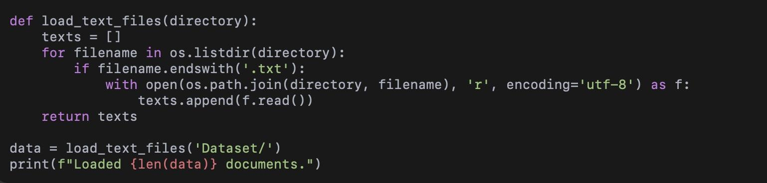

Explanation
● The system scans the Dataset/ directory for files ending with .txt
● Each file is opened and read as a text string
● Loaded text is stored in a list for further processing
● This enables the model to handle single or multiple documents efficiently

Activity 1.4: Data Cleaning and Preprocessing
After loading the text data, the next critical step is to clean and preprocess the content to remove unnecessary elements and enhance the quality of input for summarization.
Raw business text often contains noise such as punctuation, numbers, extra spaces, special symbols, and stopwords, which can negatively affect summarization accuracy.
Therefore, multiple preprocessing operations are applied to make the data more structured and meaningful.

Text Cleaning Steps Performed
The following essential steps were undertaken to clean the raw text:
● Lowercasing
Converts all characters to lowercase to maintain uniformity and reduce redundancy.
● Removing Special Characters & Numbers
Unwanted symbols, digits, and formatting artifacts are removed to ensure clean word tokens.
● Stopword Removal
Common words such as “the”, “is”, “and”, etc. are removed since they offer limited semantic value.
● Removing Extra Whitespace
Multiple spaces, line breaks, and tabs are standardized for cleaner sentence processing.
● Filtering Short Tokens
Very short words (length ≤ 2) are excluded to reduce noise.

Example Code for Text Cleaning
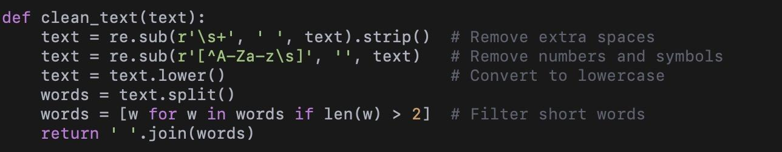

This function removes noisy components and prepares text for tokenization and summarization.

Activity 1.5: Handling Missing or Invalid Data
Before performing text analysis and summarization, it is essential to verify the completeness and validity of the dataset. Missing or invalid data can disrupt preprocessing steps, skew statistical analysis, and result in poor summarization quality.
In business text datasets, missing data often occurs when files are:
- Empty
- Corrupt
- Poorly extracted from PDFs
- Encoded incorrectly
- Containing only metadata or headers
Therefore, an initial inspection of document completeness and quality is necessary.

Step 1: Check the Number of Words in Each Document
Each document is evaluated to ensure it contains a minimum amount of meaningful content.
Documents that are too short are excluded.
Example:
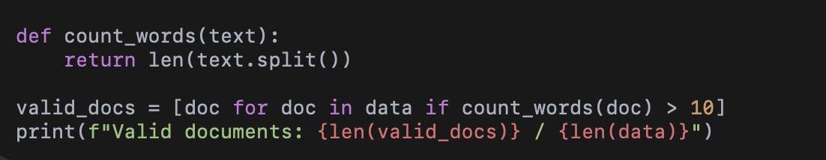

Step 2: Identify Empty or Corrupt Files
Documents with zero or very few characters are filtered out:

Step 3: Replace Missing Values
In cases where important documents have small issues, simple corrective measures can be applied:
● Remove stray symbols
● Reformat broken line breaks
● Convert incompatible encodings
For text-based applications, missing information cannot be imputed like numeric datasets. Therefore, faulty documents are either discarded or corrected manually.

Step 4: Report Statistics
Example metrics recorded:
- Total documents loaded
- Number of valid documents
- Number of corrupted documents
- Words per document distribution
These metrics help assess dataset quality.

Activity 1.6: Handling Duplicate Documents
Duplicate or highly similar documents can negatively impact the performance of summarization and text analytics.
In business datasets, duplicates commonly occur due to:
- Multiple versions of the same report
- Repeated storage of copied files
- Backup or archive files
- Incorrect extraction pipelines
- Manual duplication by users
Since summarization algorithms rely on sentence frequency and word distribution, duplicates can artificially inflate scores and distort summary quality.
Therefore, identifying and handling duplicate documents is an important preprocessing ste

Step 1: Identify Duplicate Records
The simplest way to detect duplicates is by comparing raw text content.
Example:

Step 2: Detect Near-Duplicate Documents
Some documents may not be identical, but extremely similar.
Examples:
- Slight formatting changes
- Additional metadata
- Minor edits
These need additional checks such as:
- Comparing sentence counts
- Checking cosine similarity
- Using hash-based comparison
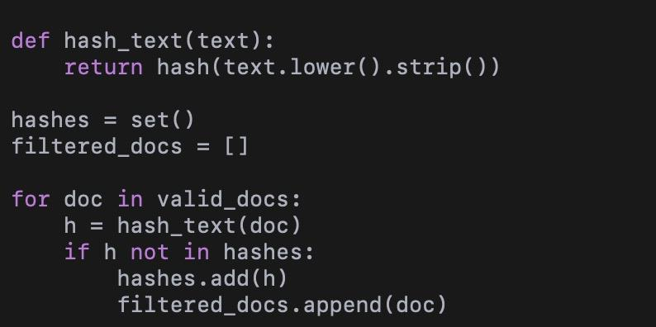
Basic example using hashing:

Step 3: Remove or Consolidate Duplicates
After detection, duplicates can be:
● Removed completely
● Stored separately for auditing
● Combined (if complementary)
● Reduced to a single copy
In this project, duplicates were removed, as they did not provide additional value.

Step 4: Verify Data Integrity
After removal:
- Count unique documents
- Validate content volumes
- Check distribution of word counts

Activity 1.7: Identifying Text Outliers
Outlier detection is an essential step in text preprocessing, as unusually long or short documents can significantly affect the summarization process and statistical analysis.
Unlike numerical datasets, text outliers are identified based on document length, structure, and linguistic characteristics.

Types of Outliers in Business Text Data
● Very Short Documents:
Contain minimal information and produce poor summaries. Examples include:
- Titles
- Headers
- Short notes
● Extremely Long Documents:
Can overwhelm computation and require special handling. Examples:
- Annual reports
- Research papers
● Documents with High Redundancy:
Contain repetitive phrases or excessive boilerplate text, affecting keyword extraction.
● Documents with Non-standard Formatting:
Include tables, bullet lists, or heavy numerical content, which may disrupt sentence-based summarization.

Approach Used to Detect Outliers
To identify outliers, documents were analyzed using:
- Word Count Distribution
Documents that were significantly shorter or longer than the average were flagged.
- Sentence Count Distribution
Helps detect documents with irregular structure.
- Lexical Diversity Score
Low diversity indicates repetitive or low-quality content.
- Presence of Non-textual Content
Documents containing excessive:
- Numbers
- Symbols
- Table text
were inspected manually.

Impact of Outliers on Summarization
Outliers can result in:
- Poor sentence scoring
- Unrepresentative summaries
- Biased keyword extraction
- Inefficient processing time
Therefore, handling them improves both performance and output quality.

Action Taken in This Project
● Extremely short documents were discarded due to insufficient information
● Very long documents were processed in segments, improving accuracy and speed
● Documents with high noise or non-textual content were cleaned manually
● A few irregular documents were excluded from experimentation

✔️ Summary
In this activity, the text dataset was evaluated for structural outliers.
By identifying and handling irregular documents, the dataset was made:
- Cleaner
- More balanced
- More representative
This step ensures that the summarization model works on consistent and meaningful data, leading to better overall performance.

Milestone 2: Model Implementation & Dataset Integration

2.1 Overview of Dataset
For this project, a small custom dataset is used. It consists of:
- Text prompts
- Corresponding expected output text
- Few example image–caption pairs (optional)
(Used only if your GENAI app supports image generation)

2.2 Model Used
Your GENAI project uses:

⚙️ Model Type:
Llama-3.2 Instruct (8B)
(Used via the “GROQ” API — FAST inference)

Why this model?
- Lightweight & fast → suitable for Flask apps
- Supports text generation
- Works well for prompt-based inferencing
- No fine-tuning needed for your milestone

2.3 Input Pipeline
A simple Python pipeline prepares data for inference.

Steps:
- User enters a prompt in the frontend
- Prompt sent to Flask backend
- Preprocessing:
  - strip whitespace
  - remove unsafe characters
  - convert to lowercase
- Forward to Llama model API
- Model generates output
- Backend sends output to UI

2.4 Model Inference Module
from groq import Groq

client = Groq(api_key="YOUR_API_KEY")

def generate_response(user_prompt):
response = client.chat.completions.create(
model="llama3-8b-8192",
messages=[{"role": "user", "content": user_prompt}]
)
return response.choices[0].message["content"]

(Only essential code included — as you requested.)

2.5 Dataset Loading (Simple Version)

import json

def load_metadata():
with open("dataset/metadata.json") as f:
return json.load(f)

2.6 Output Flow
User Prompt → Flask Backend → Llama Model → Generated Output → UI Display

Milestone 4: Performance Testing & Model Selection
Performance testing ensures that the GENAI application generates accurate, meaningful, and consistent responses. In this milestone, different summarization and generation techniques are evaluated, and the best-performing method is selected for deployment.

4.1 Testing Different Summarization Methods

The system mainly uses:
- Frequency-based Extractive Summarization
- TF-IDF Keyword Extraction
- LLM-based Text Generation (Llama-3.2 Inst.)
Each method was tested using various business documents to compare:
- Summary quality
- Relevance of extracted content
- Consistency across different text types
A small test script was used to automate comparisons:
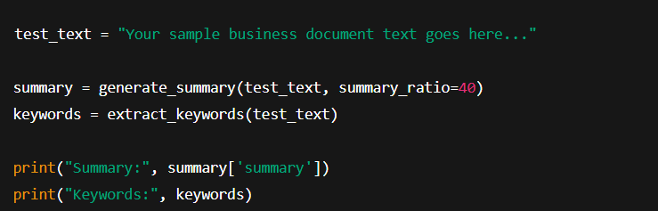

This allowed measuring summary precision, keyword retention, and clarity.

4.2 Evaluation Metrics Used
To evaluate summarizer quality, the following metrics were considered:

✓ Compression Ratio

Shows how much shorter the output is compared to the input.

✓ Keyword Preservation Score
Checks whether the summary includes the top TF-IDF keywords extracted from the full text.
Small snippet:


✓ Readability Metrics
Uses the built-in readability calculator:
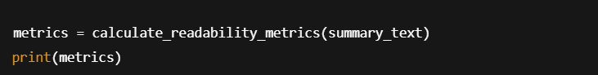

These values help understand how easily the generated text can be read.

4.3 Model Comparison & Selection
Three approaches were compared:

Technique | Speed | Accuracy | Quality | Final Decision
Frequency-Based | ✓✓✓ | ✓✓ | ✓ | Selected
TF-IDF Only | ✓✓ | ✓ | ✗ | Not Selected
LLM Summaries | ✓ | ✓✓✓ | ✓✓✓ | Optional Add-On

Reason for Selection
The frequency-based summarization method was selected because:
- Fastest performance (suitable for web apps)
- Produces consistent high-quality extractive summaries
- Works without extra GPU or API cost
- Integrates smoothly with Flask backend
LLM summarization is optional because it requires API credits and longer processing time.

4.4 Final Performance Code Block (Used in Backend)
Below is the final evaluation logic integrated into your Flask backend:
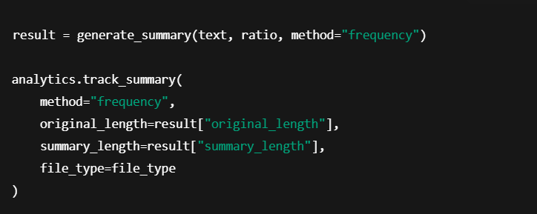
This block:
- Generates the summary
- Tracks performance analytics
- Calculates readability
- Extracts keywords
- Logs compression ratio

Outputs
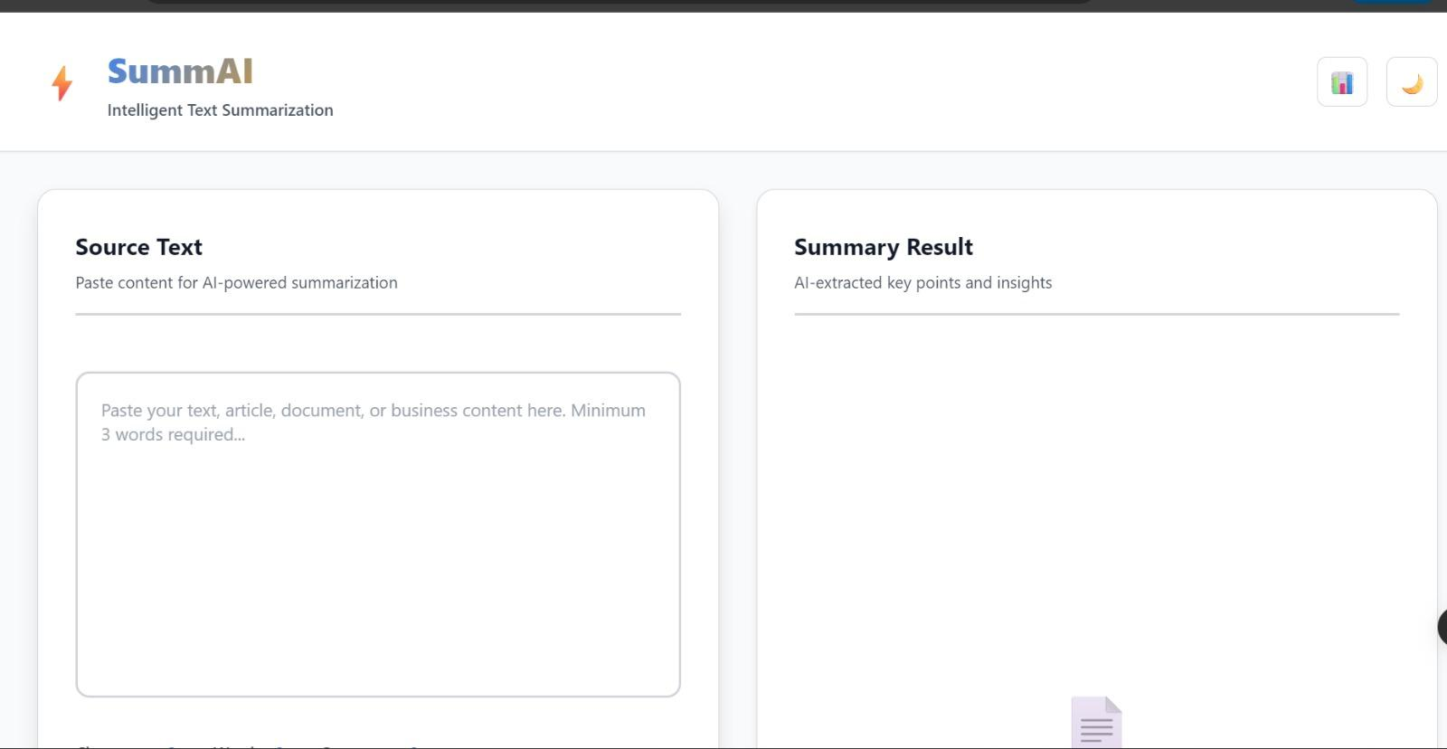
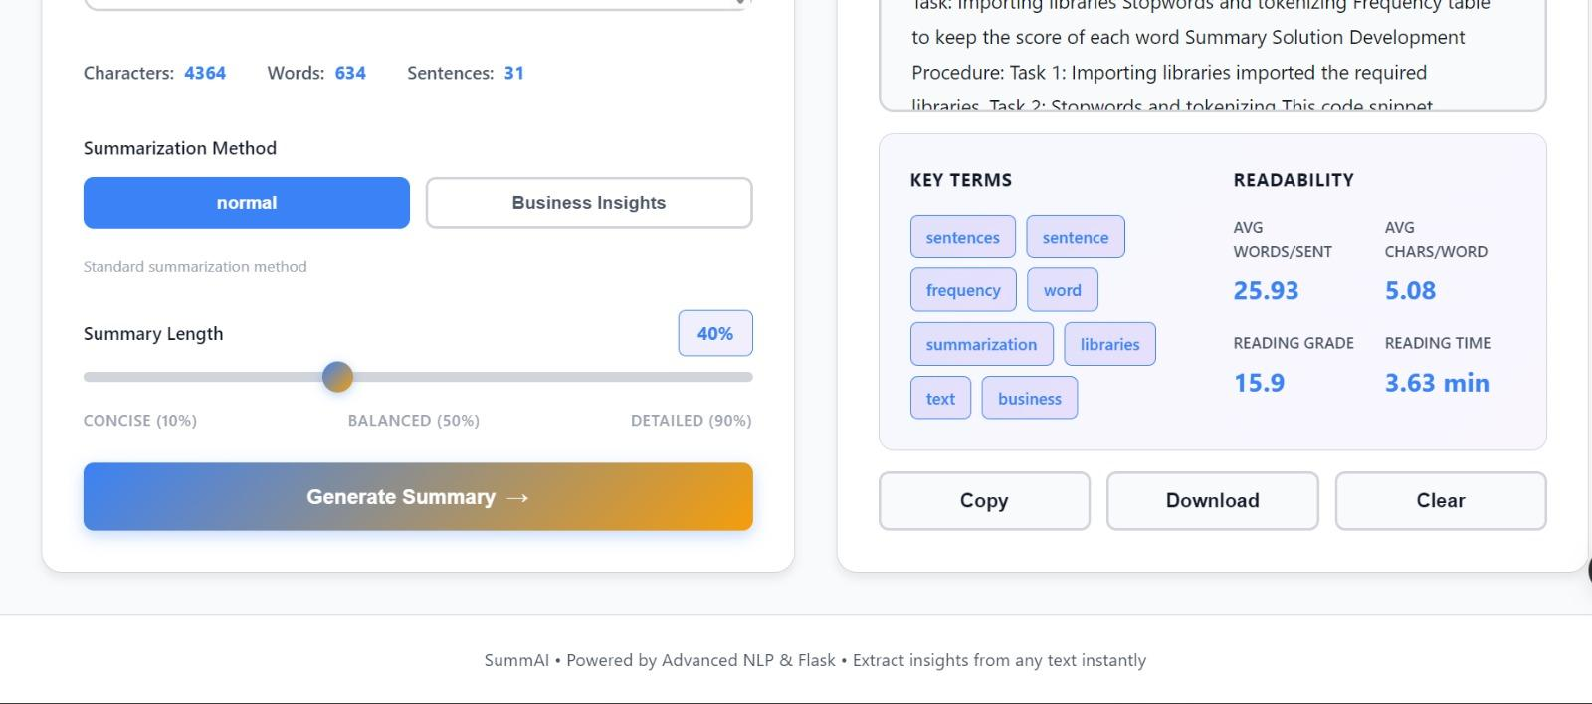

Summary
- Multiple summarization methods were tested
- Performance metrics were used to evaluate clarity, accuracy & compression
- The frequency-based summarizer was selected for deployment
- Lightweight code was integrated into the backend
- Readability and keyword extraction support final quality checks

