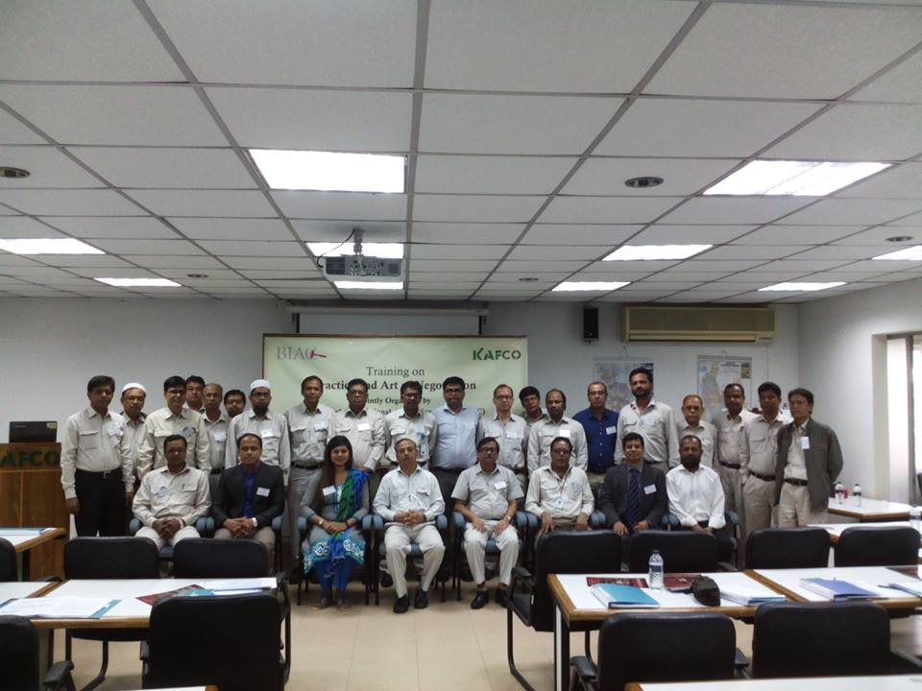
CEO of Law Abode (sitting second from left) was the Lead trainer on behalf of Bangladesh International Arbitration Centre (BIAC) to provide training to Karnaphuli Fertilizer Company LTD (KAFCO), the biggest joint venture project in Bangladesh ventured with Bangladesh, Japan, Denmark and Netherlands, having its premises in about 100 acres beside the Karnaphuli river in Chittagong. Participants in the training were 22 High officials including COO, GM, a number of DGMs and executives.
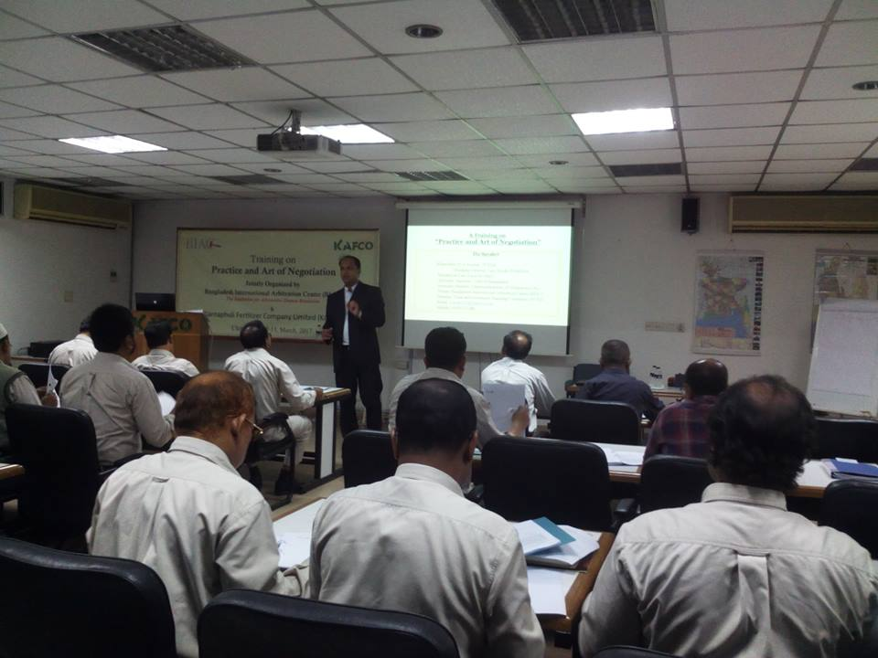
CEO of Law Abode is providing training in ’ Negotiation’ on behalf of BIAC to high officials of KAFCO including COO, GM, a number of DGMs and executives, the biggest joint venture project in Bangladesh.
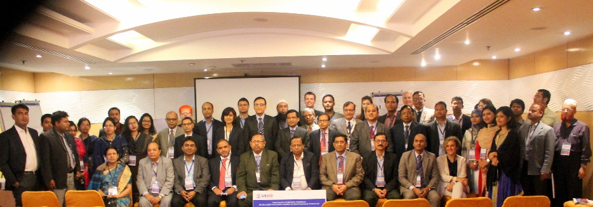
CEO of Law Abode was one of the four presenters presenting on behalf of their four small groups in a high profile Large group workshop in Westin in the issues ‘Anti-dumping, Countervailing duties and para-tariffs’ in the two day workshop organized by USAID and BUILD on the topic ‘IPEC Bangladesh Non-Tariff Barriers Action planning Workshop’ where one former minister, a number of secretaries of the Government of Bangladesh as well as High officials of NBR, BoI, Export promotion Bureau, Tariff Commission of Bangladesh and the leaders from different chambers of commerce in Bangladesh were participants.
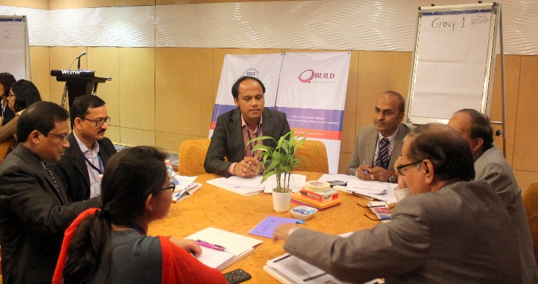
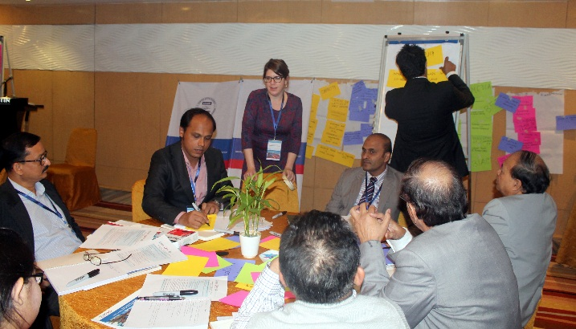
CEO of Law Abode (third from the left) is at the preparation stage before presenting on behalf of their small group in ‘IPEC Bangladesh NTB Action planning Workshop’. He presented in the issues ‘Anti-dumping, Countervailing duties and para-tariffs’ (International Trade and Commerce issues).
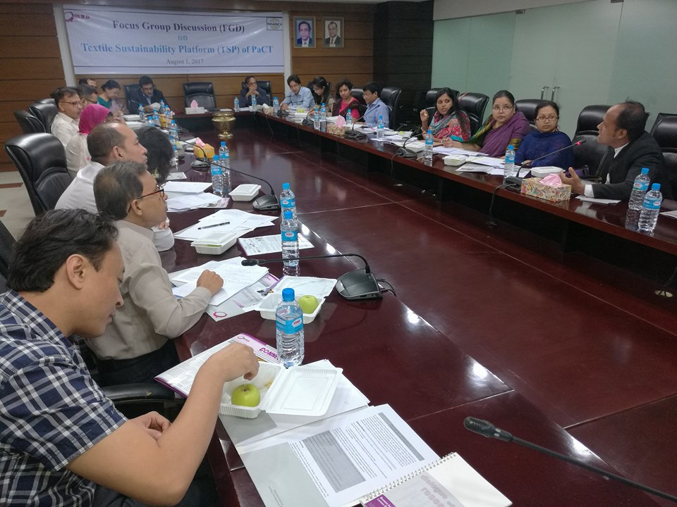
CEO participated in a Focus Group Discussion (FGD) on the Textile Sustainability Platform (TSP) implemented by IFC-WBG and BUILD in the to-be-demolished BGMEA Bhaban.
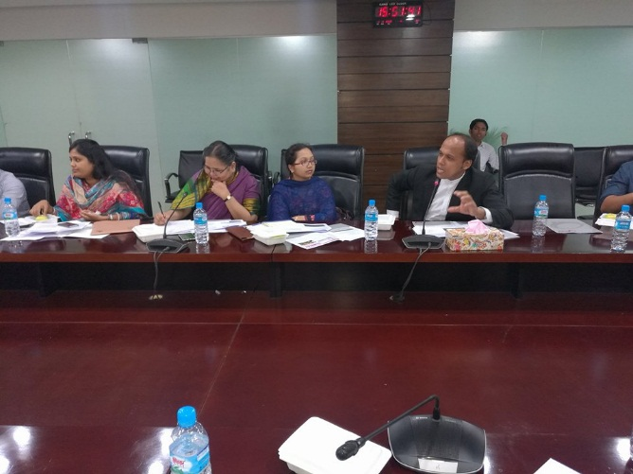
CEO is contributing in the FGD on the Textile Sustainability Platform (TSP) giving a good insight about the uses of natural resources, specially water, in textile industries and their legal requirements.
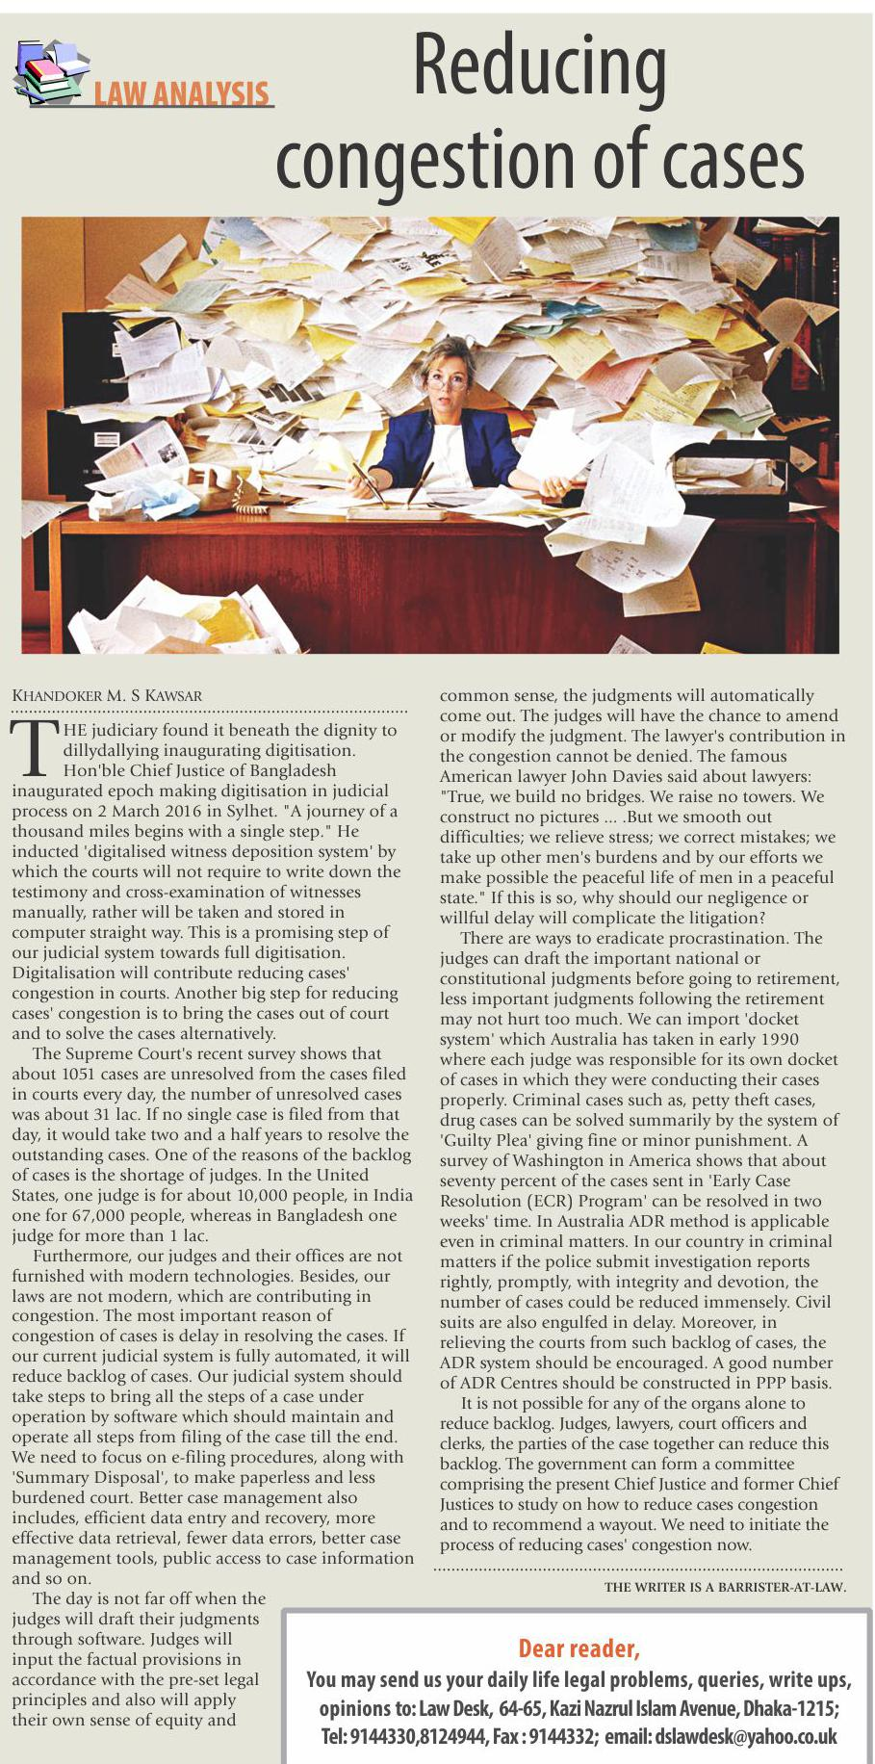
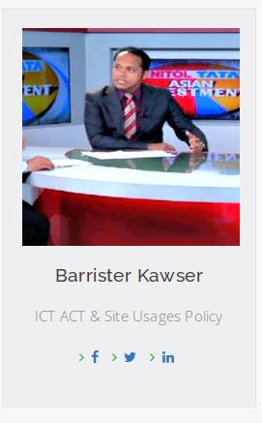
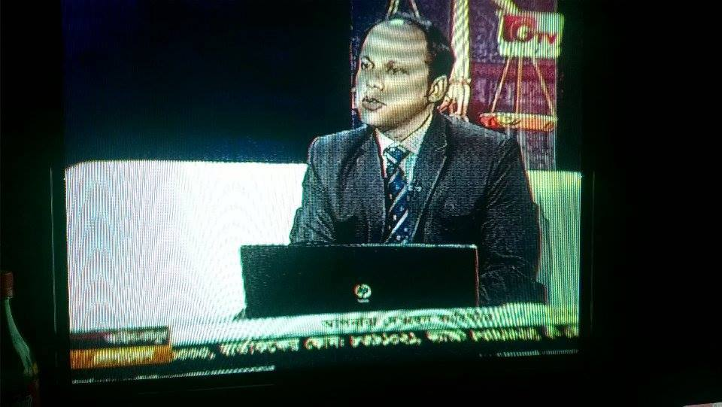
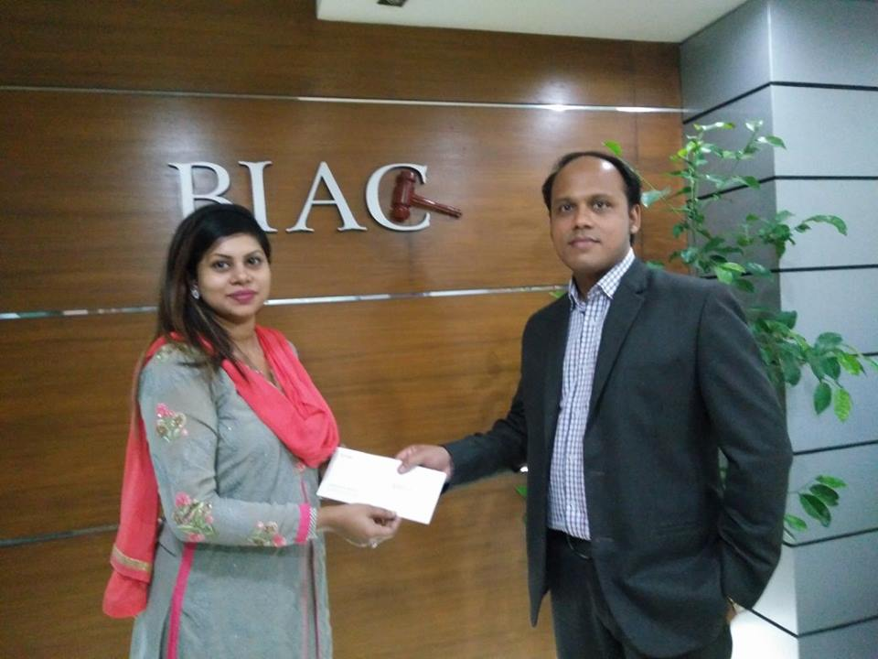
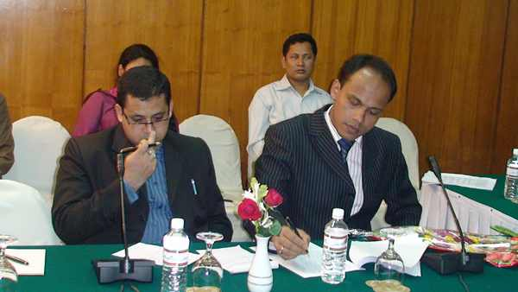
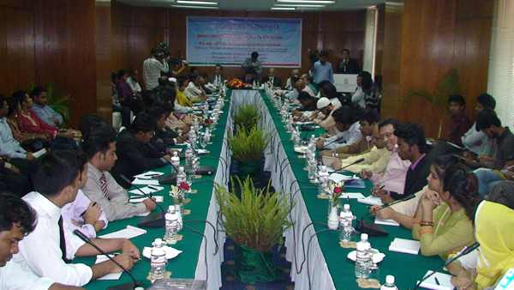
CEO Presented the Key Note in the seminar entitled “Media laws of Bangladesh: Problems and Prospects” arranged by the Northern University of Bangladesh (NUB) in Hotel pan Pacific Sonargaon on 26th February 2011.
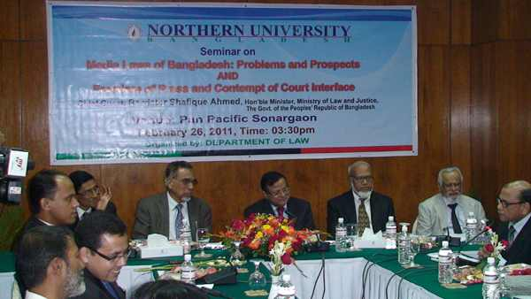
Guest review session in the seminar “Media laws of Bangladesh: Problems and Prospects ” arranged by the Northern University of Bangladesh (NUB) where delegates are (from left) Law coordinator, CEO of Law Abode, Treasurer of NUB, Registrar of NUB, Hon’ble Law Minister of Bangladesh Barrister Shafiq Ahmed, Vice Chancellor of NUB, Dean of Department of Law and Editor of The New nation. Also a number of delegates and around 64 journalists were present.
