Egypt University of Informatics
Computer and Information Systems
Data Analysis Course
The Analysis of Greater Cairo Real Estate Prices
Submitted by: Ahmed Hasaan & Team

Introduction
Understanding real estate pricing is crucial for buyers, investors, and developers. This report analyzes apartment prices in Greater Cairo to identify the key factors affecting price per square meter. The study aims to provide insights into market behavior and detect pricing inefficiencies such as overpriced or underpriced properties.

Research Question
What factors significantly affect the price per square meter of apartments in Greater Cairo, and can pricing inefficiencies be identified?

Hypothesis
H0: There is no statistically significant relationship between apartment features and price per square meter.
H1: There is a statistically significant relationship between apartment features and price per square meter, especially location.
Population of Interest:
All apartments listed in Greater Cairo.
Sampling Method:
Dataset collected from Kaggle representing real listings across multiple locations.
Bias Identification:
Potential bias includes overrepresentation of premium areas. Mitigated by using diverse listings.
Survey Questions / Dataset:
The dataset contains 4,784 listings including features such as area, rooms, location, view, and price.
Number of samples used: 4784

Analysis
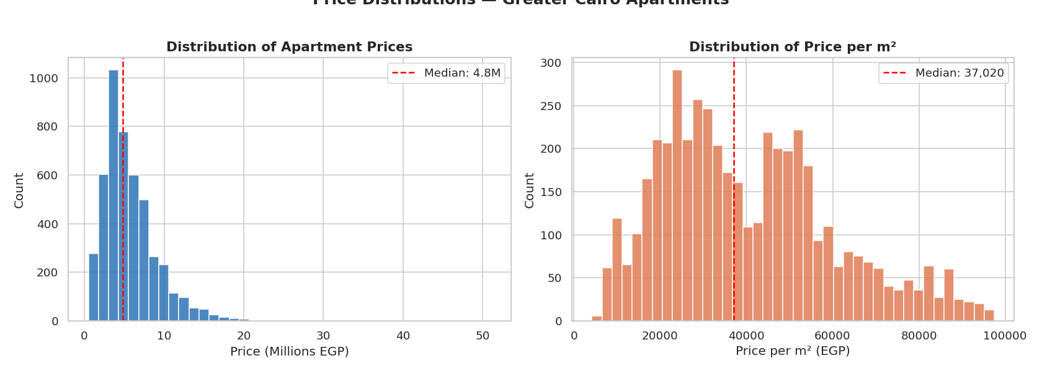
Figure 1: Price distributions show most properties are below 10M EGP, indicating a right-skewed market.
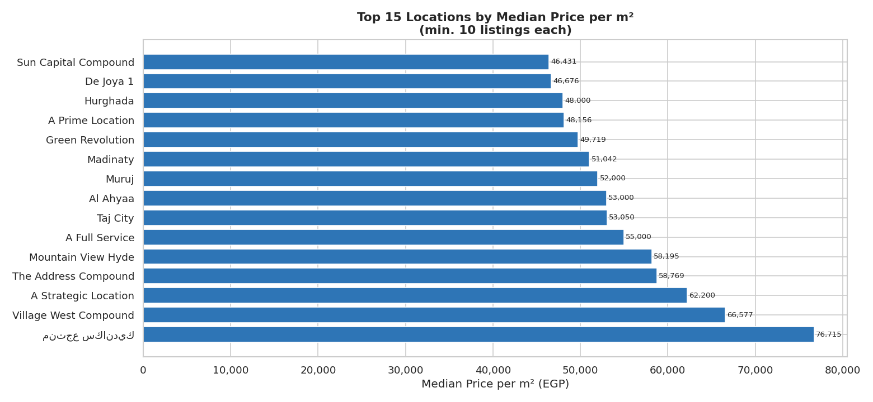
Figure 2: Location strongly affects price per m², with premium compounds significantly higher.
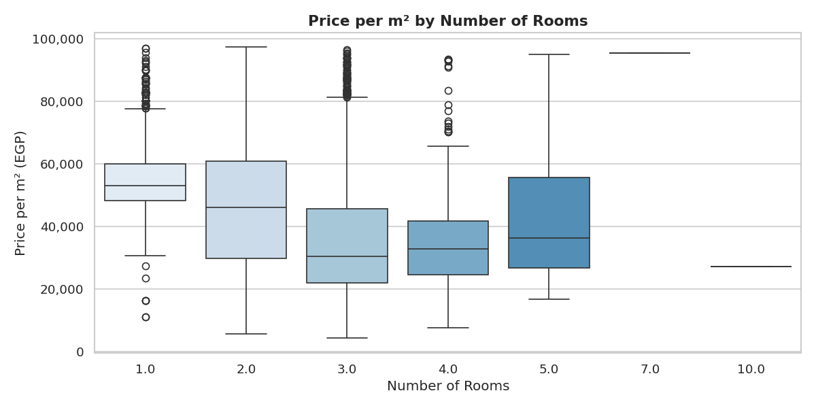
Figure 3: More rooms generally reduce price per m², indicating economies of scale.
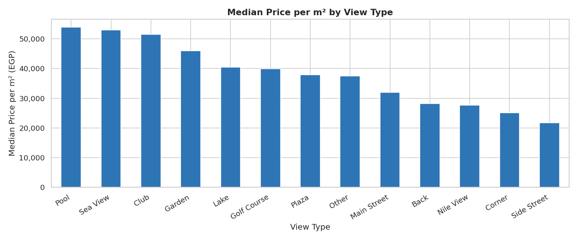
Figure 4: Premium views increase price per m² significantly.
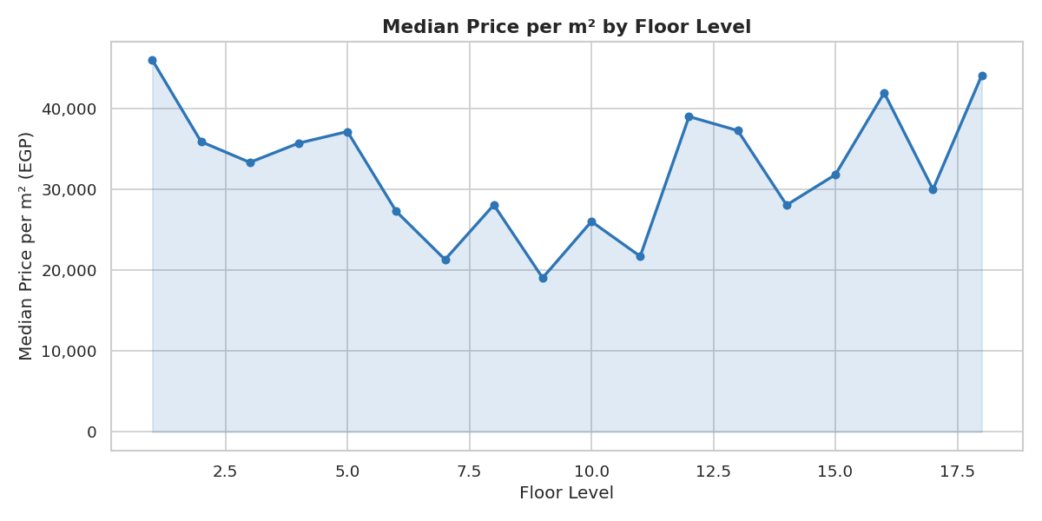
Figure 5: Floor level impacts pricing, with certain levels more desirable.
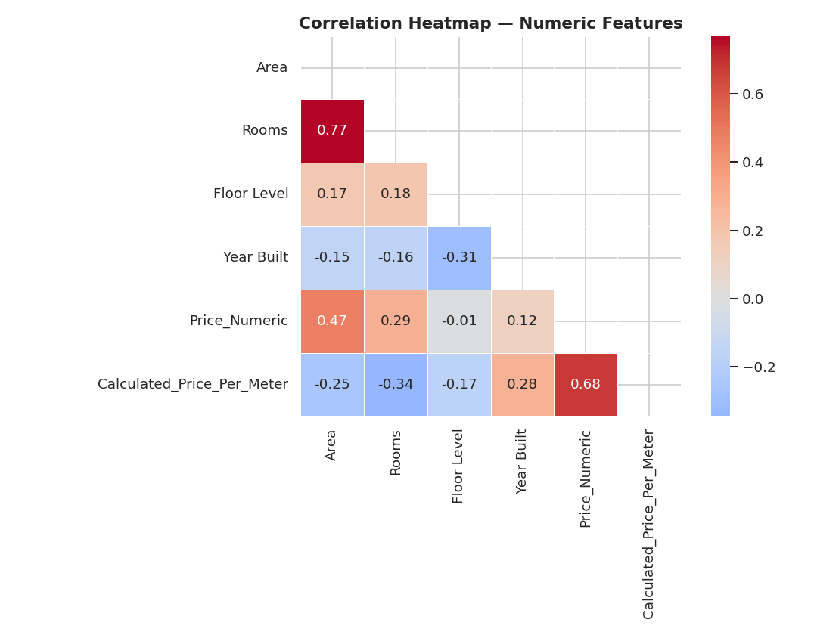
Figure 6: Strong correlation between area and rooms, and negative relation with price per m².
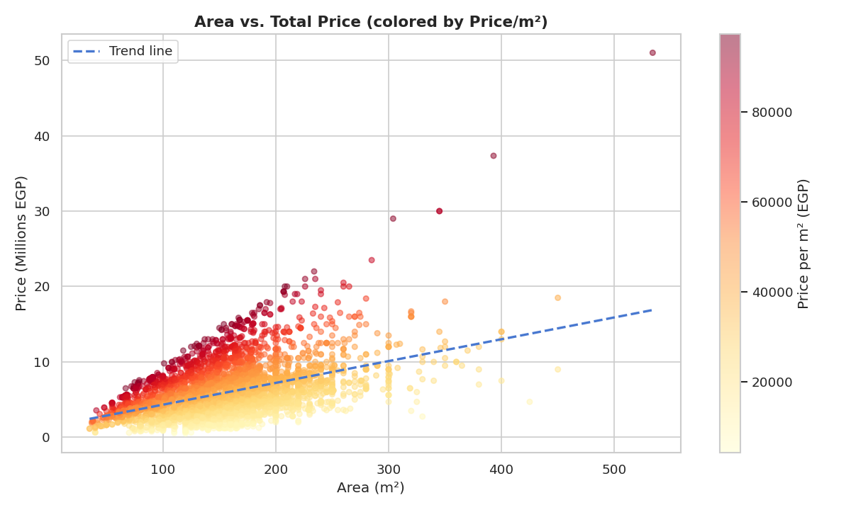
Figure 7: Larger apartments have higher total price but not necessarily higher price per m².

Hypothesis Testing Steps
Step 1: Define H0 and H1.
Step 2: Choose significance level α = 0.05.
Step 3: Perform ANOVA and T-tests.
Step 4: Compare p-values and reject H0 (all p-values < 0.05).
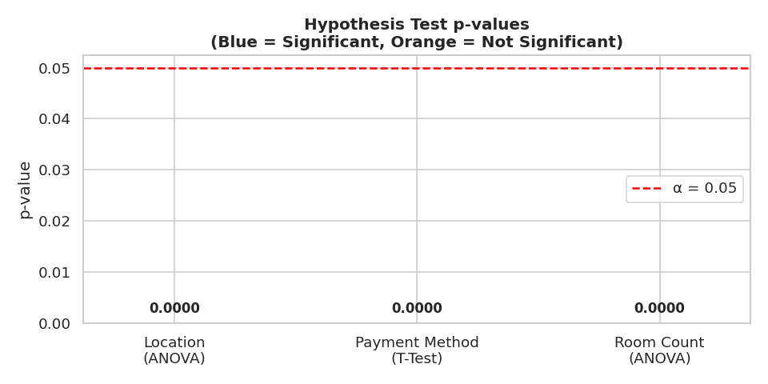
Figure 8: All tests are significant, confirming strong relationships.

Regression Model
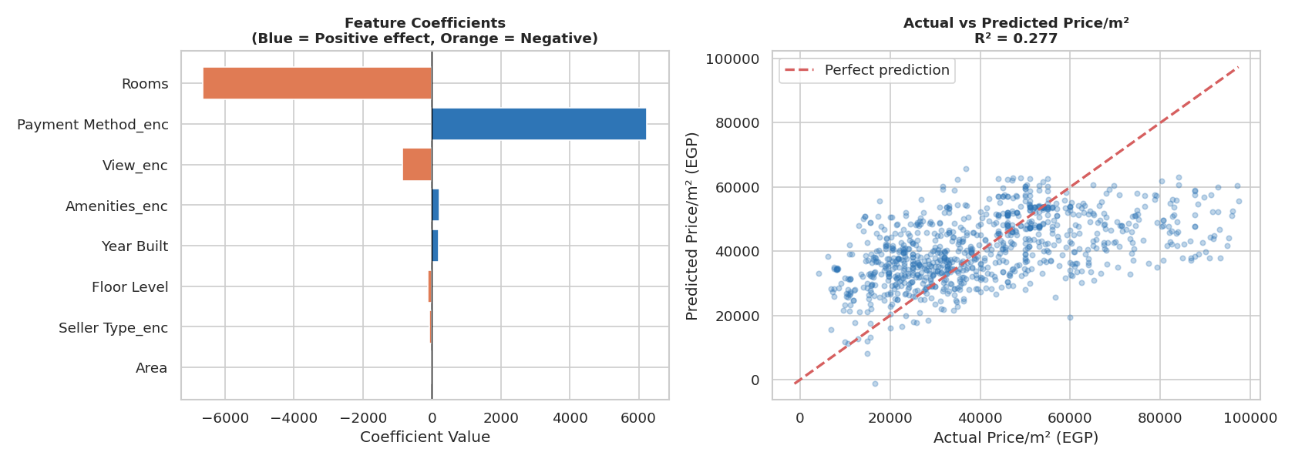
Figure 9: Model shows moderate prediction power (R² = 0.277).

Segmentation
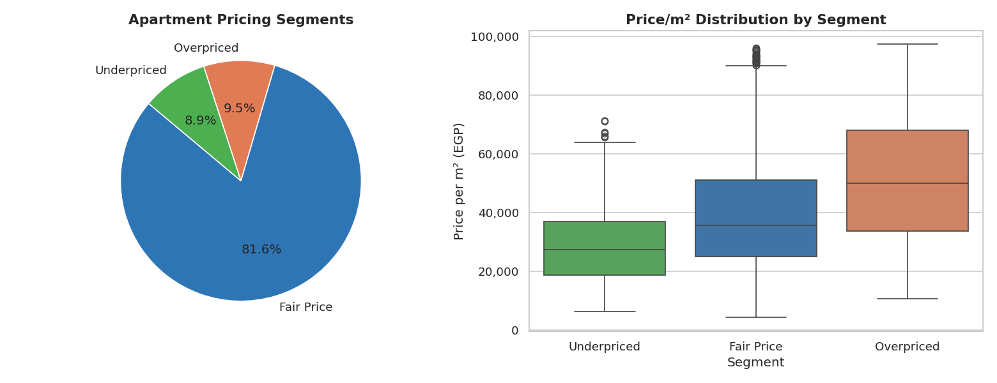
Figure 10: Majority are fairly priced, but overpriced and underpriced units exist.

Conclusion
The hypothesis testing results reject the null hypothesis, proving that apartment features significantly influence price per square meter. This indicates that real estate pricing is structured and predictable, especially driven by location.

Any Potential Issues
Limitations include lack of economic factors and moderate model accuracy. Dataset bias toward premium listings may affect generalization.

