Deep and Transfer Learning-based Research Article Recommendation System for Healthcare Services

Chinmay Trivedi

Department of Computer Science and Engineering, Institute of Technology,

Nirma University

Ahmedabad, India

21bce041@nirmauni.ac.in

Riya Kakkar

Department of Computer Science and Engineering, Institute of Technology,

Nirma University

Ahmedabad, India

21ftphde56@nirmauni.ac.in

Fenil Ramoliya

Department of Computer Science and Engineering, Institute of Technology,

Nirma University

Ahmedabad, India

21bce244@nirmauni.ac.in

Sudeep Tanwar

Department of Computer Science and Engineering, Institute of Technology,

Nirma University

Ahmedabad, India

sudeep.tanwar@nirmauni.ac.in

Rajesh Gupta

Department of Computer Science and Engineering, Institute of Technology,

Nirma University

Ahmedabad, India

rajesh.gupta@nirmauni.ac.in,

Smita Agrawal

Department of Computer Science and Engineering, Institute of Technology,

Nirma University

Ahmedabad, India

smita.agrawal@nirmauni.ac.in

*Abstract*—— To address the growing volume of confidential biomedical data in the healthcare sector, we propose an inventive Deep Learning (DL) approach for suggesting relevant articles, tailored specifically for the healthcare field. The proposed approach addresses the challenge of information curation by presenting a personalized assistant that aids both patients and medical professionals in navigating the extensive scholarly landscape. In situations where individuals face limitations in accessing healthcare services, such as remote or restricted circumstances, our approach demonstrates significant value in providing direct medical consultation. By acquiring insights into symptoms and potential diseases through medical articles, it provides a foundation for informed decision making. It harnesses advanced pre-trained models including Bidirectional Encoder Representations from Transformers (BERT), Robustly Optimized BERT Pretraining Approach (RoBERTa), and eXtreme Learning Machine Network (XLNet). These models undergo rigorous training using diverse medical article datasets, extracting nuanced semantics through tokenization, embeddings, self-attention mechanisms, and transformations. The system’s reliability is enhanced by conducting a thorough assessment of optimizers, including Root Mean Square Propagation (RMSprop), AdamW, and Stochastic Gradient Descent (SGD). Finally, the proposed approach is evaluated against various matrices such as accuracy and loss curves, F1, recall, and precision comparison.

Keywords— Transfer Learning, Healthcare, AI driven Recommendations, BERT, RoBERTa, XLNet

# Introduction

The landscape of healthcare information and resources has undergone a profound metamorphosis, driven by rapid technological advancements and the ubiquity of digital platforms. Yet, this progress has brought forth a formidable challenge – an overwhelming influx of biomedical literature. The exponential increase in the number of academic articles has further complicated the processes of manual curation and interpretation. In situations where traditional or remote medical consultations are impractical, there is a growing demand for an innovative solution that adeptly navigates this deluge of information. This approach is crucial in providing essential assistance to both patients and healthcare practitioners. Underlining the magnitude of this challenge, a recent report from [1] underscores a striking 21% surge in global scientific publication output between 2015 and 2019, intensifying the urgency for a sophisticated digital assistant. Recent data derived from Global Health Observatory [2] brings to light the extensive impact of the digital transformation in healthcare, with more than 85% of patients actively seeking health-related information online.

The imperative for personalized article recommendation based on user-provided symptoms arises from the convergence of patient-centric principles and advancements in Artificial Intelligence (AI). Within the patient context, this paradigm shift underscores a distinct patient-oriented approach, facilitated by an empowerment mechanism enabling individuals to contribute their symptoms and preferences. This process leads to tailored article recommendations seamlessly aligned with their unique medical attributes. Grounded in AI methodologies, this approach effectively navigates complex semantic nuances, leading to a meticulously crafted informational environment customised to the unique medical journey of each individual. This synthesis of patient autonomy and technological sophistication reflects the evolving dynamics of contemporary healthcare paradigms, ultimately fostering enlightened decision-making and advancing precision healthcare delivery.

Hence, within the ambit of this approach, a multitude of scholars have embarked upon a spectrum of noteworthy methodologies for medical article recommendations. To illustrate, Rahman et al. [3] proffered a technique that engenders chronological learning. Chen et al. [4] devised LitMC-BERT, a transformer-grounded approach for the multi label classification of biomedical literature, vividly manifested in its application for curating COVID-19 literature. Then, Fodeh et al. [5] advocated harnessing PubMed for the anticipation of protein molecular functions via an NMF driven multi-label classification mechanism. Lagopoulos et al. [6] unveiled a modality-multi-label classification method within the precincts of biomedical figure analysis. Further, Sood et al. [7] conducted a comparative dissection of AI driven recommendation systems employing healthcare datasets. Then, Mohammadi et al. [8] architected a context-specific recommendation paradigm to prognosticate related articles within PubMed. Later, Guo et al. [9] ushered in MDMaaS, a service dispensing AI-pioneered medical-assisted diagnostic models with an overarching emphasis on trustworthiness. Furthermore, the authors of [10] propounded an intelligent CNN-RNN fused methodology for the prescriptive pre diagnoses domain within the realm of online medical support. The authors in [11] showcased a privacy-mindful optimization framework for neighborhood-centric medical-guided diagnosis and treatment recommendations. Later, Wenbin et al. [12] introduced content-amplified collaborative filtering to augment medical article recommendations. Then, Sun et al. [13] delineated a strategic amalgamation that synergizes content analysis and network connections for the purview of suggesting scientific articles in the domain of social computing.

However, despite the notable advancements and promising potentials, this genre of recommendation systems does not elude certain limitations. One critical aspect pertains to the accuracy and specificity of symptom-based input, as userprovided data might lack precision or fail to encapsulate the full spectrum of medical conditions. Furthermore, the reliance on existing medical literature could introduce biases, leading to recommendations that may not encompass the entirety of emerging or diverse medical research. The careful consideration of the scalability and adaptability of the aforementioned systems is warranted in order to accommodate the rapid evolution of the medical landscape.

To overcome this formidable challenge, we have devised a groundbreaking methodology that amalgamates Transfer Learning (TL) and Deep Learning (DL), thereby charting an uncharted path to revolutionize the medical information retrieval and recommendation landscape. Our approach draws upon the pivotal symptom-driven discovery phase and leverages the innate semantic prowess of advanced pre-trained models such as Bidirectional Encoder Representations from Transformers (BERT) [14], A Robustly Optimized BERT Pretraining Approach (RoBERTa) [15], and eXtreme Learning Machine Network (XLNet) [16]. Through a careful integration of embedding techniques and multi-head attention mechanisms, we propose a transformative paradigm that introduces a new era characterised by personalised medical article recommendations. This innovative orchestration streamlines the intricate process of article curation, offering users and healthcare professionals a powerful instrument for making informed decisions in situations where remote or in-person consulting is not possible.

## Research Contributions

This paper presents key contributions for the healthcare information retrieval and recommendation using DL-driven TL technique.

* We introduce an innovative approach that redefines the way medical knowledge is accessed and applied, harnessing TL to establish links between patient symptoms and medical articles
* The proposed approach introduces a novel DL-based technique that takes user symptoms as input, refines the inputs using DL-driven recommendations and ultimately provides suggested articles
* The proposed DL-based medical article recommendation model involves evaluating various constraints. These parameters encompass accuracy and loss curves, as well as the construction of a confusion matrix for multilabel classification. Moreover, a thorough comparison is conducted across metrics such as F1 score, recall, and precision.

## Organization of the Paper

The rest of the paper is organized as follows. Section II discusses the system model and problem formulation of the proposed approach and Section III highlights the elaborated proposed approach. Next, Section IV presents the performance evaluation of the proposed approach. Finally, the paper is concluded with future work in Section V.

# System model and problem formulation

This section delves into the system model and problem formulation of the proposed approach.

## System Model

In this approach, we present an innovative methodology that combines TL and DL techniques to significantly transform the field of medical information retrieval and recommendation. The first step requires users or patients to input their current medical symptoms, represented as , we employ sophisticated pre-trained models including BERT, RoBERTa, and XLNet, recognized for their semantic prowess. These symptoms undergo embedding, denoted as via a dedicated embedding layer. These embeddings are subsequently subjected to a sequence of transformer blocks, each endowed with intricate self-attention mechanisms, exemplified by self-attention weight matrices for the l-th block. Multi-head attention consolidates the enriched embeddings into feature representations , which collectively inform the final hidden representations . These culminate in a sigmoid classifier, which, operating over a defined set of medical article labels facilitates efficient, personalized article recommendation.

The proposed approach, extensively evaluated on diverse medical datasets , demonstrates the adeptness of TL in bridging the gap between symptom representations and relevant medical articles. By seamlessly automating the process of article selection based on symptoms, our approach not only alleviates manual retrieval burdens but also endows medical practitioners with a potent tool for informed decision-making, heralding a new era in personalized medical information dissemination. This innovation marks the beginning of a significant period in precision healthcare, where the use of DL-based models enhances informed decision-making. This catalyses a mutually beneficial relationship between technology and healthcare.

## Problem Formulation

In the rapidly evolving landscape of healthcare, a complex challenge emerges at the intersection of information abundance and clinical decision-making. The exponential growth of biomedical literature necessitates an effective solution for navigating this vast sea of medical knowledge. In this context, we focus on the pivotal role of the user or patient . As users present a range of symptoms, both on-body and off-body, these manifestations are collectively represented as for analysis as shown in Eq. 1.

(1)

Each symptom in this ensemble carries nuanced semantics, leading to the creation of a symbolic representation through the function as shown in Eq. 2.

(2)

The symbolic encodings, denoted as , traverse a complex process of feature extraction, which can be represented as . This procedure culminates in the derivation of a feature set, denoted as , designed to encapsulate distinct facets of the input symptoms as seen in Eq. 3.

(3)

Subsequently, these features undergo meticulous numerical encoding, leading to the emergence of through a complex interplay of numerical operations as shown in Eq. 4.

(4)

This transformation serves as a bridge between the symbolic and numerical dimensions, setting the stage for further mathematical manipulations. In the subsequent phase, the primary emphasis transitions to BERT, a robust transformer-based architecture that has exhibited exceptional performance in comparison to other utilised architectures. BERT performs the transformation of the numerical symptom representation into embeddings through a tokenization process as shown in Eq. 5.

(5)

BERT employs multi-layered self-attention mechanisms, layer normalization, and dynamic feed-forward networks to collaboratively enhance the semantic understanding of symptoms. At the core of this collaboration lies the self-attention mechanism, calculating intricate attention weights to capture the nuanced interactions between tokens and at layer . Here, represents the query vector for token , while signifies the key vector for token and is the dimension of the key vectors. It serves as a normalization factor that ensures the attention weights are scaled appropriately to facilitate effective information retrieval and representation as seen in Eq. 6.

(6)

The RMSprop regularization algorithm takes the lead in harmonizing the refinement of BERT's parameters. Through an iterative optimization process, RMSprop orchestrates a series of updates that involve key elements such as , , and other vital components. As we delve deeper into the architectural intricacies, a crucial role is played by the sigmoid function classifier. This component assesses the relevance of article labels by utilizing the final hidden representations as seen in Eq. 7.

(7)

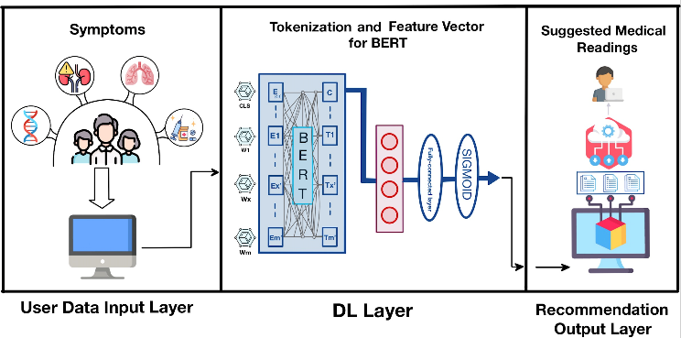The culmination of the model's performance spans a diverse spectrum of medical datasets , undergoing rigorous evaluation that effectively aligns symptom semantics with valuable medical insights. The systematic orchestration within this layer adeptly navigates the landscape of medical knowledge, guiding the selection of a curated collection of articles that are most relevant to the provided symptoms. Hence, by means of this rigorous problem formulation, a resilient approach to a medical article recommendation system is established, firmly grounded in the fundamental concept of .

# The Proposed Approach

Fig. 1 illustrates the proposed approach, encompassing three layers, i.e., user data input layer, DL layer, and the recommendation output layer. The aforementioned layers work together to enhance the effectiveness and precision of a medical article recommendation system, which is customised to cater to the specific requirements of individual users.

## User Data Input Layer

The initial layer of the proposed approach serves as the crucial entry point, where the model interacts with users or patients to gather relevant medical information. This interaction is pivotal in initiating the recommendation process, facilitating a seamless flow of data and insights. Patients provide their current medical symptoms, which are systematically structured and represented as , where each corresponds to a distinct symptom. This ensemble of symptoms forms the foundational unit for the subsequent analytical processes. The interaction between the model and users at this layer is denoted by the function , capturing the essential exchange of data as seen in Eq. 8.

(8)

This user-centric design ensures that the recommendation process is closely aligned with individual needs and medical contexts. By effectively capturing and encoding user-provided symptoms, this layer sets the stage for a cascade of intricate transformations and computations that drive the personalized and contextually relevant medical article recommendations. The establishment made during this phase serves as the fundamental basis for the subsequent layers of DL model processing, effectively incorporating user data into the overarching methodology.

## DL Layer

The data collected from user inputs will be fed into the DL layer for the recommendation task. The DL model is well trained using an extensive dataset of medical articles to ensure optimal performance. We utilized the PubMed multi-label text classification dataset [17] for rigorous model training. Proposed approach utilised a range of pre-trained models, as described in the system model section, implementing the TL techniques. These models were trained using different optimizers such as AdamW, RMSprop, and SGD [18]. Among the combinations tested, BERT with the RMSprop optimizer demonstrated the highest accuracy for the multilabel classification task on both training and testing sets.

Fig. 1: The proposed approach.

The numerical representation of symptoms is tokenized into a sequence, which is then used to extract BERT embeddings . Each is obtained using BERT's embedding lookup table to capture the meaning of the corresponding symptom. These embeddings serve as the basis for further processing. In each layer and between tokens and , calculations are performed using learnable weights and to generate queries and keys from embeddings and , as shown in Eq. 9.

(9)

Attention weights are then calculated using these queries and keys, reflecting the importance of token interactions and contributing to the hidden representation .

(10)

Values are derived through learnable weights and are combined with attention weights to enrich the hidden representation .

, (11)

The utilisation of BERT embeddings in conjunction with self-attention and feed-forward networks contributes to the improvement of understanding medical symptoms. The RMSprop optimisation technique is employed to iteratively update the parameters of BERT, leading to the refinement of these parameters. As a consequence, the resulting embeddings exhibit a high level of effectiveness in capturing subtle nuances related to symptoms. The combination of original embeddings and transformed states is further normalized, producing as seen in Eq. 12.

(12)

**--------------------------------------------------------------------------**

**Algorithm 1:** TL-based Multilabel Classification Algorithmic Flow..

--------------------------------------------------------------------------

Input:

Output:

Initialization: e = 15, b = 128, α = 0.001, =0.9

1. **Procedure** TL_Recomm ()
2. if :
3. End If
4. End Procedure

---------------------------------------------------------------------------------------------

Feed-forward networks continue the transformation process. Transformation is governed by learned weight and bias , leading to the subsequent hidden state .

(13)

The RMSprop optimization technique fine-tunes BERT's parameters. Gradients are accumulated and used for iterative updates, taking into account scaling factor , accumulated squared gradients, and a small constant to prevent division by zero.

(14)

(15)

The integration of BERT embeddings and transformations through self-attention and feed-forward networks enhances the understanding of medical symptoms. RMSprop optimization ensures BERT's parameters are refined, resulting in embeddings that precisely capture nuanced symptom semantics.

## Recommendation Output Layer

The recommendation output layer serves as the culmination of our approach, delivering tailored medical article suggestions based on user-provided symptoms. Expanding upon the intricate transformations and symptom semantics captured in the AI layer, this phase employs a sigmoid classifier to assess the relevance of medical article labels . The relevance estimation process is encapsulated by the Eq. 16.

(16)

Here, represents the final hidden representations obtained from the BERT model. The sigmoid function maps these representations to values between 0 and 1, reflecting the estimated relevance scores of each article label. Subsequently, the most relevant articles are selected for user presentation as seen in Eq. 17.

(17)

In Eq. 17, denotes the set of recommended articles, with each representing a distinct article. The articles with the highest relevance scores, ensuring tailored recommendations aligned with the user's medical context. The recommendation output layer facilitates a transformative healthcare experience by employing sophisticated semantic comprehension and relevance estimation techniques. It empowers both patients and medical professionals with curated insights, facilitating informed decision-making and fostering collaborative healthcare practices. Algorithm 1 represents the entire process of medical article recommendation based on user input. It provides the flow of model training and output provided on dataset.

# PERFORMANCE EVALUATION

The primary objective of this section is to enhance the precision of identifying the appropriate article based on keywords. This will be achieved by evaluating the efficacy of

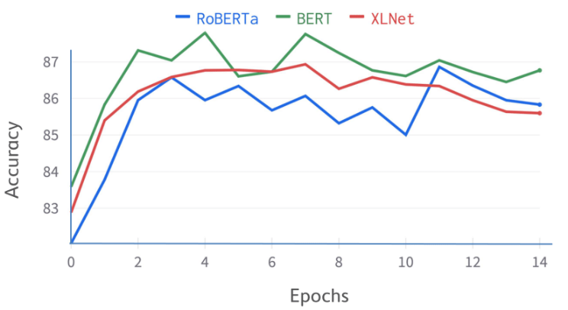

2 (a) Accuracy curve for different pre-trained models.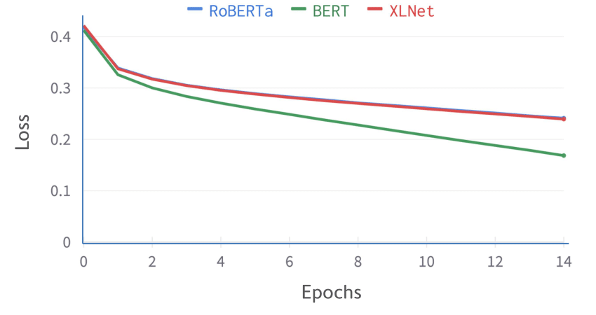

2 (b) Loss curve for different pre-trained models

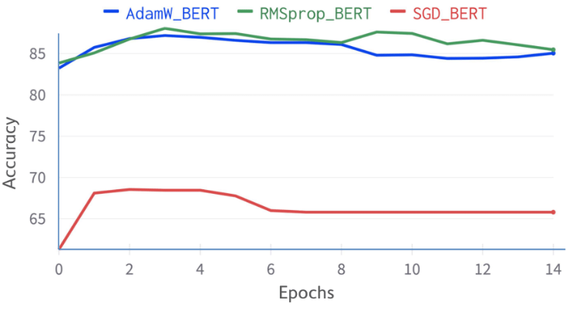

2 (c) Accuracy curve for BERT using different optimizers.

Fig. 2: (a) Accuracy curve for BERT, RoBERTa and XLNet models during the training with AdamW optimizer, (b) Loss curve for BERT, RoBERTa and XLNet models during the training with AdamW optimizer, (c) Accuracy curve for BERT using different optimizers during the training.

various optimizers and loss functions. Choosing the right optimizer holds immense significance, as it significantly influences the effectiveness of the model. For the training purpose we have used the 3 different pre-trained model called, BERT, RoBERTa and XLNet as mentioned above in system model section.

Ensuring the adherence to a consistent experimental approach enhances the reliability of this study. The integrity of the results is maintained throughout the process by maintaining the integrity of the training and testing datasets. All optimizers begin their training with starting learning rates of 0.001, decay rates of 0.9, 15 epochs and batch sizes of 128 to guarantee that all peers are on an equal footing. Furthermore, utilizing a single computer system for training efforts reduces the chances of encountering disparities due to differences in hardware or computational conditions. This careful dedication to maintaining uniformity lays the groundwork for an unbiased and comparative examination, leading to the production of the most dependable and precise results.

Analysis of model performance The visual representation of accuracy trends across different pre-trained models is depicted in Fig. 2a. Through the rigorous training process, BERT outshone its counterparts, achieving an impressive peak accuracy of 87.791%. In parallel, RoBERTa and XLNet demonstrated commendable performance, closely trailing with accuracy levels of approximately 86.86% and 86.93%, respectively. The distinct trajectories of loss curves among the employed models are illustrated in Fig. 2b. BERT exhibited an exceptional descent in loss, plummeting to a mere 0.1686 in the latter stages of training. Similarly, RoBERTa and XLNet showcased convergence at loss values of 0.2412 and 0.1686, respectively, underscoring their efficacy in capturing intricate patterns within the data.

Given the increased attention on the impressive precision of BERT, we conducted an extensive analysis to examine the influence of various optimizers on its overall effectiveness. The result is detailed in Fig. 2c. Our used optimizer contains RMSprop, which can adapts the learning rate using past squared gradients, balancing speed and stability. AdamW combines momentum and adaptive rates via past gradients, excelling in convergence. SGD iteratively adjusts parameters to minimize loss, particularly useful for large datasets. Among the optimizer choices, RMSprop emerged triumphant with a pinnacle accuracy of 87.891%, emphasizing the pivotal role of optimization strategies in harnessing model potential. Notably, the utilization of SGD led to relatively lackluster accuracy results, underscoring the nuanced interplay between optimizer selection and achieving superior model outcomes

The comprehensive assessment of classification metrics is presented in Table I. This table provides an extensive overview of precision, recall, and F1 score, each meticulously calculated for all labels encompassed within the dataset. The precision metric offers insights into the accuracy of positive predictions, while recall gauges the model’s ability to capture relevant instances. Additionally, the F1 score harmoniously balances both precision and recall, encapsulating a holistic evaluation of the classification performance. The tabulated data shows how these metrics interact across labels with a wide range of supporting values. This thorough analysis empowers a nuanced understanding of the model’s prowess in discerning and categorizing complex medical data.

The comparison of confusion matrices is presented in Fig.3, illustrating the evaluation of the multi-label classification strategy employed for the BERT-RMSprop configuration. The target labels span a range from A to Z, where each label corresponds to a specific category, comprising a total of 14 distinct labels. The labels are defined as follows: ”A”: Anatomy ”B”: Organisms ”C”: Diseases ”D”: Chemicals and Drugs ”E”: Analytical, Diagnostic and Therapeutic Techniques, and Equipment ”F”: Psychiatry and Psychology ”G”: Phenomena and Processes ”H”: Disciplines and Occupations ”I”: Anthropology, Education, Sociology, and Social Phenomena ”J”: Technology, Industry, and Agriculture ”L”: Information Science ”M”: Named Groups ”N”: Health Care ”Z”: Geographicals.

TABLE I: Classification Performance Metrics

|  |  |  |  |  |
| --- | --- | --- | --- | --- |
| Label | Precision | Recall | F1-Score | Support |
| A | 0.81 | 0.77 | 0.79 | 4609 |
| B | 0.96 | 0.99 | 0.97 | 9250 |
| C | 0.84 | 0.91 | 0.88 | 5206 |
| D | 0.92 | 0.92 | 0.92 | 6259 |
| E | 0.82 | 0.92 | 0.87 | 7778 |
| F | 0.78 | 0.78 | 0.78 | 1767 |
| G | 0.86 | 0.84 | 0.85 | 6799 |
| H | 0.56 | 0.21 | 0.31 | 1221 |
| I | 0.65 | 0.66 | 0.65 | 1068 |
| J | 0.69 | 0.60 | 0.64 | 1110 |
| L | 0.68 | 0.50 | 0.58 | 1491 |
| M | 0.87 | 0.90 | 0.88 | 4232 |
| N | 0.77 | 0.82 | 0.80 | 4602 |
| Z | 0.70 | 0.74 | 0.72 | 1558 |

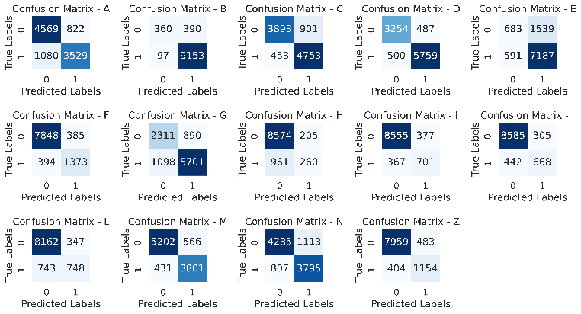

Fig. 3: Confusion matrix for BERT-RMSprop combination model for all the applied classes.

# CONCLUSION

In the digital transformation era, the convergence of DL and healthcare offers revolutionary potential for information access and decision-making. The proposed approach introduces a DL-driven article recommendation approach, propelled by TL, to navigate complex medical literature. By integrating user-provided symptoms with pre-trained models, the system enhances accessibility to pertinent medical articles for patients and professionals. The proposed approach relies on user input, DL processing, and personalised recommendations. The DL layer, rigorously trained, captures symptom essence and article semantics, yielding informative BERT embeddings for relevance assessment. Acting as a bridge between symptom representation and medical expertise, the recommendation layer empowers users and practitioners. This DL integration, fostering informed decisions and tailored resources, holds the promise of reshaping medical knowledge utilization. The performance evaluation for the proposed approach is analyzed considering various parameters such as accuracy and loss curve, F1, recall, and precision comparison. Future work entails enhancing symptom representation, integrating more deeply with health records, and expanding contextual dimensions for personalized recommendations. The convergence of DL and healthcare offers vast opportunities to optimize patient outcomes and reshape medical practices.

# REFERENCES

[1] S. Schneegans, T. Straza, and J. Lewis, “Unesco science report: The race against time for smarter development,” 2021.

[2] WHO, “The global health observatory.”

[3] S. Rahman, K. H. Emad, S. Azad, M. Mahmud, and M. S. Kaiser, “An article recommendation technique from a multi-layer reference article graph for facilitating chronological learning,” in 2022 4th International Conference on Sustainable Technologies for Industry 4.0 (STI), pp. 1–6, 2022.

[4] Q. Chen, J. Du, A. Allot, and Z. Lu, “Litmc-bert: Transformer-based multilabel classification of biomedical literature with an application on covid-19 literature curation,” IEEE/ACM Transactions on Computational Biology and Bioinformatics, vol. 19, no. 5, pp. 2584–2595, 2022.

[5] S. Fodeh, A. Tiwari, and H. Yu, “Exploiting pubmed for protein molecular function prediction via nmf based multi-label classification,” in 2017 IEEE International Conference on Data Mining Workshops (ICDMW), pp. 446– 451, 2017.

[6] A. Lagopoulos, A. Fachantidis, and G. Tsoumakas, “Multi-label modality classification for figures in biomedical literature,” in 2017 IEEE 30th International Symposium on Computer-Based Medical Systems (CBMS), pp. 79–84, 2017.

[7] G. Sood and N. Raheja, “Performance comparison of artificial intelligencebased recommendation systems based on healthcare dataset,” in 2022 International Conference on Futuristic Technologies (INCOFT), pp. 1–6, 2022.

[8] S. Mohammadi, S. Kylasa, G. Kollias, and A. Grama, “Context-specific recommendation system for predicting similar pubmed articles,” in 2016 IEEE 16th International Conference on Data Mining Workshops (ICDMW), pp. 1007–1014, 2016.

[9] K. Guo, S. Ren, M. Z. A. Bhuiyan, T. Li, D. Liu, Z. Liang, and X. Chen, “Mdmaas: Medical-assisted diagnosis model as a service with artificial intelligence and trust,” IEEE Transactions on Industrial Informatics, vol. 16, no. 3, pp. 2102–2114, 2020.

[10] X. Zhou, Y. Li, and W. Liang, “Cnn-rnn based intelligent recommendation for online medical pre-diagnosis support,” IEEE/ACM Transactions on Computational Biology and Bioinformatics, vol. 18, no. 3, pp. 912–921, 2021.

[11] M. Zhang, Y. Chen, and J. Lin, “A privacy-preserving optimization of neighborhood-based recommendation for medical-aided diagnosis and treatment,” IEEE Internet of Things Journal, vol. 8, no. 13, pp. 10830– 10842, 2021.

[12] W. Zhang and J. Wang, “Content-bootstrapped collaborative filtering for medical article recommendations,” in 2018 IEEE International Conference on Bioinformatics and Biomedicine (BIBM), pp. 1184–1188, 2018.

[13] J. Sun, J. Ma, Z. Liu, and Y. Miao, “Leveraging content and connections for scientific article recommendation in social computing contexts,” The Computer Journal, vol. 57, no. 9, pp. 1331–1342, 2014.

[14] J. Devlin, M. Chang, K. Lee, and K. Toutanova, “BERT: pre-training of deep bidirectional transformers for language understanding,” CoRR, vol. abs/1810.04805, 2018.

[15] Y. Liu, M. Ott, N. Goyal, J. Du, M. Joshi, D. Chen, O. Levy, M. Lewis, L. Zettlemoyer, and V. Stoyanov, “Roberta: A robustly optimized bert pretraining approach,” 2019.

[16] Z. Yang, Z. Dai, Y. Yang, J. Carbonell, R. Salakhutdinov, and Q. V. Le, “Xlnet: Generalized autoregressive pretraining for language understanding,” 2020.

[17] O. Khan, “Pubmed multilabel text classification,” 2022.