Week 1: Data Cleaning and Pre-processing
A reproducible quality assessment of public short-term-rental listing data
Senior Data Analytics Engineer Internship | Prepared 20 October 2026

Executive summary
The supplied extract contains 500 records and 90 columns. The workflow profiles missingness, standardizes blanks and types, checks duplicate rows and listing IDs, validates selected domains, constructs a consistent nightly price field, and flags statistical price outliers without automatically deleting them. The cleaned file is saved as listings_cleaned.csv.

1. Objective and scope
The objective is to convert a raw listing extract into an analysis-ready table while retaining traceability. Cleaning choices are explicit: invalid values are treated as missing when a safe correction is not justified; statistical outliers are flagged for review rather than silently removed; and nonessential descriptive fields are not deleted merely because they contain missing values.

2. Dataset and limitations
Item | Observed value
Input file | listings.csv.gz (user-supplied)
Initial rows | 500
Initial columns | 90
Exact duplicate rows detected | 0
Rows removed as exact duplicates | 0
Additional repeated listing IDs removed | 0
Final rows / columns | 500 / 94
Price target coverage | 467 rows with positive numeric nightly price
Important scope note: the uploaded file contains 500 rows, despite being a compressed listings extract. It should be treated as a limited sample/extract unless its provenance confirms otherwise. Findings should not be generalized to all listings without a larger representative download.

3. Cleaning methodology

3.1 Structural profiling
Inspected dimensions, columns, data types, missingness, duplicate rows, and the meaning of price-related fields before transformation.

3.2 Blank and type normalization
Whitespace-only strings were converted to missing values. Date fields were parsed with invalid dates coerced to missing. Numeric fields were converted safely so nonnumeric strings did not silently remain in numeric analyses.

3.3 Boolean standardization
Common t/f, true/false, and yes/no encodings in selected host/listing flags were mapped to Boolean values.

3.4 Duplicate handling
Exact duplicate rows were removed first. Listing IDs were then checked separately and repeated IDs were reduced to one record, keeping the first occurrence. In production, conflicting duplicate records should be resolved using scrape timestamp and a documented survivorship rule.

3.5 Domain validation
Latitude/longitude were checked against legal coordinate ranges. Negative capacity, bed/bathroom counts, stay lengths, availability counts, review counts, and host listing counts were set to missing rather than assumed to be valid.

3.6 Price normalization and outliers
A canonical price_per_night_usd field was created using the quoted nightly price when available and parsed listing price as fallback. Non-positive prices were invalidated. The IQR rule was used to flag potential outliers; flagged observations were retained because expensive listings may be genuine.

3.7 Derived fields
A host-tenure-in-years field was derived from host_since and last_scraped where both dates were available. A scrape month field supports temporal grouping.

4. Quality findings
The raw table contains 9,060 missing cells across all columns. Missingness is not uniformly problematic: optional narrative, profile, and review fields may be legitimately absent, while missing price, capacity, or location fields can block specific analyses. The most-missing fields are shown below.
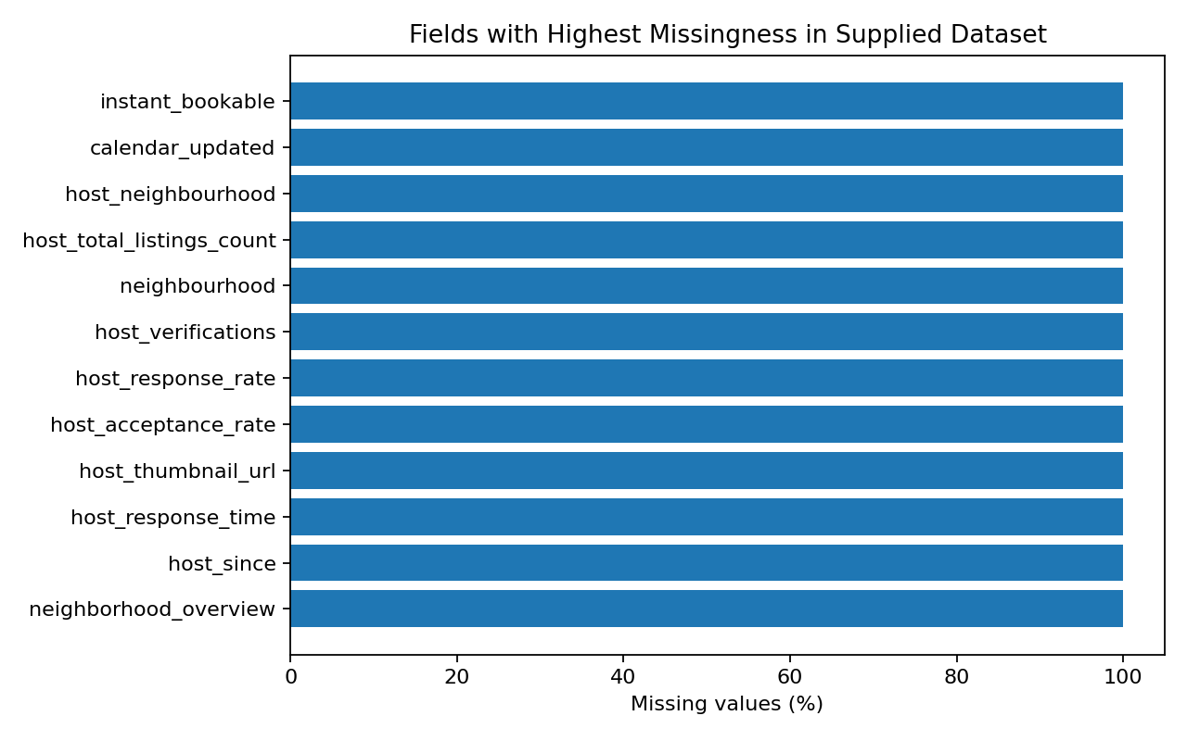
Figure 1. Fields with the highest missingness in the supplied extract.
The canonical nightly price has 467 valid positive observations; its median is $144.00 and mean is $292.59. The IQR screening rule flags 20 observations as potential price outliers. This is a review flag, not proof of error.

5. Why these choices are appropriate
- Preserving raw inputs allows the cleaning process to be audited and rerun.
- Converting impossible values to missing is safer than inventing replacement values.
- Missing-value imputation is deferred to specific modelling pipelines so training data statistics are not leaked into the test set.
- Outlier flags preserve legitimate high-value listings while making distributional risk visible.
- A canonical price variable makes downstream tasks consistent and documents the source precedence.

6. Deliverables and reproducibility
The project package includes the cleaned CSV, analysis scripts, quality summaries, charts, and requirements file. Run the script from the project root after placing the source file at data/listings.csv.gz. The notebook/report should be updated if a new source snapshot is used.

7. Conclusion
The cleaning pipeline creates a more consistent analytical base but does not claim that the extract is complete or free of all quality issues. The next stage should use the cleaned data for EDA, validate sample sizes in group comparisons, and document limitations before modelling or communicating business recommendations.

Submission description (200+ words)
This report documents a reproducible data-quality and preprocessing workflow applied to the supplied Inside Airbnb listings extract. The input contained 500 rows and 90 columns, so the work began with a structural audit of field types, missingness, duplicate records, identifier quality, and the meaning of price-related fields. The analysis standardizes blank text values, parses relevant date fields, converts selected numeric fields safely, normalizes common true/false encodings, and validates important domain constraints such as geographic coordinate ranges, non-negative capacity and review counts, and positive nightly prices. Exact duplicate rows and repeated listing identifiers are checked separately so the effect of each rule can be documented. Potential price outliers are flagged using the interquartile-range rule rather than automatically deleted; high prices can represent real premium properties and should be investigated before removal. A canonical nightly-price variable is created from the quote price when available, with the listing price as a fallback. The report explains the rationale behind each transformation, highlights the limits of the supplied extract, and distinguishes missing data from invalid data. It also records the cleaned output, key quality indicators, and a repeatable implementation that can be rerun on future snapshots. The resulting dataset is intended as a consistent analytical base for the next four weeks: exploratory analysis, predictive modelling, visual storytelling, and a practical data strategy. This is an analytical cleaning exercise rather than a claim that every field is complete or that all unusual observations are erroneous; decisions remain transparent and auditable.

References
Inside Airbnb, Get the Data: https://insideairbnb.com/get-the-data/ (source landing page; dataset extract supplied by the user).
Geographic scope note: the coordinate values in the supplied records are consistent with Albany, New York. The report therefore treats this as an Albany-area extract, not a New York City dataset.

