Week 2: Exploratory Data Analysis
Descriptive analysis of listing prices, room types, neighbourhoods, and listing attributes
Senior Data Analytics Engineer Internship | Prepared 20 October 2026

Executive summary
EDA was conducted on the Week 1 cleaned dataset (500 rows). The analysis emphasizes price distribution, segmentation by room type and neighbourhood, and numeric relationships with nightly price. Price data are skew-sensitive, so medians and sample counts accompany means.

1. Questions explored
- How is nightly price distributed, and how strongly is it affected by high-price observations?
- How do median prices differ across room types?
- Which neighbourhood groups have enough observations for cautious comparison?
- Which numeric listing characteristics are associated with nightly price?
- What data limitations should constrain business conclusions?

2. Analytical approach
The EDA uses descriptive statistics, frequency tables, grouped medians and means, histograms, horizontal/vertical bar charts, and Pearson correlations. The nightly-price histogram is clipped at the 98th percentile for display readability only; underlying records are not clipped in summary statistics. Neighbourhood comparisons require at least five observed prices to reduce the risk of ranking groups represented by one or two records.

3. Overall price distribution
Across 467 valid nightly prices, the mean is $292.59, median is $144.00, and the interquartile range runs from $89.19 to $209.12. The mean-versus-median comparison is a useful first check for skew; it should not be treated as a full distribution description.
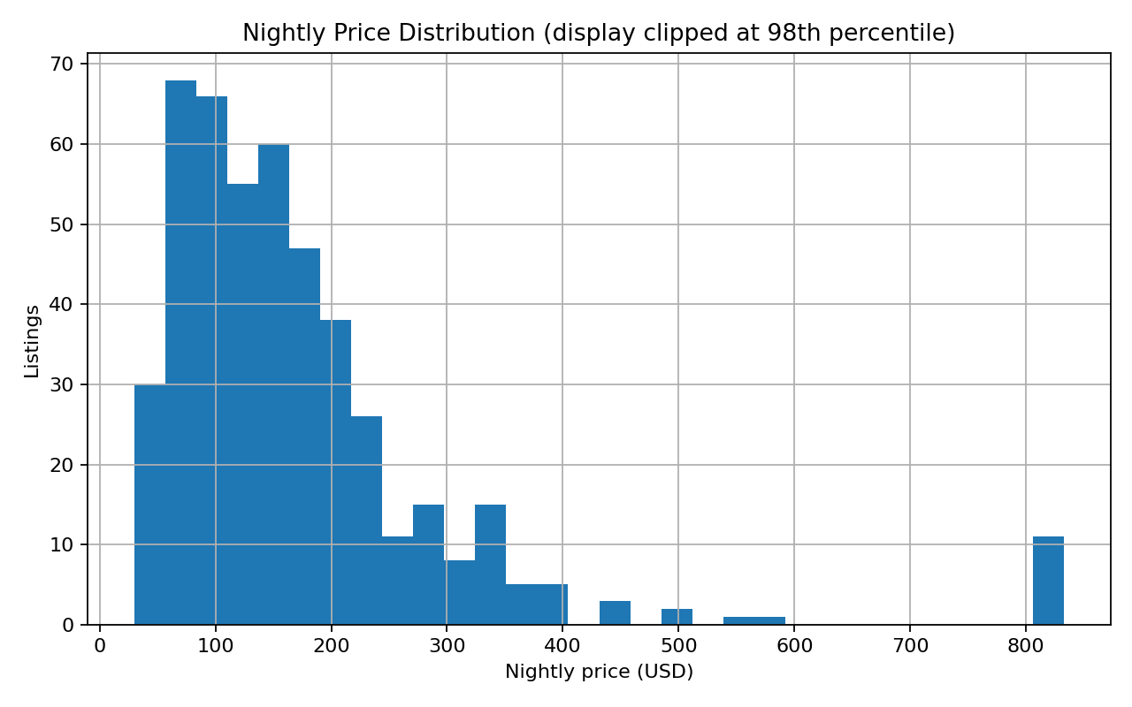
Figure 1. Nightly price distribution; the chart display is clipped at the 98th percentile for readability.

4. Price by room type
Room type | Listings with price | Median nightly price | Mean nightly price
Shared room | 1 | $840.00 | $840.00
Entire home/apt | 332 | $170.00 | $372.78
Private room | 134 | $75.00 | $89.85
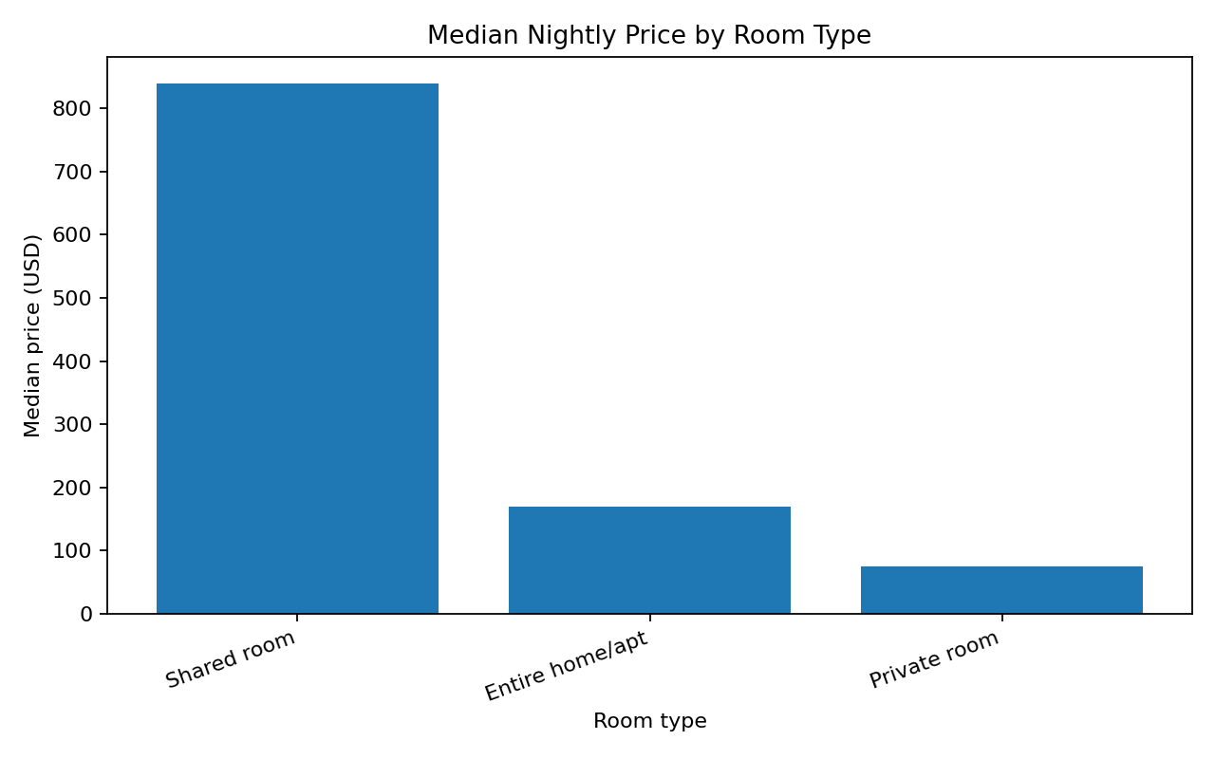
Figure 2. Median nightly price by room type.
Room-type comparisons are useful because an entire home, private room, and shared room provide different products. They should be compared within similar geographies and date conditions before being used as pricing targets.

5. Neighbourhood comparison
Neighbourhood | Listings with price | Median price | Mean price
EIGHTH WARD | 11 | $270.00 | $252.00
FIFTEENTH WARD | 17 | $245.00 | $276.95
FOURTH WARD | 15 | $212.00 | $968.80
SECOND WARD | 42 | $188.25 | $216.90
FIRST WARD | 10 | $187.56 | $221.65
SEVENTH WARD | 14 | $172.00 | $197.55
THIRD WARD | 28 | $160.00 | $153.05
SIXTH WARD | 109 | $155.00 | $578.59
NINTH WARD | 44 | $122.00 | $162.78
THIRTEENTH WARD | 43 | $111.07 | $155.43
TENTH WARD | 49 | $103.00 | $152.13
FOURTEENTH WARD | 33 | $101.67 | $182.24
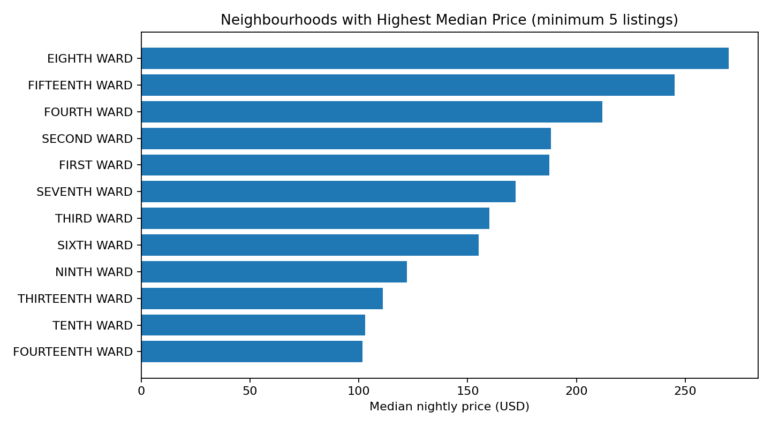
Figure 3. Highest median neighbourhood groups among groups with at least five price observations.
A minimum sample-size rule improves interpretability but does not remove all sampling bias. The supplied 500-row extract may not represent the full market, so neighbourhood rankings are descriptive of this file only.

6. Numeric relationships
Numeric variable | Pearson correlation with nightly price
price_per_night_usd | 1.000
availability_365 | 0.095
accommodates | 0.037
beds | 0.019
review_scores_rating | 0.016
bedrooms | 0.004
number_of_reviews | -0.052
minimum_nights | -0.063
estimated_occupancy_l365d | -0.079
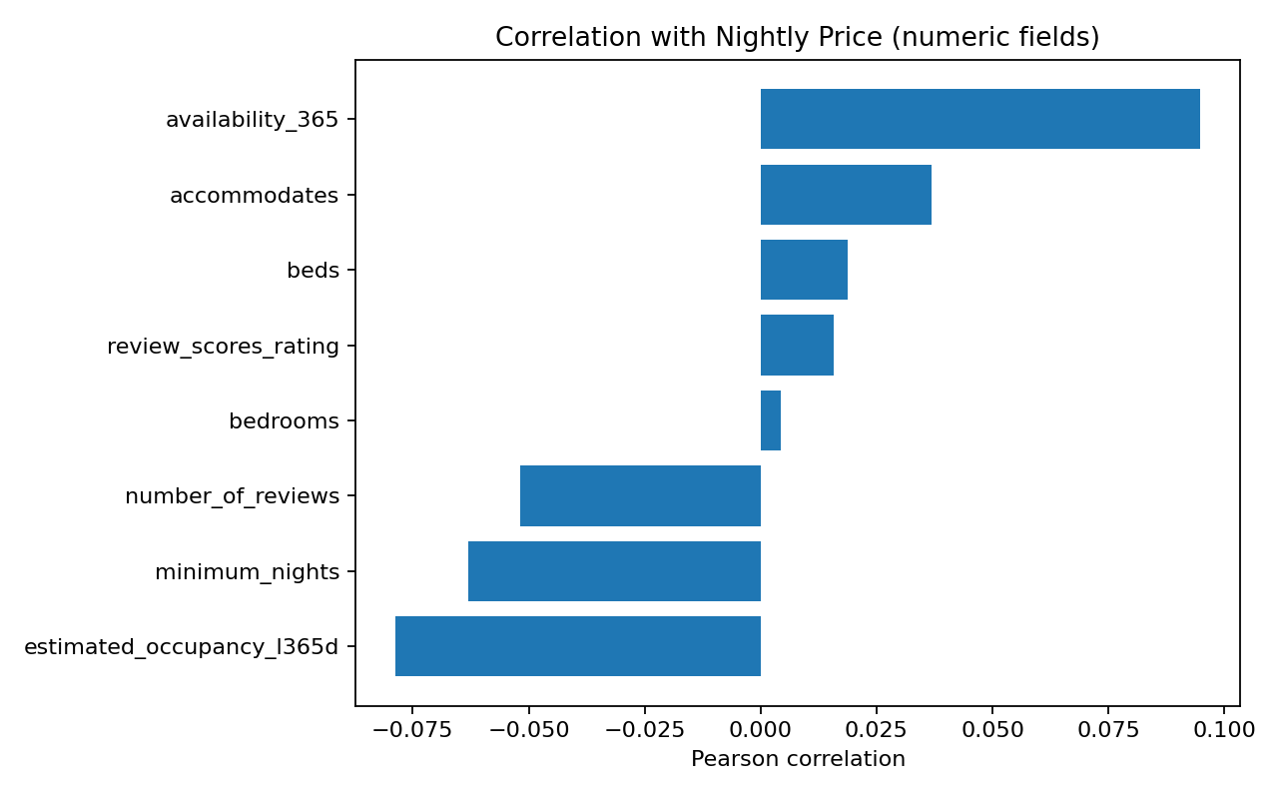
Figure 4. Correlations with nightly price; associations are not causal effects.
Pearson correlation captures linear association and can be influenced by outliers and nonlinear relationships. It should be complemented by segmentation, robust statistics, and model diagnostics.

7. Key interpretations and next actions
- Use room type and neighbourhood as primary segmentation dimensions rather than one market-wide average.
- Show median, sample size, and distribution together when publishing price benchmarks.
- Treat high prices as investigation candidates, not automatic errors.
- Refresh data and monitor missingness before interpreting movement as a market trend.
- Use the EDA to select predictors for Week 3 while excluding direct price fields from the feature matrix.

8. Limitations
This is a cross-sectional snapshot, not a randomized sample or a time-series experiment. Listing prices are not equivalent to realized booking prices or revenue. Some fields may be estimates, and the file's sample coverage is limited. Correlation does not imply causation.

9. Conclusion
EDA provides an evidence-based starting point for price segmentation and modelling. The next stage will evaluate whether listing characteristics improve price estimates beyond a simple median baseline, using a held-out test set and explicit leakage controls.

Submission description (200+ words)
This report presents an exploratory data analysis of the cleaned listing dataset produced in Week 1. It combines descriptive statistics, category comparisons, missingness awareness, distribution analysis, and relationships between listing characteristics and nightly prices. The analysis focuses on questions a short-term-rental analytics team could reasonably ask: how prices vary by room type and neighbourhood, how listing capacity relates to price, how review activity and ratings are distributed, and which data limitations should influence business decisions. Visualizations include a nightly-price distribution with display-only clipping to make the central pattern readable, median price comparisons by room type, neighbourhood comparisons restricted to groups with a minimum sample size, and correlations between price and selected numeric attributes. Summary tables report counts and central tendencies so readers can assess both magnitude and sample support. Correlation is treated as association rather than causation, and small neighbourhood groups are not presented as definitive rankings. The report explicitly notes that the uploaded extract contains 500 rows and may be a limited extract rather than a complete market census; results therefore describe this file, not all listings in Albany, NY or the entire Airbnb marketplace. Findings are translated into cautious business implications, including the need to segment price benchmarks by accommodation type and geography, monitor data freshness, and avoid making policy decisions from simple averages alone. This EDA also informs Week 3 feature selection and Week 4 dashboard design by identifying relevant fields, potential skew, and the importance of transparent filters.

References
Inside Airbnb, Get the Data: https://insideairbnb.com/get-the-data/

