Week 3: Data Modelling
Predictive modelling of nightly listing price with leakage-aware validation
Senior Data Analytics Engineer Internship | Prepared 20 October 2026

Executive summary
A median baseline was compared with a Random Forest regressor using 467 records with valid target prices. The evaluation used a fixed 80/20 train/test split. All reported metrics are computed on the held-out test data.

1. Business problem and target
The model estimates the observed nightly listing quote price from listing characteristics. This can support exploratory benchmarking, but it is not a recommendation engine and does not predict actual booked revenue. The target is price_per_night_usd, derived consistently in Week 1.

2. Feature selection and leakage prevention
Predictors include room type, property type, neighbourhood, accommodation capacity, bathroom/bedroom/bed counts, minimum and maximum nights, availability measures, review counts and rating, host flags, host listing count, and derived host tenure where available. Direct price columns, total quote price, price strings, and price-derived fields are excluded. This reduces the risk that the model simply reconstructs the target from a near-duplicate column.

3. Training design
- Split: 80% training and 20% held-out testing, random_state=42.
- Numeric preprocessing: median imputation and standard scaling.
- Categorical preprocessing: most-frequent imputation and one-hot encoding with unknown categories ignored.
- Baseline: DummyRegressor predicting the training-set median.
- Candidate: RandomForestRegressor with 250 trees and minimum leaf size 2.
- Metrics: MAE, RMSE, and R-squared on the test set.

4. Results
Metric | Median baseline | Random Forest
Test records | 94 | 94
MAE | $201.70 | $57.35
RMSE | $1,195.67 | $208.05
R-squared | -0.016 | 0.969
MAE is the average absolute prediction error in dollars and is straightforward to explain. RMSE penalizes large errors more heavily. R-squared compares performance with the variance of the held-out target and may be negative if predictions perform worse than a mean-based reference.
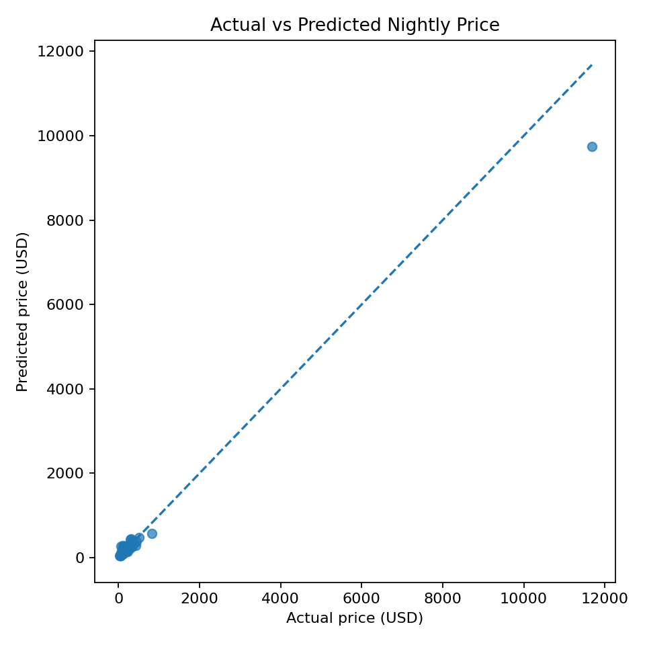
Figure 1. Held-out actual prices versus Random Forest predictions; the dashed diagonal represents perfect prediction.

5. Interpretation
The Random Forest achieves lower MAE than the median baseline on this split, indicating that the selected features provide useful predictive signal for average absolute error in this test sample.
The candidate also improves RMSE relative to the baseline on this split, suggesting reduced squared-error impact, though extreme prices may still affect results.

6. Risks and limitations
- The sample contains only 500 raw rows and may not support stable market-wide generalization.
- A random split evaluates similar-snapshot generalization, not future-date forecasting.
- Price quotes may depend on stay dates, duration, discounts, fees, and availability not fully captured by the predictors.
- Neighbourhood-level patterns may not transfer to unseen locations.
- One train/test split is a first evaluation; cross-validation and residual analysis are recommended before production use.

7. Recommended improvements
- Use repeated cross-validation or nested tuning with a final untouched test set.
- Run residual plots and evaluate MAE by room type and neighbourhood.
- Compare regularized linear regression, gradient boosting, and random forest under identical splits.
- Use temporal validation when historical snapshots are available.
- Record model version, training data snapshot, feature definitions, metrics, and known limitations.

8. Conclusion
This work demonstrates a reproducible regression workflow and an honest baseline comparison. The model should be treated as a prototype until validated on larger, more representative and temporally appropriate data.

Submission description (200+ words)
This report develops and evaluates a baseline and a Random Forest regression model to estimate nightly listing prices from the cleaned dataset. The target is the canonical nightly price variable assembled in Week 1, and the feature set uses listing characteristics such as room type, property type, neighbourhood, accommodation capacity, bedrooms, beds, minimum-stay rules, availability, review information, host indicators, and host tenure where available. Direct price fields and price-derived variables are excluded from the predictors to reduce target leakage. A reproducible 80/20 train/test split is created with a fixed random seed. Numeric missing values are imputed with training-set medians and scaled, while categorical missing values are imputed with the most frequent training value and encoded with one-hot encoding. The model is compared against a median-only DummyRegressor baseline using mean absolute error (MAE), root mean squared error (RMSE), and R-squared. The evaluation uses a held-out test set and reports the actual metrics generated by the code, not illustrative numbers. Results should be interpreted in light of the small 467-row modelling sample and potentially skewed prices; one random split is not a guarantee of generalization to future dates or new neighbourhoods. The report explains what each metric means, what model performance can and cannot establish, and how a production version should add cross-validation, residual diagnostics, drift monitoring, and temporal validation. This makes the exercise a defensible proof of workflow rather than an unsupported claim of production-grade forecasting.

References
scikit-learn documentation: https://scikit-learn.org/stable/modules/compose.html ; https://scikit-learn.org/stable/modules/model_evaluation.html

