Week 4: Data Visualization
A decision-oriented data story for short-term-rental analytics
Senior Data Analytics Engineer Internship | Prepared 20 October 2026

Executive summary
This report turns the Week 1–3 analytical outputs into a visual narrative. Each chart is connected to a question, a cautious interpretation, and a potential business use. The goal is to help a non-technical stakeholder understand patterns without overstating what a small listing extract can prove.

1. Audience and story
Audience: an analytics manager or market strategy lead at a hypothetical short-term-rental advisory organization. Storyline: listing prices vary across product types and locations; prices are skew-sensitive; listing attributes may provide predictive signal, but sample size and snapshot limitations require cautious decisions.

2. Visualization design principles
- Use medians alongside counts for skewed price distributions.
- Use bars for category comparisons and histograms for distributions.
- Apply a minimum sample threshold to neighbourhood comparisons.
- Label units, define the population, and state any display-only transformations.
- Keep association distinct from causation and prediction distinct from realized outcomes.

3. Visual 1 — Price distribution
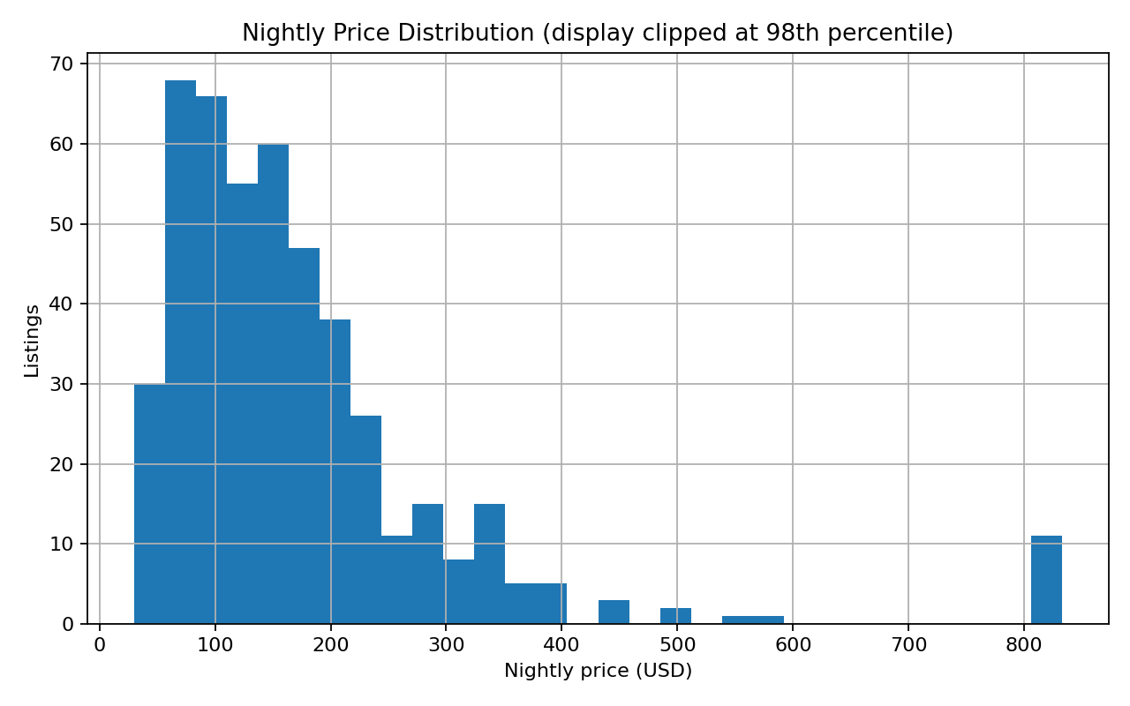
Figure 1. Nightly price distribution with display-only clipping at the 98th percentile.
The price distribution summarizes 467 valid price observations. Display clipping makes the central mass visible while leaving the source data unchanged. The median ($144.00) is a more robust headline benchmark than the mean ($292.59) when high values create skew. Business use: establish a reference point, then segment before making pricing recommendations.

4. Visual 2 — Room-type comparison
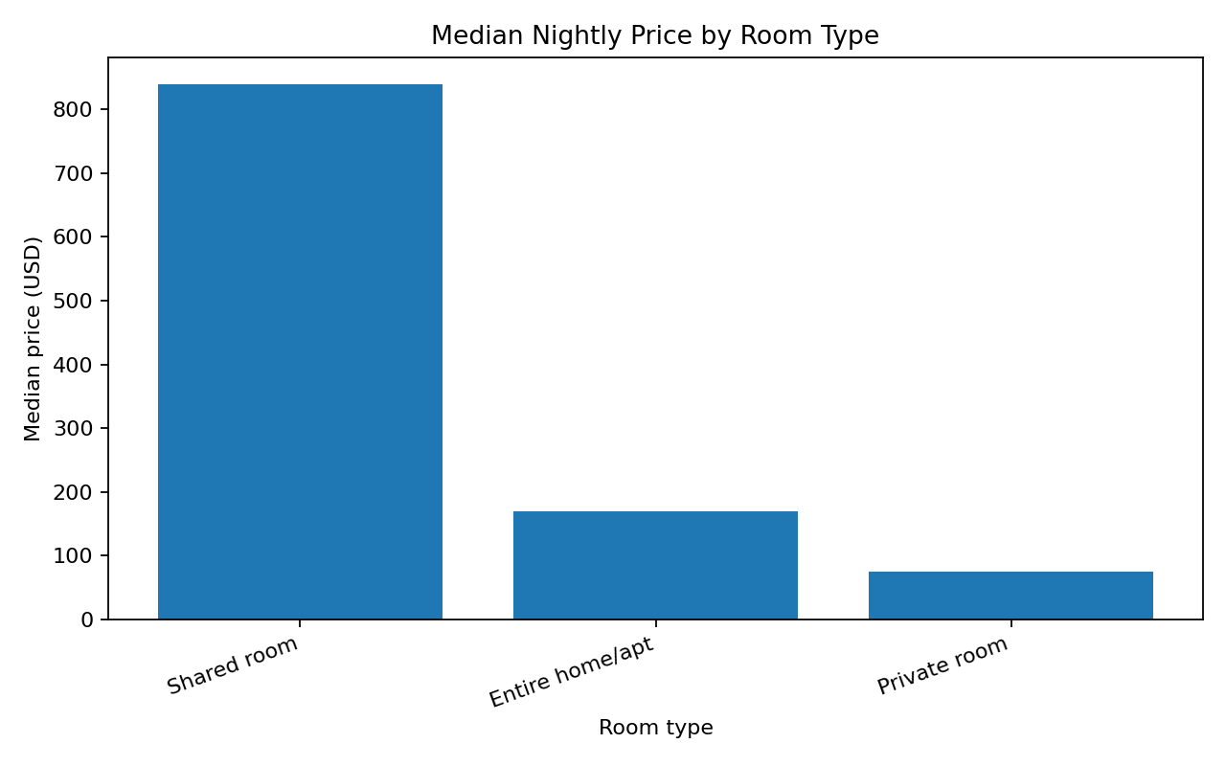
Figure 2. Median nightly price by room type.
Room types represent different customer propositions, so price differences should not be interpreted as quality differences without controlling for capacity, location, and amenities. Business use: compare like-for-like listing segments and avoid applying one benchmark to all accommodation types.

5. Visual 3 — Neighbourhood comparison
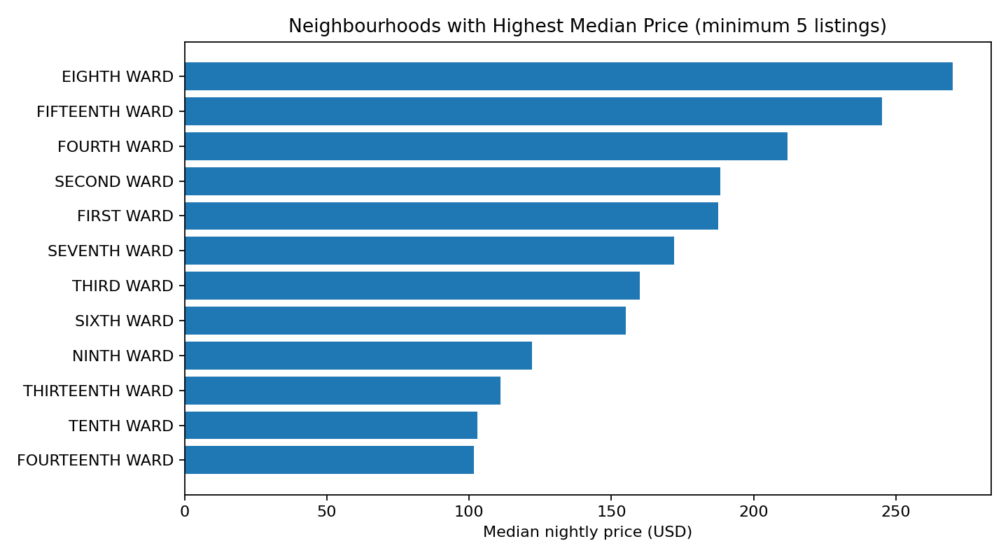
Figure 3. Higher median neighbourhood groups; only groups with at least five observations are included.
Neighbourhood medians show potential geographic variation but remain sensitive to sample coverage. Business use: identify where a deeper market review may be useful, not declare a definitive ranking of all neighbourhoods.

6. Visual 4 — Correlation view
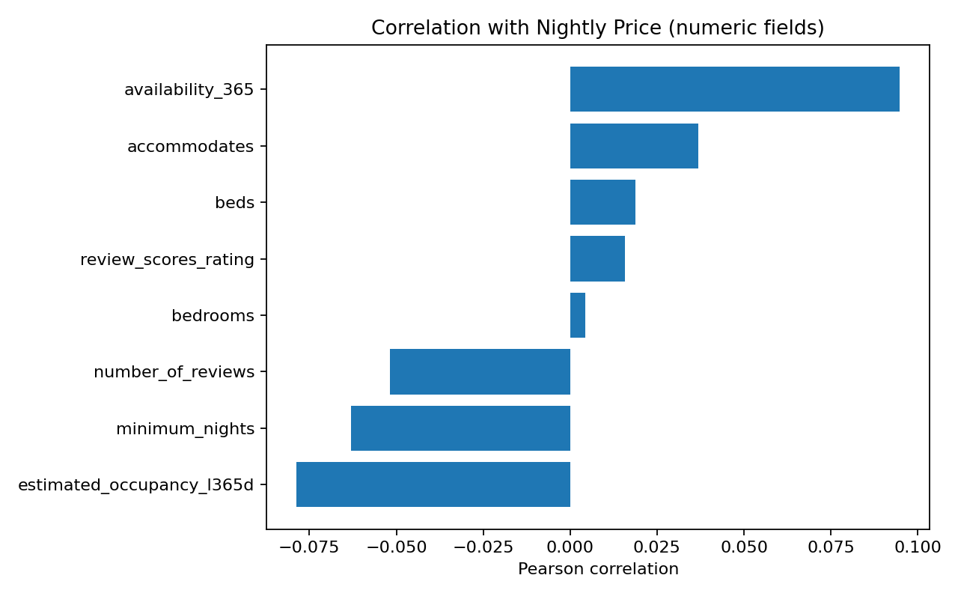
Figure 4. Pearson correlations between nightly price and selected numeric variables.
Correlation is useful for prioritizing questions but does not establish a causal relationship. Capacity variables may be correlated with price because larger listings can accommodate more guests; location, quality, and dates may confound the relationship.

7. Visual 5 — Model diagnostics
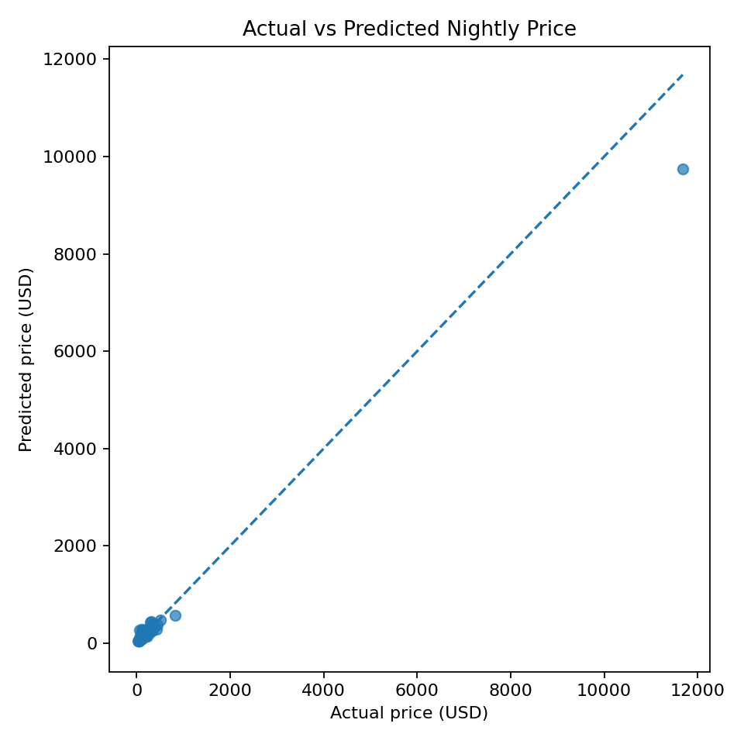
Figure 5. Actual versus predicted price on the held-out test sample.
The candidate model test MAE is $57.35 and R-squared is 0.969. The scatterplot helps identify broad prediction error patterns but should be supplemented by residual plots and subgroup metrics. Business use: communicate the uncertainty of estimates, not present them as exact prices.

8. Recommended dashboard layout
Dashboard section | Recommended contents | Decision supported
Market overview | Valid listings, median price, price coverage, data freshness | Check data health and headline context
Segment explorer | Room type, property type, neighbourhood filters; medians and counts | Compare like-for-like segments
Availability and reviews | Availability, review counts, ratings, sample counts | Explore contextual differences
Model monitoring | MAE/RMSE, residuals, performance by segment | Assess whether predictions remain useful
Data quality | Missingness, duplicates, invalid price/location rates | Identify pipeline failures

9. Conclusion
A good data story makes the evidence, uncertainty, and action visible together. The recommended dashboard should include definitions, sample counts, refresh dates, and warnings for small groups. The current extract is suitable for a prototype, not for unqualified market-wide claims.

Submission description (200+ words)
This report turns the cleaned listing data and EDA results into a visual narrative for a hypothetical short-term-rental analytics team. Rather than presenting charts as decoration, each visualization is paired with a specific question, a description of the encoding, an interpretation, and a decision it may support. The report covers the distribution of nightly prices, median price differences across room types, neighbourhood-level median price comparisons with a minimum sample threshold, and selected correlations with price. A model diagnostic plot comparing actual and predicted prices is included as a supporting view of predictive uncertainty, not as a substitute for proper model validation. Chart choices are designed to make skew and group differences visible while avoiding misleading claims: the price-distribution chart clips values only for display, summaries retain the underlying observations, and correlations are described as associations. The narrative highlights that neighbourhood and room-type segmentation can be more useful than one market-wide average, while limited sample size and missing fields constrain generalization. It also proposes a dashboard structure with headline KPIs, geographic and room-type filters, data-quality indicators, and a model-performance panel. The supplied dataset has 500 rows, so the report clearly positions the visuals as an exploratory prototype that should be refreshed and validated before commercial use. The outcome is a coherent data story that connects observed patterns to practical decisions and establishes a reusable standard for communicating analytics to non-technical stakeholders.

References
Inside Airbnb: https://insideairbnb.com/get-the-data/ ; Matplotlib documentation: https://matplotlib.org/stable/

