A Comparative Study of
FIFO, Rate Monotonic (RM), and Earliest Deadline First (EDF)
CPU Scheduling Algorithms
Operating Systems / Real-Time Systems — Course Assignment

Prepared by: Erfan Barati
Instructor: Majid Shamshirgaran
Date: 2026-10-17

Table of Contents
1. Introduction
2. CPU Scheduling Fundamentals and Performance Metrics
3. FIFO (First-In-First-Out / FCFS) Scheduling
4. Rate Monotonic (RM) Scheduling
5. Earliest Deadline First (EDF) Scheduling
6. Case Study A — Moderately Loaded Task Set
7. Case Study B — The Classic RM / EDF Counter-Example
8. Comparative Analysis
9. Discussion
10. Conclusion
References

1. Introduction
CPU scheduling is one of the central responsibilities of an operating system kernel: whenever more than one runnable process or task competes for a single processor, the scheduler must decide which one gets to execute, for how long, and in what order. The choice of scheduling policy affects almost every measurable aspect of system behavior — how quickly jobs finish, how fairly the processor is shared, how predictable response times are, and, in real-time systems, whether hard timing guarantees can be met at all.
This report presents a comparative study of three scheduling algorithms that sit at very different points along the design spectrum:
- FIFO (First-In-First-Out, also known as First-Come-First-Served / FCFS) — the simplest possible policy, which serves processes strictly in arrival order and never preempts a running process.
- Rate Monotonic (RM) — a classical fixed-priority, preemptive algorithm for periodic real-time tasks, in which shorter-period tasks are assigned higher static priority.
- Earliest Deadline First (EDF) — a dynamic-priority, preemptive algorithm that always runs the ready job whose absolute deadline is closest, and which is provably optimal among all uniprocessor scheduling algorithms for meeting deadlines.
The goal of this report is threefold: (1) to explain the operating principle of each algorithm with the help of flowcharts and pseudocode, (2) to simulate all three algorithms on identical workloads and visualize the resulting schedules with Gantt charts, and (3) to quantitatively compare them using standard scheduling metrics — average waiting time, average turnaround time, average response (acknowledge) time, and average CPU idle time — in addition to real-time-specific criteria such as deadline satisfaction.
Two task sets are used throughout the report. Case Study A is a moderately loaded, three-task periodic workload on which all three algorithms succeed in meeting every deadline, which allows a 'fair' comparison of efficiency metrics. Case Study B reproduces the classical two-task counter-example from Liu and Layland's seminal 1973 paper, in which Rate Monotonic scheduling misses a deadline that Earliest Deadline First meets — a concrete demonstration of EDF's theoretical optimality.

2. CPU Scheduling Fundamentals and Performance Metrics
Before comparing the algorithms, it is necessary to define the vocabulary and metrics used throughout this report. Processes (or, in the real-time setting, task instances called jobs) pass through a sequence of states — new, ready, running, waiting, and terminated — and the scheduler is the component that decides the transition from ready to running.

2.1 Preemptive vs. Non-Preemptive Scheduling
A non-preemptive scheduler, once it has dispatched a process to the CPU, allows that process to run until it voluntarily blocks or completes; the scheduler cannot forcibly interrupt it. FIFO is non-preemptive. A preemptive scheduler can suspend a running process at any time (typically on a clock tick or when a higher-priority job arrives) and resume it later; RM and EDF are both preemptive, which is essential for meeting hard deadlines when a more urgent job arrives mid-execution.

2.2 Key Performance Metrics
The following per-job and system-wide metrics are computed for every algorithm and every task set in this report:
- Arrival Time — the instant at which a job becomes ready to execute.
- Burst Time (Computation Time, C) — the amount of CPU time the job requires.
- Completion Time — the instant at which the job finishes execution.
- Turnaround Time = Completion Time − Arrival Time — the total time a job spends in the system.
- Waiting Time = Turnaround Time − Burst Time — the time a job spends ready but not executing.
- Response Time / Acknowledge Time = (time of first dispatch) − Arrival Time — how long a job waits before the CPU first acknowledges it and begins executing it. This is the 'average time acknowledge' metric requested for this report.
- CPU Idle Time — the number of time units (and percentage of the schedule) during which the processor has no ready job to execute. This is the 'average time idle' metric requested for this report.
- Deadline (real-time only) = Arrival Time + Relative Deadline — the absolute instant by which a job must complete.
For a real-time task set, a schedule is said to be feasible if every job meets its deadline. The processor utilization of a periodic task set is U = Σ(Ci / Ti); a necessary condition for feasibility under any algorithm is U ≤ 1, since the processor cannot deliver more than 100% of its capacity.

3. FIFO (First-In-First-Out / FCFS) Scheduling

3.1 Description
FIFO (also called First-Come-First-Served, FCFS) is the simplest scheduling discipline. Processes are held in a single queue ordered strictly by arrival time. Whenever the CPU becomes idle, the process at the head of the queue is dispatched and allowed to run to completion — FIFO never preempts a running process, regardless of the needs of processes that arrive afterward. Because of this, FIFO has no concept of priority, period, or deadline: it treats a short, urgent job exactly the same as a long, non-urgent one.
FIFO is easy to implement and perfectly fair in the sense of arrival order, but it is well known to suffer from the convoy effect: a single long process at the head of the queue forces every subsequent process — however short or urgent — to wait, which can produce very poor average waiting times and makes FIFO unsuitable for real-time systems with deadlines.

3.2 Flowchart
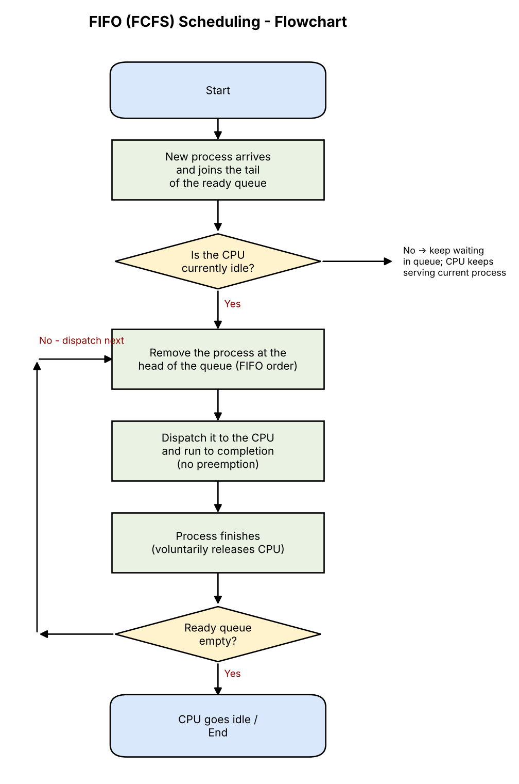
Figure 3.1 — Flowchart of the FIFO (FCFS) scheduling decision logic.

3.3 Pseudocode
ALGORITHM FIFO_Scheduler
Input: ready_queue // ordered strictly by arrival time

while system is running:
if CPU is idle and ready_queue is not empty:
job <- ready_queue.dequeue() // head of queue
dispatch(job)
run job UNTIL job.remaining_time == 0 // no preemption
record completion_time[job] <- current_time
end if
on new_process_arrival(p):
ready_queue.enqueue(p) // joins the tail
end on
end while

3.4 Advantages and Disadvantages
- Advantage: trivial to implement; requires no priority bookkeeping.
- Advantage: no starvation — every process is eventually served, strictly in arrival order.
- Disadvantage: convoy effect — a long process delays all those behind it.
- Disadvantage: no notion of urgency, so it cannot provide any timing guarantees and is unsuitable for real-time tasks with deadlines.
- Disadvantage: average waiting time is highly sensitive to the order in which jobs happen to arrive.

4. Rate Monotonic (RM) Scheduling

4.1 Description
Rate Monotonic (RM) scheduling, introduced by Liu and Layland (1973), is a fixed-priority preemptive algorithm designed for periodic real-time tasks. Each task Ti is characterized by a computation time Ci and a period Ti (with an implicit deadline equal to the period). RM assigns static priorities according to a single rule: the shorter the period, the higher the priority. At runtime, the scheduler always runs the ready job with the highest fixed priority, preempting a lower-priority job immediately if a higher-priority job becomes ready.
Liu and Layland proved that RM is optimal among fixed-priority algorithms (no other fixed-priority assignment can schedule a task set that RM cannot) and gave a sufficient (but not necessary) schedulability bound: a set of n independent periodic tasks is guaranteed schedulable under RM if
U = Σ (Ci / Ti) ≤ n(2^(1/n) − 1)
which converges to approximately 0.693 (ln 2) as n → ∞. Because this bound is only sufficient, many task sets with utilization above the bound — even very close to 1 — are still schedulable in practice; exact schedulability requires a response-time analysis. Case Study B in this report illustrates a task set whose utilization exceeds the bound and for which RM does, in fact, miss a deadline.

4.2 Flowchart
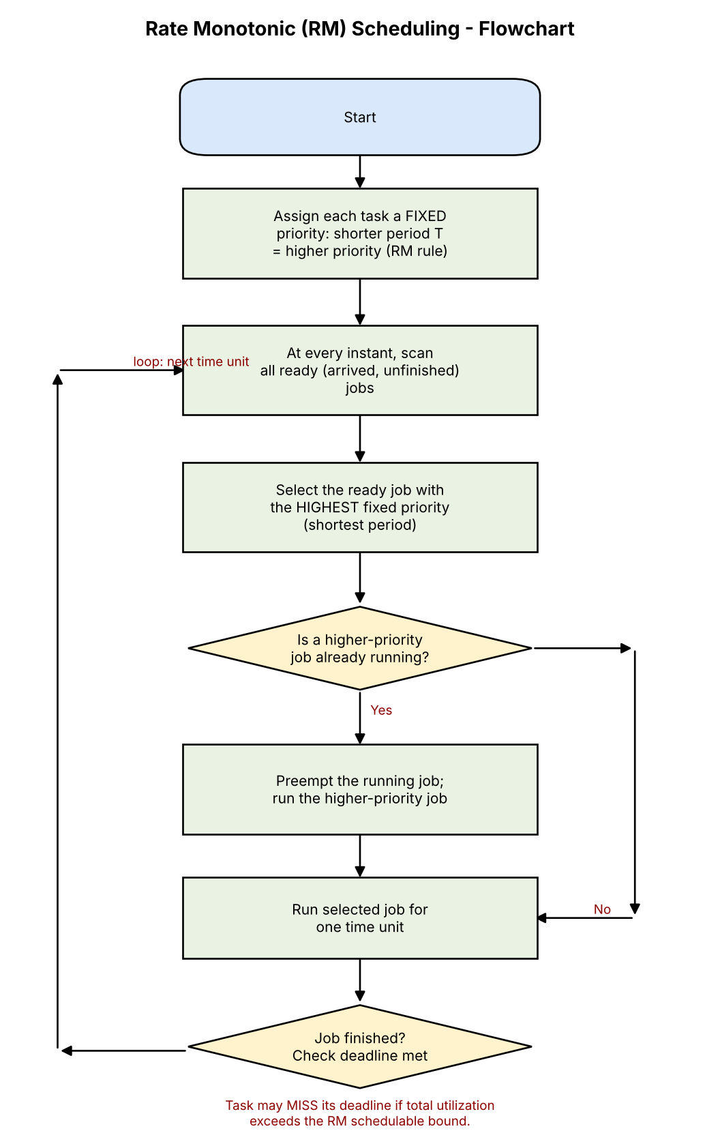
Figure 4.1 — Flowchart of the Rate Monotonic (RM) scheduling decision logic.

4.3 Pseudocode
ALGORITHM RateMonotonic_Scheduler
Input: task set {T1 .. Tn}, each with (Ci, Period_i, Deadline_i = Period_i)

// Fixed priority assignment (once, offline)
for each task Ti:
priority[Ti] <- 1 / Period_i // shorter period => higher priority

// Runtime loop (executed every time unit / on every event)
while system is running:
ready <- { jobs that have arrived and not yet completed }
if ready is not empty:
job <- argmax_{j in ready} priority[task_of(j)]
if job != currently_running_job:
preempt(currently_running_job) // if any
dispatch(job)
end if
run job for one time unit
if job.remaining_time == 0:
completion_time[job] <- current_time
check job.completion_time <= job.deadline
end if
else:
CPU idles
end if
end while

4.4 Advantages and Disadvantages
- Advantage: optimal fixed-priority algorithm — predictable, low runtime overhead (priorities computed once, offline).
- Advantage: priority ordering is stable, which simplifies analysis, debugging, and certification in safety-critical systems.
- Disadvantage: can leave processor capacity unused even below U = 1 (the sufficient bound is conservative).
- Disadvantage: low-period but low-importance tasks always outrank high-period, possibly more important tasks — priority is coupled purely to frequency, not to actual urgency at runtime.
- Disadvantage: long-period tasks can suffer large response-time jitter under heavy load, as seen in Case Study B.

5. Earliest Deadline First (EDF) Scheduling

5.1 Description
Earliest Deadline First (EDF) is a dynamic-priority preemptive algorithm. Instead of a fixed priority per task, every job is given an absolute deadline equal to its arrival time plus its relative deadline, and at every instant the scheduler runs whichever ready job currently has the earliest absolute deadline. Because deadlines change as new jobs arrive, the 'priority' of a task effectively changes from one job instance to the next.
The central theoretical result for EDF (Liu and Layland, 1973) is its optimality: for a single processor, if any scheduling algorithm can produce a feasible schedule for a set of jobs (i.e., meet every deadline), then EDF can too. For periodic tasks with deadlines equal to their periods, EDF is guaranteed to meet all deadlines if and only if
U = Σ (Ci / Ti) ≤ 1
which is both necessary and sufficient — a much tighter and more useful bound than the one available for RM. This theoretical guarantee comes at a practical cost: EDF requires dynamic priority recomputation and comparison at runtime, which carries higher scheduling overhead than RM's static priorities, and its behavior under transient overload (U > 1) is less predictable, since EDF can enter a 'domino effect' in which many jobs miss their deadlines in cascade, whereas RM degrades more gracefully for the highest-priority tasks.

5.2 Flowchart
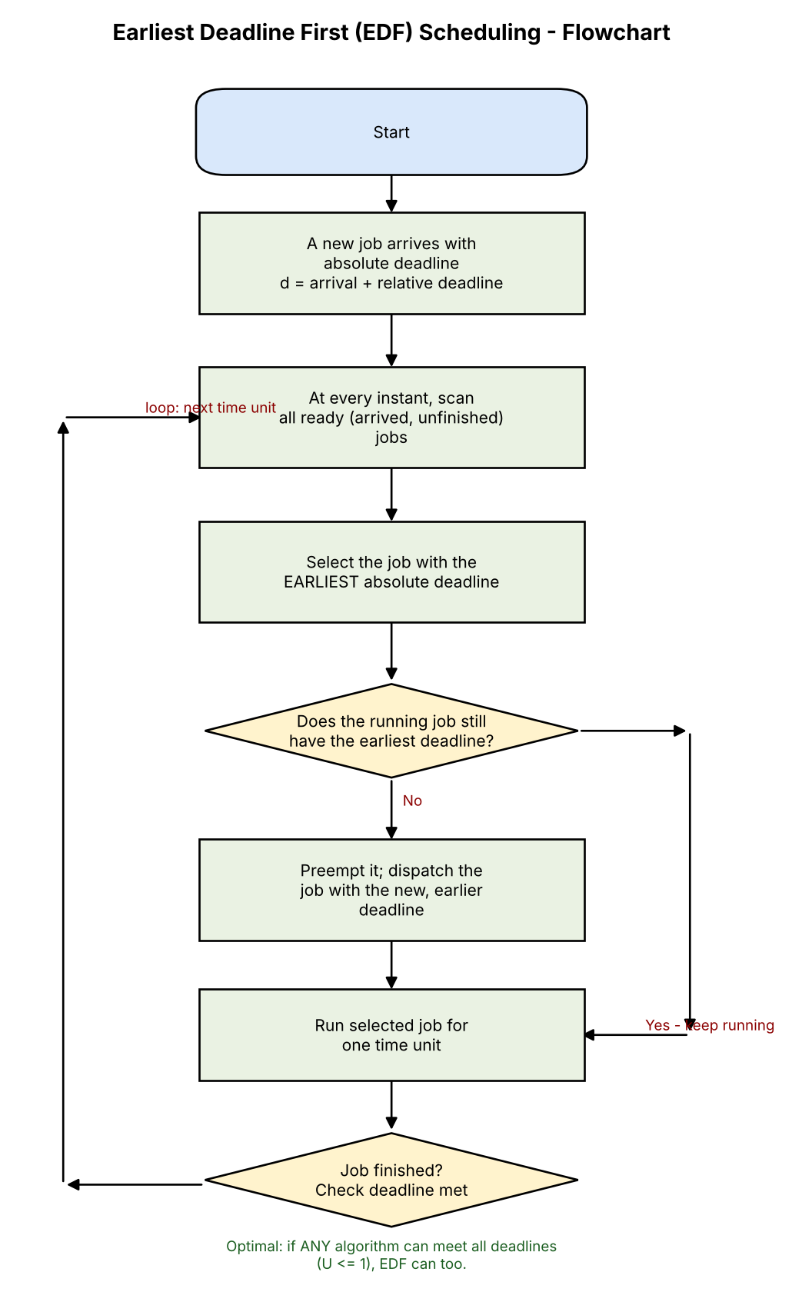
Figure 5.1 — Flowchart of the Earliest Deadline First (EDF) scheduling decision logic.

5.3 Pseudocode
ALGORITHM EDF_Scheduler
Input: task set {T1 .. Tn}, each with (Ci, Period_i, RelativeDeadline_i)

on job_arrival(j, task Ti):
j.absolute_deadline <- current_time + RelativeDeadline_i
ready.add(j)
end on

while system is running:
if ready is not empty:
job <- argmin_{j in ready} j.absolute_deadline // earliest deadline
if job != currently_running_job:
preempt(currently_running_job) // if any
dispatch(job)
end if
run job for one time unit
if job.remaining_time == 0:
completion_time[job] <- current_time
ready.remove(job)
check job.completion_time <= job.absolute_deadline
end if
else:
CPU idles
end if
end while

5.4 Advantages and Disadvantages
- Advantage: optimal — meets all deadlines whenever U ≤ 1, which is the best any uniprocessor algorithm can guarantee.
- Advantage: achieves full (100%) processor utilization in the schedulable case, unlike RM's conservative bound.
- Disadvantage: higher runtime overhead — deadlines must be recomputed and the ready set re-sorted on every arrival.
- Disadvantage: unpredictable, cascading behavior under transient overload (domino effect), making worst-case analysis harder.
- Disadvantage: harder to reason about statically / certify than RM's fixed priorities, since 'which task runs next' is a runtime, data-dependent decision.

6. Case Study A — Moderately Loaded Task Set
To compare the three algorithms on identical ground, a periodic task set is simulated under all three scheduling policies. Although FIFO has no native notion of periods or deadlines, the same stream of job arrivals generated by the periodic task set is fed to the FIFO scheduler so that all three algorithms face an identical workload; FIFO simply ignores the period/deadline fields and serves jobs strictly in arrival order.

6.1 Task Set Definition
Task | Computation Time (C) | Period (T) | Relative Deadline (D) | Utilization (C/T)
A | 1 | 4 | 4 | 0.250
B | 2 | 5 | 5 | 0.400
C | 3 | 10 | 10 | 0.300

The hyperperiod (least common multiple of all periods) is H = 20 time units, and the total processor utilization is U = 0.950. Since U < 1, the task set is, in principle, feasible, and (as will be shown) all three algorithms succeed in meeting every deadline for this particular workload — the comparison therefore focuses purely on efficiency metrics rather than on feasibility.

6.2 Gantt Charts
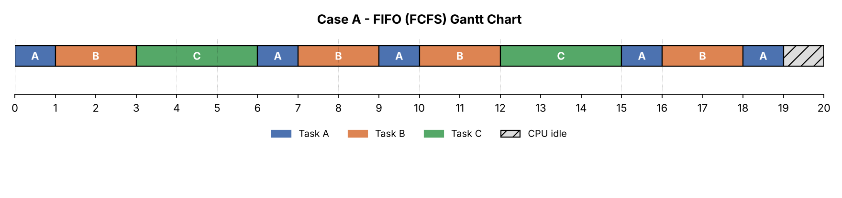
Figure 6.1 — FIFO schedule for Case Study A over one hyperperiod.
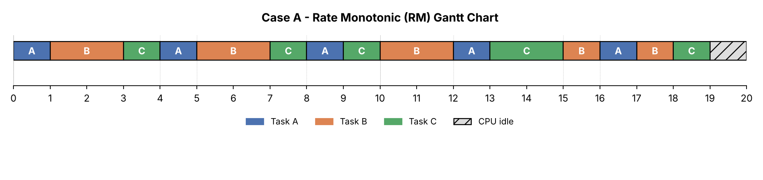
Figure 6.2 — Rate Monotonic (RM) schedule for Case Study A over one hyperperiod.
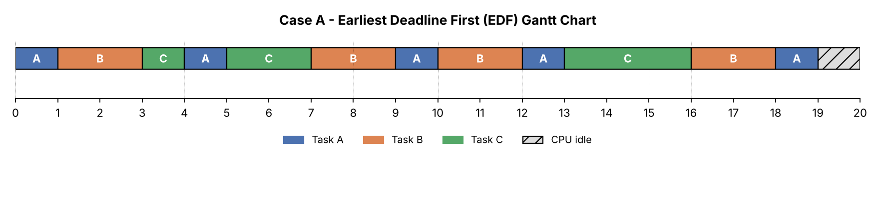
Figure 6.3 — Earliest Deadline First (EDF) schedule for Case Study A over one hyperperiod.

6.3 Per-Job Metrics

FIFO
Job | Arrival | Burst | Deadline | Start | Completion | Turnaround | Waiting | Response (Ack.) | Deadline
A0 | 0 | 1 | 4 | 0 | 1 | 1 | 0 | 0 | Met
A1 | 4 | 1 | 8 | 6 | 7 | 3 | 2 | 2 | Met
A2 | 8 | 1 | 12 | 9 | 10 | 2 | 1 | 1 | Met
A3 | 12 | 1 | 16 | 15 | 16 | 4 | 3 | 3 | Met
A4 | 16 | 1 | 20 | 18 | 19 | 3 | 2 | 2 | Met
B5 | 0 | 2 | 5 | 1 | 3 | 3 | 1 | 1 | Met
B6 | 5 | 2 | 10 | 7 | 9 | 4 | 2 | 2 | Met
B7 | 10 | 2 | 15 | 10 | 12 | 2 | 0 | 0 | Met
B8 | 15 | 2 | 20 | 16 | 18 | 3 | 1 | 1 | Met
C9 | 0 | 3 | 10 | 3 | 6 | 6 | 3 | 3 | Met
C10 | 10 | 3 | 20 | 12 | 15 | 5 | 2 | 2 | Met

Rate Monotonic (RM)
Job | Arrival | Burst | Deadline | Start | Completion | Turnaround | Waiting | Response (Ack.) | Deadline
A0 | 0 | 1 | 4 | 0 | 1 | 1 | 0 | 0 | Met
A1 | 4 | 1 | 8 | 4 | 5 | 1 | 0 | 0 | Met
A2 | 8 | 1 | 12 | 8 | 9 | 1 | 0 | 0 | Met
A3 | 12 | 1 | 16 | 12 | 13 | 1 | 0 | 0 | Met
A4 | 16 | 1 | 20 | 16 | 17 | 1 | 0 | 0 | Met
B5 | 0 | 2 | 5 | 1 | 3 | 3 | 1 | 1 | Met
B6 | 5 | 2 | 10 | 5 | 7 | 2 | 0 | 0 | Met
B7 | 10 | 2 | 15 | 10 | 12 | 2 | 0 | 0 | Met
B8 | 15 | 2 | 20 | 15 | 18 | 3 | 1 | 0 | Met
C9 | 0 | 3 | 10 | 3 | 10 | 10 | 7 | 3 | Met
C10 | 10 | 3 | 20 | 13 | 19 | 9 | 6 | 3 | Met

Earliest Deadline First (EDF)
Job | Arrival | Burst | Deadline | Start | Completion | Turnaround | Waiting | Response (Ack.) | Deadline
A0 | 0 | 1 | 4 | 0 | 1 | 1 | 0 | 0 | Met
A1 | 4 | 1 | 8 | 4 | 5 | 1 | 0 | 0 | Met
A2 | 8 | 1 | 12 | 9 | 10 | 2 | 1 | 1 | Met
A3 | 12 | 1 | 16 | 12 | 13 | 1 | 0 | 0 | Met
A4 | 16 | 1 | 20 | 18 | 19 | 3 | 2 | 2 | Met
B5 | 0 | 2 | 5 | 1 | 3 | 3 | 1 | 1 | Met
B6 | 5 | 2 | 10 | 7 | 9 | 4 | 2 | 2 | Met
B7 | 10 | 2 | 15 | 10 | 12 | 2 | 0 | 0 | Met
B8 | 15 | 2 | 20 | 16 | 18 | 3 | 1 | 1 | Met
C9 | 0 | 3 | 10 | 3 | 7 | 7 | 4 | 3 | Met
C10 | 10 | 3 | 20 | 13 | 16 | 6 | 3 | 3 | Met

6.4 Summary of Average Metrics
Algorithm | Avg. Waiting Time | Avg. Turnaround Time | Avg. Response (Acknowledge) Time | CPU Idle Time | Missed Deadlines
FIFO | 1.55 | 3.27 | 1.55 | 1 (5.0%) | 0
RM | 1.36 | 3.09 | 0.64 | 1 (5.0%) | 0
EDF | 1.27 | 3.00 | 1.18 | 1 (5.0%) | 0
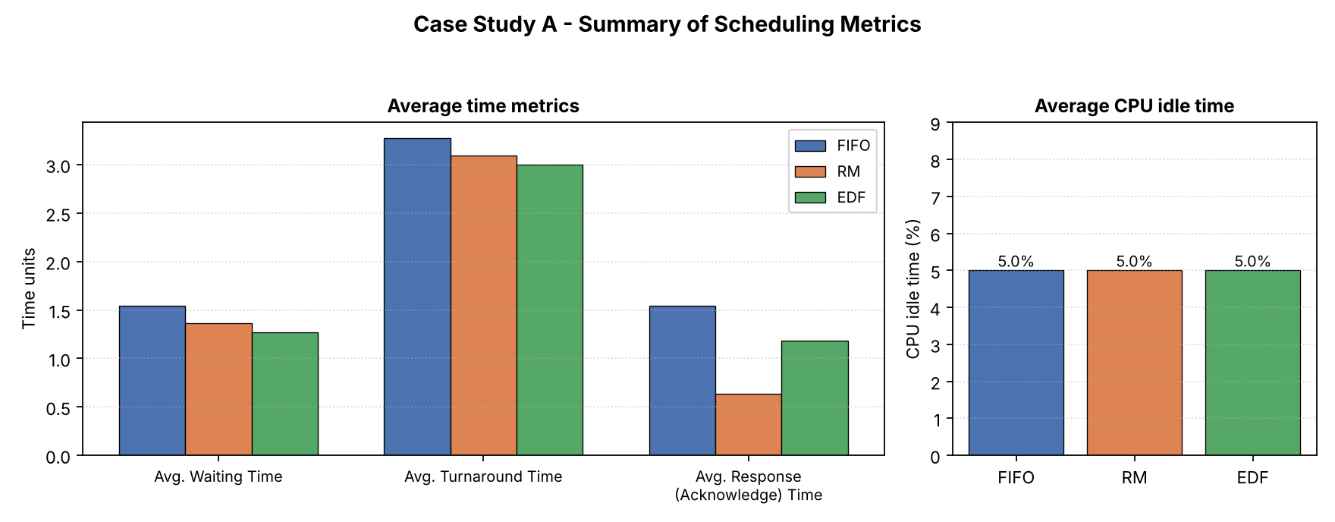
Figure 6.4 — Average time metrics and CPU idle time, Case Study A.

6.5 Analysis
All three algorithms meet every deadline in Case Study A. EDF achieves the lowest average waiting time (1.27) and the lowest average turnaround time (3.00), because it always prioritizes whichever job is closest to missing its deadline, which tends to minimize the spread of completion times across jobs. RM achieves the best average response (acknowledge) time (0.64) for the short-period Task A, since A's static high priority lets it preempt immediately on arrival — but this comes at the cost of Task C (the longest-period task), whose jobs are repeatedly preempted and experience much larger waiting times under RM than under EDF.
FIFO performs worst on turnaround and waiting time (3.27 and 1.55 respectively) because it has no mechanism to let short, urgent jobs cut ahead of a long job that happens to have arrived slightly earlier — the convoy effect described in Section 3.1 is visible directly in the Gantt chart whenever Task C's three-unit burst delays Task A and Task B.
CPU idle time is identical across all three algorithms (1 unit, 5.0% of the hyperperiod). This is expected: idle time occurs only when the ready queue is completely empty, which depends solely on the arrival pattern of the workload, not on which job the scheduler chooses to run among several ready jobs. In other words, idle time is a property of the workload and its total utilization, not of the scheduling discipline — provided the discipline never idles the CPU voluntarily while work is available, which is true of all three algorithms studied here.

7. Case Study B — The Classic RM / EDF Counter-Example
Case Study B reproduces a well-known two-task example (after Liu and Layland, 1973) that is specifically designed to push total utilization above the RM sufficient-schedulability bound while remaining at or below 1, so that EDF can still meet every deadline while RM cannot.

7.1 Task Set Definition
Task | Computation Time (C) | Period (T) | Relative Deadline (D) | Utilization (C/T)
X | 2 | 5 | 5 | 0.400
Y | 4 | 7 | 7 | 0.571

The hyperperiod is H = 35 time units and the utilization is U = 0.9714. The RM sufficient bound for n = 2 tasks is 2(2^(1/2) − 1) ≈ 0.828; since U = 0.971 exceeds this bound, RM feasibility is not guaranteed by the bound test — and, as the simulation confirms, RM does in fact miss a deadline, while EDF (whose exact feasibility condition is simply U ≤ 1) meets every deadline.

7.2 Gantt Charts
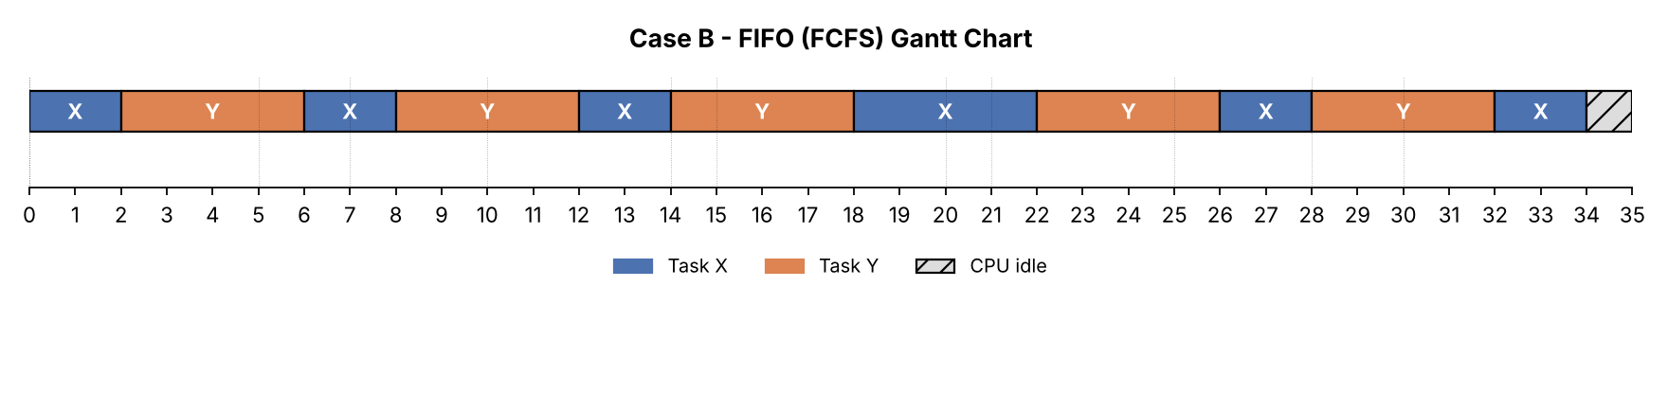
Figure 7.1 — FIFO schedule for Case Study B over one hyperperiod.
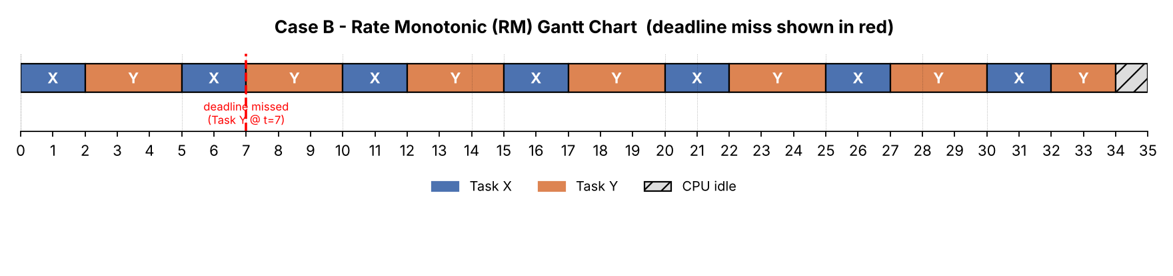
Figure 7.2 — Rate Monotonic (RM) schedule for Case Study B — note the missed deadline at t = 7, marked in red.
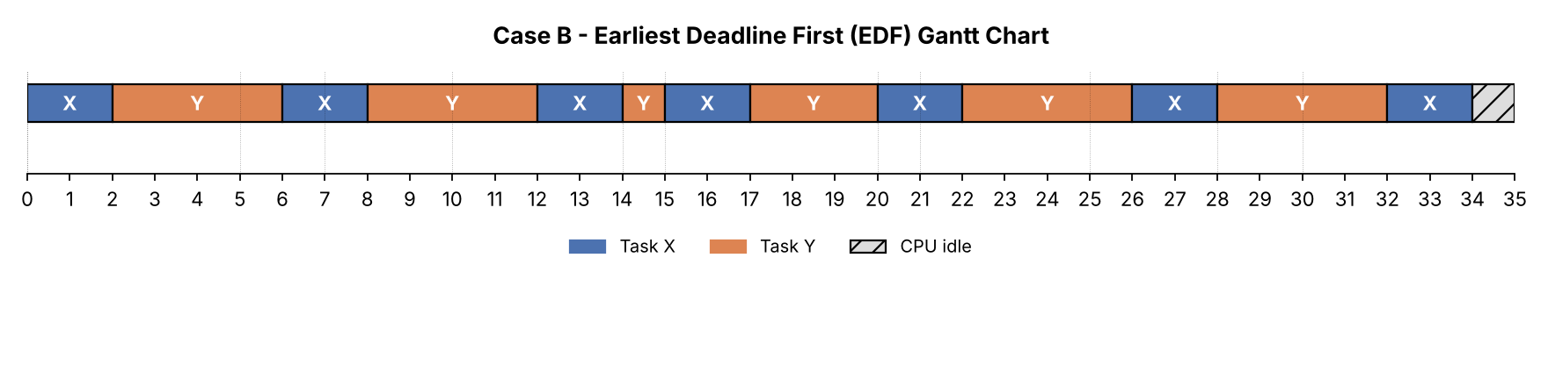
Figure 7.3 — Earliest Deadline First (EDF) schedule for Case Study B — every deadline is met.

7.3 Per-Job Metrics

FIFO
Job | Arrival | Burst | Deadline | Start | Completion | Turnaround | Waiting | Response (Ack.) | Deadline
X0 | 0 | 2 | 5 | 0 | 2 | 2 | 0 | 0 | Met
X1 | 5 | 2 | 10 | 6 | 8 | 3 | 1 | 1 | Met
X2 | 10 | 2 | 15 | 12 | 14 | 4 | 2 | 2 | Met
X3 | 15 | 2 | 20 | 18 | 20 | 5 | 3 | 3 | Met
X4 | 20 | 2 | 25 | 20 | 22 | 2 | 0 | 0 | Met
X5 | 25 | 2 | 30 | 26 | 28 | 3 | 1 | 1 | Met
X6 | 30 | 2 | 35 | 32 | 34 | 4 | 2 | 2 | Met
Y7 | 0 | 4 | 7 | 2 | 6 | 6 | 2 | 2 | Met
Y8 | 7 | 4 | 14 | 8 | 12 | 5 | 1 | 1 | Met
Y9 | 14 | 4 | 21 | 14 | 18 | 4 | 0 | 0 | Met
Y10 | 21 | 4 | 28 | 22 | 26 | 5 | 1 | 1 | Met
Y11 | 28 | 4 | 35 | 28 | 32 | 4 | 0 | 0 | Met

Rate Monotonic (RM) — deadline miss highlighted
Job | Arrival | Burst | Deadline | Start | Completion | Turnaround | Waiting | Response (Ack.) | Deadline
X0 | 0 | 2 | 5 | 0 | 2 | 2 | 0 | 0 | Met
X1 | 5 | 2 | 10 | 5 | 7 | 2 | 0 | 0 | Met
X2 | 10 | 2 | 15 | 10 | 12 | 2 | 0 | 0 | Met
X3 | 15 | 2 | 20 | 15 | 17 | 2 | 0 | 0 | Met
X4 | 20 | 2 | 25 | 20 | 22 | 2 | 0 | 0 | Met
X5 | 25 | 2 | 30 | 25 | 27 | 2 | 0 | 0 | Met
X6 | 30 | 2 | 35 | 30 | 32 | 2 | 0 | 0 | Met
Y7 | 0 | 4 | 7 | 2 | 8 | 8 | 4 | 2 | MISSED
Y8 | 7 | 4 | 14 | 8 | 14 | 7 | 3 | 1 | Met
Y9 | 14 | 4 | 21 | 14 | 20 | 6 | 2 | 0 | Met
Y10 | 21 | 4 | 28 | 22 | 28 | 7 | 3 | 1 | Met
Y11 | 28 | 4 | 35 | 28 | 34 | 6 | 2 | 0 | Met

Earliest Deadline First (EDF)
Job | Arrival | Burst | Deadline | Start | Completion | Turnaround | Waiting | Response (Ack.) | Deadline
X0 | 0 | 2 | 5 | 0 | 2 | 2 | 0 | 0 | Met
X1 | 5 | 2 | 10 | 6 | 8 | 3 | 1 | 1 | Met
X2 | 10 | 2 | 15 | 12 | 14 | 4 | 2 | 2 | Met
X3 | 15 | 2 | 20 | 15 | 17 | 2 | 0 | 0 | Met
X4 | 20 | 2 | 25 | 20 | 22 | 2 | 0 | 0 | Met
X5 | 25 | 2 | 30 | 26 | 28 | 3 | 1 | 1 | Met
X6 | 30 | 2 | 35 | 32 | 34 | 4 | 2 | 2 | Met
Y7 | 0 | 4 | 7 | 2 | 6 | 6 | 2 | 2 | Met
Y8 | 7 | 4 | 14 | 8 | 12 | 5 | 1 | 1 | Met
Y9 | 14 | 4 | 21 | 14 | 20 | 6 | 2 | 0 | Met
Y10 | 21 | 4 | 28 | 22 | 26 | 5 | 1 | 1 | Met
Y11 | 28 | 4 | 35 | 28 | 32 | 4 | 0 | 0 | Met

7.4 Summary of Average Metrics
Algorithm | Avg. Waiting Time | Avg. Turnaround Time | Avg. Response (Acknowledge) Time | CPU Idle Time | Missed Deadlines
FIFO | 1.08 | 3.92 | 1.08 | 1 (2.9%) | 0
RM | 1.17 | 4.00 | 0.33 | 1 (2.9%) | 1 job(s)
EDF | 1.00 | 3.83 | 0.83 | 1 (2.9%) | 0
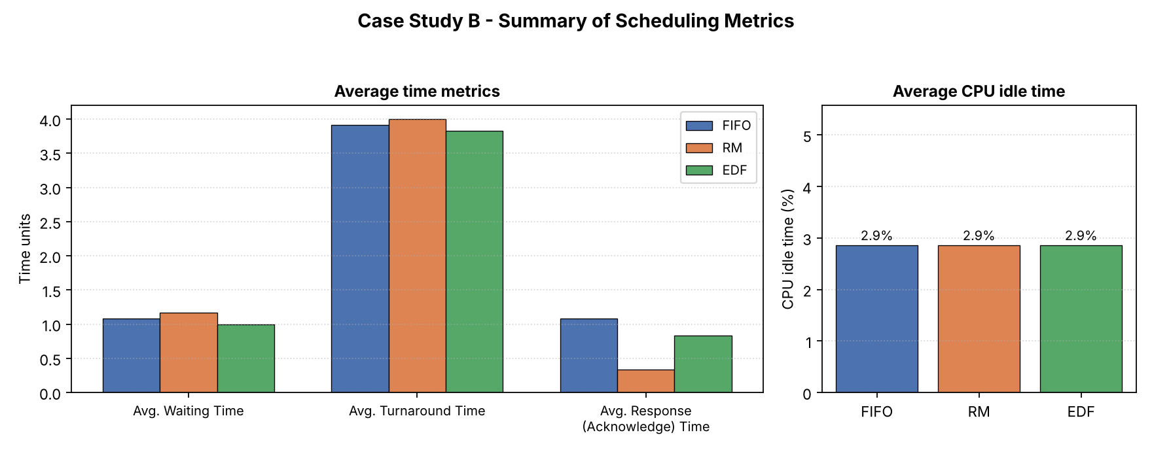
Figure 7.4 — Average time metrics and CPU idle time, Case Study B.

7.5 Analysis
The first job of Task Y (the long-period, long-burst task) arrives at t = 0 together with the first job of Task X. Under RM, Task X has the shorter period and therefore the higher static priority, so it always preempts Task Y whenever a new X-job arrives — even though, on this occasion, Task Y's job is in more urgent need of the processor to meet its own deadline at t = 7. Task Y's first job is consequently delayed until t = 8, one time unit past its deadline.
Under EDF, the same conflict is resolved correctly: at t = 5, when the second job of Task X arrives with a (later) absolute deadline of 10, Task Y's first job is still running and still has the earlier absolute deadline of 7, so EDF lets it continue; Task Y's job finishes at t = 6, one time unit before its deadline. This is a direct, concrete illustration of EDF's optimality — it is able to find a feasible schedule precisely in the situation where RM's fixed, period-only priority rule cannot.
Interestingly, FIFO also happens to meet every deadline in this particular instance, simply because Task Y arrived at the same time as Task X and FIFO's arrival-order tie-break happened to let Task X run first for only 2 units before switching — but this is incidental, not structural: FIFO provides no deadline guarantee in general, and a trivial change to arrival order or burst length would make it miss deadlines freely, since it has no mechanism to detect or react to approaching deadlines at all.
As in Case Study A, CPU idle time is again identical across the three algorithms, reinforcing the conclusion that idle time is determined by the workload's utilization and arrival pattern, not by the scheduling policy.

8. Comparative Analysis
The table below summarizes the qualitative and theoretical differences between the three algorithms, independent of any specific task set.

8.1 Qualitative Comparison
Property | FIFO | RM | EDF
Priority type | None (arrival order) | Fixed / static | Dynamic (changes per job)
Preemptive? | No | Yes | Yes
Designed for | General-purpose batch processing | Periodic real-time tasks | Periodic / aperiodic real-time tasks
Schedulability test | Not applicable (no deadlines) | Sufficient: U <= n(2^(1/n)-1) | Necessary & sufficient: U <= 1
Max. achievable utilization | Not applicable | ~69.3% as n -> infinity (bound) | 100%
Runtime overhead | Very low | Low (static priorities) | Higher (dynamic deadline sort)
Predictability / analyzability | High (simple) but no guarantees | High — well-suited to certification | Lower — harder worst-case analysis
Behavior under overload | Degrades proportionally, no guarantees | Graceful — high-priority tasks protected | Domino effect — many tasks may miss
Starvation risk | None | Low-priority (long-period) tasks can starve under high load | Low — deadlines ensure turnover
Typical use cases | Simple batch queues, print spoolers | Avionics, automotive ECUs, safety-critical RTOS | Multimedia streaming, soft real-time schedulers, network packet scheduling

8.2 Quantitative Comparison Across Both Case Studies
Metric | FIFO (A) | RM (A) | EDF (A) | FIFO (B) | RM (B) | EDF (B)
Avg. Waiting Time | 1.55 | 1.36 | 1.27 | 1.08 | 1.17 | 1.00
Avg. Turnaround Time | 3.27 | 3.09 | 3.00 | 3.92 | 4.00 | 3.83
Avg. Response (Ack.) Time | 1.55 | 0.64 | 1.18 | 1.08 | 0.33 | 0.83
Avg. CPU Idle Time (%) | 5.0 | 5.0 | 5.0 | 2.9 | 2.9 | 2.9
Missed Deadlines | 0 | 0 | 0 | 0 | 1 | 0

9. Discussion
The simulation results confirm the theoretical expectations for all three algorithms. FIFO's complete disregard for urgency makes it the weakest choice whenever tasks have heterogeneous importance or timing requirements, even though it remains attractive for simple, non-real-time batch systems because of its simplicity and absolute fairness in arrival order.
Rate Monotonic provides strong, analyzable guarantees for the highest-priority (shortest-period) tasks and is the standard choice in safety-critical, statically-analyzed real-time systems (e.g., avionics and automotive controllers) precisely because its fixed priorities make certification and worst-case timing analysis tractable. However, Case Study B demonstrates concretely that RM's sufficient schedulability bound is conservative: there exist feasible task sets (U < 1) that RM nonetheless fails to schedule correctly, because its priority assignment is coupled only to period and cannot adapt to the actual, instance-by-instance urgency of competing jobs.
Earliest Deadline First closes exactly this gap: by tracking the absolute deadline of every job dynamically, it is guaranteed to find a feasible schedule whenever one exists for utilization up to 100%. The price for this optimality is reduced predictability under transient overload and a higher runtime cost for priority (re)computation, which is why EDF is more common in systems where average-case efficiency matters more than worst-case certifiability — for example, multimedia and networking schedulers — and less common in hard real-time avionics-class systems, where RM's analyzability is often preferred even at the cost of some wasted capacity.
A further observation from both case studies is that average CPU idle time is a function of the workload (total utilization and arrival pattern) rather than of the scheduling algorithm: whenever the ready queue is non-empty, all three algorithms keep the processor busy, so idle time only appears in the gaps where no job is yet ready. This indicates that, for system designers, reducing idle time is primarily a workload/capacity-planning concern, while meeting deadlines and minimizing waiting/response time is primarily an algorithm-choice concern.

10. Conclusion
This report compared FIFO, Rate Monotonic, and Earliest Deadline First scheduling through algorithmic description, flowcharts, pseudocode, and a simulation-based evaluation on two task sets. The results show a clear ordering in capability for real-time use: FIFO offers no timing guarantees at all; RM offers strong, analyzable, but conservative guarantees for fixed-priority systems; and EDF offers theoretically optimal deadline guarantees (U ≤ 1) at the cost of higher runtime overhead and reduced predictability under overload.
In terms of classical efficiency metrics, EDF consistently achieved the lowest or near-lowest average waiting and turnaround time across both case studies, RM achieved the best response time for its highest-priority task at the expense of lower-priority tasks, and FIFO consistently performed worst whenever job lengths and arrival order were not aligned with urgency. The choice between these algorithms in practice should therefore be driven by the system's requirements: FIFO for simple, non-critical batch workloads; RM for certifiable, hard real-time systems with a small number of well-understood periodic tasks; and EDF for systems that need to extract the maximum guaranteed utilization from a single processor, and where moderate scheduling overhead and more complex worst-case analysis are acceptable trade-offs.

References
Liu, C. L., & Layland, J. W. (1973). Scheduling Algorithms for Multiprogramming in a Hard-Real-Time Environment. Journal of the ACM, 20(1), 46–61.
Silberschatz, A., Galvin, P. B., & Gagne, G. (2018). Operating System Concepts (10th ed.). Wiley.
Buttazzo, G. C. (2011). Hard Real-Time Computing Systems: Predictable Scheduling Algorithms and Applications (3rd ed.). Springer.
Stallings, W. (2017). Operating Systems: Internals and Design Principles (9th ed.). Pearson.
Tanenbaum, A. S., & Bos, H. (2014). Modern Operating Systems (4th ed.). Pearson.

