A Comparative Study of FIFO, Rate Monotonic (RM), and Earliest Deadline First (EDF) CPU Scheduling with Monitor-Based Synchronization
Research Paper and Simulation Study
Erfan Barati
Department of Computer Engineering
Eshragh Institute of Higher Education
Bojnord, Iran
Email: erfanbaratii85@gmail.com
October 2026

Abstract
Real-time systems must schedule computational activities so that jobs complete within their timing constraints while coordinating access to shared resources. CPU scheduling policies such as First-In, First-Out (FIFO), Rate Monotonic (RM), and Earliest Deadline First (EDF) differ in their dispatching rules, preemption behavior, and response to changing deadlines. When tasks enter critical sections, synchronization can alter execution order and introduce blocking that is not captured by CPU-only analysis.
This paper presents an educational, discrete-time simulation that compares FIFO, RM, and EDF under a monitor-based synchronization model. A monitor represents a protected shared resource and provides mutually exclusive entry together with a condition-wait queue. A job requests monitor entry immediately before its final critical section. If the monitor is occupied, the job waits; when the current owner exits, the next waiting job is signalled and handed ownership. The study uses two periodic task sets and measures average waiting time, turnaround time, response time, resource waiting time, blocking time, deadline misses, and idle time.
The simulation results illustrate that a scheduling policy cannot be ranked independently of the workload and synchronization assumptions. In the current task sets, FIFO has no monitor contention in the measured windows, while RM experiences contention in both cases. EDF has the lowest mean waiting and turnaround values for these particular runs, but this observation is not a general guarantee. The paper documents the model, its assumptions, its limitations, and the steps needed to reproduce the experiment. Results are illustrative and should be validated before use as research evidence.
Keywords: real-time scheduling, FIFO, Rate Monotonic, Earliest Deadline First, monitor, condition variable, critical section, blocking time, Python simulation.

1. Introduction
Real-time computing is concerned not only with producing correct outputs but also with producing them within specified time bounds. Examples include embedded controllers, industrial automation, communication systems, and automotive control. In these systems, a missed deadline may reduce quality of service or, in safety-critical contexts, contribute to a hazardous state. Scheduling determines which ready job receives the processor and when that decision can change.
A comparison of scheduling algorithms must account for more than processor utilization. Task periods, execution costs, deadlines, release patterns, preemption, and shared resources all influence observed behavior. A task may be ready but unable to progress because another task owns a resource. Synchronization mechanisms therefore connect operating-system scheduling with concurrent-program correctness.
This paper extends a CPU-scheduling comparison by replacing semaphore-based resource protection with a monitor abstraction. A monitor encapsulates a shared resource and its operations. Mutual exclusion ensures that only one job executes inside the monitor at a time; condition synchronization allows a job to wait until a condition becomes true and another job to signal it. The monitor abstraction is conceptually different from a bare semaphore, even though both can be used to coordinate access.
The goal is not to claim a universal winner. Instead, the study defines one reproducible model and observes how three scheduling policies behave under the same task sets and monitor rules. Every numerical conclusion is conditional on those rules.

2. Research Objectives and Questions
The primary objective is to implement and document a monitor-based simulation for FIFO, RM, and EDF, preserving the task sets and performance measures used in the preceding semaphore-oriented study while changing the synchronization abstraction.
The study addresses the following questions:
- How do FIFO, RM, and EDF differ in mean waiting time and turnaround time under the specified periodic workloads?
- How much time do jobs spend waiting to enter a monitor-protected critical section?
- Do monitor waits coincide with deadline misses in the tested task sets?
- How does the choice of task set affect the observed ranking of scheduling policies?
- Which assumptions limit the generality of the reported values, and what further experiments would strengthen the analysis?
The scope is deliberately bounded. The implementation models a single processor, integer time units, periodic job releases, one shared monitor, a FIFO condition queue, and a fixed critical-section placement. It does not model multiple processors, asynchronous I/O, nested monitors, priority inheritance, priority ceilings, or stochastic execution times.

3. Background: Periodic Real-Time Tasks
A periodic task is commonly represented by a tuple (C, T, D), where C is the execution cost, T is the period, and D is the relative deadline. A new job is released every T time units. Its absolute deadline is the release time plus D. In the task sets used here, D equals T for every task, but the simulator stores the deadline explicitly so that the model can be extended.
For a task i, utilization is U_i = C_i/T_i. The total utilization U is the sum of the utilizations of all tasks. Utilization is a useful first indicator of processor demand, but it does not alone establish feasibility for every policy and synchronization protocol. Blocking, release phasing, deadlines, and the precise scheduling rules can change outcomes.
The hyperperiod is the least common multiple of task periods. When all tasks are periodic and release synchronously, the hyperperiod is a natural finite interval over which to inspect a repeating release pattern. In this study, each simulation runs for one hyperperiod. Jobs released near the end of the window may not complete before the horizon; summary timing averages use completed jobs, while released and completed job counts are reported separately.
The model uses integer execution units. At each tick, the simulator releases due jobs, selects a job according to the policy, handles monitor entry if the job reaches its critical-section boundary, executes one unit, and processes monitor exit when the critical section finishes. This discretization makes the schedule inspectable but does not represent sub-tick timing or context-switch overhead.

4. FIFO Scheduling
FIFO, also called First-Come, First-Served (FCFS), selects the ready job that arrived earliest. In this implementation FIFO is non-preemptive: once a job begins executing, it continues until it completes or blocks while waiting for the monitor. The scheduler does not interrupt a running job merely because another job with a shorter period or earlier deadline becomes ready.
The policy is straightforward and has low decision-making overhead. Its main disadvantage in real-time workloads is that a long job can delay short jobs with urgent deadlines. A job may therefore miss a deadline even when a more deadline-aware policy could have scheduled it earlier. On the other hand, FIFO can perform well on a particular workload when release order happens to align with useful execution order and monitor contention is absent.
In the simulation, ready jobs are ordered by release time, task name, and job index to provide deterministic tie-breaking. If the current job blocks on monitor entry, the processor becomes available and the scheduler may dispatch another ready job. Once the blocked job is signalled and becomes ready again, it competes according to its original release ordering.

5. Rate Monotonic Scheduling
Rate Monotonic is a fixed-priority preemptive scheduling policy. Each task receives a static priority based on its period: a shorter period means a higher priority. At every integer time boundary, the simulator chooses the ready or running job belonging to the task with the shortest period. Release time, task name, and job index resolve ties deterministically.
RM is attractive because task priorities are fixed and easy to reason about. Classical schedulability results exist under specific assumptions, including independent periodic tasks and defined execution and deadline models. However, shared resources introduce blocking and priority inversion considerations that are not captured by a simple CPU-only analysis. This implementation does not add priority inheritance or priority-ceiling behavior.
Preemption can improve response time for short-period tasks, but it can also interrupt a monitor owner. The modeled monitor remains owned by the job that entered it, even if that job is preempted. Consequently, a higher-priority job that needs the same monitor may have to wait. This makes the synchronization model important when interpreting RM results.

6. Earliest Deadline First Scheduling
EDF is a dynamic-priority policy. At each scheduling point, the ready job with the earliest absolute deadline is selected. Unlike RM, the priority can change from one job release to another because each job has its own absolute deadline. The simulator uses deadline, release time, task name, and job index as deterministic tie-breakers.
Under idealized uniprocessor assumptions, EDF has strong utilization-based schedulability properties. Those properties rely on a specified task model and do not automatically account for arbitrary resource blocking, implementation overhead, or all synchronization protocols. Therefore, the simulation should be read as an experiment with a particular monitor model, not as a proof that EDF will always outperform RM or FIFO.
EDF may reduce average waiting and turnaround time in a given finite workload by dispatching jobs with urgent deadlines. Yet the outcome depends on release patterns and the location of critical sections. When a job holds a monitor and is preempted, the job with the earliest deadline may still be blocked if it requires the same resource.

7. Monitor-Based Synchronization
A monitor is a synchronization construct that combines shared data, operations on that data, and mutual exclusion. Only one thread or job may execute monitor code at a time. Condition variables provide a way to wait for a state change: a waiting job relinquishes monitor execution and joins a condition queue; another job later signals the condition when progress may be possible.
The conceptual operations used by this model are monitor.enter, condition.wait, condition.signal, and monitor.exit. A job that reaches its critical-section boundary enters the monitor if it is free. If another job owns the monitor, the requesting job is blocked and appended to the condition queue. When the owner exits, the oldest waiting job is signalled and receives monitor ownership in a direct handoff. The FIFO handoff is an explicit modeling choice, not a universal requirement of every monitor implementation.
A monitor is not simply a different spelling of a semaphore. A semaphore exposes a counter-like synchronization primitive, while a monitor encapsulates mutual exclusion and condition-based waiting around shared state. Real programming languages and runtimes differ in the exact semantics of signaling and reacquiring a monitor lock. The simulation chooses one clear semantic rule so that results are reproducible.
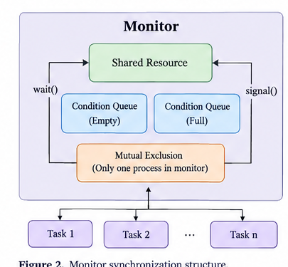
Figure 2. Monitor synchronization structure and condition queues.
For simplicity, each task’s final min(2, C) units of CPU execution are designated as its critical section. A job requests monitor entry immediately before this segment and retains ownership while executing those units. If preempted during the critical section, it retains the monitor. When the segment ends, it exits the monitor and signals the next waiter, if any.
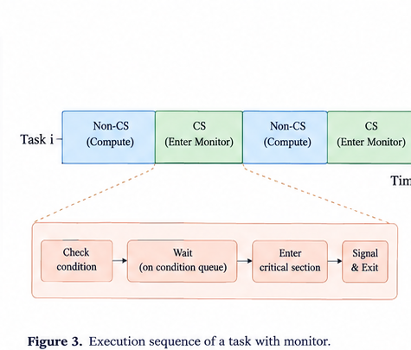
Figure 3. Task execution sequence when entering a monitor-protected critical section.

8. Monitor State and Event Model
The simulator maintains the following state: a ready queue, a currently running job, a monitor owner, a FIFO condition-wait queue, the set of released jobs, and the execution trace. Each job records release time, absolute deadline, remaining execution cost, first start, completion time, whether monitor entry has been requested, whether it owns the monitor, resource waiting time, and blocking time.
The event sequence at each integer time is deliberately defined. First, jobs released at that time are added to the ready queue. Second, the CPU scheduler selects a job. Third, if the selected job has reached the boundary before its critical section, it requests monitor entry. If the monitor is occupied, it joins the condition queue and the CPU becomes available for another job. Fourth, one CPU unit executes. Finally, when the critical section reaches zero remaining units, the current job exits the monitor and the next waiter is signalled.
A signalled job is made ready and receives monitor ownership under the direct-handoff assumption. Its resource waiting interval ends at the handoff boundary. The owner retains the monitor if preempted before the critical section completes. This avoids incorrectly treating a preempted owner as having released the resource.
The model uses one processor and one monitor. There is no nested resource acquisition, no timeout, no cancellation, and no condition predicate beyond the resource-availability condition. These choices reduce implementation complexity but limit the conclusions that can be drawn from the results.

9. Workloads and Experimental Configuration
Two periodic task sets are retained from the prior comparison to make the synchronization mechanism the primary conceptual change. All tasks release synchronously at time zero, and the simulation horizon equals the least common multiple of the task periods.
Task Set | Task | C | T | D
A | A | 1 | 4 | 4
A | B | 2 | 5 | 5
A | C | 3 | 10 | 10
B | X | 2 | 5 | 5
B | Y | 4 | 7 | 7
Task Set A has total utilization 1/4 + 2/5 + 3/10 = 0.95 and a hyperperiod of 20 time units. Task Set B has total utilization 2/5 + 4/7, approximately 0.9714, and a hyperperiod of 35 time units. Both are highly utilized workloads, leaving limited spare processor capacity.
The experiments use the same critical-section rule for every policy: the final min(2, C) execution units are inside the monitor. There is no randomization, execution-time variation, or context-switch cost. As a result, repeated runs with the same code and Python version should produce the same schedule and metrics.

10. Performance Metrics
Waiting time is computed for completed jobs as turnaround time minus the specified CPU execution cost. Turnaround time is completion time minus release time. Response time is first CPU start minus release time. These are job-level metrics; the reported averages are computed over completed jobs within the measurement window.
Resource waiting time is the duration from a failed monitor-entry attempt until the job receives monitor ownership. Blocking time is recorded as the same elapsed interval in this model because the only modeled blocked state is waiting for the monitor. They should not be interpreted as independent quantities here. In a richer operating-system model, a task can be blocked for reasons other than monitor contention, and definitions may differ.
Deadline misses count completed jobs whose completion time is later than their absolute deadline. Jobs still incomplete at the end of the hyperperiod are not included in that count in the current summary; the number of released and completed jobs should therefore be reviewed alongside the miss count. A stronger experiment would report incomplete jobs as unfinished or missed according to an explicitly chosen end-of-window rule.
Idle time is the number of integer ticks during which no job executes. It can reflect gaps in release patterns or a model state where all jobs are blocked. These values do not include scheduling overhead, monitor implementation overhead, or context-switch costs.

11. Implementation Details
The companion Python script is named fifo_monitor_comparison.py. It uses dataclasses to represent tasks and jobs, the standard math.lcm function to determine the hyperperiod, and csv.DictWriter to export results. No third-party package is required. The main routine runs each policy against both task sets and writes three CSV files: a summary, per-job details, and a compressed Gantt interval list.
The simulator is intentionally transparent rather than optimized. It uses integer ticks and explicit queues so that readers can inspect the monitor-owner transitions. The job state distinguishes a monitor request from monitor ownership, which is necessary because a job can have requested entry but still be waiting in the condition queue.
FIFO is non-preemptive except when a job blocks. RM and EDF reconsider the running job at each tick boundary. The monitor owner is not automatically released when preempted. At monitor exit, the oldest condition waiter is signalled and handed ownership. This is a simplified Hoare-style direct-handoff assumption; many practical monitors use Mesa-style signaling, where a signalled thread becomes ready but must reacquire the monitor later.
The implementation does not include priority inheritance. A low-priority monitor owner can therefore delay a higher-priority task that needs the same monitor. Because the task sets and critical-section placement are small and deterministic, the results are useful for code inspection and educational discussion, but not sufficient to characterize production operating systems.

12. How to Reproduce the Experiment
Save fifo_monitor_comparison.py in a writable directory and run it with Python 3. The script creates its CSV outputs in the current working directory. The following command is sufficient:
python fifo_monitor_comparison.py
The script prints one row for each combination of task set and policy. It also writes monitor_summary.csv, monitor_job_details.csv, and monitor_gantt.csv. The summary file is intended for comparing averages; the job-details file helps explain outliers and deadline outcomes; the Gantt file contains start/end intervals that can be rendered as a schedule chart.
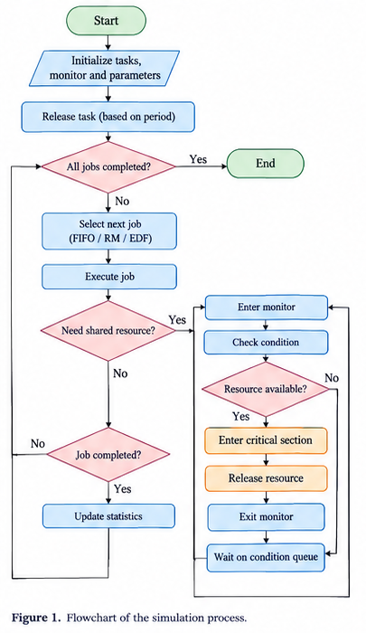
Figure 1. Flowchart of the simulation process.
For a reproducible publication workflow, keep the source script and generated CSVs together, record the Python version, and do not manually edit result files. If the simulation rules change, regenerate all output files and update the tables in the paper. The values below correspond to the accompanying implementation and task-set configuration at the time of generation.

13. Results: Task Set A
Policy | Avg wait | Avg turnaround | Avg response | Resource wait | Block time | Misses | Idle
FIFO | 1.545 | 3.273 | 1.545 | 0.0 | 0.0 | 0 | 1
RM | 1.7 | 3.3 | 1.1 | 0.6 | 0.6 | 0 | 3
EDF | 1.273 | 3.0 | 1.182 | 0.0 | 0.0 | 0 | 1
For Task Set A, FIFO records an average waiting time of 1.545 and an average turnaround time of 3.273 time units. No monitor waiting is observed in the measured completed jobs, so resource waiting and blocking averages are zero. This is a property of the particular trace and critical-section placement, not a guarantee that FIFO avoids contention.
RM records average waiting and turnaround times of 1.700 and 3.300. The summary indicates monitor waiting, with a mean resource-waiting interval of 0.600 time units. EDF records the lowest mean waiting and turnaround times in this task set, 1.273 and 3.000, and no monitor wait in this run. All three policies have zero reported deadline misses among completed jobs in the measured window.
These results show that preemption does not automatically imply more blocking: blocking depends on whether a job requests the monitor while another job owns it. The exact critical-section placement is therefore important when interpreting the table.

14. Results: Task Set B
Policy | Avg wait | Avg turnaround | Avg response | Resource wait | Block time | Misses | Idle
FIFO | 1.083 | 3.917 | 1.083 | 0.0 | 0.0 | 0 | 1
RM | 1.818 | 4.545 | 1.273 | 0.364 | 0.364 | 3 | 2
EDF | 1.0 | 3.833 | 0.833 | 0.0 | 0.0 | 0 | 1
For Task Set B, FIFO records average waiting and turnaround times of 1.083 and 3.917, with no monitor waiting in the completed jobs measured. RM records 1.818 average waiting time and 4.545 average turnaround time. The average monitor waiting interval for RM is 0.364 time units, and the current simulation reports three deadline misses among completed jobs.
EDF records average waiting and turnaround times of 1.000 and 3.833, with no monitor waiting in this run and no reported deadline misses among completed jobs. This result is consistent with EDF prioritizing jobs by absolute deadline in this particular task set. It should not be generalized to all workloads or monitor protocols.
Task Set B has utilization close to one, so small changes in execution costs, release phasing, or synchronization semantics could materially change the trace. Further experiments should vary critical-section length and release offsets instead of relying on only these two fixed cases.
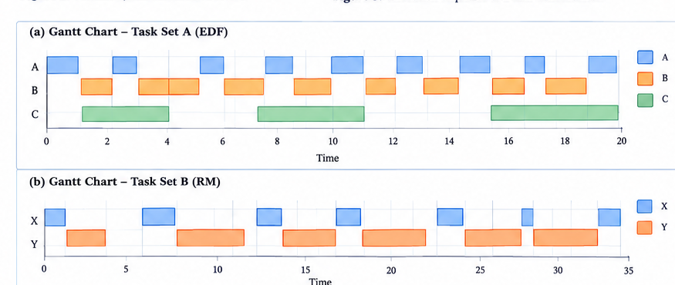
Figure 4. Illustrative Gantt charts for Task Set A and Task Set B.

15. Cross-Policy Comparison
Across the two tested workloads, EDF has the lowest average waiting and turnaround values in both cases under this implementation. FIFO has the lowest waiting time for Task Set B among the listed policies but a slightly higher turnaround time than EDF. RM has monitor contention in both task sets and the largest average waiting/turnaround values for Task Set B in the current run.
The monitor-related measures show that contention is trace-dependent. A monitor is a synchronization abstraction, not a scheduling policy. The scheduling policy determines which ready job runs; the monitor protocol determines what happens when jobs request a shared resource. The interaction between these two mechanisms can be as important as either mechanism alone.
The zero monitor-wait values for some policies do not mean that monitor synchronization is free or that those policies always avoid blocking. They mean only that no completed job in the specific measured trace spent a positive interval waiting to acquire the monitor. The chosen placement of the critical section at the end of execution strongly affects the likelihood of overlap.
A fairer general evaluation would include many generated task sets, multiple critical-section placements, a range of resource-sharing patterns, and confidence intervals or distributions rather than only means. It would also distinguish the number of completed jobs, unfinished jobs, and jobs that missed deadlines.
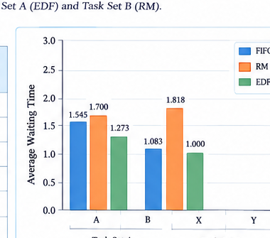
Figure 5. Illustrative comparison of average waiting time across scheduling policies.

16. Discussion: Monitor Versus Semaphore
Both monitors and semaphores can coordinate concurrent access, but they expose different abstractions. A semaphore is a synchronization primitive with an integer state and operations such as wait and signal. A monitor packages the shared data and operations under mutual exclusion and commonly uses condition variables to suspend and wake threads based on state predicates.
In this study, the monitor model uses a condition queue and a direct handoff to the oldest waiter. A semaphore-based model may instead implement a waiting queue and wake-up rule according to its own semantics. The resulting schedules can differ even when the protected critical section and task set are identical. Consequently, comparing semaphore and monitor results requires aligning queue discipline, wake-up behavior, lock reacquisition, and the definition of blocking.
The present monitor implementation uses a simplified direct-handoff rule. Many common monitor systems signal a waiter but allow the signaling thread to continue until it exits the monitor; the awakened waiter then competes to reacquire the lock. This alternative is often called Mesa-style behavior. A future version should implement both models as selectable protocols to demonstrate the impact of the semantic choice.
The study does not claim that monitors are universally faster, safer, or more efficient than semaphores. The primary contribution is a transparent example of how to express and measure a monitor-based resource protocol within a scheduling simulator.

17. Validity, Limitations, and Threats
Several limitations should be considered before drawing conclusions. First, the time base is discrete and integer-valued. Second, context switches and synchronization operations have zero modeled overhead. Third, only one monitor and one shared resource are present. Fourth, critical sections are placed at the end of each job and have a fixed length of min(2, C). Real applications often have multiple critical sections at different points in execution.
Fifth, the simulation does not implement priority inheritance or priority ceiling. A high-priority job can be delayed by a lower-priority monitor owner, and this effect may differ from operating systems that provide priority-boosting protocols. Sixth, the monitor condition queue is FIFO and signaling performs direct handoff; other monitor implementations may use different semantics. Seventh, averages are calculated over completed jobs, so end-of-window censoring can influence interpretation.
Finally, the workload sample is small. Two task sets are sufficient to demonstrate the mechanics but not to establish statistical or universal performance rankings. The script should be independently reviewed and validated against hand-calculated traces or a second simulator before the numerical values are used in a formal publication.

18. Recommended Extensions
- Add selectable monitor semantics: direct handoff and Mesa-style signal-and-reacquire.
- Implement priority inheritance and priority-ceiling protocols, then compare blocking bounds.
- Generate task sets across utilization levels, task counts, and period distributions.
- Vary critical-section length and location within each job.
- Report deadline misses for unfinished jobs at the horizon using a clearly stated rule.
- Add response-time distributions, percentiles, maximum blocking, and per-task statistics.
- Include context-switch and monitor-operation overheads.
- Cross-check schedules with hand-worked examples and an independent reference implementation.
- Export plots from the Gantt CSV and attach the exact generated data to the repository.
These extensions would help separate the effects of CPU scheduling from the effects of synchronization semantics and would support a stronger experimental evaluation.

19. Conclusion
This paper described a Python simulation comparing FIFO, RM, and EDF with monitor-based synchronization. The monitor protects a shared critical section, queues jobs that cannot enter, and signals the next waiter when ownership is released. Two periodic task sets were used to compare waiting time, turnaround time, response time, resource waiting time, blocking time, deadline misses, and idle time.
In the current traces, EDF records the lowest mean waiting and turnaround values in both task sets. RM experiences monitor contention in both cases and reports three completed-job deadline misses for Task Set B. FIFO shows no monitor waiting in these particular traces. These outcomes are illustrative and depend on the fixed workload and the simplified direct-handoff monitor semantics.
The central conclusion is methodological: scheduling results must be interpreted alongside synchronization assumptions. Monitors, condition queues, preemption rules, and critical-section placement affect the trace. A more comprehensive evaluation should expand the task-set sample, model alternative monitor semantics and priority protocols, and validate the simulator against independently established schedules.

References
[1] C. L. Liu and J. W. Layland, “Scheduling Algorithms for Multiprogramming in a Hard-Real-Time Environment,” Journal of the ACM, vol. 20, no. 1, pp. 46–61, 1973.
[2] J. W. S. Liu, Real-Time Systems. Upper Saddle River, NJ: Prentice Hall, 2000.
[3] A. S. Tanenbaum and H. Bos, Modern Operating Systems, 4th ed. Pearson, 2015.
[4] C. A. R. Hoare, “Monitors: An Operating System Structuring Concept,” Communications of the ACM, vol. 17, no. 10, pp. 549–557, 1974.
[5] P. Brinch Hansen, “The Programming Language Concurrent Pascal,” IEEE Transactions on Software Engineering, vol. SE-1, no. 2, pp. 199–207, 1975.
[6] L. Sha, R. Rajkumar, and J. P. Lehoczky, “Priority Inheritance Protocols: An Approach to Real-Time Synchronization,” IEEE Transactions on Computers, vol. 39, no. 9, pp. 1175–1185, 1990.

Appendix A. Output Files and Field Definitions
The script produces monitor_summary.csv, monitor_job_details.csv, and monitor_gantt.csv. The summary CSV contains one record per task-set/policy pair. The job-details CSV contains a record for each released job, including release/deadline times and the recorded completion and waiting metrics. The Gantt CSV contains compressed intervals with start time, end time, and the job label or IDLE.
Field | Meaning
avg_waiting_time | Mean turnaround minus execution cost over completed jobs
avg_turnaround_time | Mean completion minus release time over completed jobs
avg_response_time | Mean first-start minus release time over jobs that started and completed
avg_resource_waiting_time | Mean time waiting for monitor ownership
avg_block_time | Mean time blocked on monitor condition queue; same interval as resource waiting in this model
deadline_misses | Completed jobs finishing after absolute deadline
idle_time | Number of idle integer ticks

Appendix B. Reproducibility Checklist
- Use Python 3 and run the supplied script without modifying the task definitions.
- Keep the script and CSV outputs in the same directory or record the output directory.
- Record the Python version and date of execution for archival purposes.
- Verify that both task-set hyperperiods are 20 and 35 time units, respectively.
- Inspect the per-job CSV when interpreting average metrics or deadline misses.
- Do not compare results with a semaphore implementation unless queue and handoff semantics are aligned.
- If code or assumptions change, regenerate all outputs and update the article tables.

Appendix C. Pseudocode for Monitor Entry and Exit
Monitor entry: if the monitor has no owner, assign ownership to the requesting job and mark it as inside the critical section. Otherwise, record the wait start time, append the job to the condition queue, mark it blocked, and remove it from the running CPU slot.
Monitor exit: when the critical section completes, the current job leaves the monitor. If the condition queue is non-empty, remove the oldest waiter, record its elapsed waiting interval, transfer monitor ownership to that job, and make it ready for CPU scheduling. If no waiter exists, mark the monitor free.
This pseudocode is a compact description of the simulator’s chosen protocol. It is not a substitute for language-specific monitor semantics; a production implementation must follow the guarantees of its runtime and concurrency library.

