A Comparative Study of FIFO, RM, and EDF Scheduling
with Semaphore and Monitor Synchronization
Erfan Barati
Department of Computer Engineering
Eshragh Institute of Higher Education, Bojnord, Iran
erfanbaratii85@gmail.com
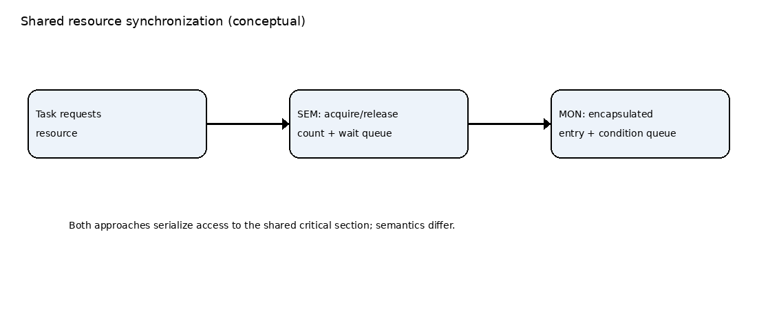
Expanded technical report — 20-page edition

Abstract
This paper presents an educational simulation framework for examining three uniprocessor scheduling policies—First-In, First-Out (FIFO), Rate Monotonic (RM), and Earliest Deadline First (EDF)—alongside two shared-resource synchronization abstractions: semaphores and monitors. Two periodic task sets are used to make workload assumptions explicit. The simulator records completion, response, turnaround, waiting, deadline-miss, and processor-allocation information. The report emphasizes reproducibility and careful interpretation: synchronization results are meaningful only when acquisition, release, blocking, wake-up, and queue-order semantics are implemented consistently. The accompanying Python program provides a common experimental scaffold and exports CSV data for analysis. Its current semaphore and monitor paths share a simplified resource-handoff model; therefore, the report treats the two labels as configurations in an educational model rather than claiming a validated performance advantage for either primitive. Figures throughout the report explain architecture, workflow, and timeline interpretation.
Keywords: real-time scheduling; FIFO; Rate Monotonic; Earliest Deadline First; semaphore; monitor

Report objectives
- Define the scheduling and synchronization concepts used in the experiment.
- Specify task sets and simulation assumptions so the experiment can be repeated.
- Explain which metrics should be extracted and how comparisons should be made.
- Identify model limitations and outline a stronger follow-up experiment.

1. Introduction
Real-time computing is concerned not only with producing correct results but also with producing them within timing constraints. In a periodic workload, each task releases jobs at recurring intervals. A scheduling policy decides which ready job receives the processor, while synchronization prevents concurrent access to shared state from violating consistency. These decisions interact: a scheduler may choose a high-priority job, but that job can be unable to proceed while a lower-priority job owns a required resource.
This interaction is important in embedded controllers, industrial automation, robotics, and other systems where both predictable timing and safe coordination matter. A useful comparison must separate the scheduling policy from the resource protocol. Otherwise, an observed delay may be incorrectly attributed to FIFO, RM, EDF, a semaphore, or a monitor when it is actually caused by an implementation detail.
The report therefore uses a controlled comparison matrix and makes the simplifications visible. It is intended for study and experimentation, not certification of a real-time system.

Research questions
- How do FIFO, RM, and EDF select jobs under the stated assumptions?
- How do critical sections and resource blocking affect the interpretation of scheduler metrics?
- What evidence is needed before comparing semaphore and monitor implementations?

2. Background: scheduling model

2.4 Preemption and dispatch overhead
Preemption means that a running job can be interrupted and later resumed. In a real operating system, a preemption may require saving and restoring execution state and can incur cache-related costs. The current educational model treats a tick of execution as the same cost regardless of whether a job was just dispatched or resumed. Consequently, it compares selection rules under idealized overhead-free conditions. If dispatch overhead is added later, it must be charged consistently to all algorithms.

2.5 Fixed-priority and dynamic-priority interpretation
RM is a fixed-priority policy at the task level: once task periods are known, their priority order remains stable. EDF is dynamic because the job with the closest absolute deadline is preferred at each decision point. FIFO is different from both because it uses queue-entry order rather than task period or deadline. These rules answer different questions, so a fair comparison must specify the same release model and preemption opportunities for all three.

Scheduler decision summary
At every dispatch point, FIFO selects the oldest eligible ready job; RM selects the eligible job whose task has the shortest period; EDF selects the eligible job with the earliest absolute deadline. The word eligible matters: a job blocked while requesting a resource cannot be selected for CPU execution, even if its priority would otherwise be highest. A deterministic tie-break rule should be used when two jobs share the same key.

2.1 First-In, First-Out
FIFO selects the ready job with the earliest queue-entry time. In this report, FIFO is modeled as non-preemptive: after a job begins execution, it continues until completion or a modeled resource wait. FIFO is simple and has low decision overhead, but it does not use task periods or deadlines when choosing the next job. Consequently, a short-deadline job may wait behind a job that arrived earlier.

2.2 Rate Monotonic
Rate Monotonic assigns each periodic task a fixed priority based on its period: the shorter the period, the higher the priority. The priority remains fixed for the task’s jobs. In the current simulation, RM is preemptive at integer tick boundaries, so a newly ready higher-priority job may displace a lower-priority running job. Classical RM analysis relies on assumptions such as independent periodic tasks, deadlines equal to periods, and bounded execution costs; departures from these assumptions affect what can be concluded.

2.3 Earliest Deadline First
Figure 4. Conceptual dispatch patterns for FIFO, RM, and EDF. The timeline is illustrative and does not represent measured output.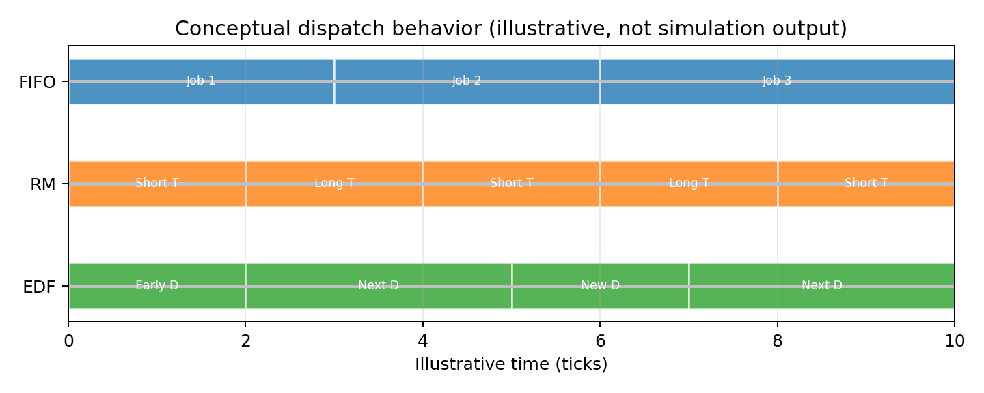
EDF uses absolute deadlines, not just task periods. Two jobs from the same periodic task can therefore compete differently as their release times change. A newly released job can preempt the current job if its deadline is earlier and the model permits preemption. Equal deadlines require a deterministic tie-breaking rule; otherwise repeated runs may produce different traces.
EDF chooses the ready job with the earliest absolute deadline. Unlike RM, its effective priority can change whenever new jobs arrive or deadlines differ. Under ideal single-processor assumptions, EDF has strong utilization-based schedulability properties, but those results do not automatically apply when blocking, overhead, non-preemptive sections, or implementation delays are introduced.

3. Synchronization: semaphore and monitor
The central correctness property is mutual exclusion: no two jobs may execute the protected region simultaneously. Mutual exclusion alone does not define fairness. A complete model also states whether waiters are served in arrival order or scheduler-priority order, whether a blocked job remains eligible for preemption, and exactly when a released waiter becomes ready. These choices must be held constant or explicitly treated as experimental factors.
A semaphore is a synchronization primitive with operations commonly described as wait/acquire and signal/release. A binary semaphore can protect one mutually exclusive resource. When the resource is unavailable, a requesting job may block until a release permits it to continue. The details depend on the semaphore implementation, including queue discipline and whether wake-up and ownership transfer are atomic.
A monitor is a higher-level construct that encapsulates shared data and the procedures that access it. Mutual exclusion is typically provided by the monitor itself; condition variables can allow a thread or job to wait for a condition and resume when notified. Monitor semantics differ across languages and runtimes, especially in whether notification immediately transfers control or merely makes a waiter eligible to compete again.
Figure 1. Conceptual architecture of shared-resource protection.
A fair experiment must specify ownership, wait queues, release behavior, wake-up order, and preemption points for both mechanisms. Naming two paths SEM and MON is not sufficient if their behavior is identical.

4. Experimental design
The comparison should be interpreted as a factorial experiment. Scheduler policy is one factor (FIFO, RM, EDF), synchronization abstraction is a second factor (semaphore, monitor), and workload is a third factor (A or B). To attribute a difference to one factor, change only that factor while keeping execution costs, releases, deadlines, resource requests, and simulation horizon fixed.
The experiment crosses two task sets with three scheduling policies and two synchronization labels. This produces twelve configuration runs. Each run uses the same task parameters and critical-section rule so that any measured difference can be traced to the modeled configuration rather than an accidental workload change.
Task set | Task | C, T, D | Purpose
A | A | 1, 4, 4 | Short period
A | B | 2, 5, 5 | Intermediate
A | C | 3, 10, 10 | Longer execution
B | X | 2, 5, 5 | Moderate period
B | Y | 4, 7, 7 | Higher execution demand
Here C is execution time, T is period, and D is relative deadline. The experiments use a single processor and periodic job releases. All times are expressed as integer simulation ticks.

5. Task set A and workload analysis

5.1 Worked utilization calculation
The utilization of a periodic task is C/T, where C is its execution demand and T is its period. For Task Set A, U = 1/4 + 2/5 + 3/10 = 0.25 + 0.40 + 0.30 = 0.95. Under the stated periodic assumptions, this means that the nominal execution demand occupies 95% of processor capacity over the long run, before synchronization or dispatch overhead is added. It does not prove that every job meets every deadline under every scheduling and blocking rule.

5.2 Hyperperiod interpretation
The hyperperiod is the least common multiple of task periods. For periods 4, 5, and 10, the hyperperiod is 20 ticks. The release pattern within this interval repeats if tasks are strictly periodic and phase offsets are zero. This makes the interval a convenient first observation window, but it does not eliminate the need to check each job’s absolute deadline and completion time.

5.3 What to inspect in the trace
For Task Set A, compare the time at which each job first starts, the number of interruptions it experiences, and whether completion occurs by its deadline. If a miss occurs, inspect the trace backward from the deadline: identify the CPU intervals consumed by other jobs, any interval during which the job was blocked on the resource, and the rule that selected the competing job. This process turns a chart into an explanation rather than a decorative picture.
Figure 5. Task Set A release pattern and execution demands over one 20-tick hyperperiod. Bars illustrate C, not a scheduler-produced CPU trace.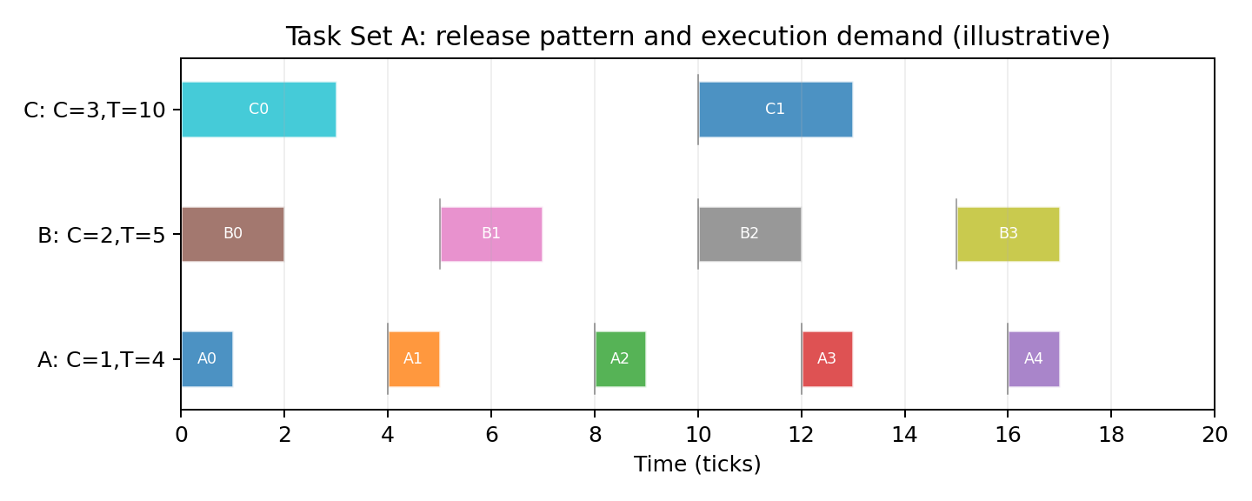
Task set A consists of A(C=1,T=4,D=4), B(C=2,T=5,D=5), and C(C=3,T=10,D=10). Its hyperperiod is the least common multiple of 4, 5, and 10, which is 20 ticks. The nominal utilization is the sum of C/T for each task: 1/4 + 2/5 + 3/10 = 0.95. This is a heavily loaded workload, leaving relatively little nominal processor capacity for overhead or blocking.
A high utilization value does not by itself prove that every job will meet its deadline. Actual behavior depends on release alignment, preemption, the discrete-time convention, and the resource protocol. The hyperperiod is useful because it provides a finite interval over which periodic release patterns repeat under the chosen task assumptions.

Interpretation notes
- A job released at a period boundary receives an absolute deadline equal to release time plus D.
- The nominal utilization excludes any extra overhead unless the simulation explicitly models it.
- Results should be reported alongside the exact horizon and the number of generated jobs.

6. Task set B and workload analysis

6.1 Worked utilization calculation
For Task Set B, U = 2/5 + 4/7 = 0.4 + approximately 0.5714 = approximately 0.9714. The nominal demand is therefore close to the full processor capacity. Small additional costs, such as synchronization overhead or context switches, may become important in a more realistic model. In this report those costs are not fully modeled, so the utilization value should be treated as a workload descriptor rather than a prediction of real operating-system performance.

6.2 Why task set B is a useful stress case
Task Set B contains only two periodic task types, but the execution demand of task Y is large relative to its period. This can create longer stretches of CPU occupancy and make the exact ordering of releases and deadlines important. Comparing it with Task Set A illustrates why task count alone is not a sufficient measure of difficulty. Periods, execution costs, deadlines, resource-use timing, and the scheduler’s decision rule all affect the observed trace.
Figure 6. Nominal CPU utilization of both workloads. Utilization is a demand indicator, not a substitute for deadline simulation.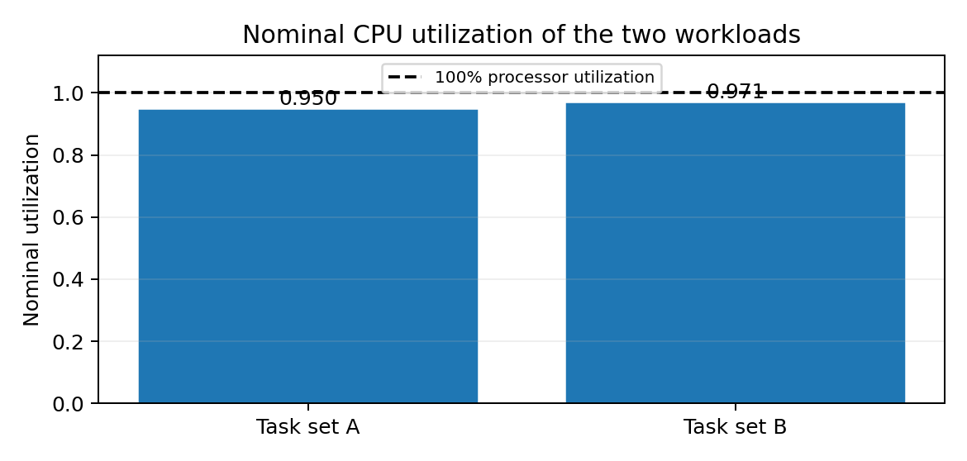
Task set B consists of X(C=2,T=5,D=5) and Y(C=4,T=7,D=7). Its hyperperiod is lcm(5,7)=35 ticks. Utilization is 2/5 + 4/7, approximately 0.9714. This workload is close to full nominal processor utilization and is useful for demonstrating why seemingly small blocking or scheduling effects can become important.
Task set B has fewer task types than set A, but the longer execution demand of Y means that individual jobs occupy the processor for a substantial fraction of their periods. It is therefore useful to compare both aggregate metrics and per-job records rather than relying only on one average value.

Why use two workloads?
A single task set can make a scheduler look favorable due to its particular periods and execution costs. Using two distinct task sets reduces dependence on one example. It does not, however, establish a universal ranking. Stronger conclusions require more task sets, varied utilization levels, randomized release phases where appropriate, and repeated runs under a clearly defined model.

7. Critical-section model
Figure 7. Common shared-resource lifecycle. The API and wake-up semantics differ between semaphore and monitor implementations.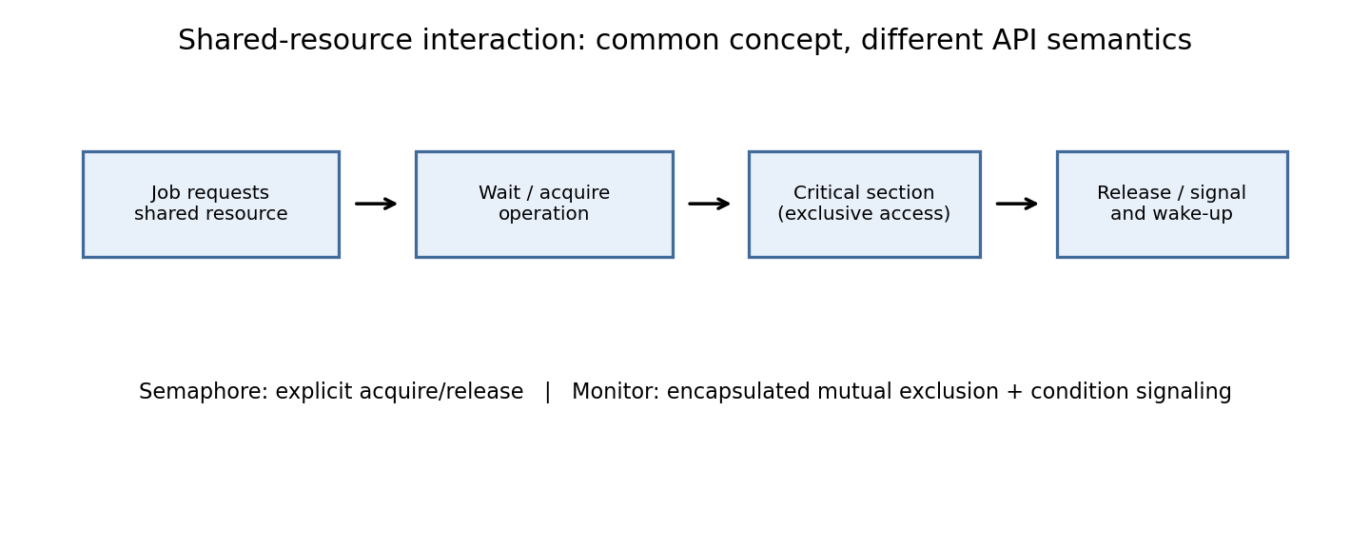
A critical section is a modeled interval during which a job accesses shared state. In this simplified scenario, the final min(2,C) execution units are designated as protected work. This convention is convenient for a small demonstration but does not represent every application: real tasks can have several critical sections, nested locks, or different resource lengths. The same critical-section placement must be used for every scheduler to avoid confounding.
The simulator marks the final min(2,C) units of each job’s execution as a critical section. Immediately before that section, a job requests the shared resource. If the resource is available, the job acquires it and executes the critical portion; otherwise, it waits until the resource becomes available. This design gives each job a bounded critical section while retaining a simple workload model.
The critical-section length is intentionally tied to execution cost to avoid assigning a section longer than the job itself. This is a teaching assumption, not a claim that real programs place their shared-resource operations at the end of execution. In a realistic application, critical-section location and length should be derived from the program’s access pattern.
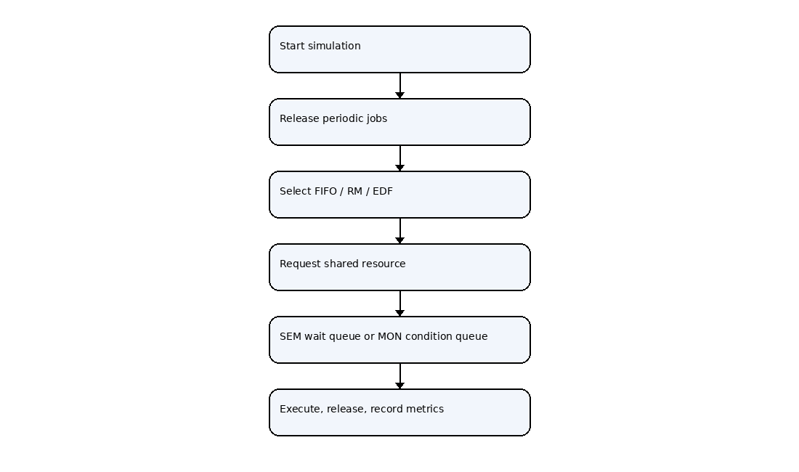
Figure 2. Workflow from release through scheduling and resource handling.

8. Scheduling loop and event ordering
Boundary conventions can change results by one tick. For example, if a job completes exactly at its deadline, the model must state whether completion is accepted before deadline-miss detection. Similarly, if a release and a resource signal occur at the same tick, event ordering determines which jobs are eligible for dispatch. The implementation should make this ordering explicit and cover it with tests.
A discrete-time simulator advances through integer ticks. At each tick it must decide when to release new jobs, update deadlines, process resource events, select a ready job, execute one unit, and record completion. The ordering of these events can affect results at boundary times. For example, a job released at tick t may or may not be eligible to run during the interval beginning at t depending on the chosen convention.
The implementation should document a single event order and apply it consistently to all configurations. Preemptive policies should reconsider the running job at the specified preemption points; FIFO should retain its non-preemptive behavior except when the model explicitly blocks the running job. Resource release must be processed in a way that does not leave a waiter stranded or grant ownership to more than one job.

Recommended event sequence
- Release jobs whose release time equals the current tick.
- Resolve completed critical sections and resource-release events.
- Update blocked and ready states and enforce queue rules.
- Select the running job according to the scheduler.
- Execute one tick and update remaining execution.
- Record completion, response, deadline, and trace information.

9. Metrics and definitions

9.3 Worked metric example
Suppose a job is released at tick 5, first receives the CPU at tick 7, completes at tick 10, and has an absolute deadline of tick 11. Its response time is 7 − 5 = 2 ticks; its turnaround time is 10 − 5 = 5 ticks; and its lateness is 10 − 11 = −1 tick. Since it completes before its deadline, it is not a deadline miss under the convention used here. This small example should be included in tests to confirm that the code uses release, first-start, completion, and deadline fields consistently.

9.4 Why averages are not enough
Two configurations can have the same mean response time while differing substantially in worst-case response or deadline-miss count. A report should therefore show a compact set of complementary measures: completed-job count, deadline-miss count, mean and maximum response time, mean turnaround time, maximum lateness, and unfinished jobs at the simulation horizon. If resource blocking is implemented explicitly, report blocked time separately from ready-queue waiting time.
For each run, report the number of released, completed, unfinished, and deadline-missing jobs. Averages should always include the sample count. Averages over completed jobs alone can be misleading when one configuration leaves more jobs unfinished; therefore unfinished jobs should be reported separately and not silently dropped. For trace-based evaluation, retain per-job release, first-start, completion, deadline, blocking, and preemption events.
The simulator exports summary and per-job data. Metrics should be defined mathematically so that results from different configurations remain comparable.

9.1 Core timing metrics
- Response time = first start time − release time.
- Turnaround time = completion time − release time.
- Waiting time for a completed job = turnaround time − CPU execution time.
- Lateness = completion time − absolute deadline.
- Deadline miss = completion time exceeds the absolute deadline, under the selected deadline convention.

9.2 Aggregate metrics
Means are useful for compact comparisons but can hide a small number of severe delays. A report should also include maximum response time, maximum lateness, deadline-miss count and ratio, completed-job count, and the distribution of outcomes by task. Jobs that remain unfinished at the simulation horizon must be counted explicitly rather than silently omitted from averages.
When waiting time is computed as turnaround minus CPU execution, it combines all non-CPU time in the model. If the analysis needs to distinguish resource-blocking time from ready-queue waiting, those quantities must be tracked separately.

10. Gantt charts and trace interpretation
A useful Gantt chart should use consistent colors for jobs, a clear time axis, and a legend that maps every label to a task and job index. If resource blocking is modeled, distinguish CPU execution from waiting: a blocked job does not consume processor time. A chart should be generated from the exact trace used for the metrics, rather than manually drawn, so visual evidence and numeric results cannot disagree.
A Gantt chart presents processor allocation over time. Each horizontal segment represents the job that owns the CPU during an interval; idle time and resource-blocked intervals should be distinguishable. A chart is most useful when accompanied by a legend, release markers, absolute deadlines, and a note about whether the trace is measured or schematic.
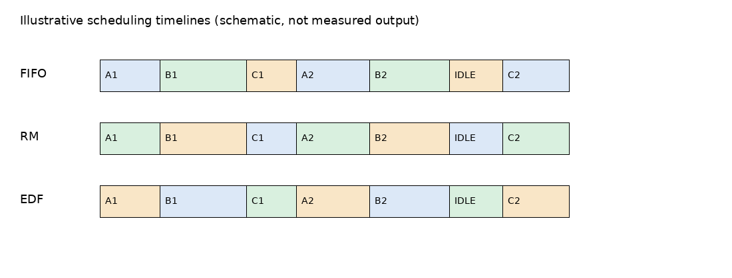
Figure 3. Schematic timeline for explaining Gantt-chart reading; not an experimental trace.
The included illustration is schematic and should not be cited as measured evidence. For an empirical result, the chart should be generated directly from the simulator’s trace output for a named task set, scheduler, synchronization model, and time window. The same scale and labeling convention should be used when comparing policies.

Questions to ask when reading a trace
- Which job is running at each interval, and why was it selected?
- When did a job become ready, blocked, resumed, or completed?
- Did a job miss its deadline, and was the cause CPU demand or resource blocking?

11. Experimental matrix
Policy | Selection key | Typical strength | Important caveat
FIFO | Oldest ready-queue entry | Simple and easy to explain | Does not prioritize deadlines or short periods
RM | Shortest task period | Stable fixed-priority order | A longer-period task may wait behind higher-priority work
EDF | Earliest absolute deadline | Directly reflects job deadlines | Requires correct deadline updates and deterministic tie handling

Table 2. High-level comparison of the three scheduling rules

11.1 Suggested experiment protocol
Run all twelve combinations using the same task parameters and simulation horizon. Before comparing results, verify that the number of generated jobs is identical across configurations unless a documented semantic difference changes eligibility. Preserve raw output rather than only copying summary averages into the paper. For each run, save a configuration identifier, source-code version, and execution timestamp so a result can be regenerated.

11.2 Separating effects
The difference between FIFO-SEM and FIFO-MON is intended to isolate synchronization behavior under a fixed scheduler. The difference between FIFO-SEM and RM-SEM is intended to isolate scheduler behavior under a fixed synchronization label. The current implementation’s simplified shared SEM/MON mechanics limit the first comparison: it can demonstrate the experimental structure, but cannot establish that semaphores and monitors produce different measured behavior. Distinct implementations are required before interpreting such differences as evidence.
The configuration matrix includes six scheduler/synchronization combinations for each task set: FIFO-SEM, FIFO-MON, RM-SEM, RM-MON, EDF-SEM, and EDF-MON. Running the complete matrix is important because a single comparison can confound scheduler behavior with a synchronization setting.
Task set | Scheduler | Sync label | Run identifier
A | FIFO | SEM | A-FIFO-SEM
A | FIFO | MON | A-FIFO-MON
A | RM | SEM | A-RM-SEM
A | RM | MON | A-RM-MON
A | EDF | SEM | A-EDF-SEM
A | EDF | MON | A-EDF-MON
B | FIFO | SEM | B-FIFO-SEM
B | FIFO | MON | B-FIFO-MON
B | RM | SEM | B-RM-SEM
B | RM | MON | B-RM-MON
B | EDF | SEM | B-EDF-SEM
B | EDF | MON | B-EDF-MON
The same parameter file, simulator version, and time horizon should be used for every run. Each output row should preserve the configuration identifier so summary tables can be traced back to individual jobs and time intervals.

12. Results: how to report observations

12.1 Recommended results table
A useful results table should contain one row per configuration and columns for task set, scheduler, synchronization implementation, released jobs, completed jobs, deadline misses, mean response time, maximum response time, mean turnaround, and maximum lateness. Include units in the column headings or a table note. If a value is undefined because no job completed, mark it as not available rather than substituting zero.

12.2 Reporting uncertainty and limitations
A deterministic simulator with fixed parameters may produce exactly the same trace on every run; repeated execution alone then does not measure statistical uncertainty. Instead, robustness can be assessed by varying task parameters, phase offsets, critical-section lengths, and tie-breaking rules across a planned set of scenarios. Each scenario should be identified clearly, and the study should avoid selecting only the cases that support a preferred conclusion.
The program generates CSV output rather than embedding unsupported numerical claims in the paper. After execution, summary metrics should be inspected for all twelve runs and validated against selected job-level traces. A result table should include at least task set, scheduler, synchronization label, number of jobs, number of completed jobs, deadline misses, mean response time, mean turnaround time, and mean waiting time.
A useful narrative does not simply announce a winner. It identifies the workload and metric, quantifies the difference, and explains which model rule could plausibly account for it. If the SEM and MON paths produce identical results because they share the same resource handoff implementation, that is evidence of implementation equivalence in this simulator—not proof that semaphores and monitors are equivalent in general.

Validation checks
- Confirm every expected configuration appears exactly once in the summary.
- Check that completion times are not earlier than release or first start times.
- Verify remaining execution never becomes negative.
- Inspect jobs that miss deadlines or remain unfinished at the horizon.
- Compare selected CSV rows with the event trace or Gantt data.

13. Semaphore versus monitor: careful comparison
A binary semaphore is typically manipulated through explicit wait/post or acquire/release calls; the caller is responsible for following the protocol. A monitor groups shared state with methods that enforce mutual exclusion, while condition variables allow a thread to wait for a predicate and be notified when it may be true. A notification does not necessarily mean the waiting job can proceed immediately: it may need to reacquire the monitor and re-check the condition.
A fair comparison requires the synchronization mechanisms to implement clearly specified semantics. For a semaphore, the implementation must define whether it is binary or counting, how waiters are ordered, and when a successful signal permits acquisition. For a monitor, the implementation must specify monitor-entry mutual exclusion, condition-variable behavior, and whether notification transfers control or merely wakes a waiter.
These distinctions may influence blocking and ready-queue competition. For example, FIFO wake-up order may differ from scheduler priority order; an awakened job might be eligible to run immediately or only after the current monitor owner exits. If both labels call the same queue and the same acquisition/release functions, these behavioral distinctions are not represented.

What can be concluded from the current code?
The current code is a reproducible scaffold for comparing scheduler labels and collecting timing records. Because the SEM and MON resource paths share simplified mechanics, it cannot support a strong empirical claim that one synchronization primitive outperforms the other. A follow-up version should implement distinct protocol classes and unit tests before interpreting differences as synchronization effects.

14. Reproducibility and software use

14.1 Suggested command-line workflow
Keep the source script in a dedicated source directory and place raw CSV output in a separate results directory. Run the script from a clean environment, check that all expected files are created, and open the summary CSV before interpreting any figure. When generating figures from CSV data, include axis labels, units, a legend, and the configuration name. Do not manually edit the raw data file; create a separate derived file if filtering or aggregation is required.

14.2 Data provenance
The article should distinguish three types of material: analytically calculated values such as utilization and hyperperiod; output produced by the simulator; and conceptual illustrations intended only to explain an idea. Mixing these categories can make an educational paper appear to claim empirical findings it has not established. Every chart caption should explicitly say which type it is.
The simulator is written in Python 3 and uses the standard library. Run it from a terminal in the directory containing the script:
python fifo_rm_edf_sem_monitor_comparison.py
The script exports CSV files for summary metrics, per-job details, and the Gantt-oriented trace. Keep the script and generated CSV files together with a short run note recording Python version, execution date, and any changes to task parameters. If the code is modified, increment a version identifier so that tables and charts can be traced to the correct implementation.

Suggested project structure
- src/ — simulator and scheduler implementations.
- results/ — raw CSV output and derived tables.
- figures/ — charts generated from the trace data.
- README.md — environment, command, assumptions, and known limitations.
- tests/ — tests for release timing, deadlines, mutual exclusion, and queue ordering.

15. Verification and testing plan
A minimal test suite should include (1) two jobs requesting the resource simultaneously, (2) a job arriving while another owns the resource, (3) multiple waiters released in sequence, (4) a preemption at a tick boundary, and (5) a job whose completion is exactly at its deadline. Each test should state the expected state transitions and assert invariants. Regression tests are particularly important after changing the semaphore and monitor implementations separately.
A simulation can produce plausible-looking charts while still containing logic errors. Verification should therefore begin with small cases whose expected behavior can be reasoned about manually. A one-task workload checks periodic release and completion accounting. A two-task workload with no shared resource checks scheduler selection. A resource-contention case checks mutual exclusion, blocking, and handoff.

Essential invariants
- At most one job owns a binary shared resource at any time.
- A job cannot execute while blocked on the resource.
- A completed job has zero remaining execution.
- Each job has exactly one release time and one absolute deadline.
- A job’s first-start time is recorded once and never overwritten.
- Every generated chart interval corresponds to the trace record for that interval.
Tests should cover simultaneous releases, a deadline at a tick boundary, a resource release when multiple waiters exist, and preemption while a lower-priority job is ready. These tests help ensure that apparent scheduler differences are not artifacts of inconsistent event ordering.

16. Limitations and threats to validity
The report is an educational framework rather than a validated real-time analysis tool. It does not establish worst-case execution-time bounds, account for context-switch overhead, or model multicore interference. The two task sets are intentionally small and do not span a broad range of utilization or deadline relationships. Therefore, no universal ranking of FIFO, RM, and EDF should be inferred from this experiment alone.
The model uses a single processor, integer time ticks, a single shared resource, fixed critical-section assumptions, and a finite simulation horizon. These choices make the code approachable but omit many operating-system effects, including context-switch cost, interrupt handling, multiple resources, nested locking, priority inheritance, priority ceiling protocols, and runtime-specific monitor semantics.
The model also uses a simplified synchronization implementation shared by the SEM and MON configurations. Thus, the current version is not suitable for drawing general conclusions about the relative performance or safety of those primitives. The Gantt illustration included in this report is schematic and must not be mistaken for a measured trace.

Threats to validity
- Internal validity: implementation details may drive measured differences.
- Construct validity: waiting time may combine ready-queue delay and resource blocking.
- External validity: two task sets cannot represent all real-time workloads.
- Conclusion validity: averages can obscure deadline misses and worst-case behavior.

17. Future improvements
A stronger implementation should represent each synchronization primitive as a separate component with its own acquire, release, waiting-queue, and wake-up rules. The simulator should record the reason for every state transition and export a machine-readable event trace. Repeated tests over generated task sets could then estimate how outcomes change with utilization, critical-section length, task count, and deadline-to-period ratio.
A stronger study should implement separate semaphore and monitor abstractions with documented, testable semantics. It should track ready-queue waiting and resource-blocking time separately, generate actual Gantt charts from trace events, and include a unit-test suite. Additional experiments could vary utilization, critical-section length, number of resources, and task count.

Recommended next steps
- Implement distinct SEM and MON acquisition, waiting, notification, and release behavior.
- Add optional priority inheritance or priority-ceiling protocols as separate experimental factors.
- Run task sets across a range of utilization values rather than only near saturation.
- Report worst-case as well as average timing metrics.
- Generate plots directly from CSV traces and include configuration labels in every figure.
- Publish code, parameter files, raw data, and a README to make the results independently reproducible.
These extensions would make it possible to test meaningful hypotheses about interactions between scheduling and synchronization instead of merely comparing labels.

18. Conclusion

18.1 Practical interpretation
The most useful outcome of this framework is a repeatable method for inspecting scheduling decisions and resource access, not a universal claim that one algorithm always wins. FIFO is simple but does not account directly for task periods or deadlines; RM uses a stable period-based priority order; EDF responds to absolute deadlines. The observed trade-offs depend on the workload and on the exact synchronization semantics implemented.

18.2 Final methodological recommendation
Before presenting a definitive SEM-versus-MON result, implement the two primitives separately, write tests for waiting and wake-up behavior, and generate all numeric tables and Gantt charts from the same event trace. This keeps the explanatory text, code, and figures aligned and makes the comparison easier for another student or researcher to reproduce.
This report has described an educational framework for comparing FIFO, RM, and EDF scheduling under semaphore and monitor synchronization labels. It defines two periodic task sets, a simple critical-section rule, a set of timing metrics, and a reproducible workflow for collecting results. The figures explain the architecture, simulation flow, and interpretation of Gantt timelines, while clearly distinguishing conceptual illustrations from measured traces.
The central methodological lesson is that scheduler comparisons and synchronization comparisons must be designed separately and then combined systematically. In particular, SEM and MON should not be treated as behaviorally different unless their implementations actually differ in acquisition, queueing, wake-up, and ownership semantics. The current program is best understood as a teaching scaffold; its output should be checked against invariants and interpreted within the model’s limits.
Field | Meaning | Why it matters
release_time | Tick when the job becomes eligible | Anchors response and deadline calculations
first_start | First CPU tick assigned to the job | Used to calculate response time
completion_time | Tick when remaining execution reaches zero | Used for turnaround and deadline checks
absolute_deadline | release_time + relative deadline | Defines timing requirement
blocked_duration | Time waiting for resource ownership | Separates synchronization delay from ready-queue delay
preemption_count | Number of interruptions after starting | Helps interpret dispatch behavior
status_at_horizon | Completed, blocked, ready, or running | Prevents unfinished jobs from disappearing from summaries

References

Reproducibility checklist
Before publishing numeric comparisons, archive the source code, Python version, task-set parameters, run command, and raw CSV files. Record whether the figures are schematic or generated from a real trace. Any change to tie-breaking, event ordering, resource wake-up rules, or deadline convention should be documented as a model change.

Table 1. Recommended trace fields and their interpretation
[1] C. L. Liu and J. W. Layland, “Scheduling Algorithms for Multiprogramming in a Hard-Real-Time Environment,” Journal of the ACM, vol. 20, no. 1, pp. 46–61, 1973.
[2] A. S. Tanenbaum and H. Bos, Modern Operating Systems, 4th ed. Pearson, 2015.
[3] G. C. Buttazzo, Hard Real-Time Computing Systems: Predictable Scheduling Algorithms and Applications, 3rd ed. Springer, 2011.
[4] E. W. Dijkstra, “Cooperating Sequential Processes,” in Programming Languages, F. Genuys, Ed. Academic Press, 1968.
Appendix note: The Python implementation and CSV outputs should accompany this report when the experiment is submitted or shared.

