A Comparative Study of Synchronization Mechanisms
Monitor, Semaphore, Peterson's Algorithm, and Dekker's Algorithm
Erfan Barati
Eshragh Institute of Higher Education

Abstract
Mutual exclusion is one of the central problems of concurrent programming. When several processes or threads share a resource, uncoordinated access can produce race conditions, lost updates, and inconsistent state. This article compares four classical approaches to the problem: the semaphore, the monitor, Peterson's algorithm, and Dekker's algorithm. The first two are high-level primitives that depend on operating system or language support. The last two are software-only solutions built from shared variables and are restricted to two processes. The comparison considers the structure of each mechanism, the correctness properties it guarantees, its waiting behavior, its implementation complexity, and its hardware requirements. Pseudocode, flowcharts, a Gantt chart, and comparison tables are provided. The article concludes that semaphores and monitors are the practical choices for general concurrent systems, while Peterson's and Dekker's algorithms remain valuable for understanding how mutual exclusion can be built from first principles.
Keywords: mutual exclusion, semaphore, monitor, Peterson's algorithm, Dekker's algorithm, critical section, concurrency.

1. Introduction
Modern computers execute many activities concurrently. Threads in an application, processes in an operating system, and interrupt handlers all run interleaved on one or more processors. Most of the time these activities are independent, but when they touch the same data structure, the order in which their operations interleave determines the result. A classic example is two processes that each read a counter, add one, and write it back. If both read the same value before either writes, one increment is lost.
The section of code that accesses the shared resource is called the critical section (CS). The purpose of a synchronization mechanism is to ensure that the CS is executed by at most one process at a time. A correct solution is usually judged by three properties, which are standard in the operating systems literature:
Mutual exclusion: at most one process is inside its critical section at any moment.
Progress: if no process is in the critical section and some processes wish to enter, the decision about which one enters next cannot be postponed indefinitely.
Bounded waiting: once a process has requested entry, the number of times other processes may enter before it is finite. This property is also called freedom from starvation.
A fourth goal, which is more practical than theoretical, is efficiency: a waiting process should not waste processor time, and the mechanism should be simple enough that programmers can use it without introducing errors. The four mechanisms studied here differ considerably in how well they meet these goals.
The remainder of the article is organized as follows. Section 2 describes semaphores, Section 3 describes monitors, Section 4 presents Peterson's algorithm, and Section 5 presents Dekker's algorithm. Section 6 compares the criteria that were identified in the handwritten comparison, and Section 7 compares all four mechanisms in a single table. Section 8 illustrates the execution of Peterson's algorithm with a Gantt chart. Section 9 discusses practical considerations, Section 10 lists limitations, and Section 11 concludes.

2. Semaphore

2.1 Definition
A semaphore, introduced by Edsger Dijkstra in the 1960s, is an integer variable that is accessed only through two atomic operations. The first operation is P (from the Dutch proberen, to test), also called wait or down. The second is V (from verhogen, to increase), also called signal or up. Atomicity means that the operation executes as a single indivisible step, so no other process can observe the variable in an intermediate state.
When S is negative, its absolute value equals the number of processes waiting on the semaphore. This invariant is useful for reasoning about correctness, although real implementations usually store the queue separately from the counter.

2.2 Types of semaphores
A binary semaphore takes only the values 0 and 1 and is initialized to 1. Used this way, it enforces mutual exclusion: the process that performs P first holds the lock, and any other process that performs P blocks until the holder performs V. A counting semaphore is initialized to a number n greater than 1 and controls access to a pool of n identical resources, such as database connections or printers.

2.3 Flowchart
Figure 1 shows the control flow of the P and V operations. Notice that a process that blocks does not consume processor time; it is removed from the run queue until another process performs V.
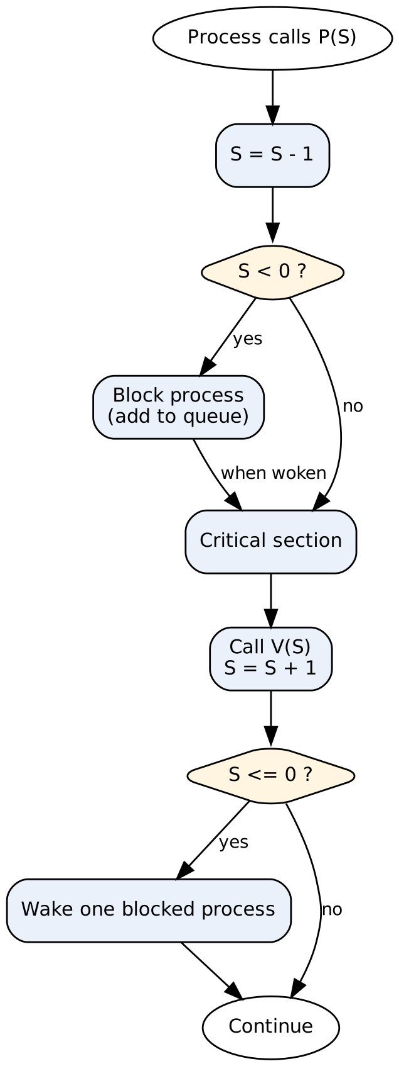
Figure 1. Flowchart of the P (wait) and V (signal) operations.

2.4 Example usage
The following pseudocode shows how a binary semaphore protects a shared counter. The programmer must pair every P with a V on every execution path, including error paths. This requirement is the main source of difficulty in practice.
shared: counter = 0; mutex = semaphore(1)

process i:
P(mutex)
counter = counter + 1 // critical section
V(mutex)

2.5 Strengths and weaknesses
Strengths: semaphores are general and flexible. The same primitive can express mutual exclusion, signaling between processes, rendezvous, and resource counting. Blocked processes sleep rather than spin, so they do not waste CPU time.
Weaknesses: semaphores are easy to misuse. A forgotten V causes all later processes to block forever, which is a deadlock. A V placed before a P in the wrong order can allow two processes into the CS. Because the compiler and the runtime cannot check these pairings, correctness depends entirely on programmer discipline. Large programs using many semaphores are difficult to verify and debug.

3. Monitor

3.1 Definition
A monitor is a higher-level construct proposed by Per Brinch Hansen and by C. A. R. Hoare in the early 1970s. A monitor bundles shared data together with the procedures that operate on that data. The language runtime guarantees that at most one process executes a monitor procedure at a time. This guarantee is provided automatically, so the programmer does not write explicit lock and unlock calls.
Because a monitor procedure may need to wait for a condition that is not yet true, monitors provide condition variables. A process calls wait(c) on a condition variable c to release the monitor and sleep until another process calls signal(c). The semantics of signal differ between implementations. In Hoare's original formulation, the signaled process runs immediately and the signaling process is suspended. In Mesa-style monitors, which are used in many practical systems, the signaled process is moved to a ready queue and must recheck its condition after it runs.

3.2 Example: bounded buffer
The bounded buffer is the standard example for comparing synchronization mechanisms. It has a fixed number of slots, producers insert items, and consumers remove them. A producer must wait when the buffer is full, and a consumer must wait when it is empty.
monitor BoundedBuffer:
condition notFull, notEmpty
integer count = 0

procedure put(item):
if count == N then wait(notFull)
insert item into buffer
count = count + 1
signal(notEmpty)

procedure get():
if count == 0 then wait(notEmpty)
remove item from buffer
count = count - 1
signal(notFull)

Notice that no explicit lock appears in the code. The mutual exclusion is provided by the monitor itself, and the condition variables handle the waiting. A Mesa-style implementation would replace the single if test with a while loop, so that the condition is rechecked after wakeup.

3.3 Flowchart
Figure 2 summarizes the entry, wait, and signal behavior of a monitor procedure.
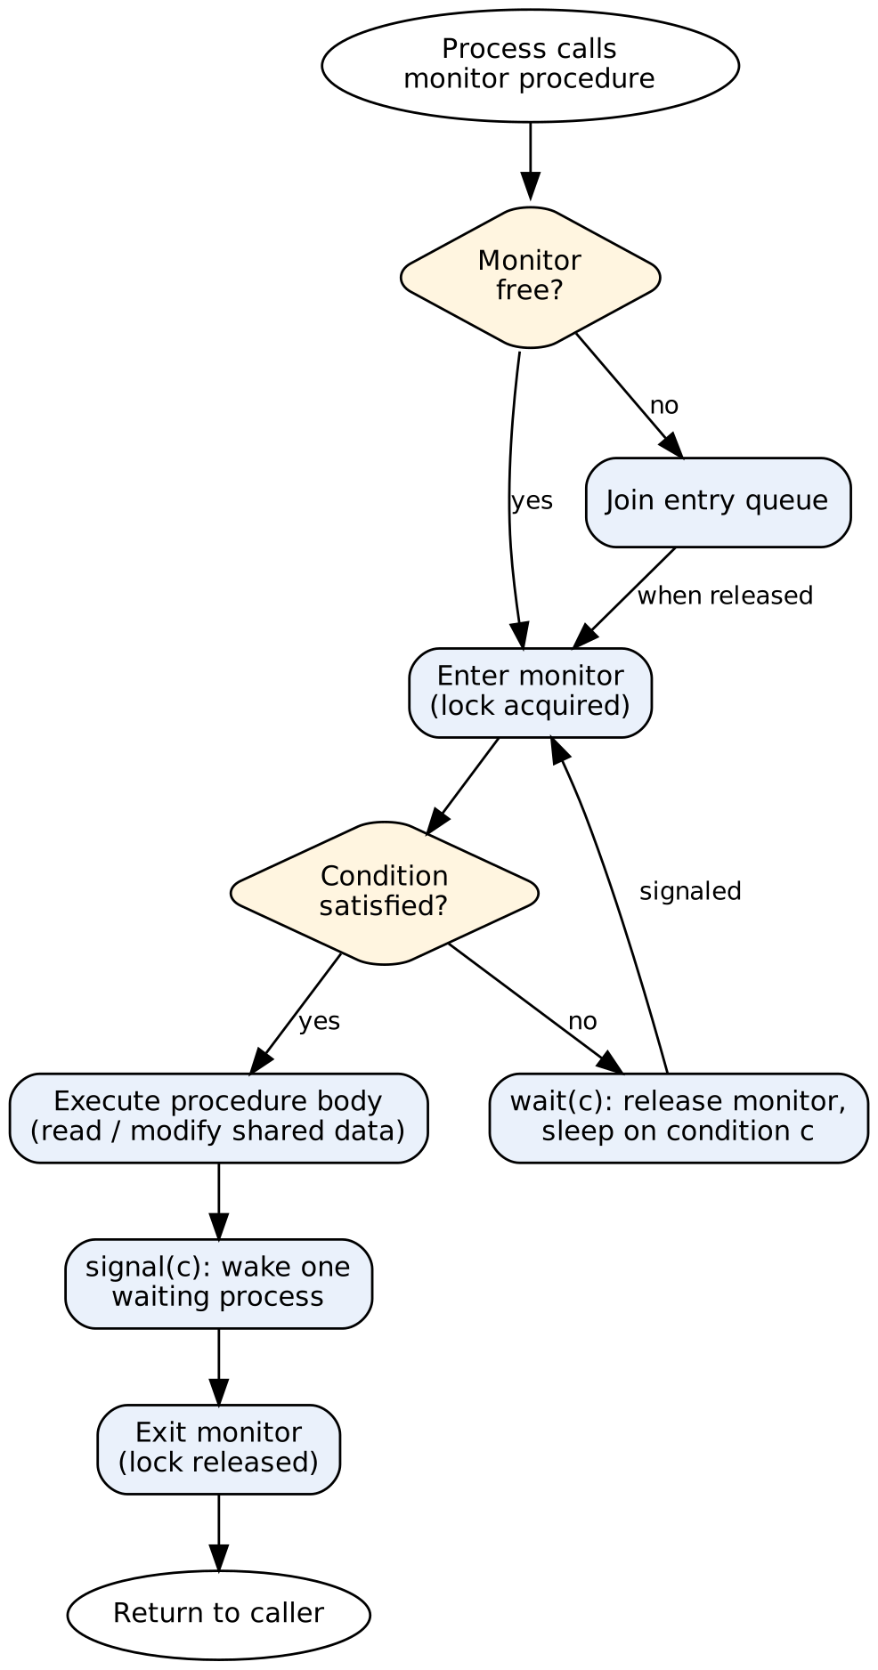
Figure 2. Flowchart of entry to and exit from a monitor procedure with condition waiting.

3.4 Strengths and weaknesses
Strengths: mutual exclusion is automatic, data and the rules for accessing it are encapsulated in one module, and the structure is less error-prone than a collection of raw semaphores. Monitors also make the synchronization logic readable, because the code that protects the data sits next to the data.
Weaknesses: monitors require support from the programming language or runtime, which is not available in every language. The exact semantics of signal vary between implementations, so programs written for one monitor model may behave differently on another. Monitors also do not prevent deadlock when a monitor procedure calls into another monitor while holding the first one.

4. Peterson's Algorithm

4.1 Background
Peterson's algorithm was published by Gary L. Peterson in 1981. It is a short software-only solution to the mutual exclusion problem for two processes. It is valuable because it uses only ordinary read and write operations on shared variables, so it shows that mutual exclusion does not require special hardware instructions in principle. In practice, as discussed later, modern processors require memory barriers for it to be correct.

4.2 Algorithm
The algorithm uses three shared variables. The array flag has one entry per process, and flag[i] is true when process i wants to enter the CS. The variable turn indicates which process must yield when both processes want to enter at the same time. Each process i uses j = 1 - i to refer to the other process.
shared: flag[0] = flag[1] = false; turn

process i (j = 1 - i):
flag[i] = true // announce intent
turn = j // give priority to the other process
while (flag[j] and turn == j) do nothing // busy wait
critical section
flag[i] = false // announce exit

4.3 Flowchart
Figure 3 shows the entry protocol for process i. The decision node loops back to itself while the other process holds priority, which is the busy-waiting behavior of the algorithm.
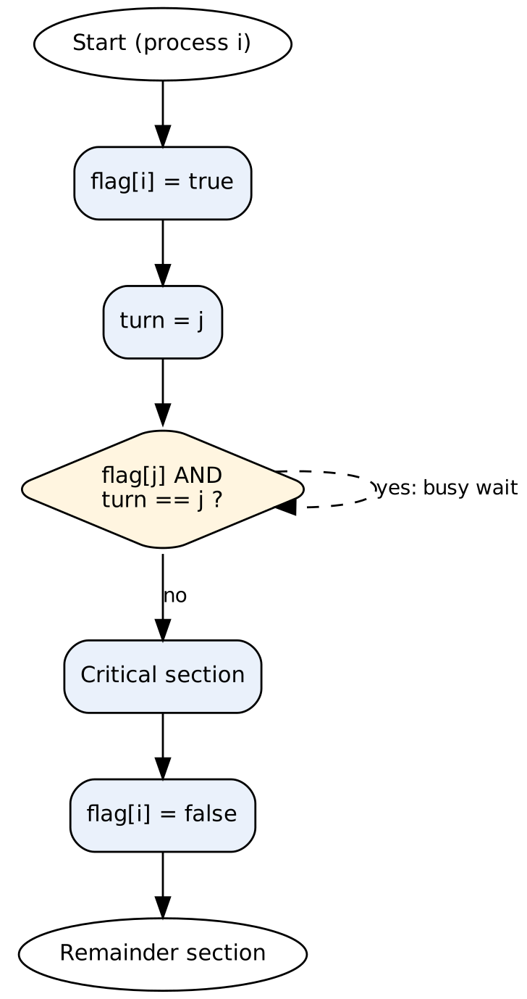
Figure 3. Flowchart of Peterson's algorithm for process i.

4.4 Correctness argument
Mutual exclusion holds because of the turn variable. Suppose both processes are in the CS at once. Each must have set its flag before testing the other's flag. Whichever process wrote turn last determines the outcome: the process that yielded last is the one that continues to wait, so it cannot enter while the other flag is still true. Progress holds because a process that is not competing does not change its flag, so the other process is never blocked by it. Bounded waiting holds because once a process has set turn to the other process, the other process can enter at most once before the waiting process is given priority.

4.5 Strengths and weaknesses
Strengths: the algorithm is short, easy to state, and provably correct for two processes under sequential consistency. It satisfies all three properties of mutual exclusion, progress, and bounded waiting, and it is widely used as a teaching example.
Weaknesses: the algorithm is limited to exactly two processes. Waiting is active, so a waiting process consumes CPU cycles. On modern processors with out-of-order execution and write buffers, the writes to flag and turn may become visible to the other processor in a different order, so the algorithm needs memory barriers to be correct.

5. Dekker's Algorithm

5.1 Background
Dekker's algorithm is the first known software-only solution to the mutual exclusion problem for two processes. It was devised by the Dutch mathematician Th. J. Dekker in the late 1950s or early 1960s, and it was published with Dijkstra's commentary in 1965. Dijkstra's paper is also the origin of the three-property framework used in this article. Dekker's algorithm is historically important because it demonstrated that mutual exclusion can be achieved without special hardware instructions.

5.2 Algorithm
Dekker's algorithm uses the same shared variables as Peterson's algorithm, but its entry protocol is different. Instead of simply giving priority to the other process, it lets a process back off explicitly when both processes indicate interest. A process that backs off clears its flag, waits until the turn variable changes, and then announces its interest again.
shared: flag[0] = flag[1] = false; turn

process i (j = 1 - i):
flag[i] = true
while flag[j] do
if turn == j then
flag[i] = false // back off
while turn == j do nothing // wait for our turn
flag[i] = true // announce again
critical section
turn = j // hand over priority
flag[i] = false

5.3 Flowchart
Figure 4 shows the entry and exit protocol of Dekker's algorithm for process i. The back-off branch is what distinguishes Dekker's algorithm from Peterson's: a process that loses a contention step retracts its claim instead of insisting on entering.
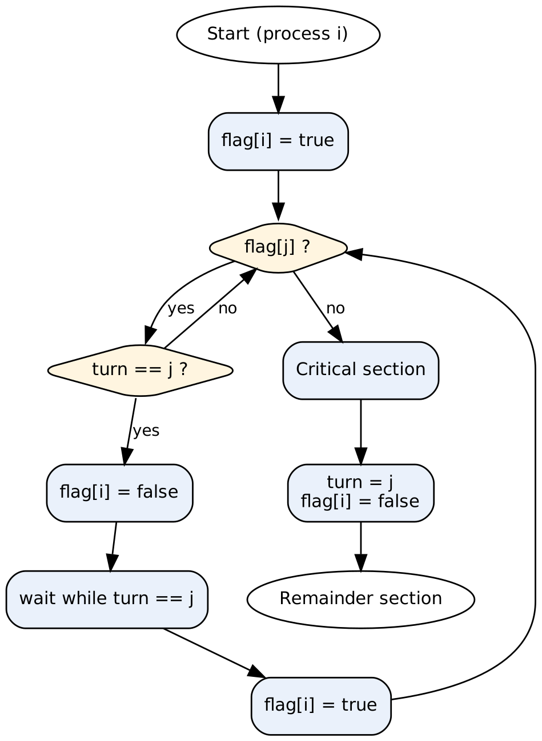
Figure 4. Flowchart of Dekker's algorithm for process i.

5.4 Strengths and weaknesses
Strengths: Dekker's algorithm satisfies mutual exclusion, progress, and bounded waiting for two processes. It is historically significant and shows the value of explicit back-off as a design technique.
Weaknesses: the entry protocol is considerably more complex than Peterson's, which makes it harder to read and to verify. The back-off logic has several nested conditions, and reasoning about all possible interleavings is more demanding. It also shares Peterson's limitations: it works only for two processes, it uses busy waiting, and it requires memory ordering guarantees on modern hardware.

6. Comparison of the Four Mechanisms by the Handwritten Criteria
The handwritten comparison lists the criteria that the author considered most important. These are the number of processes, the use of a flag array, the use of a turn variable, active waiting, starvation freedom, mutual exclusion, progress, bounded waiting, and simplicity. Table 1 applies these criteria to all four mechanisms. A check mark (✓) means that the property holds, a cross (✗) means that it does not, and a phrase means that the property depends on the implementation.
Criterion | Semaphore | Monitor | Peterson | Dekker
Number of processes | Any | Any | 2 | 2
Uses flag array | ✗ | ✗ | ✓ | ✓
Uses turn variable | ✗ | ✗ | ✓ | ✓
Active (busy) waiting | ✗ (blocks) | ✗ (blocks) | ✓ | ✓
Starvation-free (bounded waiting) | Depends on queue (✓ with FIFO) | Depends on signal policy | ✓ | ✓
Mutual exclusion | ✓ (binary) | ✓ (automatic) | ✓ | ✓
Progress | ✓ | ✓ | ✓ | ✓
Simplicity | Medium | Medium | Simpler | More complex
Table 1. Criteria comparison of the semaphore, monitor, Peterson's algorithm, and Dekker's algorithm.
Two observations follow from Table 1. First, the two software algorithms are equal with respect to every correctness property, so the choice between them is not a choice of safety. The semaphore and monitor differ from them mainly by not using flags or a turn variable and by blocking instead of spinning. Second, the only substantive difference is simplicity. Peterson's entry protocol is shorter and has fewer branches, which makes it easier to verify and less likely to contain an implementation error. Dekker's algorithm reaches the same guarantees with a more involved back-off mechanism.
A note on the handwritten table is necessary here. The handwritten version marked Peterson's algorithm with a cross in the starvation-freedom row. In the standard analysis of the algorithm, Peterson's algorithm does guarantee bounded waiting, because the turn variable gives the other process priority after one entry. For this reason, Table 1 marks the property as satisfied for both algorithms. If the course material uses a different definition of starvation, the row should be revisited against that definition.

7. Comparison of All Four Mechanisms
Table 2 extends the comparison to all four mechanisms. The semaphore and monitor are high-level primitives, so the hardware-support row refers to the platform facilities that the implementation relies on. The software-only algorithms rely on the memory model of the processor.
Criterion | Semaphore | Monitor | Peterson | Dekker
Type | OS primitive | Language construct | Software | Software
Number of processes | Any | Any | 2 | 2
Mutual exclusion | Yes (binary) | Automatic | Yes | Yes
Bounded waiting | Depends on queue policy | Depends on queue policy | Yes | Yes
Waiting style | Blocking | Blocking | Busy waiting | Busy waiting
Hardware support | Atomic operations | Runtime support | Memory barriers | Memory barriers
Error-proneness | High | Low | Low | Medium
Implementation complexity | Medium | Medium | Low | High
Scalability to n processes | Yes | Yes | No | No
Table 2. Comparison of the four synchronization mechanisms.
The table makes the main trade-off visible. Semaphores and monitors scale to any number of processes and block waiting processes, but they depend on system or language support. Peterson's and Dekker's algorithms require nothing beyond shared memory, but they are restricted to two processes and waste processor time while waiting. Among the four, the monitor is the least error-prone for application programmers, while the semaphore is the most flexible and the most dangerous to misuse.

7.1 Qualitative ranking
If the four mechanisms are ranked by ease of correct use for a typical application programmer, the order is monitor, then semaphore, then Peterson's algorithm, then Dekker's algorithm. If they are ranked by generality, the order is semaphore and monitor first, followed by the two-process algorithms. The ranking by ease of correct use is not the same as the ranking by simplicity of the algorithm, since Peterson's algorithm is simple but is still a low-level technique that most application programmers should not implement themselves.

8. Execution Timeline with a Gantt Chart
A Gantt chart makes the timing of a synchronization mechanism visible. Figure 5 shows a scenario with two processes, P1 and P2, that each request the critical section twice under Peterson's algorithm. Each bar is either non-critical work, waiting in the entry protocol, or execution inside the CS. Time is measured in abstract units.
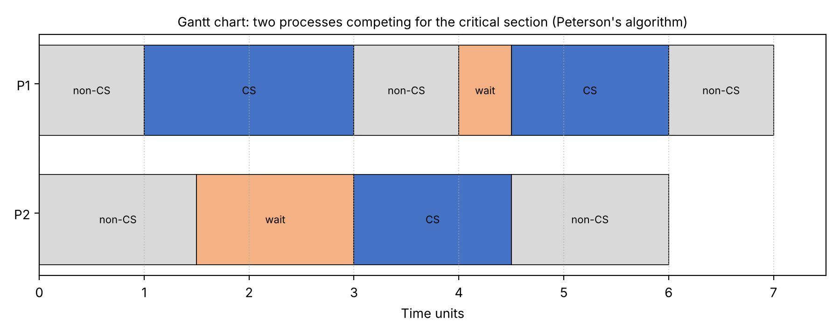
Figure 5. Gantt chart of two processes sharing the critical section under Peterson's algorithm.
The chart shows the core behavior of the algorithm. Process P1 enters the CS first at time 1, and P2 requests entry at time 1.5 and waits until P1 leaves at time 3. When P2 enters at time 3, P1 has already finished its non-critical work and requests entry at time 4. It waits briefly and enters at time 4.5, after P2 has yielded through the turn variable. Neither process is blocked forever, and each process enters the CS once between the other process's entries. This alternation is what bounded waiting means in practice.
The same scenario under a blocking mechanism such as a semaphore would look different. The waiting segments would appear as idle time rather than as spinning, and the processor could run other threads during that time. This difference is one of the main practical reasons for preferring blocking primitives in general-purpose systems.

8.1 Step-by-step trace of Peterson's algorithm
Table 3 traces the shared variables for the scenario in Figure 5. The trace makes the role of the turn variable concrete: each process writes turn to the other process's index at the moment it asks for entry, so the most recent writer is the one that waits.
Time | Event | flag[P1] | flag[P2] | turn | Who may enter
0 | Both processes in non-critical section | false | false | - | Nobody
1 | P1 sets flag and turn | true | false | P2 | P1 (P2 not interested)
1.5 | P2 sets flag and turn | true | true | P1 | P1 (turn favors P1)
3 | P1 leaves CS, flag[P1] = false | false | true | P1 | P2 (flag[P1] is false)
3 | P2 enters CS | false | true | P1 | P2 is inside
4 | P1 sets flag and turn again | true | true | P2 | P2 is still inside
4.5 | P2 leaves CS, flag[P2] = false | true | false | P2 | P1 (flag[P2] is false)
Table 3. Trace of shared variables for Peterson's algorithm in the scenario of Figure 5.
The trace also shows why the algorithm does not deadlock. At no point are both processes waiting on conditions that can only be satisfied by the other process's waiting. Whenever both flags are true, exactly one value of turn is written last, and the process it names is the one that waits; the other process proceeds.

8.2 Applications in practice
Each mechanism appears in real systems in a characteristic way. Semaphores are the underlying primitive of many operating system kernels and of the POSIX semaphore interface, and they are used for resource pools such as connection limits in servers. Monitors appear as the synchronized keyword in Java, as the lock and condition variable combination in many standard libraries, and as the design model for thread-safe classes in object-oriented languages. Peterson's algorithm is rarely used directly in production software, but its ideas are present in lock designs that rely on atomic flags and turn counters. Dekker's algorithm is almost exclusively studied for its historical and pedagogical value, because hardware atomic instructions provide simpler and faster locks.
These examples show a common pattern. The high-level primitives are used by application programmers, while the low-level algorithms are used by the implementers of those primitives. Understanding the low-level algorithms therefore helps a programmer reason about the behavior of higher-level constructs, including their performance and their failure modes.

8.3 Common implementation errors
Each mechanism has characteristic mistakes. Recognizing them is an important part of using synchronization correctly. The following examples show errors that appear frequently in student and industrial code.
Semaphore ordering error. Swapping the order of P and V in the code below allows an incorrect schedule. The first version is correct, while the second can let two processes enter the CS at once or can deadlock if the same semaphore is used for another purpose.
// correct // incorrect
P(mutex) V(mutex)
counter++ counter++
V(mutex) P(mutex)

Missing exit path. A procedure that performs P and returns early on an error branch, without performing V, leaves the semaphore permanently decremented. Later processes then block forever. Languages with exception handling and finally blocks reduce this risk, which is one reason monitors and structured locks are preferred.
Missing memory barrier. In Peterson's algorithm, writes to flag and turn must be visible to the other processor in program order. Without a barrier between the write to turn and the read of flag[j], a processor may read a stale value of flag[j] and enter the CS while the other process is also inside. The fix is a full memory fence after the writes, or the use of atomic variables with sequentially consistent ordering.
Spurious wakeup misuse. In a Mesa-style monitor, a process woken from wait must recheck its condition. Using an if statement instead of a while loop allows the process to proceed when the condition is no longer true, for example when another process consumed the item that was just signaled.
The errors above share a common cause: the correctness of each mechanism depends on an invariant that is established by the sequence of operations, not by any single operation. Good practice is to write the invariant as a comment, to keep the synchronization code short, and to test under heavy concurrent load.

9. Discussion

9.1 Level of abstraction
The four mechanisms solve the same problem at different levels of abstraction. Semaphores and monitors are provided by the operating system or the language, so the programmer uses them without knowing how they are implemented. Peterson's and Dekker's algorithms are built from ordinary memory operations, so they expose the full details of the problem. Studying them teaches how mutual exclusion depends on the ordering of reads and writes, which is a skill that remains useful when reading the source code of higher-level primitives.

9.2 Memory model and hardware
Software-only algorithms assume that the writes performed by one processor become visible to the other in program order. Modern processors do not always guarantee this. Store buffers and out-of-order execution can reorder a write to flag before a write to turn, which breaks the argument for mutual exclusion. Implementations therefore insert memory barriers, or use atomic operations such as compare-and-swap, which are the same atomic instructions that semaphores and monitors use internally. This is why real systems implement high-level primitives on top of hardware atomics rather than on pure software algorithms.

9.3 Performance
Busy waiting is acceptable when the expected wait is very short, because a spinning process avoids the cost of a context switch. For long waits it is wasteful, because the spinning process consumes a processor that could run useful work. Blocking primitives such as semaphores and monitors pay a fixed cost for sleeping and waking, but they avoid wasted cycles. Many operating systems use a hybrid strategy that spins briefly and then blocks.

9.4 Correctness and maintainability
A synchronization mechanism is only as good as the code that uses it. Semaphores place the entire burden of correctness on the programmer, and a single missing V can stop the system. Monitors reduce this burden by localizing the synchronization logic. Peterson's and Dekker's algorithms are compact enough to verify by hand, but they are not intended for direct use in large systems, where the cost of a subtle error is high.

10. Limitations of the Study
This article compares the mechanisms at the conceptual level and in terms of the criteria chosen for the course. It does not present experimental measurements of throughput, latency, or energy consumption, because those results depend heavily on the hardware, the operating system, and the workload. The Gantt chart uses abstract time units and a single scenario, so it illustrates the behavior of the algorithms rather than their measured performance. The comparison also assumes that the two software-only algorithms are run on a system where each process has its own processor or time slice. On a single processor with preemption, the busy waiting in these algorithms is especially costly, because the process holding the CS may not run while the other process spins.
The memory-model discussion is necessarily brief. A complete treatment would require a formal specification of the memory model of each target architecture, which is beyond the scope of this article.

11. Conclusion
This article compared four synchronization mechanisms for mutual exclusion: the semaphore, the monitor, Peterson's algorithm, and Dekker's algorithm. Semaphores and monitors are general-purpose mechanisms that support any number of processes and block waiting processes instead of spinning. Monitors are generally the safer choice for application programmers, because they make mutual exclusion automatic and keep the synchronization logic with the data it protects. Semaphores remain the more flexible primitive and are widely used in operating systems and in signaling between processes.
Peterson's and Dekker's algorithms are important for understanding the theory. They show that mutual exclusion can be achieved with shared memory alone, and they illustrate the three properties of mutual exclusion, progress, and bounded waiting in a concrete form. Both are limited to two processes and rely on busy waiting, and both require memory ordering guarantees on modern hardware. Among the two, Peterson's algorithm is simpler and is generally preferred for teaching and for two-process problems, while Dekker's algorithm is historically significant and more complex.

References
Brinch Hansen, P. (1973). Operating System Principles. Prentice-Hall.
Dijkstra, E. W. (1965). Solution of a problem in concurrent programming control. Communications of the ACM, 8(9), 569.
Dijkstra, E. W. (1968). Cooperating sequential processes. In F. Genuys (Ed.), Programming Languages. Academic Press.
Hoare, C. A. R. (1974). Monitors: an operating system structuring concept. Communications of the ACM, 17(10), 549–557.
Peterson, G. L. (1981). Myths about the mutual exclusion problem. Information Processing Letters, 12(3), 115–116.
Silberschatz, A., Galvin, P. B., & Gagne, G. (2018). Operating System Concepts (10th ed.). Wiley.

